Stratified simple random sampling.

Simple random sampling is used for Dutch plaice and sole landings. The flatfish landings are sorted into market categories. A fixed number of fish are sampled within each market category allowing the assessment of length, weight, sex, maturity stage and age of each fish sampled. The procedure described here starts with a general stratum.

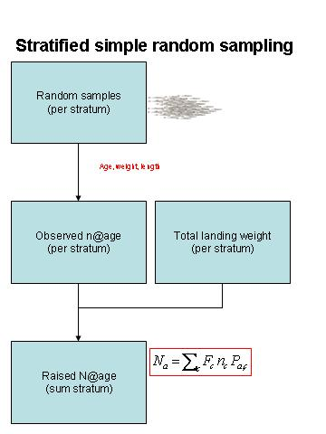
Raising procedure
Let n the (aggregated) number of fish sampled per stratum and P(a) denotes the age probability distribution per stratum. The observed numbers of fish per age group (n·P(a)), within a stratum, are multiplied with a raising factor (F) to estimate population numbers at age (Na). The raising factor (F) is the inverse of the weight fraction sampled per stratum (W/w or W/n·wbar). W, is the (aggregated) landing weight per stratum and w is the weight of the sample taken per stratum. W is considered a known figure. The numbers at age estimates for the different strata are summed, resulting in an estimate of the total number of fish landed per age group.

Uncertainty
Suppose the true (and unknown) number of age group a is N_{a}, then P_{a} equals N_{a}/N, where P_{a} is the true and unknown proportion of age a fish in the landings. In the sample each fish is aged and the resultant frequency of age a is n_{a} then Phat_{a}=n_{a}/n, and SE²(Phat_{a})=Perr²= Phat_{a} ·(1- Phat_{a})/n and if n is large (>30) then the normal approximation can be applied to obtain a confidence interval for Phat_{a}. The precision of the number at age estimates depends also on the precision of the estimated average weights of sampled fish (werr). Using the partial derivatives of the functional equation results in a row vector of these partial derivatives (d)
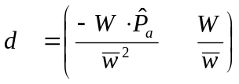 and 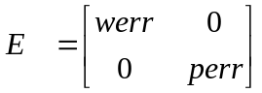 , the error terms in diagonal structure. The standard error of the number at age estimate is, written in matrix notation as: 