Stratified two-stage random sampling.

Stratified two-stage random sampling is used for Dutch cod landings. The stratified two-stage sampling scheme for cod starts in the first stage with simple random samples from the landings that allow assessments of lengths of the sampled fish. Mostly the samples are classified into length intervals with frequencies. The observed number of fish per length group within a stratum are multiplied with a raising factor (the inverse of the weight fraction sampled per stratum) to estimate numbers at length.
In the second stage subsamples of size x are taken for biological observations like weight, sex, maturity and age. In case of a fixed allocation, a constant number of fish are aged from each size class. The default allocation is proportional, with numbers of fished aged being proportional to the frequency in the LF. The resulting ALK, age-length-key, is used for the conversion of the estimated length distribution into an age distribution per stratum. The procedure described here starts with a general stratum.

Raising procedure
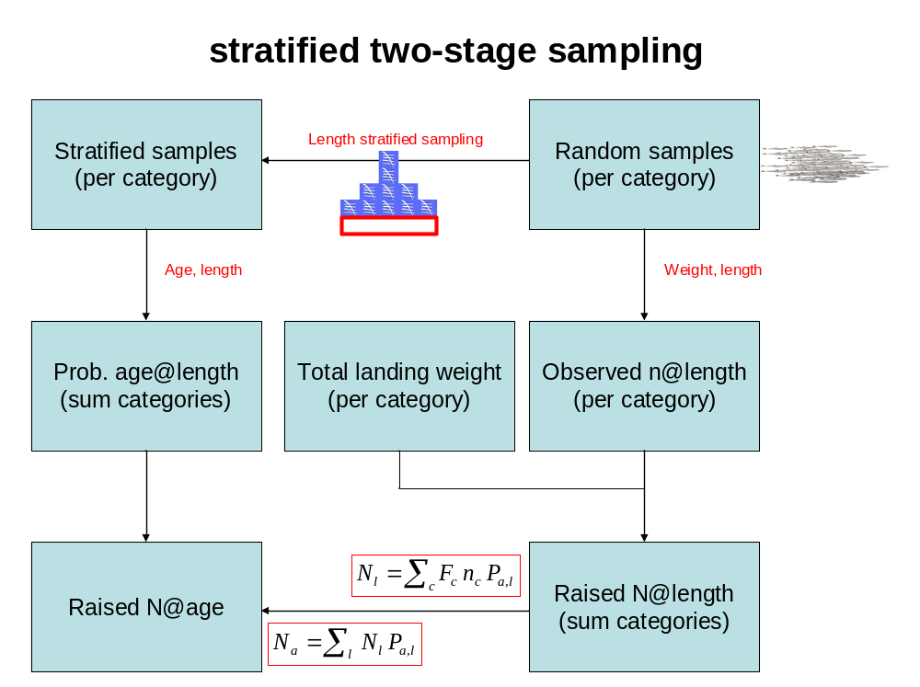
The total number of fish in a stratum is the product of raising factor F, the ratio of landing weight to the total weight of sampled landings, and n, the number of fish summed over the sampled landings. The aggregated landing weight, W, is considered to be a precise known figure (with negligible uncertainty). If the average landing weight per sample of a stratum equals 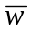 and S equals the sample size per stratum, the raising factor F can be expressed as:
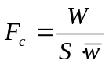
The partitioning of the estimated numbers of fish in a stratum between the age groups is done via Pa, the probability that a fish is of a particular age, given the stratum it belongs to. Pa is estimated by the integration of the product of the age-length-key, ALK, and the length probability distribution Pl. The number at age, Na, raised to the total landings is then estimated by F·n·Pa. The Na estimates for the different strata are summed. The precision of these estimates is governed by the errors of the average landing weight, the number of fish summed over the sampled landings and the probability that fish belong to particular age classes. The error is approximated by the application of the formula for error propagation (without correlation): 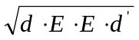, where d is a row vector of partial derivatives towards stochastic variables and E is a matrix of the error terms associated with all the stochastic variables in a diagonal structure.
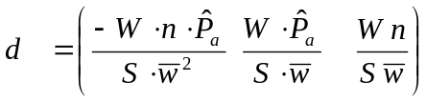and 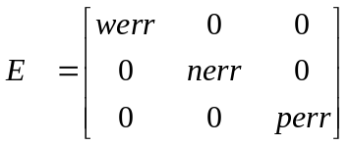
werr, the error of the estimated average landing weight is the standard error of the mean.
nerr, the error in the estimate of the estimated number of sampled fish is approximated by applying the error propagation formula with ignoring of possible correlation between sample proportion from various landings.
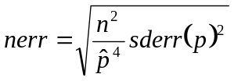, where p is the average sample proportion per sampled landing.
perr, the error in the estimate of the probability that a fish is of a particular age, Pa, is estimated from the variation of Pal and Pl as independent random variables.
,
Here,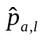 denotes the observed proportion of fish of a particular age within a length class, and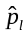denotes the observed proportion of fish of a particular length class within a stratum.

