Data quality tutorial

FishPi WP4

2016-05-19

# Framework

Fishery data have to be inspected in order to detect errors before to use them in the stock assessment procedure (Chen 2003). Finding and correcting errors is one of the first tasks one needs to perform on a dataset in this case. Currently these checks are made at national level using mainly manual methods (based on graphs and numerical summary, see Vigneau and Mahevas (2007) for example). When the amount of data is large (as it will become with the implementation of the regional database) manual methods are (1) too time consuming and (2) are difficult to track in time (when and how the corrections were made). Hence automated procedures are needed and participate intrinsically to build the data quality.

This document is a tutorial related to the use of the R fishPifct package to assess data quality on fishery sampling data. The fishPifct package was developped for the work package 4 of the fishPi project (project DG-MARE 2014/19 WP4). Its main objectives are to provide to the end users a framework to assess the quality of sampling data related to fishery.

## Data format specification

This framework concerns sampling data and leans on the csPi format in term of data structure. The csPi format is a format under development based on the fishFrame format. The fishFrame format is used in the Regional Database and by the COST packages (a collection of tools to deal with data compilation, COST (2006)). Its complete definition is given in Jansen et al. (2009). An update of this format, called csPi, is in discussion since 2014 (ICES 2014), and the version 2.1 of this format is used in this report. Tools to export fishFrame files in csPi as provided. And in order to insure a wide range of application, most of the packages functions works on csPi and fishFrame objects.

## Methodology

This framework follows the recommandation of the reproducible research statment (Gentleman and Lang 2004). Consequently this report is self-consistent: the code used to process and to analyse the sampling data are embedded in the report itself. An effort was made to select computing tools who give to the users the ability to reproduce the analyses using only a computer and an internet connection (for installation purposes mainly). Therefore all the tools are open source software, available free of charges, and running on the three main operating systems available nowadays (Linux, Windows and Mac OS).

## Software

Coding and analyses are carried out using the R environment (R Core Team 2016). R[1] is a free software environment for statistical computing and graphics. The reproducibility of the results presented in this report relies on the use of a dialect of the Mardown language called Pandoc for word processing using the Knitr R package. Markdown is a plain text formatting syntax designed so that it can optionally be converted to HTML using a tool by the same name. Pandoc[2] is a Markdown dialect which extends the conversion capability to word processing file (docx, doc and odt), html and pdf, among other formats. Pandoc understands a number of markdown syntax extensions, including document metadata (title, author, date), footnotes, tables, figures and references. Knitr[3] is an R package (a set of functions extending the R capabilities). With this package, the R code used to process and analyze the data is included directly in the report. Results are then produced dynamically. This framework has demonstrated the capacity to improve the conduct and the presentation of data analysis in a way that another person can understand and replicate (Baumer et al. 2014).

For example, if the calculus of 1+1 is needed, the code to compute it is written in the report using special hooks, as in this simple example:

'''{r test00,warn=FALSE,cache=TRUE,echo=TRUE}  
#comment: addition example.  
1+1  
'''

This code is evaluated during the compilation of the report by the knitr command and it prints the following result:

#comment: addition example.  
1+1

## [1] 2

The result is 2. In this tutorial all the numerical values, tables and figures are produced following this procedure. The scripts and the report can be elaborated in a single integrated development environment (IDE), called Rstudio[4]. It includes a console and a syntax-highlighting editor that supports direct code execution, as well as tools for plotting, debugging and writing report. Consequently, all the tools and code presented here are already available to the end user.

## Installation

This package is available  
in the [fihPifct repository](https://github.com/lodbk/fishPifct/tree/master/vignettes) on Github. The installation procedure is simple as :

install.packages("devtools")  
library(devtools)  
install_github("ldbk/fishPifct")

### Issues

Technical problem support during the installation process (R version, missing packages...) is far beyond the scope of this tutorial. In case of problem, please contact your IT support.

Some users reported issues with the openxlsx package installation (needed to import and export csPi and csData object in excel file). Please read carefully the error messages R gives to you (the way to fix these errors are explained to you in these messages). The average procedure to fix them should be something like:

install.packages("installr")  
installr::installr("Rtools")

During the installation, tick the PATH modification option. Then, restart your computer.

### COST library

If needed, COST related package (for windows) can be found here :

* <https://dl.dropboxusercontent.com/u/6181692/COSTcore_1.4-0.zip>
* <https://dl.dropboxusercontent.com/u/6181692/COSTdbe_1.4-1.zip>
* <https://dl.dropboxusercontent.com/u/6181692/COSTeda_1.4.0.zip>

and here for Unix system :

* <https://dl.dropboxusercontent.com/u/6181692/COSTcore_1.4-0.tar.gz>
* <https://dl.dropboxusercontent.com/u/6181692/COSTdbe_1.4-1.tar.gz>
* <https://dl.dropboxusercontent.com/u/6181692/COSTeda_1.4.0.tar.gz>

The COST manuel can be downloaded here :

* <https://dl.dropboxusercontent.com/u/6181692/COST%20User%20Manual%20V1_1.pdf>

# Data

## Format specification

In this tutorial, only the main characteristics of this format are illustrated. A detailed version of the csPi format specifications is given in ICES (2014) and in the help page of the csPi function.

csPi is an S4 object containing 10 slots :

library(pander);library(fishPifct)

## Loading required package: dplyr

##   
## Attaching package: 'dplyr'

## The following objects are masked from 'package:stats':  
##   
## filter, lag

## The following objects are masked from 'package:base':  
##   
## intersect, setdiff, setequal, union

## Loading required package: openxlsx

## Loading required package: readxl

## Loading required package: rmarkdown

## Loading required package: robustbase

##   
## Attaching package: 'robustbase'

## The following object is masked from 'package:stats':  
##   
## sigma

## Loading required package: ggplot2

## Loading required package: mapdata

## Loading required package: maps

##   
## # maps v3.1: updated 'world': all lakes moved to separate new #  
## # 'lakes' database. Type '?world' or 'news(package="maps")'. #

pander(format_definition_csPi$slots,split.table=Inf)

|  |  |  |
| --- | --- | --- |
| slot_name | mandatory | definition_table |
| classVersion | TRUE | slot_classVersion |
| desc | FALSE | slot_desc |
| popData | FALSE | slot_popData |
| design | FALSE | slot_design |
| se | TRUE | slot_se |
| tr | TRUE | slot_tr |
| hh | FALSE | slot_hh |
| sl | FALSE | slot_sl |
| hl | FALSE | slot_hl |
| ca | FALSE | slot_ca |

The slots desc, popData, design are not mandatory and serve as descriptive fields for future applications.

The slots classVersion provides the version number of the csPi format. This format is still in development, and keeping the format version will insure retrocompatibility with the future development of the package. The slots hold the sampling information : the sampling events description (se), the trip information (tr), the hauls caracteristics (hh), the species sampled (sl) and the correspondings length measurments (hl), and the biological parameters (ca). Each of these slots is a data.frame who lists the different parameters requested for each sample. Type of the vessel, its characteristic, the fishing location and the quantity landed, the scientific name of the sampled species, the length class of the fishes, the age, etc... are reported in these tables. These variables can be numeric, text or codelist. For each table, a group of variables represent the primary key and insure the links with the other tables. The next figure gives an overview of the structure of the table.

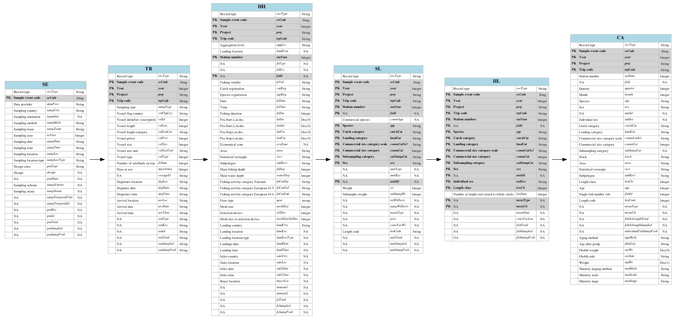

Overview of the csPi format

## Example dataset

The data are generated based on the sole dataset coming from the COST package. The fishFrame COST format is exported in the csPi format using the function csDataTocsPi:

library(fishPifct)  
data(sole)  
sole <- csDataTocsPi(sole.cs)

## No seObj provided. Trips are used as sampling events. Use only for testing !

## Loading required package: COSTcore

## -------------------------------------------------------------------  
## COSTcore - "The DCF Statistical Suite"  
## (Version: 1.4-0. Built on: R 3.2.2; ; 2015-11-03 08:23:08 UTC; unix)  
## -------------------------------------------------------------------

##   
## Attaching package: 'COSTcore'

## The following object is masked from 'package:dplyr':  
##   
## desc

head(sole)

## An object of class "csPi"  
## Slot "classVersion":  
## [1] "2.1"  
##   
## Slot "desc":  
## [1] "Commercial Sampling Data format for the fishPi project"  
##   
## Slot "popData":  
## [1] "Named population data object"  
##   
## Slot "design":  
## [1] "Design description"  
##   
## Slot "history":  
## [1] "modification history"  
##   
## Slot "se":  
## recType seCode dataProv sampCtry sampInst sampMeth sampTeam seYear  
## 1 se ARY178 FRA FRA Obsmer NA Obsmer 2006  
## 2 se DIL1196 FRA FRA Obsmer NA Obsmer 2006  
## 3 se DIL1197 FRA FRA Obsmer NA Obsmer 2006  
## 4 se ELR214 FRA FRA Obsmer NA Obsmer 2006  
## 5 se ELR219 FRA FRA Obsmer NA Obsmer 2006  
## 6 se FAD73 FRA FRA Obsmer NA Obsmer 2006  
## sampDate sampTime sampLoc sampLocType psuType design popData sampScheme  
## 1 NA NA NA NA NA NA NA NA  
## 2 NA NA NA NA NA NA NA NA  
## 3 NA NA NA NA NA NA NA NA  
## 4 NA NA NA NA NA NA NA NA  
## 5 NA NA NA NA NA NA NA NA  
## 6 NA NA NA NA NA NA NA NA  
## sampStrata sampTemporalUnit sampTemporalId psuKey psuId psuTotal  
## 1 NA NA NA NA NA NA  
## 2 NA NA NA NA NA NA  
## 3 NA NA NA NA NA NA  
## 4 NA NA NA NA NA NA  
## 5 NA NA NA NA NA NA  
## 6 NA NA NA NA NA NA  
## psuSampled psuSampProb  
## 1 1 1  
## 2 1 1  
## 3 1 1  
## 4 1 1  
## 5 1 1  
## 6 1 1  
##   
## Slot "tr":  
## recType seCode year proj trpCode sampType vslFlgCtry vslId vslLen  
## 1 tr ARY178 2006 Obsmer ARY178 S FRA 98 NA  
## 2 tr DIL1196 2006 Obsmer DIL1196 S FRA 85 NA  
## 3 tr DIL1197 2006 Obsmer DIL1197 S FRA 21 NA  
## 4 tr ELR214 2006 Obsmer ELR214 S FRA 42 NA  
## 5 tr ELR219 2006 Obsmer ELR219 S FRA 43 NA  
## 6 tr FAD73 2006 Obsmer FAD73 S FRA 41 NA  
## vslLenCat vslPwr vslSize vslSizeUnit vslType foNum daysAtSea voyageId  
## 1 <NA> NA NA <NA> 1 27 4 <NA>  
## 2 <NA> NA NA <NA> 1 30 5 <NA>  
## 3 <NA> NA NA <NA> 1 5 2 <NA>  
## 4 <NA> NA NA <NA> 1 56 13 <NA>  
## 5 <NA> NA NA <NA> 1 13 10 <NA>  
## 6 <NA> NA NA <NA> 3 3 4 <NA>  
## depLoc depDate depTime arvLoc arvDate arvTime ssuType ssuKey ssuId  
## 1 <NA> <NA> <NA> <NA> <NA> <NA> <NA> <NA> <NA>  
## 2 <NA> <NA> <NA> <NA> <NA> <NA> <NA> <NA> <NA>  
## 3 <NA> <NA> <NA> <NA> <NA> <NA> <NA> <NA> <NA>  
## 4 <NA> <NA> <NA> <NA> <NA> <NA> <NA> <NA> <NA>  
## 5 <NA> <NA> <NA> <NA> <NA> <NA> <NA> <NA> <NA>  
## 6 <NA> <NA> <NA> <NA> <NA> <NA> <NA> <NA> <NA>  
## ssuTotal ssuSampled ssuSampProb  
## 1 <NA> <NA> <NA>  
## 2 <NA> <NA> <NA>  
## 3 <NA> <NA> <NA>  
## 4 <NA> <NA> <NA>  
## 5 <NA> <NA> <NA>  
## 6 <NA> <NA> <NA>  
##   
## Slot "hh":  
## recType seCode year proj trpCode aggLev landFrac staNum foType foKey  
## 1 hh ARY178 2006 Obsmer ARY178 H <NA> 1 <NA> <NA>  
## 2 hh ARY178 2006 Obsmer ARY178 H <NA> 2 <NA> <NA>  
## 3 hh ARY178 2006 Obsmer ARY178 H <NA> 3 <NA> <NA>  
## 4 hh ARY178 2006 Obsmer ARY178 H <NA> 4 <NA> <NA>  
## 5 hh ARY178 2006 Obsmer ARY178 H <NA> 5 <NA> <NA>  
## 6 hh ARY178 2006 Obsmer ARY178 H <NA> 6 <NA> <NA>  
## foId foVal catReg sppReg foDate foTime foDur latIni lonIni  
## 1 <NA> V All All 2006-04-03 <NA> 150 50.05360 1.623667  
## 2 <NA> V All All 2006-04-03 <NA> 180 51.19133 1.786333  
## 3 <NA> V Non Non 2006-04-03 <NA> 165 51.11667 1.672667  
## 4 <NA> V All All 2006-04-03 <NA> 195 51.03933 1.568667  
## 5 <NA> V All All 2006-04-03 <NA> 190 51.03933 1.666667  
## 6 <NA> V Non Non 2006-04-04 <NA> 180 51.11667 1.672667  
## latFin lonFin ecoZone area rect subRect foDep waterDep foCatNat  
## 1 NA NA <NA> 27.7.d 29F1 <NA> NA 40 7D-OTB-Merlan  
## 2 NA NA <NA> 27.4.c 31F1 <NA> NA 40 4C-OTB-Merlan  
## 3 NA NA <NA> 27.4.c 31F1 <NA> NA 40 4C-OTB-Merlan  
## 4 NA NA <NA> 27.4.c 31F1 <NA> NA 40 4C-OTB-Merlan  
## 5 NA NA <NA> 27.4.c 31F1 <NA> NA 40 4C-OTB-Merlan  
## 6 NA NA <NA> 27.4.c 31F1 <NA> NA 40 4C-OTB-Merlan  
## foCatEu5 foCatEu6 gear meshSize selDev meshSizeSelDev landCtry  
## 1 OTB_DEF OTB_DEF_80_0_0 <NA> 80 0 NA FRA  
## 2 OTB_DEF OTB_DEF_80_0_0 <NA> 80 0 NA FRA  
## 3 OTB_DEF OTB_DEF_80_0_0 <NA> 80 0 NA FRA  
## 4 OTB_DEF OTB_DEF_80_0_0 <NA> 80 0 NA FRA  
## 5 OTB_DEF OTB_DEF_80_0_0 <NA> 80 0 NA FRA  
## 6 OTB_DEF OTB_DEF_80_0_0 <NA> 80 0 NA FRA  
## landLoc landLocType landDate landTime saleCtry saleLoc saleDate saleTime  
## 1 <NA> <NA> <NA> <NA> <NA> <NA> <NA> <NA>  
## 2 <NA> <NA> <NA> <NA> <NA> <NA> <NA> <NA>  
## 3 <NA> <NA> <NA> <NA> <NA> <NA> <NA> <NA>  
## 4 <NA> <NA> <NA> <NA> <NA> <NA> <NA> <NA>  
## 5 <NA> <NA> <NA> <NA> <NA> <NA> <NA> <NA>  
## 6 <NA> <NA> <NA> <NA> <NA> <NA> <NA> <NA>  
## buyerLoc domain1 domain2 foTotal foSampled foSampProb  
## 1 <NA> <NA> <NA> <NA> <NA> <NA>  
## 2 <NA> <NA> <NA> <NA> <NA> <NA>  
## 3 <NA> <NA> <NA> <NA> <NA> <NA>  
## 4 <NA> <NA> <NA> <NA> <NA> <NA>  
## 5 <NA> <NA> <NA> <NA> <NA> <NA>  
## 6 <NA> <NA> <NA> <NA> <NA> <NA>  
##   
## Slot "sl":  
## recType seCode year proj trpCode staNum foId commSpp spp  
## 1 sl DIL1197 2006 Obsmer DIL1197 1 <NA> <NA> Solea solea  
## 2 sl DIL1197 2006 Obsmer DIL1197 1 <NA> <NA> Solea solea  
## 3 sl DIL1197 2006 Obsmer DIL1197 2 <NA> <NA> Solea solea  
## 4 sl DIL1197 2006 Obsmer DIL1197 2 <NA> <NA> Solea solea  
## 5 sl DIL1197 2006 Obsmer DIL1197 3 <NA> <NA> Solea solea  
## 6 sl DIL1197 2006 Obsmer DIL1197 3 <NA> <NA> Solea solea  
## catchCat landCat commCatScl commCat subSampCat sex unitType unitKey  
## 1 LAN HUC EU <NA> <NA> <NA> <NA> <NA>  
## 2 DIS HUC EU <NA> <NA> <NA> <NA> <NA>  
## 3 LAN HUC EU <NA> <NA> <NA> <NA> <NA>  
## 4 DIS HUC EU <NA> <NA> <NA> <NA> <NA>  
## 5 LAN HUC EU <NA> <NA> <NA> <NA> <NA>  
## 6 DIS HUC EU <NA> <NA> <NA> <NA> <NA>  
## unitId wt subSampWt totWtDeriv sampWtDeriv measType pres convFacWt  
## 1 <NA> 11000 NA <NA> <NA> <NA> <NA> <NA>  
## 2 <NA> 10000 1560 <NA> <NA> <NA> <NA> <NA>  
## 3 <NA> 26321 NA <NA> <NA> <NA> <NA> <NA>  
## 4 <NA> 12000 2570 <NA> <NA> <NA> <NA> <NA>  
## 5 <NA> 73000 NA <NA> <NA> <NA> <NA> <NA>  
## 6 <NA> 7000 4217 <NA> <NA> <NA> <NA> <NA>  
## lenCode unitTotal unitSampled unitSampProb  
## 1 cm <NA> <NA> <NA>  
## 2 cm <NA> <NA> <NA>  
## 3 cm <NA> <NA> <NA>  
## 4 cm <NA> <NA> <NA>  
## 5 cm <NA> <NA> <NA>  
## 6 cm <NA> <NA> <NA>  
##   
## Slot "hl":  
## recType seCode year proj trpCode staNum foId spp catchCat  
## 1 hl DIL1197 2006 Obsmer DIL1197 1 <NA> Solea solea DIS  
## 2 hl DIL1197 2006 Obsmer DIL1197 1 <NA> Solea solea DIS  
## 3 hl DIL1197 2006 Obsmer DIL1197 1 <NA> Solea solea DIS  
## 4 hl DIL1197 2006 Obsmer DIL1197 1 <NA> Solea solea DIS  
## 5 hl DIL1197 2006 Obsmer DIL1197 2 <NA> Solea solea DIS  
## 6 hl DIL1197 2006 Obsmer DIL1197 2 <NA> Solea solea DIS  
## landCat commCatScl commCat subSampCat sex unitId indSex lenCls lenNum  
## 1 HUC EU <NA> <NA> <NA> <NA> <NA> 180 3  
## 2 HUC EU <NA> <NA> <NA> <NA> <NA> 190 6  
## 3 HUC EU <NA> <NA> <NA> <NA> <NA> 200 5  
## 4 HUC EU <NA> <NA> <NA> <NA> <NA> 210 1  
## 5 HUC EU <NA> <NA> <NA> <NA> <NA> 160 1  
## 6 HUC EU <NA> <NA> <NA> <NA> <NA> 170 1  
## measType measCls measNum convFacLen fishTotal fishSampled fishSampProb  
## 1 <NA> <NA> <NA> <NA> <NA> <NA> <NA>  
## 2 <NA> <NA> <NA> <NA> <NA> <NA> <NA>  
## 3 <NA> <NA> <NA> <NA> <NA> <NA> <NA>  
## 4 <NA> <NA> <NA> <NA> <NA> <NA> <NA>  
## 5 <NA> <NA> <NA> <NA> <NA> <NA> <NA>  
## 6 <NA> <NA> <NA> <NA> <NA> <NA> <NA>  
##   
## Slot "ca":  
## recType seCode year proj trpCode staNum foId quarter month spp  
## 1 ca 12 2006 BioPar 12 999 <NA> 2 4 Solea solea  
## 2 ca 12 2006 BioPar 12 999 <NA> 2 4 Solea solea  
## 3 ca 12 2006 BioPar 12 999 <NA> 2 4 Solea solea  
## 4 ca 12 2006 BioPar 12 999 <NA> 2 4 Solea solea  
## 5 ca 12 2006 BioPar 12 999 <NA> 2 4 Solea solea  
## 6 ca 12 2006 BioPar 12 999 <NA> 2 4 Solea solea  
## sex unitId indSex catchCat landCat commCatScl commCat subSampCat stock  
## 1 M <NA> <NA> LAN HUC <NA> <NA> <NA> <NA>  
## 2 M <NA> <NA> LAN HUC <NA> <NA> <NA> <NA>  
## 3 M <NA> <NA> LAN HUC <NA> <NA> <NA> <NA>  
## 4 F <NA> <NA> LAN HUC <NA> <NA> <NA> <NA>  
## 5 F <NA> <NA> LAN HUC <NA> <NA> <NA> <NA>  
## 6 M <NA> <NA> LAN HUC <NA> <NA> <NA> <NA>  
## area rect subRect lenCls age fishId lenCode measType measCls  
## 1 27.7.d 28E9 <NA> 330 5 1 cm <NA> <NA>  
## 2 27.7.d 28E9 <NA> 340 7 2 cm <NA> <NA>  
## 3 27.7.d 28E9 <NA> 320 7 3 cm <NA> <NA>  
## 4 27.7.d 28E9 <NA> 320 4 4 cm <NA> <NA>  
## 5 27.7.d 28E9 <NA> 350 7 5 cm <NA> <NA>  
## 6 27.7.d 28E9 <NA> 340 9 6 cm <NA> <NA>  
## fishAtLengthTotal fishAtlengthSampled individualFishSampProb  
## 1 <NA> <NA> <NA>  
## 2 <NA> <NA> <NA>  
## 3 <NA> <NA> <NA>  
## 4 <NA> <NA> <NA>  
## 5 <NA> <NA> <NA>  
## 6 <NA> <NA> <NA>  
## ageMeth plusGrp otoWt otoSide indWt  
## 1 Otoliths - slides with transmitted light - NA <NA> 355  
## 2 Otoliths - slides with transmitted light - NA <NA> 360  
## 3 Otoliths - slides with transmitted light - NA <NA> 339  
## 4 Otoliths - slides with transmitted light - NA <NA> 416  
## 5 Otoliths - slides with transmitted light - NA <NA> 412  
## 6 Otoliths - slides with transmitted light - NA <NA> 411  
## matMeth matScale matStage  
## 1 Visual 1-7 2  
## 2 Visual 1-7 2  
## 3 Visual 1-7 2  
## 4 Visual 1-7 5  
## 5 Visual 1-7 4  
## 6 Visual 1-7 2

The csPi object is named sole in our example.

## Handling csPi ojects

A collection of methods and functions gives to the user the ability to explore and visualize a csPi objects:

methods(class="csPi")

## [1] dim export head summary tail   
## see '?methods' for accessing help and source code

#subset csPi object  
#?csSubset

Their behaviours are similar to the generic one (ie dim gives the dimension of all the csPi slots).

## Import and export in spreadsheet

Fishing data rely usually on national database. Correction procedures in these systems can be a tedious work, not really in accordance to quick corrections (during working groups, to harmonize datasets between countries for example). Manual data corrections are difficult and spreadsheet is nowadays the common tools to correct locally the data. A local import/export procedure is available to export the csPi in excel file format. Thus, the user can use a spreadsheet to do some corrections in the tables and then import directly the corrected tables in a csPi object in R.

In this package the import and export functions do these transformation easily:

export(sole,file="sole.xlsx",type="xlsx")

## [1] "sole.xlsx"

#use a spreadsheet to open the sole.xlsx file and do some corrections if needed  
#save the file, and import it in R with:  
solecorrected<-importxlsx(file="sole.xlsx")

# Data quality checks

## Data structure checks

A seminal step in data quality is to check the structure of the data. The structure check includes the ordered verification of :

* the objects' slots: name, existence, mandatory or not.
* the slots' tables: dimension, variables names, mandatory or not, uniqueness of the primary keys if applicable.
* the tables'variables: their types - numeric (integer or real, lower and upper limits), character, codelist (a list of authorized values)-, nullable, mandatory or not.

The data structure definition is given for csPi objects by the list format_definition_csPi. This list is built from the excel file format_definition_csPi.xlsx in the data directory of the installation directory of the package. Providing the excel file gives to the end user the possibility to modify the data structure check (for example the lower and upper limits of the length class, or a limited list of metier).

### Slot definition

A slot definition is a table reporting the characteristics of a given slot :

|  |  |  |
| --- | --- | --- |
| slot_name | mandatory | definition_table |
| base | TRUE | slot_base |

Here the slot names base is mandatory and its definition is given by the table slot_base. During the structure check, each slot is checked against its definition given by the structure definition list.

### Table definition

A table definition is a table reporting the characteristics of a given table. For example here, the first 8 lines of the tr table definition :

library(pander);library(fishPifct)  
pander(format_definition_csPi$slot_tr[1:8,],split.table=Inf)

|  |  |  |  |  |  |
| --- | --- | --- | --- | --- | --- |
| column_name | nullable | mandatory | pk | type_name | category |
| recType | FALSE | TRUE | FALSE | type_recType | codelist |
| seCode | FALSE | TRUE | TRUE | type_seCode | text |
| year | FALSE | TRUE | TRUE | type_year | numeric |
| proj | FALSE | TRUE | TRUE | type_proj | text |
| trpCode | FALSE | TRUE | TRUE | type_trpCode | text |
| sampType | FALSE | TRUE | FALSE | type_sampType | codelist |
| vslFlgCtry | FALSE | TRUE | FALSE | type_ctry | codelist |
| vslId | FALSE | FALSE | FALSE | type_vslId | text |

Each table's column is checked against its definition. For example, the trpCode variable has to be non nullable, is mandatory and is part of the primary key of the tr table. It is a text variable (category), and its category definition is referenced in the type_trpCode of the definition file (or the excel sheet with this name).

### Variable checks

After the table definition, each variable are checked according to their types. For example in the previous table vslFlagCtry is non nullable, mandatory and is not included in the primary key. The variable's type is a codelist, and the corresponding authorized value are registered in the codelist_type list of the format description, namely the list codelist_ctry (here the first 10 lines):

pander(format_definition_csPi$codelist_ctry[1:10,],split.table=Inf)

|  |  |
| --- | --- |
| CODE | DESCRIPTION |
| ABW | Aruba |
| AFG | Afghanistan |
| AGO | Angola |
| AIA | Anguilla |
| ALA | Åland Islands |
| ALB | Albania |
| AND | Andorra |
| ARE | United Arab Emirates |
| ARG | Argentina |
| ARM | Armenia |

This list is the list of the ISO 3166-1 alpha-3 country codes. Limiting this list strengths the data quality check, according to the end user needs.

For the variables with a numeric type, the numeric_type list of the data definition brings information related to the numerical limits and if the numbers are integer (number of samples, age...) or real (probability...).

For example here, the first 8 lines of the numeric_type table definition:

library(pander);library(fishPifct)  
pander(format_definition_csPi$numeric_type[1:8,],split.table=Inf)

|  |  |  |  |
| --- | --- | --- | --- |
| type_name | is_integer | min | max |
| type_year | TRUE | 1900 | 2020 |
| type_psuTotal | TRUE | 0 | 1e+07 |
| type_psuSampled | TRUE | 0 | 2000 |
| type_psuSampProb | FALSE | 0 | 1 |
| type_vslLen | TRUE | 3 | 160 |
| type_vslPwr | TRUE | 4 | 8500 |
| type_vslSize | TRUE | 1 | 2500 |
| type_foNum | TRUE | 1 | 300 |

In this example, year is an integer between 1900 and 2020. As previously stated the modification of the data structure is open to the end user needs.

### Notes

The data structure checks were developped by the sister project of fishPi related to the Mediterranean area, for fishFrame object (<https://git.outils-is.ird.fr/billet/SDEFQuality/wikis/home>). Consequently, this data structure check is applicable to any object structure, and it can be extended to landings or effort file in a near future for example.

### Outputs

The results of the data structure checks are given in a report summarizing all the checks, if these checks pass, and why. Using the sole dataset previously loaded:

#generating a report in an R object  
structurecheck<-validateData(obj=sole,formatDb=format_definition_csPi,report="list")

The meta information related to the check are:

pander(structurecheck$meta,split.table=Inf)

|  |  |
| --- | --- |
| parameter | value |
| format_name | csPi |
| format_version | 2.1 |
| validate_date | 2016-05-19 09:04:26 |
| dataset_container | object |
| format_container | object |

The 10 first lines of the slots checks are:

pander(structurecheck$struct[1:10,],split.table=Inf)

|  |  |  |  |  |
| --- | --- | --- | --- | --- |
| slot | column | test | result | message |
| classVersion | NA | Slot exists ? | OK | Found |
| classVersion | classVersion | Column exists ? | OK | Found |
| desc | NA | Slot exists ? | OK | Found |
| desc | desc | Column exists ? | OK | Found |
| popData | NA | Slot exists ? | OK | Found |
| popData | popData | Column exists ? | OK | Found |
| design | NA | Slot exists ? | OK | Found |
| design | design | Column exists ? | OK | Found |
| se | NA | Slot exists ? | OK | Found |
| se | recType | Column exists ? | OK | Found |

The 10 first lines of the variables checks are:

pander(structurecheck$data[1:10,],split.table=Inf)

|  |  |  |  |  |
| --- | --- | --- | --- | --- |
| slot | column | test | result | message |
| classVersion | classVersion | is text ? | OK | All values are text |
| classVersion | classVersion | is null ? | OK | All values are not null |
| desc | desc | is text ? | OK | All values are text |
| desc | desc | is null ? | OK | All values are not null |
| popData | popData | is text ? | OK | All values are text |
| popData | popData | is null ? | OK | All values are not null |
| design | design | is text ? | OK | All values are text |
| design | design | is null ? | OK | All values are not null |
| se | recType | is valid code list ? | OK | All values are valid codes |
| se | recType | is null ? | OK | All values are not null |

The tables are explicits and doesn't need any comments. To generate a complete report in pdf or html format :

#generating a pdf report  
renderValidationReport(obj=sole,formatDb=format_definition_csPi,  
 title="test",reportFormat="pdf")

## Report generated [/tmp/RtmpHXMPUo/dataValidationReport_20160519_090427_17163132ffce.pdf]

## [1] "/tmp/RtmpHXMPUo/dataValidationReport_20160519_090427_17163132ffce.pdf"

#a copy of this report can be found in  
system.file('data',   
'dataValidationReport_20160518_235140_29d51c808f9b.pdf',  
 package='fishPifct')

## [1] "/home/moi/R/x86_64-pc-linux-gnu-library/3.3/fishPifct/data/dataValidationReport_20160518_235140_29d51c808f9b.pdf"

### Consistency check

In this section, the consistency of the information between the 'csPi' slots is checked, e.g. identification of trips without fishing operations. To do so, the function consistency performs hierachical anti jointure between related table and generates a simple table reporting the trpCode who have to be checked between the tables:

#consistency check generating a pdf report  
consistencycheck<-consistency(sole)  
pander(consistencycheck,split.table=Inf)

|  |  |  |
| --- | --- | --- |
| test | message | check |
| tr->se | 0 tr records have no correspondings se records | orphans tr trpCode: |
| hh->tr | 0 hh records have no correspondings tr records | orphans hh trpCode: |
| sl->hh | 0 sl records have no correspondings hh records | orphans sl trpCode: |
| hl->sl | 0 hl records have no correspondings sl records | orphans hl trpCode: |

In our sole example, no consistency errors were detected.

## Outliers detection

The literature on outliers is extensive, and cover all the areas of science, but determining whether or not an observation is an outlier is ultimately a subjective exercise and hence makes automation a difficult task. Here we will use the definition of Barnett and Lewis (1994) for outlier: "Indicate that an outlying observation, or outlier, is one that appears to deviate markedly from other members of the sample in which it occurs". Outlier detection methods can be divide between univariate methods (looking at only one variable) and multivariate methods (looking at more than one variable and their relationships). For example univariate methods spot observations reported in tons instead of kilos in landings, while multivariate methods can identify wrong weigths in a size-weight relationship. Then outlier detection methods can be categorized between parametric (statistical) methods and non-parametric methods that are model free. Statistical parametric methods either assume a known underlying distribution of the data or, at least, they are based on statistical estimates of unknown distribution parameters. Observations that deviate from the model assumptions are flagged as outliers. Here we focus on two generic non parametric methods for numerical and non numerical univariate data. The function outliers do the outliers detection for a csPi object.

### Numeric variables

The adjusted outlyingness index is used to detect outliers. It's a non parametric methods, adapted to skewed data. The function adjOutliness of the package robustBase is used. More details of this method can be found in the help page of this function. An example on the fishing duration (variable foDur of slot hh):

tabaoutlier<-outliers(sole,slot="hh",var="foDur")

## `stat_bin()` using `bins = 30`. Pick better value with `binwidth`.

## Warning: Removed 48 rows containing non-finite values (stat_bin).

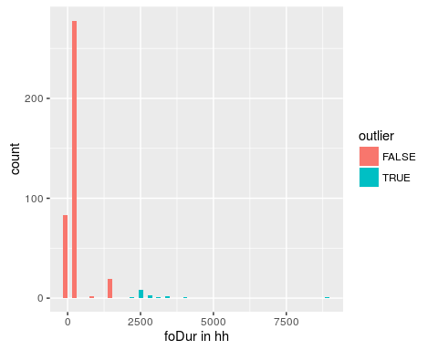 High fishing duration values are flagged as outliers, as presented in the figure. The function output gives to the user the complete lines who includes the outliers:

#10 first lines and 5 first columns of the outliers  
pander(tabaoutlier[1:10,1:5],split.table=Inf)

|  |  |  |  |  |  |
| --- | --- | --- | --- | --- | --- |
|  | recType | seCode | year | proj | trpCode |
| **63** | hh | ELR214 | 2006 | Obsmer | ELR214 |
| **274** | hh | MAC3 | 2006 | Obsmer | MAC3 |
| **275** | hh | MAC3 | 2006 | Obsmer | MAC3 |
| **276** | hh | MAC3 | 2006 | Obsmer | MAC3 |
| **277** | hh | MAC3 | 2006 | Obsmer | MAC3 |
| **278** | hh | MAC3 | 2006 | Obsmer | MAC3 |
| **279** | hh | MAC3 | 2006 | Obsmer | MAC3 |
| **280** | hh | MAC3 | 2006 | Obsmer | MAC3 |
| **281** | hh | MAC3 | 2006 | Obsmer | MAC3 |
| **282** | hh | MAC3 | 2006 | Obsmer | MAC3 |

### Text and codelist variables

For a non-numerical variable, the outliers are detected using the occurence of the modality of the value, expressed in percentage and a treshold (by default 1%). If a modality is expressed less than this treshold, an outlier is considered detected. The treshold can be fixed by the user. Here an example using the statistical rectangle fished :

tabaoutlier<-outliers(sole,slot="hh",var="rect")

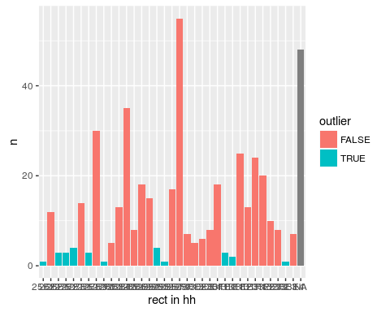 Rare fished rectangle are flagged as outliers. The function output gives to the user the complete lines who includes the outliers:

#10 first lines and 5 first columns of the outliers  
pander(tabaoutlier[1:10,1:5],split.table=Inf)

|  |  |  |  |  |  |
| --- | --- | --- | --- | --- | --- |
|  | recType | seCode | year | proj | trpCode |
| **65** | hh | ELR214 | 2006 | Obsmer | ELR214 |
| **68** | hh | ELR214 | 2006 | Obsmer | ELR214 |
| **77** | hh | ELR214 | 2006 | Obsmer | ELR214 |
| **78** | hh | ELR214 | 2006 | Obsmer | ELR214 |
| **79** | hh | ELR214 | 2006 | Obsmer | ELR214 |
| **81** | hh | ELR214 | 2006 | Obsmer | ELR214 |
| **82** | hh | ELR214 | 2006 | Obsmer | ELR214 |
| **83** | hh | ELR214 | 2006 | Obsmer | ELR214 |
| **90** | hh | ELR214 | 2006 | Obsmer | ELR214 |
| **110** | hh | ELR214 | 2006 | Obsmer | ELR214 |

These fonctions are generic and can be applied to the whole set of variables of a csPi object.

## Plots

### Maps

The function csMap gives the ability to the user to map easily a variable over the ICES statistical rectangle.

csMap(sole,"hh","foDur","tile","sum")

## [1] "Statistical rectangles missing and not mapped: "  
## [1] NA

## Joining by: "rect"

## Warning: Removed 1 rows containing missing values (geom_tile).

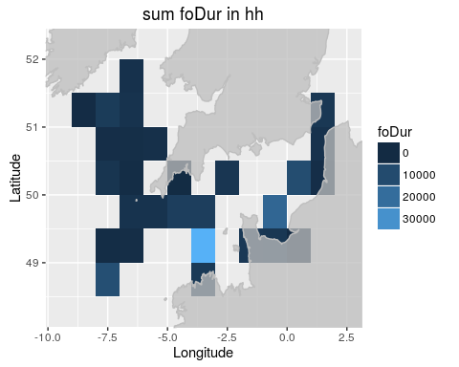

csMap(sole,"hh","foCatEu5","bubble")

## [1] "Statistical rectangles missing and not mapped: "  
## [1] NA

## Joining by: "rect"

## Warning: Removed 1 rows containing missing values (geom_tile).

## Warning: Removed 3 rows containing missing values (geom_point).

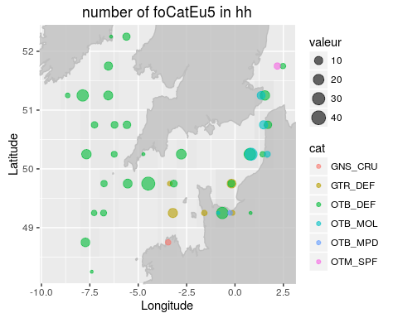

csMap(sole,"hl","lenNum","tile","sum")

## [1] "Statistical rectangles missing and not mapped: "  
## [1] NA

## Joining by: "rect"

## Warning: Removed 1 rows containing missing values (geom_tile).

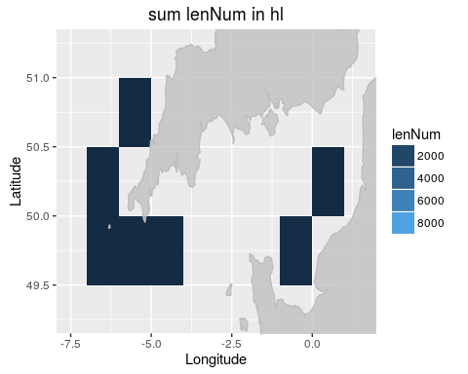

csMap(sole,"tr","daysAtSea","bubble","sum")

## [1] "Statistical rectangles missing and not mapped: "  
## [1] NA

## Joining by: "rect"

## Warning: Removed 1 rows containing missing values (geom_point).

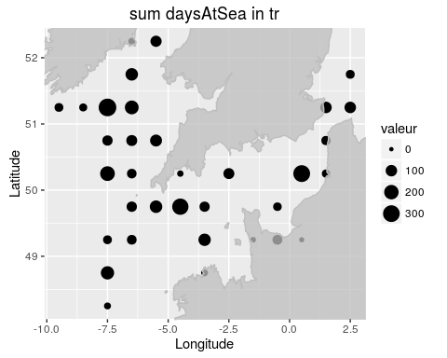

csMap(sole,"tr","vslId","bubble","n_distinct")

## [1] "Statistical rectangles missing and not mapped: "  
## [1] NA

## Joining by: "rect"

## Warning: Removed 1 rows containing missing values (geom_point).

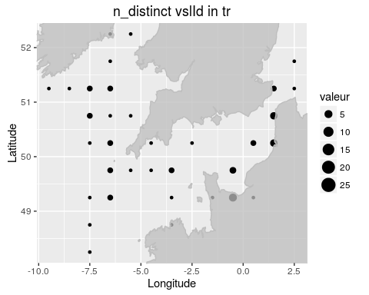

### Generic functions

The function lengthHist plots histograms of the length frequency data from the hl table of csPi object.

lengthHist(sole)

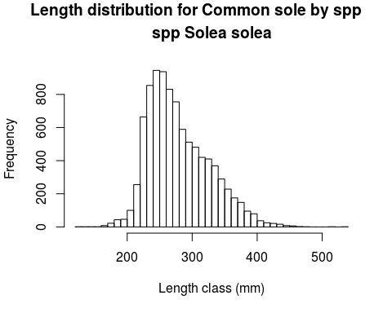 The function agelenPlot plots age given length from the ca table of a csPiobject.

agelenPlot(sole)

## Warning in agelenPlot(sole): Only LAN fraction present in data

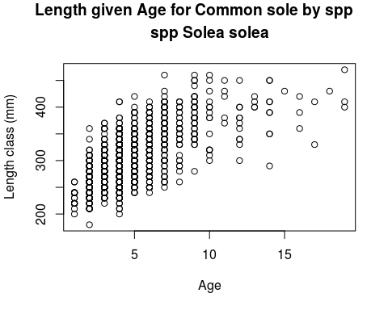

# About this vignette

This vignette was built using the vignette engine knitr::rmarkdown in the **knitr** package. You can find the source in the [fihPifct repository](https://github.com/lodbk/fishPifct/tree/master/vignettes) on Github, or if the fishPifct package is installed on your computer:

system.file('doc', 'tutorial.Rmd', package='fishPifct')

## [1] "/home/moi/R/x86_64-pc-linux-gnu-library/3.3/fishPifct/doc/tutorial.Rmd"

# References

Barnett, V, and T Lewis. 1994. *Outliers in Statistical Data. 3rd Ed.* Wiley.

Baumer, Ben, Mine Cetinkaya-Rundel, Andrew Bray, Linda Loi, and Nicholas J. Horton. 2014. “R Markdown: Integrating a Reproducible Analysis Tool into Introductory Statistics.” *Technology Innovations in Statistics Education* 8 (1).

Chen, Y. 2003. “Quality of Fisheries Data and Uncertainty in Stock Assessment.” *Scientia Marina* 67 (1): 75–87.

COST. 2006. *Studies and Pilot Projects for Carrying Out the Common Fisheries Policy Call for Proposal Ref : FISH/2006/15 – Lot 2 Project No :SI2.467814 Project Acronym :COST*. EUROPEAN COMMISSION.

Gentleman, Robert, and Duncan Temple Lang. 2004. “Statistical Analyses and Reproducible Research.” Bioconductor Project Working Papers. Working Paper 2. <http://www.bepress.com/bioconductor/paper2>.

ICES. 2014. *Report of the Workshop on Developing the RDB Data Format for Design Based Sampling and Estimation (WKRDB 2014-1) 27-31 October 2014 Aberdeen, Scotland, United-Kingdom ICES WKRDB 2014-1 REPORT 2014 ICES ACOM c OMMITTEE ICES CM 2014:68*. ICES.

Jansen, Teunis, Henrik Degel, Joel Vigneau, and Ernesto Jardim. 2009. *Definition of Standard Data-Exchange Format for Sampling, Landings, and Effort Data Commercial Fisheries*. ICES COOPERATIVE RESEARCH REPORT 296. ICES.

R Core Team. 2016. *R: A Language and Environment for Statistical Computing*. Vienna, Austria: R Foundation for Statistical Computing. <https://www.R-project.org/>.

Vigneau, Joel, and Stephanie Mahevas. 2007. “Detecting Sampling Outliers and Sampling Heterogeneity When Catch-at-Length Is Estimated Using the Ratio Estimator.” *ICES Journal of Marine Science: Journal Du Conseil* 64 (5): 1028–32. doi:[10.1093/icesjms/fsm077](http://dx.doi.org/10.1093/icesjms/fsm077).

1. <http://www.r-project.org/>.
2. <http://johnmacfarlane.net/pandoc/>.
3. <http://yihui.name/knitr/>.
4. <http://www.rstudio.com/>.