# CS 340 README Animal Shelter

## Project Two: Animal Shelter

*This application allows a user access, search and filter the database of animals in Austin Animal Center (AAC). The user would search using a filter for animals with Grazioso Salvarethe requester of this project to create a dashboard. Additionally, this project allows a user the use of geolocation mapping, user interaction, and charts to locate and utilize animals for the main purpose of assistance in the search and rescue of said animals.*

## Motivation

*This program was designed with the purpose of manipulating databases and garnering better understanding of databases as a whole. Python was chosen as the language to drive for mongodb. Python is less complicated than most and works well with mongodb. Python is easily accessible, with a built-in compiler using Jupyter Notebook.*

## Getting Started

1. *MongoImport the csv file aac_shelter_outvome.csv.*
2. *Next, create a simple and complex index to parse the data stored.*
3. *Create both an Admin account, if not established already, and an aacuser account to access the database.*
4. *If python is not installed a user should do so and run the program out of a notebook.*
5. *Type in an appropriate address on the dash and connect.*

## Installation

* *Up to date version of Python and Jupyter Notebook to run both the .py and .ipynb files.*
* *PyMongo, Dash, Plotly, Pandas, And Leaflet libraries to create functions in the dash.*
* *MongoDB*

## Usage

*Use this space to show useful examples of how your project works and how it can be used. Be sure to include examples of your code, tests, and screenshots.*

### Code Example

Running Dash:  
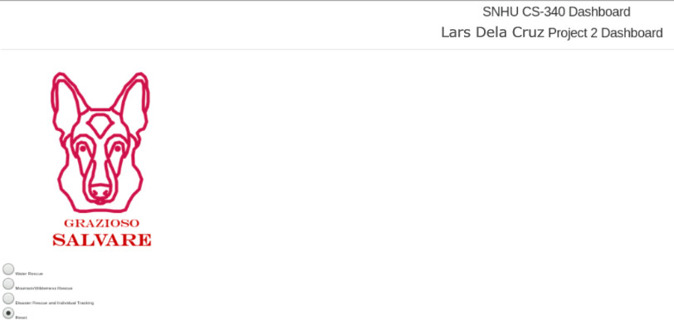

Geolocation options/switches:

Radio Buttons:

**Errors:**

On initial executions/running of code of the dash it outputs raw data. In order to alleviate this, I looked into the return in my animalSheleter where I saw it was attempting to print ALL animals.

## Contact

Your name: Lars Dela Cruz