Idea

At the moment of developing this game, I was inspired by the game that I had played in my childhood [**Fireboy and Watergirl**](https://www.coolmathgames.com/0-fireboy-watergirl-forest-temple). In this game, I tried to make as much as pitfalls and challenges as well as mind-hacking situation.

Features

Main menu

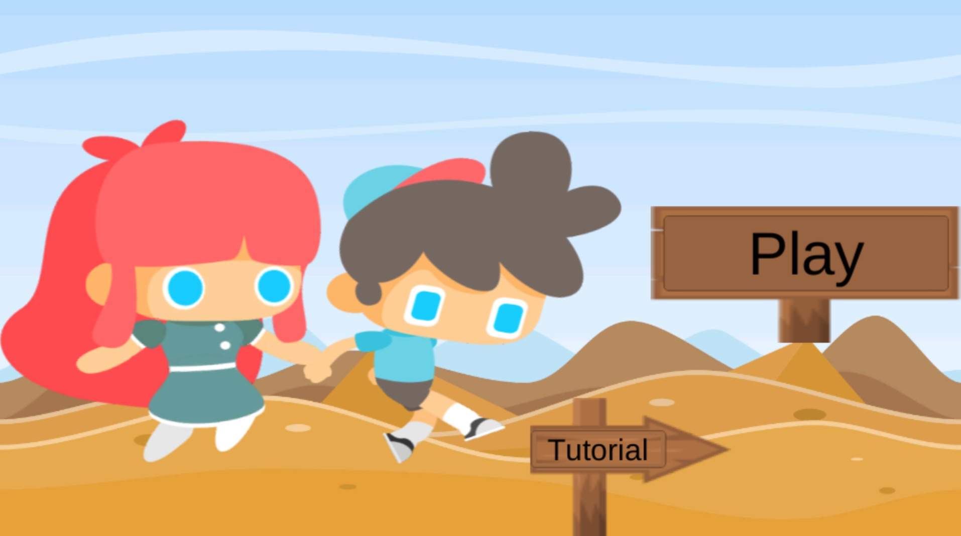

Tutorial level

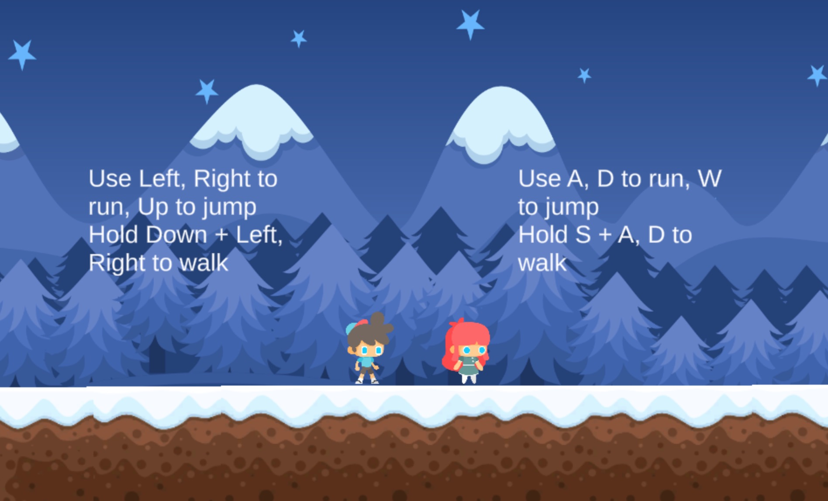

One single level

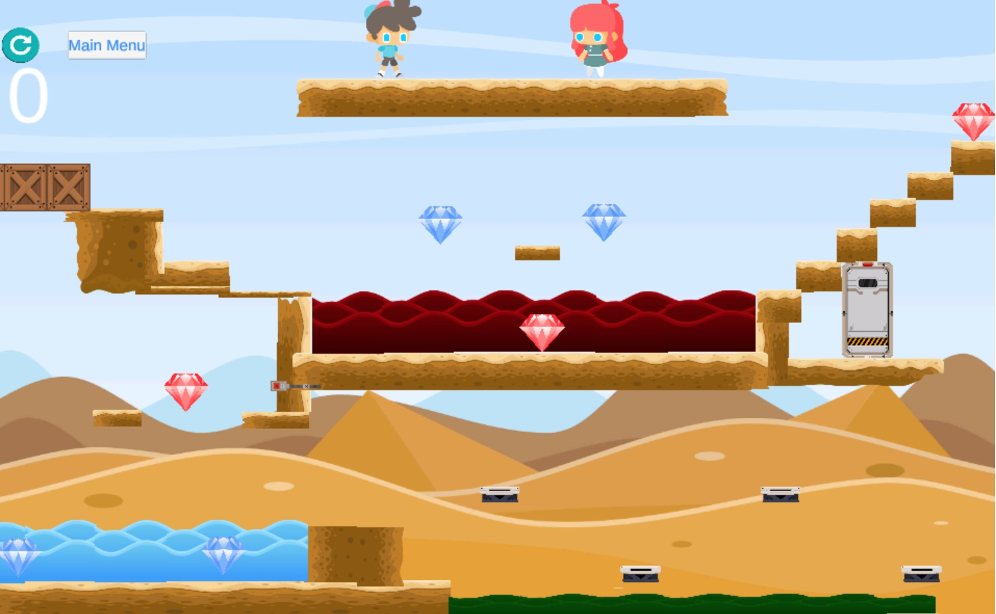

Many triggered events

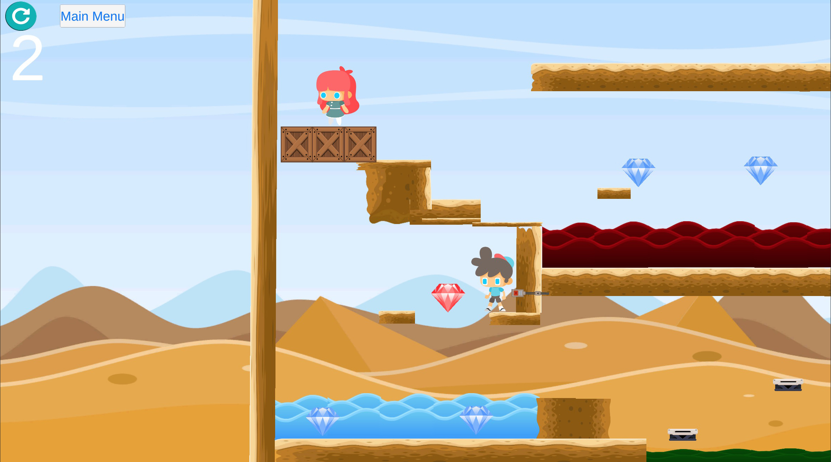

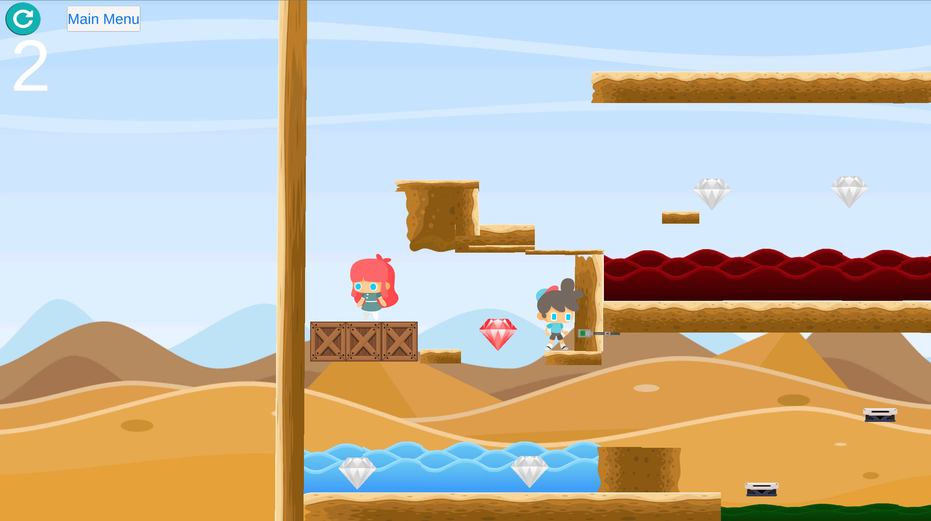

**Multiplayer**

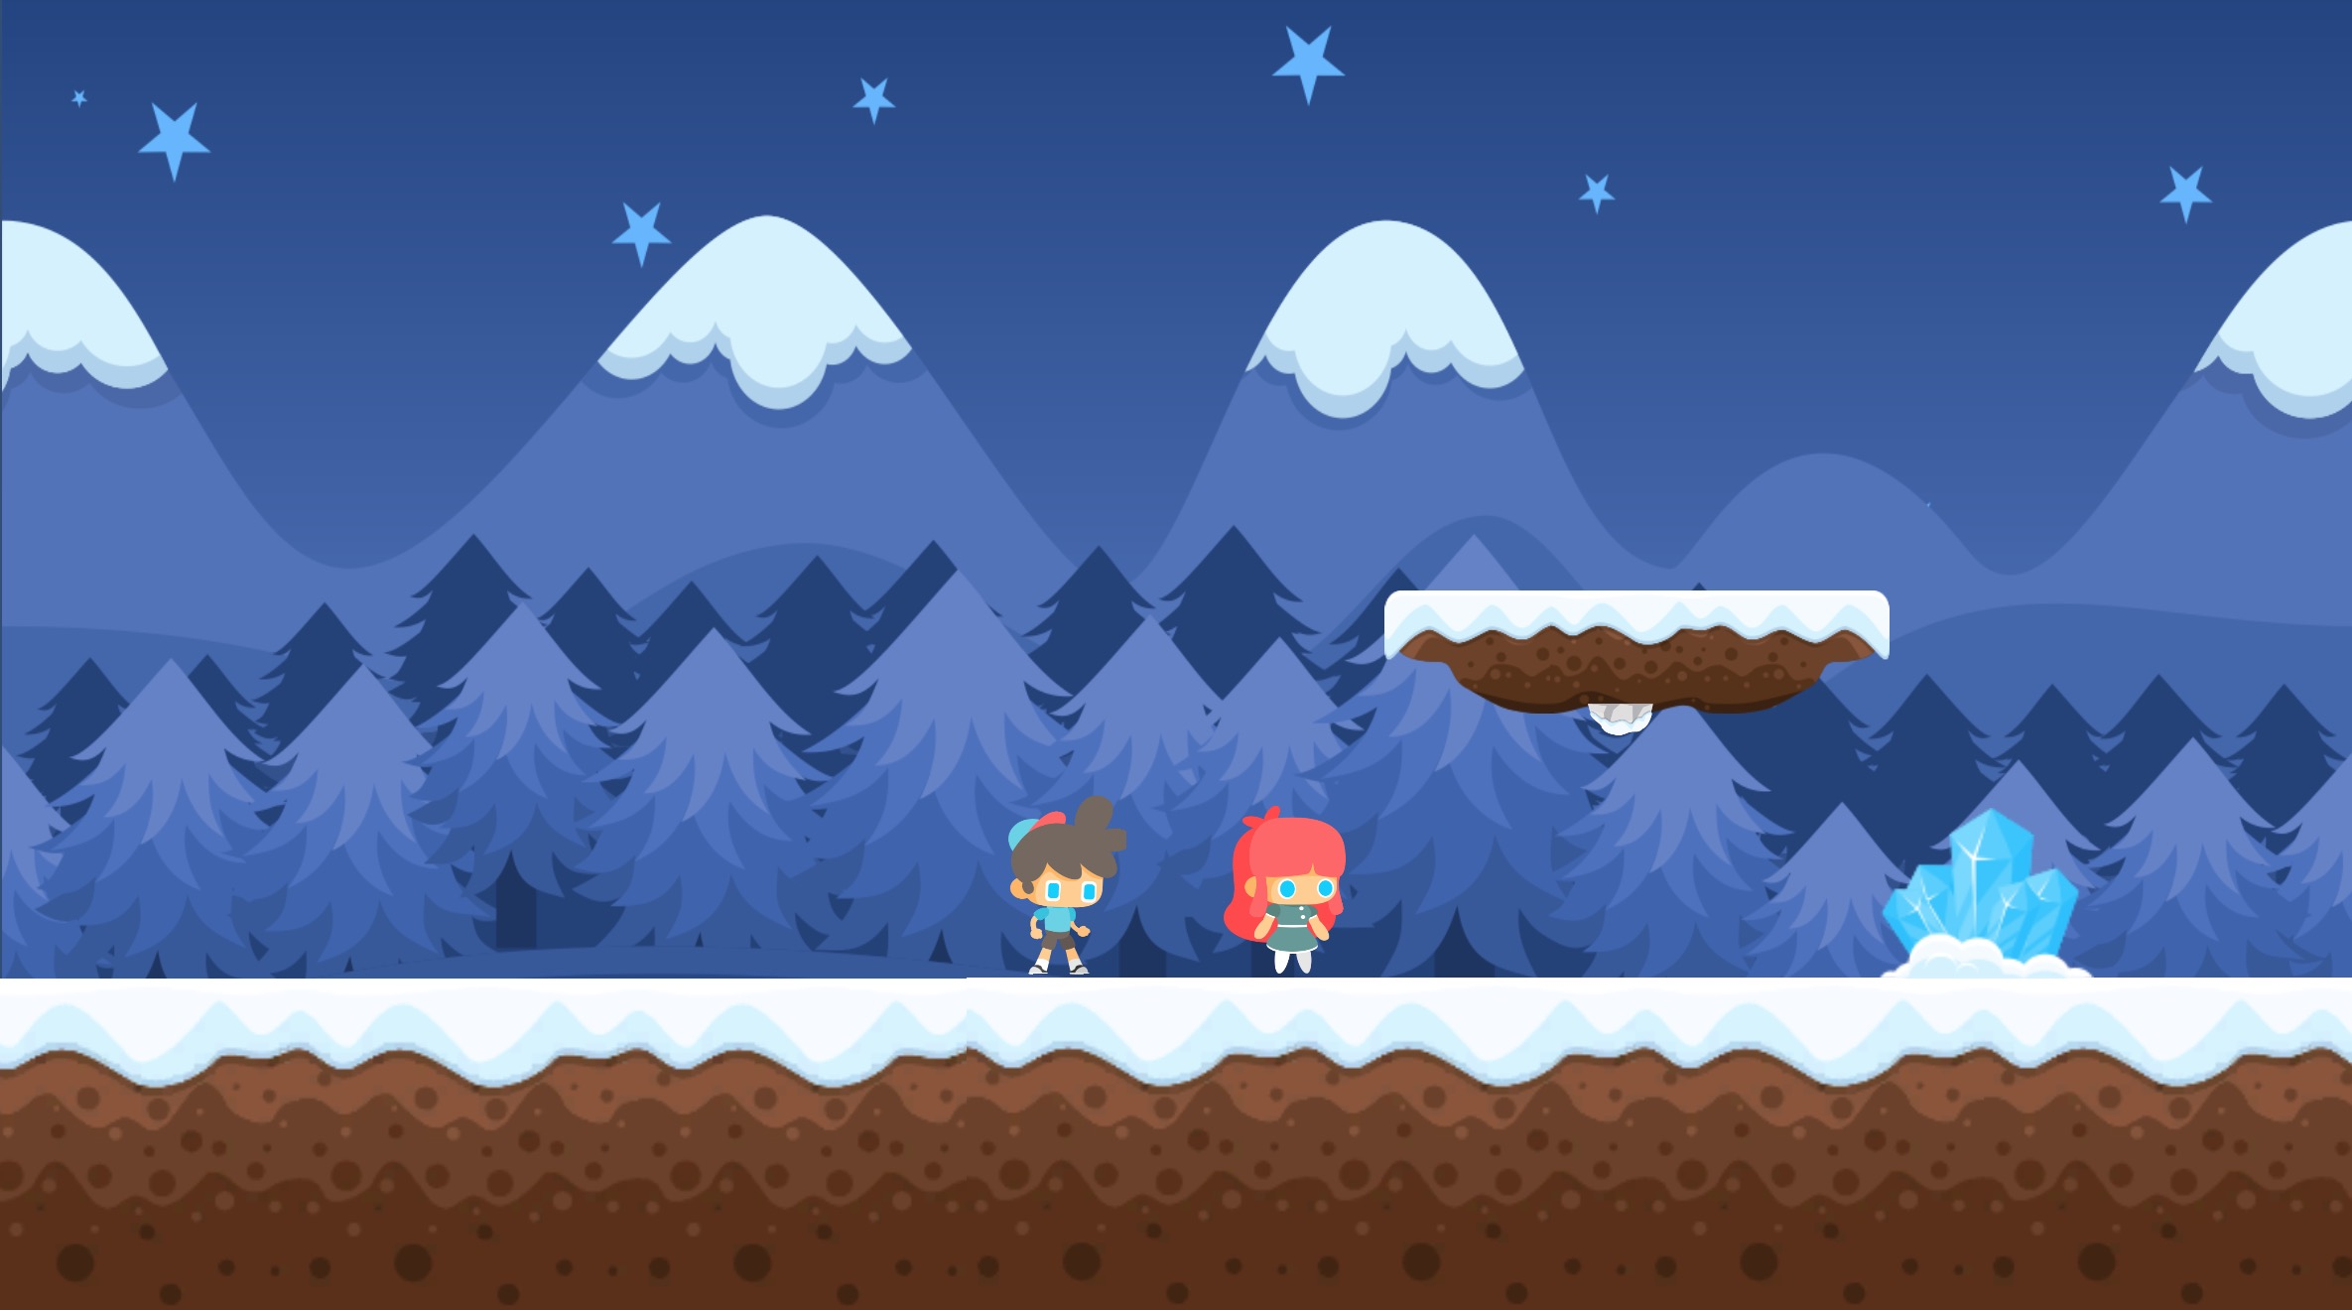

Techniques

**Camera moves along with players**

To carry out this feature, I stick the camera X position to the middle of X position of 2 players. I also stick the background image to the camera to assure that people always see the background correctly when they move.

**Player collision ignore (2 players)**

This feature allows two players to go through each other by ignoring the collision (box colliders) of another player. I implement this by detect if the collision object is the other player then I ignore it.

**High quality text on zooming**

Use TextMeshPro

**Players stick to the moving platform**

I implement a script to stick the player to the platform by considering it as a platform’s children component When player stands on the moving platform (up-down, left-right) and when player leave the platform I unset it as the platform’s children component.

**Speed changing upon several actions**

I implement a C# namespace to contains all of the constants belongs to settings and apply these setting constants to all scripts in the game. In this namespace, there are constant for *speedFactor, jumpFactor, walkSpeed, runSpeed, slideSpeed*. And when we press the DOWN/S key + (LEFT/A key or RIGHT/D key) I apply the *walkSpeed* to *moveSpeed*, otherwise apply the *runSpeed*.

Resources

<https://www.gameart2d.com/cute-girl-free-sprites.html>  
<https://www.gameart2d.com/the-boy---free-sprites.html>  
<https://www.gameart2d.com/free-platformer-game-tileset.html>  
<https://www.gameart2d.com/winter-platformer-game-tileset.html>  
<https://www.gameart2d.com/free-desert-platformer-tileset.html>  
<https://www.gameart2d.com/free-graveyard-platformer-tileset.html>  
<https://www.gameart2d.com/free-sci-fi-platformer-tileset.html>  
<https://opengameart.org/content/animated-spinning-gems>  
<https://opengameart.org/content/diamond>  
<https://www.youtube.com/watch?v=1MPBnVU8_I4>  
<https://www.youtube.com/watch?v=rudx0-gXZD4>  
<https://www.youtube.com/watch?v=q9swmo6309U>