**重要逻辑类度量数据**

1. **耦合的度量**

|  |  |  |  |  |  |
| --- | --- | --- | --- | --- | --- |
| 包名 | 类名 | NOC | DIT | CBO | DAC |
| accountbl | AccountBL | 0 | 1 | 30 | 9 |
| 调用其他类15  被其他类调用15 |
| approvebl | ApproveBL | 0 | 1 |  |  |
| 调用其他类  被其他类调用 |
| billbl | BillBL | 0 | 1 | 15 | 5 |
| 调用其他类9  被其他类调用6 |
| checklistbl | Check | 0 | 1 | 3 | 2 |
| 调用其他类1  被其他类调用2 |
| ChecklistController | 0 | 1 | 4 | 2 |
| 调用其他类1  被其他类调用3 |
| financebl | CalculateBL | 0 | 1 | 5 | 3 |
| 调用其他类2  被其他类调用3 |
| OrderList | 0 | 1 |  |  |
| 调用其他类  被其他类调用 |
| PayeeOrderBL | 0 | 1 | 28 | 12 |
| 调用其他类22  被其他类调用6 |
| PayorderBL | 0 | 1 | 36 | 10 |
| 调用其他类23  被其他类调用13 |
| StatisticsBL | 0 | 1 | 26 | 8 |
| 调用其他类20  被其他类调用6 |
| listinbl | ListApprove | 0 | 1 |  |  |
| 调用其他类  被其他类调用 |
| Listinbl | 0 | 1 | 113 | 6 |
| 调用其他类89  被其他类调用24 |
| Receiverinbl | 0 | 1 | 27 | 2 |
| 调用其他类21  被其他类调用6 |
| loadbl | LoadBL | 0 | 1 | 28 | 10 |
| 调用其他类24  被其他类调用4 |
| ShippingBL | 0 | 1 | 40 | 15 |
| 调用其他类34  被其他类调用6 |
| loginbl | LoginBL | 0 | 1 | 12 | 16 |
| 调用其他类3  被其他类调用9 |
| policybl | ConstantPolicybl | 0 | 1 | 21 | 4 |
| 调用其他类13  被其他类调用8 |
| SalaryPolicybl | 0 | 1 | 18 | 4 |
| 调用其他类11  被其他类调用7 |
| staffbl | Staffbl | 0 | 1 | 64 | 10 |
| 调用其他类52  被其他类调用12 |
| UserBL | 0 | 1 | 35 | 10 |
| 调用其他类19  被其他类调用16 |
| storebl | Inventory_managementBL | 0 | 1 | 31 | 13 |
| 调用其他类21  被其他类调用10 |
| StoreMessageBL | 0 | 1 | 33 | 4 |
| 调用其他类14  被其他类调用19 |
| Warehouse_inBL | 0 | 1 | 37 | 14 |
| 调用其他类32  被其他类调用5 |
| Warehouse_outBL | 0 | 1 | 35 | 17 |
| 调用其他类29  被其他类调用6 |
| transferbl | ReceiveFormBL | 0 | 1 | 22 | 11 |
| 调用其他类20  被其他类调用2 |
| ReceiveBL | 0 | 1 | 32 | 13 |
| 调用其他类25  被其他类调用7 |
| TransferBL | 0 | 1 | 27 | 8 |
| 调用其他类20  被其他类调用7 |
| vehiclebl | DriverBL | 0 | 1 | 43 | 5 |
| 调用其他类37  被其他类调用6 |
| VehicleBL | 0 | 1 | 52 | 5 |
| 调用其他类38  被其他类调用14 |

**二、内聚的度量**

|  |  |  |
| --- | --- | --- |
| 包名 | 类名 | LCOM |
| accountbl | AccountBL | 0 |
| approvebl | ApproveBL | 0 |
| billbl | BillBL | 0 |
| checklistbl | Check | 0 |
| ChecklistController | 0 |
| financebl | CalculateBL | 0 |
| OrderList | 0 |
| PayeeOrderBL | 0.5 |
| PayorderBL | 0 |
| StatisticsBL | 0 |
| listinbl | ListApprove | 0 |
| Listinbl | 0.571 |
| Receiverinbl | 0 |
| loadbl | LoadBL | 0 |
| ShippingBL | 0 |
| loginbl | LoginBL | 0 |
| policybl | ConstantPolicybl | 0 |
| SalaryPolicybl | 0 |
| staffbl | Staffbl | 0 |
| UserBL | 0 |
| storebl | Inventory_managementBL | 0 |
| StoreMessageBL | 0 |
| Warehouse_inBL | 0 |
| Warehouse_outBL | 0 |
| transferbl | ReceiveFormBL | 0 |
| ReceiveBL | 0 |
| TransferBL | 0 |
| vehiclebl | DriverBL | 0 |
| VehicleBL | 0 |

**三、其他度量**

**代码行数与注释行数**

|  |  |  |  |
| --- | --- | --- | --- |
| 包名 | 类名 | 代码行数 | 注释行数 |
| accountbl | AccountBL | 73 | 5 |
| approvebl | ApproveBL | 141 | 4 |
| billbl | BillBL | 37 | 2 |
| checklistbl | Check | 12 | 0 |
| ChecklistController | 12 | 1 |
| financebl | CalculateBL | 20 | 2 |
| OrderList | 3 |  |
| PayeeOrderBL | 84 | 4 |
| PayorderBL | 78 | 5 |
| StatisticsBL | 53 | 3 |
| listinbl | ListApprove | 6 |  |
| Listinbl | 147 | 10 |
| Receiverinbl | 38 | 3 |
| loadbl | LoadBL | 79 | 9 |
| ShippingBL | 125 | 12 |
| loginbl | LoginBL | 108 | 3 |
| policybl | ConstantPolicybl | 42 | 5 |
| SalaryPolicybl | 42 | 2 |
| staffbl | Staffbl | 97 | 9 |
| UserBL | 78 | 6 |
| storebl | Inventory_managementBL | 115 | 10 |
| StoreMessageBL | 79 | 19 |
| Warehouse_inBL | 111 | 13 |
| Warehouse_outBL | 106 | 9 |
| transferbl | ReceiveFormBL | 83 | 7 |
| ReceiveBL | 101 | 9 |
| TransferBL | 82 | 7 |
| vehiclebl | DriverBL | 68 | 6 |
| VehicleBL | 68 | 6 |

**圈内复杂度**

|  |  |  |  |
| --- | --- | --- | --- |
| 包名 | 类名 | 圈内复杂度 | |
| 方法名 | 复杂度 |
| accountbl | AccountBL | check | 2 |
| addAccount | 2 |
| updateAccount | 2 |
| deleteAccount | 2 |
| save | 2 |
| findAccount | 1 |
| approvebl | ApproveBL |  |  |
| billbl | BillBL | addBill | 2 |
| checkBill | 2 |
| checklistbl | Check | getOrder | 1 |
| ChecklistController | getOrder | 1 |
| financebl | CalculateBL | check |  |
| total | 1 |
| OrderList |  |  |
| PayeeOrderBL | addReceiForm | 3 |
| checkPayeeorder | 2 |
| save | 2 |
| checkPayeeorder | 2 |
| getTotal | 1 |
| getTotal | 1 |
| PayorderBL | addPayorder | 2 |
| checkPayorder | 2 |
| save | 2 |
| profit | 1 |
| excel | 1 |
| StatisticsBL | checkPay | 1 |
| checkPayee | 1 |
| excel | 1 |
| listinbl | ListApprove |  |  |
| Listinbl | JudgeNull | 20 |
| PackPrice | 3 |
| ExpressPrice | 3 |
| addOrder | 2 |
| getTotalMoney | 2 |
| WeightPrice | 2 |
| getTotalTime | 2 |
| getOrder | 2 |
| update | 2 |
| getWeight | 2 |
| getAllOrders | 2 |
| changestate | 2 |
| Receiverinbl | JudgeNull | 8 |
| addReceiver | 2 |
| searchOrder | 2 |
| loadbl | LoadBL | addLoadOrder | 3 |
| getTotal | 2 |
| get | 2 |
| save | 2 |
| update | 1 |
| ShippingBL | checkRemind | 3 |
| getPrice | 3 |
| build | 2 |
| getTotal | 2 |
| get | 2 |
| save | 2 |
| update | 1 |
| loginbl | LoginBL | Enter | 9 |
| setUser | 2 |
| getUser | 2 |
| isLegal | 1 |
| getUserInfo | 1 |
| policybl | ConstantPolicybl | checkConstant | 2 |
| editConstant | 2 |
| endConstant | 1 |
| GetConstant | 1 |
| GetMoney | 1 |
| SalaryPolicybl | selectModel | 3 |
| checkSalary | 2 |
| editSalary | 2 |
| staffbl | Staffbl | JudgeNull | 8 |
| showStaff | 3 |
| checkStaff | 3 |
| addStaff | 2 |
| editStaff | 2 |
| deleteStaff | 2 |
| getStaffPO | 2 |
| endStaff | 1 |
| editTheID | 1 |
| UserBL | addUser | 2 |
| updateUser | 2 |
| deleteUser | 2 |
| checkUsers | 2 |
| UpdatePassword | 2 |
| checkUser | 1 |
| storebl | Inventory_managementBL | checkInventory | 6 |
| checkInventoryOrder | 2 |
| InventoryOrderToExcel | 2 |
| getWarnData | 1 |
| setWarnData | 1 |
| getRemindData | 1 |
| setRemindData | 1 |
| StoreMessageBL | getInstance | 2 |
| init | 2 |
| save | 2 |
| StoreMessageBL | 1 |
| storein_update | 1 |
| getId | 1 |
| getId | 1 |
| getStoreRatio | 1 |
| getWarnData | 1 |
| setWarnData | 1 |
| getRemindData | 1 |
| setRemindData | 1 |
| getOrderList | 1 |
| Warehouse_inBL | build | 2 |
| checkRemind | 2 |
| deleteRemind | 2 |
| get | 2 |
| save | 2 |
| getLocation | 2 |
| update | 1 |
| Warehouse_outBL | checkRemind | 3 |
| build | 2 |
| get | 2 |
| save | 2 |
| update | 1 |
| transferbl | ReceiveFormBL | getState | 3 |
| addReceiveOrder | 2 |
| get | 2 |
| save | 2 |
| update | 1 |
| ReceiveBL | checkUnreceive_loadorderPO | 3 |
| getState | 3 |
| build | 2 |
| get | 2 |
| save | 2 |
| update | 1 |
| TransferBL | checkRemind | 3 |
| build | 2 |
| get | 2 |
| save | 2 |
| checkStore | 1 |
| vehiclebl | DriverBL | addDriver | 2 |
| updateDriver | 2 |
| deleteDriver | 2 |
| searchDriver | 2 |
| find | 2 |
| update | 2 |
| VehicleBL | addVehicle | 2 |
| updateVehicle | 2 |
| deleteVehicle | 2 |
| searchVehicle | 2 |
| find | 2 |
| update | 2 |

**附:三个项目总的数据度量截图**

**1、client**

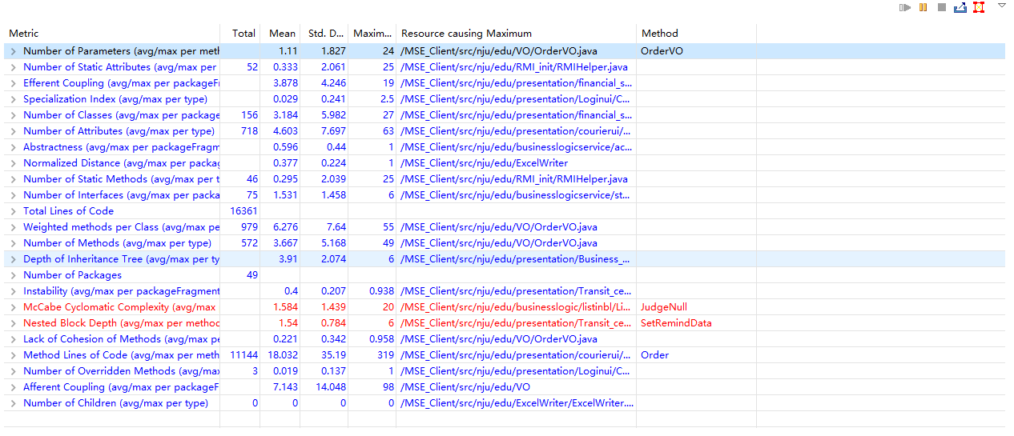

**2、common**

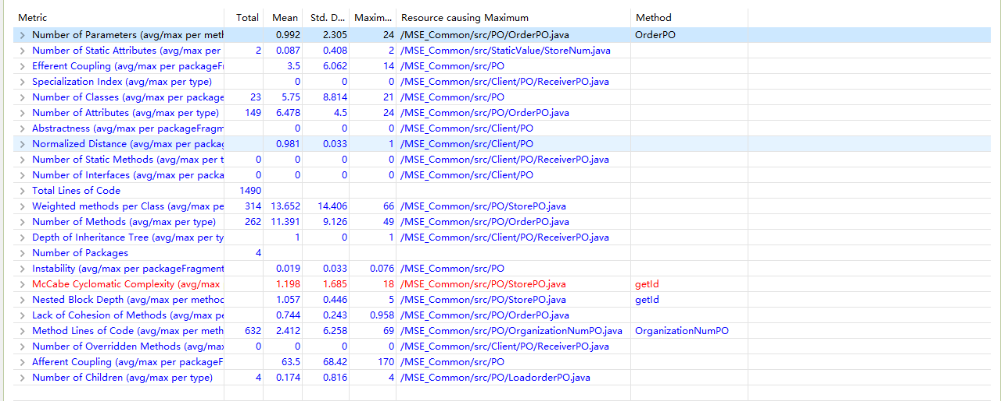

**3、server**

