Char Driver Blinky Program

# Wiring it Up

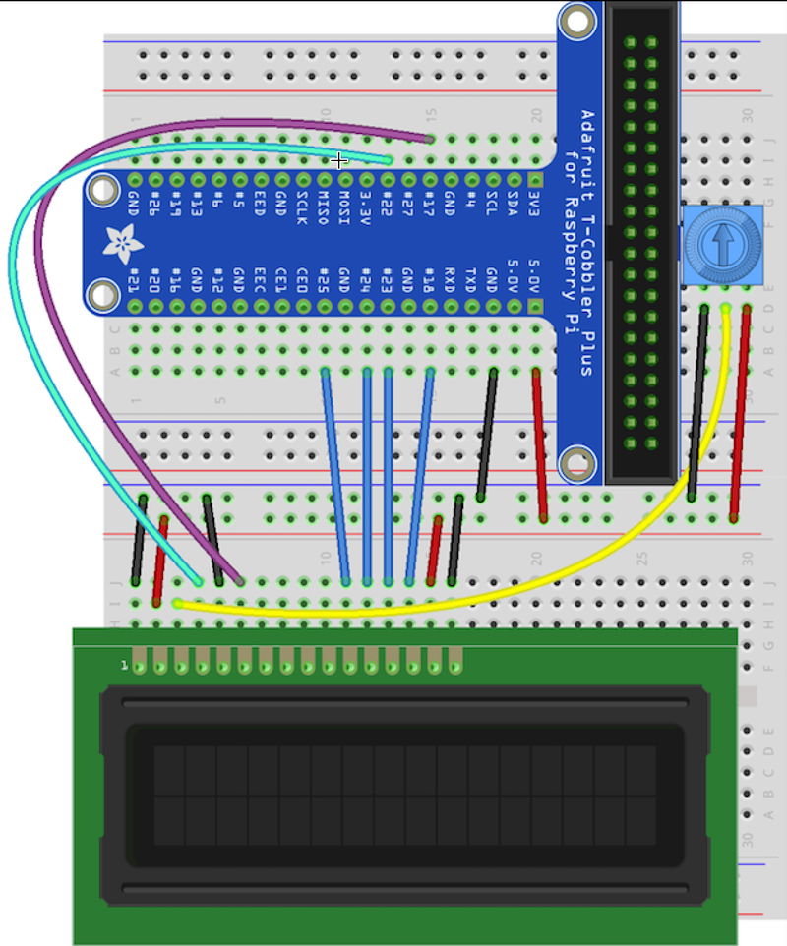

Replicate the connections depicted in this image. Be sure to use the +5V rail.

Use a 10K potentiometer to control contrast.

* Pin #1 of the LCD goes to ground
* Pin #2 of the LCD goes to +5V
* Pin #3 (Vo) connects to the middle of the potentiometer
* Pin #4 (RS) connects to the Cobbler #22
* Pin #5 (RW) goes to ground
* Pin #6 (EN) connects to Cobbler #17
* Skip LCD Pins #7, #8, #9 and #10
* Pin #11 (D4) connects to Cobbler #25
* Pin #12 (D5) connects to Cobbler #24
* Pin #13 (D6) connects to Cobber #23
* Pin #14 (D7) connects to Cobber #18
* Pin #15 (LED +) goes to +5V (red wire)
* Pin #16 (LED -) goes to ground (black wire)

# TASK

Using the file_operations constructor, setup a char driver to control the LCD screen. Using IOCTL constructors to implement LCD control commands.

TIP: Download and install WinSCP for file transfer between the RPi and your system. If it does not work from the VNC Viewer Interface.