Setting up the RPi & Kernel Source

# RPI HEADLESS SETUP:

[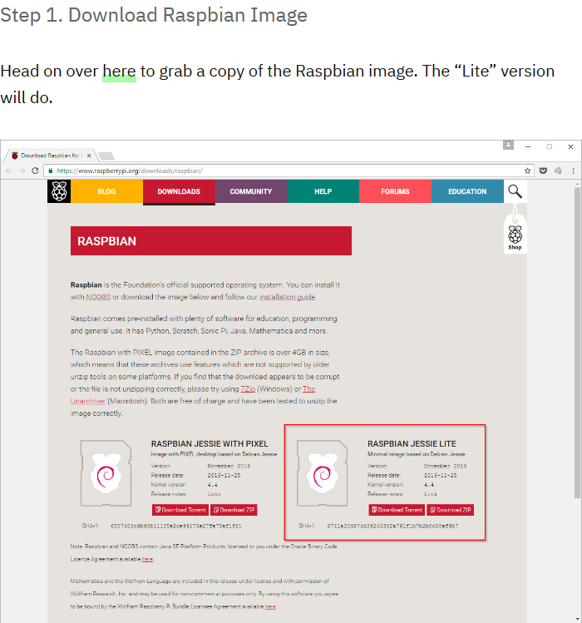](https://www.raspberrypi.org/downloads/raspbian/)

[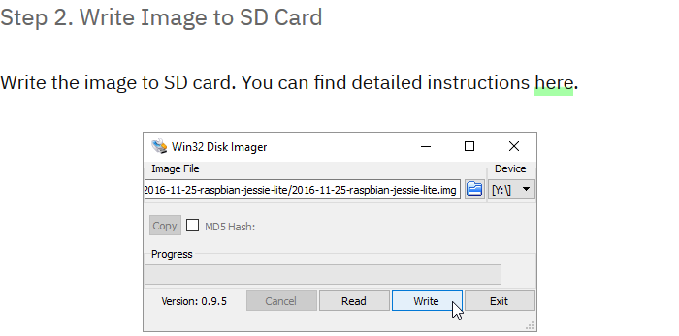](https://www.raspberrypi.org/documentation/installation/installing-images/README.md)

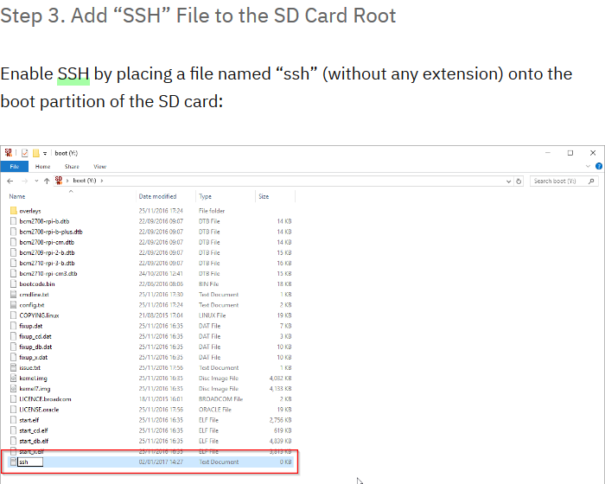



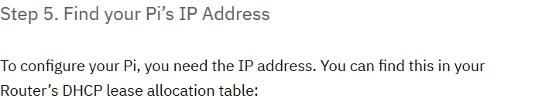

Alternative methods to find/troubleshoot the device IP:

1. In your system, open a command terminal, enter ---> **ipconfig**

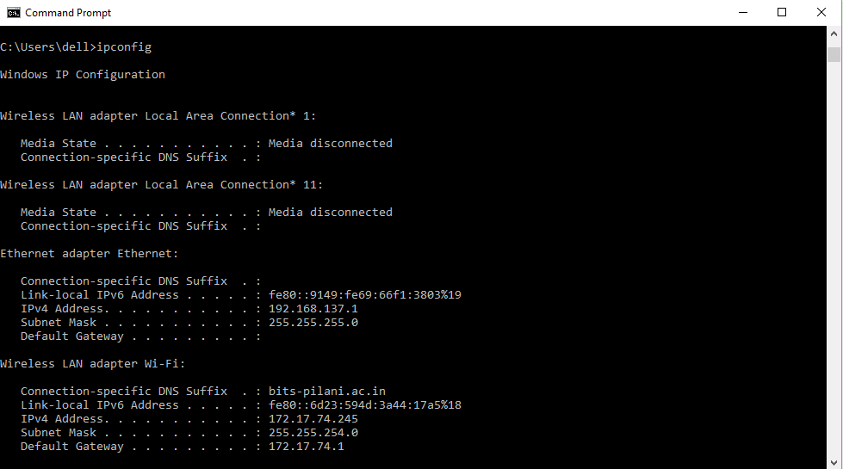

If the network does not form, check your system’s firewall settings and try again. Since we will be updating the RPi and downloading libraries etc. it is recommended to setup network connection sharing over ethernet.

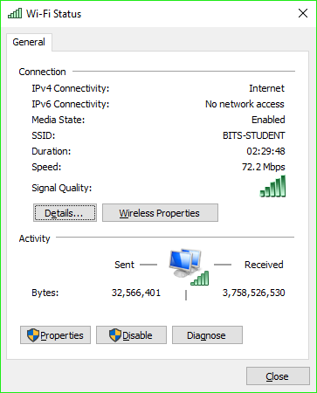

1. Go to Network and Sharing Centre
2. Find and open this Menu ----->
3. Go to Properties --> (Top tabs) Sharing
4. Check the option that says:

“Allow other network users to connect through this computer’s internet connection” and exit.

1. Replug your RPi (Power).
2. Type ---> **arp -a**

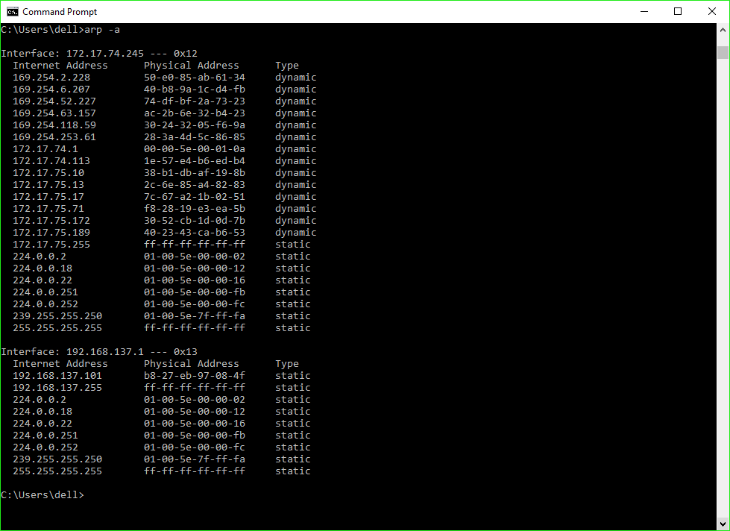

This will tell you what all devices have been allocated IPs on the local area network. Try pinging the IPs with a physical address that doesn’t start with a 01 or FF. Only one will work as it’s a closed LAN network.

[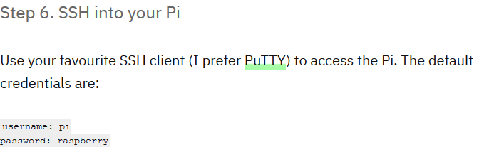](https://www.chiark.greenend.org.uk/~sgtatham/putty/latest.html)



First thing to do is check if the internet connection sharing is functioning. So, in the PUTTY terminal. Type ---> **sudo apt-get update**

If it works let it update, if not, maybe you missed a step or have a firewall issue.

After the update completes type ---> **sudo raspi-config**

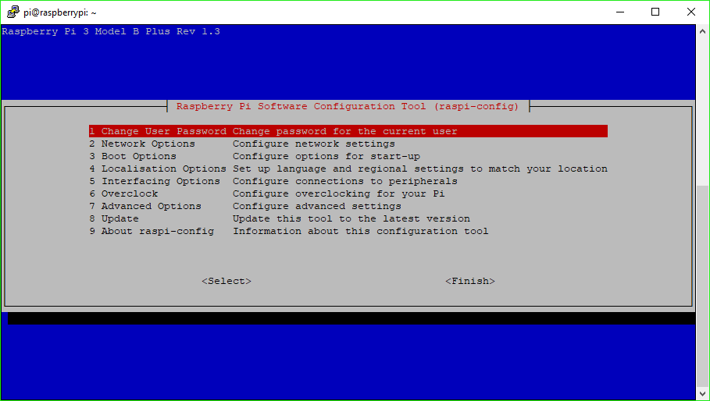

1. Interfacing Options --> SSH --> Enable
2. Interfacing Options --> VNC --> Enable (proceed with the install as well.)
3. Any more config settings are optional.

Step 8. VNC Linking

Download VNC Viewer [here](https://www.realvnc.com/en/connect/download/viewer/).

In the putty window enter ---> **vncserver :1 -geometry WWWWxLLLL**

Where you can replace WWWW by your screen width and LLLL by your screen height.

It will ask you for an 8-digit password. Use ---> **rasp1234**

Open VNC Viewer.

Enter the RPi’s IP and password and if it works alright.

Then you are done with the Headless Setup of your RPi!

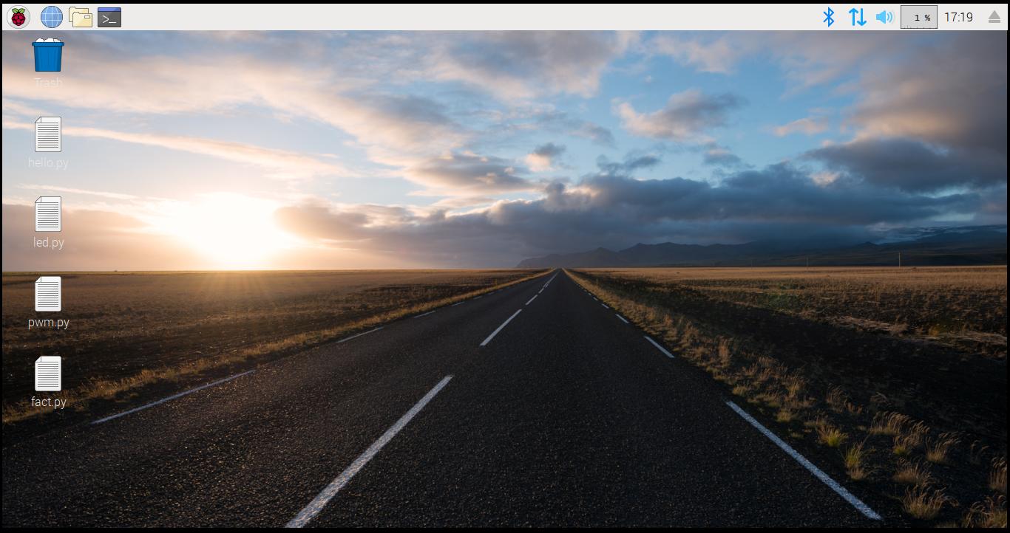

# Setting Up the Kernel Source

Run the [following](https://raspberrypi.stackexchange.com/questions/39845/how-compile-a-loadable-kernel-module-without-recompiling-kernel) chain of commands in your putty terminal/RPi desktop terminal as root

# The usual update routine

apt-get update -y

apt-get upgrade -y

# Update the kernel and dependencies

rpi-update

**sudo apt install git bc bison flex libssl-dev make**

# Get rpi-source

sudo wget https://raw.githubusercontent.com/notro/rpi-source/master/rpi-source -O /usr/bin/rpi-source

# Make it executable

sudo chmod +x /usr/bin/rpi-source

# Tell the update mechanism that this is the latest version of the script

/usr/bin/rpi-source -q --tag-update

# Get the kernel files things.

rpi-source --skip-gcc

During the execution of the last command you will get an option to install something called *code coverage for “KCOV”*, **DO NOT DO THAT.**

After you’re done with the install try loading a hello world kernel module.