Project 6
Group 6
IT372 - DL1: Applied Generative AI
03/01/2026
Professor Azamy
Lily DeBell and Flo Lawendy

- Topic: Job application process made easy for college students or young adults applying to internships and/or entry-level jobs. Includes help with resumes, cover letters, LinkedIn, self-marketing, interviewing skills, and success on the job.

- Pitch: A good job should challenge you, getting one shouldn’t.

- Selected concept: “Job interview body language and etiquette guide for acing any interview”
  - Visual outcome statement: “By looking at this graphic, someone should be able to understand proper and improper etiquette and mannerisms for attending job interviews in under 60 seconds.”
- Final Image:

PNG: 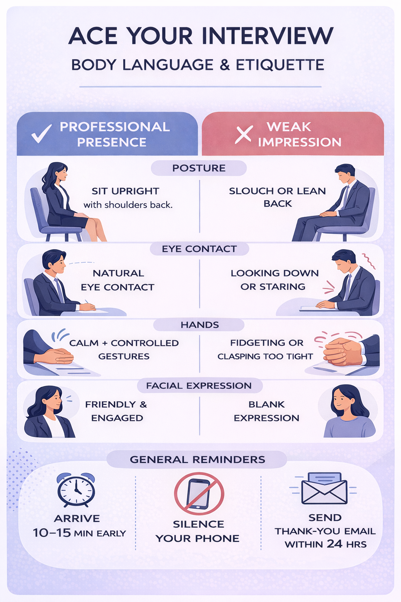

PDF Provide in Canvas and GitHub.

- Image Decision Rationale: Our main reason for selecting this image over the other one was visual clarity and logic. This image makes it clear that the left side is ‘Do’ and the right side is ‘Don’t. Additionally, this do and don't format made more sense as compared to approach B, which was a chronological before, during, and after the interview process. Although the alternative AI bot we had asked to evaluate said that the other image was better, all human input we received stated that this was the better image.

- Finalized Prompt: Create a clean, professional 8.5x11 portrait infographic about job interview body language and etiquette using a soft lavender-blue background and muted, non-saturated accent colors. Structure the layout with a bold centered title at the top, followed by a clearly divided two-column comparison section labeled “Professional Presence” and “Weak Impression,” using consistent character illustrations and balanced spacing. Organize the comparison into four horizontally stacked categories (Posture, Eye Contact, Hands, Facial Expression), each with a centered category label and concise text on both sides supported by simple, proportional flat-style illustrations. At the bottom, include a separate rounded “General Reminders” section with three evenly spaced icons and short captions. Maintain strong visual hierarchy, readable typography (no tiny text), symmetrical alignment, and generous white space to ensure clarity and print-readiness. The overall aesthetic should feel modern, minimal, instructional, and polished.

- GitHub Screenshot: <Paste a screenshot of Project6 folder content, showing all deliverables are uploaded there.>

- Flo’s Github: https://gitfront.io/r/flawendy/WYdGvf8haUaj/Spring2026-Group17-AI-Projects/
- Lily’s Github: https://gitfront.io/r/ldebell/Mr9Xha7NEzVM/Spring2026-Group17-AI-Projects/

References
OpenAI. (2025). ChatGPT. ChatGPT; OpenAI. https://chatgpt.com/

