Group 17
IT372 - DL1: Applied Generative AI
01/24/2026
Professor Azamy
Lily DeBell and Flo Lawendy

Step 1

Selected Topic: Healthy routine builder for busy college students

Audience (who it’s for) | College Students. Particularly those struggling with time management, unhealthy habits, and/or busy schedules.
Problem (what pain point is the topic  solving or what desire it is fulfilling) | Many college students face more responsibilities than the average person, and they are typically young adults who do not yet have a firm grasp on time and stress management. Our program aims to help users efficiently manage their time while creating and maintaining healthy habits.
Outcome (what changes for them) | A routine that is tailored to each student that takes into account factors such as class schedule, job schedule, exercise, diet, sleep, and social life. The goal is to provide each user with a routine that will contribute to a balanced, healthy lifestyle.
Constraints (time, budget, skill level,  environment) | College students have limited time, tight budgets, varying experience with healthy routines, and often live in shared spaces that make consistent habits harder to maintain.

One liner: A smart routine builder that helps college students build healthier lives around their real schedules.

Key words: “balanced student lifestyle”, stress management”, “sustainable habits”.

Step 2

From the video we learned that the best way to get value from AI is not by trying to learn everything at once, but by building small, consistent habits over time. The video explains that setting weekly goals, such as learning one AI tool or improving one workflow, makes AI feel manageable instead of overwhelming. It also emphasized focusing on real use cases that actually help your daily work or life, rather than chasing hype.The main idea is that steady progress with clear goals leads to real improvement when using AI.

Step 3

- Examples of projects other people made: The gallery shows real projects that people built during the program. This helps us understand what a completed project should look like. We plan to use these examples when building our own healthy routine tools.

- Weekly step-by-step missions: The website breaks everything into weekly missions, which makes learning feel less overwhelming. We plan to follow this structure to build our projects slowly and stay organized.

- Tips on using different AI tools: The site explains how different AI tools are better for different tasks. We plan to use these tips to choose the right AI tool for each part of our future projects.

Step 4

Tool | Flo Lawendy | Lily DeBell
Google AI Studio | 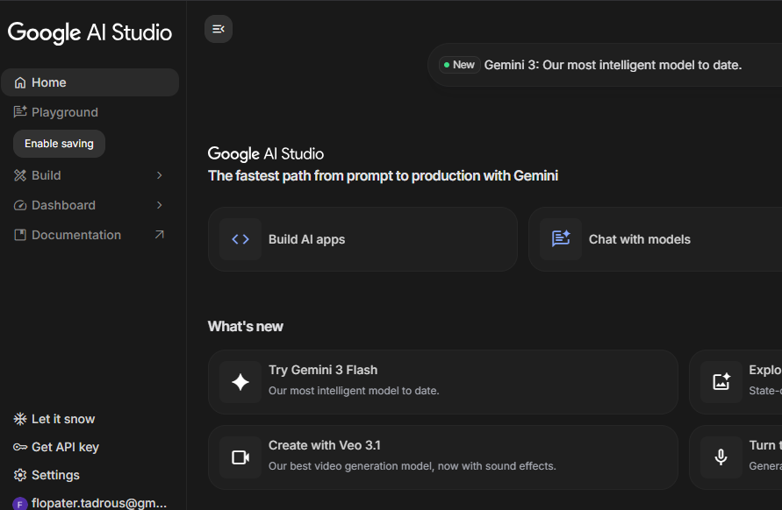 | 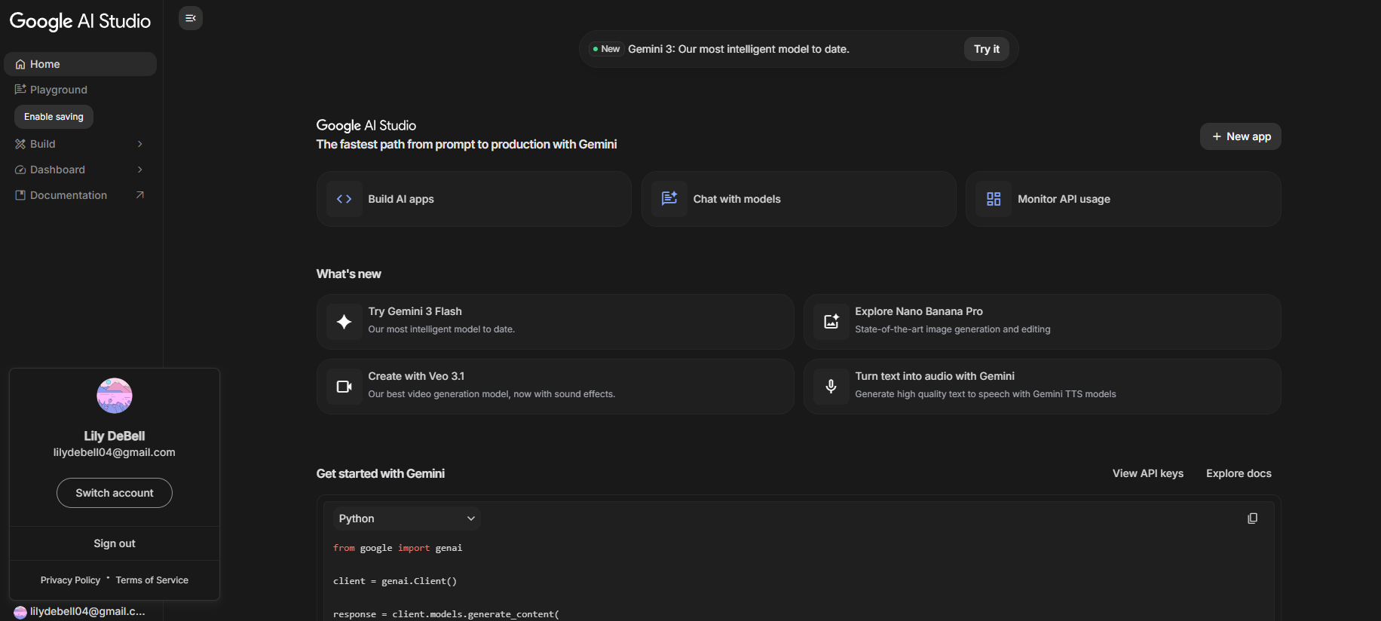
Lovable | 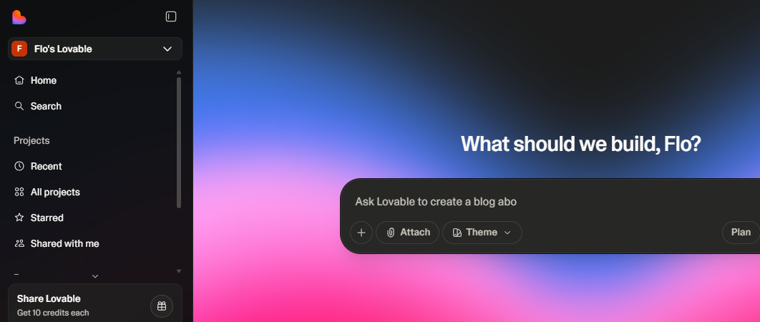 | 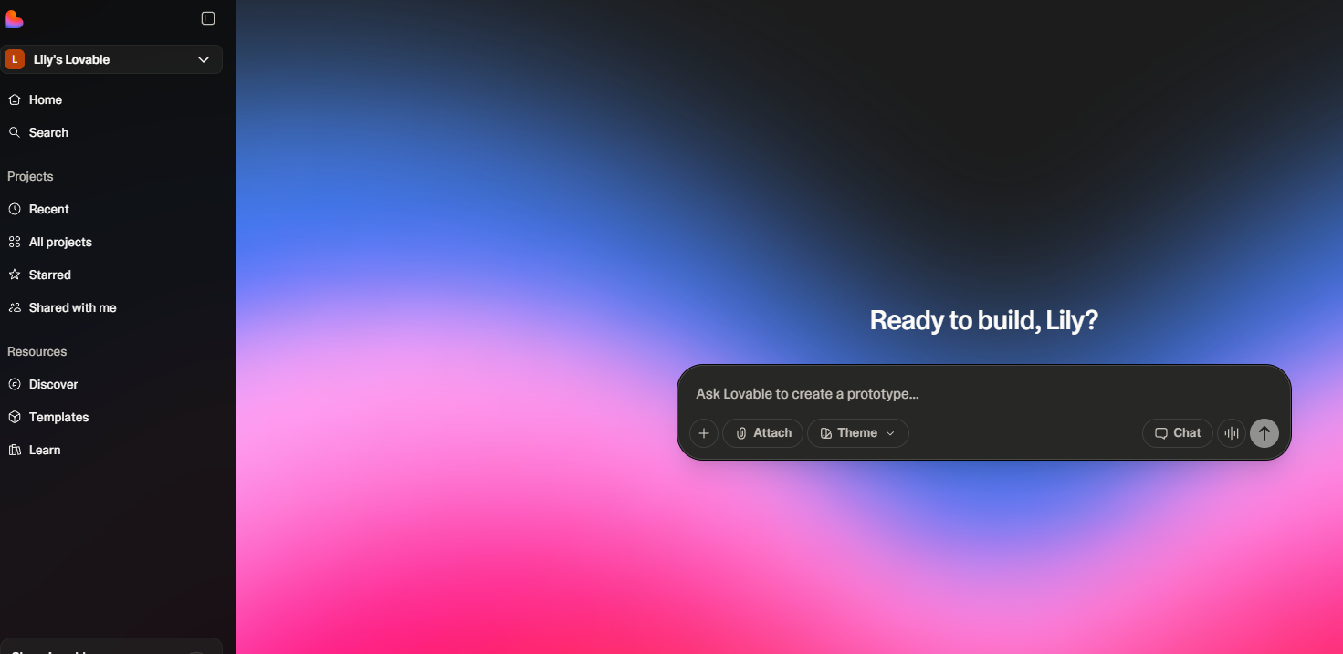
Replit | 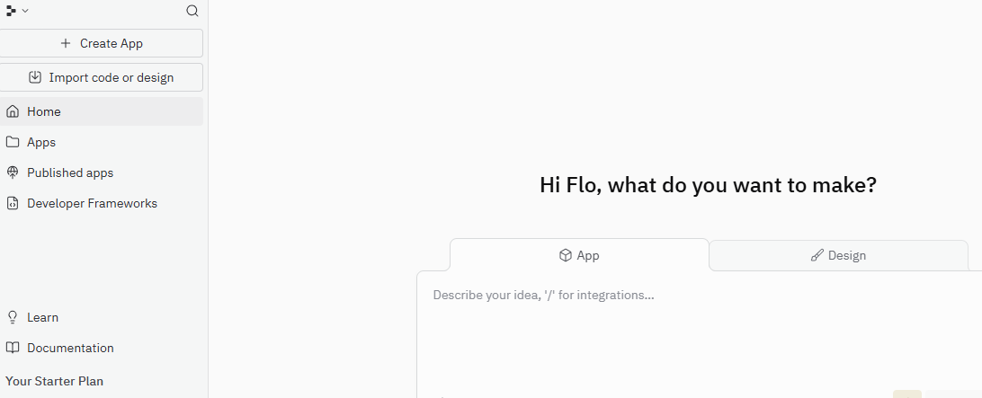 | 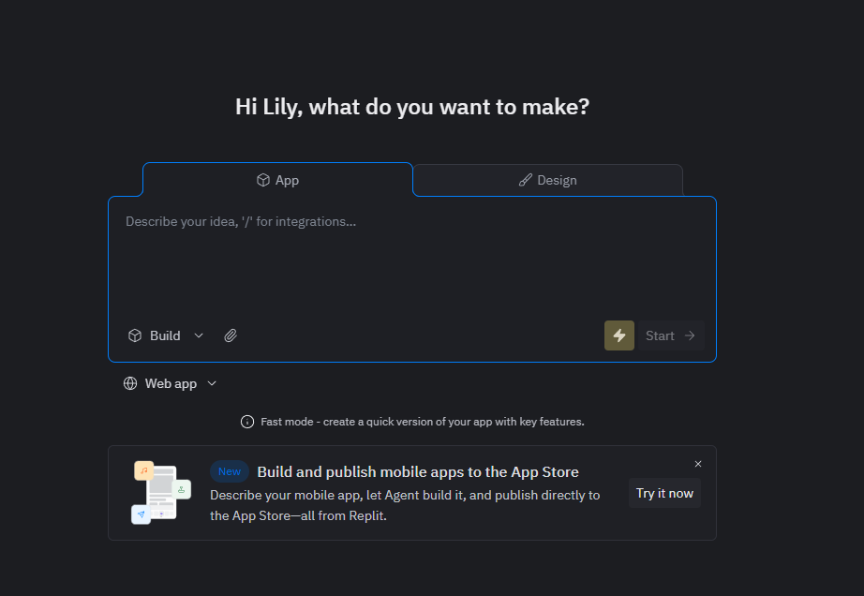

Statement: All members have successfully created accounts for the remaining services not pictured above.

Step 5

Flo’s GitHub Repository: https://github.com/flopater30/Spring2026_Group17_AI_Projects
Lily’s GitHub Repository: https://github.com/ldebell4/Spring2026_Group17_AI_Projects

References

Brief, A. D. (2026). AI Daily Brief New Year’s Resolution. Aidbnewyear.com. https://aidbnewyear.com/
OpenAI. (2023). ChatGPT (Jan 22 version) [Large language model]. https://chat.openai.com/chat
The AI Daily Brief: Artificial Intelligence News. (2026, January 1). AI New Year’s: The 10 Week AI Resolution. YouTube. https://www.youtube.com/watch?v=EhQeGgZxdHU
Your Fix Guide. (2025, June 8). How To Upload Files & Folders in GitHub (Full Guide). YouTube. https://www.youtube.com/watch?v=-9rTsx6ilvo

