Lilybeth Delgado

Numerical Computation

**Project 2:Bisection Method**

The following lines were used to display the root from all three options and the graph was also used to analyze the and visualize the graph.

Code:

root1=BisectionFunctionTest(@(x)2*sin(x)-exp(x)/(4-1),-7,-5,10^-6,1);

disp(root1);

root2=BisectionFunctionTest(@(x)2*sin(x)-exp(x)/(4-1),-7,-5,10^-6,2);

disp(root2);

root3=BisectionFunctionTest(@(x)2*sin(x)-exp(x)/(4-1),-7,-5,10^-6,3);

disp(root3);

figure(1);

%visualizing the function

%fplot(f,[-7,-5]);grid on

%title('F(x)=2*sin(x)-exp(x)/(4-1), Intervals [-7,-5]');

%Visualizing the function

figure(2);

fplot(f,[-5,-3]);grid on

title('F(x)=2*sin(x)-exp(x)/(4-1), Intervals [-5,-3]');

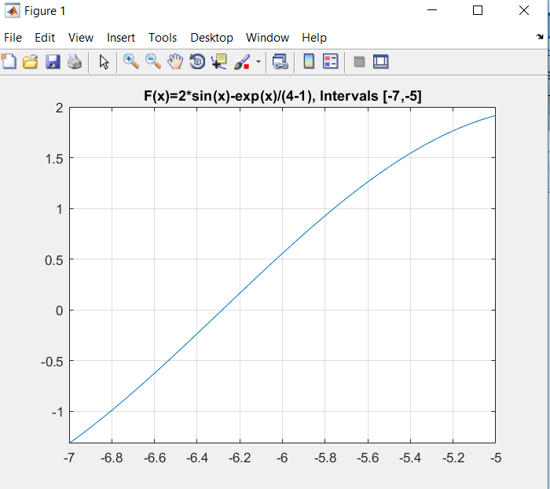

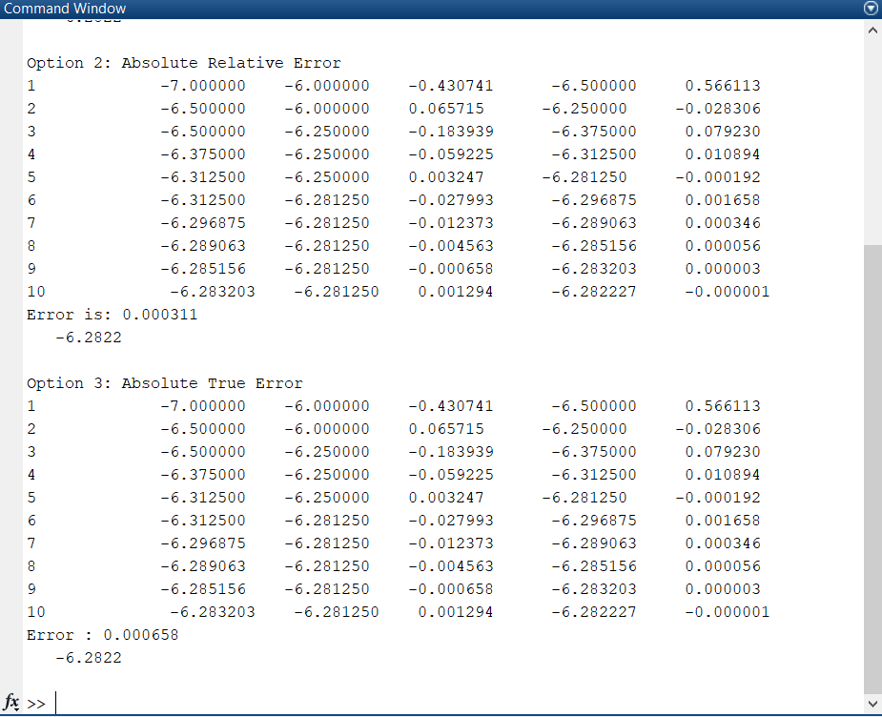

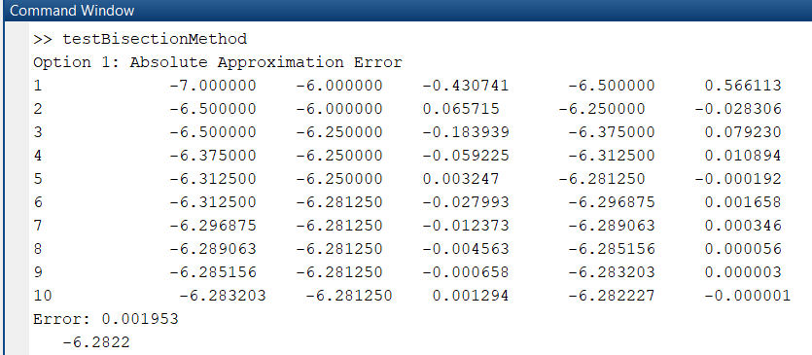

First Interval: [-7,-5], I did upto ten intervals because when I tried the while loop it kept on to infinity.

All roots found were= -6.2822 and -3.1494, I understand perhaps I should have gotten numbers that difference since the error made the loop stop sooner since the approximation was not as close to the threshold. Although I do understand that I may have some technical errors in the operation. I also can infer that these are very accurate results. For this case the Approximate Relative Error gave a more accurate result in the sense of having a lower number in error. For the second root (-3.1494) option3, which was stop at true error should have given us a more previce approximation.

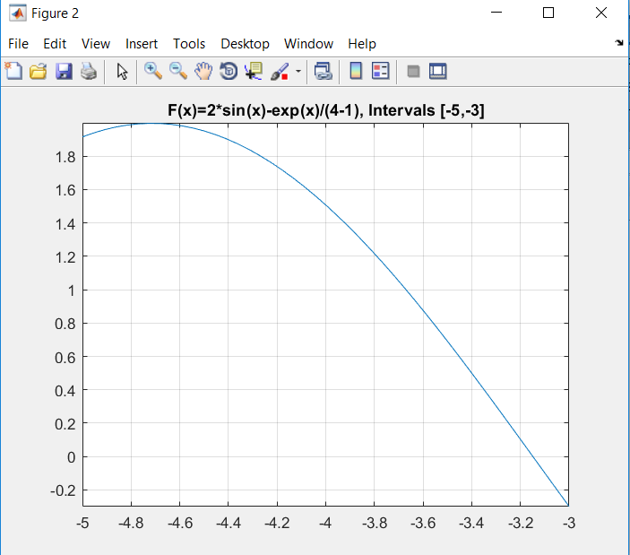

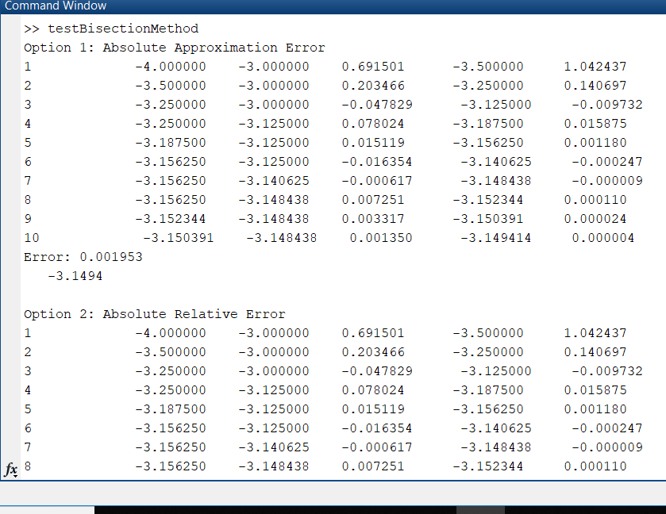

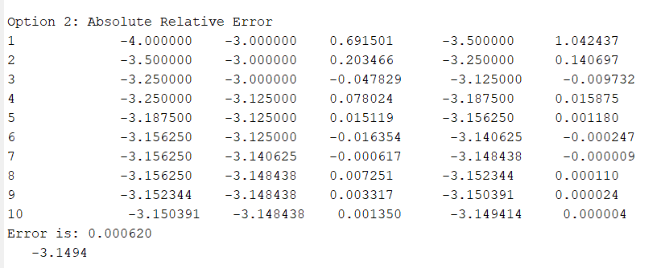

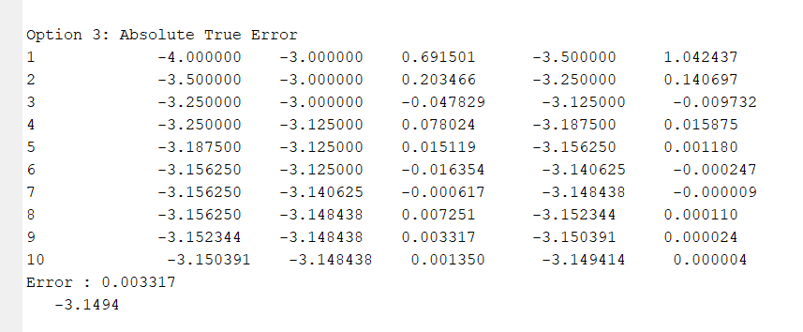

Overall we can see that bisection method can calculate the roots of a continuous graph, although it may skip out of one root if there happens to be more than one. In this case we were given the intervals therefore knew and were able to test our functions. The graph was used to determine the proximity of the roots.