Gauss/Jacobi Iterative Method

Numerical Computation

Lilybeth Delgado

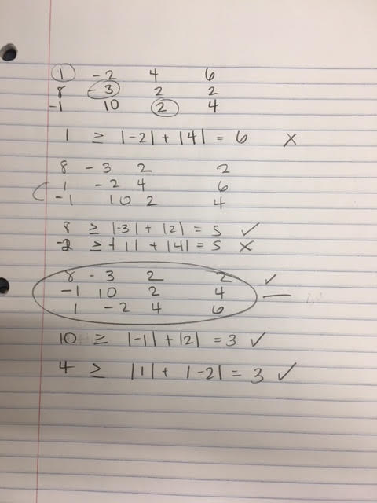Project #7

The following image shows the work done to determine the diagonal

dominant matrix. This could have been done on MATLAB but it was

visually and algebraically easier by hand. Although in the future for

an arbitrary matrix of length x it would be much more difficult to

perform all permutations to find the dominant diagonal. The

Gaussian and Jacobi follow similar approaches in the iterations but

differ in that Jacobi takes the previous approximations while Gauss-

Seidal takes on ones currently available.

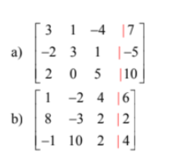

Let Matrix A=

Let Matrix B=

Results:

|  |  |  |  |  |  |
| --- | --- | --- | --- | --- | --- |
|  | Matrix A | Iterations | Stopping Criteria | Matrix B | Iterations |
| Gauss | 3.2094  0.2343  0.7163 | 63 | MAE | -0.1131 0.0756 1.5661 | 15 |
| Gauss | 3.2094  0.2343  0.7163 | 63 | RMSE | -0.1132 0.0755 1.5660 | 18 |
| Jacobi | 3.2087  0.2351  0.7159 | 169 | MAE | -0.1132 0.0755 1.5659 | 21 |
| Jacobi | 3.2094  0.2339  0.7165 | 171 | RMSE | -0.1132 0.0755 1.5659 | 21 |

The following is table demonstrating all the roots and the iterations followed by which stopping criteria. Gaussian Iteration method does converge faster in both cases. And for some the roots differ be 0.001 or 0.0002 which questions the accuracy of our results, although very close to each other. On the bottom or some screen shots that display the iteration number to confirm my results on the table. The rest can be seen through the “testingAssign2.m” file.

