Escenario y pasos de las pruebas:

Originalmente se creó el escenario para comprobar el correcto comportamiento del login cuando se coloca una contraseña incorrecta, pero debido a una funcionalidad de protección de Google, cada vez que se ingresaba la contraseña incorrecta en uno de los pasos, solicitaba un captcha.

La estructura de los escenarios y los pasos se crearon bajo la sintaxis del framework Cucumber.

6 Escenarios, 19 pasos.

Feature: Login and send messages

Send an email, logging in previously. Send with CC, BCC and to the same sender and verify. Discard the draft and delete the first message from the inbox

Scenario: As a user, i want login on gmail with wrong password

Given the user is on gmail login page

When the user fill the mail field and put wrong password

Then the user go to main page

And page show a error message

Scenario: As a user, i want login on gmail

When the user fill the password field with correct password

Then the user go to main page

Scenario: As a user, i want open form for new email and send with basic fields

When the user is on main page, make clic on compose

Then the user fill the basic fields

And send the mail

Scenario: As a user, i want open form for new email and send with CC and BCC fields

When the user is on main page, make clic on compose

Then fill the field CC and BCC

And send the mail

Scenario: As a user, i want open form for new email and self im self and verify

When the user is on main page, make clic on compose

Then fill the field to with "test.automation8412@gmail.com"

And send the mail

Then verify

Scenario: As a user, i want open form a ner email, and discard draft

When the user is on main page, make clic on compose

Then make click on discard draft

And delete the first top message on the inbox

**Escenarios implementados:**

5 Escenarios, 16 pasos

Feature: Login and send messages

Send an email, logging in previously. Send with CC, BCC and to the same sender and verify. Discard the draft and delete the first message from the inbox

Scenario: As a user, i want login on gmail with correct password

Given the user is on gmail login page

When the user fill the mail field and put correct password

Then the user go to main page

Scenario: As a user, i want open form for new email and send with basic fields

When the user is on main page, make clic on compose

Then the user fill the basic fields

And send the mail

Scenario: As a user, i want open form for new email and send with CC and BCC fields

When the user is on main page, make clic on compose

Then fill the field CC and BCC

And send the mail

Scenario: As a user, i want open form for new email and self im self and verify

When the user is on main page, make clic on compose

Then fill the field to with "test.automation8412@gmail.com"

And send the mail

Then verify

Scenario: As a user, i want open form a ner email, and discard draft

When the user is on main page, make clic on compose

Then make click on discard draft

And delete the first top message on the inbox

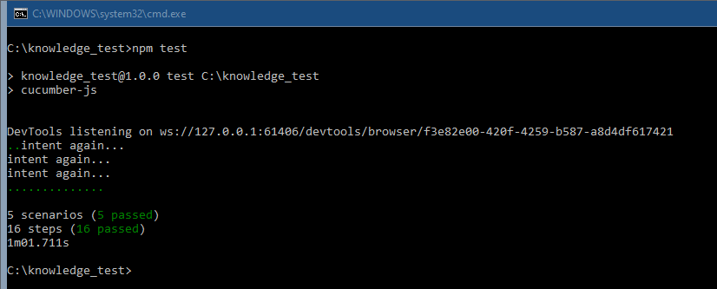

**Reports**

|  |  |
| --- | --- |
| Summary | GMAIL – Login, when the password is wrong, do not show the error message |
| Description | When I try to enter an incorrect password, the system does not display the message with the error. |
| Priority | High |
| Enviroment | Web |
| OS: | Windows, Google Chrome |
| Attachment |  |