

Authentication and authorization using
the SII Südtirol Pass server

Redatto da: | Lorenzo Dematte´ | Lorenzo.Dematte@sad.it | 20/09/2013
Codice documento: | SPASS_OAuth_authentication
Revisione | Rev. 2

Storia delle modifiche apportate - Changelog

Revisione | Data | Modifica
Rev.1 | 13/07/2013 | Prima emissione
Rev.2 | 30/09/2013 | Aggiunto schema risposta “cardids”

Contenuto
1.The actors: 3
How to use it: 3
2.Detailing the process 4
Obtaining client credentials 4
Authentication 4
API access 8
Increased card security 8
3.Sample Code 8
Get cardid for token 8
Validating cardid 11
4.References 12

The actors:
- SPASS Server (holds the protected resources, e.g. user data) – also “Server”

- Client application (“Client”)

- User (identified by a login & password OR by a SPASS smartcard)

The SII Suedtirol Pass server uses OAuth to provide authorized access to its API. OAuth is secure – the protocol has been reviewed by security experts, to the point that in many situations it can work on non-secure channels and still prevent attacks (e.g. the reply-attack). Also, users are not required to share their passwords with 3rd party applications, increasing account security.
OAuth is a standard, and therefore a lot of client libraries and example code is compatible and can be used with our OAuth implementation.

Additionally, an authentication mechanism based on OAuth allows to have:
- Mutual authentication: both the user AND the application are identified;
- The client application doesn't need to store a login and password
- The client application delegates authorization to a trusted location (https on spass server)
- If the user's password changes, the client application continues functioning
- The user is in control and can remove application authorization at any time (loosing application functionalities, of course)

How to use it:
The process of authenticating a user follows these steps:
- The developer of the Client application obtains a set of credentials from SII
Then, authentication proceeds as follows
- The user visit the client application (web or mobile)
- The user selects to login using his/her SPASS credentials (“Login with SPASS”)
- Users are redirected to the sii.bz.it and login page, where their credentials are validated
- Users are asked (on SII site) to authorize to the Client application (reading which type of access and timespan are requested) and grant access
- Users are redirected back to the Client application
- (optional) Now the Client application can use the API to fetch and operate on user data (e.g. Name, surname, cardid...) based on authorization granted at step 4

Detailing the process

Obtaining client credentials
The developer(s) of the Client application have to obtain from SII two things:
- A client identifier (also “consumer key”) which is a number that uniquely identifies the client
- An RSA certificate (private-public key pair) that will be used by the client to sign the requests (and by the server to verify the signature).

Authentication
We run through the same steps again, highlighting how the developer should code his/her application to implement the flow:
- The user visit the client application (web or mobile)
- The user selects to login using his/her SPASS credentials (“Login with SPASS”)

At this point, to start a sign in flow, the client application must obtain a request token by sending a message to the oAuth/request.php. The only unique parameter in this request is oauth_callback, which must be a URL-encoded version of the URL you wish your user to be redirected to when they complete step 4. The remaining parameter(s) are added by the OAuth library of your choice.
The Client application should examine the HTTP status of the response. Any value other than 200 indicates a failure. The body of the response will contain the oauth_token, oauth_token_secret, and oauth_callback_confirmed parameters. Your application should verify that oauth_callback_confirmed is true and store the other two values for the next steps.
The next step is to direct the user to www.sii.bz.it so that they may log-in. Direct the user to oAuth/authorize.php, passing the request token oauth_token obtained with the previous call as the oauth_token parameter.
Note that these steps are completely standard and should be done through a OAuth library that will do all the heavy lifting for you; for example, using oauth-signpost, all the procedure describe in this step boils down to a single line of code:
String authUrl = provider.retrieveRequestToken(consumer, callbackUrl);
which will return the URL to which to redirected the user for the log-in and authorization
The most seamless way for a website to implement this would be to issue a HTTP 302 redirect as the response to the original "sign in" request. Mobile and desktop apps should open a new browser window or direct to the URL via an embedded web view.

- Users are redirected to the sii.bz.it and login page, where their credentials are validated:

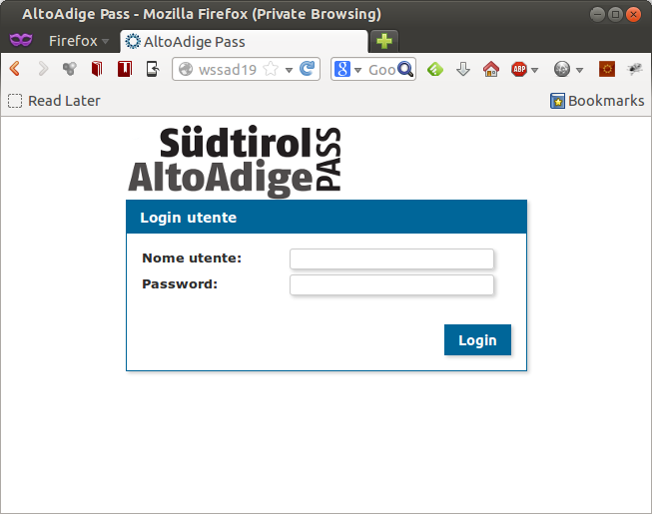
- Users are asked (on SII site) to authorize to the Client application (reading which type of access and timespan are requested) and grant access
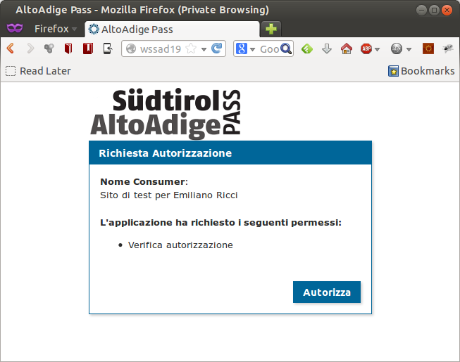
- Users are redirected back to the Client application
Upon a successful authentication, your callback_url would receive a request containing the oauth_token and oauth_verifier parameters. Your application should verify that the token matches the request token received in step 1 (again, this is likely done by your OAuth library of choice).
Now, if the Client application needs to access user data (which is almost always the case), it needs to convert the request token to an access token.
To render the request token into a usable access token, your application must make a request to the oAuth/access.php endpoint, with the oauth_verifier value obtained in step 5. The request token is also passed in the oauth_token portion of the header (but this will have been added by the signing process by your OAuth library of choice)
Again, this potentially complex interaction is completely standard, and therefore usually done through a library. Oauth-signpost provides a call that will perform all the steps to upgrade your token:
OAuthConsumer consume …
provider.retrieveRequestToken(consumer, …)
consumer.getToken() // new access token

- (optional, but recommended) the client application stores the access token in a secure place, associated with the current user. In this way, the client application can reuse the token later to issue requests to our API on behalf of the user.
- (optional) Now the Client application can use the API to fetch and operate on user data (e.g. cardid...) based on authorization(s) granted at step 4
Requests to the API will be done as normal, with the addition of an OAuth signature; the signature will contain the user access token, and therefore each request will act on behalf of the user.
An information that will (almost always) requested is the list of cardids for a user. The cardid is a key information: it could be used as an ID in place of username/password pair, and it is used for all subsequent cals to the SPASS API.
The API requires that requests needing authorization contain an additional HTTP Authorization header with the relevant information Again, this can be added by hand to the HTTP request:
GET /oAuth/cardid.php HTTP/1.1
…
Authorization:
OAuth oauth_consumer_key="xvz1evFS4wEEPTGEFPHBog",
oauth_nonce="kYjzVBB8Y0ZFabxSWbWovY3uYSQ2pTgmZeNu2VS4cg",
oauth_signature="tnnArxj06cWHq44gCs1OSKk%2FjLY%3D",
oauth_signature_method="RSA-SHA1",
oauth_timestamp="1318622958",
oauth_token="370773112-GmHxMAgYyLbNEtIKZeRNFsMKPR9EyMZeS9weJAEb",
oauth_version="1.0a"
… or, better, done through an appropriate library (again, the example is given using oauth-signpost) :
HttpGet request = new HttpGet(“http://www.sii.bz.it/oAuth/cardid.php);
consumer.sign(request);

At this point: the client knows that this card is linked to that user AND the user knows the client is identified (we checked it) and authorized (and which info it can access).
In order to recognize a card at a later stage, the Client can store the cardid for later usage, associating it with its own user information and access token in its local DB; when users present their cards, they use the card as their ID.
It is up to che Client developer to store the (user – access token – cardid) combination in a secure and reliable way.
The Client can be satisfied and stop here at this point; the cardid is known, and valid for that period/device combination.
This is the solution that allows for the maximum availability: no further online interaction is necessary.

API access
The same pattern can be used to access any API requests needing authorization:
- the Client application uses the cardid to retrieve (locally) its access token;
- the Client application builds an HTTP request, and signs it with the access token.
Obviously, the Server will check the access token (must be valid), and will check authorizations linked to the access token (e.g. if an application requested only read permission, it cannot use APIs that write user data).
In the next section we provide an example of the usage of the first (and most important) API function: retrieve the list of cards (and their info) for the current user (i.e. the user on which behalf we are acting, through the access token).
For details about other available API calls (if needed) see the “SPASS Server API” document.

Sample Code

Get cardid for token
- returns list of valid cardids for token
Using raw HTTP:

GET /oAuth/cardid.php HTTP/1.1
…
Authorization:
OAuth oauth_consumer_key="xvz1evFS4wEEPTGEFPHBog",
oauth_nonce="kYjzVBB8Y0ZFabxSWbWovY3uYSQ2pTgmZeNu2VS4cg",
oauth_signature="tnnArxj06cWHq44gCs1OSKk%2FjLY%3D",
oauth_signature_method="RSA-SHA1",
oauth_timestamp="1318622958",
oauth_token="370773112-GmHxMAgYyLbNEtIKZeRNFsMKPR9EyMZeS9weJAEb",
oauth_version="1.0a"

Using an OAuth library (example given using oauth-signpost) :
HttpGet request = new HttpGet(“http://www.sii.bz.it/oAuth/cardid.php);
consumer.sign(request);
org.apache.http.HttpResponse response = client.execute(request);
StringWriter writer = new StringWriter();
IOUtils.copy(response.getEntity().getContent(), writer);
String responseBody = writer.toString();

responseBody will be a JSON containing a (potentially empty) list of cardids.
The returned JSON object will have the following schema (http://json-schema.org/):

{
“type” : “object”,
“properties”: {
“cardids”: {
“type”: “array”
"items": {
“type": "object",
“requested”: [ “id”, “ticket_type”, “contract”, “customer”,
“request”, “number”, “mifare_id”, “ticket_office”,
“valid_from”, “valid_until”, “ticket_status”,
“status_user”, “status_time”, …],
“properties”: {
“id” : { “type”: “integer” },
“ticket_type” : { “type”: “integer” },
“contract” : { “type”: “integer” },
“customer” : { “type”: “integer” },
“request” : { “type”: “integer” },
“old_ticket”: { “type”: “integer” },
“number: { “type”: “string” },
“mifare_id : { “type”: “string” },
“ticket_office: { “type”: “integer” },
“valid_from : { “type”: “date-time” },
“valid_until : { “type”: “date-time” },
“ticket_status: { “type”: “integer” },
“status_user: { “type”: “integer” },
“status_time : { “type”: “date-time” },
“create_user: { “type”: “integer” },
“create_time : { “type”: “date-time” },
“delete_user: { “type”: “integer” },
“delete_time : { “type”: “date-time” }
}
}
}
}
"required": [ "cardids" ]
}

where date-time is:
{
“type” : “object”,
“properties”: {
“date”: { “type”: “string” },
“timezone_type”: { “type”: “integer” },
“timezone”: { “type”: “string” },
}
}

The JSON object can then be deserialized using your library of choice. As an example, these are the corresponing C# classes and C# code we use to deserialize the responseBody:

var cardInfoList = JsonSerializer.
DeserializeFromString<CardInfoList>(responseBody);

where the above JSON schema is implemented using the following classes:

public class DateTime {
public string date { get; set; }
public int timezone_type {get; set; }
public string timezone { get; set; }
}

public class CardInfoList {
public List<CardInfo> cardids {
get;
set;
}
}

public class CardInfo {
public int id { get; set; }

public int ticket_type { get; set; }
public int contract { get; set; }
public int customer { get; set; }
public int request { get; set; }
public int? old_ticket { get; set; }
public string number { get; set; }
public string mifare_id { get; set; }

public int ticket_office { get; set; }

public DateTime valid_from { get; set; }
public DateTime valid_until { get; set; }

public int ticket_status { get; set; }
public int status_user { get; set; }
public DateTime status_time { get; set; }

public int create_user { get; set; }
public DateTime create_time { get; set; }

public int delete_user { get; set; }
public DateTime delete_time { get; set; }
}

Validating cardid
- is this cardid authorized to use my service?
This information needs to be handled by the client, requesting the valid cardid(s) for a user upon authentication, and then refreshing the list on a regular basis (see example above).
In the future, if needed, we plan to provide an alternative/backup solution, where the Client can ask, using a cardid, if it has any valid access token for the user with that card; in this way if a Client loses the access token, it can retrieve it.
This functionality requires application-only authorization, and will be implemented as the Client Credentials Flow of OAuth 2.0 (see http://tools.ietf.org/html/rfc6749#section-4.4)

The API endpoiunt will be
GET /oAuth/get-token.php?cardid=XXXXXX

References

Oauth:
http://oauth.net/
http://tools.ietf.org/html/rfc6749

Camel Oauth Tutorial:
http://camel.apache.org/tutorial-oauth.html

