MERDs Data Analyses

Lukas Bell-Dereske

8/27/2020

Import dataset into R from your directory Here is my directory

# SEED GERMINATION PORTION OF THE EXPERIEMENT BEGINS

### Time to first germination in a given pot

### Full Statistical model

Diagnostic Graphs

day_t0_germ_model= lmer((t0_germ)^-1~precip*soil_root+(1|block), data= dataSG_seed_1st_germ_trt)  
qqPlot(resid(day_t0_germ_model))

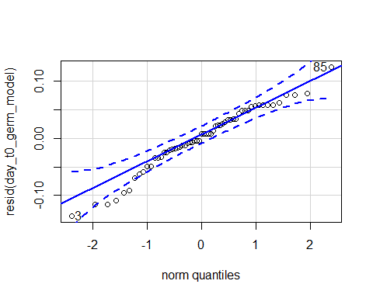

## 3 85   
## 2 56

hist(resid(day_t0_germ_model))

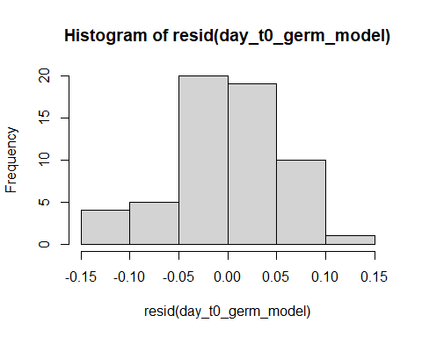

shapiro.test(resid(day_t0_germ_model))

##   
## Shapiro-Wilk normality test  
##   
## data: resid(day_t0_germ_model)  
## W = 0.96991, p-value = 0.1514

Raw Statistical output

anova(day_t0_germ_model)

## Type III Analysis of Variance Table with Satterthwaite's method  
## Sum Sq Mean Sq NumDF DenDF F value Pr(>F)   
## precip 0.0119463 0.0119463 1 50.215 3.5356 0.06587 .  
## soil_root 0.0313006 0.0156503 2 50.655 4.6318 0.01421 *  
## precip:soil_root 0.0045726 0.0022863 2 51.349 0.6766 0.51279   
## ---  
## Signif. codes: 0 '***' 0.001 '**' 0.01 '*' 0.05 '.' 0.1 ' ' 1

emmeans(day_t0_germ_model, pairwise~soil_root)

## Warning in ref_grid(object, ...): There are unevaluated constants in the response formula  
## Auto-detection of the response transformation may be incorrect

## NOTE: Results may be misleading due to involvement in interactions

## Note: Use 'contrast(regrid(object), ...)' to obtain contrasts of back-transformed estimates

## $emmeans  
## soil_root emmean SE df lower.CL upper.CL  
## L.B 0.195 0.0148 11.9 0.162 0.227  
## S.B 0.140 0.0176 21.6 0.103 0.176  
## L.R 0.195 0.0150 12.7 0.163 0.228  
##   
## Results are averaged over the levels of: precip   
## Degrees-of-freedom method: kenward-roger   
## Results are given on the ( (not the response) scale.   
## Confidence level used: 0.95   
##   
## $contrasts  
## contrast estimate SE df t.ratio p.value  
## L.B - S.B 0.054728 0.0201 49.2 2.726 0.0236   
## L.B - L.R -0.000469 0.0183 51.3 -0.026 0.9996   
## S.B - L.R -0.055197 0.0204 50.1 -2.702 0.0250   
##   
## Results are averaged over the levels of: precip   
## Note: contrasts are still on the ( scale   
## Degrees-of-freedom method: kenward-roger   
## P value adjustment: tukey method for comparing a family of 3 estimates

emmeans(day_t0_germ_model, pairwise~soil_root|precip)

## Warning in ref_grid(object, ...): There are unevaluated constants in the response formula  
## Auto-detection of the response transformation may be incorrect

## Note: Use 'contrast(regrid(object), ...)' to obtain contrasts of back-transformed estimates

## $emmeans  
## precip = A:  
## soil_root emmean SE df lower.CL upper.CL  
## L.B 0.187 0.0186 24.8 0.1488 0.226  
## S.B 0.111 0.0223 35.9 0.0656 0.156  
## L.R 0.187 0.0168 19.7 0.1519 0.222  
##   
## precip = D:  
## soil_root emmean SE df lower.CL upper.CL  
## L.B 0.202 0.0202 29.5 0.1608 0.243  
## S.B 0.169 0.0254 42.2 0.1178 0.220  
## L.R 0.203 0.0225 34.9 0.1576 0.249  
##   
## Degrees-of-freedom method: kenward-roger   
## Results are given on the ( (not the response) scale.   
## Confidence level used: 0.95   
##   
## $contrasts  
## precip = A:  
## contrast estimate SE df t.ratio p.value  
## L.B - S.B 0.076424 0.0272 51.2 2.807 0.0190   
## L.B - L.R 0.000133 0.0227 49.8 0.006 1.0000   
## S.B - L.R -0.076292 0.0257 50.0 -2.964 0.0127   
##   
## precip = D:  
## contrast estimate SE df t.ratio p.value  
## L.B - S.B 0.033031 0.0303 49.8 1.091 0.5241   
## L.B - L.R -0.001071 0.0283 51.2 -0.038 0.9992   
## S.B - L.R -0.034101 0.0325 51.9 -1.048 0.5504   
##   
## Note: contrasts are still on the ( scale   
## Degrees-of-freedom method: kenward-roger   
## P value adjustment: tukey method for comparing a family of 3 estimates

Formatted Anova table

Days to germination

|  |  |  |  |  |
| --- | --- | --- | --- | --- |
|  | Df | Resid.Df | F.value | P.value |
| precip | 1 | 50.22 | 3.54 | 0.066 |
| soil_root | 2 | 50.66 | 4.63 | 0.014 |
| precip:soil_root | 2 | 51.35 | 0.68 | 0.513 |

Graph for publication

## Warning: `funs()` is deprecated as of dplyr 0.8.0.  
## Please use a list of either functions or lambdas:   
##   
## # Simple named list:   
## list(mean = mean, median = median)  
##   
## # Auto named with `tibble::lst()`:   
## tibble::lst(mean, median)  
##   
## # Using lambdas  
## list(~ mean(., trim = .2), ~ median(., na.rm = TRUE))  
## This warning is displayed once every 8 hours.  
## Call `lifecycle::last_warnings()` to see where this warning was generated.

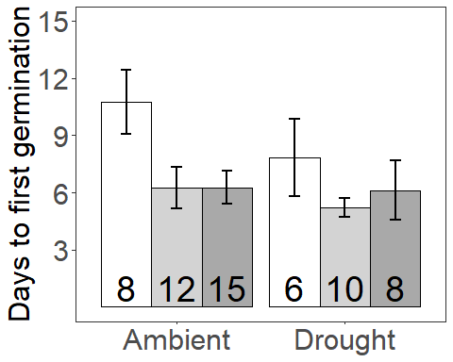

## Presence Days to first Germination

Diagnostic Graphs

dataSG_seed_1st_germ_pres=subset(dataSG_seed_1st_germ_trt, root_association =="B")  
unique(dataSG_seed_1st_germ_pres$soil_root)

## [1] L.B S.B  
## Levels: L.B S.B L.R S.R

nrow(dataSG_seed_1st_germ_pres)

## [1] 60

day_t0_germ_model_pres= lmer((t0_germ)^-1~precip*soil_root+(1|block), data= dataSG_seed_1st_germ_pres)  
qqPlot(resid(day_t0_germ_model_pres))

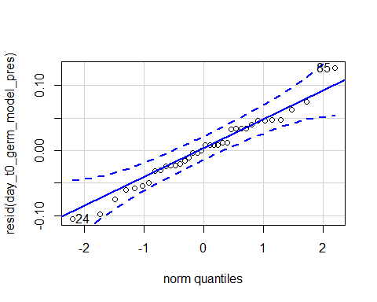

## 85 24   
## 33 6

hist(resid(day_t0_germ_model_pres))

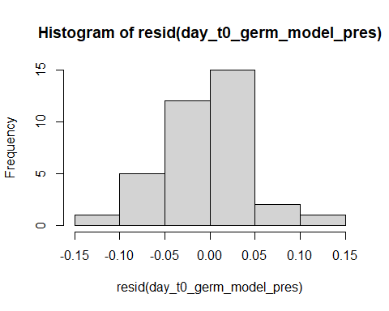

shapiro.test(resid(day_t0_germ_model_pres))

##   
## Shapiro-Wilk normality test  
##   
## data: resid(day_t0_germ_model_pres)  
## W = 0.98241, p-value = 0.8234

Raw Statistical output

anova(day_t0_germ_model_pres)

## Type III Analysis of Variance Table with Satterthwaite's method  
## Sum Sq Mean Sq NumDF DenDF F value Pr(>F)   
## precip 0.0122308 0.0122308 1 29.562 4.2813 0.047376 *   
## soil_root 0.0252094 0.0252094 1 28.581 8.8243 0.005968 **  
## precip:soil_root 0.0052936 0.0052936 1 30.328 1.8530 0.183466   
## ---  
## Signif. codes: 0 '***' 0.001 '**' 0.01 '*' 0.05 '.' 0.1 ' ' 1

emmeans(day_t0_germ_model_pres, pairwise~soil_root)

## Warning in ref_grid(object, ...): There are unevaluated constants in the response formula  
## Auto-detection of the response transformation may be incorrect

## NOTE: Results may be misleading due to involvement in interactions

## Note: Use 'contrast(regrid(object), ...)' to obtain contrasts of back-transformed estimates

## $emmeans  
## soil_root emmean SE df lower.CL upper.CL  
## L.B 0.196 0.0168 5.72 0.1546 0.238  
## S.B 0.141 0.0188 9.08 0.0987 0.184  
##   
## Results are averaged over the levels of: precip   
## Degrees-of-freedom method: kenward-roger   
## Results are given on the ( (not the response) scale.   
## Confidence level used: 0.95   
##   
## $contrasts  
## contrast estimate SE df t.ratio p.value  
## L.B - S.B 0.0548 0.0185 28.2 2.966 0.0061   
##   
## Results are averaged over the levels of: precip   
## Note: contrasts are still on the ( scale   
## Degrees-of-freedom method: kenward-roger

emmeans(day_t0_germ_model_pres, pairwise~soil_root|precip)

## Warning in ref_grid(object, ...): There are unevaluated constants in the response formula  
## Auto-detection of the response transformation may be incorrect

## Note: Use 'contrast(regrid(object), ...)' to obtain contrasts of back-transformed estimates

## $emmeans  
## precip = A:  
## soil_root emmean SE df lower.CL upper.CL  
## L.B 0.190 0.0197 10.4 0.1459 0.233  
## S.B 0.109 0.0227 15.8 0.0607 0.157  
##   
## precip = D:  
## soil_root emmean SE df lower.CL upper.CL  
## L.B 0.203 0.0211 12.6 0.1569 0.248  
## S.B 0.174 0.0256 19.9 0.1201 0.227  
##   
## Degrees-of-freedom method: kenward-roger   
## Results are given on the ( (not the response) scale.   
## Confidence level used: 0.95   
##   
## $contrasts  
## precip = A:  
## contrast estimate SE df t.ratio p.value  
## L.B - S.B 0.0807 0.0255 29.9 3.161 0.0036   
##   
## precip = D:  
## contrast estimate SE df t.ratio p.value  
## L.B - S.B 0.0290 0.0280 28.7 1.033 0.3103   
##   
## Note: contrasts are still on the ( scale   
## Degrees-of-freedom method: kenward-roger

Formatted Anova table

Days to germination

|  |  |  |  |  |
| --- | --- | --- | --- | --- |
|  | Df | Resid.Df | F.value | P.value |
| precip | 1 | 29.56 | 4.28 | 0.047 |
| soil_root | 1 | 28.58 | 8.82 | 0.006 |
| precip:soil_root | 1 | 30.33 | 1.85 | 0.183 |

## Origin Days to first Germination

Diagnostic Graphs

dataSG_seed_1st_germ_orig=subset(dataSG_seed_1st_germ_trt, soil_status =="L")  
unique(dataSG_seed_1st_germ_orig$soil_root)

## [1] L.R L.B  
## Levels: L.B S.B L.R S.R

nrow(dataSG_seed_1st_germ_orig)

## [1] 60

#60  
  
  
day_t0_germ_model_orig= lmer((t0_germ)^-2~precip*soil_root+(1|block), data= dataSG_seed_1st_germ_orig)  
qqPlot(resid(day_t0_germ_model_orig))

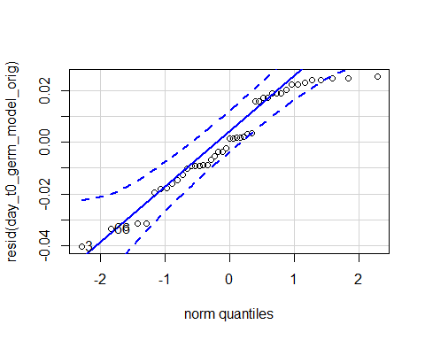

## 3 66   
## 2 37

hist(resid(day_t0_germ_model_orig))

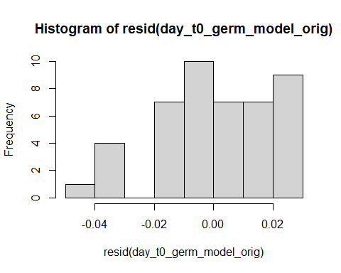

shapiro.test(resid(day_t0_germ_model_orig))

##   
## Shapiro-Wilk normality test  
##   
## data: resid(day_t0_germ_model_orig)  
## W = 0.93385, p-value = 0.01286

#0.01286

Raw Statistical output

anova(day_t0_germ_model_orig)

## Type III Analysis of Variance Table with Satterthwaite's method  
## Sum Sq Mean Sq NumDF DenDF F value Pr(>F)  
## precip 0.00040305 0.00040305 1 39.847 1.0708 0.3070  
## soil_root 0.00001075 0.00001075 1 40.258 0.0285 0.8667  
## precip:soil_root 0.00000263 0.00000263 1 38.791 0.0070 0.9339

#emmeans(day_t0_germ_model_orig, pairwise~soil_root)  
#emmeans(day_t0_germ_model_orig, pairwise~soil_root|precip)

Formatted Anova table

Days to germination

|  |  |  |  |  |
| --- | --- | --- | --- | --- |
|  | Df | Resid.Df | F.value | P.value |
| precip | 1 | 39.85 | 1.07 | 0.307 |
| soil_root | 1 | 40.26 | 0.03 | 0.867 |
| precip:soil_root | 1 | 38.79 | 0.01 | 0.934 |

## Final number of germinates

Diagnostic Graphs

#Total germination  
#convert to percentages  
fin_dataSG_seed_surv_trt_tot_seedling$prop_tot_num_germ=fin_dataSG_seed_surv_trt_tot_seedling$tot_num_germ/10  
seed_germ_model= glmer.nb((tot_num_germ)~precip*soil_root+(1|block), data= fin_dataSG_seed_surv_trt_tot_seedling)

## Warning in theta.ml(Y, mu, weights = object@resp$weights, limit = limit, :  
## iteration limit reached

## boundary (singular) fit: see ?isSingular

qqPlot(resid(seed_germ_model))

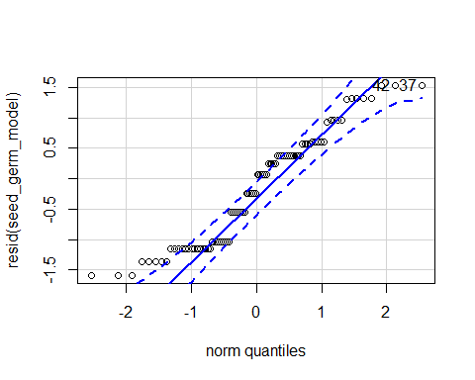

## 37 42   
## 59 61

hist(resid(seed_germ_model))

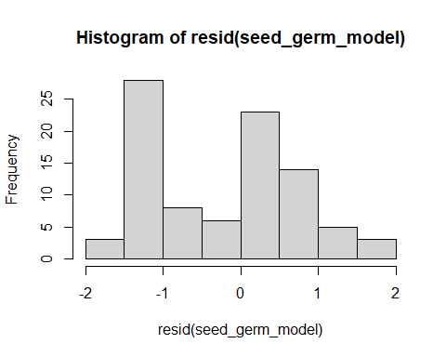

shapiro.test(resid(seed_germ_model))

##   
## Shapiro-Wilk normality test  
##   
## data: resid(seed_germ_model)  
## W = 0.93147, p-value = 0.0001422

#p-value = 0.0001422  
plot(seed_germ_model)

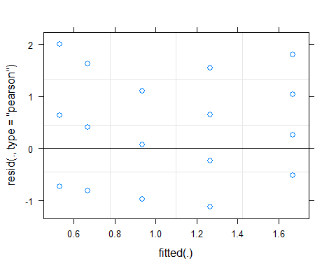

#Chad's code for checking for over dispersion  
overdisp_fun <- function(model) {  
 vpars <- function(m) {  
 nrow(m)*(nrow(m)+1)/2  
 }  
 model.df <- sum(sapply(VarCorr(model),vpars))+length(fixef(model))  
 rdf <- nrow(model.frame(model))-model.df  
 rp <- residuals(model,type="pearson")  
 Pearson.chisq <- sum(rp^2)  
 prat <- Pearson.chisq/rdf  
 pval <- pchisq(Pearson.chisq, df=rdf, lower.tail=FALSE)  
 c(chisq=Pearson.chisq,ratio=prat,rdf=rdf,p=pval)  
}  
  
overdisp_fun(seed_germ_model)

## chisq ratio rdf p   
## 61.5017682 0.7409852 83.0000000 0.9629765

Raw Statistical output

summary(seed_germ_model)

## Generalized linear mixed model fit by maximum likelihood (Laplace  
## Approximation) [glmerMod]  
## Family: Negative Binomial(54342.88) ( log )  
## Formula: (tot_num_germ) ~ precip * soil_root + (1 | block)  
## Data: fin_dataSG_seed_surv_trt_tot_seedling  
##   
## AIC BIC logLik deviance df.resid   
## 222.9 242.9 -103.5 206.9 82   
##   
## Scaled residuals:   
## Min 1Q Median 3Q Max   
## -1.12545 -0.73029 -0.08396 0.40823 2.00830   
##   
## Random effects:  
## Groups Name Variance Std.Dev.   
## block (Intercept) 5.981e-11 7.733e-06  
## Number of obs: 90, groups: block, 5  
##   
## Fixed effects:  
## Estimate Std. Error z value Pr(>|z|)   
## (Intercept) -0.12688 0.11619 -1.092 0.2748   
## precip1 0.24080 0.11618 2.073 0.0382 *  
## soil_root1 0.21058 0.15408 1.367 0.1717   
## soil_root2 -0.39015 0.17898 -2.180 0.0293 *  
## precip1:soil_root1 -0.08811 0.15408 -0.572 0.5674   
## precip1:soil_root2 -0.12923 0.17898 -0.722 0.4703   
## ---  
## Signif. codes: 0 '***' 0.001 '**' 0.01 '*' 0.05 '.' 0.1 ' ' 1  
##   
## Correlation of Fixed Effects:  
## (Intr) precp1 sl_rt1 sl_rt2 pr1:_1  
## precip1 -0.211   
## soil_root1 -0.178 0.072   
## soil_root2 0.245 0.039 -0.556   
## prcp1:sl_r1 0.072 -0.178 -0.185 0.027   
## prcp1:sl_r2 0.039 0.245 0.027 -0.153 -0.556  
## convergence code: 0  
## boundary (singular) fit: see ?isSingular

Anova(seed_germ_model,type = 3)

## Analysis of Deviance Table (Type III Wald chisquare tests)  
##   
## Response: (tot_num_germ)  
## Chisq Df Pr(>Chisq)   
## (Intercept) 1.1925 1 0.27483   
## precip 4.2959 1 0.03821 *  
## soil_root 4.7863 2 0.09134 .  
## precip:soil_root 1.8911 2 0.38847   
## ---  
## Signif. codes: 0 '***' 0.001 '**' 0.01 '*' 0.05 '.' 0.1 ' ' 1

emmeans(seed_germ_model,pairwise~soil_root|precip)

## $emmeans  
## precip = A:  
## soil_root emmean SE df asymp.LCL asymp.UCL  
## L.B 0.236 0.229 Inf -0.212 0.6849  
## S.B -0.405 0.315 Inf -1.023 0.2119  
## L.R 0.511 0.200 Inf 0.120 0.9021  
##   
## precip = D:  
## soil_root emmean SE df asymp.LCL asymp.UCL  
## L.B -0.069 0.267 Inf -0.592 0.4535  
## S.B -0.629 0.352 Inf -1.318 0.0609  
## L.R -0.405 0.315 Inf -1.023 0.2122  
##   
## Results are given on the log (not the response) scale.   
## Confidence level used: 0.95   
##   
## $contrasts  
## precip = A:  
## contrast estimate SE df z.ratio p.value  
## L.B - S.B 0.642 0.389 Inf 1.650 0.2248   
## L.B - L.R -0.274 0.304 Inf -0.903 0.6381   
## S.B - L.R -0.916 0.373 Inf -2.457 0.0373   
##   
## precip = D:  
## contrast estimate SE df z.ratio p.value  
## L.B - S.B 0.560 0.441 Inf 1.269 0.4126   
## L.B - L.R 0.336 0.413 Inf 0.815 0.6938   
## S.B - L.R -0.223 0.472 Inf -0.472 0.8843   
##   
## Results are given on the log (not the response) scale.   
## P value adjustment: tukey method for comparing a family of 3 estimates

Formatted Anova table

Number of seeds that germinated

|  |  |  |  |
| --- | --- | --- | --- |
|  | Df | Chi.Sq | P.value |
| (Intercept) | 1 | 1.19 | 0.275 |
| precip | 1 | 4.30 | 0.038 |
| soil_root | 2 | 4.79 | 0.091 |
| precip:soil_root | 2 | 1.89 | 0.388 |

## Presence Number of Seeds that Geminated

Diagnostic Graphs

fin_dataSG_seed_surv_trt_tot_seedling_pres=subset(fin_dataSG_seed_surv_trt_tot_seedling, root_association =="B")  
seed_germ_model_pres= glmer.nb((tot_num_germ)~precip*soil_root+(1|block), data= fin_dataSG_seed_surv_trt_tot_seedling_pres)

## Warning in theta.ml(Y, mu, weights = object@resp$weights, limit = limit, :  
## iteration limit reached

qqPlot(resid(seed_germ_model_pres))

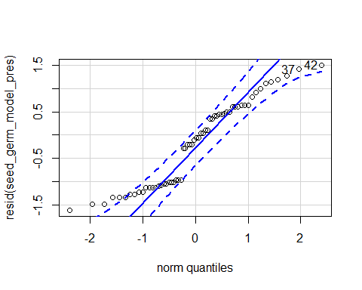

## 42 37   
## 43 41

hist(resid(seed_germ_model_pres))

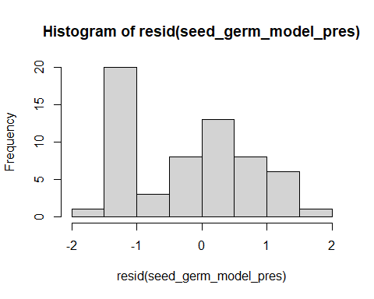

shapiro.test(resid(seed_germ_model_pres))

##   
## Shapiro-Wilk normality test  
##   
## data: resid(seed_germ_model_pres)  
## W = 0.92034, p-value = 0.0007916

#p-value = 0.0007916  
plot(seed_germ_model_pres)

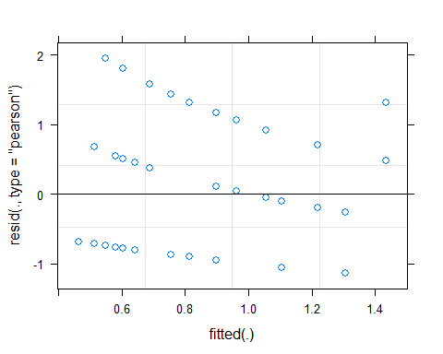 Raw Statistical output

summary(seed_germ_model_pres)

## Generalized linear mixed model fit by maximum likelihood (Laplace  
## Approximation) [glmerMod]  
## Family: Negative Binomial(52724.35) ( log )  
## Formula: (tot_num_germ) ~ precip * soil_root + (1 | block)  
## Data: fin_dataSG_seed_surv_trt_tot_seedling_pres  
##   
## AIC BIC logLik deviance df.resid   
## 146.5 159.1 -67.3 134.5 54   
##   
## Scaled residuals:   
## Min 1Q Median 3Q Max   
## -1.14275 -0.76619 -0.07703 0.58158 1.95560   
##   
## Random effects:  
## Groups Name Variance Std.Dev.  
## block (Intercept) 0.03097 0.176   
## Number of obs: 60, groups: block, 5  
##   
## Fixed effects:  
## Estimate Std. Error z value Pr(>|z|)   
## (Intercept) -0.23211 0.17146 -1.354 0.1758   
## precip1 0.13213 0.14743 0.896 0.3701   
## soil_root1 0.30036 0.14750 2.036 0.0417 *  
## precip1:soil_root1 0.02056 0.14753 0.139 0.8892   
## ---  
## Signif. codes: 0 '***' 0.001 '**' 0.01 '*' 0.05 '.' 0.1 ' ' 1  
##   
## Correlation of Fixed Effects:  
## (Intr) precp1 sl_rt1  
## precip1 -0.106   
## soil_root1 -0.246 0.018   
## prcp1:sl_r1 0.015 -0.289 -0.126

Anova(seed_germ_model_pres,type = 3)

## Analysis of Deviance Table (Type III Wald chisquare tests)  
##   
## Response: (tot_num_germ)  
## Chisq Df Pr(>Chisq)   
## (Intercept) 1.8325 1 0.17583   
## precip 0.8033 1 0.37012   
## soil_root 4.1466 1 0.04172 *  
## precip:soil_root 0.0194 1 0.88918   
## ---  
## Signif. codes: 0 '***' 0.001 '**' 0.01 '*' 0.05 '.' 0.1 ' ' 1

emmeans(seed_germ_model_pres,pairwise~soil_root|precip)

## $emmeans  
## precip = A:  
## soil_root emmean SE df asymp.LCL asymp.UCL  
## L.B 0.2209 0.246 Inf -0.261 0.7024  
## S.B -0.4209 0.327 Inf -1.063 0.2210  
##   
## precip = D:  
## soil_root emmean SE df asymp.LCL asymp.UCL  
## L.B -0.0844 0.281 Inf -0.635 0.4664  
## S.B -0.6440 0.363 Inf -1.356 0.0681  
##   
## Results are given on the log (not the response) scale.   
## Confidence level used: 0.95   
##   
## $contrasts  
## precip = A:  
## contrast estimate SE df z.ratio p.value  
## L.B - S.B 0.642 0.390 Inf 1.645 0.0999   
##   
## precip = D:  
## contrast estimate SE df z.ratio p.value  
## L.B - S.B 0.560 0.443 Inf 1.264 0.2062   
##   
## Results are given on the log (not the response) scale.

Formatted Anova table

Number of seeds that germinated

|  |  |  |  |
| --- | --- | --- | --- |
|  | Df | Chi.Sq | P.value |
| (Intercept) | 1 | 1.83 | 0.176 |
| precip | 1 | 0.80 | 0.370 |
| soil_root | 1 | 4.15 | 0.042 |
| precip:soil_root | 1 | 0.02 | 0.889 |

## Origin Number of Seeds that Geminated

Diagnostic Graphs

fin_dataSG_seed_surv_trt_tot_seedling_org=subset(fin_dataSG_seed_surv_trt_tot_seedling, soil_status =="L")  
  
seed_germ_model_org= glmer.nb((tot_num_germ)~precip*soil_root+(1|block), data= fin_dataSG_seed_surv_trt_tot_seedling_org)

## Warning in theta.ml(Y, mu, weights = object@resp$weights, limit = limit, :  
## iteration limit reached

## boundary (singular) fit: see ?isSingular

qqPlot(resid(seed_germ_model_org))

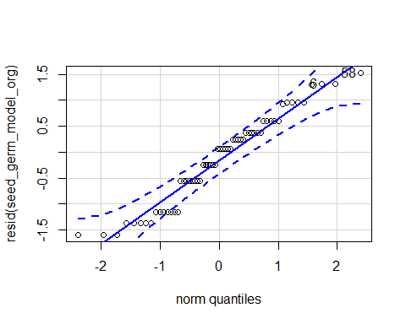

## 58 6   
## 49 26

hist(resid(seed_germ_model_org))

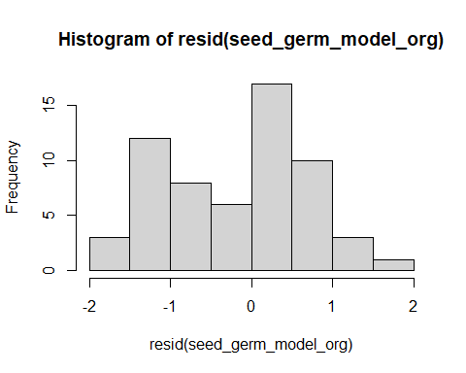

shapiro.test(resid(seed_germ_model_org))

##   
## Shapiro-Wilk normality test  
##   
## data: resid(seed_germ_model_org)  
## W = 0.95425, p-value = 0.02477

#p-value = 0.02477  
plot(seed_germ_model_org)

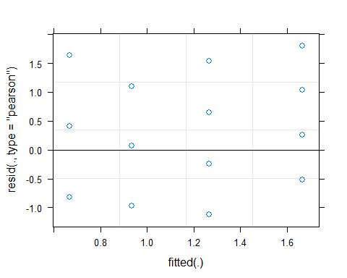 Raw Statistical output

summary(seed_germ_model_org)

## Generalized linear mixed model fit by maximum likelihood (Laplace  
## Approximation) [glmerMod]  
## Family: Negative Binomial(77187.13) ( log )  
## Formula: (tot_num_germ) ~ precip * soil_root + (1 | block)  
## Data: fin_dataSG_seed_surv_trt_tot_seedling_org  
##   
## AIC BIC logLik deviance df.resid   
## 159.2 171.8 -73.6 147.2 54   
##   
## Scaled residuals:   
## Min 1Q Median 3Q Max   
## -1.12545 -0.59142 0.06902 0.40825 1.80738   
##   
## Random effects:  
## Groups Name Variance Std.Dev.  
## block (Intercept) 0 0   
## Number of obs: 60, groups: block, 5  
##   
## Fixed effects:  
## Estimate Std. Error z value Pr(>|z|)   
## (Intercept) 0.06818 0.12820 0.532 0.5948   
## precip1 0.30542 0.12820 2.382 0.0172 *  
## soil_root1 0.01551 0.12820 0.121 0.9037   
## precip1:soil_root1 -0.15272 0.12820 -1.191 0.2335   
## ---  
## Signif. codes: 0 '***' 0.001 '**' 0.01 '*' 0.05 '.' 0.1 ' ' 1  
##   
## Correlation of Fixed Effects:  
## (Intr) precp1 sl_rt1  
## precip1 -0.297   
## soil_root1 -0.064 0.158   
## prcp1:sl_r1 0.158 -0.064 -0.297  
## convergence code: 0  
## boundary (singular) fit: see ?isSingular

Anova(seed_germ_model_org,type = 3)

## Analysis of Deviance Table (Type III Wald chisquare tests)  
##   
## Response: (tot_num_germ)  
## Chisq Df Pr(>Chisq)   
## (Intercept) 0.2829 1 0.5948   
## precip 5.6755 1 0.0172 *  
## soil_root 0.0146 1 0.9037   
## precip:soil_root 1.4191 1 0.2335   
## ---  
## Signif. codes: 0 '***' 0.001 '**' 0.01 '*' 0.05 '.' 0.1 ' ' 1

emmeans(seed_germ_model_org,pairwise~soil_root|precip)

## $emmeans  
## precip = A:  
## soil_root emmean SE df asymp.LCL asymp.UCL  
## L.B 0.236 0.229 Inf -0.213 0.685  
## L.R 0.511 0.200 Inf 0.119 0.903  
##   
## precip = D:  
## soil_root emmean SE df asymp.LCL asymp.UCL  
## L.B -0.069 0.266 Inf -0.590 0.452  
## L.R -0.405 0.316 Inf -1.025 0.214  
##   
## Results are given on the log (not the response) scale.   
## Confidence level used: 0.95   
##   
## $contrasts  
## precip = A:  
## contrast estimate SE df z.ratio p.value  
## L.B - L.R -0.274 0.304 Inf -0.902 0.3668   
##   
## precip = D:  
## contrast estimate SE df z.ratio p.value  
## L.B - L.R 0.336 0.413 Inf 0.815 0.4152   
##   
## Results are given on the log (not the response) scale.

Formatted Anova table

Number of seeds that germinated

|  |  |  |  |
| --- | --- | --- | --- |
|  | Df | Chi.Sq | P.value |
| (Intercept) | 1 | 0.28 | 0.59 |
| precip | 1 | 5.68 | 0.02 |
| soil_root | 1 | 0.01 | 0.90 |
| precip:soil_root | 1 | 1.42 | 0.23 |

Graph for publication 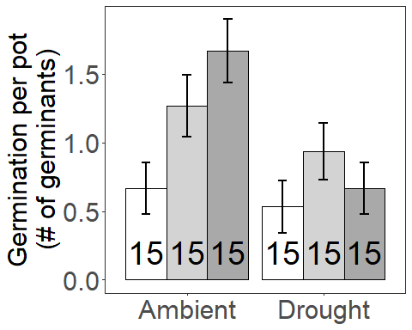

## Cummulative germination and survival

### Full Statistical model

Diagnostic Graphs

seed_final_plant_no_model= glmer(final_plant_no~precip*soil_root+(1|block), data= data_SG_biomass_seed_surv_trt, family="binomial")  
qqPlot(resid(seed_final_plant_no_model))

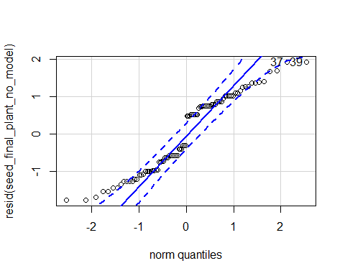

## [1] 37 39

hist(resid(seed_final_plant_no_model))

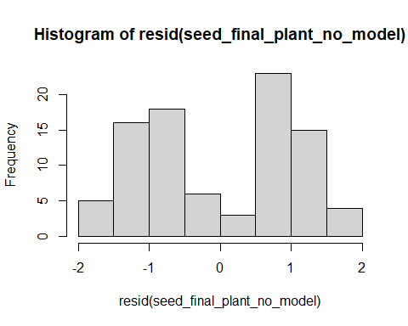

shapiro.test(resid(seed_final_plant_no_model))

##   
## Shapiro-Wilk normality test  
##   
## data: resid(seed_final_plant_no_model)  
## W = 0.92628, p-value = 7.527e-05

#7.527e-05  
plot(seed_final_plant_no_model)

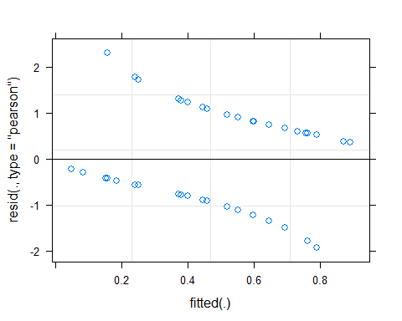

Raw Statistical output

Anova(seed_final_plant_no_model)

## Analysis of Deviance Table (Type II Wald chisquare tests)  
##   
## Response: final_plant_no  
## Chisq Df Pr(>Chisq)   
## precip 4.0955 1 0.042996 *   
## soil_root 11.8658 2 0.002651 **  
## precip:soil_root 1.4088 2 0.494401   
## ---  
## Signif. codes: 0 '***' 0.001 '**' 0.01 '*' 0.05 '.' 0.1 ' ' 1

emmeans(seed_final_plant_no_model, pairwise~soil_root)

## NOTE: Results may be misleading due to involvement in interactions

## $emmeans  
## soil_root emmean SE df asymp.LCL asymp.UCL  
## L.B 0.608 0.517 Inf -0.406 1.622  
## S.B -1.416 0.592 Inf -2.576 -0.256  
## L.R 0.689 0.543 Inf -0.376 1.753  
##   
## Results are averaged over the levels of: precip   
## Results are given on the logit (not the response) scale.   
## Confidence level used: 0.95   
##   
## $contrasts  
## contrast estimate SE df z.ratio p.value  
## L.B - S.B 2.0240 0.647 Inf 3.128 0.0050   
## L.B - L.R -0.0804 0.592 Inf -0.136 0.9899   
## S.B - L.R -2.1044 0.669 Inf -3.147 0.0047   
##   
## Results are averaged over the levels of: precip   
## Results are given on the log odds ratio (not the response) scale.   
## P value adjustment: tukey method for comparing a family of 3 estimates

emmeans(seed_final_plant_no_model, pairwise~soil_root|precip)

## $emmeans  
## precip = A:  
## soil_root emmean SE df asymp.LCL asymp.UCL  
## L.B 0.770 0.665 Inf -0.5336 2.073  
## S.B -0.782 0.664 Inf -2.0827 0.519  
## L.R 1.536 0.757 Inf 0.0527 3.019  
##   
## precip = D:  
## soil_root emmean SE df asymp.LCL asymp.UCL  
## L.B 0.447 0.645 Inf -0.8178 1.712  
## S.B -2.050 0.855 Inf -3.7255 -0.374  
## L.R -0.159 0.636 Inf -1.4057 1.088  
##   
## Results are given on the logit (not the response) scale.   
## Confidence level used: 0.95   
##   
## $contrasts  
## precip = A:  
## contrast estimate SE df z.ratio p.value  
## L.B - S.B 1.551 0.826 Inf 1.878 0.1452   
## L.B - L.R -0.766 0.890 Inf -0.861 0.6651   
## S.B - L.R -2.318 0.907 Inf -2.555 0.0286   
##   
## precip = D:  
## contrast estimate SE df z.ratio p.value  
## L.B - S.B 2.497 0.973 Inf 2.565 0.0279   
## L.B - L.R 0.606 0.783 Inf 0.773 0.7196   
## S.B - L.R -1.891 0.960 Inf -1.971 0.1195   
##   
## Results are given on the log odds ratio (not the response) scale.   
## P value adjustment: tukey method for comparing a family of 3 estimates

Formatted Anova table

Seedling pots

|  |  |  |  |
| --- | --- | --- | --- |
|  | Df | Chi.Sq | P.value |
| (Intercept) | 1 | 0.01 | 0.923 |
| precip | 1 | 4.51 | 0.034 |
| soil_root | 2 | 12.34 | 0.002 |
| precip:soil_root | 2 | 1.41 | 0.494 |
| Graph for publicati | on |  |  |
| [](MERDS_R_code_SG | _reAna | lysis_2020 | 0828_files/figure-docx/unnamed-chunk-29-1.png) |

### Presence Cummulative germination and survival

Diagnostic Graphs

data_SG_biomass_seed_surv_trt_pres=subset(data_SG_biomass_seed_surv_trt, root_association =="B")  
seed_final_plant_no_model_pres= glmer(final_plant_no~precip*soil_root+(1|block), data= data_SG_biomass_seed_surv_trt_pres, family="binomial")  
qqPlot(resid(seed_final_plant_no_model_pres))

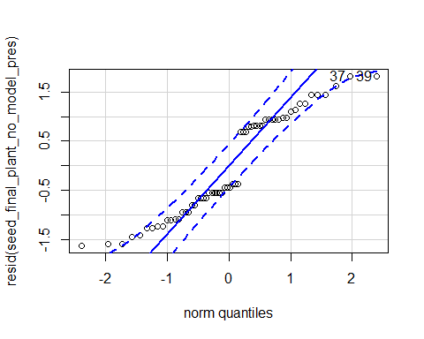

## 37 39   
## 22 24

hist(resid(seed_final_plant_no_model_pres))

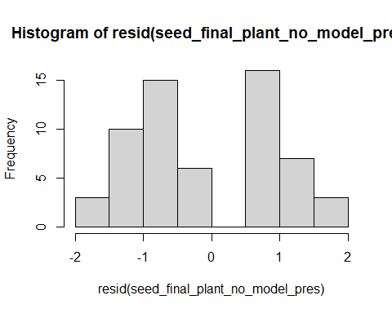

shapiro.test(resid(seed_final_plant_no_model_pres))

##   
## Shapiro-Wilk normality test  
##   
## data: resid(seed_final_plant_no_model_pres)  
## W = 0.9058, p-value = 0.0002155

#0.0002155  
plot(seed_final_plant_no_model_pres)

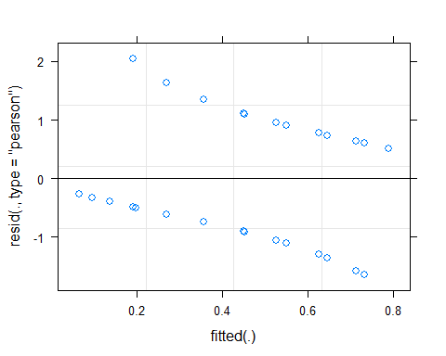

Raw Statistical output

Anova(seed_final_plant_no_model_pres, type=3)

## Analysis of Deviance Table (Type III Wald chisquare tests)  
##   
## Response: final_plant_no  
## Chisq Df Pr(>Chisq)   
## (Intercept) 0.8862 1 0.346504   
## precip 1.5576 1 0.212011   
## soil_root 9.2413 1 0.002366 **  
## precip:soil_root 0.5650 1 0.452261   
## ---  
## Signif. codes: 0 '***' 0.001 '**' 0.01 '*' 0.05 '.' 0.1 ' ' 1

emmeans(seed_final_plant_no_model_pres, pairwise~soil_root)

## NOTE: Results may be misleading due to involvement in interactions

## $emmeans  
## soil_root emmean SE df asymp.LCL asymp.UCL  
## L.B 0.597 0.485 Inf -0.354 1.547  
## S.B -1.380 0.567 Inf -2.492 -0.268  
##   
## Results are averaged over the levels of: precip   
## Results are given on the logit (not the response) scale.   
## Confidence level used: 0.95   
##   
## $contrasts  
## contrast estimate SE df z.ratio p.value  
## L.B - S.B 1.98 0.65 Inf 3.040 0.0024   
##   
## Results are averaged over the levels of: precip   
## Results are given on the log odds ratio (not the response) scale.

emmeans(seed_final_plant_no_model_pres, pairwise~soil_root|precip)

## $emmeans  
## precip = A:  
## soil_root emmean SE df asymp.LCL asymp.UCL  
## L.B 0.753 0.637 Inf -0.495 2.001  
## S.B -0.755 0.636 Inf -2.003 0.493  
##   
## precip = D:  
## soil_root emmean SE df asymp.LCL asymp.UCL  
## L.B 0.441 0.616 Inf -0.766 1.647  
## S.B -2.004 0.839 Inf -3.649 -0.359  
##   
## Results are given on the logit (not the response) scale.   
## Confidence level used: 0.95   
##   
## $contrasts  
## precip = A:  
## contrast estimate SE df z.ratio p.value  
## L.B - S.B 1.51 0.820 Inf 1.838 0.0661   
##   
## precip = D:  
## contrast estimate SE df z.ratio p.value  
## L.B - S.B 2.44 0.974 Inf 2.510 0.0121   
##   
## Results are given on the log odds ratio (not the response) scale.

Formatted Anova table

Presence Seedling pots

|  |  |  |  |
| --- | --- | --- | --- |
|  | Df | Chi.Sq | P.value |
| (Intercept) | 1 | 0.89 | 0.347 |
| precip | 1 | 1.56 | 0.212 |
| soil_root | 1 | 9.24 | 0.002 |
| precip:soil_root | 1 | 0.56 | 0.452 |

### Origin Cummulative germination and survival

Diagnostic Graphs

data_SG_biomass_seed_surv_trt_orig=subset(data_SG_biomass_seed_surv_trt, soil_status =="L")  
seed_final_plant_no_model_orig= glmer(final_plant_no~precip*soil_root+(1|block), data= data_SG_biomass_seed_surv_trt_orig, family="binomial")  
qqPlot(resid(seed_final_plant_no_model_orig))

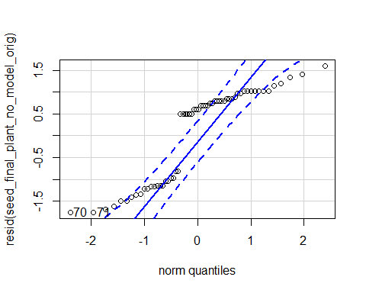

## 70 71   
## 55 56

hist(resid(seed_final_plant_no_model_orig))

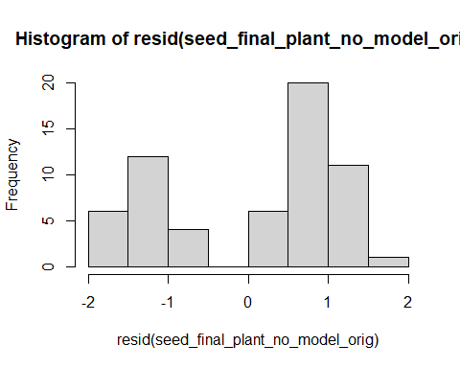

shapiro.test(resid(seed_final_plant_no_model_orig))

##   
## Shapiro-Wilk normality test  
##   
## data: resid(seed_final_plant_no_model_orig)  
## W = 0.828, p-value = 7.245e-07

#7.245e-07  
plot(seed_final_plant_no_model_orig)

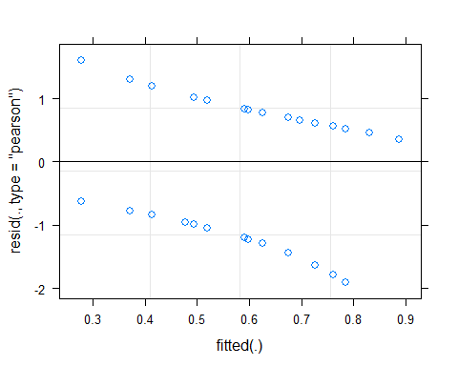

Raw Statistical output

Anova(seed_final_plant_no_model_orig, type=3)

## Analysis of Deviance Table (Type III Wald chisquare tests)  
##   
## Response: final_plant_no  
## Chisq Df Pr(>Chisq)   
## (Intercept) 2.2148 1 0.13669   
## precip 2.8189 1 0.09316 .  
## soil_root 0.0174 1 0.89494   
## precip:soil_root 1.3245 1 0.24978   
## ---  
## Signif. codes: 0 '***' 0.001 '**' 0.01 '*' 0.05 '.' 0.1 ' ' 1

emmeans(seed_final_plant_no_model_orig, pairwise~soil_root)

## NOTE: Results may be misleading due to involvement in interactions

## $emmeans  
## soil_root emmean SE df asymp.LCL asymp.UCL  
## L.B 0.612 0.514 Inf -0.396 1.62  
## L.R 0.690 0.540 Inf -0.368 1.75  
##   
## Results are averaged over the levels of: precip   
## Results are given on the logit (not the response) scale.   
## Confidence level used: 0.95   
##   
## $contrasts  
## contrast estimate SE df z.ratio p.value  
## L.B - L.R -0.0777 0.589 Inf -0.132 0.8949   
##   
## Results are averaged over the levels of: precip   
## Results are given on the log odds ratio (not the response) scale.

emmeans(seed_final_plant_no_model_orig, pairwise~soil_root|precip)

## $emmeans  
## precip = A:  
## soil_root emmean SE df asymp.LCL asymp.UCL  
## L.B 0.772 0.661 Inf -0.5242 2.07  
## L.R 1.532 0.754 Inf 0.0542 3.01  
##   
## precip = D:  
## soil_root emmean SE df asymp.LCL asymp.UCL  
## L.B 0.452 0.642 Inf -0.8058 1.71  
## L.R -0.152 0.633 Inf -1.3932 1.09  
##   
## Results are given on the logit (not the response) scale.   
## Confidence level used: 0.95   
##   
## $contrasts  
## precip = A:  
## contrast estimate SE df z.ratio p.value  
## L.B - L.R -0.759 0.884 Inf -0.859 0.3905   
##   
## precip = D:  
## contrast estimate SE df z.ratio p.value  
## L.B - L.R 0.604 0.783 Inf 0.772 0.4403   
##   
## Results are given on the log odds ratio (not the response) scale.

Formatted Anova table

Origin Seedling pots

|  |  |  |  |
| --- | --- | --- | --- |
|  | Df | Chi.Sq | P.value |
| (Intercept) | 1 | 2.21 | 0.137 |
| precip | 1 | 2.82 | 0.093 |
| soil_root | 1 | 0.02 | 0.895 |
| precip:soil_root | 1 | 1.32 | 0.250 |

## Survival given germination

### Full Statistical model

Diagnostic Graphs

seed_surv_germ_model= glmer(surv_germ~precip*soil_root+(1|block), data= fin_dataSG_biomass_seed_surv_trt_w_germ, family="binomial")  
qqPlot(resid(seed_surv_germ_model))

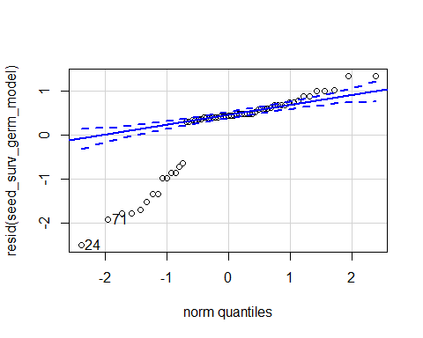

## 24 71   
## 14 47

hist(resid(seed_surv_germ_model))

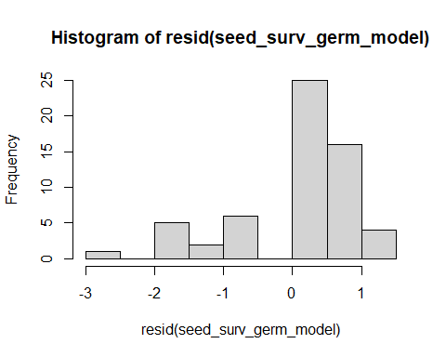

shapiro.test(resid(seed_surv_germ_model))

##   
## Shapiro-Wilk normality test  
##   
## data: resid(seed_surv_germ_model)  
## W = 0.79433, p-value = 1.174e-07

#1.174e-07  
plot(seed_surv_germ_model)

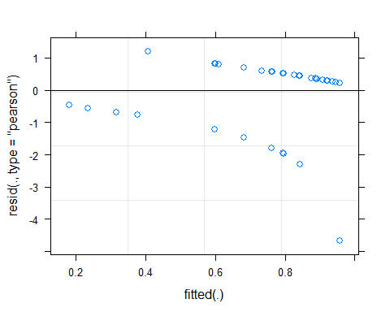

Raw Statistical output

Anova(seed_surv_germ_model, type=3)

## Analysis of Deviance Table (Type III Wald chisquare tests)  
##   
## Response: surv_germ  
## Chisq Df Pr(>Chisq)   
## (Intercept) 4.6354 1 0.03132 *  
## precip 0.0623 1 0.80290   
## soil_root 7.0596 2 0.02931 *  
## precip:soil_root 2.3638 2 0.30669   
## ---  
## Signif. codes: 0 '***' 0.001 '**' 0.01 '*' 0.05 '.' 0.1 ' ' 1

#soil_root 9.8880 2 0.007126 **  
#soil_root 7.0596 2 0.02931 *  
#precip:soil_root 4.3070 2 0.116077   
emmeans(seed_surv_germ_model, pairwise~soil_root)

## NOTE: Results may be misleading due to involvement in interactions

## $emmeans  
## soil_root emmean SE df asymp.LCL asymp.UCL  
## L.B 1.946 0.813 Inf 0.353 3.54  
## S.B -0.243 0.746 Inf -1.705 1.22  
## L.R 2.015 0.850 Inf 0.350 3.68  
##   
## Results are averaged over the levels of: precip   
## Results are given on the logit (not the response) scale.   
## Confidence level used: 0.95   
##   
## $contrasts  
## contrast estimate SE df z.ratio p.value  
## L.B - S.B 2.1897 0.942 Inf 2.324 0.0526   
## L.B - L.R -0.0682 0.977 Inf -0.070 0.9973   
## S.B - L.R -2.2579 0.996 Inf -2.266 0.0606   
##   
## Results are averaged over the levels of: precip   
## Results are given on the log odds ratio (not the response) scale.   
## P value adjustment: tukey method for comparing a family of 3 estimates

emmeans(seed_surv_germ_model, pairwise~soil_root|precip)

## $emmeans  
## precip = A:  
## soil_root emmean SE df asymp.LCL asymp.UCL  
## L.B 1.644 0.928 Inf -0.1741 3.462  
## S.B 0.731 0.929 Inf -1.0904 2.552  
## L.R 1.629 0.846 Inf -0.0287 3.287  
##   
## precip = D:  
## soil_root emmean SE df asymp.LCL asymp.UCL  
## L.B 2.249 1.187 Inf -0.0779 4.576  
## S.B -1.217 1.087 Inf -3.3480 0.913  
## L.R 2.400 1.270 Inf -0.0886 4.888  
##   
## Results are given on the logit (not the response) scale.   
## Confidence level used: 0.95   
##   
## $contrasts  
## precip = A:  
## contrast estimate SE df z.ratio p.value  
## L.B - S.B 0.9133 1.16 Inf 0.787 0.7110   
## L.B - L.R 0.0146 1.08 Inf 0.013 0.9999   
## S.B - L.R -0.8987 1.06 Inf -0.845 0.6748   
##   
## precip = D:  
## contrast estimate SE df z.ratio p.value  
## L.B - S.B 3.4662 1.53 Inf 2.259 0.0617   
## L.B - L.R -0.1510 1.59 Inf -0.095 0.9951   
## S.B - L.R -3.6172 1.67 Inf -2.168 0.0767   
##   
## Results are given on the log odds ratio (not the response) scale.   
## P value adjustment: tukey method for comparing a family of 3 estimates

Formatted Anova table

Survival given germination

|  |  |  |  |
| --- | --- | --- | --- |
|  | Df | Chi.Sq | P.value |
| (Intercept) | 1 | 4.64 | 0.031 |
| precip | 1 | 0.06 | 0.803 |
| soil_root | 2 | 7.06 | 0.029 |
| precip:soil_root | 2 | 2.36 | 0.307 |
| Graph for publicati | on |  |  |
| [](MERDS_R_code_SG | _reAna | lysis_2020 | 0828_files/figure-docx/unnamed-chunk-40-1.png) |

### Presence survival given germination

Diagnostic Graphs

fin_dataSG_biomass_seed_surv_pres_w_germ=subset(fin_dataSG_biomass_seed_surv_trt_w_germ, root_association =="B")  
seed_surv_germ_model_pres= glmer(surv_germ~precip*soil_root+(1|block), data= fin_dataSG_biomass_seed_surv_pres_w_germ, family="binomial")

## boundary (singular) fit: see ?isSingular

qqPlot(resid(seed_surv_germ_model_pres))

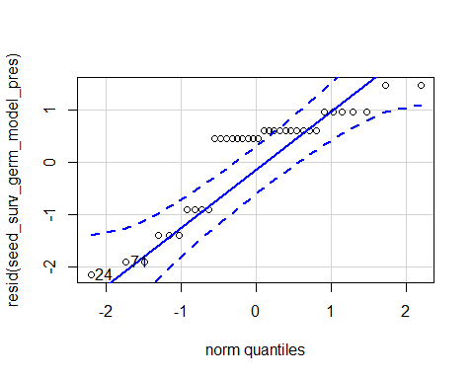

## 24 71   
## 6 24

hist(resid(seed_surv_germ_model_pres))

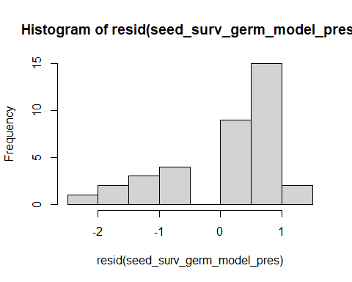

shapiro.test(resid(seed_surv_germ_model_pres))

##   
## Shapiro-Wilk normality test  
##   
## data: resid(seed_surv_germ_model_pres)  
## W = 0.81516, p-value = 3.305e-05

#3.305e-05  
plot(seed_surv_germ_model_pres)

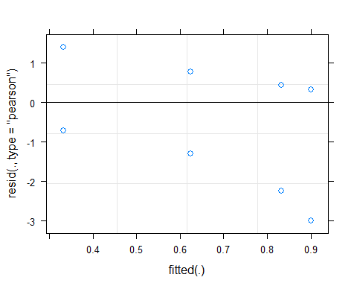

Raw Statistical output

Anova(seed_surv_germ_model_pres, type=3)

## Analysis of Deviance Table (Type III Wald chisquare tests)  
##   
## Response: surv_germ  
## Chisq Df Pr(>Chisq)   
## (Intercept) 4.3867 1 0.03622 *  
## precip 0.1268 1 0.72178   
## soil_root 5.3138 1 0.02116 *  
## precip:soil_root 1.0721 1 0.30047   
## ---  
## Signif. codes: 0 '***' 0.001 '**' 0.01 '*' 0.05 '.' 0.1 ' ' 1

emmeans(seed_surv_germ_model_pres, pairwise~soil_root)

## NOTE: Results may be misleading due to involvement in interactions

## $emmeans  
## soil_root emmean SE df asymp.LCL asymp.UCL  
## L.B 1.9033 0.654 Inf 0.621 3.19  
## S.B -0.0912 0.566 Inf -1.201 1.02  
##   
## Results are averaged over the levels of: precip   
## Results are given on the logit (not the response) scale.   
## Confidence level used: 0.95   
##   
## $contrasts  
## contrast estimate SE df z.ratio p.value  
## L.B - S.B 1.99 0.865 Inf 2.305 0.0212   
##   
## Results are averaged over the levels of: precip   
## Results are given on the log odds ratio (not the response) scale.

emmeans(seed_surv_germ_model_pres, pairwise~soil_root|precip)

## $emmeans  
## precip = A:  
## soil_root emmean SE df asymp.LCL asymp.UCL  
## L.B 1.609 0.775 Inf 0.0913 3.13  
## S.B 0.511 0.730 Inf -0.9205 1.94  
##   
## precip = D:  
## soil_root emmean SE df asymp.LCL asymp.UCL  
## L.B 2.197 1.054 Inf 0.1312 4.26  
## S.B -0.693 0.866 Inf -2.3905 1.00  
##   
## Results are given on the logit (not the response) scale.   
## Confidence level used: 0.95   
##   
## $contrasts  
## precip = A:  
## contrast estimate SE df z.ratio p.value  
## L.B - S.B 1.10 1.06 Inf 1.032 0.3021   
##   
## precip = D:  
## contrast estimate SE df z.ratio p.value  
## L.B - S.B 2.89 1.36 Inf 2.119 0.0341   
##   
## Results are given on the log odds ratio (not the response) scale.

Formatted Anova table

Survival given germination

|  |  |  |  |
| --- | --- | --- | --- |
|  | Df | Chi.Sq | P.value |
| (Intercept) | 1 | 4.39 | 0.036 |
| precip | 1 | 0.13 | 0.722 |
| soil_root | 1 | 5.31 | 0.021 |
| precip:soil_root | 1 | 1.07 | 0.300 |

### Origin survival given germination

Diagnostic Graphs

fin_dataSG_biomass_seed_surv_orig_w_germ=subset(fin_dataSG_biomass_seed_surv_trt_w_germ, soil_status =="L")  
seed_surv_germ_model_orig= glmer(surv_germ~precip*soil_root+(1|block), data= fin_dataSG_biomass_seed_surv_orig_w_germ, family="binomial")  
qqPlot(resid(seed_surv_germ_model_orig))

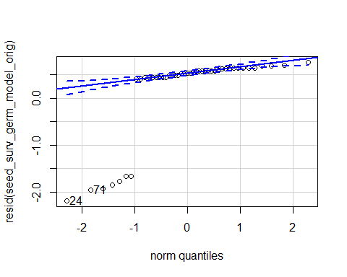

## 24 71   
## 14 41

hist(resid(seed_surv_germ_model_orig))

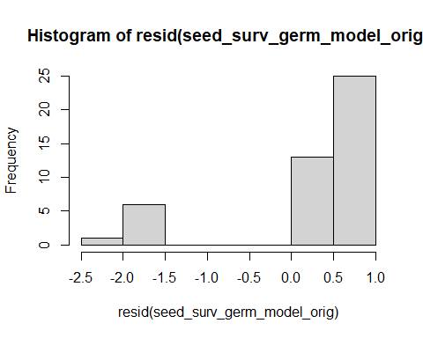

shapiro.test(resid(seed_surv_germ_model_orig))

##   
## Shapiro-Wilk normality test  
##   
## data: resid(seed_surv_germ_model_orig)  
## W = 0.54238, p-value = 1.23e-10

#1.23e-10  
plot(seed_surv_germ_model_orig)

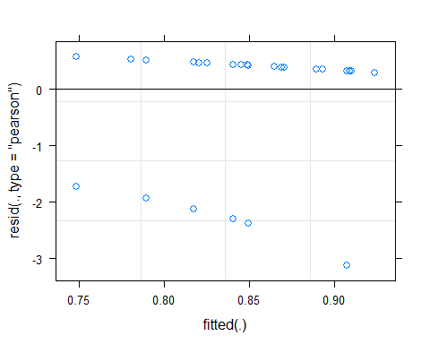

Raw Statistical output

Anova(seed_surv_germ_model_orig, type=3)

## Analysis of Deviance Table (Type III Wald chisquare tests)  
##   
## Response: surv_germ  
## Chisq Df Pr(>Chisq)   
## (Intercept) 11.8503 1 0.0005765 ***  
## precip 0.3965 1 0.5288941   
## soil_root 0.0390 1 0.8433818   
## precip:soil_root 0.0001 1 0.9942924   
## ---  
## Signif. codes: 0 '***' 0.001 '**' 0.01 '*' 0.05 '.' 0.1 ' ' 1

emmeans(seed_surv_germ_model_orig, pairwise~soil_root)

## NOTE: Results may be misleading due to involvement in interactions

## $emmeans  
## soil_root emmean SE df asymp.LCL asymp.UCL  
## L.B 1.92 0.700 Inf 0.551 3.30  
## L.R 1.74 0.714 Inf 0.341 3.14  
##   
## Results are averaged over the levels of: precip   
## Results are given on the logit (not the response) scale.   
## Confidence level used: 0.95   
##   
## $contrasts  
## contrast estimate SE df z.ratio p.value  
## L.B - L.R 0.184 0.931 Inf 0.198 0.8434   
##   
## Results are averaged over the levels of: precip   
## Results are given on the log odds ratio (not the response) scale.

emmeans(seed_surv_germ_model_orig, pairwise~soil_root|precip)

## $emmeans  
## precip = A:  
## soil_root emmean SE df asymp.LCL asymp.UCL  
## L.B 1.63 0.819 Inf 0.0263 3.24  
## L.R 1.45 0.724 Inf 0.0350 2.87  
##   
## precip = D:  
## soil_root emmean SE df asymp.LCL asymp.UCL  
## L.B 2.22 1.086 Inf 0.0865 4.34  
## L.R 2.03 1.139 Inf -0.2070 4.26  
##   
## Results are given on the logit (not the response) scale.   
## Confidence level used: 0.95   
##   
## $contrasts  
## precip = A:  
## contrast estimate SE df z.ratio p.value  
## L.B - L.R 0.177 1.03 Inf 0.172 0.8634   
##   
## precip = D:  
## contrast estimate SE df z.ratio p.value  
## L.B - L.R 0.190 1.53 Inf 0.125 0.9009   
##   
## Results are given on the log odds ratio (not the response) scale.

Formatted Anova table

Survival given germination

|  |  |  |  |
| --- | --- | --- | --- |
|  | Df | Chi.Sq | P.value |
| (Intercept) | 1 | 11.85 | 0.001 |
| precip | 1 | 0.40 | 0.529 |
| soil_root | 1 | 0.04 | 0.843 |
| precip:soil_root | 1 | 0.00 | 0.994 |

## Biomass given germination

Diagnostic Graphs

seed_biomas_model= lmer(log(total_biomass)~precip*soil_root+(1|block), data= fin_dataSG_biomass_seed_surv_trt_given_germ)

## boundary (singular) fit: see ?isSingular

qqPlot(resid(seed_biomas_model))

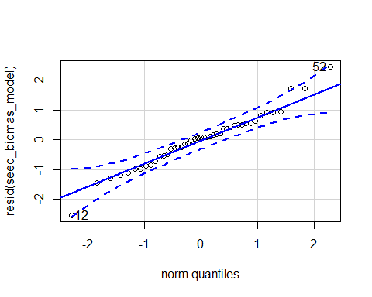

## 12 52   
## 6 23

hist(resid(seed_biomas_model))

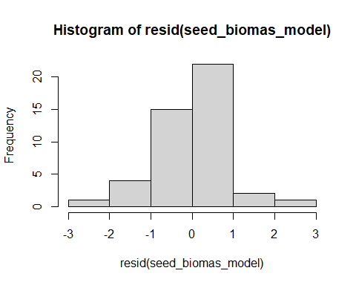

shapiro.test(resid(seed_biomas_model))

##   
## Shapiro-Wilk normality test  
##   
## data: resid(seed_biomas_model)  
## W = 0.9757, p-value = 0.457

#p-value = 0.457

Raw Statistical output

anova(seed_biomas_model)

## Type III Analysis of Variance Table with Satterthwaite's method  
## Sum Sq Mean Sq NumDF DenDF F value Pr(>F)   
## precip 0.7614 0.7614 1 39 0.8395 0.3651603   
## soil_root 7.2196 3.6098 2 39 3.9802 0.0267300 *   
## precip:soil_root 18.1525 9.0763 2 39 10.0075 0.0003104 ***  
## ---  
## Signif. codes: 0 '***' 0.001 '**' 0.01 '*' 0.05 '.' 0.1 ' ' 1

emmeans(seed_biomas_model, pairwise~soil_root)

## NOTE: Results may be misleading due to involvement in interactions

## $emmeans  
## soil_root emmean SE df lower.CL upper.CL  
## L.B -3.03 0.222 14.6 -3.51 -2.555  
## S.B -1.76 0.427 28.4 -2.63 -0.885  
## L.R -2.85 0.237 14.2 -3.36 -2.342  
##   
## Results are averaged over the levels of: precip   
## Degrees-of-freedom method: kenward-roger   
## Results are given on the log (not the response) scale.   
## Confidence level used: 0.95   
##   
## $contrasts  
## contrast estimate SE df t.ratio p.value  
## L.B - S.B -1.271 0.475 38.9 -2.677 0.0285   
## L.B - L.R -0.181 0.322 37.5 -0.563 0.8404   
## S.B - L.R 1.089 0.495 38.0 2.201 0.0839   
##   
## Results are averaged over the levels of: precip   
## Degrees-of-freedom method: kenward-roger   
## Results are given on the log (not the response) scale.   
## P value adjustment: tukey method for comparing a family of 3 estimates

emmeans(seed_biomas_model, pairwise~soil_root|precip)

## $emmeans  
## precip = A:  
## soil_root emmean SE df lower.CL upper.CL  
## L.B -2.639 0.309 28.4 -3.27 -2.01  
## S.B -3.184 0.435 37.2 -4.07 -2.30  
## L.R -2.281 0.278 25.8 -2.85 -1.71  
##   
## precip = D:  
## soil_root emmean SE df lower.CL upper.CL  
## L.B -3.421 0.323 31.2 -4.08 -2.76  
## S.B -0.335 0.740 32.3 -1.84 1.17  
## L.R -3.417 0.379 30.9 -4.19 -2.64  
##   
## Degrees-of-freedom method: kenward-roger   
## Results are given on the log (not the response) scale.   
## Confidence level used: 0.95   
##   
## $contrasts  
## precip = A:  
## contrast estimate SE df t.ratio p.value  
## L.B - S.B 0.54492 0.538 38.0 1.014 0.5729   
## L.B - L.R -0.35848 0.413 36.5 -0.868 0.6635   
## S.B - L.R -0.90339 0.511 36.3 -1.767 0.1951   
##   
## precip = D:  
## contrast estimate SE df t.ratio p.value  
## L.B - S.B -3.08610 0.807 37.8 -3.822 0.0014   
## L.B - L.R -0.00398 0.488 37.1 -0.008 1.0000   
## S.B - L.R 3.08212 0.863 32.0 3.572 0.0032   
##   
## Degrees-of-freedom method: kenward-roger   
## Results are given on the log (not the response) scale.   
## P value adjustment: tukey method for comparing a family of 3 estimates

Formatted Anova table

Total biomass given germination

|  |  |  |  |  |
| --- | --- | --- | --- | --- |
|  | Df | Resid.Df | F.value | P.value |
| precip | 1 | 39 | 0.84 | 0.365 |
| soil_root | 2 | 39 | 3.98 | 0.027 |
| precip:soil_root | 2 | 39 | 10.01 | 0.000 |
| Graph for publicati | on |  |  |  |
| [](MERDS_R_code_SG | _reAna | lysis_202008 | 28_files/fi | gure-docx/unnamed-chunk-51-1.png) |

### Presence total biomass of germinate

Diagnostic Graphs

fin_dataSG_biomass_seed_surv_pres_w_germ=subset(fin_dataSG_biomass_seed_surv_trt_given_germ, root_association =="B")  
nrow(fin_dataSG_biomass_seed_surv_pres_w_germ)

## [1] 26

#26  
unique(fin_dataSG_biomass_seed_surv_pres_w_germ$soil_root)

## [1] L.B S.B  
## Levels: L.B S.B L.R S.R

seed_biomas_model_pres= lmer((total_biomass)~precip*soil_root+(1|block), data= fin_dataSG_biomass_seed_surv_pres_w_germ)

## boundary (singular) fit: see ?isSingular

qqPlot(resid(seed_biomas_model_pres))

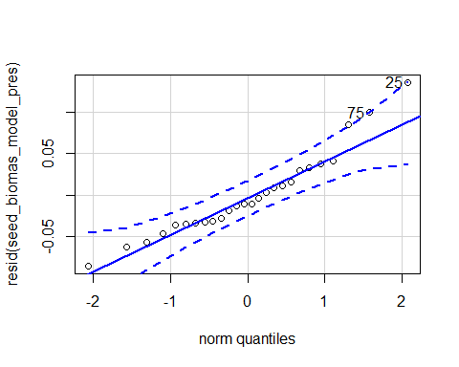

## 25 75   
## 6 21

hist(resid(seed_biomas_model_pres))

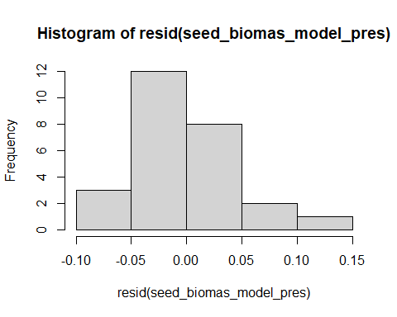

shapiro.test(resid(seed_biomas_model_pres))

##   
## Shapiro-Wilk normality test  
##   
## data: resid(seed_biomas_model_pres)  
## W = 0.93832, p-value = 0.1224

#p-value = 0.1224

Raw Statistical output

anova(seed_biomas_model_pres)

## Type III Analysis of Variance Table with Satterthwaite's method  
## Sum Sq Mean Sq NumDF DenDF F value Pr(>F)   
## precip 0.43448 0.43448 1 22 147.58 3.139e-11 ***  
## soil_root 0.44799 0.44799 1 22 152.17 2.336e-11 ***  
## precip:soil_root 0.55107 0.55107 1 22 187.19 3.080e-12 ***  
## ---  
## Signif. codes: 0 '***' 0.001 '**' 0.01 '*' 0.05 '.' 0.1 ' ' 1

emmeans(seed_biomas_model_pres, pairwise~soil_root)

## NOTE: Results may be misleading due to involvement in interactions

## Note: Use 'contrast(regrid(object), ...)' to obtain contrasts of back-transformed estimates

## $emmeans  
## soil_root emmean SE df lower.CL upper.CL  
## L.B 0.0664 0.0129 5.22 0.0338 0.099  
## S.B 0.3859 0.0262 12.75 0.3291 0.443  
##   
## Results are averaged over the levels of: precip   
## Degrees-of-freedom method: kenward-roger   
## Results are given on the ( (not the response) scale.   
## Confidence level used: 0.95   
##   
## $contrasts  
## contrast estimate SE df t.ratio p.value  
## L.B - S.B -0.319 0.0284 21.9 -11.252 <.0001   
##   
## Results are averaged over the levels of: precip   
## Note: contrasts are still on the ( scale   
## Degrees-of-freedom method: kenward-roger

emmeans(seed_biomas_model_pres, pairwise~soil_root|precip)

## Note: Use 'contrast(regrid(object), ...)' to obtain contrasts of back-transformed estimates

## $emmeans  
## precip = A:  
## soil_root emmean SE df lower.CL upper.CL  
## L.B 0.0863 0.0180 12.8 0.047359 0.1252  
## S.B 0.0514 0.0251 20.1 -0.000969 0.1038  
##   
## precip = D:  
## soil_root emmean SE df lower.CL upper.CL  
## L.B 0.0466 0.0187 14.8 0.006715 0.0864  
## S.B 0.7203 0.0466 15.7 0.621443 0.8192  
##   
## Degrees-of-freedom method: kenward-roger   
## Results are given on the ( (not the response) scale.   
## Confidence level used: 0.95   
##   
## $contrasts  
## precip = A:  
## contrast estimate SE df t.ratio p.value  
## L.B - S.B 0.0348 0.0313 20.9 1.114 0.2780   
##   
## precip = D:  
## contrast estimate SE df t.ratio p.value  
## L.B - S.B -0.6737 0.0501 20.7 -13.448 <.0001   
##   
## Note: contrasts are still on the ( scale   
## Degrees-of-freedom method: kenward-roger

Formatted Anova table

Total biomass given germination

|  |  |  |  |  |
| --- | --- | --- | --- | --- |
|  | Df | Resid.Df | F.value | P.value |
| precip | 1 | 22 | 147.58 | 0 |
| soil_root | 1 | 22 | 152.17 | 0 |
| precip:soil_root | 1 | 22 | 187.19 | 0 |
| ### Origin total bi | omass | of germinate | d |  |

Diagnostic Graphs

fin_dataSG_biomass_seed_surv_orig_w_germ=subset(fin_dataSG_biomass_seed_surv_trt_given_germ, soil_status =="L")  
nrow(fin_dataSG_biomass_seed_surv_orig_w_germ)

## [1] 38

#38  
unique(fin_dataSG_biomass_seed_surv_orig_w_germ$soil_root)

## [1] L.R L.B  
## Levels: L.B S.B L.R S.R

seed_biomas_model_orig= lmer(log(total_biomass)~precip*soil_root+(1|block), data= fin_dataSG_biomass_seed_surv_orig_w_germ)

## boundary (singular) fit: see ?isSingular

qqPlot(resid(seed_biomas_model_orig))

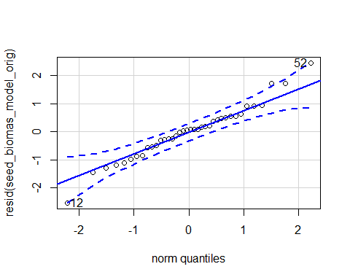

## 12 52   
## 6 21

hist(resid(seed_biomas_model_orig))

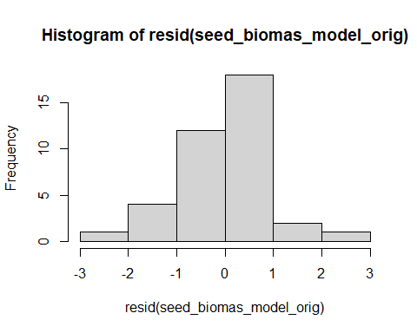

shapiro.test(resid(seed_biomas_model_orig))

##   
## Shapiro-Wilk normality test  
##   
## data: resid(seed_biomas_model_orig)  
## W = 0.97636, p-value = 0.5891

#p-value = 0.5891

Raw Statistical output

anova(seed_biomas_model_orig)

## Type III Analysis of Variance Table with Satterthwaite's method  
## Sum Sq Mean Sq NumDF DenDF F value Pr(>F)   
## precip 8.4164 8.4164 1 34 8.7072 0.005705 **  
## soil_root 0.3004 0.3004 1 34 0.3108 0.580839   
## precip:soil_root 0.2874 0.2874 1 34 0.2973 0.589143   
## ---  
## Signif. codes: 0 '***' 0.001 '**' 0.01 '*' 0.05 '.' 0.1 ' ' 1

emmeans(seed_biomas_model_orig, pairwise~soil_root)

## NOTE: Results may be misleading due to involvement in interactions

## $emmeans  
## soil_root emmean SE df lower.CL upper.CL  
## L.B -3.03 0.230 11.8 -3.53 -2.53  
## L.R -2.85 0.246 11.4 -3.39 -2.31  
##   
## Results are averaged over the levels of: precip   
## Degrees-of-freedom method: kenward-roger   
## Results are given on the log (not the response) scale.   
## Confidence level used: 0.95   
##   
## $contrasts  
## contrast estimate SE df t.ratio p.value  
## L.B - L.R -0.181 0.333 32.4 -0.544 0.5901   
##   
## Results are averaged over the levels of: precip   
## Degrees-of-freedom method: kenward-roger   
## Results are given on the log (not the response) scale.

emmeans(seed_biomas_model_orig, pairwise~soil_root|precip)

## $emmeans  
## precip = A:  
## soil_root emmean SE df lower.CL upper.CL  
## L.B -2.64 0.320 24.0 -3.30 -1.98  
## L.R -2.28 0.288 21.6 -2.88 -1.68  
##   
## precip = D:  
## soil_root emmean SE df lower.CL upper.CL  
## L.B -3.42 0.335 26.6 -4.11 -2.73  
## L.R -3.42 0.393 26.3 -4.23 -2.61  
##   
## Degrees-of-freedom method: kenward-roger   
## Results are given on the log (not the response) scale.   
## Confidence level used: 0.95   
##   
## $contrasts  
## precip = A:  
## contrast estimate SE df t.ratio p.value  
## L.B - L.R -0.35848 0.427 31.4 -0.840 0.4074   
##   
## precip = D:  
## contrast estimate SE df t.ratio p.value  
## L.B - L.R -0.00398 0.505 32.1 -0.008 0.9938   
##   
## Degrees-of-freedom method: kenward-roger   
## Results are given on the log (not the response) scale.

Formatted Anova table

Total biomass given germination

|  |  |  |  |  |
| --- | --- | --- | --- | --- |
|  | Df | Resid.Df | F.value | P.value |
| precip | 1 | 34 | 8.71 | 0.006 |
| soil_root | 1 | 34 | 0.31 | 0.581 |
| precip:soil_root | 1 | 34 | 0.30 | 0.589 |

####Total final biomass across plots

|  |  |  |
| --- | --- | --- |
| precip | soil_root | total_biomass |
| A | L.B | 0.8627 |
| A | S.B | 0.2571 |
| A | L.R | 2.5588 |
| D | L.B | 0.4191 |
| D | S.B | 1.4406 |
| D | L.R | 0.3327 |

### Root:shoot ratio given germination

Diagnostic Graphs

#now root:shoot ratio  
fin_dataSG_biomass_seed_surv_trt_given_germ$root_shoot=fin_dataSG_biomass_seed_surv_trt_given_germ$root_weight_g/fin_dataSG_biomass_seed_surv_trt_given_germ$shoot_weight_g  
  
root_shoot_seed_model= lmer(log(root_shoot)~precip*soil_root+(1|block), data= fin_dataSG_biomass_seed_surv_trt_given_germ)  
qqPlot(resid(root_shoot_seed_model))

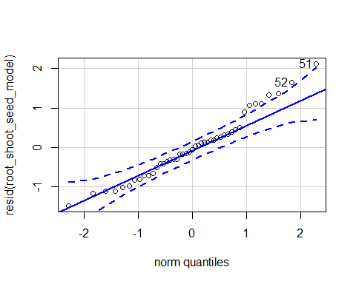

## 51 52   
## 22 23

hist(resid(root_shoot_seed_model))

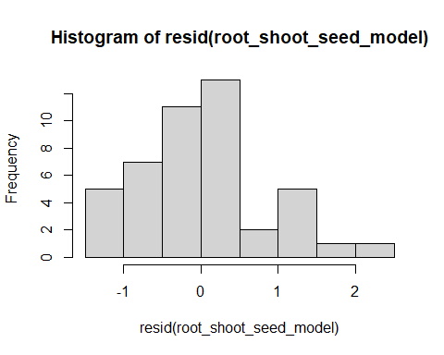

shapiro.test(resid(root_shoot_seed_model))

##   
## Shapiro-Wilk normality test  
##   
## data: resid(root_shoot_seed_model)  
## W = 0.97031, p-value = 0.2972

#0.2972

Raw Statistical output

anova(root_shoot_seed_model, type=3)

## Type III Analysis of Variance Table with Satterthwaite's method  
## Sum Sq Mean Sq NumDF DenDF F value Pr(>F)   
## precip 6.3079 6.3079 1 37.122 8.3663 0.006359 **  
## soil_root 1.4238 0.7119 2 37.992 0.9442 0.397931   
## precip:soil_root 3.9101 1.9550 2 38.417 2.5930 0.087835 .   
## ---  
## Signif. codes: 0 '***' 0.001 '**' 0.01 '*' 0.05 '.' 0.1 ' ' 1

emmeans(root_shoot_seed_model, pairwise~soil_root)

## NOTE: Results may be misleading due to involvement in interactions

## $emmeans  
## soil_root emmean SE df lower.CL upper.CL  
## L.B 2.06 0.229 10.5 1.55 2.57  
## S.B 2.56 0.406 28.2 1.73 3.39  
## L.R 2.35 0.240 11.1 1.83 2.88  
##   
## Results are averaged over the levels of: precip   
## Degrees-of-freedom method: kenward-roger   
## Results are given on the log (not the response) scale.   
## Confidence level used: 0.95   
##   
## $contrasts  
## contrast estimate SE df t.ratio p.value  
## L.B - S.B -0.504 0.432 38.0 -1.165 0.4808   
## L.B - L.R -0.293 0.293 36.5 -1.002 0.5802   
## S.B - L.R 0.211 0.451 39.0 0.467 0.8869   
##   
## Results are averaged over the levels of: precip   
## Degrees-of-freedom method: kenward-roger   
## Results are given on the log (not the response) scale.   
## P value adjustment: tukey method for comparing a family of 3 estimates

emmeans(root_shoot_seed_model, pairwise~soil_root|precip)

## $emmeans  
## precip = A:  
## soil_root emmean SE df lower.CL upper.CL  
## L.B 2.00 0.300 22.1 1.382 2.63  
## S.B 1.54 0.412 34.2 0.701 2.37  
## L.R 2.08 0.276 18.5 1.506 2.66  
##   
## precip = D:  
## soil_root emmean SE df lower.CL upper.CL  
## L.B 2.11 0.313 24.7 1.469 2.76  
## S.B 3.59 0.683 36.3 2.203 4.97  
## L.R 2.62 0.359 28.2 1.887 3.36  
##   
## Degrees-of-freedom method: kenward-roger   
## Results are given on the log (not the response) scale.   
## Confidence level used: 0.95   
##   
## $contrasts  
## precip = A:  
## contrast estimate SE df t.ratio p.value  
## L.B - S.B 0.4664 0.487 36.8 0.957 0.6082   
## L.B - L.R -0.0791 0.375 35.8 -0.211 0.9758   
## S.B - L.R -0.5455 0.466 35.8 -1.171 0.4779   
##   
## precip = D:  
## contrast estimate SE df t.ratio p.value  
## L.B - S.B -1.4742 0.734 39.0 -2.010 0.1233   
## L.B - L.R -0.5076 0.445 36.4 -1.141 0.4954   
## S.B - L.R 0.9666 0.783 38.4 1.235 0.4403   
##   
## Degrees-of-freedom method: kenward-roger   
## Results are given on the log (not the response) scale.   
## P value adjustment: tukey method for comparing a family of 3 estimates

Formatted Anova table

Days to germination

|  |  |  |  |  |
| --- | --- | --- | --- | --- |
|  | Df | Resid.Df | F.value | P.value |
| precip | 1 | 37.12 | 8.37 | 0.006 |
| soil_root | 2 | 37.99 | 0.94 | 0.398 |
| precip:soil_root | 2 | 38.42 | 2.59 | 0.088 |

Graph for publication 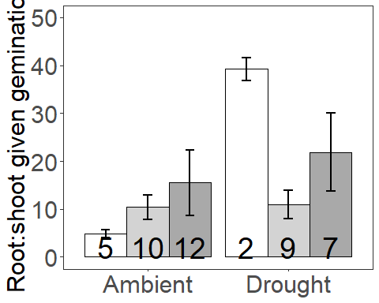

### Presence Root:shoot ratio given germination

Diagnostic Graphs

#now root:shoot ratio  
fin_dataSG_biomass_seed_surv_pres_w_germ=subset(fin_dataSG_biomass_seed_surv_trt_given_germ, root_association =="B")  
  
root_shoot_seed_model_pres= lmer(log(root_shoot)~precip*soil_root+(1|block), data= fin_dataSG_biomass_seed_surv_pres_w_germ)

## boundary (singular) fit: see ?isSingular

qqPlot(resid(root_shoot_seed_model_pres))

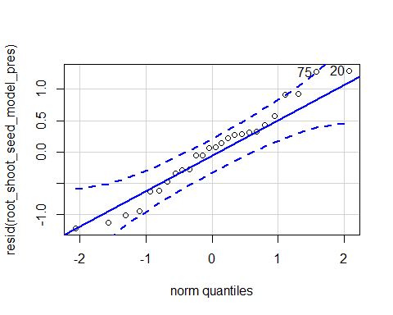

## 20 75   
## 2 21

hist(resid(root_shoot_seed_model_pres))

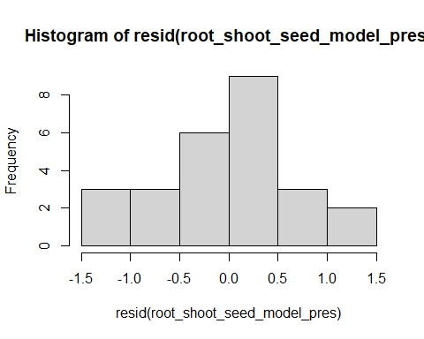

shapiro.test(resid(root_shoot_seed_model_pres))

##   
## Shapiro-Wilk normality test  
##   
## data: resid(root_shoot_seed_model_pres)  
## W = 0.97141, p-value = 0.6602

#0.6602

Raw Statistical output

anova(root_shoot_seed_model_pres, type=3)

## Type III Analysis of Variance Table with Satterthwaite's method  
## Sum Sq Mean Sq NumDF DenDF F value Pr(>F)   
## precip 5.2766 5.2766 1 22 9.7046 0.005042 **  
## soil_root 1.1572 1.1572 1 22 2.1283 0.158731   
## precip:soil_root 4.8231 4.8231 1 22 8.8704 0.006934 **  
## ---  
## Signif. codes: 0 '***' 0.001 '**' 0.01 '*' 0.05 '.' 0.1 ' ' 1

emmeans(root_shoot_seed_model_pres, pairwise~soil_root)

## NOTE: Results may be misleading due to involvement in interactions

## $emmeans  
## soil_root emmean SE df lower.CL upper.CL  
## L.B 2.08 0.175 5.22 1.64 2.52  
## S.B 2.59 0.356 12.75 1.82 3.37  
##   
## Results are averaged over the levels of: precip   
## Degrees-of-freedom method: kenward-roger   
## Results are given on the log (not the response) scale.   
## Confidence level used: 0.95   
##   
## $contrasts  
## contrast estimate SE df t.ratio p.value  
## L.B - S.B -0.513 0.386 21.9 -1.331 0.1970   
##   
## Results are averaged over the levels of: precip   
## Degrees-of-freedom method: kenward-roger   
## Results are given on the log (not the response) scale.

emmeans(root_shoot_seed_model_pres, pairwise~soil_root|precip)

## $emmeans  
## precip = A:  
## soil_root emmean SE df lower.CL upper.CL  
## L.B 2.06 0.244 12.8 1.529 2.59  
## S.B 1.52 0.341 20.1 0.811 2.23  
##   
## precip = D:  
## soil_root emmean SE df lower.CL upper.CL  
## L.B 2.11 0.254 14.8 1.564 2.65  
## S.B 3.67 0.633 15.7 2.324 5.01  
##   
## Degrees-of-freedom method: kenward-roger   
## Results are given on the log (not the response) scale.   
## Confidence level used: 0.95   
##   
## $contrasts  
## precip = A:  
## contrast estimate SE df t.ratio p.value  
## L.B - S.B 0.535 0.425 20.9 1.258 0.2224   
##   
## precip = D:  
## contrast estimate SE df t.ratio p.value  
## L.B - S.B -1.562 0.681 20.7 -2.294 0.0324   
##   
## Degrees-of-freedom method: kenward-roger   
## Results are given on the log (not the response) scale.

Formatted Anova table

Root:Shoot given germination

|  |  |  |  |  |
| --- | --- | --- | --- | --- |
|  | Df | Resid.Df | F.value | P.value |
| precip | 1 | 22 | 9.70 | 0.005 |
| soil_root | 1 | 22 | 2.13 | 0.159 |
| precip:soil_root | 1 | 22 | 8.87 | 0.007 |
| ### Origin Root:sho | ot rat | io given ger | mination |  |

Diagnostic Graphs

#now root:shoot ratio  
fin_dataSG_biomass_seed_surv_orig_w_germ=subset(fin_dataSG_biomass_seed_surv_trt_given_germ, soil_status =="L")  
  
root_shoot_seed_model_orig= lmer(log(root_shoot)~precip*soil_root+(1|block), data= fin_dataSG_biomass_seed_surv_orig_w_germ)  
qqPlot(resid(root_shoot_seed_model_orig))

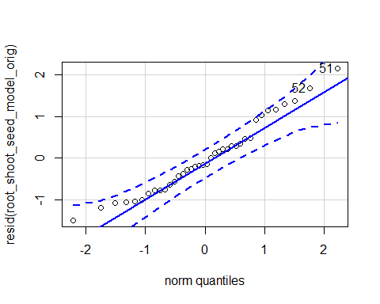

## 51 52   
## 20 21

hist(resid(root_shoot_seed_model_orig))

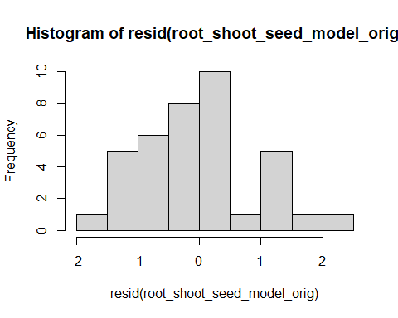

shapiro.test(resid(root_shoot_seed_model_orig))

##   
## Shapiro-Wilk normality test  
##   
## data: resid(root_shoot_seed_model_orig)  
## W = 0.96601, p-value = 0.2958

#0.2958

Raw Statistical output

anova(root_shoot_seed_model_orig, type=3)

## Type III Analysis of Variance Table with Satterthwaite's method  
## Sum Sq Mean Sq NumDF DenDF F value Pr(>F)  
## precip 0.86205 0.86205 1 33.304 1.0003 0.3245  
## soil_root 0.73422 0.73422 1 32.163 0.8519 0.3629  
## precip:soil_root 0.41700 0.41700 1 31.393 0.4839 0.4918

emmeans(root_shoot_seed_model_orig, pairwise~soil_root)

## NOTE: Results may be misleading due to involvement in interactions

## $emmeans  
## soil_root emmean SE df lower.CL upper.CL  
## L.B 2.07 0.238 9.66 1.53 2.60  
## L.R 2.35 0.250 10.07 1.79 2.91  
##   
## Results are averaged over the levels of: precip   
## Degrees-of-freedom method: kenward-roger   
## Results are given on the log (not the response) scale.   
## Confidence level used: 0.95   
##   
## $contrasts  
## contrast estimate SE df t.ratio p.value  
## L.B - L.R -0.285 0.314 31.8 -0.907 0.3711   
##   
## Results are averaged over the levels of: precip   
## Degrees-of-freedom method: kenward-roger   
## Results are given on the log (not the response) scale.

emmeans(root_shoot_seed_model_orig, pairwise~soil_root|precip)

## $emmeans  
## precip = A:  
## soil_root emmean SE df lower.CL upper.CL  
## L.B 2.02 0.316 20.6 1.36 2.68  
## L.R 2.09 0.289 17.5 1.48 2.70  
##   
## precip = D:  
## soil_root emmean SE df lower.CL upper.CL  
## L.B 2.11 0.330 23.0 1.43 2.80  
## L.R 2.61 0.382 25.2 1.83 3.40  
##   
## Degrees-of-freedom method: kenward-roger   
## Results are given on the log (not the response) scale.   
## Confidence level used: 0.95   
##   
## $contrasts  
## precip = A:  
## contrast estimate SE df t.ratio p.value  
## L.B - L.R -0.0709 0.402 31.0 -0.176 0.8612   
##   
## precip = D:  
## contrast estimate SE df t.ratio p.value  
## L.B - L.R -0.4989 0.477 31.5 -1.046 0.3033   
##   
## Degrees-of-freedom method: kenward-roger   
## Results are given on the log (not the response) scale.

Formatted Anova table

Root:Shoot given germination

|  |  |  |  |  |
| --- | --- | --- | --- | --- |
|  | Df | Resid.Df | F.value | P.value |
| precip | 1 | 33.30 | 1.00 | 0.324 |
| soil_root | 1 | 32.16 | 0.85 | 0.363 |
| precip:soil_root | 1 | 31.39 | 0.48 | 0.492 |

### Soil nitrate

Diagnostic Graphs

SG_inorg_N_trt$soil_root=with(SG_inorg_N_trt, interaction(soil_status,root_association))  
  
SG_inorg_N_seed_trt= subset(SG_inorg_N_trt, life_stage=="S")  
SG_soil_nit_model= lmer((ug_N_NO3_g_dry_soil)~precip*soil_root+(1|block), data= SG_inorg_N_seed_trt)

## boundary (singular) fit: see ?isSingular

qqPlot(resid(SG_soil_nit_model))

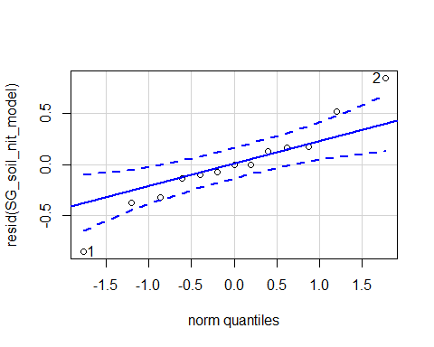

## [1] 1 2

hist(resid(SG_soil_nit_model))

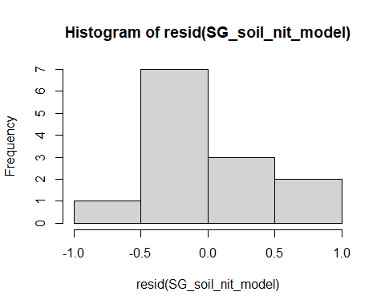

shapiro.test(resid(SG_soil_nit_model))

##   
## Shapiro-Wilk normality test  
##   
## data: resid(SG_soil_nit_model)  
## W = 0.95913, p-value = 0.7402

#0.7402

Raw Statistical output

anova(SG_soil_nit_model, type=3)

## Type III Analysis of Variance Table with Satterthwaite's method  
## Sum Sq Mean Sq NumDF DenDF F value Pr(>F)   
## precip 11.4658 11.4658 1 7 38.967 0.0004273 ***  
## soil_root 9.9131 4.9566 2 7 16.845 0.0021117 **   
## precip:soil_root 8.8261 4.4131 2 7 14.998 0.0029466 **   
## ---  
## Signif. codes: 0 '***' 0.001 '**' 0.01 '*' 0.05 '.' 0.1 ' ' 1

emmeans(SG_soil_nit_model, pairwise~soil_root)

## NOTE: Results may be misleading due to involvement in interactions

## Note: Use 'contrast(regrid(object), ...)' to obtain contrasts of back-transformed estimates

## $emmeans  
## soil_root emmean SE df lower.CL upper.CL  
## L.B 5.98 0.344 7.00 5.17 6.80  
## S.B 3.33 0.369 7.00 2.46 4.21  
## L.R 4.68 0.257 5.49 4.04 5.32  
##   
## Results are averaged over the levels of: precip   
## Degrees-of-freedom method: kenward-roger   
## Results are given on the ( (not the response) scale.   
## Confidence level used: 0.95   
##   
## $contrasts  
## contrast estimate SE df t.ratio p.value  
## L.B - S.B 2.65 0.505 5.35 5.249 0.0064   
## L.B - L.R 1.30 0.419 4.74 3.111 0.0621   
## S.B - L.R -1.35 0.450 5.49 -2.991 0.0603   
##   
## Results are averaged over the levels of: precip   
## Note: contrasts are still on the ( scale   
## Degrees-of-freedom method: kenward-roger   
## P value adjustment: tukey method for comparing a family of 3 estimates

emmeans(SG_soil_nit_model, pairwise~soil_root|precip)

## Note: Use 'contrast(regrid(object), ...)' to obtain contrasts of back-transformed estimates

## $emmeans  
## precip = A:  
## soil_root emmean SE df lower.CL upper.CL  
## L.B 3.57 0.344 7 2.76 4.38  
## S.B 3.31 0.436 7 2.28 4.35  
## L.R 3.91 0.271 7 3.27 4.55  
##   
## precip = D:  
## soil_root emmean SE df lower.CL upper.CL  
## L.B 8.40 0.690 7 6.77 10.03  
## S.B 3.35 0.664 7 1.78 4.92  
## L.R 5.45 0.436 7 4.42 6.48  
##   
## Degrees-of-freedom method: kenward-roger   
## Results are given on the ( (not the response) scale.   
## Confidence level used: 0.95   
##   
## $contrasts  
## precip = A:  
## contrast estimate SE df t.ratio p.value  
## L.B - S.B 0.254 0.571 6.37 0.445 0.8984   
## L.B - L.R -0.339 0.438 4.82 -0.773 0.7346   
## S.B - L.R -0.593 0.514 5.49 -1.153 0.5230   
##   
## precip = D:  
## contrast estimate SE df t.ratio p.value  
## L.B - S.B 5.043 0.985 7.00 5.123 0.0034   
## L.B - L.R 2.946 0.784 5.49 3.758 0.0254   
## S.B - L.R -2.098 0.848 7.00 -2.475 0.0953   
##   
## Note: contrasts are still on the ( scale   
## Degrees-of-freedom method: kenward-roger   
## P value adjustment: tukey method for comparing a family of 3 estimates

Formatted Anova table

Days to germination

|  |  |  |  |  |
| --- | --- | --- | --- | --- |
|  | Df | Resid.Df | F.value | P.value |
| precip | 1 | 29.56 | 4.28 | 0.047 |
| soil_root | 1 | 28.58 | 8.82 | 0.006 |
| precip:soil_root | 1 | 30.33 | 1.85 | 0.183 |
| Graph for publicati | on |  |  |  |
| [](MERDS_R_code_SG | _reAna | lysis_202008 | 28_files/fi | gure-docx/unnamed-chunk-72-1.png) |

### Soil ammonium

Diagnostic Graphs

SG_soil_amm_model= lmer((ug_N_NH4_g_dry_soil_negto0)~precip*soil_root+(1|block), data= SG_inorg_N_seed_trt)

## boundary (singular) fit: see ?isSingular

qqPlot(resid(SG_soil_amm_model))

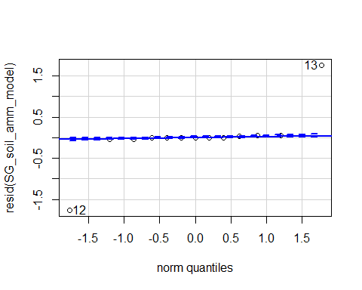

## [1] 12 13

hist(resid(SG_soil_amm_model))

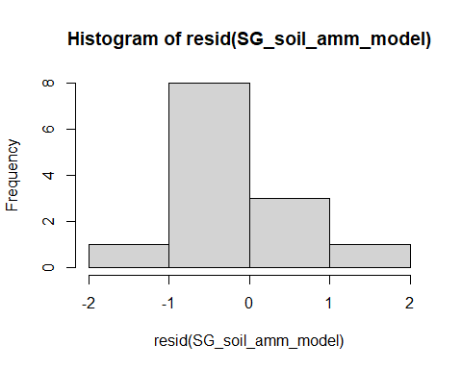

shapiro.test(resid(SG_soil_amm_model))

##   
## Shapiro-Wilk normality test  
##   
## data: resid(SG_soil_amm_model)  
## W = 0.60938, p-value = 7.899e-05

#p-value = 7.899e-05

Raw Statistical output

anova(SG_soil_amm_model, type=3)

## Type III Analysis of Variance Table with Satterthwaite's method  
## Sum Sq Mean Sq NumDF DenDF F value Pr(>F)  
## precip 0.2271 0.22709 1 7 0.2559 0.6285  
## soil_root 5.3807 2.69034 2 7 3.0317 0.1126  
## precip:soil_root 0.0893 0.04463 2 7 0.0503 0.9513

emmeans(SG_soil_amm_model, pairwise~soil_root)

## NOTE: Results may be misleading due to involvement in interactions

## Note: Use 'contrast(regrid(object), ...)' to obtain contrasts of back-transformed estimates

## $emmeans  
## soil_root emmean SE df lower.CL upper.CL  
## L.B 0.131 0.597 7.00 -1.281 1.54  
## S.B 1.851 0.641 7.00 0.335 3.37  
## L.R 0.279 0.446 5.49 -0.837 1.40  
##   
## Results are averaged over the levels of: precip   
## Degrees-of-freedom method: kenward-roger   
## Results are given on the ( (not the response) scale.   
## Confidence level used: 0.95   
##   
## $contrasts  
## contrast estimate SE df t.ratio p.value  
## L.B - S.B -1.721 0.876 5.35 -1.964 0.2106   
## L.B - L.R -0.148 0.728 4.74 -0.204 0.9774   
## S.B - L.R 1.572 0.781 5.49 2.013 0.1966   
##   
## Results are averaged over the levels of: precip   
## Note: contrasts are still on the ( scale   
## Degrees-of-freedom method: kenward-roger   
## P value adjustment: tukey method for comparing a family of 3 estimates

emmeans(SG_soil_amm_model, pairwise~soil_root|precip)

## Note: Use 'contrast(regrid(object), ...)' to obtain contrasts of back-transformed estimates

## $emmeans  
## precip = A:  
## soil_root emmean SE df lower.CL upper.CL  
## L.B 0.0406 0.597 7 -1.3716 1.45  
## S.B 1.7611 0.758 7 -0.0307 3.55  
## L.R 0.0088 0.471 7 -1.1050 1.12  
##   
## precip = D:  
## soil_root emmean SE df lower.CL upper.CL  
## L.B 0.2210 1.198 7 -2.6121 3.05  
## S.B 1.9418 1.154 7 -0.7864 4.67  
## L.R 0.5498 0.758 7 -1.2420 2.34  
##   
## Degrees-of-freedom method: kenward-roger   
## Results are given on the ( (not the response) scale.   
## Confidence level used: 0.95   
##   
## $contrasts  
## precip = A:  
## contrast estimate SE df t.ratio p.value  
## L.B - S.B -1.7205 0.992 6.37 -1.735 0.2644   
## L.B - L.R 0.0318 0.761 4.82 0.042 0.9990   
## S.B - L.R 1.7523 0.892 5.49 1.964 0.2085   
##   
## precip = D:  
## contrast estimate SE df t.ratio p.value  
## L.B - S.B -1.7207 1.710 7.00 -1.006 0.5963   
## L.B - L.R -0.3288 1.361 5.49 -0.242 0.9685   
## S.B - L.R 1.3919 1.472 7.00 0.946 0.6310   
##   
## Note: contrasts are still on the ( scale   
## Degrees-of-freedom method: kenward-roger   
## P value adjustment: tukey method for comparing a family of 3 estimates

Graph for publication

## Warning: Removed 2 rows containing missing values (geom_text).

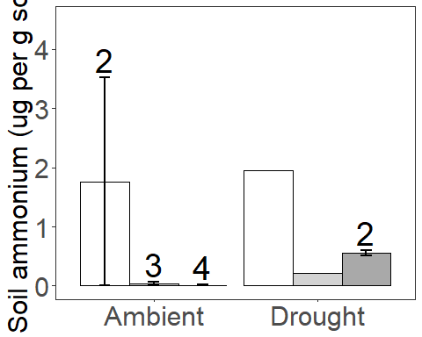

## TRANSPLANT PORTION OF THE EXPERIEMENT BEGINING

Was there treatment effects on intial survival

Graph 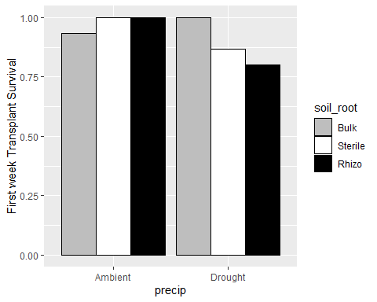 Was there a bias in initial height?

Diagnostic Graphs

SG_intial_height_model= lmer((int_height_cm)^(1/3)~precip*soil_root+(1|block), data= fin_dataSG_trans_surv_trt_planting)  
qqPlot(resid(SG_intial_height_model))

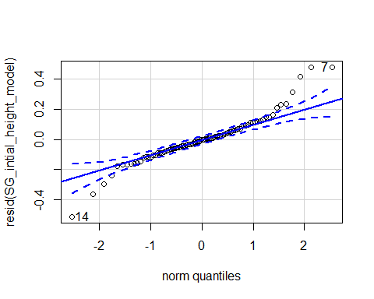

## [1] 14 7

hist(resid(SG_intial_height_model))

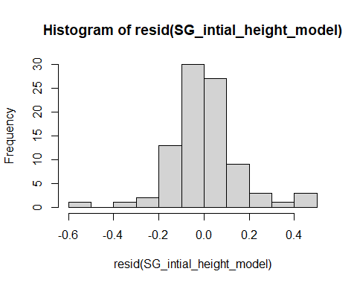

shapiro.test(resid(SG_intial_height_model))

##   
## Shapiro-Wilk normality test  
##   
## data: resid(SG_intial_height_model)  
## W = 0.93125, p-value = 0.0001383

#p-value = 0.0001383

Raw Statistical output

anova(SG_intial_height_model)

## Type III Analysis of Variance Table with Satterthwaite's method  
## Sum Sq Mean Sq NumDF DenDF F value Pr(>F)  
## precip 0.000081 0.0000813 1 80 0.0033 0.9546  
## soil_root 0.044662 0.0223308 2 80 0.8961 0.4122  
## precip:soil_root 0.060344 0.0301722 2 80 1.2108 0.3034

Formatted Anova table

|  |  |  |  |  |
| --- | --- | --- | --- | --- |
|  | Df | Resid.Df | F.value | P.value |
| precip | 1 | 80 | 0.00 | 0.955 |
| soil_root | 2 | 80 | 0.90 | 0.412 |
| precip:soil_root | 2 | 80 | 1.21 | 0.303 |
| ### Total biomass |  |  |  |  |

Diagnostic Graphs

trans_biomas_model= lmer(log(total_biomass_0+.001)~precip*soil_root+(1|block), data= data_SG_biomass_trans_surv_trt)  
qqPlot(resid(trans_biomas_model))

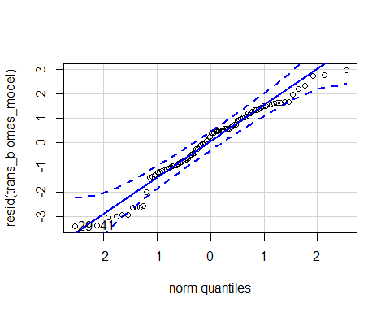

## [1] 29 41

hist(resid(trans_biomas_model))

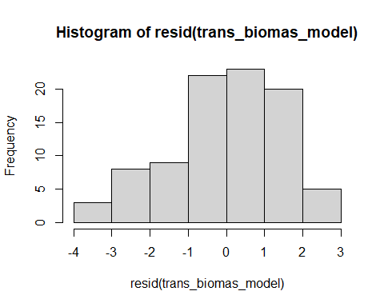

shapiro.test(resid(trans_biomas_model))

##   
## Shapiro-Wilk normality test  
##   
## data: resid(trans_biomas_model)  
## W = 0.96619, p-value = 0.01918

Raw Statistical output

anova(trans_biomas_model, type=3)

## Type III Analysis of Variance Table with Satterthwaite's method  
## Sum Sq Mean Sq NumDF DenDF F value Pr(>F)   
## precip 31.948 31.948 1 80 13.4201 0.0004457 ***  
## soil_root 23.301 11.651 2 80 4.8939 0.0098833 **   
## precip:soil_root 15.880 7.940 2 80 3.3353 0.0406192 *   
## ---  
## Signif. codes: 0 '***' 0.001 '**' 0.01 '*' 0.05 '.' 0.1 ' ' 1

emmeans(trans_biomas_model, pairwise~soil_root)

## NOTE: Results may be misleading due to involvement in interactions

## $emmeans  
## soil_root emmean SE df lower.CL upper.CL  
## L.B -3.39 0.323 15.6 -4.08 -2.71  
## S.B -2.48 0.323 15.6 -3.17 -1.80  
## L.R -3.67 0.323 15.6 -4.36 -2.99  
##   
## Results are averaged over the levels of: precip   
## Degrees-of-freedom method: kenward-roger   
## Results are given on the log(mu + 0.001) (not the response) scale.   
## Confidence level used: 0.95   
##   
## $contrasts  
## contrast estimate SE df t.ratio p.value  
## L.B - S.B -0.909 0.398 80 -2.282 0.0641   
## L.B - L.R 0.284 0.398 80 0.712 0.7570   
## S.B - L.R 1.193 0.398 80 2.994 0.0101   
##   
## Results are averaged over the levels of: precip   
## Degrees-of-freedom method: kenward-roger   
## Results are given on the log (not the response) scale.   
## P value adjustment: tukey method for comparing a family of 3 estimates

emmeans(trans_biomas_model, pairwise~soil_root|precip)

## $emmeans  
## precip = A:  
## soil_root emmean SE df lower.CL upper.CL  
## L.B -3.16 0.429 38.4 -4.03 -2.294  
## S.B -1.30 0.429 38.4 -2.17 -0.431  
## L.R -3.30 0.429 38.4 -4.17 -2.434  
##   
## precip = D:  
## soil_root emmean SE df lower.CL upper.CL  
## L.B -3.62 0.429 38.4 -4.49 -2.754  
## S.B -3.67 0.429 38.4 -4.53 -2.799  
## L.R -4.05 0.429 38.4 -4.92 -3.181  
##   
## Degrees-of-freedom method: kenward-roger   
## Results are given on the log(mu + 0.001) (not the response) scale.   
## Confidence level used: 0.95   
##   
## $contrasts  
## precip = A:  
## contrast estimate SE df t.ratio p.value  
## L.B - S.B -1.8632 0.563 80 -3.307 0.0040   
## L.B - L.R 0.1403 0.563 80 0.249 0.9664   
## S.B - L.R 2.0036 0.563 80 3.556 0.0018   
##   
## precip = D:  
## contrast estimate SE df t.ratio p.value  
## L.B - S.B 0.0449 0.563 80 0.080 0.9965   
## L.B - L.R 0.4272 0.563 80 0.758 0.7295   
## S.B - L.R 0.3823 0.563 80 0.678 0.7767   
##   
## Degrees-of-freedom method: kenward-roger   
## Results are given on the log (not the response) scale.   
## P value adjustment: tukey method for comparing a family of 3 estimates

Formatted Anova table

Total biomass

|  |  |  |  |
| --- | --- | --- | --- |
| Df | Resid.Df | F.value | P.value |
| 1 | 80 | 13.42 | 0.000 |
| 2 | 80 | 4.89 | 0.010 |
| 2 | 80 | 3.34 | 0.041 |

Graph for publication

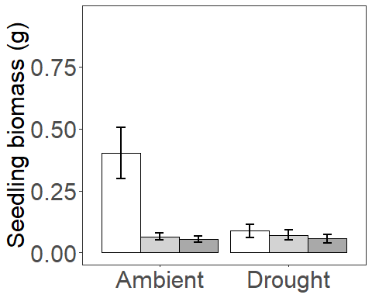

### Presence at total biomass

Diagnostic Graphs

data_SG_biomass_trans_surv_pres=subset(data_SG_biomass_trans_surv_trt, root_association =="B")  
  
trans_biomas_model_pres= lmer((total_biomass_0+.001)^(1/4)~precip*soil_root+(1|block), data= data_SG_biomass_trans_surv_pres)

## boundary (singular) fit: see ?isSingular

qqPlot(resid(trans_biomas_model_pres))

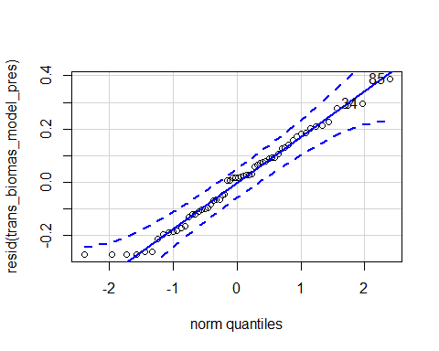

## 85 34   
## 55 19

hist(resid(trans_biomas_model_pres))

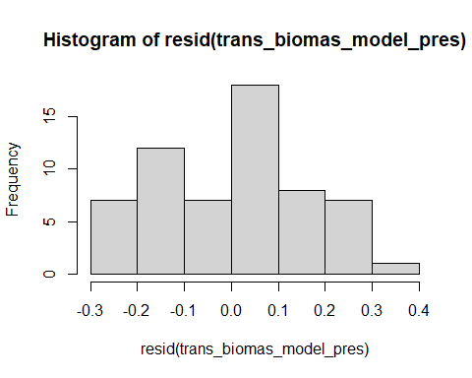

shapiro.test(resid(trans_biomas_model_pres))

##   
## Shapiro-Wilk normality test  
##   
## data: resid(trans_biomas_model_pres)  
## W = 0.97499, p-value = 0.254

#p-value = 0.254

Raw Statistical output

anova(trans_biomas_model_pres, type=3)

## Type III Analysis of Variance Table with Satterthwaite's method  
## Sum Sq Mean Sq NumDF DenDF F value Pr(>F)   
## precip 0.38241 0.38241 1 56 13.2458 0.0005969 ***  
## soil_root 0.29851 0.29851 1 56 10.3396 0.0021637 **   
## precip:soil_root 0.25587 0.25587 1 56 8.8628 0.0042933 **   
## ---  
## Signif. codes: 0 '***' 0.001 '**' 0.01 '*' 0.05 '.' 0.1 ' ' 1

emmeans(trans_biomas_model_pres, pairwise~soil_root)

## Warning in ref_grid(object, ...): There are unevaluated constants in the response formula  
## Auto-detection of the response transformation may be incorrect

## NOTE: Results may be misleading due to involvement in interactions

## Note: Use 'contrast(regrid(object), ...)' to obtain contrasts of back-transformed estimates

## $emmeans  
## soil_root emmean SE df lower.CL upper.CL  
## L.B 0.455 0.031 14.9 0.389 0.521  
## S.B 0.596 0.031 14.9 0.530 0.662  
##   
## Results are averaged over the levels of: precip   
## Degrees-of-freedom method: kenward-roger   
## Results are given on the ( (not the response) scale.   
## Confidence level used: 0.95   
##   
## $contrasts  
## contrast estimate SE df t.ratio p.value  
## L.B - S.B -0.141 0.0439 52 -3.216 0.0022   
##   
## Results are averaged over the levels of: precip   
## Note: contrasts are still on the ( scale   
## Degrees-of-freedom method: kenward-roger

emmeans(trans_biomas_model_pres, pairwise~soil_root|precip)

## Warning in ref_grid(object, ...): There are unevaluated constants in the response formula  
## Auto-detection of the response transformation may be incorrect

## Note: Use 'contrast(regrid(object), ...)' to obtain contrasts of back-transformed estimates

## $emmeans  
## precip = A:  
## soil_root emmean SE df lower.CL upper.CL  
## L.B 0.469 0.0439 37.8 0.380 0.558  
## S.B 0.741 0.0439 37.8 0.652 0.830  
##   
## precip = D:  
## soil_root emmean SE df lower.CL upper.CL  
## L.B 0.440 0.0439 37.8 0.351 0.529  
## S.B 0.451 0.0439 37.8 0.362 0.540  
##   
## Degrees-of-freedom method: kenward-roger   
## Results are given on the ( (not the response) scale.   
## Confidence level used: 0.95   
##   
## $contrasts  
## precip = A:  
## contrast estimate SE df t.ratio p.value  
## L.B - S.B -0.2717 0.062 52 -4.379 0.0001   
##   
## precip = D:  
## contrast estimate SE df t.ratio p.value  
## L.B - S.B -0.0105 0.062 52 -0.169 0.8667   
##   
## Note: contrasts are still on the ( scale   
## Degrees-of-freedom method: kenward-roger

Formatted Anova table

Total biomass

|  |  |  |  |
| --- | --- | --- | --- |
| Df | Resid.Df | F.value | P.value |
| 1 | 56 | 13.25 | 0.001 |
| 1 | 56 | 10.34 | 0.002 |
| 1 | 56 | 8.86 | 0.004 |

### Origin at total biomass

Diagnostic Graphs

data_SG_biomass_trans_surv_orig=subset(data_SG_biomass_trans_surv_trt, soil_status =="L")  
nrow(data_SG_biomass_trans_surv_orig)

## [1] 60

trans_biomas_model_orig= lmer((total_biomass_0+0.001)^(1/4)~precip*soil_root+(1|block), data= data_SG_biomass_trans_surv_orig)  
qqPlot(resid(trans_biomas_model_orig))

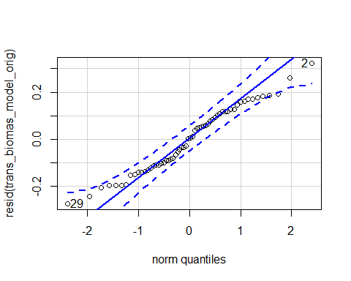

## [1] 2 29

hist(resid(trans_biomas_model_orig))

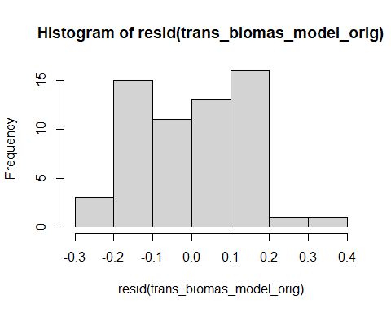

shapiro.test(resid(trans_biomas_model_orig))

##   
## Shapiro-Wilk normality test  
##   
## data: resid(trans_biomas_model_orig)  
## W = 0.97214, p-value = 0.1856

#p-value = 0.1856

Raw Statistical output

anova(trans_biomas_model_orig)

## Type III Analysis of Variance Table with Satterthwaite's method  
## Sum Sq Mean Sq NumDF DenDF F value Pr(>F)  
## precip 0.0212028 0.0212028 1 52 1.0133 0.3188  
## soil_root 0.0111201 0.0111201 1 52 0.5314 0.4693  
## precip:soil_root 0.0010927 0.0010927 1 52 0.0522 0.8201

emmeans(trans_biomas_model_orig, pairwise~soil_root)

## Warning in ref_grid(object, ...): There are unevaluated constants in the response formula  
## Auto-detection of the response transformation may be incorrect

## NOTE: Results may be misleading due to involvement in interactions

## Note: Use 'contrast(regrid(object), ...)' to obtain contrasts of back-transformed estimates

## $emmeans  
## soil_root emmean SE df lower.CL upper.CL  
## L.B 0.455 0.0313 9.4 0.384 0.525  
## L.R 0.428 0.0313 9.4 0.357 0.498  
##   
## Results are averaged over the levels of: precip   
## Degrees-of-freedom method: kenward-roger   
## Results are given on the ( (not the response) scale.   
## Confidence level used: 0.95   
##   
## $contrasts  
## contrast estimate SE df t.ratio p.value  
## L.B - L.R 0.0272 0.0373 52 0.729 0.4693   
##   
## Results are averaged over the levels of: precip   
## Note: contrasts are still on the ( scale   
## Degrees-of-freedom method: kenward-roger

emmeans(trans_biomas_model_orig, pairwise~soil_root|precip)

## Warning in ref_grid(object, ...): There are unevaluated constants in the response formula  
## Auto-detection of the response transformation may be incorrect

## Note: Use 'contrast(regrid(object), ...)' to obtain contrasts of back-transformed estimates

## $emmeans  
## precip = A:  
## soil_root emmean SE df lower.CL upper.CL  
## L.B 0.469 0.041 23.3 0.385 0.554  
## L.R 0.451 0.041 23.3 0.366 0.535  
##   
## precip = D:  
## soil_root emmean SE df lower.CL upper.CL  
## L.B 0.440 0.041 23.3 0.356 0.525  
## L.R 0.404 0.041 23.3 0.320 0.489  
##   
## Degrees-of-freedom method: kenward-roger   
## Results are given on the ( (not the response) scale.   
## Confidence level used: 0.95   
##   
## $contrasts  
## precip = A:  
## contrast estimate SE df t.ratio p.value  
## L.B - L.R 0.0187 0.0528 52 0.354 0.7249   
##   
## precip = D:  
## contrast estimate SE df t.ratio p.value  
## L.B - L.R 0.0358 0.0528 52 0.677 0.5014   
##   
## Note: contrasts are still on the ( scale   
## Degrees-of-freedom method: kenward-roger

Formatted Anova table

Total biomass

|  |  |  |  |  |
| --- | --- | --- | --- | --- |
|  | Df | Resid.Df | F.value | P.value |
| precip | 1 | 52 | 1.01 | 0.319 |
| soil_root | 1 | 52 | 0.53 | 0.469 |
| precip:soil_root | 1 | 52 | 0.05 | 0.820 |

# Root:shoot ratio

Diagnostic Graphs

root_shoot_model_na= lmer(log(root_shoot)~precip*soil_root+(1|block), data= data_SG_biomass_trans_surv_trt_na)

## boundary (singular) fit: see ?isSingular

qqPlot(resid(root_shoot_model_na))

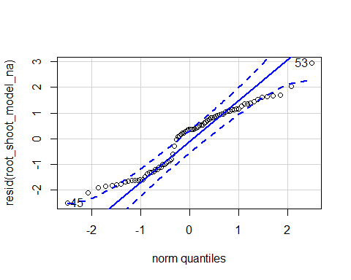

## 53 45   
## 43 35

hist(resid(root_shoot_model_na))

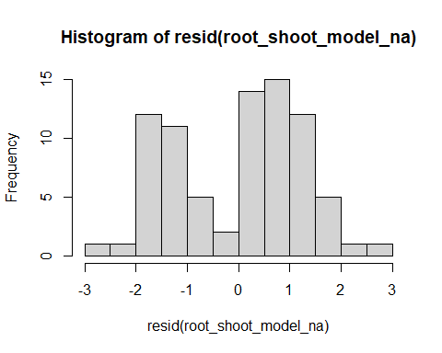

shapiro.test(resid(root_shoot_model_na))

##   
## Shapiro-Wilk normality test  
##   
## data: resid(root_shoot_model_na)  
## W = 0.94233, p-value = 0.001287

#p-value = 0.001287  
plot(root_shoot_model_na)

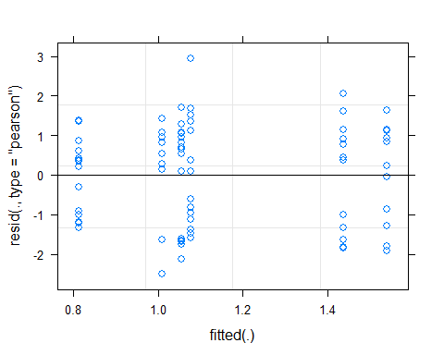 Raw Statistical output

anova(root_shoot_model_na)

## Type III Analysis of Variance Table with Satterthwaite's method  
## Sum Sq Mean Sq NumDF DenDF F value Pr(>F)  
## precip 2.3613 2.36129 1 74 1.4419 0.2337  
## soil_root 1.0009 0.50045 2 74 0.3056 0.7376  
## precip:soil_root 1.5907 0.79534 2 74 0.4857 0.6172

emmeans(root_shoot_model_na, pairwise~soil_root)

## NOTE: Results may be misleading due to involvement in interactions

## $emmeans  
## soil_root emmean SE df lower.CL upper.CL  
## L.B 1.13 0.243 26.7 0.628 1.62  
## S.B 1.03 0.255 29.7 0.511 1.55  
## L.R 1.31 0.257 28.1 0.782 1.83  
##   
## Results are averaged over the levels of: precip   
## Degrees-of-freedom method: kenward-roger   
## Results are given on the log (not the response) scale.   
## Confidence level used: 0.95   
##   
## $contrasts  
## contrast estimate SE df t.ratio p.value  
## L.B - S.B 0.0942 0.352 70.7 0.267 0.9614   
## L.B - L.R -0.1818 0.354 71.9 -0.514 0.8648   
## S.B - L.R -0.2759 0.361 71.3 -0.765 0.7258   
##   
## Results are averaged over the levels of: precip   
## Degrees-of-freedom method: kenward-roger   
## Results are given on the log (not the response) scale.   
## P value adjustment: tukey method for comparing a family of 3 estimates

emmeans(root_shoot_model_na, pairwise~soil_root|precip)

## $emmeans  
## precip = A:  
## soil_root emmean SE df lower.CL upper.CL  
## L.B 0.814 0.330 54.4 0.152 1.48  
## S.B 1.054 0.330 54.4 0.392 1.72  
## L.R 1.077 0.330 54.4 0.415 1.74  
##   
## precip = D:  
## soil_root emmean SE df lower.CL upper.CL  
## L.B 1.438 0.356 58.5 0.726 2.15  
## S.B 1.010 0.389 61.7 0.232 1.79  
## L.R 1.539 0.393 56.9 0.752 2.33  
##   
## Degrees-of-freedom method: kenward-roger   
## Results are given on the log (not the response) scale.   
## Confidence level used: 0.95   
##   
## $contrasts  
## precip = A:  
## contrast estimate SE df t.ratio p.value  
## L.B - S.B -0.2403 0.467 70.0 -0.514 0.8647   
## L.B - L.R -0.2630 0.467 70.0 -0.563 0.8402   
## S.B - L.R -0.0227 0.467 70.0 -0.049 0.9987   
##   
## precip = D:  
## contrast estimate SE df t.ratio p.value  
## L.B - S.B 0.4286 0.527 71.2 0.814 0.6959   
## L.B - L.R -0.1006 0.531 73.0 -0.189 0.9804   
## S.B - L.R -0.5292 0.550 72.1 -0.962 0.6031   
##   
## Degrees-of-freedom method: kenward-roger   
## Results are given on the log (not the response) scale.   
## P value adjustment: tukey method for comparing a family of 3 estimates

Formatted Anova table

Root:Shoot Ratio

|  |  |  |  |  |
| --- | --- | --- | --- | --- |
|  | Df | Resid.Df | F.value | P.value |
| precip | 1 | 74 | 1.44 | 0.234 |
| soil_root | 2 | 74 | 0.31 | 0.738 |
| precip:soil_root | 2 | 74 | 0.49 | 0.617 |

Graph for publication

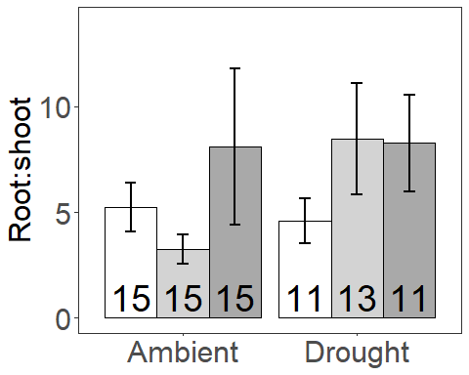

### Presence Root:shoot ratio

Diagnostic Graphs

data_SG_biomass_trans_surv_pres_na=subset(data_SG_biomass_trans_surv_trt_na, root_association =="B")  
  
root_shoot_model_pres_na= lmer((root_shoot)^(1/4)~precip*soil_root+(1|block), data= data_SG_biomass_trans_surv_pres_na)

## boundary (singular) fit: see ?isSingular

qqPlot(resid(root_shoot_model_pres_na))

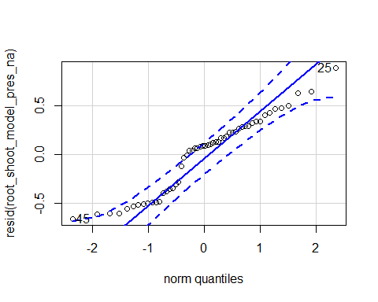

## 25 45   
## 9 24

hist(resid(root_shoot_model_pres_na))

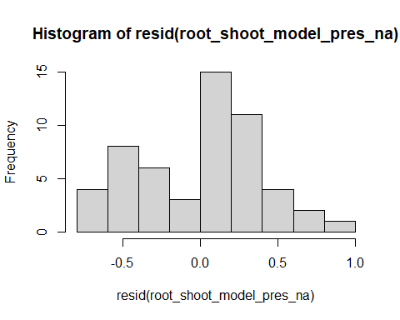

shapiro.test(resid(root_shoot_model_pres_na))

##   
## Shapiro-Wilk normality test  
##   
## data: resid(root_shoot_model_pres_na)  
## W = 0.94371, p-value = 0.01335

#p-value = 0.01335  
plot(root_shoot_model_pres_na)

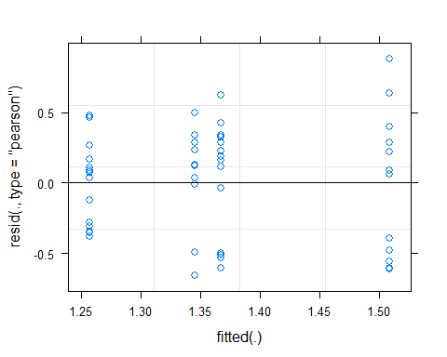 Raw Statistical output

anova(root_shoot_model_pres_na)

## Type III Analysis of Variance Table with Satterthwaite's method  
## Sum Sq Mean Sq NumDF DenDF F value Pr(>F)  
## precip 0.175840 0.175840 1 50 1.1108 0.2970  
## soil_root 0.009263 0.009263 1 50 0.0585 0.8099  
## precip:soil_root 0.250414 0.250414 1 50 1.5818 0.2143

emmeans(root_shoot_model_pres_na, pairwise~soil_root)

## Warning in ref_grid(object, ...): There are unevaluated constants in the response formula  
## Auto-detection of the response transformation may be incorrect

## NOTE: Results may be misleading due to involvement in interactions

## Note: Use 'contrast(regrid(object), ...)' to obtain contrasts of back-transformed estimates

## $emmeans  
## soil_root emmean SE df lower.CL upper.CL  
## L.B 1.38 0.0756 13.6 1.22 1.55  
## S.B 1.36 0.0795 15.4 1.19 1.53  
##   
## Results are averaged over the levels of: precip   
## Degrees-of-freedom method: kenward-roger   
## Results are given on the ( (not the response) scale.   
## Confidence level used: 0.95   
##   
## $contrasts  
## contrast estimate SE df t.ratio p.value  
## L.B - S.B 0.0264 0.11 46.7 0.241 0.8107   
##   
## Results are averaged over the levels of: precip   
## Note: contrasts are still on the ( scale   
## Degrees-of-freedom method: kenward-roger

emmeans(root_shoot_model_pres_na, pairwise~soil_root|precip)

## Warning in ref_grid(object, ...): There are unevaluated constants in the response formula  
## Auto-detection of the response transformation may be incorrect

## Note: Use 'contrast(regrid(object), ...)' to obtain contrasts of back-transformed estimates

## $emmeans  
## precip = A:  
## soil_root emmean SE df lower.CL upper.CL  
## L.B 1.26 0.103 32.5 1.05 1.47  
## S.B 1.37 0.103 32.5 1.16 1.58  
##   
## precip = D:  
## soil_root emmean SE df lower.CL upper.CL  
## L.B 1.51 0.111 35.8 1.28 1.73  
## S.B 1.35 0.121 38.5 1.10 1.59  
##   
## Degrees-of-freedom method: kenward-roger   
## Results are given on the ( (not the response) scale.   
## Confidence level used: 0.95   
##   
## $contrasts  
## precip = A:  
## contrast estimate SE df t.ratio p.value  
## L.B - S.B -0.111 0.145 46.0 -0.763 0.4492   
##   
## precip = D:  
## contrast estimate SE df t.ratio p.value  
## L.B - S.B 0.164 0.164 47.2 0.997 0.3238   
##   
## Note: contrasts are still on the ( scale   
## Degrees-of-freedom method: kenward-roger

Formatted Anova table

Root:Shoot Ratio

|  |  |  |  |  |
| --- | --- | --- | --- | --- |
|  | Df | Resid.Df | F.value | P.value |
| precip | 1 | 50 | 1.11 | 0.297 |
| soil_root | 1 | 50 | 0.06 | 0.810 |
| precip:soil_root | 1 | 50 | 1.58 | 0.214 |

### Origin Root:shoot ratio

Diagnostic Graphs

data_SG_biomass_trans_surv_orig_na=subset(data_SG_biomass_trans_surv_trt_na,soil_status =="L")  
  
root_shoot_model_orig_na= lmer(log(root_shoot)~precip*soil_root+(1|block), data= data_SG_biomass_trans_surv_orig_na)

## boundary (singular) fit: see ?isSingular

qqPlot(resid(root_shoot_model_orig_na))

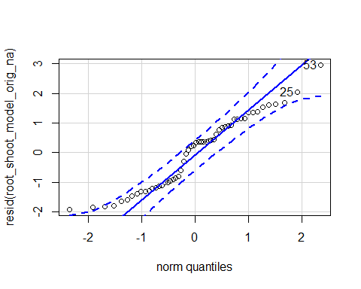

## 53 25   
## 32 20

hist(resid(root_shoot_model_orig_na))

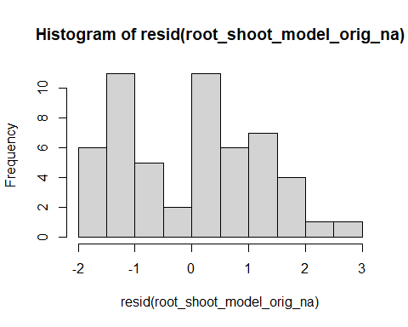

shapiro.test(resid(root_shoot_model_orig_na))

##   
## Shapiro-Wilk normality test  
##   
## data: resid(root_shoot_model_orig_na)  
## W = 0.94863, p-value = 0.02169

#p-value = 0.02169  
plot(root_shoot_model_orig_na)

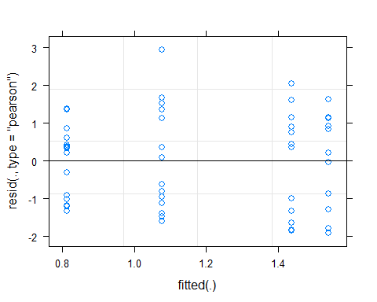 Raw Statistical output

anova(root_shoot_model_orig_na)

## Type III Analysis of Variance Table with Satterthwaite's method  
## Sum Sq Mean Sq NumDF DenDF F value Pr(>F)  
## precip 3.9134 3.9134 1 50 2.4860 0.1212  
## soil_root 0.4389 0.4389 1 50 0.2788 0.5998  
## precip:soil_root 0.0875 0.0875 1 50 0.0556 0.8145

emmeans(root_shoot_model_orig_na, pairwise~soil_root|precip)

## $emmeans  
## precip = A:  
## soil_root emmean SE df lower.CL upper.CL  
## L.B 0.814 0.324 32.3 0.155 1.47  
## L.R 1.077 0.324 32.3 0.417 1.74  
##   
## precip = D:  
## soil_root emmean SE df lower.CL upper.CL  
## L.B 1.438 0.350 35.6 0.729 2.15  
## L.R 1.539 0.388 34.2 0.750 2.33  
##   
## Degrees-of-freedom method: kenward-roger   
## Results are given on the log (not the response) scale.   
## Confidence level used: 0.95   
##   
## $contrasts  
## precip = A:  
## contrast estimate SE df t.ratio p.value  
## L.B - L.R -0.263 0.458 46 -0.574 0.5688   
##   
## precip = D:  
## contrast estimate SE df t.ratio p.value  
## L.B - L.R -0.101 0.523 49 -0.192 0.8484   
##   
## Degrees-of-freedom method: kenward-roger   
## Results are given on the log (not the response) scale.

Formatted Anova table

Root:Shoot Ratio

|  |  |  |  |  |
| --- | --- | --- | --- | --- |
|  | Df | Resid.Df | F.value | P.value |
| precip | 1 | 50 | 2.49 | 0.121 |
| soil_root | 1 | 50 | 0.28 | 0.600 |
| precip:soil_root | 1 | 50 | 0.06 | 0.815 |

## Final survival

data_SG_biomass_trans_surv_trt$surv=data_SG_biomass_trans_surv_trt$total_biomass  
data_SG_biomass_trans_surv_trt$surv[is.na(data_SG_biomass_trans_surv_trt$surv)]=0  
data_SG_biomass_trans_surv_trt$surv[data_SG_biomass_trans_surv_trt$surv!=0]=1

Diagnostic Graphs

Raw Statistical output

Graph for publication

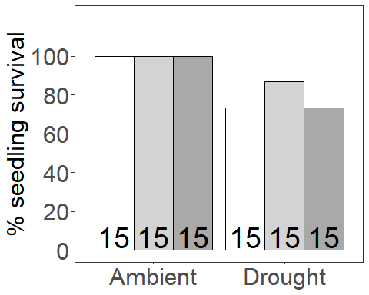

### Survival of the transplant

Final survival in the drought treatment only since all pots had live transs in the ambient treatments

Diagnostic Graphs

data_SG_biomass_trans_surv_drought=subset(data_SG_biomass_trans_surv_trt, precip=="D")  
drought_surv_model= glmer(surv~soil_root+(1|block), data= data_SG_biomass_trans_surv_drought, family = binomial)

## Warning in checkConv(attr(opt, "derivs"), opt$par, ctrl = control$checkConv, :  
## Model failed to converge with max|grad| = 0.0139762 (tol = 0.002, component 1)

qqPlot(resid(drought_surv_model))

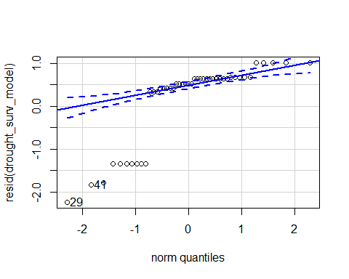

## [1] 29 41

hist(resid(drought_surv_model))

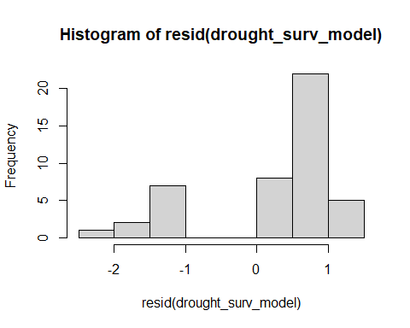 Raw Statistical output

Anova(drought_surv_model,type = 3)

## Analysis of Deviance Table (Type III Wald chisquare tests)  
##   
## Response: surv  
## Chisq Df Pr(>Chisq)   
## (Intercept) 88736 1 < 2.2e-16 ***  
## soil_root 15916 2 < 2.2e-16 ***  
## ---  
## Signif. codes: 0 '***' 0.001 '**' 0.01 '*' 0.05 '.' 0.1 ' ' 1

emmeans(drought_surv_model, pairwise~soil_root)

## $emmeans  
## soil_root emmean SE df asymp.LCL asymp.UCL  
## L.B 2.15 0.00716 Inf 2.133 2.16  
## S.B 1.19 0.44169 Inf 0.323 2.05  
## L.R 1.19 0.44169 Inf 0.323 2.05  
##   
## Results are given on the logit (not the response) scale.   
## Confidence level used: 0.95   
##   
## $contrasts  
## contrast estimate SE df z.ratio p.value  
## L.B - S.B 9.58e-01 0.442 Inf 2.168 0.0767   
## L.B - L.R 9.58e-01 0.442 Inf 2.168 0.0767   
## S.B - L.R 2.16e-05 0.883 Inf 0.000 1.0000   
##   
## Results are given on the log odds ratio (not the response) scale.   
## P value adjustment: tukey method for comparing a family of 3 estimates

Formatted Anova table

Survival

|  |  |  |  |
| --- | --- | --- | --- |
|  | Df | Chi.Sq | P.value |
| (Intercept) | 1 | 88735.85 | 0 |
| soil_root | 2 | 15916.28 | 0 |

### Presence survival of the transplant

Diagnostic Graphs

data_SG_biomass_trans_surv_drought_pres=subset(data_SG_biomass_trans_surv_drought, root_association =="B")  
  
drought_surv_model_pres= glmer(surv~soil_root+(1|block), data= data_SG_biomass_trans_surv_drought_pres, family = binomial)  
qqPlot(resid(drought_surv_model_pres))

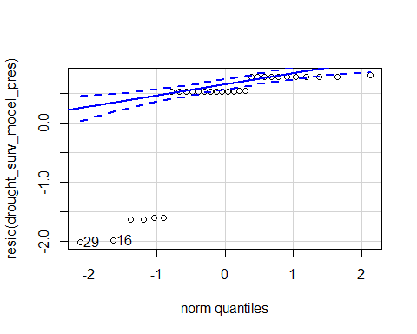

## 29 16   
## 14 1

hist(resid(drought_surv_model_pres))

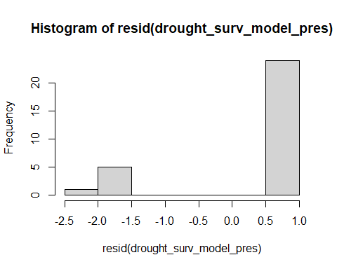 Raw Statistical output

Anova(drought_surv_model_pres,type = 3)

## Analysis of Deviance Table (Type III Wald chisquare tests)  
##   
## Response: surv  
## Chisq Df Pr(>Chisq)   
## (Intercept) 7.2643 1 0.007034 **  
## soil_root 0.8025 1 0.370340   
## ---  
## Signif. codes: 0 '***' 0.001 '**' 0.01 '*' 0.05 '.' 0.1 ' ' 1

emmeans(drought_surv_model_pres, pairwise~soil_root)

## $emmeans  
## soil_root emmean SE df asymp.LCL asymp.UCL  
## L.B 1.89 0.815 Inf 0.288 3.48  
## S.B 1.02 0.619 Inf -0.192 2.23  
##   
## Results are given on the logit (not the response) scale.   
## Confidence level used: 0.95   
##   
## $contrasts  
## contrast estimate SE df z.ratio p.value  
## L.B - S.B 0.865 0.966 Inf 0.896 0.3703   
##   
## Results are given on the log odds ratio (not the response) scale.

Formatted Anova table

Survival

|  |  |  |  |
| --- | --- | --- | --- |
|  | Df | Chi.Sq | P.value |
| (Intercept) | 1 | 7.26 | 0.007 |
| soil_root | 1 | 0.80 | 0.370 |

### Origin survival of the transplant

Diagnostic Graphs

data_SG_biomass_trans_surv_drought_orig=subset(data_SG_biomass_trans_surv_drought, soil_status =="L")  
  
drought_surv_model_orig= glmer(surv~soil_root+(1|block), data= data_SG_biomass_trans_surv_drought_orig, family = binomial)  
qqPlot(resid(drought_surv_model_orig))

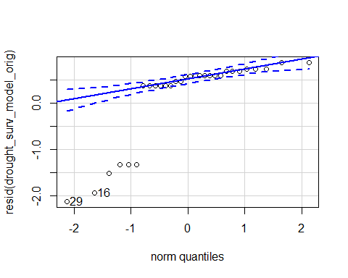

## [1] 29 16

hist(resid(drought_surv_model_orig))

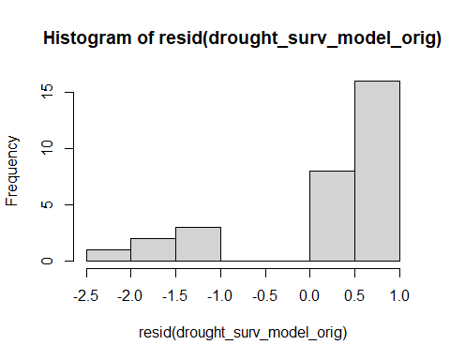 Raw Statistical output

Anova(drought_surv_model_orig,type = 3)

## Analysis of Deviance Table (Type III Wald chisquare tests)  
##   
## Response: surv  
## Chisq Df Pr(>Chisq)   
## (Intercept) 4.9500 1 0.02609 *  
## soil_root 0.8716 1 0.35052   
## ---  
## Signif. codes: 0 '***' 0.001 '**' 0.01 '*' 0.05 '.' 0.1 ' ' 1

emmeans(drought_surv_model_orig, pairwise~soil_root)

## $emmeans  
## soil_root emmean SE df asymp.LCL asymp.UCL  
## L.B 2.12 0.996 Inf 0.173 4.08  
## L.R 1.17 0.791 Inf -0.377 2.73  
##   
## Results are given on the logit (not the response) scale.   
## Confidence level used: 0.95   
##   
## $contrasts  
## contrast estimate SE df z.ratio p.value  
## L.B - L.R 0.95 1.02 Inf 0.934 0.3505   
##   
## Results are given on the log odds ratio (not the response) scale.

Formatted Anova table

Survival

|  |  |  |  |
| --- | --- | --- | --- |
|  | Df | Chi.Sq | P.value |
| (Intercept) | 1 | 4.95 | 0.026 |
| soil_root | 1 | 0.87 | 0.351 |

## Root traits

Diagnostic Graphs

SRL_trans_model= lmer((SRL_length_drymass)~precip*soil_root+(1|block), data= SG_roottraits_trt)  
qqPlot(resid(SRL_trans_model))

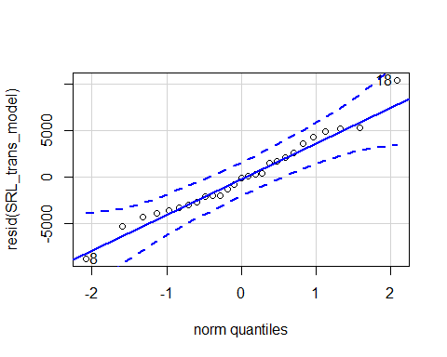

## [1] 18 8

hist(resid(SRL_trans_model))

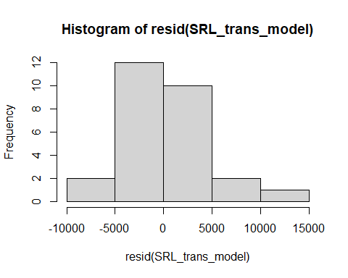

shapiro.test(resid(SRL_trans_model))

##   
## Shapiro-Wilk normality test  
##   
## data: resid(SRL_trans_model)  
## W = 0.97902, p-value = 0.8396

Raw Statistical output

anova(SRL_trans_model)

## Type III Analysis of Variance Table with Satterthwaite's method  
## Sum Sq Mean Sq NumDF DenDF F value Pr(>F)   
## precip 119509598 119509598 1 18.017 5.5697 0.02975 *  
## soil_root 33012605 16506303 2 17.454 0.7693 0.47843   
## precip:soil_root 174500103 87250052 2 17.454 4.0663 0.03551 *  
## ---  
## Signif. codes: 0 '***' 0.001 '**' 0.01 '*' 0.05 '.' 0.1 ' ' 1

emmeans(SRL_trans_model, pairwise~soil_root|precip)

## Note: Use 'contrast(regrid(object), ...)' to obtain contrasts of back-transformed estimates

## $emmeans  
## precip = A:  
## soil_root emmean SE df lower.CL upper.CL  
## L.B 14406 2145 20.6 9939 18873  
## S.B 10446 2145 20.6 5979 14913  
## L.R 11348 2145 20.6 6882 15815  
##   
## precip = D:  
## soil_root emmean SE df lower.CL upper.CL  
## L.B 12476 2145 20.6 8009 16942  
## S.B 21317 2844 21.0 15402 27232  
## L.R 15338 2430 20.8 10282 20394  
##   
## Degrees-of-freedom method: kenward-roger   
## Results are given on the ( (not the response) scale.   
## Confidence level used: 0.95   
##   
## $contrasts  
## precip = A:  
## contrast estimate SE df t.ratio p.value  
## L.B - S.B 3960 2930 17.1 1.352 0.3872   
## L.B - L.R 3058 2930 17.1 1.044 0.5604   
## S.B - L.R -902 2930 17.1 -0.308 0.9492   
##   
## precip = D:  
## contrast estimate SE df t.ratio p.value  
## L.B - S.B -8841 3474 18.2 -2.545 0.0504   
## L.B - L.R -2862 3144 17.6 -0.910 0.6411   
## S.B - L.R 5979 3593 17.7 1.664 0.2462   
##   
## Note: contrasts are still on the ( scale   
## Degrees-of-freedom method: kenward-roger   
## P value adjustment: tukey method for comparing a family of 3 estimates

Formatted Anova table

SRL

|  |  |  |  |  |
| --- | --- | --- | --- | --- |
|  | Df | Resid.Df | F.value | P.value |
| precip | 1 | 18.02 | 5.57 | 0.030 |
| soil_root | 2 | 17.45 | 0.77 | 0.478 |
| precip:soil_root | 2 | 17.45 | 4.07 | 0.036 |
| Graph for publicati | on |  |  |  |

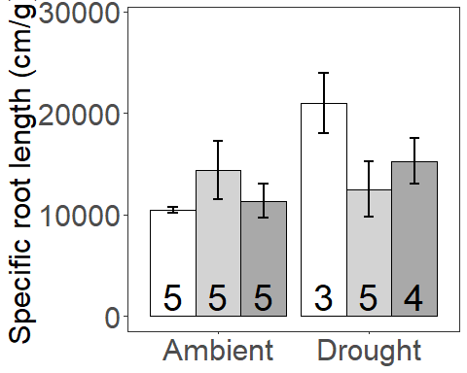

### Presence specific root length

Diagnostic Graphs

SG_roottraits_pres=subset(SG_roottraits_trt, root_association =="B")  
  
SRL_trans_model_pres= lmer((SRL_length_drymass)~precip*soil_root+(1|block), data= SG_roottraits_pres)  
qqPlot(resid(SRL_trans_model_pres))

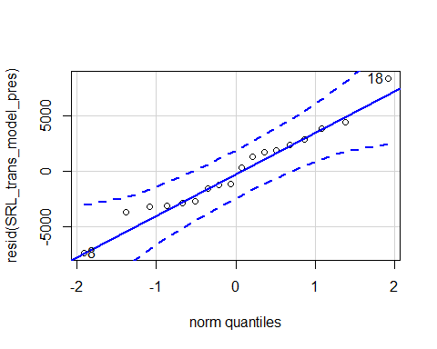

## 18 8   
## 9 4

hist(resid(SRL_trans_model_pres))

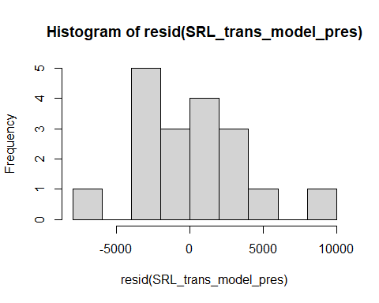

shapiro.test(resid(SRL_trans_model_pres))

##   
## Shapiro-Wilk normality test  
##   
## data: resid(SRL_trans_model_pres)  
## W = 0.97446, p-value = 0.876

Raw Statistical output

anova(SRL_trans_model_pres)

## Type III Analysis of Variance Table with Satterthwaite's method  
## Sum Sq Mean Sq NumDF DenDF F value Pr(>F)   
## precip 95886515 95886515 1 10.131 4.8407 0.05209 .  
## soil_root 31805805 31805805 1 10.131 1.6057 0.23345   
## precip:soil_root 188806702 188806702 1 10.131 9.5317 0.01133 *  
## ---  
## Signif. codes: 0 '***' 0.001 '**' 0.01 '*' 0.05 '.' 0.1 ' ' 1

emmeans(SRL_trans_model_pres, pairwise~soil_root|precip)

## Note: Use 'contrast(regrid(object), ...)' to obtain contrasts of back-transformed estimates

## $emmeans  
## precip = A:  
## soil_root emmean SE df lower.CL upper.CL  
## L.B 14406 2304 12.0 9387 19424  
## S.B 10446 2304 12.0 5428 15464  
##   
## precip = D:  
## soil_root emmean SE df lower.CL upper.CL  
## L.B 12476 2304 12.0 7457 17494  
## S.B 21949 2987 13.8 15532 28366  
##   
## Degrees-of-freedom method: kenward-roger   
## Results are given on the ( (not the response) scale.   
## Confidence level used: 0.95   
##   
## $contrasts  
## precip = A:  
## contrast estimate SE df t.ratio p.value  
## L.B - S.B 3960 2815 10.0 1.407 0.1897   
##   
## precip = D:  
## contrast estimate SE df t.ratio p.value  
## L.B - S.B -9473 3397 10.8 -2.789 0.0180   
##   
## Note: contrasts are still on the ( scale   
## Degrees-of-freedom method: kenward-roger

Formatted Anova table

SRL

|  |  |  |  |  |
| --- | --- | --- | --- | --- |
|  | Df | Resid.Df | F.value | P.value |
| precip | 1 | 10.13 | 4.84 | 0.052 |
| soil_root | 1 | 10.13 | 1.61 | 0.233 |
| precip:soil_root | 1 | 10.13 | 9.53 | 0.011 |

### Origin specific root length

Diagnostic Graphs

SG_roottraits_orig=subset(SG_roottraits_trt,soil_status =="L")  
SRL_trans_model_orig= lmer((SRL_length_drymass)~precip*soil_root+(1|block), data= SG_roottraits_orig)  
qqPlot(resid(SRL_trans_model_orig))

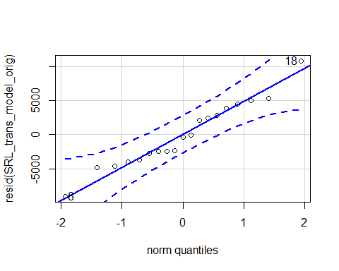

## 18 8   
## 15 8

hist(resid(SRL_trans_model_orig))

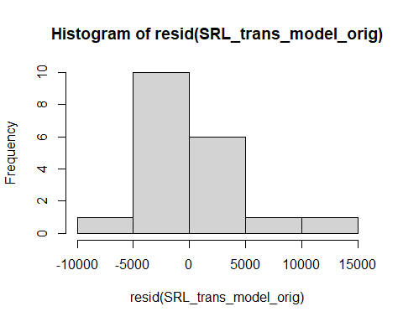

shapiro.test(resid(SRL_trans_model_orig))

##   
## Shapiro-Wilk normality test  
##   
## data: resid(SRL_trans_model_orig)  
## W = 0.968, p-value = 0.7359

Raw Statistical output

anova(SRL_trans_model_orig)

## Type III Analysis of Variance Table with Satterthwaite's method  
## Sum Sq Mean Sq NumDF DenDF F value Pr(>F)  
## precip 4777217 4777217 1 11.588 0.1724 0.6856  
## soil_root 66735 66735 1 11.588 0.0024 0.9617  
## precip:soil_root 40567718 40567718 1 11.588 1.4637 0.2504

emmeans(SRL_trans_model_orig, pairwise~soil_root|precip)

## Note: Use 'contrast(regrid(object), ...)' to obtain contrasts of back-transformed estimates

## $emmeans  
## precip = A:  
## soil_root emmean SE df lower.CL upper.CL  
## L.B 14406 2390 15 9312 19500  
## L.R 11348 2390 15 6254 16443  
##   
## precip = D:  
## soil_root emmean SE df lower.CL upper.CL  
## L.B 12476 2390 15 7381 17570  
## L.R 15295 2741 15 9452 21138  
##   
## Degrees-of-freedom method: kenward-roger   
## Results are given on the ( (not the response) scale.   
## Confidence level used: 0.95   
##   
## $contrasts  
## precip = A:  
## contrast estimate SE df t.ratio p.value  
## L.B - L.R 3058 3330 11.0 0.918 0.3781   
##   
## precip = D:  
## contrast estimate SE df t.ratio p.value  
## L.B - L.R -2819 3590 11.6 -0.785 0.4480   
##   
## Note: contrasts are still on the ( scale   
## Degrees-of-freedom method: kenward-roger

Formatted Anova table

SRL

|  |  |  |  |  |
| --- | --- | --- | --- | --- |
|  | Df | Resid.Df | F.value | P.value |
| precip | 1 | 11.59 | 0.17 | 0.686 |
| soil_root | 1 | 11.59 | 0.00 | 0.962 |
| precip:soil_root | 1 | 11.59 | 1.46 | 0.250 |

### Root length density

Diagnostic Graphs

RLD_trans_model= lmer((RLD_length_volume)~precip*soil_root+(1|block), data= SG_roottraits_trt)  
qqPlot(resid(RLD_trans_model))

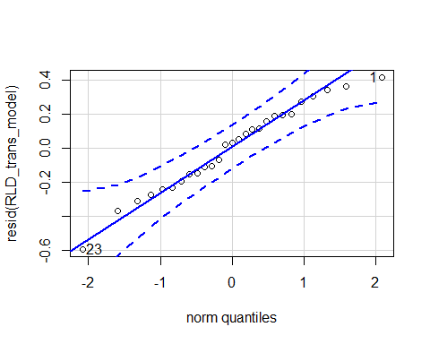

## [1] 23 1

hist(resid(RLD_trans_model))

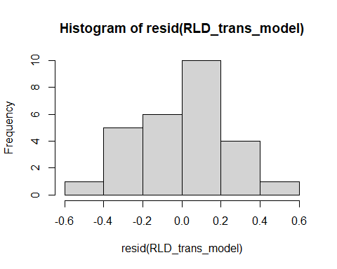 Raw Statistical output

anova(RLD_trans_model, type=3)

## Type III Analysis of Variance Table with Satterthwaite's method  
## Sum Sq Mean Sq NumDF DenDF F value Pr(>F)   
## precip 0.4102 0.4102 1 16.865 5.0491 0.038322 *   
## soil_root 6.3528 3.1764 2 16.061 39.0983 6.734e-07 ***  
## precip:soil_root 1.2403 0.6201 2 16.061 7.6332 0.004677 **   
## ---  
## Signif. codes: 0 '***' 0.001 '**' 0.01 '*' 0.05 '.' 0.1 ' ' 1

emmeans(RLD_trans_model, pairwise~soil_root|precip)

## Note: Use 'contrast(regrid(object), ...)' to obtain contrasts of back-transformed estimates

## $emmeans  
## precip = A:  
## soil_root emmean SE df lower.CL upper.CL  
## L.B 0.548 0.130 20.9 0.277 0.818  
## S.B 2.071 0.130 20.9 1.801 2.342  
## L.R 0.487 0.130 20.9 0.216 0.757  
##   
## precip = D:  
## soil_root emmean SE df lower.CL upper.CL  
## L.B 0.472 0.130 20.9 0.202 0.743  
## S.B 1.195 0.173 21.0 0.835 1.555  
## L.R 0.683 0.148 20.9 0.376 0.990  
##   
## Degrees-of-freedom method: kenward-roger   
## Results are given on the ( (not the response) scale.   
## Confidence level used: 0.95   
##   
## $contrasts  
## precip = A:  
## contrast estimate SE df t.ratio p.value  
## L.B - S.B -1.5238 0.180 17.1 -8.453 <.0001   
## L.B - L.R 0.0609 0.180 17.1 0.338 0.9393   
## S.B - L.R 1.5847 0.180 17.1 8.791 <.0001   
##   
## precip = D:  
## contrast estimate SE df t.ratio p.value  
## L.B - S.B -0.7229 0.214 18.4 -3.384 0.0086   
## L.B - L.R -0.2109 0.193 17.7 -1.091 0.5318   
## S.B - L.R 0.5119 0.221 17.8 2.315 0.0794   
##   
## Note: contrasts are still on the ( scale   
## Degrees-of-freedom method: kenward-roger   
## P value adjustment: tukey method for comparing a family of 3 estimates

Formatted Anova table

RLD

|  |  |  |  |  |
| --- | --- | --- | --- | --- |
|  | Df | Resid.Df | F.value | P.value |
| precip | 1 | 16.86 | 5.05 | 0.038 |
| soil_root | 2 | 16.06 | 39.10 | 0.000 |
| precip:soil_root | 2 | 16.06 | 7.63 | 0.005 |
| [](MERDS_R_code_SG | _reAna | lysis_202008 | 28_files/fi | gure-docx/unnamed-chunk-131-1.png) |

## Rhizosheath

Diagnostic Graphs

rhizosheath_model= lmer(log(RhizosheathSoil_DryRoots_g +1)~precip*soil_root+(1|block), data= SG_roottraits_trt)

## boundary (singular) fit: see ?isSingular

qqPlot(resid(rhizosheath_model))

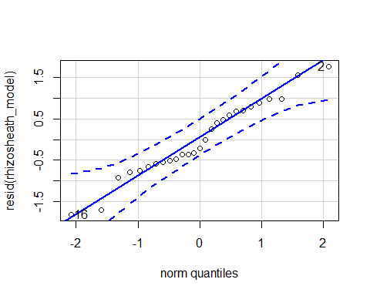

## [1] 16 2

hist(resid(rhizosheath_model))

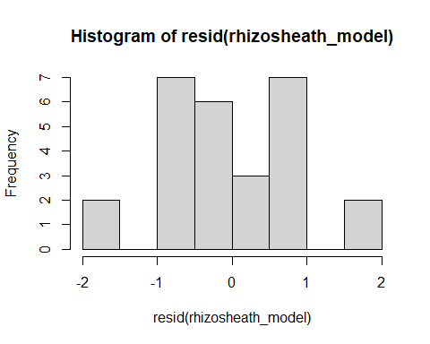

shapiro.test(resid(rhizosheath_model))

##   
## Shapiro-Wilk normality test  
##   
## data: resid(rhizosheath_model)  
## W = 0.97019, p-value = 0.6068

#0.6068

Raw Statistical output

anova(rhizosheath_model, type=3)

## Type III Analysis of Variance Table with Satterthwaite's method  
## Sum Sq Mean Sq NumDF DenDF F value Pr(>F)   
## precip 0.1008 0.10081 1 21 0.1016 0.75304   
## soil_root 5.1477 2.57383 2 21 2.5945 0.09841 .  
## precip:soil_root 0.1843 0.09213 2 21 0.0929 0.91169   
## ---  
## Signif. codes: 0 '***' 0.001 '**' 0.01 '*' 0.05 '.' 0.1 ' ' 1

Formatted Anova table

Rhizosheath

|  |  |  |  |  |
| --- | --- | --- | --- | --- |
|  | Df | Resid.Df | F.value | P.value |
| precip | 1 | 21 | 0.10 | 0.753 |
| soil_root | 2 | 21 | 2.59 | 0.098 |
| precip:soil_root | 2 | 21 | 0.09 | 0.912 |

Graph for publication 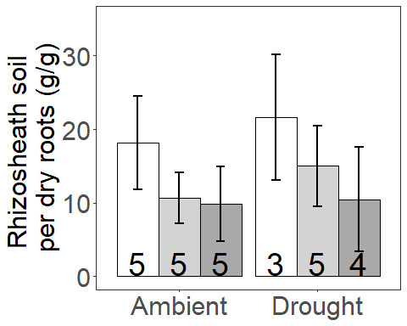

### Presence Rhizosheath

Diagnostic Graphs

SG_roottraits_pres=subset(SG_roottraits_trt, root_association =="B")  
  
rhizosheath_model_pres= lmer(log(RhizosheathSoil_DryRoots_g)~precip*soil_root+(1|block), data= SG_roottraits_pres)  
qqPlot(resid(rhizosheath_model_pres))

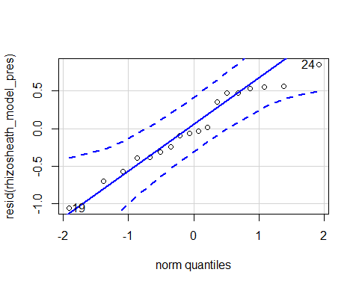

## 19 24   
## 10 15

hist(resid(rhizosheath_model_pres))

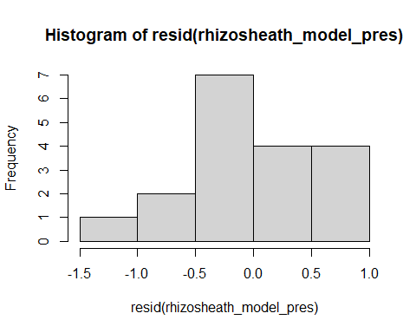

shapiro.test(resid(rhizosheath_model_pres))

##   
## Shapiro-Wilk normality test  
##   
## data: resid(rhizosheath_model_pres)  
## W = 0.95982, p-value = 0.5982

#0.5982

Raw Statistical output

anova(rhizosheath_model_pres, type=3)

## Type III Analysis of Variance Table with Satterthwaite's method  
## Sum Sq Mean Sq NumDF DenDF F value Pr(>F)   
## precip 0.59058 0.59058 1 10.064 1.4693 0.2531   
## soil_root 1.72540 1.72540 1 10.064 4.2926 0.0649 .  
## precip:soil_root 0.03550 0.03550 1 10.064 0.0883 0.7724   
## ---  
## Signif. codes: 0 '***' 0.001 '**' 0.01 '*' 0.05 '.' 0.1 ' ' 1

Formatted Anova table

Rhizosheath presence

|  |  |  |  |  |
| --- | --- | --- | --- | --- |
|  | Df | Resid.Df | F.value | P.value |
| precip | 1 | 10.06 | 1.47 | 0.253 |
| soil_root | 1 | 10.06 | 4.29 | 0.065 |
| precip:soil_root | 1 | 10.06 | 0.09 | 0.772 |
| ### Origin Rhizoshe | ath |  |  |  |

Diagnostic Graphs

SG_roottraits_orig=subset(SG_roottraits_trt,soil_status =="L")  
  
rhizosheath_model_orig= lmer(log(RhizosheathSoil_DryRoots_g+1)~precip*soil_root+(1|block), data= SG_roottraits_orig)

## boundary (singular) fit: see ?isSingular

qqPlot(resid(rhizosheath_model_orig))

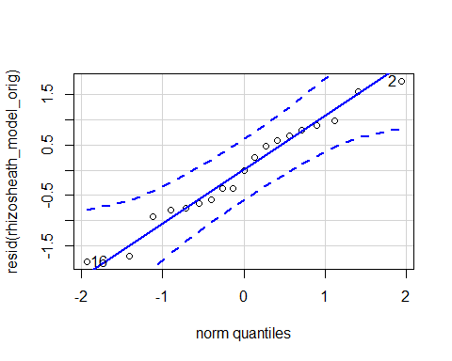

## 16 2   
## 13 2

hist(resid(rhizosheath_model_orig))

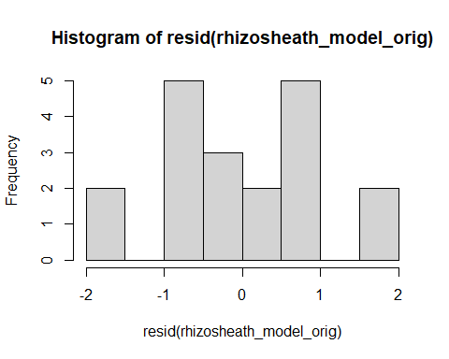

shapiro.test(resid(rhizosheath_model_orig))

##   
## Shapiro-Wilk normality test  
##   
## data: resid(rhizosheath_model_orig)  
## W = 0.96907, p-value = 0.7577

#0.7577

Raw Statistical output

anova(rhizosheath_model_orig, type=3)

## Type III Analysis of Variance Table with Satterthwaite's method  
## Sum Sq Mean Sq NumDF DenDF F value Pr(>F)  
## precip 0.02583 0.02583 1 15 0.0212 0.8862  
## soil_root 1.90925 1.90925 1 15 1.5649 0.2301  
## precip:soil_root 0.15779 0.15779 1 15 0.1293 0.7241

Formatted Anova table

Rhizosheath origin

|  |  |  |  |  |
| --- | --- | --- | --- | --- |
|  | Df | Resid.Df | F.value | P.value |
| precip | 1 | 15 | 0.02 | 0.886 |
| soil_root | 1 | 15 | 1.56 | 0.230 |
| precip:soil_root | 1 | 15 | 0.13 | 0.724 |

## Soil nitrogen

Diagnostic Graphs

SG_soil_nit_trans_model= lmer((ug_N_NO3_g_dry_soil)~precip*soil_root+(1|block), data= SG_inorg_N_trans_trt)  
qqPlot(resid(SG_soil_nit_trans_model))

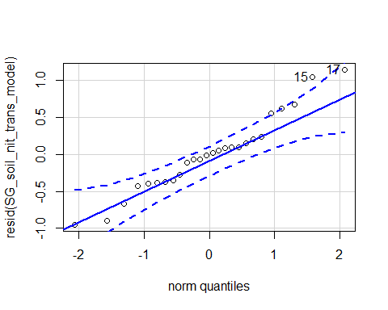

## 17 15   
## 4 2

hist(resid(SG_soil_nit_trans_model))

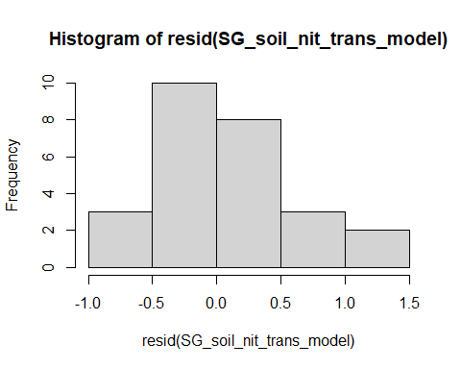

shapiro.test(resid(SG_soil_nit_trans_model))

##   
## Shapiro-Wilk normality test  
##   
## data: resid(SG_soil_nit_trans_model)  
## W = 0.96397, p-value = 0.4755

Raw Statistical output

anova(SG_soil_nit_trans_model, type=3)

## Type III Analysis of Variance Table with Satterthwaite's method  
## Sum Sq Mean Sq NumDF DenDF F value Pr(>F)   
## precip 5.3802 5.3802 1 16.868 15.2231 0.001162 **  
## soil_root 6.4455 3.2227 2 17.249 9.1186 0.001986 **  
## precip:soil_root 3.2720 1.6360 2 16.841 4.6289 0.025001 *   
## ---  
## Signif. codes: 0 '***' 0.001 '**' 0.01 '*' 0.05 '.' 0.1 ' ' 1

emmeans(SG_soil_nit_trans_model, pairwise~soil_root)

## NOTE: Results may be misleading due to involvement in interactions

## Note: Use 'contrast(regrid(object), ...)' to obtain contrasts of back-transformed estimates

## $emmeans  
## soil_root emmean SE df lower.CL upper.CL  
## L.B 4.42 0.230 14.5 3.93 4.92  
## S.B 3.44 0.201 13.6 3.01 3.87  
## L.R 4.52 0.234 16.0 4.03 5.02  
##   
## Results are averaged over the levels of: precip   
## Degrees-of-freedom method: kenward-roger   
## Results are given on the ( (not the response) scale.   
## Confidence level used: 0.95   
##   
## $contrasts  
## contrast estimate SE df t.ratio p.value  
## L.B - S.B 0.9848 0.289 17.4 3.413 0.0086   
## L.B - L.R -0.0989 0.307 16.8 -0.323 0.9445   
## S.B - L.R -1.0837 0.292 16.9 -3.715 0.0047   
##   
## Results are averaged over the levels of: precip   
## Note: contrasts are still on the ( scale   
## Degrees-of-freedom method: kenward-roger   
## P value adjustment: tukey method for comparing a family of 3 estimates

emmeans(SG_soil_nit_trans_model, pairwise~soil_root|precip)

## Note: Use 'contrast(regrid(object), ...)' to obtain contrasts of back-transformed estimates

## $emmeans  
## precip = A:  
## soil_root emmean SE df lower.CL upper.CL  
## L.B 3.86 0.312 19.8 3.21 4.51  
## S.B 3.45 0.275 19.6 2.87 4.02  
## L.R 3.69 0.275 19.6 3.11 4.26  
##   
## precip = D:  
## soil_root emmean SE df lower.CL upper.CL  
## L.B 4.99 0.312 19.8 4.34 5.64  
## S.B 3.43 0.275 19.6 2.86 4.01  
## L.R 5.36 0.365 20.0 4.59 6.12  
##   
## Degrees-of-freedom method: kenward-roger   
## Results are given on the ( (not the response) scale.   
## Confidence level used: 0.95   
##   
## $contrasts  
## precip = A:  
## contrast estimate SE df t.ratio p.value  
## L.B - S.B 0.409 0.403 16.8 1.015 0.5780   
## L.B - L.R 0.168 0.403 16.8 0.415 0.9099   
## S.B - L.R -0.242 0.376 16.1 -0.643 0.7986   
##   
## precip = D:  
## contrast estimate SE df t.ratio p.value  
## L.B - S.B 1.560 0.403 16.8 3.867 0.0034   
## L.B - L.R -0.365 0.462 16.8 -0.791 0.7133   
## S.B - L.R -1.925 0.446 17.4 -4.315 0.0012   
##   
## Note: contrasts are still on the ( scale   
## Degrees-of-freedom method: kenward-roger   
## P value adjustment: tukey method for comparing a family of 3 estimates

Formatted Anova table

Soil nitrate

|  |  |  |  |  |
| --- | --- | --- | --- | --- |
|  | Df | Resid.Df | F.value | P.value |
| precip | 1 | 16.87 | 15.22 | 0.001 |
| soil_root | 2 | 17.25 | 9.12 | 0.002 |
| precip:soil_root | 2 | 16.84 | 4.63 | 0.025 |
| Graph for publicati | on |  |  |  |
| [](MERDS_R_code_SG | _reAna | lysis_202008 | 28_files/fi | gure-docx/unnamed-chunk-146-1.png) |

## Presence nitrate transplant

Diagnostic Graphs

SG_inorg_N_trans_pres=subset(SG_inorg_N_trans_trt, root_association =="B")  
SG_soil_nit_trans_model_pres= lmer((ug_N_NO3_g_dry_soil)~precip*soil_root+(1|block), data= SG_inorg_N_trans_pres)  
qqPlot(resid(SG_soil_nit_trans_model_pres))

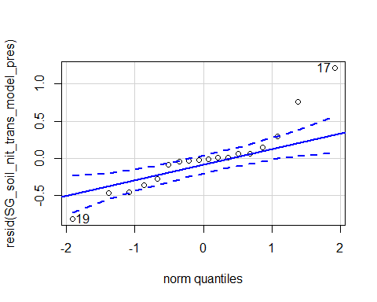

## 17 19   
## 1 3

hist(resid(SG_soil_nit_trans_model_pres))

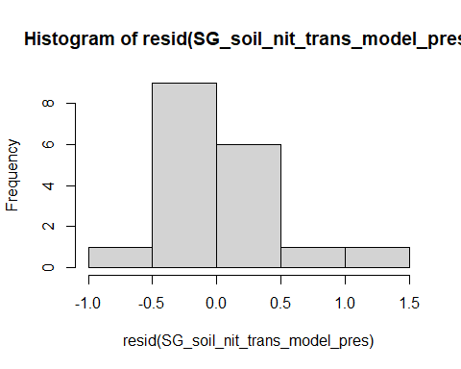

shapiro.test(resid(SG_soil_nit_trans_model_pres))

##   
## Shapiro-Wilk normality test  
##   
## data: resid(SG_soil_nit_trans_model_pres)  
## W = 0.89259, p-value = 0.04276

Raw Statistical output

anova(SG_soil_nit_trans_model_pres, type=3)

## Type III Analysis of Variance Table with Satterthwaite's method  
## Sum Sq Mean Sq NumDF DenDF F value Pr(>F)   
## precip 1.3872 1.3872 1 13.998 5.5927 0.033015 *   
## soil_root 4.2187 4.2187 1 13.998 17.0078 0.001033 **  
## precip:soil_root 1.4715 1.4715 1 13.998 5.9324 0.028831 *   
## ---  
## Signif. codes: 0 '***' 0.001 '**' 0.01 '*' 0.05 '.' 0.1 ' ' 1

emmeans(SG_soil_nit_trans_model_pres, pairwise~soil_root)

## NOTE: Results may be misleading due to involvement in interactions

## Note: Use 'contrast(regrid(object), ...)' to obtain contrasts of back-transformed estimates

## $emmeans  
## soil_root emmean SE df lower.CL upper.CL  
## L.B 4.41 0.183 10.2 4.01 4.82  
## S.B 3.44 0.157 10.2 3.09 3.79  
##   
## Results are averaged over the levels of: precip   
## Degrees-of-freedom method: kenward-roger   
## Results are given on the ( (not the response) scale.   
## Confidence level used: 0.95   
##   
## $contrasts  
## contrast estimate SE df t.ratio p.value  
## L.B - S.B 0.974 0.242 11.4 4.031 0.0018   
##   
## Results are averaged over the levels of: precip   
## Note: contrasts are still on the ( scale   
## Degrees-of-freedom method: kenward-roger

emmeans(SG_soil_nit_trans_model_pres, pairwise~soil_root|precip)

## Note: Use 'contrast(regrid(object), ...)' to obtain contrasts of back-transformed estimates

## $emmeans  
## precip = A:  
## soil_root emmean SE df lower.CL upper.CL  
## L.B 3.85 0.254 14 3.30 4.39  
## S.B 3.45 0.223 14 2.97 3.93  
##   
## precip = D:  
## soil_root emmean SE df lower.CL upper.CL  
## L.B 4.98 0.254 14 4.44 5.53  
## S.B 3.43 0.223 14 2.95 3.91  
##   
## Degrees-of-freedom method: kenward-roger   
## Results are given on the ( (not the response) scale.   
## Confidence level used: 0.95   
##   
## $contrasts  
## precip = A:  
## contrast estimate SE df t.ratio p.value  
## L.B - S.B 0.399 0.338 10.8 1.180 0.2632   
##   
## precip = D:  
## contrast estimate SE df t.ratio p.value  
## L.B - S.B 1.550 0.338 10.8 4.585 0.0008   
##   
## Note: contrasts are still on the ( scale   
## Degrees-of-freedom method: kenward-roger

Formatted Anova table

Soil nitrate

|  |  |  |  |  |
| --- | --- | --- | --- | --- |
|  | Df | Resid.Df | F.value | P.value |
| precip | 1 | 14 | 5.59 | 0.033 |
| soil_root | 1 | 14 | 17.01 | 0.001 |
| precip:soil_root | 1 | 14 | 5.93 | 0.029 |

## Origin nitrate transplant

Diagnostic Graphs

SG_inorg_N_trans_orig=subset(SG_inorg_N_trans_trt,soil_status =="L")  
SG_soil_nit_trans_model_orig= lmer((ug_N_NO3_g_dry_soil)~precip*soil_root+(1|block), data= SG_inorg_N_trans_orig)  
qqPlot(resid(SG_soil_nit_trans_model_orig))

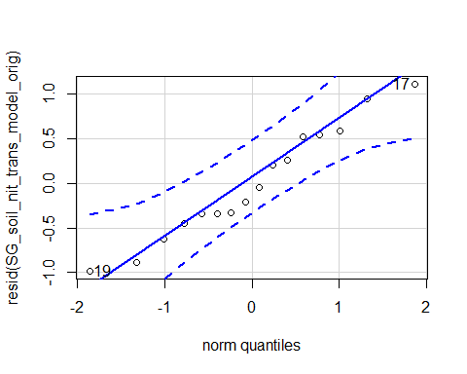

## 17 19   
## 4 6

hist(resid(SG_soil_nit_trans_model_orig))

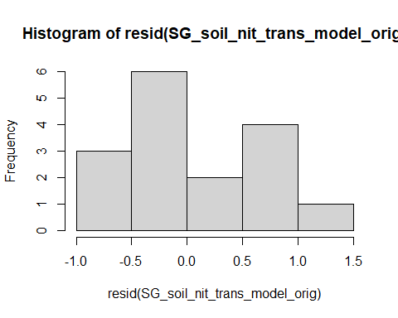

shapiro.test(resid(SG_soil_nit_trans_model_orig))

##   
## Shapiro-Wilk normality test  
##   
## data: resid(SG_soil_nit_trans_model_orig)  
## W = 0.96308, p-value = 0.7179

Raw Statistical output

anova(SG_soil_nit_trans_model_orig, type=3)

## Type III Analysis of Variance Table with Satterthwaite's method  
## Sum Sq Mean Sq NumDF DenDF F value Pr(>F)   
## precip 7.5837 7.5837 1 9.2345 14.0014 0.004408 **  
## soil_root 0.0385 0.0385 1 9.2345 0.0711 0.795559   
## precip:soil_root 0.2890 0.2890 1 9.2345 0.5335 0.483251   
## ---  
## Signif. codes: 0 '***' 0.001 '**' 0.01 '*' 0.05 '.' 0.1 ' ' 1

emmeans(SG_soil_nit_trans_model_orig, pairwise~soil_root)

## NOTE: Results may be misleading due to involvement in interactions

## Note: Use 'contrast(regrid(object), ...)' to obtain contrasts of back-transformed estimates

## $emmeans  
## soil_root emmean SE df lower.CL upper.CL  
## L.B 4.43 0.302 7.39 3.72 5.14  
## L.R 4.53 0.307 8.59 3.83 5.23  
##   
## Results are averaged over the levels of: precip   
## Degrees-of-freedom method: kenward-roger   
## Results are given on the ( (not the response) scale.   
## Confidence level used: 0.95   
##   
## $contrasts  
## contrast estimate SE df t.ratio p.value  
## L.B - L.R -0.1 0.383 8.99 -0.262 0.7992   
##   
## Results are averaged over the levels of: precip   
## Note: contrasts are still on the ( scale   
## Degrees-of-freedom method: kenward-roger

emmeans(SG_soil_nit_trans_model_orig, pairwise~soil_root|precip)

## Note: Use 'contrast(regrid(object), ...)' to obtain contrasts of back-transformed estimates

## $emmeans  
## precip = A:  
## soil_root emmean SE df lower.CL upper.CL  
## L.B 3.86 0.399 11.7 2.99 4.74  
## L.R 3.69 0.351 11.6 2.92 4.46  
##   
## precip = D:  
## soil_root emmean SE df lower.CL upper.CL  
## L.B 5.00 0.399 11.7 4.13 5.87  
## L.R 5.37 0.473 11.9 4.34 6.40  
##   
## Degrees-of-freedom method: kenward-roger   
## Results are given on the ( (not the response) scale.   
## Confidence level used: 0.95   
##   
## $contrasts  
## precip = A:  
## contrast estimate SE df t.ratio p.value  
## L.B - L.R 0.175 0.503 9.05 0.347 0.7362   
##   
## precip = D:  
## contrast estimate SE df t.ratio p.value  
## L.B - L.R -0.376 0.579 8.95 -0.649 0.5328   
##   
## Note: contrasts are still on the ( scale   
## Degrees-of-freedom method: kenward-roger

Formatted Anova table

Soil nitrate

|  |  |  |  |  |
| --- | --- | --- | --- | --- |
|  | Df | Resid.Df | F.value | P.value |
| precip | 1 | 9.23 | 14.00 | 0.004 |
| soil_root | 1 | 9.23 | 0.07 | 0.796 |
| precip:soil_root | 1 | 9.23 | 0.53 | 0.483 |

## Ammonium

Diagnostic Graphs

SG_soil_amm_trans_model= lmer(log(ug_N_NH4_g_dry_soil_negto0+0.007)~precip*soil_root+(1|block), data= SG_inorg_N_trans_trt)

## boundary (singular) fit: see ?isSingular

qqPlot(resid(SG_soil_amm_trans_model))

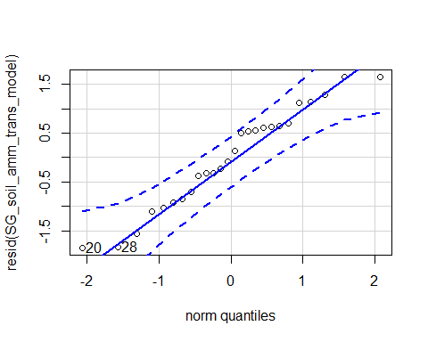

## 20 28   
## 7 15

hist(resid(SG_soil_amm_trans_model))

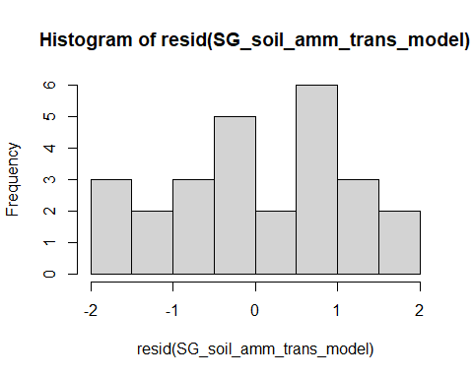

shapiro.test(resid(SG_soil_amm_trans_model))

##   
## Shapiro-Wilk normality test  
##   
## data: resid(SG_soil_amm_trans_model)  
## W = 0.96033, p-value = 0.3981

Raw Statistical output

anova(SG_soil_amm_trans_model, type=3)

## Type III Analysis of Variance Table with Satterthwaite's method  
## Sum Sq Mean Sq NumDF DenDF F value Pr(>F)   
## precip 7.010 7.0097 1 20 5.3624 0.03131 *   
## soil_root 43.257 21.6285 2 20 16.5458 5.755e-05 ***  
## precip:soil_root 8.962 4.4812 2 20 3.4281 0.05246 .   
## ---  
## Signif. codes: 0 '***' 0.001 '**' 0.01 '*' 0.05 '.' 0.1 ' ' 1

emmeans(SG_soil_amm_trans_model, pairwise~soil_root)

## NOTE: Results may be misleading due to involvement in interactions

## $emmeans  
## soil_root emmean SE df lower.CL upper.CL  
## L.B -2.8384 0.415 16.2 -3.718 -1.959  
## S.B 0.0188 0.362 16.2 -0.747 0.784  
## L.R -2.3990 0.428 17.7 -3.299 -1.499  
##   
## Results are averaged over the levels of: precip   
## Degrees-of-freedom method: kenward-roger   
## Results are given on the log(mu + 0.007) (not the response) scale.   
## Confidence level used: 0.95   
##   
## $contrasts  
## contrast estimate SE df t.ratio p.value  
## L.B - S.B -2.857 0.551 17.5 -5.188 0.0002   
## L.B - L.R -0.439 0.588 17.0 -0.747 0.7396   
## S.B - L.R 2.418 0.560 17.1 4.317 0.0013   
##   
## Results are averaged over the levels of: precip   
## Degrees-of-freedom method: kenward-roger   
## Results are given on the log (not the response) scale.   
## P value adjustment: tukey method for comparing a family of 3 estimates

emmeans(SG_soil_amm_trans_model, pairwise~soil_root|precip)

## $emmeans  
## precip = A:  
## soil_root emmean SE df lower.CL upper.CL  
## L.B -2.56 0.580 20 -3.7734 -1.3554  
## S.B -1.10 0.511 20 -2.1707 -0.0376  
## L.R -3.13 0.511 20 -4.2015 -2.0683  
##   
## precip = D:  
## soil_root emmean SE df lower.CL upper.CL  
## L.B -3.11 0.580 20 -4.3214 -1.9034  
## S.B 1.14 0.511 20 0.0751 2.2083  
## L.R -1.66 0.686 20 -3.0934 -0.2327  
##   
## Degrees-of-freedom method: kenward-roger   
## Results are given on the log(mu + 0.007) (not the response) scale.   
## Confidence level used: 0.95   
##   
## $contrasts  
## precip = A:  
## contrast estimate SE df t.ratio p.value  
## L.B - S.B -1.460 0.773 16.9 -1.889 0.1723   
## L.B - L.R 0.571 0.773 16.9 0.738 0.7447   
## S.B - L.R 2.031 0.723 16.2 2.808 0.0317   
##   
## precip = D:  
## contrast estimate SE df t.ratio p.value  
## L.B - S.B -4.254 0.773 16.9 -5.504 0.0001   
## L.B - L.R -1.449 0.888 17.1 -1.633 0.2593   
## S.B - L.R 2.805 0.855 17.7 3.279 0.0112   
##   
## Degrees-of-freedom method: kenward-roger   
## Results are given on the log (not the response) scale.   
## P value adjustment: tukey method for comparing a family of 3 estimates

Formatted Anova table

Soil ammonium

|  |  |  |  |  |
| --- | --- | --- | --- | --- |
|  | Df | Resid.Df | F.value | P.value |
| precip | 1 | 20 | 5.36 | 0.031 |
| soil_root | 2 | 20 | 16.55 | 0.000 |
| precip:soil_root | 2 | 20 | 3.43 | 0.052 |

Graph for publication 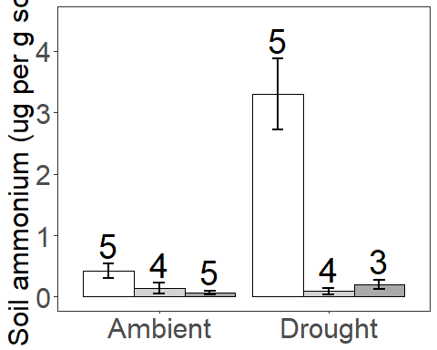

### Presence Amonnium

Diagnostic Graphs

SG_inorg_N_trans_pres=subset(SG_inorg_N_trans_trt, root_association =="B")  
  
SG_soil_amm_trans_model_pres= lmer(sqrt(ug_N_NH4_g_dry_soil_negto0)~precip*soil_root+(1|block), data= SG_inorg_N_trans_pres)

## boundary (singular) fit: see ?isSingular

qqPlot(resid(SG_soil_amm_trans_model_pres))

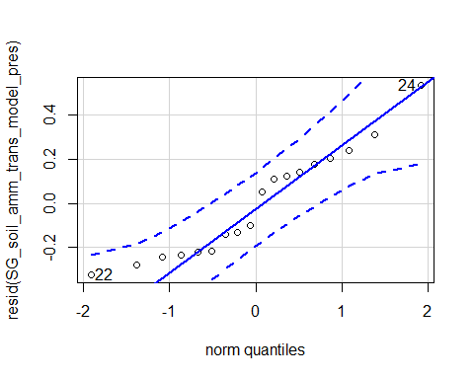

## 24 22   
## 8 6

hist(resid(SG_soil_amm_trans_model_pres))

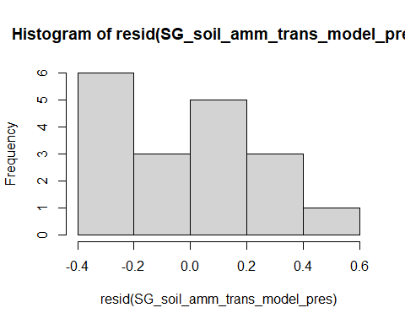

shapiro.test(resid(SG_soil_amm_trans_model_pres))

##   
## Shapiro-Wilk normality test  
##   
## data: resid(SG_soil_amm_trans_model_pres)  
## W = 0.93074, p-value = 0.2001

Raw Statistical output

anova(SG_soil_amm_trans_model_pres, type=3)

## Type III Analysis of Variance Table with Satterthwaite's method  
## Sum Sq Mean Sq NumDF DenDF F value Pr(>F)   
## precip 1.3408 1.3408 1 14 18.813 0.0006824 ***  
## soil_root 3.8066 3.8066 1 14 53.410 3.86e-06 ***  
## precip:soil_root 1.7746 1.7746 1 14 24.899 0.0001982 ***  
## ---  
## Signif. codes: 0 '***' 0.001 '**' 0.01 '*' 0.05 '.' 0.1 ' ' 1

emmeans(SG_soil_amm_trans_model_pres, pairwise~soil_root|precip)

## Note: Use 'contrast(regrid(object), ...)' to obtain contrasts of back-transformed estimates

## $emmeans  
## precip = A:  
## soil_root emmean SE df lower.CL upper.CL  
## L.B 0.317 0.136 14 0.0245 0.609  
## S.B 0.610 0.119 14 0.3543 0.866  
##   
## precip = D:  
## soil_root emmean SE df lower.CL upper.CL  
## L.B 0.234 0.136 14 -0.0581 0.526  
## S.B 1.792 0.119 14 1.5354 2.048  
##   
## Degrees-of-freedom method: kenward-roger   
## Results are given on the sqrt (not the response) scale.   
## Confidence level used: 0.95   
##   
## $contrasts  
## precip = A:  
## contrast estimate SE df t.ratio p.value  
## L.B - S.B -0.294 0.181 10.8 -1.620 0.1338   
##   
## precip = D:  
## contrast estimate SE df t.ratio p.value  
## L.B - S.B -1.557 0.181 10.8 -8.596 <.0001   
##   
## Note: contrasts are still on the sqrt scale   
## Degrees-of-freedom method: kenward-roger

Formatted Anova table

Soil ammonium presence

|  |  |  |  |  |
| --- | --- | --- | --- | --- |
|  | Df | Resid.Df | F.value | P.value |
| precip | 1 | 14 | 18.81 | 0.001 |
| soil_root | 1 | 14 | 53.41 | 0.000 |
| precip:soil_root | 1 | 14 | 24.90 | 0.000 |

### Origin ammonium transplant

Diagnostic Graphs

SG_inorg_N_trans_orig=subset(SG_inorg_N_trans_trt,soil_status =="L")  
  
SG_soil_amm_trans_model_orig= lmer((ug_N_NH4_g_dry_soil_negto0)~precip*soil_root+(1|block), data= SG_inorg_N_trans_orig)

## boundary (singular) fit: see ?isSingular

qqPlot(resid(SG_soil_amm_trans_model_orig))

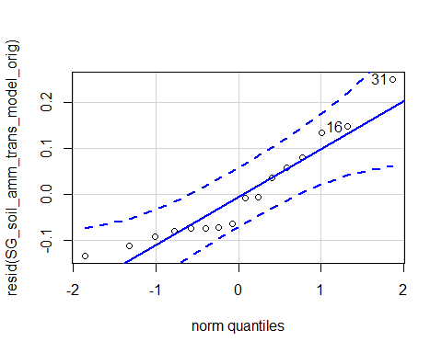

## 31 16   
## 13 3

hist(resid(SG_soil_amm_trans_model_orig))

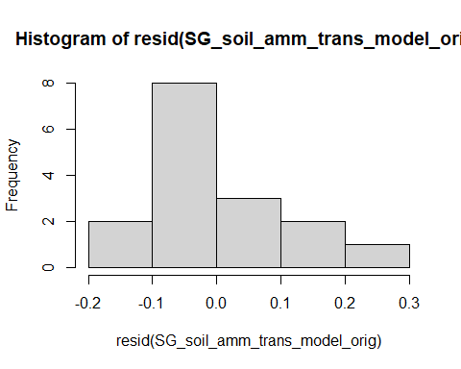

shapiro.test(resid(SG_soil_amm_trans_model_orig))

##   
## Shapiro-Wilk normality test  
##   
## data: resid(SG_soil_amm_trans_model_orig)  
## W = 0.9063, p-value = 0.1014

Raw Statistical output

anova(SG_soil_amm_trans_model_orig, type=3)

## Type III Analysis of Variance Table with Satterthwaite's method  
## Sum Sq Mean Sq NumDF DenDF F value Pr(>F)  
## precip 0.006632 0.006632 1 12 0.4456 0.5171  
## soil_root 0.001692 0.001692 1 12 0.1137 0.7418  
## precip:soil_root 0.033168 0.033168 1 12 2.2285 0.1613

emmeans(SG_soil_amm_trans_model_orig, pairwise~soil_root|precip)

## Note: Use 'contrast(regrid(object), ...)' to obtain contrasts of back-transformed estimates

## $emmeans  
## precip = A:  
## soil_root emmean SE df lower.CL upper.CL  
## L.B 0.1422 0.0618 12 0.00754 0.277  
## L.R 0.0705 0.0546 12 -0.04833 0.189  
##   
## precip = D:  
## soil_root emmean SE df lower.CL upper.CL  
## L.B 0.0910 0.0618 12 -0.04363 0.226  
## L.R 0.2045 0.0745 12 0.04209 0.367  
##   
## Degrees-of-freedom method: kenward-roger   
## Results are given on the ( (not the response) scale.   
## Confidence level used: 0.95   
##   
## $contrasts  
## precip = A:  
## contrast estimate SE df t.ratio p.value  
## L.B - L.R 0.0717 0.0824 9.12 0.869 0.4070   
##   
## precip = D:  
## contrast estimate SE df t.ratio p.value  
## L.B - L.R -0.1135 0.0958 9.27 -1.184 0.2657   
##   
## Note: contrasts are still on the ( scale   
## Degrees-of-freedom method: kenward-roger

Formatted Anova table

Soil ammonium origin

|  |  |  |  |  |
| --- | --- | --- | --- | --- |
|  | Df | Resid.Df | F.value | P.value |
| precip | 1 | 12 | 0.45 | 0.517 |
| soil_root | 1 | 12 | 0.11 | 0.742 |
| precip:soil_root | 1 | 12 | 2.23 | 0.161 |

## VWC Analyses

Diagnostic Graphs

SG_soil_VWC_model= lmer((percent_soil_moisture_dry_weight)~precip*soil_root*life_stage+(1|block), data= SG_inorg_N_trt)

## boundary (singular) fit: see ?isSingular

qqPlot(resid(SG_soil_VWC_model))

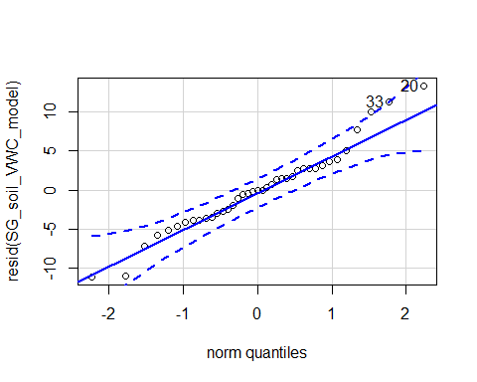

## [1] 20 33

hist(resid(SG_soil_VWC_model))

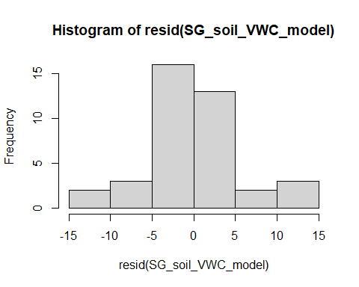

shapiro.test(resid(SG_soil_VWC_model))

##   
## Shapiro-Wilk normality test  
##   
## data: resid(SG_soil_VWC_model)  
## W = 0.96851, p-value = 0.3377

#0.3377

Raw Statistical output

anova(SG_soil_VWC_model, type=3)

## Type III Analysis of Variance Table with Satterthwaite's method  
## Sum Sq Mean Sq NumDF DenDF F value Pr(>F)   
## precip 307.117 307.117 1 27 7.9808 0.008782 **  
## soil_root 41.285 20.643 2 27 0.5364 0.590938   
## life_stage 135.010 135.010 1 27 3.5084 0.071923 .   
## precip:soil_root 22.074 11.037 2 27 0.2868 0.752914   
## precip:life_stage 0.405 0.405 1 27 0.0105 0.919080   
## soil_root:life_stage 13.084 6.542 2 27 0.1700 0.844555   
## precip:soil_root:life_stage 3.642 1.821 2 27 0.0473 0.953857   
## ---  
## Signif. codes: 0 '***' 0.001 '**' 0.01 '*' 0.05 '.' 0.1 ' ' 1

emmeans(SG_soil_VWC_model, pairwise~soil_root)

## NOTE: Results may be misleading due to involvement in interactions

## Note: Use 'contrast(regrid(object), ...)' to obtain contrasts of back-transformed estimates

## $emmeans  
## soil_root emmean SE df lower.CL upper.CL  
## L.B 11.96 2.17 21.0 7.45 16.5  
## S.B 8.86 2.20 23.1 4.32 13.4  
## L.R 10.60 1.80 16.9 6.81 14.4  
##   
## Results are averaged over the levels of: precip, life_stage   
## Degrees-of-freedom method: kenward-roger   
## Results are given on the ( (not the response) scale.   
## Confidence level used: 0.95   
##   
## $contrasts  
## contrast estimate SE df t.ratio p.value  
## L.B - S.B 3.10 3.06 25.0 1.011 0.5771   
## L.B - L.R 1.35 2.74 23.6 0.493 0.8753   
## S.B - L.R -1.74 2.82 24.7 -0.618 0.8117   
##   
## Results are averaged over the levels of: precip, life_stage   
## Note: contrasts are still on the ( scale   
## Degrees-of-freedom method: kenward-roger   
## P value adjustment: tukey method for comparing a family of 3 estimates

emmeans(SG_soil_VWC_model, pairwise~soil_root|precip)

## NOTE: Results may be misleading due to involvement in interactions  
## Note: Use 'contrast(regrid(object), ...)' to obtain contrasts of back-transformed estimates

## $emmeans  
## precip = A:  
## soil_root emmean SE df lower.CL upper.CL  
## L.B 15.40 2.43 24.2 10.396 20.4  
## S.B 11.00 2.68 25.7 5.489 16.5  
## L.R 14.83 2.09 24.1 10.524 19.1  
##   
## precip = D:  
## soil_root emmean SE df lower.CL upper.CL  
## L.B 8.51 3.68 26.4 0.958 16.1  
## S.B 6.73 3.59 26.5 -0.639 14.1  
## L.R 6.37 2.90 26.4 0.408 12.3  
##   
## Results are averaged over the levels of: life_stage   
## Degrees-of-freedom method: kenward-roger   
## Results are given on the ( (not the response) scale.   
## Confidence level used: 0.95   
##   
## $contrasts  
## precip = A:  
## contrast estimate SE df t.ratio p.value  
## L.B - S.B 4.408 3.63 25.7 1.213 0.4564   
## L.B - L.R 0.570 3.18 24.2 0.179 0.9825   
## S.B - L.R -3.838 3.39 24.7 -1.133 0.5033   
##   
## precip = D:  
## contrast estimate SE df t.ratio p.value  
## L.B - S.B 1.784 5.20 26.9 0.343 0.9373   
## L.B - L.R 2.136 4.53 24.1 0.472 0.8852   
## S.B - L.R 0.352 4.66 26.5 0.075 0.9969   
##   
## Results are averaged over the levels of: life_stage   
## Note: contrasts are still on the ( scale   
## Degrees-of-freedom method: kenward-roger   
## P value adjustment: tukey method for comparing a family of 3 estimates

Formatted Anova table

Soil VWC

|  |  |  |  |  |
| --- | --- | --- | --- | --- |
|  | Df | Resid.Df | F.value | P.value |
| precip | 1 | 27 | 7.98 | 0.009 |
| soil_root | 2 | 27 | 0.54 | 0.591 |
| life_stage | 1 | 27 | 3.51 | 0.072 |
| precip:soil_root | 2 | 27 | 0.29 | 0.753 |
| precip:life_stage | 1 | 27 | 0.01 | 0.919 |
| soil_root:life_stage | 2 | 27 | 0.17 | 0.845 |
| precip:soil_root:life_stage | 2 | 27 | 0.05 | 0.954 |

# Start Soil nitrogen

## Soil nitrate

Diagnostic Graphs

SG_start_inorg_N$soil_root=with(SG_start_inorg_N, interaction(soil_status,root_association))  
  
SG_Soil_nit_start= lm((ug_N_NO3_g_dry_soil)~soil_root+block, data= SG_start_inorg_N)  
qqPlot(resid(SG_Soil_nit_start))

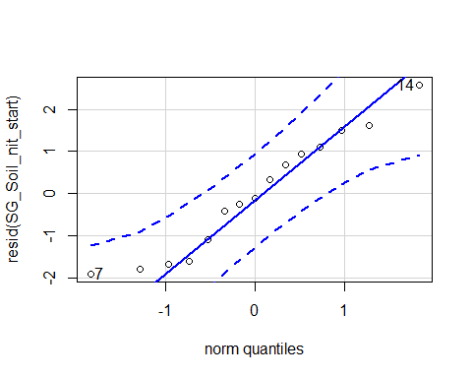

## [1] 14 7

hist(resid(SG_Soil_nit_start))

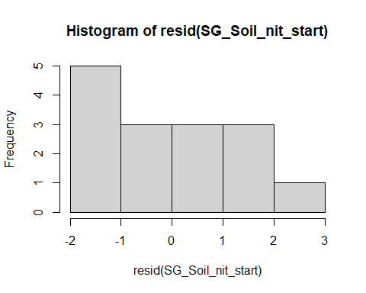

shapiro.test(resid(SG_Soil_nit_start))

##   
## Shapiro-Wilk normality test  
##   
## data: resid(SG_Soil_nit_start)  
## W = 0.94653, p-value = 0.4716

Raw Statistical output

Anova(SG_Soil_nit_start,type = 3)

## Anova Table (Type III tests)  
##   
## Response: (ug_N_NO3_g_dry_soil)  
## Sum Sq Df F value Pr(>F)   
## (Intercept) 124.752 1 49.7581 2.116e-05 ***  
## soil_root 3.977 2 0.7931 0.4767   
## block 3.893 1 1.5529 0.2386   
## Residuals 27.579 11   
## ---  
## Signif. codes: 0 '***' 0.001 '**' 0.01 '*' 0.05 '.' 0.1 ' ' 1

Formatted Anova table

Soil Nitrate

|  |  |  |  |
| --- | --- | --- | --- |
|  | Df | F.value | P.value |
| (Intercept) | 1 | 49.76 | 0.000 |
| soil_root | 2 | 0.79 | 0.477 |
| block | 1 | 1.55 | 0.239 |
| Residuals | 11 | NA | NA |

Graph for publication 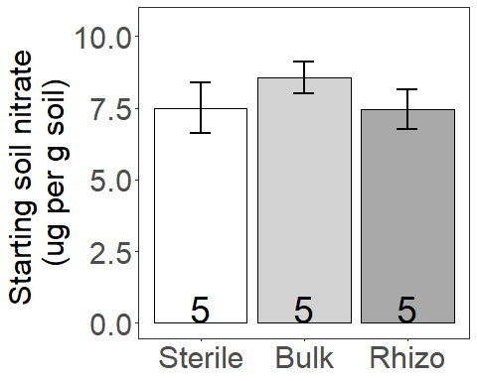

### Presence Start SOil nitrate

Diagnostic Graphs

SG_start_inorg_N_pres=subset(SG_start_inorg_N, root_association =="B")  
  
SG_Soil_nit_start_pres= lm((ug_N_NO3_g_dry_soil)~soil_root+block, data= SG_start_inorg_N_pres)  
qqPlot(resid(SG_Soil_nit_start_pres))

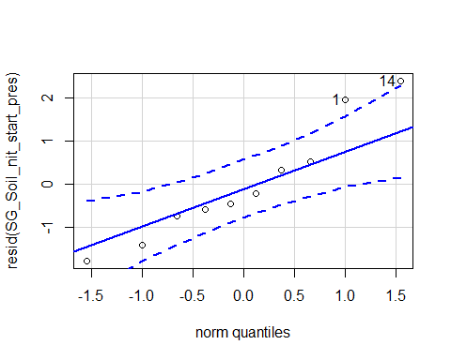

## 14 1   
## 9 1

hist(resid(SG_Soil_nit_start_pres))

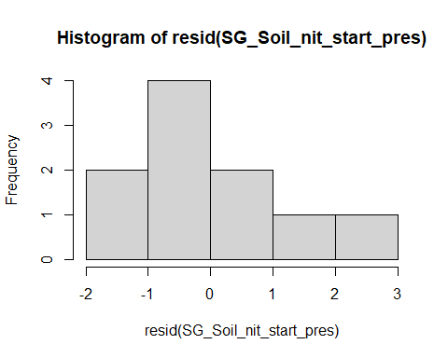

shapiro.test(resid(SG_Soil_nit_start_pres))

##   
## Shapiro-Wilk normality test  
##   
## data: resid(SG_Soil_nit_start_pres)  
## W = 0.93286, p-value = 0.4766

Raw Statistical output

Anova(SG_Soil_nit_start_pres,type = 3)

## Anova Table (Type III tests)  
##   
## Response: (ug_N_NO3_g_dry_soil)  
## Sum Sq Df F value Pr(>F)   
## (Intercept) 75.236 1 32.3655 0.0007437 ***  
## soil_root 2.846 1 1.2242 0.3051005   
## block 5.728 1 2.4643 0.1604494   
## Residuals 16.272 7   
## ---  
## Signif. codes: 0 '***' 0.001 '**' 0.01 '*' 0.05 '.' 0.1 ' ' 1

Formatted Anova table

Soil Nitrate

|  |  |  |  |
| --- | --- | --- | --- |
|  | Df | F.value | P.value |
| (Intercept) | 1 | 32.37 | 0.001 |
| soil_root | 1 | 1.22 | 0.305 |
| block | 1 | 2.46 | 0.160 |
| Residuals | 7 | NA | NA |

### Origin Start SOil nitrate

Diagnostic Graphs

SG_start_inorg_N_orig=subset(SG_start_inorg_N, soil_status =="L")  
  
SG_Soil_nit_start_orig= lm((ug_N_NO3_g_dry_soil)^3~soil_root+block, data= SG_start_inorg_N_orig)  
qqPlot(resid(SG_Soil_nit_start_orig))

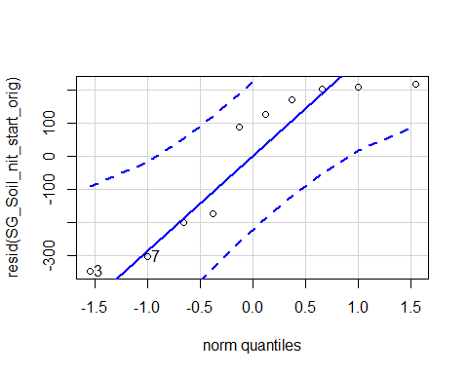

## [1] 3 7

hist(resid(SG_Soil_nit_start_orig))

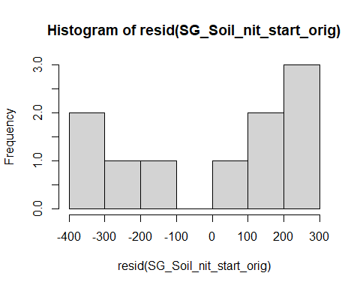

shapiro.test(resid(SG_Soil_nit_start_orig))

##   
## Shapiro-Wilk normality test  
##   
## data: resid(SG_Soil_nit_start_orig)  
## W = 0.82833, p-value = 0.03194

boxCox(SG_Soil_nit_start_orig)

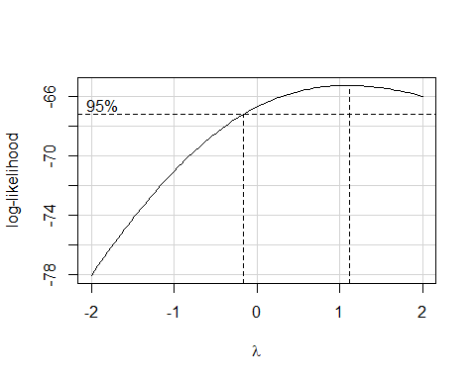 Raw Statistical output

Anova(SG_Soil_nit_start_orig,type = 3)

## Anova Table (Type III tests)  
##   
## Response: (ug_N_NO3_g_dry_soil)^3  
## Sum Sq Df F value Pr(>F)   
## (Intercept) 496747 1 7.4104 0.02967 *  
## soil_root 104794 1 1.5633 0.25136   
## block 2696 1 0.0402 0.84675   
## Residuals 469239 7   
## ---  
## Signif. codes: 0 '***' 0.001 '**' 0.01 '*' 0.05 '.' 0.1 ' ' 1

Formatted Anova table

Soil Nitrate

|  |  |  |  |
| --- | --- | --- | --- |
|  | Df | F.value | P.value |
| (Intercept) | 1 | 7.41 | 0.030 |
| soil_root | 1 | 1.56 | 0.251 |
| block | 1 | 0.04 | 0.847 |
| Residuals | 7 | NA | NA |

## Soil ammonium

Diagnostic Graphs

SG_start_inorg_N$soil_root=with(SG_start_inorg_N, interaction(soil_status,root_association))  
  
SG_Soil_amm_start= lm(log(ug_N_NH4_g_dry_soil)~soil_root+block, data= SG_start_inorg_N)  
qqPlot(resid(SG_Soil_amm_start))

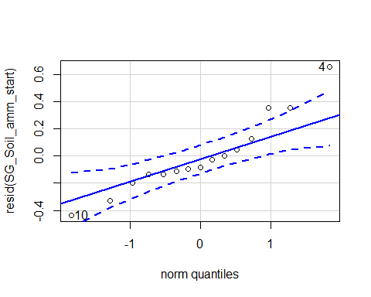

## [1] 4 10

hist(resid(SG_Soil_amm_start))

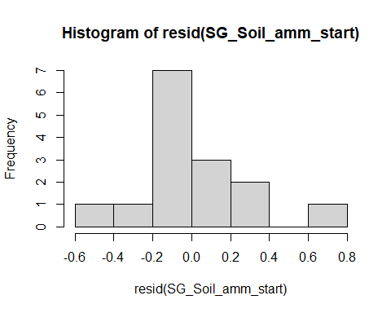

shapiro.test(resid(SG_Soil_amm_start))

##   
## Shapiro-Wilk normality test  
##   
## data: resid(SG_Soil_amm_start)  
## W = 0.93105, p-value = 0.2829

boxCox(SG_Soil_amm_start)

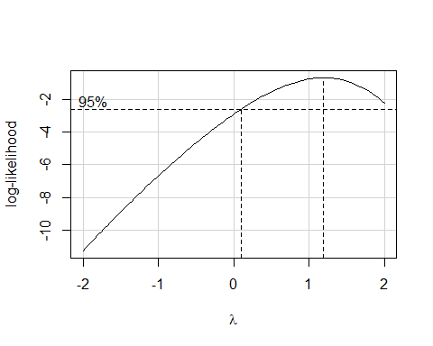 Raw Statistical output

Anova(SG_Soil_amm_start,type = 3)

## Anova Table (Type III tests)  
##   
## Response: log(ug_N_NH4_g_dry_soil)  
## Sum Sq Df F value Pr(>F)   
## (Intercept) 9.9251 1 98.8744 7.823e-07 ***  
## soil_root 12.6065 2 62.7930 9.615e-07 ***  
## block 0.0374 1 0.3728 0.5539   
## Residuals 1.1042 11   
## ---  
## Signif. codes: 0 '***' 0.001 '**' 0.01 '*' 0.05 '.' 0.1 ' ' 1

Formatted Anova table

Soil Ammonium

|  |  |  |  |
| --- | --- | --- | --- |
|  | Df | F.value | P.value |
| (Intercept) | 1 | 98.87 | 0.000 |
| soil_root | 2 | 62.79 | 0.000 |
| block | 1 | 0.37 | 0.554 |
| Residuals | 11 | NA | NA |

Graph for publication 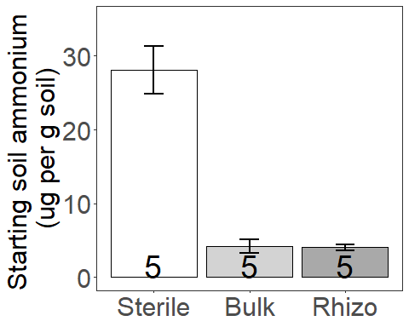

### Presence Start SOil Ammonium

Diagnostic Graphs

SG_start_inorg_N_pres=subset(SG_start_inorg_N, root_association =="B")  
  
SG_Soil_amm_start_pres= lm((ug_N_NH4_g_dry_soil)~soil_root+block, data= SG_start_inorg_N_pres)  
qqPlot(resid(SG_Soil_amm_start_pres))

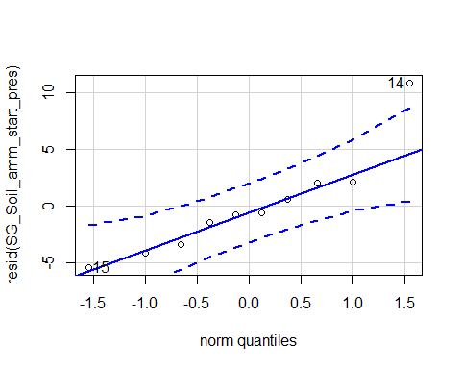

## 14 15   
## 9 10

hist(resid(SG_Soil_amm_start_pres))

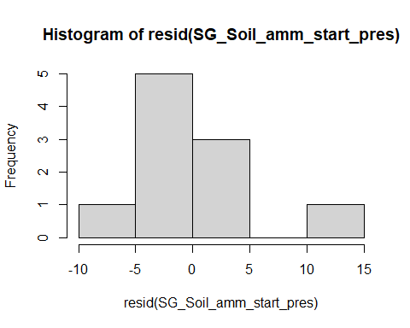

shapiro.test(resid(SG_Soil_amm_start_pres))

##   
## Shapiro-Wilk normality test  
##   
## data: resid(SG_Soil_amm_start_pres)  
## W = 0.87313, p-value = 0.1087

boxCox(SG_Soil_amm_start_pres)

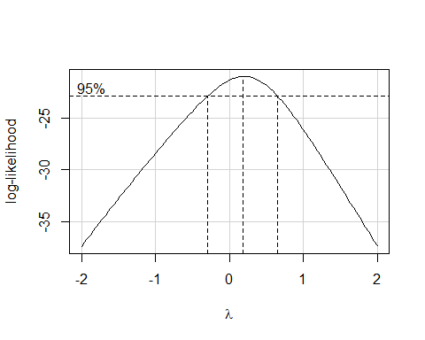 Raw Statistical output

Anova(SG_Soil_amm_start_pres,type = 3)

## Anova Table (Type III tests)  
##   
## Response: (ug_N_NH4_g_dry_soil)  
## Sum Sq Df F value Pr(>F)   
## (Intercept) 247.50 1 9.3004 0.0185923 *   
## soil_root 1423.78 1 53.5011 0.0001608 ***  
## block 44.24 1 1.6626 0.2382233   
## Residuals 186.29 7   
## ---  
## Signif. codes: 0 '***' 0.001 '**' 0.01 '*' 0.05 '.' 0.1 ' ' 1

Formatted Anova table

Soil Ammonium

|  |  |  |  |
| --- | --- | --- | --- |
|  | Df | F.value | P.value |
| (Intercept) | 1 | 9.30 | 0.019 |
| soil_root | 1 | 53.50 | 0.000 |
| block | 1 | 1.66 | 0.238 |
| Residuals | 7 | NA | NA |

### Origin Start SOil Ammonium

Diagnostic Graphs

SG_start_inorg_N_orig=subset(SG_start_inorg_N, soil_status =="L")  
  
SG_Soil_amm_start_orig= lm((ug_N_NH4_g_dry_soil)^-1~soil_root+block, data= SG_start_inorg_N_orig)  
qqPlot(resid(SG_Soil_amm_start_orig))

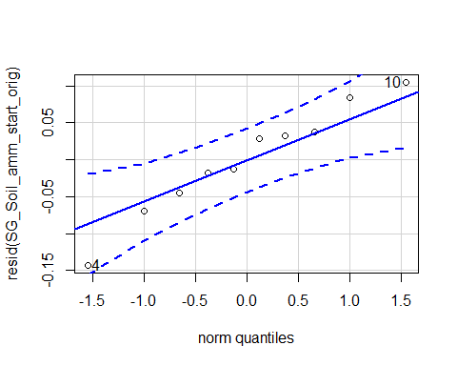

## [1] 4 10

hist(resid(SG_Soil_amm_start_orig))

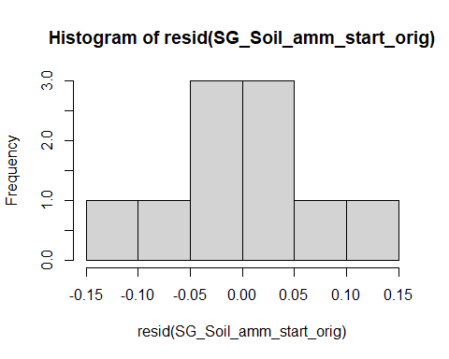

shapiro.test(resid(SG_Soil_amm_start_orig))

##   
## Shapiro-Wilk normality test  
##   
## data: resid(SG_Soil_amm_start_orig)  
## W = 0.96944, p-value = 0.8856

boxCox(SG_Soil_amm_start_orig)

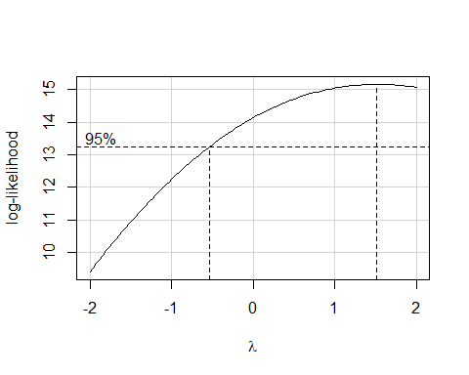 Raw Statistical output

Anova(SG_Soil_amm_start_orig,type = 3)

## Anova Table (Type III tests)  
##   
## Response: (ug_N_NH4_g_dry_soil)^-1  
## Sum Sq Df F value Pr(>F)   
## (Intercept) 0.128490 1 18.228 0.003704 **  
## soil_root 0.000268 1 0.038 0.850978   
## block 0.000000 1 0.000 0.996817   
## Residuals 0.049344 7   
## ---  
## Signif. codes: 0 '***' 0.001 '**' 0.01 '*' 0.05 '.' 0.1 ' ' 1

Formatted Anova table

Soil Ammonium

|  |  |  |  |
| --- | --- | --- | --- |
|  | Df | F.value | P.value |
| (Intercept) | 1 | 18.23 | 0.004 |
| soil_root | 1 | 0.04 | 0.851 |
| block | 1 | 0.00 | 0.997 |
| Residuals | 7 | NA | NA |

## Total organic carbon

Diagnostic Graphs

SG_Soil_DOC_mod= lm(log(unfumigated_DOC_concentration_ugC_gsoil)~soil_root+block, data= SG_MBC_DOC_trt)  
qqPlot(resid(SG_Soil_DOC_mod))

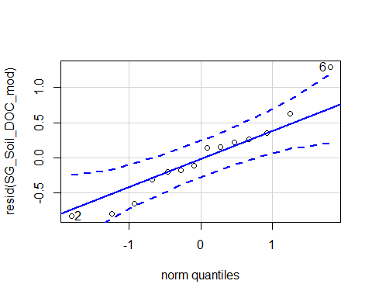

## [1] 6 2

hist(resid(SG_Soil_DOC_mod))

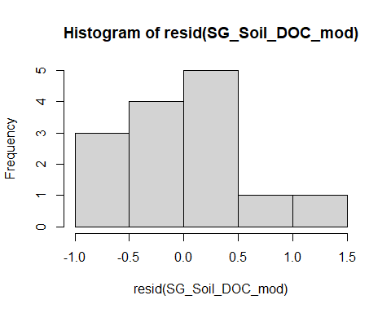

shapiro.test(resid(SG_Soil_DOC_mod))

##   
## Shapiro-Wilk normality test  
##   
## data: resid(SG_Soil_DOC_mod)  
## W = 0.9533, p-value = 0.6131

boxCox(SG_Soil_DOC_mod)

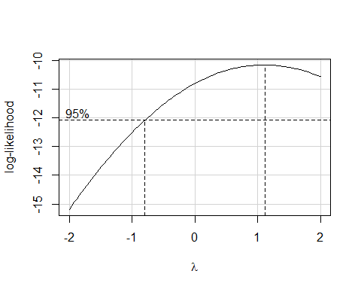 Raw Statistical output

Anova(SG_Soil_DOC_mod,type = 3)

## Anova Table (Type III tests)  
##   
## Response: log(unfumigated_DOC_concentration_ugC_gsoil)  
## Sum Sq Df F value Pr(>F)   
## (Intercept) 16.5452 1 38.7139 9.857e-05 ***  
## soil_root 2.2287 2 2.6074 0.1226   
## block 0.0006 1 0.0014 0.9712   
## Residuals 4.2737 10   
## ---  
## Signif. codes: 0 '***' 0.001 '**' 0.01 '*' 0.05 '.' 0.1 ' ' 1

Formatted Anova table

Dissolved organic carbon

|  |  |  |  |
| --- | --- | --- | --- |
|  | Df | F.value | P.value |
| (Intercept) | 1 | 38.71 | 0.000 |
| soil_root | 2 | 2.61 | 0.123 |
| block | 1 | 0.00 | 0.971 |
| Residuals | 10 | NA | NA |
| Graph for publ | icatio | n |  |
| [](MERDS_R_co | de_SG_ | reAnalysis_ | 20200828_files/figure-docx/unnamed-chunk-190-1.png) |

## Microbial Biomass

Diagnostic Graphs

SG_Soil_MBC_mod= lm((ugC_MicBiomass_g_dry_soil)~soil_root+block,   
 data= SG_MBC_DOC_trt)  
qqPlot(resid(SG_Soil_MBC_mod))

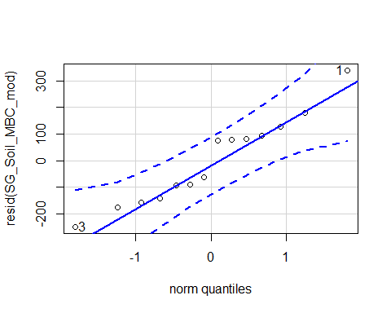

## [1] 1 3

hist(resid(SG_Soil_MBC_mod))

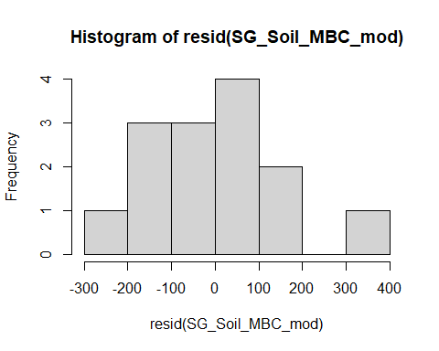

shapiro.test(resid(SG_Soil_MBC_mod))

##   
## Shapiro-Wilk normality test  
##   
## data: resid(SG_Soil_MBC_mod)  
## W = 0.95033, p-value = 0.5658

Raw Statistical output

Anova(SG_Soil_MBC_mod, type=3)

## Anova Table (Type III tests)  
##   
## Response: (ugC_MicBiomass_g_dry_soil)  
## Sum Sq Df F value Pr(>F)   
## (Intercept) 159491 1 4.5643 0.05839 .  
## soil_root 63425 2 0.9075 0.43433   
## block 1756 1 0.0503 0.82712   
## Residuals 349433 10   
## ---  
## Signif. codes: 0 '***' 0.001 '**' 0.01 '*' 0.05 '.' 0.1 ' ' 1

Formatted Anova table

Microbial biomass carbon

|  |  |  |  |
| --- | --- | --- | --- |
|  | Df | F.value | P.value |
| (Intercept) | 1 | 4.56 | 0.058 |
| soil_root | 2 | 0.91 | 0.434 |
| block | 1 | 0.05 | 0.827 |
| Residuals | 10 | NA | NA |

Graph for publication 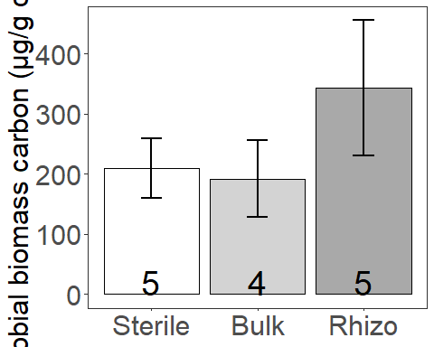

# Combined Seed and Seedling Analyses

## Survival

Diagnostic Graphs

#data_SG_biomass_trans_surv_drought=subset(data_SG_biomass_trans_surv_trt, precip=="D")  
SG_combin_surv_model= glmer(surv~soil_root*precip*life_stage+(1|block/life_stage), data= data_SG_biomass_surv_trt_comb, family = binomial)

## Warning in checkConv(attr(opt, "derivs"), opt$par, ctrl = control$checkConv, :  
## unable to evaluate scaled gradient

## Warning in checkConv(attr(opt, "derivs"), opt$par, ctrl = control$checkConv, :  
## Model failed to converge: degenerate Hessian with 3 negative eigenvalues

qqPlot(resid(SG_combin_surv_model))

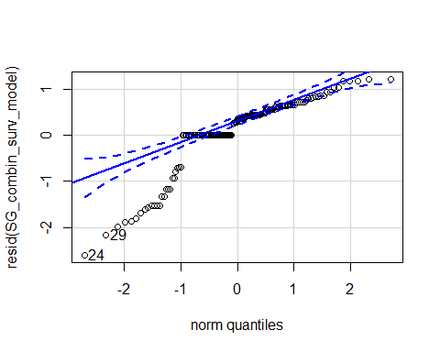

## 24 29   
## 14 88

hist(resid(SG_combin_surv_model))

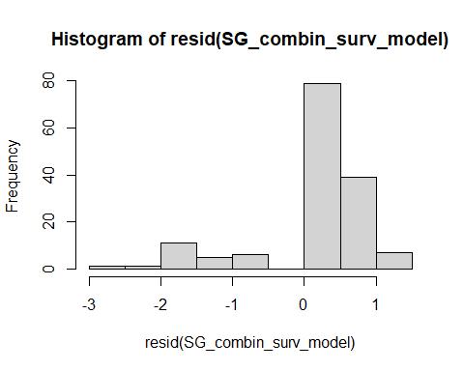

shapiro.test(resid(SG_combin_surv_model))

##   
## Shapiro-Wilk normality test  
##   
## data: resid(SG_combin_surv_model)  
## W = 0.83916, p-value = 1.729e-11

Raw Statistical output

Anova(SG_combin_surv_model,type = 3)

## Warning in vcov.merMod(mod, complete = FALSE): variance-covariance matrix computed from finite-difference Hessian is  
## not positive definite or contains NA values: falling back to var-cov estimated from RX  
  
## Warning in vcov.merMod(mod, complete = FALSE): variance-covariance matrix computed from finite-difference Hessian is  
## not positive definite or contains NA values: falling back to var-cov estimated from RX

## Analysis of Deviance Table (Type III Wald chisquare tests)  
##   
## Response: surv  
## Chisq Df Pr(>Chisq)  
## (Intercept) 0 1 0.9949  
## soil_root 0 2 1.0000  
## precip 0 1 0.9960  
## life_stage 0 1 0.9959  
## soil_root:precip 0 2 1.0000  
## soil_root:life_stage 0 2 1.0000  
## precip:life_stage 0 1 0.9961  
## soil_root:precip:life_stage 0 2 1.0000

emmeans(SG_combin_surv_model, pairwise~soil_root)

## Warning in vcov.merMod(object, correlation = FALSE): variance-covariance matrix computed from finite-difference Hessian is  
## not positive definite or contains NA values: falling back to var-cov estimated from RX

## NOTE: Results may be misleading due to involvement in interactions

## $emmeans  
## soil_root emmean SE df asymp.LCL asymp.UCL  
## L.B 6.67 1656 Inf -3239 3253  
## S.B 5.37 1762 Inf -3449 3460  
## L.R 6.44 1555 Inf -3042 3055  
##   
## Results are averaged over the levels of: precip, life_stage   
## Results are given on the logit (not the response) scale.   
## Confidence level used: 0.95   
##   
## $contrasts  
## contrast estimate SE df z.ratio p.value  
## L.B - S.B 1.297 2418 Inf 0.001 1.0000   
## L.B - L.R 0.225 2272 Inf 0.000 1.0000   
## S.B - L.R -1.071 2351 Inf 0.000 1.0000   
##   
## Results are averaged over the levels of: precip, life_stage   
## Results are given on the log odds ratio (not the response) scale.   
## P value adjustment: tukey method for comparing a family of 3 estimates

Formatted Anova table

## Warning in vcov.merMod(mod, complete = FALSE): variance-covariance matrix computed from finite-difference Hessian is  
## not positive definite or contains NA values: falling back to var-cov estimated from RX  
  
## Warning in vcov.merMod(mod, complete = FALSE): variance-covariance matrix computed from finite-difference Hessian is  
## not positive definite or contains NA values: falling back to var-cov estimated from RX

Survival

|  |  |  |  |
| --- | --- | --- | --- |
|  | Df | Chi.Sq | P.value |
| (Intercept) | 1 | 0 | 0.995 |
| soil_root | 2 | 0 | 1.000 |
| precip | 1 | 0 | 0.996 |
| life_stage | 1 | 0 | 0.996 |
| soil_root:precip | 2 | 0 | 1.000 |
| soil_root:life_stage | 2 | 0 | 1.000 |
| precip:life_stage | 1 | 0 | 0.996 |
| soil_root:precip:life_stage | 2 | 0 | 1.000 |

### Focus in on Drought treatment

Diagnostic Graphs

data_SG_biomass_surv_trt_comb_drought=subset(data_SG_biomass_surv_trt_comb, precip=="D")  
SG_combin_surv_drought_model= glmer(surv~soil_root*life_stage+(1|block/life_stage), data= data_SG_biomass_surv_trt_comb_drought, family = binomial)

## boundary (singular) fit: see ?isSingular

qqPlot(resid(SG_combin_surv_drought_model))

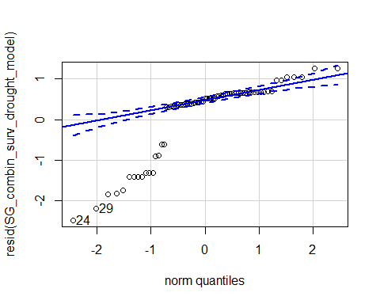

## 24 29   
## 14 53

hist(resid(SG_combin_surv_drought_model))

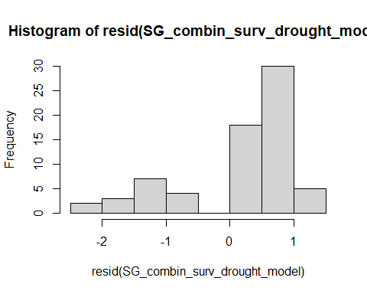

shapiro.test(resid(SG_combin_surv_drought_model))

##   
## Shapiro-Wilk normality test  
##   
## data: resid(SG_combin_surv_drought_model)  
## W = 0.76715, p-value = 4.209e-09

Raw Statistical output

Anova(SG_combin_surv_drought_model,type = 3)

## Analysis of Deviance Table (Type III Wald chisquare tests)  
##   
## Response: surv  
## Chisq Df Pr(>Chisq)   
## (Intercept) 6.5558 1 0.01045 *  
## soil_root 6.1744 2 0.04563 *  
## life_stage 0.1295 1 0.71900   
## soil_root:life_stage 3.7279 2 0.15506   
## ---  
## Signif. codes: 0 '***' 0.001 '**' 0.01 '*' 0.05 '.' 0.1 ' ' 1

emmeans(SG_combin_surv_drought_model, pairwise~soil_root)

## NOTE: Results may be misleading due to involvement in interactions

## $emmeans  
## soil_root emmean SE df asymp.LCL asymp.UCL  
## L.B 2.1866 0.778 Inf 0.662 3.71  
## S.B 0.0958 0.668 Inf -1.214 1.41  
## L.R 1.7439 0.761 Inf 0.253 3.23  
##   
## Results are averaged over the levels of: life_stage   
## Results are given on the logit (not the response) scale.   
## Confidence level used: 0.95   
##   
## $contrasts  
## contrast estimate SE df z.ratio p.value  
## L.B - S.B 2.091 0.896 Inf 2.335 0.0511   
## L.B - L.R 0.443 0.912 Inf 0.486 0.8781   
## S.B - L.R -1.648 0.886 Inf -1.860 0.1504   
##   
## Results are averaged over the levels of: life_stage   
## Results are given on the log odds ratio (not the response) scale.   
## P value adjustment: tukey method for comparing a family of 3 estimates

Formatted Anova table

Survival

|  |  |  |  |
| --- | --- | --- | --- |
|  | Df | Chi.Sq | P.value |
| (Intercept) | 1 | 6.56 | 0.010 |
| soil_root | 2 | 6.17 | 0.046 |
| life_stage | 1 | 0.13 | 0.719 |
| soil_root:life_stage | 2 | 3.73 | 0.155 |
| ### Presence combined s | urviva | l |  |
| Diagnostic Graphs |  |  |  |

data_SG_biomass_surv_trt_comb_drought_pres=subset(data_SG_biomass_surv_trt_comb_drought, root_association =="B")  
SG_combin_surv_drought_pres_model= glmer(surv~soil_root*life_stage+(1|block/life_stage), data= data_SG_biomass_surv_trt_comb_drought_pres, family = binomial)

## boundary (singular) fit: see ?isSingular

qqPlot(resid(SG_combin_surv_drought_pres_model))

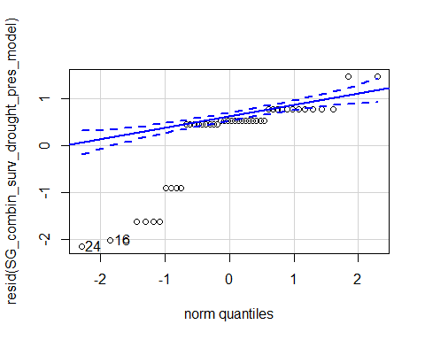

## 24 16   
## 6 17

hist(resid(SG_combin_surv_drought_pres_model))

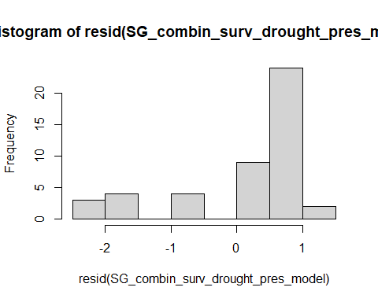

shapiro.test(resid(SG_combin_surv_drought_pres_model))

##   
## Shapiro-Wilk normality test  
##   
## data: resid(SG_combin_surv_drought_pres_model)  
## W = 0.74597, p-value = 1.487e-07

Raw Statistical output

Anova(SG_combin_surv_drought_pres_model,type = 3)

## Analysis of Deviance Table (Type III Wald chisquare tests)  
##   
## Response: surv  
## Chisq Df Pr(>Chisq)   
## (Intercept) 6.9271 1 0.00849 **  
## soil_root 5.0619 1 0.02446 *   
## life_stage 0.6846 1 0.40800   
## soil_root:life_stage 1.4832 1 0.22328   
## ---  
## Signif. codes: 0 '***' 0.001 '**' 0.01 '*' 0.05 '.' 0.1 ' ' 1

emmeans(SG_combin_surv_drought_pres_model, pairwise~soil_root)

## NOTE: Results may be misleading due to involvement in interactions

## $emmeans  
## soil_root emmean SE df asymp.LCL asymp.UCL  
## L.B 2.035 0.650 Inf 0.761 3.31  
## S.B 0.159 0.522 Inf -0.864 1.18  
##   
## Results are averaged over the levels of: life_stage   
## Results are given on the logit (not the response) scale.   
## Confidence level used: 0.95   
##   
## $contrasts  
## contrast estimate SE df z.ratio p.value  
## L.B - S.B 1.88 0.834 Inf 2.250 0.0245   
##   
## Results are averaged over the levels of: life_stage   
## Results are given on the log odds ratio (not the response) scale.

Formatted Anova table

Survival

|  |  |  |  |
| --- | --- | --- | --- |
|  | Df | Chi.Sq | P.value |
| (Intercept) | 1 | 6.93 | 0.008 |
| soil_root | 1 | 5.06 | 0.024 |
| life_stage | 1 | 0.68 | 0.408 |
| soil_root:life_stage | 1 | 1.48 | 0.223 |

### Origin combined survival

Diagnostic Graphs

data_SG_biomass_surv_trt_comb_drought_orig=subset(data_SG_biomass_surv_trt_comb_drought, soil_status =="L")  
SG_combin_surv_drought_orig_model= glmer(surv~soil_root*life_stage+(1|block/life_stage), data= data_SG_biomass_surv_trt_comb_drought_orig, family = binomial)  
qqPlot(resid(SG_combin_surv_drought_orig_model))

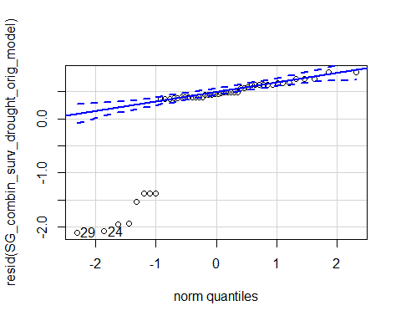

## 29 24   
## 47 14

hist(resid(SG_combin_surv_drought_orig_model))

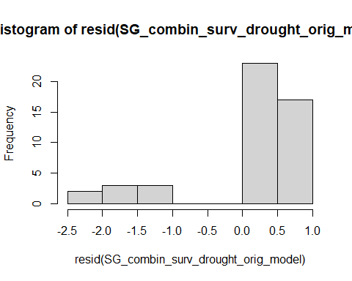

shapiro.test(resid(SG_combin_surv_drought_orig_model))

##   
## Shapiro-Wilk normality test  
##   
## data: resid(SG_combin_surv_drought_orig_model)  
## W = 0.61185, p-value = 4.955e-10

Raw Statistical output

Anova(SG_combin_surv_drought_orig_model,type = 3)

## Analysis of Deviance Table (Type III Wald chisquare tests)  
##   
## Response: surv  
## Chisq Df Pr(>Chisq)   
## (Intercept) 10.0712 1 0.001506 **  
## soil_root 0.4678 1 0.493979   
## life_stage 0.3427 1 0.558290   
## soil_root:life_stage 0.0938 1 0.759389   
## ---  
## Signif. codes: 0 '***' 0.001 '**' 0.01 '*' 0.05 '.' 0.1 ' ' 1

emmeans(SG_combin_surv_drought_orig_model, pairwise~soil_root)

## NOTE: Results may be misleading due to involvement in interactions

## $emmeans  
## soil_root emmean SE df asymp.LCL asymp.UCL  
## L.B 2.23 0.813 Inf 0.637 3.82  
## L.R 1.58 0.712 Inf 0.188 2.98  
##   
## Results are averaged over the levels of: life_stage   
## Results are given on the logit (not the response) scale.   
## Confidence level used: 0.95   
##   
## $contrasts  
## contrast estimate SE df z.ratio p.value  
## L.B - L.R 0.646 0.944 Inf 0.684 0.4940   
##   
## Results are averaged over the levels of: life_stage   
## Results are given on the log odds ratio (not the response) scale.

Formatted Anova table

Survival

|  |  |  |  |
| --- | --- | --- | --- |
|  | Df | Chi.Sq | P.value |
| (Intercept) | 1 | 10.07 | 0.002 |
| soil_root | 1 | 0.47 | 0.494 |
| life_stage | 1 | 0.34 | 0.558 |
| soil_root:life_stage | 1 | 0.09 | 0.759 |

## Biomass

Diagnostic Graphs

SG_combin_biomass_model= lmer(log(total_biomass+0.001)~soil_root*precip*life_stage+(1|block/life_stage), data= data_SG_biomass_trt_comb)

## boundary (singular) fit: see ?isSingular

qqPlot(resid(SG_combin_biomass_model))

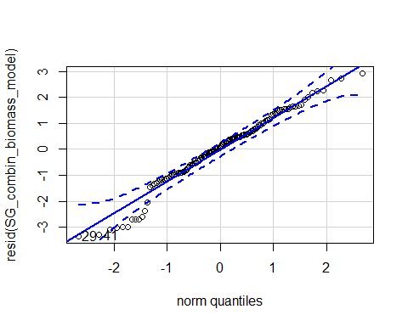

## 29 41   
## 74 86

hist(resid(SG_combin_biomass_model))

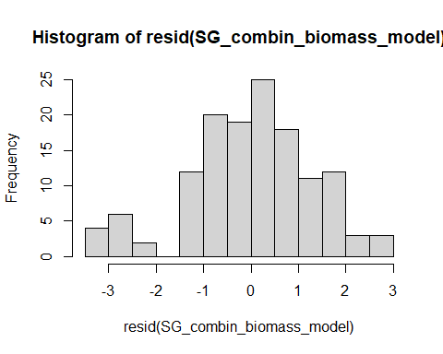

shapiro.test(resid(SG_combin_biomass_model))

##   
## Shapiro-Wilk normality test  
##   
## data: resid(SG_combin_biomass_model)  
## W = 0.97333, p-value = 0.009383

Raw Statistical output

anova(SG_combin_biomass_model)

## Type III Analysis of Variance Table with Satterthwaite's method  
## Sum Sq Mean Sq NumDF DenDF F value Pr(>F)   
## soil_root 16.1994 8.0997 2 120.64 4.2800 0.016003 *   
## precip 4.8969 4.8969 1 119.83 2.5876 0.110338   
## life_stage 8.0818 8.0818 1 122.02 4.2705 0.040894 *   
## soil_root:precip 3.1145 1.5573 2 121.19 0.8229 0.441607   
## soil_root:life_stage 1.5159 0.7580 2 120.64 0.4005 0.670864   
## precip:life_stage 12.5200 12.5200 1 119.83 6.6157 0.011330 *   
## soil_root:precip:life_stage 26.2502 13.1251 2 121.19 6.9355 0.001407 **  
## ---  
## Signif. codes: 0 '***' 0.001 '**' 0.01 '*' 0.05 '.' 0.1 ' ' 1

emmeans(SG_combin_biomass_model, pairwise~soil_root)

## NOTE: Results may be misleading due to involvement in interactions

## $emmeans  
## soil_root emmean SE df lower.CL upper.CL  
## L.B -3.21 0.244 12.6 -3.74 -2.68  
## S.B -2.21 0.357 39.6 -2.93 -1.49  
## L.R -3.24 0.250 13.3 -3.78 -2.70  
##   
## Results are averaged over the levels of: precip, life_stage   
## Degrees-of-freedom method: kenward-roger   
## Results are given on the log(mu + 0.001) (not the response) scale.   
## Confidence level used: 0.95   
##   
## $contrasts  
## contrast estimate SE df t.ratio p.value  
## L.B - S.B -1.0068 0.383 121 -2.627 0.0261   
## L.B - L.R 0.0259 0.291 118 0.089 0.9956   
## S.B - L.R 1.0327 0.394 120 2.622 0.0265   
##   
## Results are averaged over the levels of: precip, life_stage   
## Degrees-of-freedom method: kenward-roger   
## Results are given on the log (not the response) scale.   
## P value adjustment: tukey method for comparing a family of 3 estimates

emmeans(SG_combin_biomass_model, pairwise~life_stage)

## NOTE: Results may be misleading due to involvement in interactions

## $emmeans  
## life_stage emmean SE df lower.CL upper.CL  
## germinant -2.59 0.292 16.74 -3.21 -1.97  
## seedling -3.18 0.198 4.93 -3.69 -2.67  
##   
## Results are averaged over the levels of: soil_root, precip   
## Degrees-of-freedom method: kenward-roger   
## Results are given on the log(mu + 0.001) (not the response) scale.   
## Confidence level used: 0.95   
##   
## $contrasts  
## contrast estimate SE df t.ratio p.value  
## germinant - seedling 0.593 0.297 5.87 1.996 0.0940   
##   
## Results are averaged over the levels of: soil_root, precip   
## Degrees-of-freedom method: kenward-roger   
## Results are given on the log (not the response) scale.

emmeans(SG_combin_biomass_model, pairwise~precip*life_stage)

## NOTE: Results may be misleading due to involvement in interactions

## $emmeans  
## precip life_stage emmean SE df lower.CL upper.CL  
## A germinant -2.73 0.322 26.6 -3.39 -2.07  
## D germinant -2.45 0.437 57.6 -3.33 -1.58  
## A seedling -2.59 0.245 11.6 -3.12 -2.05  
## D seedling -3.78 0.245 11.6 -4.31 -3.24  
##   
## Results are averaged over the levels of: soil_root   
## Degrees-of-freedom method: kenward-roger   
## Results are given on the log(mu + 0.001) (not the response) scale.   
## Confidence level used: 0.95   
##   
## $contrasts  
## contrast estimate SE df t.ratio p.value  
## A,germinant - D,germinant -0.275 0.497 119.8 -0.552 0.9458   
## A,germinant - A,seedling -0.140 0.357 13.4 -0.391 0.9789   
## A,germinant - D,seedling 1.052 0.357 13.4 2.943 0.0482   
## D,germinant - A,seedling 0.135 0.463 28.7 0.291 0.9912   
## D,germinant - D,seedling 1.327 0.463 28.7 2.862 0.0369   
## A,seedling - D,seedling 1.192 0.290 115.7 4.109 0.0004   
##   
## Results are averaged over the levels of: soil_root   
## Degrees-of-freedom method: kenward-roger   
## Results are given on the log (not the response) scale.   
## P value adjustment: tukey method for comparing a family of 4 estimates

emmeans(SG_combin_biomass_model, pairwise~life_stage|soil_root|precip)

## $emmeans  
## soil_root = L.B, precip = A:  
## life_stage emmean SE df lower.CL upper.CL  
## germinant -2.657 0.464 74.8 -3.58 -1.733  
## seedling -3.161 0.380 52.7 -3.92 -2.399  
##   
## soil_root = S.B, precip = A:  
## life_stage emmean SE df lower.CL upper.CL  
## germinant -3.218 0.642 109.2 -4.49 -1.947  
## seedling -1.298 0.380 52.7 -2.06 -0.536  
##   
## soil_root = L.R, precip = A:  
## life_stage emmean SE df lower.CL upper.CL  
## germinant -2.304 0.424 64.2 -3.15 -1.457  
## seedling -3.301 0.380 52.7 -4.06 -2.540  
##   
## soil_root = L.B, precip = D:  
## life_stage emmean SE df lower.CL upper.CL  
## germinant -3.412 0.485 82.6 -4.38 -2.448  
## seedling -3.621 0.380 52.7 -4.38 -2.859  
##   
## soil_root = S.B, precip = D:  
## life_stage emmean SE df lower.CL upper.CL  
## germinant -0.642 1.058 102.9 -2.74 1.456  
## seedling -3.666 0.380 52.7 -4.43 -2.904  
##   
## soil_root = L.R, precip = D:  
## life_stage emmean SE df lower.CL upper.CL  
## germinant -3.301 0.556 90.3 -4.41 -2.197  
## seedling -4.048 0.380 52.7 -4.81 -3.287  
##   
## Degrees-of-freedom method: kenward-roger   
## Results are given on the log(mu + 0.001) (not the response) scale.   
## Confidence level used: 0.95   
##   
## $contrasts  
## soil_root = L.B, precip = A:  
## contrast estimate SE df t.ratio p.value  
## germinant - seedling 0.504 0.568 59.1 0.887 0.3786   
##   
## soil_root = S.B, precip = A:  
## contrast estimate SE df t.ratio p.value  
## germinant - seedling -1.920 0.721 86.3 -2.663 0.0092   
##   
## soil_root = L.R, precip = A:  
## contrast estimate SE df t.ratio p.value  
## germinant - seedling 0.997 0.537 53.4 1.858 0.0687   
##   
## soil_root = L.B, precip = D:  
## contrast estimate SE df t.ratio p.value  
## germinant - seedling 0.209 0.586 64.1 0.356 0.7229   
##   
## soil_root = S.B, precip = D:  
## contrast estimate SE df t.ratio p.value  
## germinant - seedling 3.024 1.108 89.6 2.729 0.0076   
##   
## soil_root = L.R, precip = D:  
## contrast estimate SE df t.ratio p.value  
## germinant - seedling 0.747 0.646 68.9 1.157 0.2513   
##   
## Degrees-of-freedom method: kenward-roger   
## Results are given on the log (not the response) scale.

Formatted Anova table

Total biomass

|  |  |  |  |  |
| --- | --- | --- | --- | --- |
|  | Df | Resid.Df | F.value | P.value |
| soil_root | 2 | 120.63 | 4.28 | 0.016 |
| precip | 1 | 119.83 | 2.59 | 0.110 |
| life_stage | 1 | 122.02 | 4.27 | 0.041 |
| soil_root:precip | 2 | 121.20 | 0.82 | 0.442 |
| soil_root:life_stage | 2 | 120.63 | 0.40 | 0.671 |
| precip:life_stage | 1 | 119.83 | 6.62 | 0.011 |
| soil_root:precip:life_stage | 2 | 121.20 | 6.94 | 0.001 |
| ### Presence Combined Biomass |  |  |  |  |

Diagnostic Graphs

data_SG_biomass_trt_comb_pres=subset(data_SG_biomass_trt_comb, root_association =="B")  
SG_combin_biomass_pres_model= lmer(log(total_biomass+0.001)~soil_root*precip*life_stage+(1|block/life_stage), data= data_SG_biomass_trt_comb_pres)

## boundary (singular) fit: see ?isSingular

qqPlot(resid(SG_combin_biomass_pres_model))

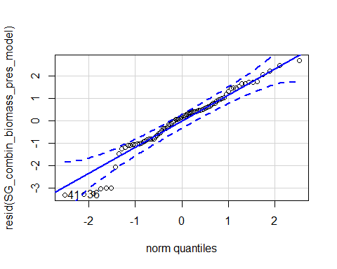

## 41 36   
## 52 47

hist(resid(SG_combin_biomass_pres_model))

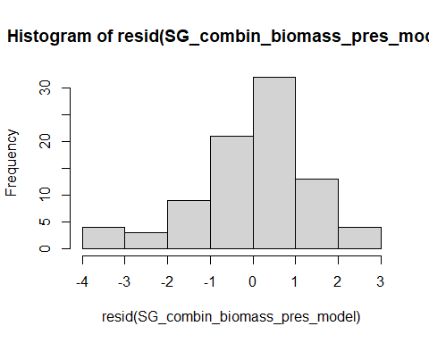

shapiro.test(resid(SG_combin_biomass_pres_model))

##   
## Shapiro-Wilk normality test  
##   
## data: resid(SG_combin_biomass_pres_model)  
## W = 0.95636, p-value = 0.005474

Raw Statistical output

anova(SG_combin_biomass_pres_model)

## Type III Analysis of Variance Table with Satterthwaite's method  
## Sum Sq Mean Sq NumDF DenDF F value Pr(>F)   
## soil_root 14.6111 14.6111 1 76.129 7.7962 0.0066170 **   
## precip 0.6526 0.6526 1 76.407 0.3482 0.5568529   
## life_stage 3.1065 3.1065 1 77.802 1.6576 0.2017495   
## soil_root:precip 2.0195 2.0195 1 77.573 1.0776 0.3024683   
## soil_root:life_stage 0.2408 0.2408 1 76.129 0.1285 0.7209959   
## precip:life_stage 19.0950 19.0950 1 76.407 10.1887 0.0020518 **   
## soil_root:precip:life_stage 24.0017 24.0017 1 77.573 12.8068 0.0005993 ***  
## ---  
## Signif. codes: 0 '***' 0.001 '**' 0.01 '*' 0.05 '.' 0.1 ' ' 1

emmeans(SG_combin_biomass_pres_model, pairwise~soil_root)

## NOTE: Results may be misleading due to involvement in interactions

## $emmeans  
## soil_root emmean SE df lower.CL upper.CL  
## L.B -3.22 0.235 8.46 -3.75 -2.68  
## S.B -2.17 0.357 27.22 -2.91 -1.44  
##   
## Results are averaged over the levels of: precip, life_stage   
## Degrees-of-freedom method: kenward-roger   
## Results are given on the log(mu + 0.001) (not the response) scale.   
## Confidence level used: 0.95   
##   
## $contrasts  
## contrast estimate SE df t.ratio p.value  
## L.B - S.B -1.04 0.387 76.3 -2.694 0.0087   
##   
## Results are averaged over the levels of: precip, life_stage   
## Degrees-of-freedom method: kenward-roger   
## Results are given on the log (not the response) scale.

emmeans(SG_combin_biomass_pres_model, pairwise~precip*life_stage)

## NOTE: Results may be misleading due to involvement in interactions

## $emmeans  
## precip life_stage emmean SE df lower.CL upper.CL  
## A germinant -2.94 0.403 37.1 -3.76 -2.122  
## D germinant -1.97 0.606 47.9 -3.18 -0.748  
## A seedling -2.23 0.275 13.5 -2.82 -1.637  
## D seedling -3.64 0.275 13.5 -4.24 -3.051  
##   
## Results are averaged over the levels of: soil_root   
## Degrees-of-freedom method: kenward-roger   
## Results are given on the log(mu + 0.001) (not the response) scale.   
## Confidence level used: 0.95   
##   
## $contrasts  
## contrast estimate SE df t.ratio p.value  
## A,germinant - D,germinant -0.973 0.694 76.7 -1.402 0.5021   
## A,germinant - A,seedling -0.709 0.460 14.4 -1.542 0.4399   
## A,germinant - D,seedling 0.705 0.460 14.4 1.531 0.4454   
## D,germinant - A,seedling 0.263 0.645 24.7 0.408 0.9765   
## D,germinant - D,seedling 1.677 0.645 24.7 2.601 0.0689   
## A,seedling - D,seedling 1.414 0.353 71.1 4.000 0.0009   
##   
## Results are averaged over the levels of: soil_root   
## Degrees-of-freedom method: kenward-roger   
## Results are given on the log (not the response) scale.   
## P value adjustment: tukey method for comparing a family of 4 estimates

emmeans(SG_combin_biomass_pres_model, pairwise~life_stage|soil_root|precip)

## $emmeans  
## soil_root = L.B, precip = A:  
## life_stage emmean SE df lower.CL upper.CL  
## germinant -2.661 0.461 49.7 -3.59 -1.734  
## seedling -3.161 0.372 36.6 -3.92 -2.407  
##   
## soil_root = S.B, precip = A:  
## life_stage emmean SE df lower.CL upper.CL  
## germinant -3.217 0.642 70.8 -4.50 -1.938  
## seedling -1.298 0.372 36.6 -2.05 -0.544  
##   
## soil_root = L.B, precip = D:  
## life_stage emmean SE df lower.CL upper.CL  
## germinant -3.422 0.482 55.1 -4.39 -2.456  
## seedling -3.621 0.372 36.6 -4.37 -2.867  
##   
## soil_root = S.B, precip = D:  
## life_stage emmean SE df lower.CL upper.CL  
## germinant -0.511 1.094 62.9 -2.70 1.675  
## seedling -3.666 0.372 36.6 -4.42 -2.912  
##   
## Degrees-of-freedom method: kenward-roger   
## Results are given on the log(mu + 0.001) (not the response) scale.   
## Confidence level used: 0.95   
##   
## $contrasts  
## soil_root = L.B, precip = A:  
## contrast estimate SE df t.ratio p.value  
## germinant - seedling 0.501 0.570 28.5 0.879 0.3867   
##   
## soil_root = S.B, precip = A:  
## contrast estimate SE df t.ratio p.value  
## germinant - seedling -1.919 0.723 46.7 -2.653 0.0109   
##   
## soil_root = L.B, precip = D:  
## contrast estimate SE df t.ratio p.value  
## germinant - seedling 0.200 0.586 31.5 0.341 0.7357   
##   
## soil_root = S.B, precip = D:  
## contrast estimate SE df t.ratio p.value  
## germinant - seedling 3.155 1.144 52.0 2.759 0.0080   
##   
## Degrees-of-freedom method: kenward-roger   
## Results are given on the log (not the response) scale.

Formatted Anova table

Total biomass

|  |  |  |  |  |
| --- | --- | --- | --- | --- |
|  | Df | Resid.Df | F.value | P.value |
| soil_root | 1 | 76.13 | 7.80 | 0.007 |
| precip | 1 | 76.41 | 0.35 | 0.557 |
| life_stage | 1 | 77.80 | 1.66 | 0.202 |
| soil_root:precip | 1 | 77.57 | 1.08 | 0.302 |
| soil_root:life_stage | 1 | 76.13 | 0.13 | 0.721 |
| precip:life_stage | 1 | 76.41 | 10.19 | 0.002 |
| soil_root:precip:life_stage | 1 | 77.57 | 12.81 | 0.001 |

### Origin Combined Biomass

Diagnostic Graphs

data_SG_biomass_trt_comb_orig=subset(data_SG_biomass_trt_comb, soil_status =="L")  
SG_combin_biomass_orig_model= lmer(log(total_biomass+0.001)~soil_root*precip*life_stage+(1|block/life_stage), data= data_SG_biomass_trt_comb_orig)  
qqPlot(resid(SG_combin_biomass_orig_model))

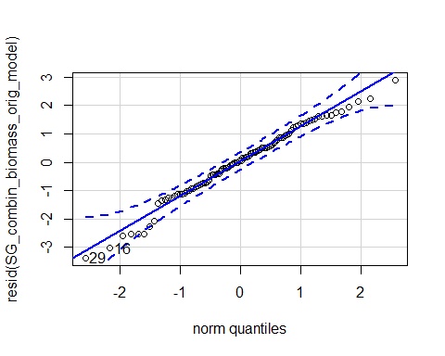

## 29 16   
## 67 54

hist(resid(SG_combin_biomass_orig_model))

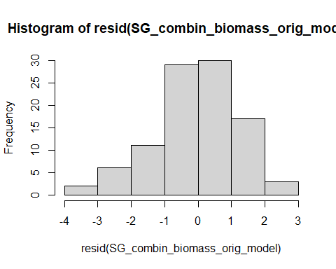

shapiro.test(resid(SG_combin_biomass_orig_model))

##   
## Shapiro-Wilk normality test  
##   
## data: resid(SG_combin_biomass_orig_model)  
## W = 0.98373, p-value = 0.2687

Raw Statistical output

anova(SG_combin_biomass_orig_model)

## Type III Analysis of Variance Table with Satterthwaite's method  
## Sum Sq Mean Sq NumDF DenDF F value Pr(>F)   
## soil_root 0.0170 0.0170 1 85.439 0.0100 0.920743   
## precip 12.2652 12.2652 1 87.205 7.1861 0.008784 **  
## life_stage 6.5403 6.5403 1 4.368 3.8319 0.115906   
## soil_root:precip 0.4565 0.4565 1 84.367 0.2674 0.606410   
## soil_root:life_stage 1.4816 1.4816 1 85.439 0.8681 0.354118   
## precip:life_stage 0.4221 0.4221 1 87.205 0.2473 0.620225   
## soil_root:precip:life_stage 0.0001 0.0001 1 84.367 0.0000 0.995601   
## ---  
## Signif. codes: 0 '***' 0.001 '**' 0.01 '*' 0.05 '.' 0.1 ' ' 1

emmeans(SG_combin_biomass_orig_model, pairwise~precip)

## NOTE: Results may be misleading due to involvement in interactions

## $emmeans  
## precip emmean SE df lower.CL upper.CL  
## A -2.85 0.224 8.49 -3.36 -2.34  
## D -3.59 0.243 11.13 -4.12 -3.05  
##   
## Results are averaged over the levels of: soil_root, life_stage   
## Degrees-of-freedom method: kenward-roger   
## Results are given on the log(mu + 0.001) (not the response) scale.   
## Confidence level used: 0.95   
##   
## $contrasts  
## contrast estimate SE df t.ratio p.value  
## A - D 0.741 0.281 86.7 2.636 0.0099   
##   
## Results are averaged over the levels of: soil_root, life_stage   
## Degrees-of-freedom method: kenward-roger   
## Results are given on the log (not the response) scale.

Formatted Anova table

Total biomass

|  |  |  |  |  |
| --- | --- | --- | --- | --- |
|  | Df | Resid.Df | F.value | P.value |
| soil_root | 1 | 85.44 | 0.01 | 0.921 |
| precip | 1 | 87.20 | 7.19 | 0.009 |
| life_stage | 1 | 4.37 | 3.83 | 0.116 |
| soil_root:precip | 1 | 84.37 | 0.27 | 0.606 |
| soil_root:life_stage | 1 | 85.44 | 0.87 | 0.354 |
| precip:life_stage | 1 | 87.20 | 0.25 | 0.620 |
| soil_root:precip:life_stage | 1 | 84.37 | 0.00 | 0.996 |

## Root:shoot ratio

Diagnostic Graphs

SG_combin_root_shoot_model= lmer(log(root_shoot+0.001)~soil_root*precip*life_stage+(1|block/life_stage), data= data_SG_root_shoot_trt_comb)

## boundary (singular) fit: see ?isSingular

qqPlot(resid(SG_combin_root_shoot_model))

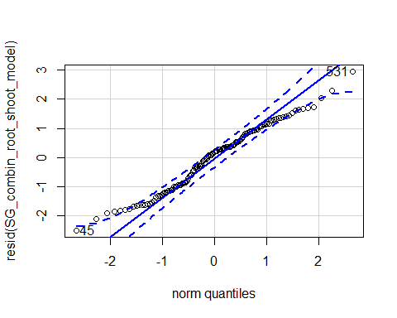

## 531 45   
## 88 80

hist(resid(SG_combin_root_shoot_model))

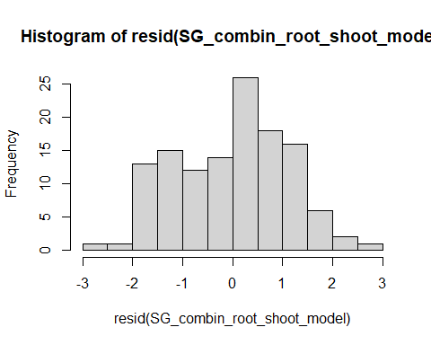

shapiro.test(resid(SG_combin_root_shoot_model))

##   
## Shapiro-Wilk normality test  
##   
## data: resid(SG_combin_root_shoot_model)  
## W = 0.97959, p-value = 0.05557

Raw Statistical output

anova(SG_combin_root_shoot_model)

## Type III Analysis of Variance Table with Satterthwaite's method  
## Sum Sq Mean Sq NumDF DenDF F value Pr(>F)   
## soil_root 1.231 0.615 2 113 0.4566 0.63462   
## precip 8.680 8.680 1 113 6.4396 0.01252 *   
## life_stage 31.625 31.625 1 113 23.4632 4.08e-06 ***  
## soil_root:precip 1.711 0.856 2 113 0.6349 0.53189   
## soil_root:life_stage 1.276 0.638 2 113 0.4735 0.62405   
## precip:life_stage 1.687 1.687 1 113 1.2517 0.26560   
## soil_root:precip:life_stage 6.372 3.186 2 113 2.3637 0.09871 .   
## ---  
## Signif. codes: 0 '***' 0.001 '**' 0.01 '*' 0.05 '.' 0.1 ' ' 1

emmeans(SG_combin_root_shoot_model, pairwise~life_stage)

## NOTE: Results may be misleading due to involvement in interactions

## $emmeans  
## life_stage emmean SE df lower.CL upper.CL  
## germinant 2.34 0.217 21.53 1.890 2.79  
## seedling 1.16 0.132 5.06 0.817 1.50  
##   
## Results are averaged over the levels of: soil_root, precip   
## Degrees-of-freedom method: kenward-roger   
## Results are given on the log(mu + 0.001) (not the response) scale.   
## Confidence level used: 0.95   
##   
## $contrasts  
## contrast estimate SE df t.ratio p.value  
## germinant - seedling 1.18 0.254 6.13 4.661 0.0033   
##   
## Results are averaged over the levels of: soil_root, precip   
## Degrees-of-freedom method: kenward-roger   
## Results are given on the log (not the response) scale.

emmeans(SG_combin_root_shoot_model, pairwise~life_stage|soil_root|precip)

## $emmeans  
## soil_root = L.B, precip = A:  
## life_stage emmean SE df lower.CL upper.CL  
## germinant 2.058 0.374 92.1 1.316 2.80  
## seedling 0.815 0.300 78.7 0.218 1.41  
##   
## soil_root = S.B, precip = A:  
## life_stage emmean SE df lower.CL upper.CL  
## germinant 1.523 0.528 109.8 0.477 2.57  
## seedling 1.055 0.300 78.7 0.459 1.65  
##   
## soil_root = L.R, precip = A:  
## life_stage emmean SE df lower.CL upper.CL  
## germinant 2.099 0.339 86.2 1.426 2.77  
## seedling 1.078 0.300 78.7 0.481 1.67  
##   
## soil_root = L.B, precip = D:  
## life_stage emmean SE df lower.CL upper.CL  
## germinant 2.106 0.392 98.2 1.327 2.88  
## seedling 1.439 0.323 85.6 0.796 2.08  
##   
## soil_root = S.B, precip = D:  
## life_stage emmean SE df lower.CL upper.CL  
## germinant 3.667 0.881 100.4 1.918 5.42  
## seedling 1.010 0.353 90.9 0.309 1.71  
##   
## soil_root = L.R, precip = D:  
## life_stage emmean SE df lower.CL upper.CL  
## germinant 2.588 0.454 97.6 1.687 3.49  
## seedling 1.539 0.359 82.8 0.824 2.25  
##   
## Degrees-of-freedom method: kenward-roger   
## Results are given on the log(mu + 0.001) (not the response) scale.   
## Confidence level used: 0.95   
##   
## $contrasts  
## soil_root = L.B, precip = A:  
## contrast estimate SE df t.ratio p.value  
## germinant - seedling 1.243 0.479 58.3 2.595 0.0120   
##   
## soil_root = S.B, precip = A:  
## contrast estimate SE df t.ratio p.value  
## germinant - seedling 0.468 0.607 84.7 0.770 0.4432   
##   
## soil_root = L.R, precip = A:  
## contrast estimate SE df t.ratio p.value  
## germinant - seedling 1.021 0.452 52.6 2.259 0.0280   
##   
## soil_root = L.B, precip = D:  
## contrast estimate SE df t.ratio p.value  
## germinant - seedling 0.667 0.508 63.4 1.312 0.1942   
##   
## soil_root = S.B, precip = D:  
## contrast estimate SE df t.ratio p.value  
## germinant - seedling 2.657 0.950 91.5 2.798 0.0063   
##   
## soil_root = L.R, precip = D:  
## contrast estimate SE df t.ratio p.value  
## germinant - seedling 1.049 0.579 75.6 1.811 0.0741   
##   
## Degrees-of-freedom method: kenward-roger   
## Results are given on the log (not the response) scale.

Formatted Anova table

Root:Shoot

|  |  |  |  |  |
| --- | --- | --- | --- | --- |
|  | Df | Resid.Df | F.value | P.value |
| soil_root | 2 | 113 | 0.46 | 0.635 |
| precip | 1 | 113 | 6.44 | 0.013 |
| life_stage | 1 | 113 | 23.46 | 0.000 |
| soil_root:precip | 2 | 113 | 0.63 | 0.532 |
| soil_root:life_stage | 2 | 113 | 0.47 | 0.624 |
| precip:life_stage | 1 | 113 | 1.25 | 0.266 |
| soil_root:precip:life_stage | 2 | 113 | 2.36 | 0.099 |
| ### Presence Combined Root:Sho | ot |  |  |  |

Diagnostic Graphs

data_SG_root_shoot_trt_comb_pres=subset(data_SG_root_shoot_trt_comb, root_association =="B")  
SG_combin_root_shoot_pres_model= lmer(sqrt(root_shoot)~soil_root*precip*life_stage+(1|block/life_stage), data= data_SG_root_shoot_trt_comb_pres)

## boundary (singular) fit: see ?isSingular

qqPlot(resid(SG_combin_root_shoot_pres_model))

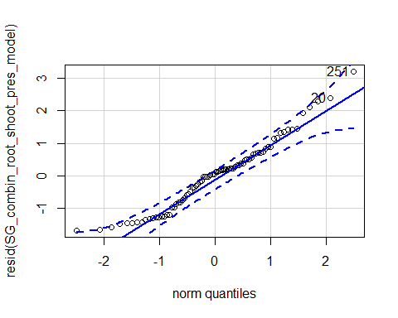

## 251 20   
## 35 2

hist(resid(SG_combin_root_shoot_pres_model))

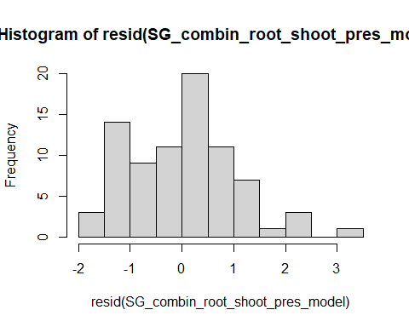

shapiro.test(resid(SG_combin_root_shoot_pres_model))

##   
## Shapiro-Wilk normality test  
##   
## data: resid(SG_combin_root_shoot_pres_model)  
## W = 0.96226, p-value = 0.01852

Raw Statistical output

anova(SG_combin_root_shoot_pres_model)

## Type III Analysis of Variance Table with Satterthwaite's method  
## Sum Sq Mean Sq NumDF DenDF F value Pr(>F)   
## soil_root 3.820 3.820 1 72 3.0989 0.0825929 .   
## precip 19.930 19.930 1 72 16.1697 0.0001411 ***  
## life_stage 33.827 33.827 1 72 27.4445 1.542e-06 ***  
## soil_root:precip 7.796 7.796 1 72 6.3251 0.0141377 *   
## soil_root:life_stage 5.247 5.247 1 72 4.2571 0.0426929 *   
## precip:life_stage 9.546 9.546 1 72 7.7446 0.0068752 **   
## soil_root:precip:life_stage 20.164 20.164 1 72 16.3594 0.0001300 ***  
## ---  
## Signif. codes: 0 '***' 0.001 '**' 0.01 '*' 0.05 '.' 0.1 ' ' 1

emmeans(SG_combin_root_shoot_pres_model, pairwise~precip*life_stage)

## NOTE: Results may be misleading due to involvement in interactions

## Note: Use 'contrast(regrid(object), ...)' to obtain contrasts of back-transformed estimates

## $emmeans  
## precip life_stage emmean SE df lower.CL upper.CL  
## A germinant 2.59 0.311 42.1 1.97 3.22  
## D germinant 4.67 0.481 47.4 3.71 5.64  
## A seedling 1.84 0.203 14.9 1.41 2.27  
## D seedling 2.22 0.230 20.8 1.74 2.70  
##   
## Results are averaged over the levels of: soil_root   
## Degrees-of-freedom method: kenward-roger   
## Results are given on the sqrt (not the response) scale.   
## Confidence level used: 0.95   
##   
## $contrasts  
## contrast estimate SE df t.ratio p.value  
## A,germinant - D,germinant -2.079 0.563 72.0 -3.696 0.0023   
## A,germinant - A,seedling 0.750 0.371 14.8 2.022 0.2242   
## A,germinant - D,seedling 0.372 0.387 15.4 0.962 0.7723   
## D,germinant - A,seedling 2.830 0.522 26.4 5.425 0.0001   
## D,germinant - D,seedling 2.451 0.533 25.5 4.601 0.0005   
## A,seedling - D,seedling -0.378 0.307 66.9 -1.234 0.6075   
##   
## Results are averaged over the levels of: soil_root   
## Note: contrasts are still on the sqrt scale   
## Degrees-of-freedom method: kenward-roger   
## P value adjustment: tukey method for comparing a family of 4 estimates

emmeans(SG_combin_root_shoot_pres_model, pairwise~life_stage|soil_root|precip)

## Note: Use 'contrast(regrid(object), ...)' to obtain contrasts of back-transformed estimates

## $emmeans  
## soil_root = L.B, precip = A:  
## life_stage emmean SE df lower.CL upper.CL  
## germinant 3.01 0.361 53.5 2.29 3.74  
## seedling 1.66 0.287 43.2 1.08 2.23  
##   
## soil_root = S.B, precip = A:  
## life_stage emmean SE df lower.CL upper.CL  
## germinant 2.18 0.509 69.0 1.16 3.19  
## seedling 2.03 0.287 43.2 1.45 2.61  
##   
## soil_root = L.B, precip = D:  
## life_stage emmean SE df lower.CL upper.CL  
## germinant 3.09 0.378 58.5 2.33 3.84  
## seedling 2.50 0.310 48.3 1.88 3.12  
##   
## soil_root = S.B, precip = D:  
## life_stage emmean SE df lower.CL upper.CL  
## germinant 6.26 0.881 60.4 4.50 8.02  
## seedling 1.94 0.339 52.5 1.26 2.62  
##   
## Degrees-of-freedom method: kenward-roger   
## Results are given on the sqrt (not the response) scale.   
## Confidence level used: 0.95   
##   
## $contrasts  
## soil_root = L.B, precip = A:  
## contrast estimate SE df t.ratio p.value  
## germinant - seedling 1.356 0.461 28.7 2.941 0.0064   
##   
## soil_root = S.B, precip = A:  
## contrast estimate SE df t.ratio p.value  
## germinant - seedling 0.145 0.584 46.8 0.248 0.8051   
##   
## soil_root = L.B, precip = D:  
## contrast estimate SE df t.ratio p.value  
## germinant - seedling 0.585 0.489 31.9 1.197 0.2401   
##   
## soil_root = S.B, precip = D:  
## contrast estimate SE df t.ratio p.value  
## germinant - seedling 4.318 0.944 52.6 4.575 <.0001   
##   
## Note: contrasts are still on the sqrt scale   
## Degrees-of-freedom method: kenward-roger

Formatted Anova table

Total biomass

|  |  |  |  |  |
| --- | --- | --- | --- | --- |
|  | Df | Resid.Df | F.value | P.value |
| soil_root | 1 | 72 | 3.10 | 0.083 |
| precip | 1 | 72 | 16.17 | 0.000 |
| life_stage | 1 | 72 | 27.44 | 0.000 |
| soil_root:precip | 1 | 72 | 6.33 | 0.014 |
| soil_root:life_stage | 1 | 72 | 4.26 | 0.043 |
| precip:life_stage | 1 | 72 | 7.74 | 0.007 |
| soil_root:precip:life_stage | 1 | 72 | 16.36 | 0.000 |

### Origin Combined Root:Shoot

Diagnostic Graphs

data_SG_root_shoot_trt_comb_orig=subset(data_SG_root_shoot_trt_comb, soil_status =="L")  
SG_combin_root_shoot_orig_model= lmer(log(root_shoot+0.001)~soil_root*precip*life_stage+(1|block/life_stage), data= data_SG_root_shoot_trt_comb_orig)

## boundary (singular) fit: see ?isSingular

qqPlot(resid(SG_combin_root_shoot_orig_model))

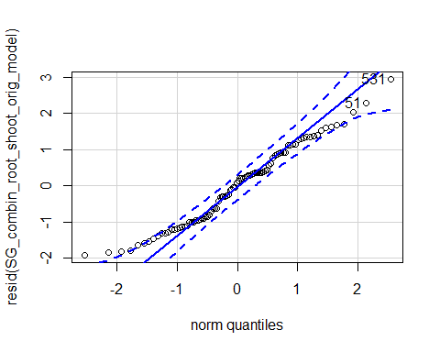

## 531 51   
## 70 20

hist(resid(SG_combin_root_shoot_orig_model))

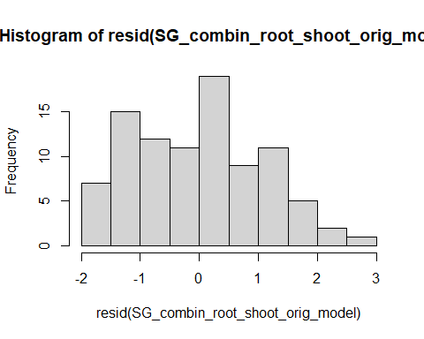

shapiro.test(resid(SG_combin_root_shoot_orig_model))

##   
## Shapiro-Wilk normality test  
##   
## data: resid(SG_combin_root_shoot_orig_model)  
## W = 0.97332, p-value = 0.0558

Raw Statistical output

anova(SG_combin_root_shoot_orig_model)

## Type III Analysis of Variance Table with Satterthwaite's method  
## Sum Sq Mean Sq NumDF DenDF F value Pr(>F)   
## soil_root 1.0674 1.0674 1 84 0.8207 0.3675748   
## precip 3.5647 3.5647 1 84 2.7406 0.1015573   
## life_stage 21.4534 21.4534 1 84 16.4939 0.0001091 ***  
## soil_root:precip 0.1050 0.1050 1 84 0.0807 0.7770479   
## soil_root:life_stage 0.0350 0.0350 1 84 0.0269 0.8700175   
## precip:life_stage 0.4067 0.4067 1 84 0.3127 0.5775090   
## soil_root:precip:life_stage 0.4929 0.4929 1 84 0.3790 0.5398262   
## ---  
## Signif. codes: 0 '***' 0.001 '**' 0.01 '*' 0.05 '.' 0.1 ' ' 1

emmeans(SG_combin_root_shoot_orig_model, pairwise~life_stage)

## NOTE: Results may be misleading due to involvement in interactions

## $emmeans  
## life_stage emmean SE df lower.CL upper.CL  
## germinant 2.21 0.196 10.4 1.778 2.65  
## seedling 1.22 0.158 5.8 0.827 1.61  
##   
## Results are averaged over the levels of: soil_root, precip   
## Degrees-of-freedom method: kenward-roger   
## Results are given on the log(mu + 0.001) (not the response) scale.   
## Confidence level used: 0.95   
##   
## $contrasts  
## contrast estimate SE df t.ratio p.value  
## germinant - seedling 0.995 0.252 4.03 3.949 0.0166   
##   
## Results are averaged over the levels of: soil_root, precip   
## Degrees-of-freedom method: kenward-roger   
## Results are given on the log (not the response) scale.

Formatted Anova table

Total biomass

|  |  |  |  |  |
| --- | --- | --- | --- | --- |
|  | Df | Resid.Df | F.value | P.value |
| soil_root | 1 | 84 | 0.82 | 0.368 |
| precip | 1 | 84 | 2.74 | 0.102 |
| life_stage | 1 | 84 | 16.49 | 0.000 |
| soil_root:precip | 1 | 84 | 0.08 | 0.777 |
| soil_root:life_stage | 1 | 84 | 0.03 | 0.870 |
| precip:life_stage | 1 | 84 | 0.31 | 0.578 |
| soil_root:precip:life_stage | 1 | 84 | 0.38 | 0.540 |