MERDs Bacterial Community Analyses

Lukas Bell-Dereske

9/1/2020

Here is the Code for analyzing the bacterial community composition of MERDS Switchgrass Experiment Lukas ([belldere@msu.edu](mailto:belldere@msu.edu)) processed the sequences and subset the larger run to only have samples from MERDS (MERDs 56 of 317 samples in the run)

# Begin OTU based community

## Change from initial soil community

#### Transplant Experimental Distance from start community seedling

##### Graph for publication

## [1] 24

## [1] G  
## Levels: G S Start

## [1] L.R S.B L.B  
## Levels: L.B S.B L.R

## [1] A D  
## Levels: A D Start

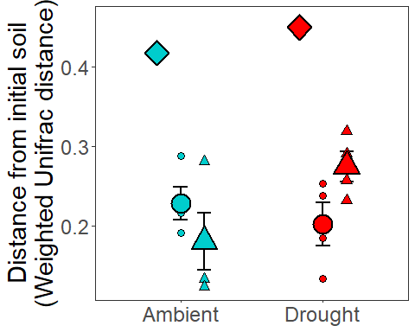 #### Presence Distance from start community seedling Diagnostic Graphs

SILVA_MERDS_rar_WU_dis_wi_bl_trans_pres=subset(SILVA_MERDS_rar_WU_dis_start_wi_bl_trans_exp,time!="Start"&s1_soil_root!="L.R")  
  
nrow(SILVA_MERDS_rar_WU_dis_wi_bl_trans_pres)

## [1] 16

#16  
  
  
WU_pair_trans_mod_pres= lmer(w_unifrac~s1_soil_root*s1_precip+(1|sample2), data= SILVA_MERDS_rar_WU_dis_wi_bl_trans_pres)  
qqPlot(resid(WU_pair_trans_mod_pres))

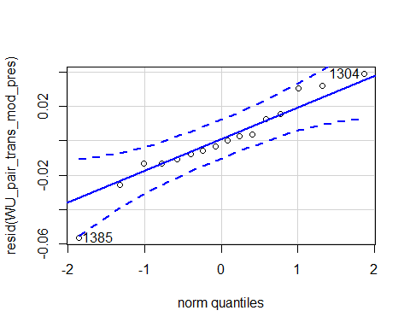

## 1385 1304   
## 14 6

hist(resid(WU_pair_trans_mod_pres))

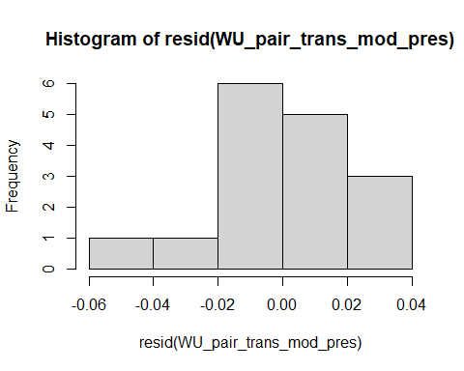

shapiro.test(resid(WU_pair_trans_mod_pres))

##   
## Shapiro-Wilk normality test  
##   
## data: resid(WU_pair_trans_mod_pres)  
## W = 0.95278, p-value = 0.535

#0.535

Raw Statistical output

anova(WU_pair_trans_mod_pres, type=3)

## Type III Analysis of Variance Table with Satterthwaite's method  
## Sum Sq Mean Sq NumDF DenDF F value Pr(>F)   
## s1_soil_root 0.190650 0.190650 1 9 231.0966 1.004e-07 ***  
## s1_precip 0.000034 0.000034 1 9 0.0416 0.84284   
## s1_soil_root:s1_precip 0.003398 0.003398 1 9 4.1193 0.07298 .   
## ---  
## Signif. codes: 0 '***' 0.001 '**' 0.01 '*' 0.05 '.' 0.1 ' ' 1

emmeans(WU_pair_trans_mod_pres, pairwise~s1_soil_root|s1_precip)

## $emmeans  
## s1_precip = A:  
## s1_soil_root emmean SE df lower.CL upper.CL  
## L.B 0.228 0.0173 9.3 0.189 0.267  
## S.B 0.417 0.0173 9.3 0.378 0.456  
##   
## s1_precip = D:  
## s1_soil_root emmean SE df lower.CL upper.CL  
## L.B 0.202 0.0173 9.3 0.163 0.241  
## S.B 0.450 0.0173 9.3 0.411 0.488  
##   
## Degrees-of-freedom method: kenward-roger   
## Confidence level used: 0.95   
##   
## $contrasts  
## s1_precip = A:  
## contrast estimate SE df t.ratio p.value  
## L.B - S.B -0.189 0.0203 9 -9.314 <.0001   
##   
## s1_precip = D:  
## contrast estimate SE df t.ratio p.value  
## L.B - S.B -0.247 0.0203 9 -12.184 <.0001   
##   
## Degrees-of-freedom method: kenward-roger

Formatted Anova table

Trans Distance to initial soil communtiy

|  |  |  |  |  |
| --- | --- | --- | --- | --- |
|  | Df | Resid.Df | F.value | P.value |
| s1_soil_root | 1 | 9 | 231.10 | 0.000 |
| s1_precip | 1 | 9 | 0.04 | 0.843 |
| s1_soil_root:s1_precip | 1 | 9 | 4.12 | 0.073 |

#### Origin Distance from start community seedling

##### Graph for publication

## [1] 16

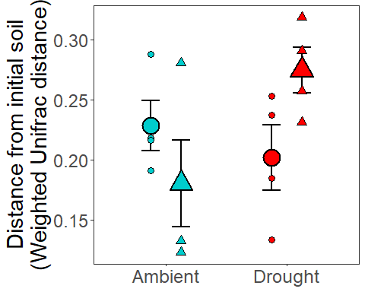

#### Origin Distance from start community seedling

Diagnostic Graphs

SILVA_MERDS_rar_WU_dis_wi_bl_trans=subset(SILVA_MERDS_rar_WU_dis_start_wi_bl_trans,time!="Start")  
  
nrow(SILVA_MERDS_rar_WU_dis_wi_bl_trans)

## [1] 16

#16  
  
  
WU_pair_trans_mod= lmer(w_unifrac~s1_soil_root*s1_precip+(1|sample2), data= SILVA_MERDS_rar_WU_dis_wi_bl_trans)

## boundary (singular) fit: see ?isSingular

qqPlot(resid(WU_pair_trans_mod))

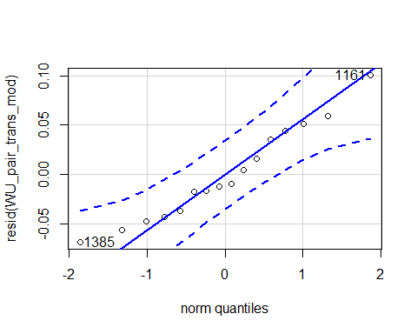

## 1161 1385   
## 3 13

hist(resid(WU_pair_trans_mod))

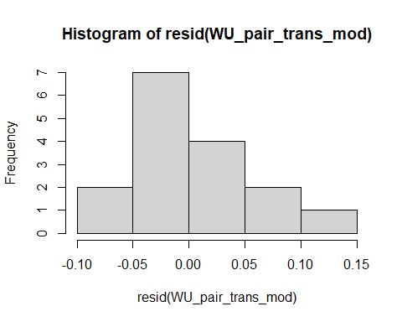

shapiro.test(resid(WU_pair_trans_mod))

##   
## Shapiro-Wilk normality test  
##   
## data: resid(WU_pair_trans_mod)  
## W = 0.96081, p-value = 0.6766

# 0.6766

Raw Statistical output

anova(WU_pair_trans_mod, type=3)

## Type III Analysis of Variance Table with Satterthwaite's method  
## Sum Sq Mean Sq NumDF DenDF F value Pr(>F)   
## s1_soil_root 0.0005971 0.0005971 1 12 0.2102 0.65480   
## s1_precip 0.0046420 0.0046420 1 12 1.6342 0.22530   
## s1_soil_root:s1_precip 0.0145361 0.0145361 1 12 5.1174 0.04304 *  
## ---  
## Signif. codes: 0 '***' 0.001 '**' 0.01 '*' 0.05 '.' 0.1 ' ' 1

emmeans(WU_pair_trans_mod, pairwise~s1_soil_root|s1_precip)

## $emmeans  
## s1_precip = A:  
## s1_soil_root emmean SE df lower.CL upper.CL  
## L.B 0.228 0.0266 12 0.170 0.286  
## L.R 0.180 0.0266 12 0.122 0.238  
##   
## s1_precip = D:  
## s1_soil_root emmean SE df lower.CL upper.CL  
## L.B 0.202 0.0266 12 0.144 0.260  
## L.R 0.275 0.0266 12 0.216 0.333  
##   
## Degrees-of-freedom method: kenward-roger   
## Confidence level used: 0.95   
##   
## $contrasts  
## s1_precip = A:  
## contrast estimate SE df t.ratio p.value  
## L.B - L.R 0.0481 0.0377 12 1.275 0.2263   
##   
## s1_precip = D:  
## contrast estimate SE df t.ratio p.value  
## L.B - L.R -0.0725 0.0377 12 -1.924 0.0784   
##   
## Degrees-of-freedom method: kenward-roger

Formatted Anova table

Trans Distance to initial soil communtiy

|  |  |  |  |  |
| --- | --- | --- | --- | --- |
|  | Df | Resid.Df | F.value | P.value |
| s1_soil_root | 1 | 12 | 0.21 | 0.655 |
| s1_precip | 1 | 12 | 1.63 | 0.225 |
| s1_soil_root:s1_precip | 1 | 12 | 5.12 | 0.043 |

#### Seed Experimental Distance from start community seed

##### Graph for publication

## [1] 23

## [1] L.R L.B S.B  
## Levels: L.B S.B L.R

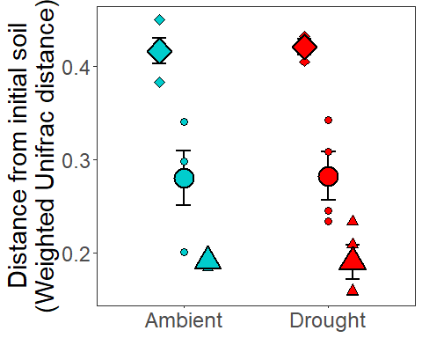

#### Presence Distance from start community seed

Diagnostic Graphs

SILVA_MERDS_rar_WU_dis_wi_bl_seed_pres=subset(SILVA_MERDS_rar_WU_dis_start_wi_bl_seed_exp,time!="Start"&s1_soil_root!="L.R")  
nrow(SILVA_MERDS_rar_WU_dis_wi_bl_seed_pres)

## [1] 15

#15  
WU_pair_seed_mod_pres= lmer(w_unifrac~s1_soil_root*s1_precip+(1|sample2), data= SILVA_MERDS_rar_WU_dis_wi_bl_seed_pres)  
qqPlot(resid(WU_pair_seed_mod_pres))

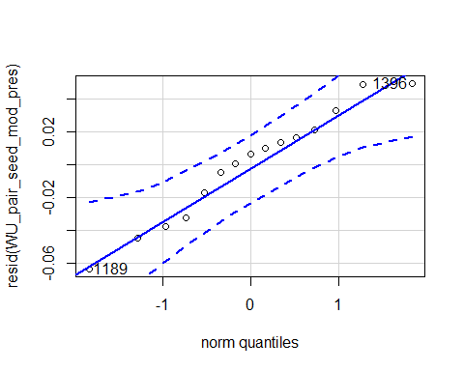

## 1189 1396   
## 2 14

hist(resid(WU_pair_seed_mod_pres))

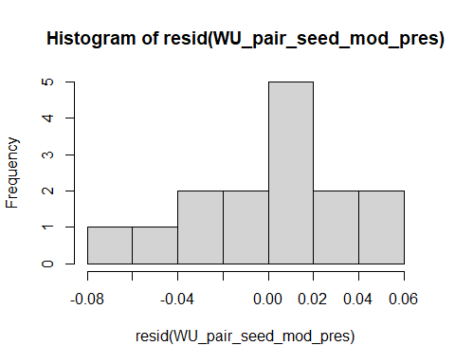

shapiro.test(resid(WU_pair_seed_mod_pres))

##   
## Shapiro-Wilk normality test  
##   
## data: resid(WU_pair_seed_mod_pres)  
## W = 0.96396, p-value = 0.7608

Raw Statistical output

anova(WU_pair_seed_mod_pres)

## Type III Analysis of Variance Table with Satterthwaite's method  
## Sum Sq Mean Sq NumDF DenDF F value Pr(>F)   
## s1_soil_root 0.065142 0.065142 1 8.3692 40.6645 0.0001766 ***  
## s1_precip 0.000008 0.000008 1 8.3692 0.0048 0.9466099   
## s1_soil_root:s1_precip 0.000001 0.000001 1 8.3692 0.0006 0.9815586   
## ---  
## Signif. codes: 0 '***' 0.001 '**' 0.01 '*' 0.05 '.' 0.1 ' ' 1

emmeans(WU_pair_seed_mod_pres,pairwise~s1_soil_root|s1_precip)

## $emmeans  
## s1_precip = A:  
## s1_soil_root emmean SE df lower.CL upper.CL  
## L.B 0.281 0.0220 10.01 0.232 0.330  
## S.B 0.416 0.0220 10.01 0.367 0.465  
##   
## s1_precip = D:  
## s1_soil_root emmean SE df lower.CL upper.CL  
## L.B 0.283 0.0220 10.01 0.234 0.332  
## S.B 0.417 0.0288 9.83 0.353 0.482  
##   
## Degrees-of-freedom method: kenward-roger   
## Confidence level used: 0.95   
##   
## $contrasts  
## s1_precip = A:  
## contrast estimate SE df t.ratio p.value  
## L.B - S.B -0.136 0.0283 8.03 -4.792 0.0014   
##   
## s1_precip = D:  
## contrast estimate SE df t.ratio p.value  
## L.B - S.B -0.135 0.0339 9.43 -3.971 0.0030   
##   
## Degrees-of-freedom method: kenward-roger

Formatted Anova table

Seed Distance to initial soil communtiy

|  |  |  |  |  |
| --- | --- | --- | --- | --- |
|  | Df | Resid.Df | F.value | P.value |
| s1_soil_root | 1 | 8.37 | 40.66 | 0.000 |
| s1_precip | 1 | 8.37 | 0.00 | 0.947 |
| s1_soil_root:s1_precip | 1 | 8.37 | 0.00 | 0.982 |

#### Origin Distance from start community seedling

##### Graph for publication

## [1] 16

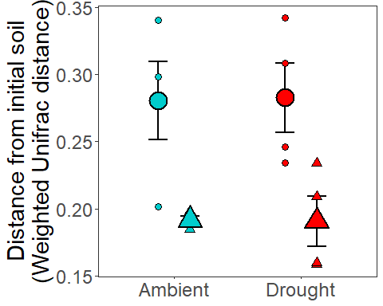

Diagnostic Graphs

SILVA_MERDS_rar_WU_dis_wi_bl_seed=subset(SILVA_MERDS_rar_WU_dis_start_wi_bl_seed,time!="Start")  
  
WU_pair_seed_mod= lmer(w_unifrac~s1_soil_root*s1_precip+(1|sample2), data= SILVA_MERDS_rar_WU_dis_wi_bl_seed)  
qqPlot(resid(WU_pair_seed_mod))

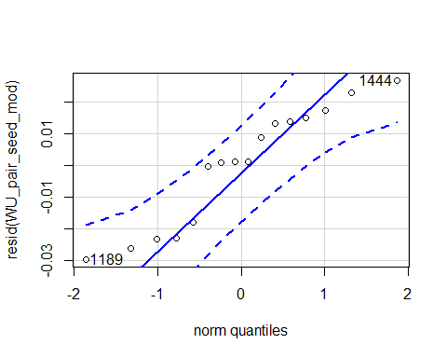

## 1189 1444   
## 5 15

hist(resid(WU_pair_seed_mod))

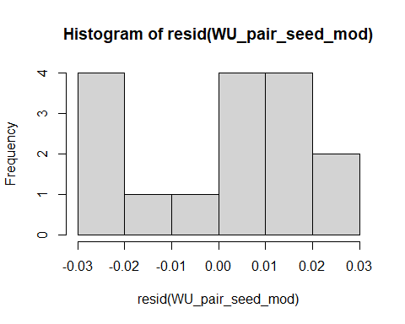

shapiro.test(resid(WU_pair_seed_mod))

##   
## Shapiro-Wilk normality test  
##   
## data: resid(WU_pair_seed_mod)  
## W = 0.91232, p-value = 0.1268

Raw Statistical output

anova(WU_pair_seed_mod)

## Type III Analysis of Variance Table with Satterthwaite's method  
## Sum Sq Mean Sq NumDF DenDF F value Pr(>F)   
## s1_soil_root 0.0071116 0.0071116 1 6.0651 10.2120 0.01843 *  
## s1_precip 0.0000088 0.0000088 1 6.5707 0.0127 0.91378   
## s1_soil_root:s1_precip 0.0000007 0.0000007 1 6.5707 0.0010 0.97556   
## ---  
## Signif. codes: 0 '***' 0.001 '**' 0.01 '*' 0.05 '.' 0.1 ' ' 1

emmeans(WU_pair_seed_mod,pairwise~s1_soil_root|s1_precip)

## $emmeans  
## s1_precip = A:  
## s1_soil_root emmean SE df lower.CL upper.CL  
## L.B 0.281 0.0218 8.30 0.231 0.331  
## L.R 0.191 0.0218 8.30 0.142 0.241  
##   
## s1_precip = D:  
## s1_soil_root emmean SE df lower.CL upper.CL  
## L.B 0.283 0.0218 8.30 0.233 0.333  
## L.R 0.193 0.0233 8.85 0.140 0.245  
##   
## Degrees-of-freedom method: kenward-roger   
## Confidence level used: 0.95   
##   
## $contrasts  
## s1_precip = A:  
## contrast estimate SE df t.ratio p.value  
## L.B - L.R 0.0892 0.0308 8.30 2.895 0.0193   
##   
## s1_precip = D:  
## contrast estimate SE df t.ratio p.value  
## L.B - L.R 0.0901 0.0319 8.59 2.823 0.0209   
##   
## Degrees-of-freedom method: kenward-roger

Formatted Anova table

Seed Distance to initial soil communtiy

|  |  |  |  |  |
| --- | --- | --- | --- | --- |
|  | Df | Resid.Df | F.value | P.value |
| s1_soil_root | 1 | 6.07 | 10.21 | 0.018 |
| s1_precip | 1 | 6.57 | 0.01 | 0.914 |
| s1_soil_root:s1_precip | 1 | 6.57 | 0.00 | 0.976 |

### Initial Community Analyses

SILVA_MERDS_rar_start=subset_samples(SILVA_MERDS_rar, life_stage=="Start")  
nsamples(SILVA_MERDS_rar_start)

## [1] 8

#8  
  
SILVA_MERDS_rar_start_WU_dis=distance(SILVA_MERDS_rar_start,method = "wunifrac")  
SILVA_MERDS_rar_start_map=sample_data(SILVA_MERDS_rar_start)  
  
  
adonis(SILVA_MERDS_rar_start_WU_dis~SILVA_MERDS_rar_start_map$root_association,permutations = 9999)

##   
## Call:  
## adonis(formula = SILVA_MERDS_rar_start_WU_dis ~ SILVA_MERDS_rar_start_map$root_association, permutations = 9999)   
##   
## Permutation: free  
## Number of permutations: 9999  
##   
## Terms added sequentially (first to last)  
##   
## Df SumsOfSqs MeanSqs F.Model  
## SILVA_MERDS_rar_start_map$root_association 1 0.004389 0.0043891 0.88149  
## Residuals 6 0.029875 0.0049792   
## Total 7 0.034264   
## R2 Pr(>F)  
## SILVA_MERDS_rar_start_map$root_association 0.1281 0.5958  
## Residuals 0.8719   
## Total 1.0000

### Community Analyses both life stages

File creation for the analysis in Primer

#####Weighted Unifrac####  
SILVA_MERDS_rar_NS=subset_samples(SILVA_MERDS_rar, life_stage!="Start")  
nsamples(SILVA_MERDS_rar_NS)

## [1] 47

#47  
SILVA_MERDS_rar_NS_WU_ord=ordinate(SILVA_MERDS_rar_NS, method = "NMDS", distance = "wunifrac")

## Run 0 stress 0.08503251   
## Run 1 stress 0.08503253   
## ... Procrustes: rmse 4.201347e-05 max resid 0.0001959107   
## ... Similar to previous best  
## Run 2 stress 0.1040579   
## Run 3 stress 0.1213149   
## Run 4 stress 0.102611   
## Run 5 stress 0.1026117   
## Run 6 stress 0.1102147   
## Run 7 stress 0.1086128   
## Run 8 stress 0.1031278   
## Run 9 stress 0.0850325   
## ... New best solution  
## ... Procrustes: rmse 2.322057e-05 max resid 7.037863e-05   
## ... Similar to previous best  
## Run 10 stress 0.08503251   
## ... Procrustes: rmse 1.740916e-05 max resid 6.028026e-05   
## ... Similar to previous best  
## Run 11 stress 0.08788484   
## Run 12 stress 0.0850325   
## ... Procrustes: rmse 8.401201e-06 max resid 3.101962e-05   
## ... Similar to previous best  
## Run 13 stress 0.08503251   
## ... Procrustes: rmse 1.521667e-05 max resid 6.713753e-05   
## ... Similar to previous best  
## Run 14 stress 0.1074504   
## Run 15 stress 0.1114272   
## Run 16 stress 0.08788487   
## Run 17 stress 0.08788484   
## Run 18 stress 0.1143396   
## Run 19 stress 0.08503251   
## ... Procrustes: rmse 1.10438e-05 max resid 4.069963e-05   
## ... Similar to previous best  
## Run 20 stress 0.1063788   
## *** Solution reached

#*** Solution reached  
#0.08503251   
plot_ordination(SILVA_MERDS_rar_NS,SILVA_MERDS_rar_NS_WU_ord, color="root_association",shape="life_stage")+geom_point(size=3)+  
 theme_bw()

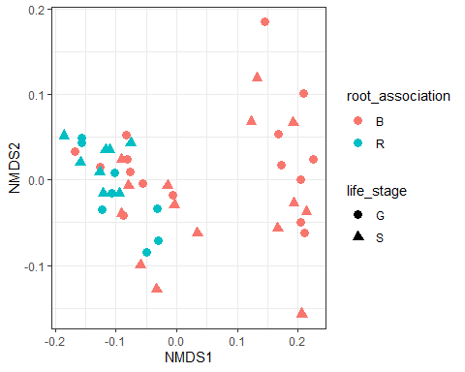

#Treatment factors   
#write.csv(data.frame(sample_data(SILVA_MERDS_rar_NS))[c("precip","block","soil_root","root_association","soil_status","life_stage")],"D:/MERDS_2018/merds/Switchgrass/R_data/SILVA_MERDS_rar_NS_map.csv")  
#distance file   
#write.csv(as.matrix(distance(SILVA_MERDS_rar_NS,method = "wunifrac")),"D:/MERDS_2018/merds/Switchgrass/R_data/Weight_Uni_SILVA_MERDS_rar_NS_dist.csv")

### Community Analyses Transplants

##### Graph for publication

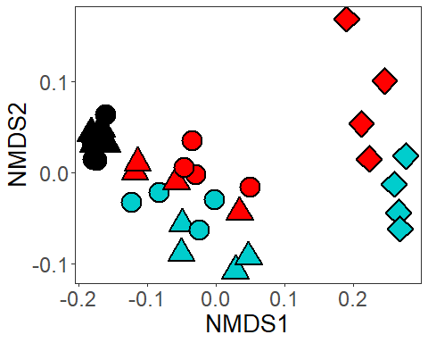

### Community Analyses Live Transplants

##### Graph for publication

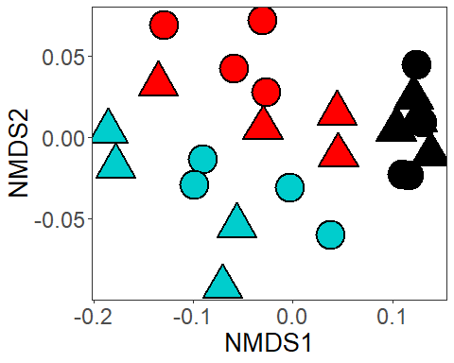

### Community Analyses Transplants with no Start

##### Graph for publication

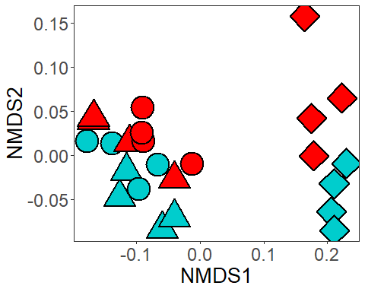

### Community Analyses Transplants with no Start

File creation for analyses in Primer

### Community Analyses Germination

##### Graph for publication

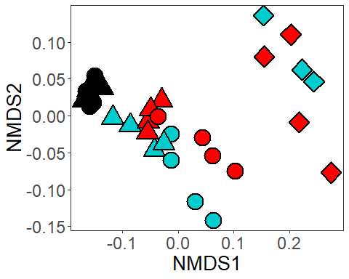

### Community Analyses Live Germination

##### Graph for publication

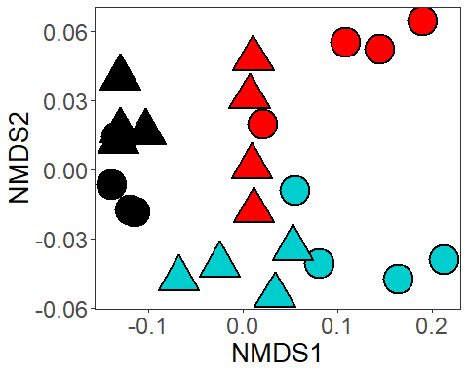

### Community Analyses Germination with no Start

##### Graph for publication

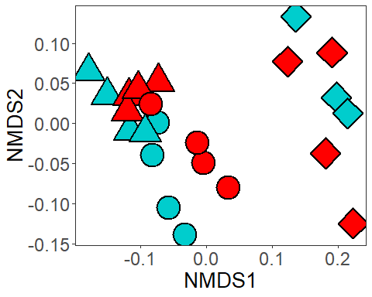

### Community Analyses Germination with no Start

File creation for analyses in Primer

### Transplant Stack bar graphs

## [1] 24

## [1] 8366

## [1] "L.B.A" "S.B.A" "L.R.A" "L.B.D" "S.B.D" "L.R.D"

## [1] "p:Deinococcus-Thermus" "p:TM6"   
## [3] "UNKNOWN" "p:Acidobacteria"   
## [5] "p:Elusimicrobia" "p:Parcubacteria"   
## [7] "p:Proteobacteria" "p:Microgenomates"   
## [9] "p:Candidate_division_SR1" "p:SM2F11"   
## [11] "p:Gracilibacteria" "p:WCHB1-60"   
## [13] "p:Saccharibacteria" "p:Euryarchaeota"   
## [15] "p:Thaumarchaeota" "p:Woesearchaeota_[DHVEG-6]"  
## [17] "p:Omnitrophica" "p:Cyanobacteria"   
## [19] "p:Spirochaetae" "p:Chlorobi"   
## [21] "p:GOUTA4" "p:Bacteroidetes"   
## [23] "p:Planctomycetes" "p:Armatimonadetes"   
## [25] "p:Fibrobacteres" "p:Chloroflexi"   
## [27] "p:SHA-109" "p:Thermotogae"   
## [29] "p:Firmicutes" "p:Tenericutes"   
## [31] "p:Actinobacteria" "p:WD272"   
## [33] "p:Aerophobetes" "p:GAL08"   
## [35] "p:Latescibacteria" "p:Nitrospirae"   
## [37] "p:Candidate_division_OP3" "p:Verrucomicrobia"   
## [39] "p:Hydrogenedentes" "p:Chlamydiae"   
## [41] "p:Lentisphaerae" "p:JL-ETNP-Z39"   
## [43] "p:Gemmatimonadetes"

## phyloseq-class experiment-level object  
## otu_table() OTU Table: [ 44 taxa and 6 samples ]  
## sample_data() Sample Data: [ 6 samples by 42 sample variables ]  
## tax_table() Taxonomy Table: [ 44 taxa by 7 taxonomic ranks ]  
## phy_tree() Phylogenetic Tree: [ 44 tips and 43 internal nodes ]

## L.B.A S.B.A L.R.A L.B.D   
## Min. :0.01085 Min. :0.000250 Min. :0.01075 Min. :0.008125   
## 1st Qu.:0.02134 1st Qu.:0.002838 1st Qu.:0.02950 1st Qu.:0.025200   
## Median :0.03973 Median :0.022425 Median :0.04285 Median :0.032475   
## Mean :0.09091 Mean :0.090909 Mean :0.09091 Mean :0.090909   
## 3rd Qu.:0.06989 3rd Qu.:0.047762 3rd Qu.:0.07831 3rd Qu.:0.088975   
## Max. :0.56235 Max. :0.687650 Max. :0.48518 Max. :0.498475   
## S.B.D L.R.D   
## Min. :0.000425 Min. :0.005475   
## 1st Qu.:0.001825 1st Qu.:0.018437   
## Median :0.002550 Median :0.022450   
## Mean :0.090909 Mean :0.090909   
## 3rd Qu.:0.029413 3rd Qu.:0.063613   
## Max. :0.785525 Max. :0.626300

## L.B.A S.B.A L.R.A L.B.D   
## Min. :0.01085 Min. :0.000250 Min. :0.01075 Min. :0.008125   
## 1st Qu.:0.02134 1st Qu.:0.002838 1st Qu.:0.02950 1st Qu.:0.025200   
## Median :0.03973 Median :0.022425 Median :0.04285 Median :0.032475   
## Mean :0.09091 Mean :0.090909 Mean :0.09091 Mean :0.090909   
## 3rd Qu.:0.06989 3rd Qu.:0.047762 3rd Qu.:0.07831 3rd Qu.:0.088975   
## Max. :0.56235 Max. :0.687650 Max. :0.48518 Max. :0.498475   
## S.B.D L.R.D Phylum   
## Min. :0.000425 Min. :0.005475 Length:11   
## 1st Qu.:0.001825 1st Qu.:0.018437 Class :character   
## Median :0.002550 Median :0.022450 Mode :character   
## Mean :0.090909 Mean :0.090909   
## 3rd Qu.:0.029413 3rd Qu.:0.063613   
## Max. :0.785525 Max. :0.626300

## Phylum variable value   
## Length:66 L.B.A:11 Min. :0.00025   
## Class :character S.B.A:11 1st Qu.:0.01239   
## Mode :character L.R.A:11 Median :0.02686   
## L.B.D:11 Mean :0.09091   
## S.B.D:11 3rd Qu.:0.06125   
## L.R.D:11 Max. :0.78553

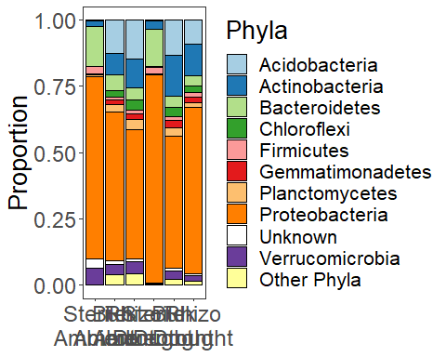

## [1] "#A6CEE3" "#1F78B4" "#B2DF8A" "#33A02C" "#FB9A99" "#E31A1C" "#FDBF6F"  
## [8] "#FF7F00" "#CAB2D6" "#6A3D9A" "#FFFF99" "#B15928"

### Seed Stack bar graphs

## [1] 23

## [1] 8366

## [1] "L.B.A" "S.B.A" "L.R.A" "L.B.D" "S.B.D" "L.R.D"

## [1] "p:Deinococcus-Thermus" "p:TM6"   
## [3] "UNKNOWN" "p:Acidobacteria"   
## [5] "p:Elusimicrobia" "p:Parcubacteria"   
## [7] "p:Proteobacteria" "p:Microgenomates"   
## [9] "p:Candidate_division_SR1" "p:SM2F11"   
## [11] "p:Gracilibacteria" "p:WCHB1-60"   
## [13] "p:Saccharibacteria" "p:Euryarchaeota"   
## [15] "p:Thaumarchaeota" "p:Woesearchaeota_[DHVEG-6]"  
## [17] "p:Omnitrophica" "p:Cyanobacteria"   
## [19] "p:Spirochaetae" "p:Chlorobi"   
## [21] "p:GOUTA4" "p:Bacteroidetes"   
## [23] "p:Planctomycetes" "p:Armatimonadetes"   
## [25] "p:Fibrobacteres" "p:Chloroflexi"   
## [27] "p:SHA-109" "p:Thermotogae"   
## [29] "p:Firmicutes" "p:Tenericutes"   
## [31] "p:Actinobacteria" "p:WD272"   
## [33] "p:Aerophobetes" "p:GAL08"   
## [35] "p:Latescibacteria" "p:Nitrospirae"   
## [37] "p:Candidate_division_OP3" "p:Verrucomicrobia"   
## [39] "p:Hydrogenedentes" "p:Chlamydiae"   
## [41] "p:Lentisphaerae" "p:JL-ETNP-Z39"   
## [43] "p:Gemmatimonadetes"

## phyloseq-class experiment-level object  
## otu_table() OTU Table: [ 44 taxa and 6 samples ]  
## sample_data() Sample Data: [ 6 samples by 42 sample variables ]  
## tax_table() Taxonomy Table: [ 44 taxa by 7 taxonomic ranks ]  
## phy_tree() Phylogenetic Tree: [ 44 tips and 43 internal nodes ]

## L.B.A S.B.A L.R.A L.B.D   
## Min. :0.01307 Min. :0.000575 Min. :0.01385 Min. :0.00255   
## 1st Qu.:0.01695 1st Qu.:0.007537 1st Qu.:0.02410 1st Qu.:0.01744   
## Median :0.02420 Median :0.023550 Median :0.03770 Median :0.02025   
## Mean :0.09091 Mean :0.090909 Mean :0.09091 Mean :0.09091   
## 3rd Qu.:0.05906 3rd Qu.:0.048438 3rd Qu.:0.08709 3rd Qu.:0.06198   
## Max. :0.64765 Max. :0.709200 Max. :0.49155 Max. :0.65085   
## S.B.D L.R.D   
## Min. :0.0000000 Min. :0.00475   
## 1st Qu.:0.0003167 1st Qu.:0.03144   
## Median :0.0046667 Median :0.03762   
## Mean :0.0909091 Mean :0.09091   
## 3rd Qu.:0.1003667 3rd Qu.:0.09221   
## Max. :0.6411333 Max. :0.44603

## L.B.A S.B.A L.R.A L.B.D   
## Min. :0.01307 Min. :0.000575 Min. :0.01385 Min. :0.00255   
## 1st Qu.:0.01695 1st Qu.:0.007537 1st Qu.:0.02410 1st Qu.:0.01744   
## Median :0.02420 Median :0.023550 Median :0.03770 Median :0.02025   
## Mean :0.09091 Mean :0.090909 Mean :0.09091 Mean :0.09091   
## 3rd Qu.:0.05906 3rd Qu.:0.048438 3rd Qu.:0.08709 3rd Qu.:0.06198   
## Max. :0.64765 Max. :0.709200 Max. :0.49155 Max. :0.65085   
## S.B.D L.R.D Phylum   
## Min. :0.0000000 Min. :0.00475 Length:11   
## 1st Qu.:0.0003167 1st Qu.:0.03144 Class :character   
## Median :0.0046667 Median :0.03762 Mode :character   
## Mean :0.0909091 Mean :0.09091   
## 3rd Qu.:0.1003667 3rd Qu.:0.09221   
## Max. :0.6411333 Max. :0.44603

## Phylum variable value   
## Length:66 L.B.A:11 Min. :0.00000   
## Class :character S.B.A:11 1st Qu.:0.01649   
## Mode :character L.R.A:11 Median :0.03047   
## L.B.D:11 Mean :0.09091   
## S.B.D:11 3rd Qu.:0.08233   
## L.R.D:11 Max. :0.70920

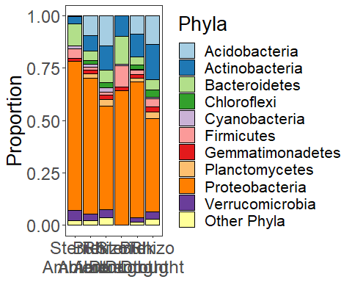 ##### Combined taxon stacked bargraph 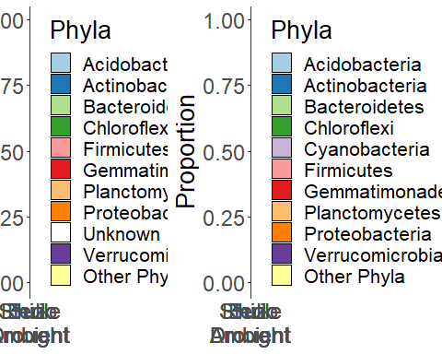 ### Starting community Stack bar graphs

## [1] 8

## [1] "B" "R"

## [1] "p:Deinococcus-Thermus" "p:TM6"   
## [3] "UNKNOWN" "p:Acidobacteria"   
## [5] "p:Elusimicrobia" "p:Parcubacteria"   
## [7] "p:Proteobacteria" "p:Microgenomates"   
## [9] "p:Candidate_division_SR1" "p:SM2F11"   
## [11] "p:Gracilibacteria" "p:WCHB1-60"   
## [13] "p:Saccharibacteria" "p:Euryarchaeota"   
## [15] "p:Thaumarchaeota" "p:Woesearchaeota_[DHVEG-6]"  
## [17] "p:Omnitrophica" "p:Cyanobacteria"   
## [19] "p:Spirochaetae" "p:Chlorobi"   
## [21] "p:GOUTA4" "p:Bacteroidetes"   
## [23] "p:Planctomycetes" "p:Armatimonadetes"   
## [25] "p:Fibrobacteres" "p:Chloroflexi"   
## [27] "p:SHA-109" "p:Thermotogae"   
## [29] "p:Firmicutes" "p:Tenericutes"   
## [31] "p:Actinobacteria" "p:WD272"   
## [33] "p:Aerophobetes" "p:GAL08"   
## [35] "p:Latescibacteria" "p:Nitrospirae"   
## [37] "p:Candidate_division_OP3" "p:Verrucomicrobia"   
## [39] "p:Hydrogenedentes" "p:Chlamydiae"   
## [41] "p:Lentisphaerae" "p:JL-ETNP-Z39"   
## [43] "p:Gemmatimonadetes"

## phyloseq-class experiment-level object  
## otu_table() OTU Table: [ 44 taxa and 2 samples ]  
## sample_data() Sample Data: [ 2 samples by 41 sample variables ]  
## tax_table() Taxonomy Table: [ 44 taxa by 7 taxonomic ranks ]  
## phy_tree() Phylogenetic Tree: [ 44 tips and 43 internal nodes ]

## B R   
## Min. :0.01970 Min. :0.01777   
## 1st Qu.:0.04110 1st Qu.:0.04225   
## Median :0.05315 Median :0.05505   
## Mean :0.09091 Mean :0.09091   
## 3rd Qu.:0.10319 3rd Qu.:0.09050   
## Max. :0.26222 Max. :0.27448

## B R Phylum   
## Min. :0.01970 Min. :0.01777 Length:11   
## 1st Qu.:0.04110 1st Qu.:0.04225 Class :character   
## Median :0.05315 Median :0.05505 Mode :character   
## Mean :0.09091 Mean :0.09091   
## 3rd Qu.:0.10319 3rd Qu.:0.09050   
## Max. :0.26222 Max. :0.27448

## Phylum variable value   
## Length:22 B:11 Min. :0.01777   
## Class :character R:11 1st Qu.:0.03886   
## Mode :character Median :0.05410   
## Mean :0.09091   
## 3rd Qu.:0.09811   
## Max. :0.27448

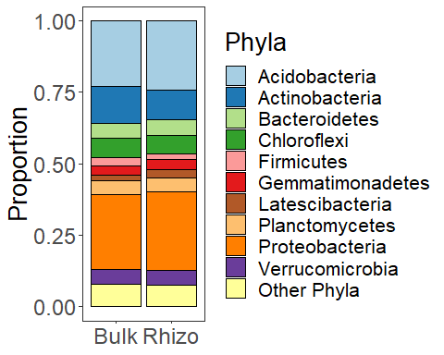

# Community Diversity

### Start community Richness

Diagnostic Graphs

bact_obs_rich_model_start= lmer((Observed)~soil_root+(1|block), data= SILVA_MERDS_rar.divfil_start)  
qqPlot(resid(bact_obs_rich_model_start))

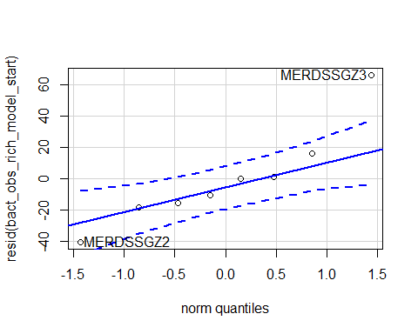

## MERDSSGZ3 MERDSSGZ2   
## 6 5

hist(resid(bact_obs_rich_model_start))

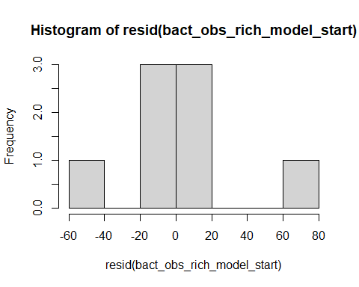

shapiro.test(resid(bact_obs_rich_model_start))

##   
## Shapiro-Wilk normality test  
##   
## data: resid(bact_obs_rich_model_start)  
## W = 0.89522, p-value = 0.2615

#0.2615

Raw Statistical output

anova(bact_obs_rich_model_start)

## Type III Analysis of Variance Table with Satterthwaite's method  
## Sum Sq Mean Sq NumDF DenDF F value Pr(>F)  
## soil_root 10.125 10.125 1 3 0.0062 0.9422

emmeans(bact_obs_rich_model_start, pairwise~soil_root)

## Note: Use 'contrast(regrid(object), ...)' to obtain contrasts of back-transformed estimates

## $emmeans  
## soil_root emmean SE df lower.CL upper.CL  
## L.B 2067 26.3 5.14 2000 2134  
## L.R 2070 26.3 5.14 2002 2137  
##   
## Degrees-of-freedom method: kenward-roger   
## Results are given on the ( (not the response) scale.   
## Confidence level used: 0.95   
##   
## $contrasts  
## contrast estimate SE df t.ratio p.value  
## L.B - L.R -2.25 28.6 3 -0.079 0.9422   
##   
## Note: contrasts are still on the ( scale   
## Degrees-of-freedom method: kenward-roger

Formatted Anova table

Starting soil communtiy richness

|  |  |  |  |  |
| --- | --- | --- | --- | --- |
|  | Df | Resid.Df | F.value | P.value |
| soil_root | 1 | 3 | 0.01 | 0.942 |

##### Graph for publication

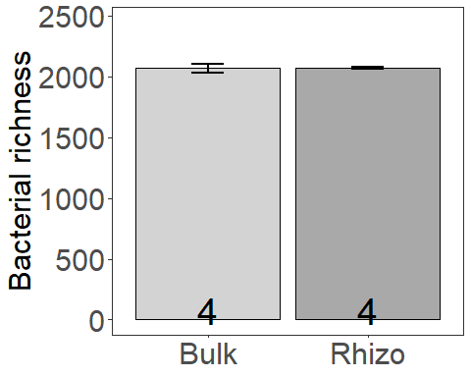

### Start community inv Simpson

Diagnostic Graphs

bact_InvSimp_model_start= lmer((InvSimpson)~soil_root+(1|block), data= SILVA_MERDS_rar.divfil_start)  
qqPlot(resid(bact_InvSimp_model_start))

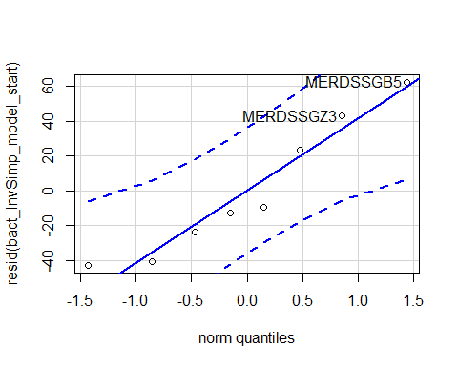

## MERDSSGB5 MERDSSGZ3   
## 4 6

hist(resid(bact_InvSimp_model_start))

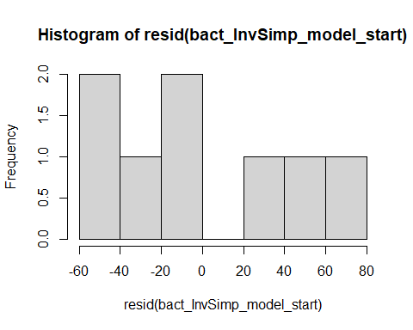

shapiro.test(resid(bact_InvSimp_model_start))

##   
## Shapiro-Wilk normality test  
##   
## data: resid(bact_InvSimp_model_start)  
## W = 0.91752, p-value = 0.4101

#0.4101

Raw Statistical output

anova(bact_InvSimp_model_start)

## Type III Analysis of Variance Table with Satterthwaite's method  
## Sum Sq Mean Sq NumDF DenDF F value Pr(>F)  
## soil_root 359.08 359.08 1 3 0.143 0.7305

emmeans(bact_InvSimp_model_start, pairwise~soil_root)

## Note: Use 'contrast(regrid(object), ...)' to obtain contrasts of back-transformed estimates

## $emmeans  
## soil_root emmean SE df lower.CL upper.CL  
## L.B 265 33.2 5.06 180 350  
## L.R 279 33.2 5.06 193 364  
##   
## Degrees-of-freedom method: kenward-roger   
## Results are given on the ( (not the response) scale.   
## Confidence level used: 0.95   
##   
## $contrasts  
## contrast estimate SE df t.ratio p.value  
## L.B - L.R -13.4 35.4 3 -0.378 0.7305   
##   
## Note: contrasts are still on the ( scale   
## Degrees-of-freedom method: kenward-roger

Formatted Anova table

Starting soil communtiy inverse Simpson

|  |  |  |  |  |
| --- | --- | --- | --- | --- |
|  | Df | Resid.Df | F.value | P.value |
| soil_root | 1 | 3 | 0.14 | 0.73 |

##### Graph for publication

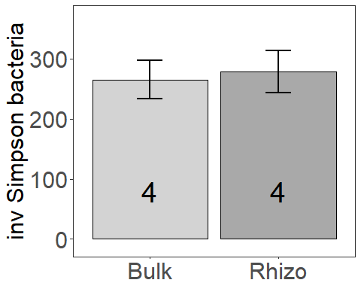

### Transplant Richness

Diagnostic Graphs

bact_obs_rich_model_trans= lmer((Observed)~soil_root*precip+(1|block), data= SILVA_MERDS_rar.divfil_trt_trans)

## boundary (singular) fit: see ?isSingular

qqPlot(resid(bact_obs_rich_model_trans))

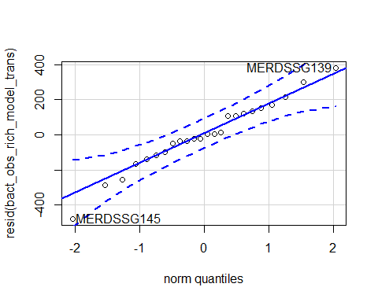

## MERDSSG145 MERDSSG139   
## 13 11

hist(resid(bact_obs_rich_model_trans))

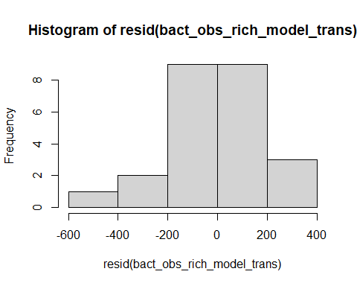

shapiro.test(resid(bact_obs_rich_model_trans))

##   
## Shapiro-Wilk normality test  
##   
## data: resid(bact_obs_rich_model_trans)  
## W = 0.98049, p-value = 0.9046

Raw Statistical output

anova(bact_obs_rich_model_trans)

## Type III Analysis of Variance Table with Satterthwaite's method  
## Sum Sq Mean Sq NumDF DenDF F value Pr(>F)   
## soil_root 6371572 3185786 2 18 67.9823 4.08e-09 ***  
## precip 234235 234235 1 18 4.9984 0.03828 *   
## soil_root:precip 219760 109880 2 18 2.3448 0.12446   
## ---  
## Signif. codes: 0 '***' 0.001 '**' 0.01 '*' 0.05 '.' 0.1 ' ' 1

emmeans(bact_obs_rich_model_trans, pairwise~soil_root|precip)

## Note: Use 'contrast(regrid(object), ...)' to obtain contrasts of back-transformed estimates

## $emmeans  
## precip = A:  
## soil_root emmean SE df lower.CL upper.CL  
## L.B 1368 108 18 1141.1 1596  
## S.B 242 108 18 14.6 469  
## L.R 1533 108 18 1305.9 1761  
##   
## precip = D:  
## soil_root emmean SE df lower.CL upper.CL  
## L.B 1286 108 18 1058.4 1513  
## S.B 199 108 18 -28.1 427  
## L.R 1066 108 18 838.6 1293  
##   
## Degrees-of-freedom method: kenward-roger   
## Results are given on the ( (not the response) scale.   
## Confidence level used: 0.95   
##   
## $contrasts  
## precip = A:  
## contrast estimate SE df t.ratio p.value  
## L.B - S.B 1126 153 15 7.359 <.0001   
## L.B - L.R -165 153 15 -1.076 0.5426   
## S.B - L.R -1291 153 15 -8.436 <.0001   
##   
## precip = D:  
## contrast estimate SE df t.ratio p.value  
## L.B - S.B 1086 153 15 7.098 <.0001   
## L.B - L.R 220 153 15 1.436 0.3486   
## S.B - L.R -867 153 15 -5.662 0.0001   
##   
## Note: contrasts are still on the ( scale   
## Degrees-of-freedom method: kenward-roger   
## P value adjustment: tukey method for comparing a family of 3 estimates

emmeans(bact_obs_rich_model_trans, pairwise~soil_root)

## NOTE: Results may be misleading due to involvement in interactions  
## Note: Use 'contrast(regrid(object), ...)' to obtain contrasts of back-transformed estimates

## $emmeans  
## soil_root emmean SE df lower.CL upper.CL  
## L.B 1327 76.5 15 1164.0 1490  
## S.B 221 76.5 15 57.5 384  
## L.R 1300 76.5 15 1136.5 1463  
##   
## Results are averaged over the levels of: precip   
## Degrees-of-freedom method: kenward-roger   
## Results are given on the ( (not the response) scale.   
## Confidence level used: 0.95   
##   
## $contrasts  
## contrast estimate SE df t.ratio p.value  
## L.B - S.B 1106.5 108 15 10.223 <.0001   
## L.B - L.R 27.5 108 15 0.254 0.9651   
## S.B - L.R -1079.0 108 15 -9.969 <.0001   
##   
## Results are averaged over the levels of: precip   
## Note: contrasts are still on the ( scale   
## Degrees-of-freedom method: kenward-roger   
## P value adjustment: tukey method for comparing a family of 3 estimates

Formatted Anova table

Transplant soil communtiy richness

|  |  |  |  |  |
| --- | --- | --- | --- | --- |
|  | Df | Resid.Df | F.value | P.value |
| soil_root | 2 | 18 | 67.98 | 0.000 |
| precip | 1 | 18 | 5.00 | 0.038 |
| soil_root:precip | 2 | 18 | 2.34 | 0.124 |

##### Graph for publication

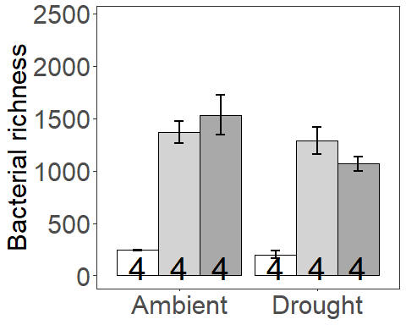

### Presence Richness

Diagnostic Graphs

SILVA_MERDS_rar.divfil_pres_trans=subset(SILVA_MERDS_rar.divfil_trt_trans, root_association =="B")  
  
bact_obs_rich_model_trans_pres= lmer((Observed)~soil_root*precip+(1|block), data= SILVA_MERDS_rar.divfil_pres_trans)  
qqPlot(resid(bact_obs_rich_model_trans_pres))

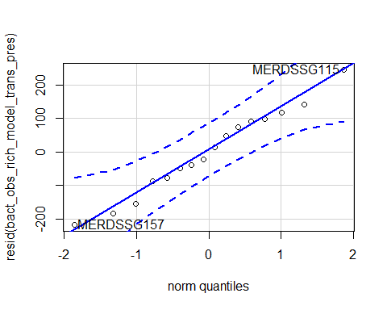

## MERDSSG115 MERDSSG157   
## 3 10

hist(resid(bact_obs_rich_model_trans_pres))

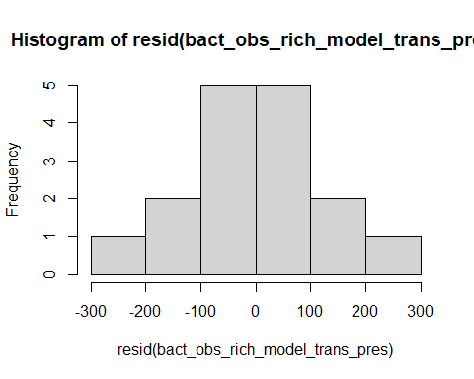

shapiro.test(resid(bact_obs_rich_model_trans_pres))

##   
## Shapiro-Wilk normality test  
##   
## data: resid(bact_obs_rich_model_trans_pres)  
## W = 0.98107, p-value = 0.9715

Raw Statistical output

anova(bact_obs_rich_model_trans_pres)

## Type III Analysis of Variance Table with Satterthwaite's method  
## Sum Sq Mean Sq NumDF DenDF F value Pr(>F)   
## soil_root 4897369 4897369 1 9 210.6111 1.503e-07 ***  
## precip 15750 15750 1 9 0.6773 0.4318   
## soil_root:precip 1600 1600 1 9 0.0688 0.7990   
## ---  
## Signif. codes: 0 '***' 0.001 '**' 0.01 '*' 0.05 '.' 0.1 ' ' 1

emmeans(bact_obs_rich_model_trans_pres, pairwise~soil_root|precip)

## Note: Use 'contrast(regrid(object), ...)' to obtain contrasts of back-transformed estimates

## $emmeans  
## precip = A:  
## soil_root emmean SE df lower.CL upper.CL  
## L.B 1368 85.2 10.7 1180.4 1557  
## S.B 242 85.2 10.7 53.9 430  
##   
## precip = D:  
## soil_root emmean SE df lower.CL upper.CL  
## L.B 1286 85.2 10.7 1097.7 1474  
## S.B 199 85.2 10.7 11.2 387  
##   
## Degrees-of-freedom method: kenward-roger   
## Results are given on the ( (not the response) scale.   
## Confidence level used: 0.95   
##   
## $contrasts  
## precip = A:  
## contrast estimate SE df t.ratio p.value  
## L.B - S.B 1126 108 9 10.447 <.0001   
##   
## precip = D:  
## contrast estimate SE df t.ratio p.value  
## L.B - S.B 1086 108 9 10.076 <.0001   
##   
## Note: contrasts are still on the ( scale   
## Degrees-of-freedom method: kenward-roger

Formatted Anova table

Presence Transplant soil communtiy richness

|  |  |  |  |  |
| --- | --- | --- | --- | --- |
|  | Df | Resid.Df | F.value | P.value |
| soil_root | 1 | 9 | 210.61 | 0.000 |
| precip | 1 | 9 | 0.68 | 0.432 |
| soil_root:precip | 1 | 9 | 0.07 | 0.799 |

### Origin Richness

Diagnostic Graphs

SILVA_MERDS_rar.divfil_orig_trans=subset(SILVA_MERDS_rar.divfil_trt_trans, soil_status =="L")  
  
bact_obs_rich_model_trans_orig= lmer((Observed)~soil_root*precip+(1|block), data= SILVA_MERDS_rar.divfil_orig_trans)

## boundary (singular) fit: see ?isSingular

qqPlot(resid(bact_obs_rich_model_trans_orig))

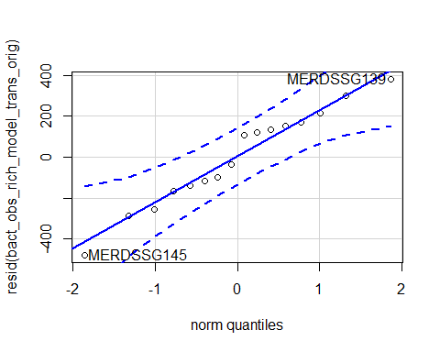

## MERDSSG145 MERDSSG139   
## 9 7

hist(resid(bact_obs_rich_model_trans_orig))

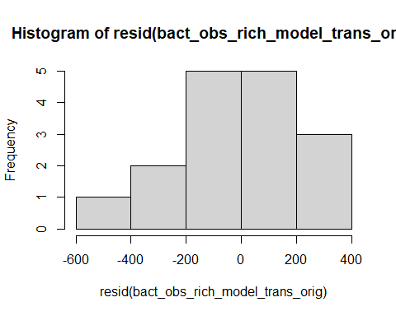

shapiro.test(resid(bact_obs_rich_model_trans_orig))

##   
## Shapiro-Wilk normality test  
##   
## data: resid(bact_obs_rich_model_trans_orig)  
## W = 0.96971, p-value = 0.834

Raw Statistical output

anova(bact_obs_rich_model_trans_orig)

## Type III Analysis of Variance Table with Satterthwaite's method  
## Sum Sq Mean Sq NumDF DenDF F value Pr(>F)   
## soil_root 3025 3025 1 12 0.0439 0.83759   
## precip 302500 302500 1 12 4.3880 0.05808 .  
## soil_root:precip 147840 147840 1 12 2.1445 0.16878   
## ---  
## Signif. codes: 0 '***' 0.001 '**' 0.01 '*' 0.05 '.' 0.1 ' ' 1

emmeans(bact_obs_rich_model_trans_orig, pairwise~soil_root|precip)

## Note: Use 'contrast(regrid(object), ...)' to obtain contrasts of back-transformed estimates

## $emmeans  
## precip = A:  
## soil_root emmean SE df lower.CL upper.CL  
## L.B 1368 131 12 1082 1655  
## L.R 1533 131 12 1247 1819  
##   
## precip = D:  
## soil_root emmean SE df lower.CL upper.CL  
## L.B 1286 131 12 1000 1572  
## L.R 1066 131 12 780 1352  
##   
## Degrees-of-freedom method: kenward-roger   
## Results are given on the ( (not the response) scale.   
## Confidence level used: 0.95   
##   
## $contrasts  
## precip = A:  
## contrast estimate SE df t.ratio p.value  
## L.B - L.R -165 186 9 -0.887 0.3980   
##   
## precip = D:  
## contrast estimate SE df t.ratio p.value  
## L.B - L.R 220 186 9 1.184 0.2669   
##   
## Note: contrasts are still on the ( scale   
## Degrees-of-freedom method: kenward-roger

Formatted Anova table

Presence Transplant soil communtiy richness

|  |  |  |  |  |
| --- | --- | --- | --- | --- |
|  | Df | Resid.Df | F.value | P.value |
| soil_root | 1 | 12 | 0.04 | 0.838 |
| precip | 1 | 12 | 4.39 | 0.058 |
| soil_root:precip | 1 | 12 | 2.14 | 0.169 |

### Transplant inv Simpson

Diagnostic Graphs

bact_inv_simp_model_trans= lmer((InvSimpson)~soil_root*precip+(1|block), data= SILVA_MERDS_rar.divfil_trt_trans)

## boundary (singular) fit: see ?isSingular

qqPlot(resid(bact_inv_simp_model_trans))

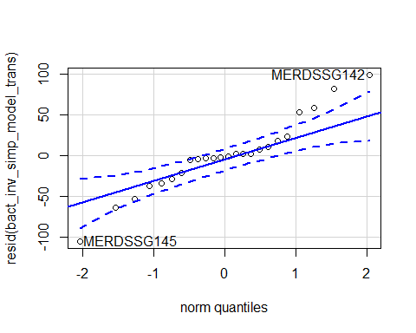

## MERDSSG145 MERDSSG142   
## 13 12

hist(resid(bact_inv_simp_model_trans))

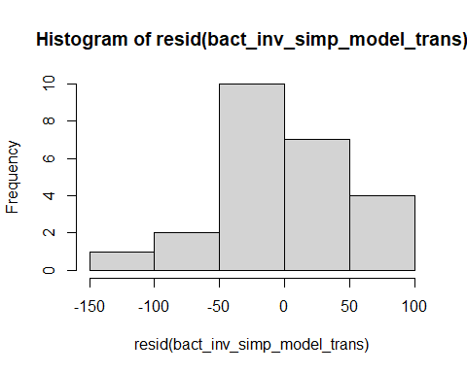

shapiro.test(resid(bact_inv_simp_model_trans))

##   
## Shapiro-Wilk normality test  
##   
## data: resid(bact_inv_simp_model_trans)  
## W = 0.95212, p-value = 0.3009

Raw Statistical output

anova(bact_inv_simp_model_trans)

## Type III Analysis of Variance Table with Satterthwaite's method  
## Sum Sq Mean Sq NumDF DenDF F value Pr(>F)   
## soil_root 19678.6 9839.3 2 18 3.8952 0.03929 *  
## precip 3523.8 3523.8 1 18 1.3950 0.25293   
## soil_root:precip 14434.7 7217.3 2 18 2.8572 0.08363 .  
## ---  
## Signif. codes: 0 '***' 0.001 '**' 0.01 '*' 0.05 '.' 0.1 ' ' 1

emmeans(bact_inv_simp_model_trans, pairwise~soil_root|precip)

## Note: Use 'contrast(regrid(object), ...)' to obtain contrasts of back-transformed estimates

## $emmeans  
## precip = A:  
## soil_root emmean SE df lower.CL upper.CL  
## L.B 54.2 25.1 18 1.4 107.0  
## S.B 20.8 25.1 18 -32.0 73.6  
## L.R 127.9 25.1 18 75.1 180.7  
##   
## precip = D:  
## soil_root emmean SE df lower.CL upper.CL  
## L.B 81.4 25.1 18 28.6 134.2  
## S.B 11.1 25.1 18 -41.7 63.9  
## L.R 37.7 25.1 18 -15.1 90.5  
##   
## Degrees-of-freedom method: kenward-roger   
## Results are given on the ( (not the response) scale.   
## Confidence level used: 0.95   
##   
## $contrasts  
## precip = A:  
## contrast estimate SE df t.ratio p.value  
## L.B - S.B 33.4 35.5 15 0.939 0.6246   
## L.B - L.R -73.7 35.5 15 -2.074 0.1291   
## S.B - L.R -107.1 35.5 15 -3.014 0.0224   
##   
## precip = D:  
## contrast estimate SE df t.ratio p.value  
## L.B - S.B 70.3 35.5 15 1.979 0.1517   
## L.B - L.R 43.8 35.5 15 1.231 0.4537   
## S.B - L.R -26.6 35.5 15 -0.747 0.7398   
##   
## Note: contrasts are still on the ( scale   
## Degrees-of-freedom method: kenward-roger   
## P value adjustment: tukey method for comparing a family of 3 estimates

emmeans(bact_inv_simp_model_trans, pairwise~soil_root)

## NOTE: Results may be misleading due to involvement in interactions  
## Note: Use 'contrast(regrid(object), ...)' to obtain contrasts of back-transformed estimates

## $emmeans  
## soil_root emmean SE df lower.CL upper.CL  
## L.B 67.8 17.8 15 29.9 105.7  
## S.B 16.0 17.8 15 -21.9 53.8  
## L.R 82.8 17.8 15 44.9 120.7  
##   
## Results are averaged over the levels of: precip   
## Degrees-of-freedom method: kenward-roger   
## Results are given on the ( (not the response) scale.   
## Confidence level used: 0.95   
##   
## $contrasts  
## contrast estimate SE df t.ratio p.value  
## L.B - S.B 51.9 25.1 15 2.064 0.1314   
## L.B - L.R -15.0 25.1 15 -0.596 0.8244   
## S.B - L.R -66.8 25.1 15 -2.659 0.0445   
##   
## Results are averaged over the levels of: precip   
## Note: contrasts are still on the ( scale   
## Degrees-of-freedom method: kenward-roger   
## P value adjustment: tukey method for comparing a family of 3 estimates

Formatted Anova table

Transplant soil communtiy inv Simpson

|  |  |  |  |  |
| --- | --- | --- | --- | --- |
|  | Df | Resid.Df | F.value | P.value |
| soil_root | 2 | 18 | 3.90 | 0.039 |
| precip | 1 | 18 | 1.40 | 0.253 |
| soil_root:precip | 2 | 18 | 2.86 | 0.084 |

##### Graph for publication

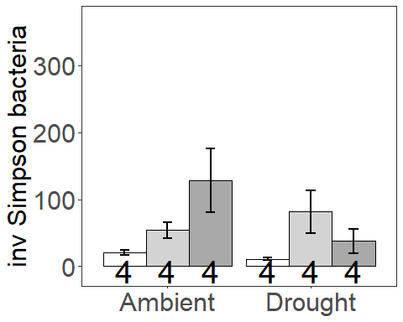

### Presence inv Simpson

Diagnostic Graphs

SILVA_MERDS_rar.divfil_pres_trans=subset(SILVA_MERDS_rar.divfil_trt_trans, root_association =="B")  
  
bact_inv_simp_model_trans_pres= lmer((InvSimpson)^(-1/2)~soil_root*precip+(1|block), data= SILVA_MERDS_rar.divfil_pres_trans)  
qqPlot(resid(bact_inv_simp_model_trans_pres))

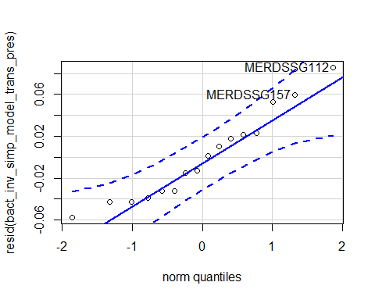

## MERDSSG112 MERDSSG157   
## 2 10

hist(resid(bact_inv_simp_model_trans_pres))

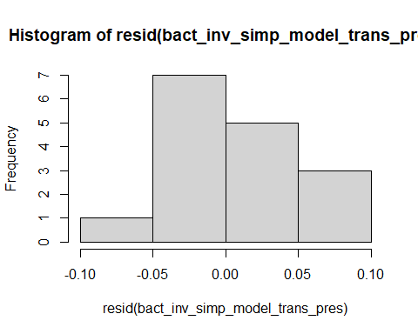

shapiro.test(resid(bact_inv_simp_model_trans_pres))

##   
## Shapiro-Wilk normality test  
##   
## data: resid(bact_inv_simp_model_trans_pres)  
## W = 0.94386, p-value = 0.399

Raw Statistical output

anova(bact_inv_simp_model_trans_pres)

## Type III Analysis of Variance Table with Satterthwaite's method  
## Sum Sq Mean Sq NumDF DenDF F value Pr(>F)   
## soil_root 0.058495 0.058495 1 9 25.1118 0.0007278 ***  
## precip 0.005318 0.005318 1 9 2.2832 0.1650705   
## soil_root:precip 0.007404 0.007404 1 9 3.1784 0.1082930   
## ---  
## Signif. codes: 0 '***' 0.001 '**' 0.01 '*' 0.05 '.' 0.1 ' ' 1

emmeans(bact_inv_simp_model_trans_pres, pairwise~soil_root|precip)

## Warning in ref_grid(object, ...): There are unevaluated constants in the response formula  
## Auto-detection of the response transformation may be incorrect

## Note: Use 'contrast(regrid(object), ...)' to obtain contrasts of back-transformed estimates

## $emmeans  
## precip = A:  
## soil_root emmean SE df lower.CL upper.CL  
## L.B 0.148 0.0253 11.7 0.0931 0.203  
## S.B 0.226 0.0253 11.7 0.1710 0.281  
##   
## precip = D:  
## soil_root emmean SE df lower.CL upper.CL  
## L.B 0.142 0.0253 11.7 0.0865 0.197  
## S.B 0.306 0.0253 11.7 0.2505 0.361  
##   
## Degrees-of-freedom method: kenward-roger   
## Results are given on the ( (not the response) scale.   
## Confidence level used: 0.95   
##   
## $contrasts  
## precip = A:  
## contrast estimate SE df t.ratio p.value  
## L.B - S.B -0.0779 0.0341 9 -2.283 0.0483   
##   
## precip = D:  
## contrast estimate SE df t.ratio p.value  
## L.B - S.B -0.1640 0.0341 9 -4.804 0.0010   
##   
## Note: contrasts are still on the ( scale   
## Degrees-of-freedom method: kenward-roger

Formatted Anova table

Presence Transplant soil communtiy inv Simpson

|  |  |  |  |  |
| --- | --- | --- | --- | --- |
|  | Df | Resid.Df | F.value | P.value |
| soil_root | 1 | 9 | 25.11 | 0.001 |
| precip | 1 | 9 | 2.28 | 0.165 |
| soil_root:precip | 1 | 9 | 3.18 | 0.108 |

### Origin inv Simpson

Diagnostic Graphs

SILVA_MERDS_rar.divfil_orig_trans=subset(SILVA_MERDS_rar.divfil_trt_trans, soil_status =="L")  
  
bact_inv_simp_model_trans_orig= lmer((InvSimpson)~soil_root*precip+(1|block), data= SILVA_MERDS_rar.divfil_orig_trans)

## boundary (singular) fit: see ?isSingular

qqPlot(resid(bact_inv_simp_model_trans_orig))

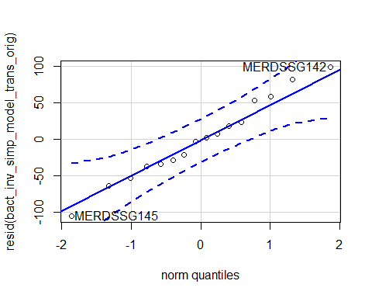

## MERDSSG145 MERDSSG142   
## 9 8

hist(resid(bact_inv_simp_model_trans_orig))

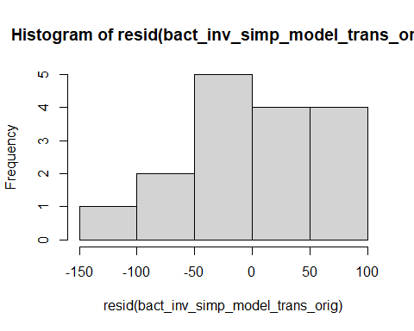

shapiro.test(resid(bact_inv_simp_model_trans_orig))

##   
## Shapiro-Wilk normality test  
##   
## data: resid(bact_inv_simp_model_trans_orig)  
## W = 0.98535, p-value = 0.9921

Raw Statistical output

anova(bact_inv_simp_model_trans_orig)

## Type III Analysis of Variance Table with Satterthwaite's method  
## Sum Sq Mean Sq NumDF DenDF F value Pr(>F)   
## soil_root 896.9 896.9 1 12 0.2377 0.63464   
## precip 3969.5 3969.5 1 12 1.0521 0.32526   
## soil_root:precip 13800.8 13800.8 1 12 3.6577 0.07997 .  
## ---  
## Signif. codes: 0 '***' 0.001 '**' 0.01 '*' 0.05 '.' 0.1 ' ' 1

emmeans(bact_inv_simp_model_trans_orig, pairwise~soil_root|precip)

## Note: Use 'contrast(regrid(object), ...)' to obtain contrasts of back-transformed estimates

## $emmeans  
## precip = A:  
## soil_root emmean SE df lower.CL upper.CL  
## L.B 54.2 30.7 12 -12.7 121  
## L.R 127.9 30.7 12 61.0 195  
##   
## precip = D:  
## soil_root emmean SE df lower.CL upper.CL  
## L.B 81.4 30.7 12 14.5 148  
## L.R 37.7 30.7 12 -29.3 105  
##   
## Degrees-of-freedom method: kenward-roger   
## Results are given on the ( (not the response) scale.   
## Confidence level used: 0.95   
##   
## $contrasts  
## precip = A:  
## contrast estimate SE df t.ratio p.value  
## L.B - L.R -73.7 43.4 9 -1.697 0.1239   
##   
## precip = D:  
## contrast estimate SE df t.ratio p.value  
## L.B - L.R 43.8 43.4 9 1.008 0.3400   
##   
## Note: contrasts are still on the ( scale   
## Degrees-of-freedom method: kenward-roger

Formatted Anova table

Presence Transplant soil communtiy inv Simpson

|  |  |  |  |  |
| --- | --- | --- | --- | --- |
|  | Df | Resid.Df | F.value | P.value |
| soil_root | 1 | 12 | 0.24 | 0.635 |
| precip | 1 | 12 | 1.05 | 0.325 |
| soil_root:precip | 1 | 12 | 3.66 | 0.080 |

### Seed Richness

Diagnostic Graphs

bact_obs_rich_model_seed= lmer(log(Observed)~soil_root*precip+(1|block), data= SILVA_MERDS_rar.divfil_trt_seed)  
qqPlot(resid(bact_obs_rich_model_seed))

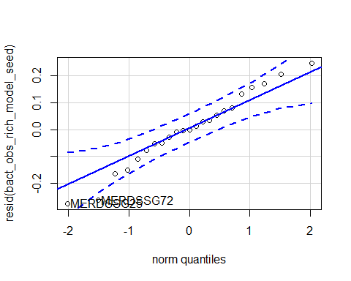

## MERDSSG25 MERDSSG72   
## 5 18

hist(resid(bact_obs_rich_model_seed))

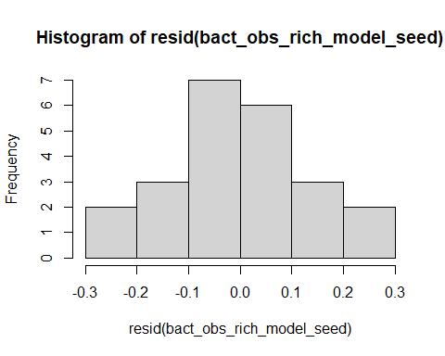

shapiro.test(resid(bact_obs_rich_model_seed))

##   
## Shapiro-Wilk normality test  
##   
## data: resid(bact_obs_rich_model_seed)  
## W = 0.97783, p-value = 0.866

Raw Statistical output

anova(bact_obs_rich_model_seed)

## Type III Analysis of Variance Table with Satterthwaite's method  
## Sum Sq Mean Sq NumDF DenDF F value Pr(>F)   
## soil_root 18.1186 9.0593 2 15.160 355.6853 1.825e-13 ***  
## precip 0.0405 0.0405 1 14.304 1.5890 0.2276   
## soil_root:precip 0.0354 0.0177 2 15.160 0.6958 0.5139   
## ---  
## Signif. codes: 0 '***' 0.001 '**' 0.01 '*' 0.05 '.' 0.1 ' ' 1

emmeans(bact_obs_rich_model_seed, pairwise~soil_root|precip)

## $emmeans  
## precip = A:  
## soil_root emmean SE df lower.CL upper.CL  
## L.B 6.93 0.0831 16.3 6.76 7.11  
## S.B 5.21 0.0831 16.3 5.03 5.38  
## L.R 7.23 0.0831 16.3 7.06 7.41  
##   
## precip = D:  
## soil_root emmean SE df lower.CL upper.CL  
## L.B 6.90 0.0831 16.3 6.72 7.08  
## S.B 5.01 0.1055 15.3 4.78 5.23  
## L.R 7.21 0.0881 15.2 7.03 7.40  
##   
## Degrees-of-freedom method: kenward-roger   
## Results are given on the log (not the response) scale.   
## Confidence level used: 0.95   
##   
## $contrasts  
## precip = A:  
## contrast estimate SE df t.ratio p.value  
## L.B - S.B 1.724 0.113 14.0 15.276 <.0001   
## L.B - L.R -0.301 0.113 14.0 -2.668 0.0454   
## S.B - L.R -2.025 0.113 14.0 -17.945 <.0001   
##   
## precip = D:  
## contrast estimate SE df t.ratio p.value  
## L.B - S.B 1.893 0.130 15.8 14.541 <.0001   
## L.B - L.R -0.312 0.117 14.9 -2.680 0.0428   
## S.B - L.R -2.206 0.142 17.0 -15.561 <.0001   
##   
## Degrees-of-freedom method: kenward-roger   
## Results are given on the log (not the response) scale.   
## P value adjustment: tukey method for comparing a family of 3 estimates

emmeans(bact_obs_rich_model_seed, pairwise~soil_root)

## NOTE: Results may be misleading due to involvement in interactions

## $emmeans  
## soil_root emmean SE df lower.CL upper.CL  
## L.B 6.92 0.0610 10.7 6.78 7.05  
## S.B 5.11 0.0691 10.9 4.96 5.26  
## L.R 7.22 0.0627 10.1 7.08 7.36  
##   
## Results are averaged over the levels of: precip   
## Degrees-of-freedom method: kenward-roger   
## Results are given on the log (not the response) scale.   
## Confidence level used: 0.95   
##   
## $contrasts  
## contrast estimate SE df t.ratio p.value  
## L.B - S.B 1.809 0.0861 15.1 20.994 <.0001   
## L.B - L.R -0.307 0.0811 14.5 -3.782 0.0051   
## S.B - L.R -2.115 0.0906 16.3 -23.351 <.0001   
##   
## Results are averaged over the levels of: precip   
## Degrees-of-freedom method: kenward-roger   
## Results are given on the log (not the response) scale.   
## P value adjustment: tukey method for comparing a family of 3 estimates

Formatted Anova table

Seed soil communtiy richness

|  |  |  |  |  |
| --- | --- | --- | --- | --- |
|  | Df | Resid.Df | F.value | P.value |
| soil_root | 2 | 15.16 | 355.69 | 0.000 |
| precip | 1 | 14.30 | 1.59 | 0.228 |
| soil_root:precip | 2 | 15.16 | 0.70 | 0.514 |

##### Graph for publication

## Warning: `funs()` is deprecated as of dplyr 0.8.0.  
## Please use a list of either functions or lambdas:   
##   
## # Simple named list:   
## list(mean = mean, median = median)  
##   
## # Auto named with `tibble::lst()`:   
## tibble::lst(mean, median)  
##   
## # Using lambdas  
## list(~ mean(., trim = .2), ~ median(., na.rm = TRUE))  
## This warning is displayed once every 8 hours.  
## Call `lifecycle::last_warnings()` to see where this warning was generated.

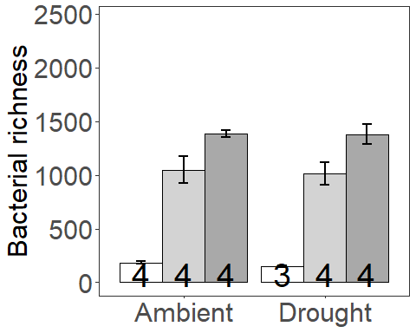

#### Percent Difference from initial community in Bulk

## [1] -50.24187

#### Percent Difference from initial community in Rhizosphere

## [1] -33.17226

### Presence Richness

Diagnostic Graphs

SILVA_MERDS_rar.divfil_pres_seed=subset(SILVA_MERDS_rar.divfil_trt_seed, root_association =="B")  
  
bact_obs_rich_model_seed_pres= lmer((Observed)~soil_root*precip+(1|block), data= SILVA_MERDS_rar.divfil_pres_seed)  
qqPlot(resid(bact_obs_rich_model_seed_pres))

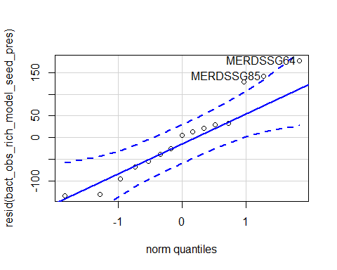

## MERDSSG64 MERDSSG85   
## 8 14

hist(resid(bact_obs_rich_model_seed_pres))

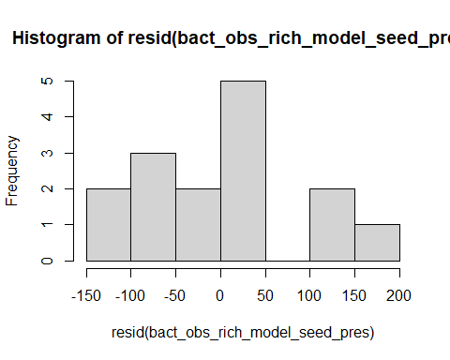

shapiro.test(resid(bact_obs_rich_model_seed_pres))

##   
## Shapiro-Wilk normality test  
##   
## data: resid(bact_obs_rich_model_seed_pres)  
## W = 0.94845, p-value = 0.5004

Raw Statistical output

anova(bact_obs_rich_model_seed_pres)

## Type III Analysis of Variance Table with Satterthwaite's method  
## Sum Sq Mean Sq NumDF DenDF F value Pr(>F)   
## soil_root 2552683 2552683 1 8.1575 175.6413 8.377e-07 ***  
## precip 3934 3934 1 8.1575 0.2707 0.6167   
## soil_root:precip 21 21 1 8.1575 0.0015 0.9704   
## ---  
## Signif. codes: 0 '***' 0.001 '**' 0.01 '*' 0.05 '.' 0.1 ' ' 1

emmeans(bact_obs_rich_model_seed_pres, pairwise~soil_root|precip)

## Note: Use 'contrast(regrid(object), ...)' to obtain contrasts of back-transformed estimates

## $emmeans  
## precip = A:  
## soil_root emmean SE df lower.CL upper.CL  
## L.B 1047 88.9 6.03 829.5 1264  
## S.B 184 88.9 6.03 -33.0 402  
##   
## precip = D:  
## soil_root emmean SE df lower.CL upper.CL  
## L.B 1010 88.9 6.03 793.2 1228  
## S.B 153 103.6 7.89 -86.6 393  
##   
## Degrees-of-freedom method: kenward-roger   
## Results are given on the ( (not the response) scale.   
## Confidence level used: 0.95   
##   
## $contrasts  
## precip = A:  
## contrast estimate SE df t.ratio p.value  
## L.B - S.B 862 85.2 8.00 10.118 <.0001   
##   
## precip = D:  
## contrast estimate SE df t.ratio p.value  
## L.B - S.B 858 100.5 8.49 8.530 <.0001   
##   
## Note: contrasts are still on the ( scale   
## Degrees-of-freedom method: kenward-roger

Formatted Anova table

Presence Seed soil communtiy richness

|  |  |  |  |  |
| --- | --- | --- | --- | --- |
|  | Df | Resid.Df | F.value | P.value |
| soil_root | 1 | 8.16 | 175.64 | 0.000 |
| precip | 1 | 8.16 | 0.27 | 0.617 |
| soil_root:precip | 1 | 8.16 | 0.00 | 0.970 |

### Origin Richness

Diagnostic Graphs

SILVA_MERDS_rar.divfil_orig_seed=subset(SILVA_MERDS_rar.divfil_trt_seed, soil_status =="L")  
  
bact_obs_rich_model_seed_orig= lmer((Observed)~soil_root*precip+(1|block), data= SILVA_MERDS_rar.divfil_orig_seed)

## boundary (singular) fit: see ?isSingular

qqPlot(resid(bact_obs_rich_model_seed_orig))

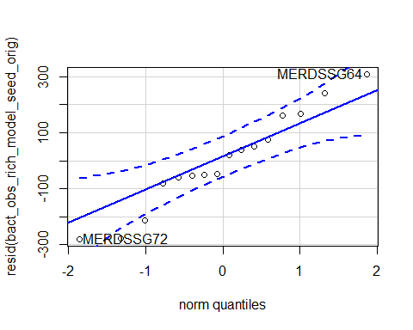

## MERDSSG64 MERDSSG72   
## 13 15

hist(resid(bact_obs_rich_model_seed_orig))

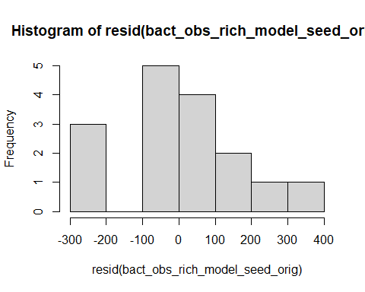

shapiro.test(resid(bact_obs_rich_model_seed_orig))

##   
## Shapiro-Wilk normality test  
##   
## data: resid(bact_obs_rich_model_seed_orig)  
## W = 0.96217, p-value = 0.7012

Raw Statistical output

anova(bact_obs_rich_model_seed_orig)

## Type III Analysis of Variance Table with Satterthwaite's method  
## Sum Sq Mean Sq NumDF DenDF F value Pr(>F)   
## soil_root 502327 502327 1 12 13.8057 0.00295 **  
## precip 1785 1785 1 12 0.0491 0.82843   
## soil_root:precip 915 915 1 12 0.0251 0.87663   
## ---  
## Signif. codes: 0 '***' 0.001 '**' 0.01 '*' 0.05 '.' 0.1 ' ' 1

emmeans(bact_obs_rich_model_seed_orig, pairwise~soil_root|precip)

## Note: Use 'contrast(regrid(object), ...)' to obtain contrasts of back-transformed estimates

## $emmeans  
## precip = A:  
## soil_root emmean SE df lower.CL upper.CL  
## L.B 1047 95.4 12.0 839 1255  
## L.R 1386 95.4 12.0 1178 1594  
##   
## precip = D:  
## soil_root emmean SE df lower.CL upper.CL  
## L.B 1010 95.4 12.0 803 1218  
## L.R 1380 104.7 10.9 1149 1611  
##   
## Degrees-of-freedom method: kenward-roger   
## Results are given on the ( (not the response) scale.   
## Confidence level used: 0.95   
##   
## $contrasts  
## precip = A:  
## contrast estimate SE df t.ratio p.value  
## L.B - L.R -339 135 9.08 -2.515 0.0328   
##   
## precip = D:  
## contrast estimate SE df t.ratio p.value  
## L.B - L.R -370 142 10.20 -2.609 0.0257   
##   
## Note: contrasts are still on the ( scale   
## Degrees-of-freedom method: kenward-roger

Formatted Anova table

Presence Seed soil communtiy richness

|  |  |  |  |  |
| --- | --- | --- | --- | --- |
|  | Df | Resid.Df | F.value | P.value |
| soil_root | 1 | 12 | 13.81 | 0.003 |
| precip | 1 | 12 | 0.05 | 0.828 |
| soil_root:precip | 1 | 12 | 0.03 | 0.877 |

### Seed inv Simpson

Diagnostic Graphs

bact_inv_simp_model_seed= lmer(log(InvSimpson)~soil_root*precip+(1|block), data= SILVA_MERDS_rar.divfil_trt_seed)

## boundary (singular) fit: see ?isSingular

qqPlot(resid(bact_inv_simp_model_seed))

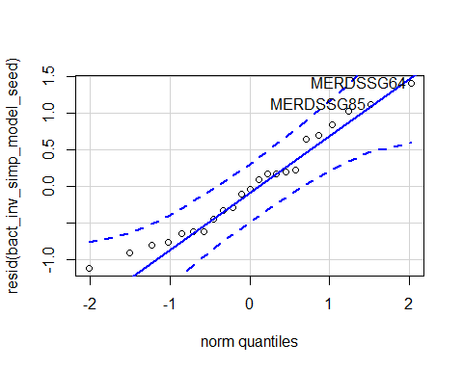

## MERDSSG64 MERDSSG85   
## 16 22

hist(resid(bact_inv_simp_model_seed))

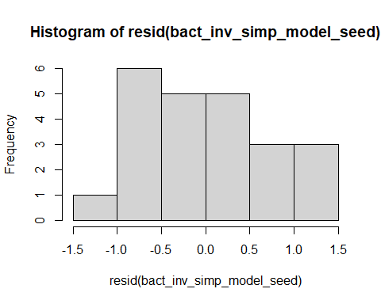

shapiro.test(resid(bact_inv_simp_model_seed))

##   
## Shapiro-Wilk normality test  
##   
## data: resid(bact_inv_simp_model_seed)  
## W = 0.9605, p-value = 0.4735

Raw Statistical output

anova(bact_inv_simp_model_seed)

## Type III Analysis of Variance Table with Satterthwaite's method  
## Sum Sq Mean Sq NumDF DenDF F value Pr(>F)   
## soil_root 21.1667 10.5834 2 17 16.4729 0.0001051 ***  
## precip 0.0194 0.0194 1 17 0.0301 0.8642430   
## soil_root:precip 0.3080 0.1540 2 17 0.2397 0.7894614   
## ---  
## Signif. codes: 0 '***' 0.001 '**' 0.01 '*' 0.05 '.' 0.1 ' ' 1

emmeans(bact_inv_simp_model_seed, pairwise~soil_root|precip)

## $emmeans  
## precip = A:  
## soil_root emmean SE df lower.CL upper.CL  
## L.B 2.91 0.401 17.0 2.07 3.76  
## S.B 2.09 0.401 17.0 1.24 2.94  
## L.R 4.62 0.401 17.0 3.78 5.47  
##   
## precip = D:  
## soil_root emmean SE df lower.CL upper.CL  
## L.B 2.71 0.401 17.0 1.86 3.56  
## S.B 2.37 0.515 15.0 1.27 3.46  
## L.R 4.37 0.428 15.8 3.47 5.28  
##   
## Degrees-of-freedom method: kenward-roger   
## Results are given on the log (not the response) scale.   
## Confidence level used: 0.95   
##   
## $contrasts  
## precip = A:  
## contrast estimate SE df t.ratio p.value  
## L.B - S.B 0.824 0.567 14.0 1.453 0.3420   
## L.B - L.R -1.711 0.567 14.0 -3.019 0.0234   
## S.B - L.R -2.535 0.567 14.0 -4.472 0.0014   
##   
## precip = D:  
## contrast estimate SE df t.ratio p.value  
## L.B - S.B 0.342 0.652 16.3 0.524 0.8607   
## L.B - L.R -1.665 0.586 15.3 -2.841 0.0310   
## S.B - L.R -2.007 0.710 16.4 -2.827 0.0303   
##   
## Degrees-of-freedom method: kenward-roger   
## Results are given on the log (not the response) scale.   
## P value adjustment: tukey method for comparing a family of 3 estimates

emmeans(bact_inv_simp_model_seed, pairwise~soil_root)

## NOTE: Results may be misleading due to involvement in interactions

## $emmeans  
## soil_root emmean SE df lower.CL upper.CL  
## L.B 2.81 0.283 13.3 2.20 3.42  
## S.B 2.23 0.326 12.0 1.52 2.94  
## L.R 4.50 0.293 11.9 3.86 5.14  
##   
## Results are averaged over the levels of: precip   
## Degrees-of-freedom method: kenward-roger   
## Results are given on the log (not the response) scale.   
## Confidence level used: 0.95   
##   
## $contrasts  
## contrast estimate SE df t.ratio p.value  
## L.B - S.B 0.583 0.432 15.4 1.349 0.3908   
## L.B - L.R -1.688 0.408 14.7 -4.141 0.0025   
## S.B - L.R -2.271 0.454 16.8 -5.000 0.0003   
##   
## Results are averaged over the levels of: precip   
## Degrees-of-freedom method: kenward-roger   
## Results are given on the log (not the response) scale.   
## P value adjustment: tukey method for comparing a family of 3 estimates

Formatted Anova table

Seed soil communtiy inv Simpson

|  |  |  |  |  |
| --- | --- | --- | --- | --- |
|  | Df | Resid.Df | F.value | P.value |
| soil_root | 2 | 17 | 16.47 | 0.000 |
| precip | 1 | 17 | 0.03 | 0.864 |
| soil_root:precip | 2 | 17 | 0.24 | 0.789 |

##### Graph for publication

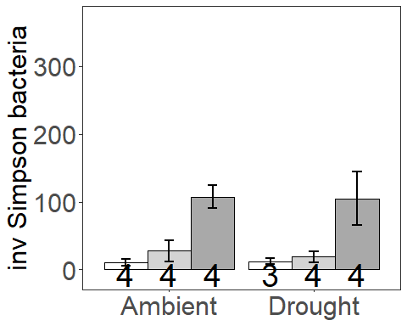

##### Combined Graph for publication

### Presence inv Simpson

Diagnostic Graphs

SILVA_MERDS_rar.divfil_pres_seed=subset(SILVA_MERDS_rar.divfil_trt_seed, root_association =="B")  
  
bact_inv_simp_model_seed_pres= lmer(log(InvSimpson)~soil_root*precip+(1|block), data= SILVA_MERDS_rar.divfil_pres_seed)

## boundary (singular) fit: see ?isSingular

qqPlot(resid(bact_inv_simp_model_seed_pres))

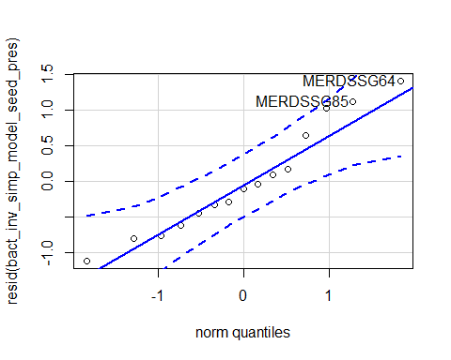

## MERDSSG64 MERDSSG85   
## 8 14

hist(resid(bact_inv_simp_model_seed_pres))

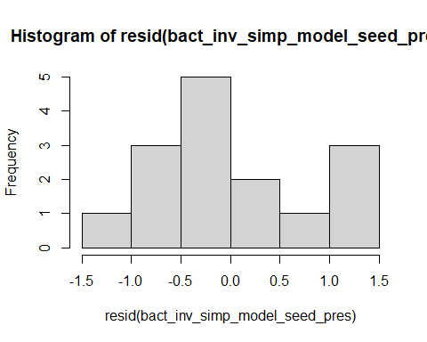

shapiro.test(resid(bact_inv_simp_model_seed_pres))

##   
## Shapiro-Wilk normality test  
##   
## data: resid(bact_inv_simp_model_seed_pres)  
## W = 0.94488, p-value = 0.4478

Raw Statistical output

anova(bact_inv_simp_model_seed_pres)

## Type III Analysis of Variance Table with Satterthwaite's method  
## Sum Sq Mean Sq NumDF DenDF F value Pr(>F)  
## soil_root 1.25385 1.25385 1 11 1.7263 0.2156  
## precip 0.00516 0.00516 1 11 0.0071 0.9343  
## soil_root:precip 0.21415 0.21415 1 11 0.2948 0.5980

emmeans(bact_inv_simp_model_seed_pres, pairwise~soil_root|precip)

## $emmeans  
## precip = A:  
## soil_root emmean SE df lower.CL upper.CL  
## L.B 2.91 0.426 10.98 1.98 3.85  
## S.B 2.09 0.426 10.98 1.15 3.03  
##   
## precip = D:  
## soil_root emmean SE df lower.CL upper.CL  
## L.B 2.71 0.426 10.98 1.77 3.65  
## S.B 2.37 0.590 9.05 1.03 3.70  
##   
## Degrees-of-freedom method: kenward-roger   
## Results are given on the log (not the response) scale.   
## Confidence level used: 0.95   
##   
## $contrasts  
## precip = A:  
## contrast estimate SE df t.ratio p.value  
## L.B - S.B 0.824 0.603 8.1 1.367 0.2085   
##   
## precip = D:  
## contrast estimate SE df t.ratio p.value  
## L.B - S.B 0.342 0.728 10.3 0.470 0.6484   
##   
## Degrees-of-freedom method: kenward-roger   
## Results are given on the log (not the response) scale.

Formatted Anova table

Presence Seed soil communtiy inv Simpson

|  |  |  |  |  |
| --- | --- | --- | --- | --- |
|  | Df | Resid.Df | F.value | P.value |
| soil_root | 1 | 11 | 1.73 | 0.216 |
| precip | 1 | 11 | 0.01 | 0.934 |
| soil_root:precip | 1 | 11 | 0.29 | 0.598 |

### Origin inv Simpson

Diagnostic Graphs

SILVA_MERDS_rar.divfil_orig_seed=subset(SILVA_MERDS_rar.divfil_trt_seed, soil_status =="L")  
  
bact_inv_simp_model_seed_orig= lmer((InvSimpson)~soil_root*precip+(1|block), data= SILVA_MERDS_rar.divfil_orig_seed)

## boundary (singular) fit: see ?isSingular

qqPlot(resid(bact_inv_simp_model_seed_orig))

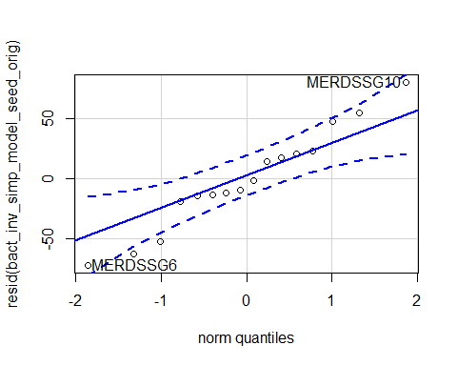

## MERDSSG10 MERDSSG6   
## 1 12

hist(resid(bact_inv_simp_model_seed_orig))

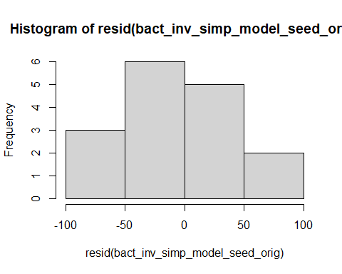

shapiro.test(resid(bact_inv_simp_model_seed_orig))

##   
## Shapiro-Wilk normality test  
##   
## data: resid(bact_inv_simp_model_seed_orig)  
## W = 0.97082, p-value = 0.8517

Raw Statistical output

anova(bact_inv_simp_model_seed_orig)

## Type III Analysis of Variance Table with Satterthwaite's method  
## Sum Sq Mean Sq NumDF DenDF F value Pr(>F)   
## soil_root 27358.3 27358.3 1 12 12.5228 0.00408 **  
## precip 130.5 130.5 1 12 0.0597 0.81107   
## soil_root:precip 32.0 32.0 1 12 0.0146 0.90569   
## ---  
## Signif. codes: 0 '***' 0.001 '**' 0.01 '*' 0.05 '.' 0.1 ' ' 1

emmeans(bact_inv_simp_model_seed_orig, pairwise~soil_root|precip)

## Note: Use 'contrast(regrid(object), ...)' to obtain contrasts of back-transformed estimates

## $emmeans  
## precip = A:  
## soil_root emmean SE df lower.CL upper.CL  
## L.B 27.7 23.4 12.0 -23.2 78.6  
## L.R 107.6 23.4 12.0 56.7 158.5  
##   
## precip = D:  
## soil_root emmean SE df lower.CL upper.CL  
## L.B 19.2 23.4 12.0 -31.7 70.1  
## L.R 104.7 25.6 10.9 48.2 161.2  
##   
## Degrees-of-freedom method: kenward-roger   
## Results are given on the ( (not the response) scale.   
## Confidence level used: 0.95   
##   
## $contrasts  
## precip = A:  
## contrast estimate SE df t.ratio p.value  
## L.B - L.R -79.9 33.1 9.08 -2.417 0.0386   
##   
## precip = D:  
## contrast estimate SE df t.ratio p.value  
## L.B - L.R -85.5 34.7 10.20 -2.465 0.0330   
##   
## Note: contrasts are still on the ( scale   
## Degrees-of-freedom method: kenward-roger

Formatted Anova table

Presence Seed soil communtiy inv Simpson

|  |  |  |  |  |
| --- | --- | --- | --- | --- |
|  | Df | Resid.Df | F.value | P.value |
| soil_root | 1 | 12 | 12.52 | 0.004 |
| precip | 1 | 12 | 0.06 | 0.811 |
| soil_root:precip | 1 | 12 | 0.01 | 0.906 |

## Diversity across the life stages

### Combined Richness

Diagnostic Graphs

bact_obs_rich_model_comb= lmer(log(Observed)~soil_root*precip*life_stage+(1|block), data= SILVA_MERDS_rar.divfil_trt)  
qqPlot(resid(bact_obs_rich_model_comb))

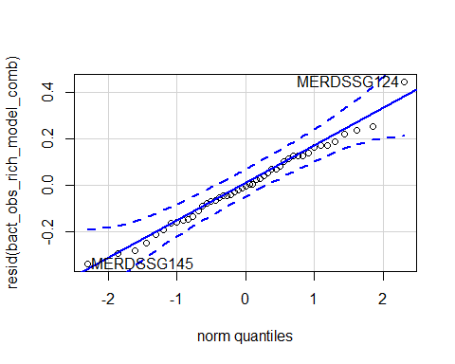

## MERDSSG124 MERDSSG145   
## 8 15

hist(resid(bact_obs_rich_model_comb))

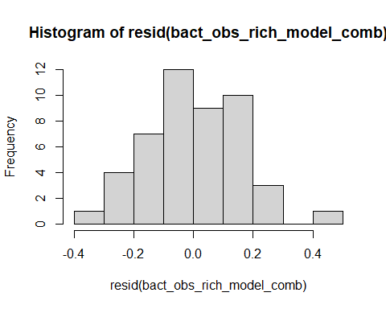

shapiro.test(resid(bact_obs_rich_model_comb))

##   
## Shapiro-Wilk normality test  
##   
## data: resid(bact_obs_rich_model_comb)  
## W = 0.99017, p-value = 0.9593

Raw Statistical output

anova(bact_obs_rich_model_comb)

## Type III Analysis of Variance Table with Satterthwaite's method  
## Sum Sq Mean Sq NumDF DenDF F value Pr(>F)   
## soil_root 35.332 17.6660 2 32.690 509.2191 < 2e-16 ***  
## precip 0.260 0.2599 1 32.106 7.4926 0.01002 *   
## life_stage 0.246 0.2462 1 32.106 7.0961 0.01198 *   
## soil_root:precip 0.060 0.0301 2 32.690 0.8683 0.42910   
## soil_root:life_stage 0.315 0.1573 2 32.690 4.5331 0.01830 *   
## precip:life_stage 0.052 0.0516 1 32.106 1.4876 0.23147   
## soil_root:precip:life_stage 0.054 0.0271 2 32.690 0.7806 0.46647   
## ---  
## Signif. codes: 0 '***' 0.001 '**' 0.01 '*' 0.05 '.' 0.1 ' ' 1

emmeans(bact_obs_rich_model_comb, pairwise~soil_root|life_stage)

## NOTE: Results may be misleading due to involvement in interactions

## $emmeans  
## life_stage = G:  
## soil_root emmean SE df lower.CL upper.CL  
## L.B 7.18 0.0680 27.8 7.04 7.32  
## S.B 5.37 0.0680 27.8 5.23 5.51  
## L.R 7.14 0.0680 27.8 7.00 7.28  
##   
## life_stage = S:  
## soil_root emmean SE df lower.CL upper.CL  
## L.B 6.92 0.0680 27.8 6.78 7.06  
## S.B 5.11 0.0752 27.8 4.96 5.26  
## L.R 7.22 0.0689 26.6 7.08 7.36  
##   
## Results are averaged over the levels of: precip   
## Degrees-of-freedom method: kenward-roger   
## Results are given on the log (not the response) scale.   
## Confidence level used: 0.95   
##   
## $contrasts  
## life_stage = G:  
## contrast estimate SE df t.ratio p.value  
## L.B - S.B 1.8081 0.0931 32.0 19.415 <.0001   
## L.B - L.R 0.0405 0.0931 32.0 0.435 0.9012   
## S.B - L.R -1.7675 0.0931 32.0 -18.979 <.0001   
##   
## life_stage = S:  
## contrast estimate SE df t.ratio p.value  
## L.B - S.B 1.8061 0.0985 33.1 18.332 <.0001   
## L.B - L.R -0.3071 0.0938 32.5 -3.273 0.0069   
## S.B - L.R -2.1132 0.1009 34.3 -20.951 <.0001   
##   
## Results are averaged over the levels of: precip   
## Degrees-of-freedom method: kenward-roger   
## Results are given on the log (not the response) scale.   
## P value adjustment: tukey method for comparing a family of 3 estimates

emmeans(bact_obs_rich_model_comb, pairwise~life_stage|soil_root)

## NOTE: Results may be misleading due to involvement in interactions

## $emmeans  
## soil_root = L.B:  
## life_stage emmean SE df lower.CL upper.CL  
## G 7.18 0.0680 27.8 7.04 7.32  
## S 6.92 0.0680 27.8 6.78 7.06  
##   
## soil_root = S.B:  
## life_stage emmean SE df lower.CL upper.CL  
## G 5.37 0.0680 27.8 5.23 5.51  
## S 5.11 0.0752 27.8 4.96 5.26  
##   
## soil_root = L.R:  
## life_stage emmean SE df lower.CL upper.CL  
## G 7.14 0.0680 27.8 7.00 7.28  
## S 7.22 0.0689 26.6 7.08 7.36  
##   
## Results are averaged over the levels of: precip   
## Degrees-of-freedom method: kenward-roger   
## Results are given on the log (not the response) scale.   
## Confidence level used: 0.95   
##   
## $contrasts  
## soil_root = L.B:  
## contrast estimate SE df t.ratio p.value  
## G - S 0.2618 0.0931 32.0 2.811 0.0084   
##   
## soil_root = S.B:  
## contrast estimate SE df t.ratio p.value  
## G - S 0.2599 0.0985 33.1 2.638 0.0126   
##   
## soil_root = L.R:  
## contrast estimate SE df t.ratio p.value  
## G - S -0.0858 0.0938 32.5 -0.915 0.3669   
##   
## Results are averaged over the levels of: precip   
## Degrees-of-freedom method: kenward-roger   
## Results are given on the log (not the response) scale.

Formatted Anova table

Combined soil communtiy richness

|  |  |  |  |  |
| --- | --- | --- | --- | --- |
|  | Df | Resid.Df | F.value | P.value |
| soil_root | 2 | 32.69 | 509.22 | 0.000 |
| precip | 1 | 32.11 | 7.49 | 0.010 |
| life_stage | 1 | 32.11 | 7.10 | 0.012 |
| soil_root:precip | 2 | 32.69 | 0.87 | 0.429 |
| soil_root:life_stage | 2 | 32.69 | 4.53 | 0.018 |
| precip:life_stage | 1 | 32.11 | 1.49 | 0.231 |
| soil_root:precip:life_stage | 2 | 32.69 | 0.78 | 0.466 |

### Presence Richness

Diagnostic Graphs

SILVA_MERDS_rar.divfil_pres_comb=subset(SILVA_MERDS_rar.divfil_trt, root_association =="B")  
  
bact_obs_rich_model_comb_pres= lmer(log(Observed)~soil_root*precip*life_stage+(1|block), data= SILVA_MERDS_rar.divfil_pres_comb)  
qqPlot(resid(bact_obs_rich_model_comb_pres))

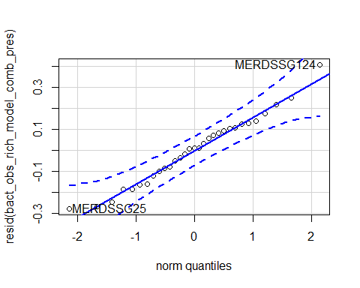

## MERDSSG124 MERDSSG25   
## 5 19

hist(resid(bact_obs_rich_model_comb_pres))

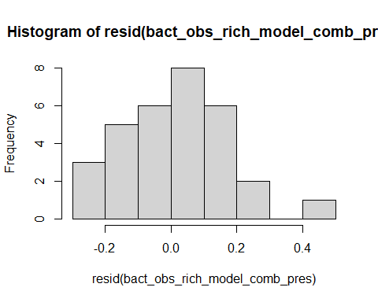

shapiro.test(resid(bact_obs_rich_model_comb_pres))

##   
## Shapiro-Wilk normality test  
##   
## data: resid(bact_obs_rich_model_comb_pres)  
## W = 0.9803, p-value = 0.8209

Raw Statistical output

anova(bact_obs_rich_model_comb_pres)

## Type III Analysis of Variance Table with Satterthwaite's method  
## Sum Sq Mean Sq NumDF DenDF F value Pr(>F)   
## soil_root 24.7191 24.7191 1 20.297 685.0705 < 2.2e-16 ***  
## precip 0.1250 0.1250 1 20.297 3.4652 0.077218 .   
## life_stage 0.4998 0.4998 1 20.297 13.8510 0.001321 **   
## soil_root:precip 0.0469 0.0469 1 20.297 1.2994 0.267590   
## soil_root:life_stage 0.0002 0.0002 1 20.297 0.0063 0.937615   
## precip:life_stage 0.0040 0.0040 1 20.297 0.1122 0.741128   
## soil_root:precip:life_stage 0.0002 0.0002 1 20.297 0.0059 0.939416   
## ---  
## Signif. codes: 0 '***' 0.001 '**' 0.01 '*' 0.05 '.' 0.1 ' ' 1

Formatted Anova table

Presence Combined soil communtiy richness

|  |  |  |  |  |
| --- | --- | --- | --- | --- |
|  | Df | Resid.Df | F.value | P.value |
| soil_root | 1 | 20.3 | 685.07 | 0.000 |
| precip | 1 | 20.3 | 3.47 | 0.077 |
| life_stage | 1 | 20.3 | 13.85 | 0.001 |
| soil_root:precip | 1 | 20.3 | 1.30 | 0.268 |
| soil_root:life_stage | 1 | 20.3 | 0.01 | 0.938 |
| precip:life_stage | 1 | 20.3 | 0.11 | 0.741 |
| soil_root:precip:life_stage | 1 | 20.3 | 0.01 | 0.939 |

### Origin Richness

Diagnostic Graphs

SILVA_MERDS_rar.divfil_orig_comb=subset(SILVA_MERDS_rar.divfil_trt, soil_status =="L")  
  
bact_obs_rich_model_comb_orig= lmer((Observed)~soil_root*precip*life_stage+(1|block), data= SILVA_MERDS_rar.divfil_orig_comb)

## boundary (singular) fit: see ?isSingular

qqPlot(resid(bact_obs_rich_model_comb_orig))

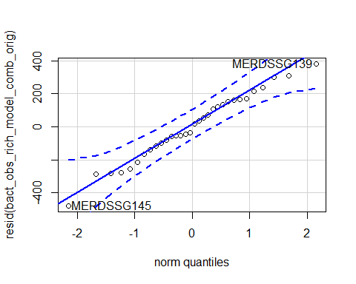

## MERDSSG145 MERDSSG139   
## 11 8

hist(resid(bact_obs_rich_model_comb_orig))

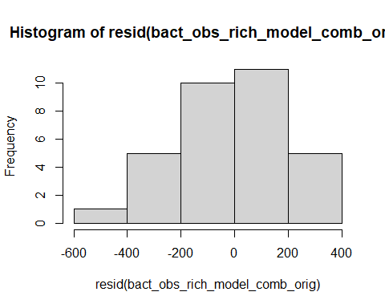

shapiro.test(resid(bact_obs_rich_model_comb_orig))

##   
## Shapiro-Wilk normality test  
##   
## data: resid(bact_obs_rich_model_comb_orig)  
## W = 0.98421, p-value = 0.9085

Raw Statistical output

anova(bact_obs_rich_model_comb_orig)

## Type III Analysis of Variance Table with Satterthwaite's method  
## Sum Sq Mean Sq NumDF DenDF F value Pr(>F)   
## soil_root 213695 213695 1 24 4.0578 0.05530 .  
## precip 175380 175380 1 24 3.3303 0.08049 .  
## life_stage 92558 92558 1 24 1.7576 0.19741   
## soil_root:precip 62747 62747 1 24 1.1915 0.28587   
## soil_root:life_stage 291657 291657 1 24 5.5383 0.02713 *  
## precip:life_stage 128905 128905 1 24 2.4478 0.13078   
## soil_root:precip:life_stage 86009 86009 1 24 1.6332 0.21348   
## ---  
## Signif. codes: 0 '***' 0.001 '**' 0.01 '*' 0.05 '.' 0.1 ' ' 1

emmeans(bact_obs_rich_model_comb_orig, pairwise~soil_root|life_stage)

## NOTE: Results may be misleading due to involvement in interactions

## Note: Use 'contrast(regrid(object), ...)' to obtain contrasts of back-transformed estimates

## $emmeans  
## life_stage = G:  
## soil_root emmean SE df lower.CL upper.CL  
## L.B 1327 81.1 20.8 1158 1496  
## L.R 1300 81.1 20.8 1131 1468  
##   
## life_stage = S:  
## soil_root emmean SE df lower.CL upper.CL  
## L.B 1029 81.1 20.8 860 1197  
## L.R 1383 83.0 19.4 1210 1556  
##   
## Results are averaged over the levels of: precip   
## Degrees-of-freedom method: kenward-roger   
## Results are given on the ( (not the response) scale.   
## Confidence level used: 0.95   
##   
## $contrasts  
## life_stage = G:  
## contrast estimate SE df t.ratio p.value  
## L.B - L.R 27.5 115 21.0 0.240 0.8129   
##   
## life_stage = S:  
## contrast estimate SE df t.ratio p.value  
## L.B - L.R -354.4 116 21.7 -3.053 0.0059   
##   
## Results are averaged over the levels of: precip   
## Note: contrasts are still on the ( scale   
## Degrees-of-freedom method: kenward-roger

emmeans(bact_obs_rich_model_comb_orig, pairwise~life_stage|soil_root)

## NOTE: Results may be misleading due to involvement in interactions  
## Note: Use 'contrast(regrid(object), ...)' to obtain contrasts of back-transformed estimates

## $emmeans  
## soil_root = L.B:  
## life_stage emmean SE df lower.CL upper.CL  
## G 1327 81.1 20.8 1158 1496  
## S 1029 81.1 20.8 860 1197  
##   
## soil_root = L.R:  
## life_stage emmean SE df lower.CL upper.CL  
## G 1300 81.1 20.8 1131 1468  
## S 1383 83.0 19.4 1210 1556  
##   
## Results are averaged over the levels of: precip   
## Degrees-of-freedom method: kenward-roger   
## Results are given on the ( (not the response) scale.   
## Confidence level used: 0.95   
##   
## $contrasts  
## soil_root = L.B:  
## contrast estimate SE df t.ratio p.value  
## G - S 298.5 115 21.0 2.602 0.0167   
##   
## soil_root = L.R:  
## contrast estimate SE df t.ratio p.value  
## G - S -83.4 116 21.7 -0.718 0.4802   
##   
## Results are averaged over the levels of: precip   
## Note: contrasts are still on the ( scale   
## Degrees-of-freedom method: kenward-roger

Formatted Anova table

Presence Combined soil communtiy richness

|  |  |  |  |  |
| --- | --- | --- | --- | --- |
|  | Df | Resid.Df | F.value | P.value |
| soil_root | 1 | 24 | 4.06 | 0.055 |
| precip | 1 | 24 | 3.33 | 0.080 |
| life_stage | 1 | 24 | 1.76 | 0.197 |
| soil_root:precip | 1 | 24 | 1.19 | 0.286 |
| soil_root:life_stage | 1 | 24 | 5.54 | 0.027 |
| precip:life_stage | 1 | 24 | 2.45 | 0.131 |
| soil_root:precip:life_stage | 1 | 24 | 1.63 | 0.213 |

### Combined inv Simpson

Diagnostic Graphs

bact_inv_simp_model_comb= lmer(log(InvSimpson)~soil_root*precip*life_stage+(1|block), data= SILVA_MERDS_rar.divfil_trt)

## boundary (singular) fit: see ?isSingular

qqPlot(resid(bact_inv_simp_model_comb))

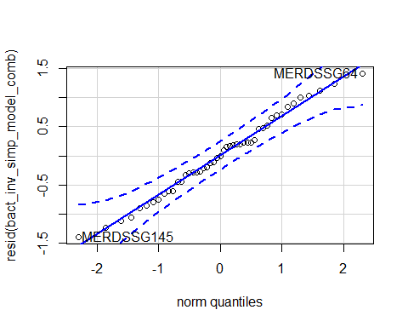

## MERDSSG64 MERDSSG145   
## 38 15

hist(resid(bact_inv_simp_model_comb))

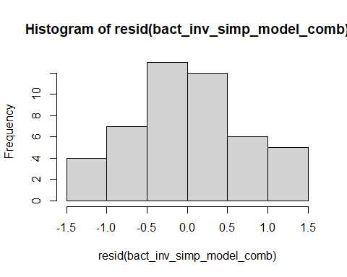

shapiro.test(resid(bact_inv_simp_model_comb))

##   
## Shapiro-Wilk normality test  
##   
## data: resid(bact_inv_simp_model_comb)  
## W = 0.98673, p-value = 0.8654

Raw Statistical output

anova(bact_inv_simp_model_comb)

## Type III Analysis of Variance Table with Satterthwaite's method  
## Sum Sq Mean Sq NumDF DenDF F value Pr(>F)   
## soil_root 23.2852 11.6426 2 35 18.9361 2.669e-06 ***  
## precip 1.0949 1.0949 1 35 1.7809 0.19066   
## life_stage 1.3884 1.3884 1 35 2.2582 0.14188   
## soil_root:precip 1.2519 0.6260 2 35 1.0181 0.37174   
## soil_root:life_stage 6.3974 3.1987 2 35 5.2025 0.01052 *   
## precip:life_stage 0.7174 0.7174 1 35 1.1668 0.28745   
## soil_root:precip:life_stage 1.2213 0.6107 2 35 0.9932 0.38059   
## ---  
## Signif. codes: 0 '***' 0.001 '**' 0.01 '*' 0.05 '.' 0.1 ' ' 1

emmeans(bact_inv_simp_model_comb, pairwise~soil_root|life_stage)

## NOTE: Results may be misleading due to involvement in interactions

## $emmeans  
## life_stage = G:  
## soil_root emmean SE df lower.CL upper.CL  
## L.B 3.99 0.277 31.6 3.42 4.55  
## S.B 2.69 0.277 31.6 2.12 3.25  
## L.R 3.90 0.277 31.6 3.33 4.46  
##   
## life_stage = S:  
## soil_root emmean SE df lower.CL upper.CL  
## L.B 2.81 0.277 31.6 2.25 3.38  
## S.B 2.23 0.309 30.1 1.60 2.86  
## L.R 4.50 0.281 30.1 3.92 5.07  
##   
## Results are averaged over the levels of: precip   
## Degrees-of-freedom method: kenward-roger   
## Results are given on the log (not the response) scale.   
## Confidence level used: 0.95   
##   
## $contrasts  
## life_stage = G:  
## contrast estimate SE df t.ratio p.value  
## L.B - S.B 1.3010 0.392 32.0 3.318 0.0062   
## L.B - L.R 0.0902 0.392 32.0 0.230 0.9712   
## S.B - L.R -1.2108 0.392 32.0 -3.088 0.0112   
##   
## life_stage = S:  
## contrast estimate SE df t.ratio p.value  
## L.B - S.B 0.5827 0.415 33.4 1.404 0.3501   
## L.B - L.R -1.6879 0.395 32.7 -4.272 0.0004   
## S.B - L.R -2.2707 0.425 34.8 -5.341 <.0001   
##   
## Results are averaged over the levels of: precip   
## Degrees-of-freedom method: kenward-roger   
## Results are given on the log (not the response) scale.   
## P value adjustment: tukey method for comparing a family of 3 estimates

emmeans(bact_inv_simp_model_comb, pairwise~life_stage|soil_root)

## NOTE: Results may be misleading due to involvement in interactions

## $emmeans  
## soil_root = L.B:  
## life_stage emmean SE df lower.CL upper.CL  
## G 3.99 0.277 31.6 3.42 4.55  
## S 2.81 0.277 31.6 2.25 3.38  
##   
## soil_root = S.B:  
## life_stage emmean SE df lower.CL upper.CL  
## G 2.69 0.277 31.6 2.12 3.25  
## S 2.23 0.309 30.1 1.60 2.86  
##   
## soil_root = L.R:  
## life_stage emmean SE df lower.CL upper.CL  
## G 3.90 0.277 31.6 3.33 4.46  
## S 4.50 0.281 30.1 3.92 5.07  
##   
## Results are averaged over the levels of: precip   
## Degrees-of-freedom method: kenward-roger   
## Results are given on the log (not the response) scale.   
## Confidence level used: 0.95   
##   
## $contrasts  
## soil_root = L.B:  
## contrast estimate SE df t.ratio p.value  
## G - S 1.177 0.392 32.0 3.002 0.0052   
##   
## soil_root = S.B:  
## contrast estimate SE df t.ratio p.value  
## G - S 0.459 0.415 33.4 1.106 0.2768   
##   
## soil_root = L.R:  
## contrast estimate SE df t.ratio p.value  
## G - S -0.601 0.395 32.7 -1.522 0.1377   
##   
## Results are averaged over the levels of: precip   
## Degrees-of-freedom method: kenward-roger   
## Results are given on the log (not the response) scale.

Formatted Anova table

Combined soil communtiy inv Simpson

|  |  |  |  |  |
| --- | --- | --- | --- | --- |
|  | Df | Resid.Df | F.value | P.value |
| soil_root | 2 | 35 | 18.94 | 0.000 |
| precip | 1 | 35 | 1.78 | 0.191 |
| life_stage | 1 | 35 | 2.26 | 0.142 |
| soil_root:precip | 2 | 35 | 1.02 | 0.372 |
| soil_root:life_stage | 2 | 35 | 5.20 | 0.011 |
| precip:life_stage | 1 | 35 | 1.17 | 0.287 |
| soil_root:precip:life_stage | 2 | 35 | 0.99 | 0.381 |

### Presence inv Simpson

Diagnostic Graphs

SILVA_MERDS_rar.divfil_pres_comb=subset(SILVA_MERDS_rar.divfil_trt, root_association =="B")  
  
bact_inv_simp_model_comb_pres= lmer(log(InvSimpson)~soil_root*precip*life_stage+(1|block), data= SILVA_MERDS_rar.divfil_pres_comb)

## boundary (singular) fit: see ?isSingular

qqPlot(resid(bact_inv_simp_model_comb_pres))

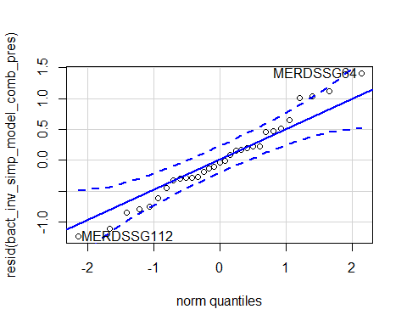

## MERDSSG64 MERDSSG112   
## 24 2

hist(resid(bact_inv_simp_model_comb_pres))

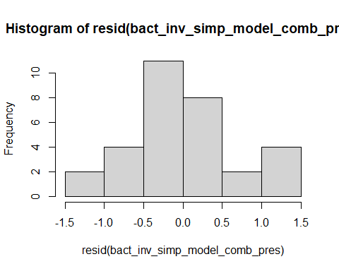

shapiro.test(resid(bact_inv_simp_model_comb_pres))

##   
## Shapiro-Wilk normality test  
##   
## data: resid(bact_inv_simp_model_comb_pres)  
## W = 0.9812, p-value = 0.8451

Raw Statistical output

anova(bact_inv_simp_model_comb_pres)

## Type III Analysis of Variance Table with Satterthwaite's method  
## Sum Sq Mean Sq NumDF DenDF F value Pr(>F)   
## soil_root 6.8130 6.8130 1 23 12.6310 0.001690 **  
## precip 0.0521 0.0521 1 23 0.0966 0.758782   
## life_stage 5.1370 5.1370 1 23 9.5238 0.005217 **  
## soil_root:precip 0.0530 0.0530 1 23 0.0983 0.756683   
## soil_root:life_stage 0.9905 0.9905 1 23 1.8363 0.188543   
## precip:life_stage 0.1101 0.1101 1 23 0.2042 0.655601   
## soil_root:precip:life_stage 0.8058 0.8058 1 23 1.4940 0.233975   
## ---  
## Signif. codes: 0 '***' 0.001 '**' 0.01 '*' 0.05 '.' 0.1 ' ' 1

emmeans(bact_inv_simp_model_comb_pres, pairwise~soil_root|precip)

## NOTE: Results may be misleading due to involvement in interactions

## $emmeans  
## precip = A:  
## soil_root emmean SE df lower.CL upper.CL  
## L.B 3.40 0.260 19.7 2.86 3.94  
## S.B 2.54 0.260 19.7 2.00 3.08  
##   
## precip = D:  
## soil_root emmean SE df lower.CL upper.CL  
## L.B 3.40 0.260 19.7 2.86 3.94  
## S.B 2.38 0.295 18.4 1.76 2.99  
##   
## Results are averaged over the levels of: life_stage   
## Degrees-of-freedom method: kenward-roger   
## Results are given on the log (not the response) scale.   
## Confidence level used: 0.95   
##   
## $contrasts  
## precip = A:  
## contrast estimate SE df t.ratio p.value  
## L.B - S.B 0.859 0.367 20.0 2.339 0.0298   
##   
## precip = D:  
## contrast estimate SE df t.ratio p.value  
## L.B - S.B 1.025 0.393 21.4 2.610 0.0162   
##   
## Results are averaged over the levels of: life_stage   
## Degrees-of-freedom method: kenward-roger   
## Results are given on the log (not the response) scale.

Formatted Anova table

Presence Combined soil communtiy inv Simpson

|  |  |  |  |  |
| --- | --- | --- | --- | --- |
|  | Df | Resid.Df | F.value | P.value |
| soil_root | 1 | 23 | 12.63 | 0.002 |
| precip | 1 | 23 | 0.10 | 0.759 |
| life_stage | 1 | 23 | 9.52 | 0.005 |
| soil_root:precip | 1 | 23 | 0.10 | 0.757 |
| soil_root:life_stage | 1 | 23 | 1.84 | 0.189 |
| precip:life_stage | 1 | 23 | 0.20 | 0.656 |
| soil_root:precip:life_stage | 1 | 23 | 1.49 | 0.234 |

### Origin inv Simpson

Diagnostic Graphs

SILVA_MERDS_rar.divfil_orig_comb=subset(SILVA_MERDS_rar.divfil_trt, soil_status =="L")  
  
bact_inv_simp_model_comb_orig= lmer((InvSimpson)~soil_root*precip*life_stage+(1|block), data= SILVA_MERDS_rar.divfil_orig_comb)

## boundary (singular) fit: see ?isSingular

qqPlot(resid(bact_inv_simp_model_comb_orig))

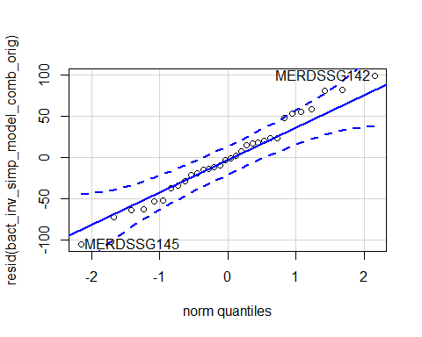

## MERDSSG145 MERDSSG142   
## 11 10

hist(resid(bact_inv_simp_model_comb_orig))

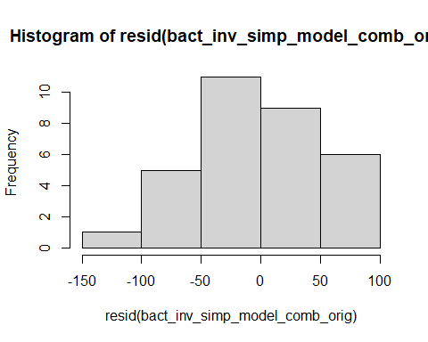

shapiro.test(resid(bact_inv_simp_model_comb_orig))

##   
## Shapiro-Wilk normality test  
##   
## data: resid(bact_inv_simp_model_comb_orig)  
## W = 0.98752, p-value = 0.9655

Raw Statistical output

anova(bact_inv_simp_model_comb_orig)

## Type III Analysis of Variance Table with Satterthwaite's method  
## Sum Sq Mean Sq NumDF DenDF F value Pr(>F)   
## soil_root 19081.3 19081.3 1 24 6.4055 0.01834 *  
## precip 2769.6 2769.6 1 24 0.9298 0.34454   
## life_stage 881.1 881.1 1 24 0.2958 0.59155   
## soil_root:precip 6252.0 6252.0 1 24 2.0988 0.16036   
## soil_root:life_stage 9174.0 9174.0 1 24 3.0797 0.09204 .  
## precip:life_stage 1330.4 1330.4 1 24 0.4466 0.51033   
## soil_root:precip:life_stage 7580.8 7580.8 1 24 2.5449 0.12374   
## ---  
## Signif. codes: 0 '***' 0.001 '**' 0.01 '*' 0.05 '.' 0.1 ' ' 1

emmeans(bact_inv_simp_model_comb_orig, pairwise~soil_root|precip)

## NOTE: Results may be misleading due to involvement in interactions

## Note: Use 'contrast(regrid(object), ...)' to obtain contrasts of back-transformed estimates

## $emmeans  
## precip = A:  
## soil_root emmean SE df lower.CL upper.CL  
## L.B 41.0 19.3 20.8 0.803 81.1  
## L.R 117.8 19.3 20.8 77.597 157.9  
##   
## precip = D:  
## soil_root emmean SE df lower.CL upper.CL  
## L.B 50.3 19.3 20.8 10.152 90.5  
## L.R 71.2 19.7 19.4 29.931 112.4  
##   
## Results are averaged over the levels of: life_stage   
## Degrees-of-freedom method: kenward-roger   
## Results are given on the ( (not the response) scale.   
## Confidence level used: 0.95   
##   
## $contrasts  
## precip = A:  
## contrast estimate SE df t.ratio p.value  
## L.B - L.R -76.8 27.3 21.0 -2.814 0.0104   
##   
## precip = D:  
## contrast estimate SE df t.ratio p.value  
## L.B - L.R -20.9 27.6 21.7 -0.757 0.4575   
##   
## Results are averaged over the levels of: life_stage   
## Note: contrasts are still on the ( scale   
## Degrees-of-freedom method: kenward-roger

Formatted Anova table

Presence Combined soil communtiy inv Simpson

|  |  |  |  |  |
| --- | --- | --- | --- | --- |
|  | Df | Resid.Df | F.value | P.value |
| soil_root | 1 | 24 | 6.41 | 0.018 |
| precip | 1 | 24 | 0.93 | 0.345 |
| life_stage | 1 | 24 | 0.30 | 0.592 |
| soil_root:precip | 1 | 24 | 2.10 | 0.160 |
| soil_root:life_stage | 1 | 24 | 3.08 | 0.092 |
| precip:life_stage | 1 | 24 | 0.45 | 0.510 |
| soil_root:precip:life_stage | 1 | 24 | 2.54 | 0.124 |