Water Budget RHS Method B - Step-by-Step hand check

1. Purpose
This verification checks the Water RHS Method B calculation in the same order as Section 2.3 of the budget methodology. The objective is to demonstrate that the Python implementation correctly converts nodal velocity and vertical geometry into water transport across one selected SCHISM-style edge.

2. Verification configuration
Figure 1 uses the same triangular-grid concept as the Water Method B schematic. One internal vertical edge is selected. The Main CV is defined on the right-hand side of this edge, so positive flux points to the right. Both elements adjacent to the selected internal edge are assumed to remain wet throughout the verification.
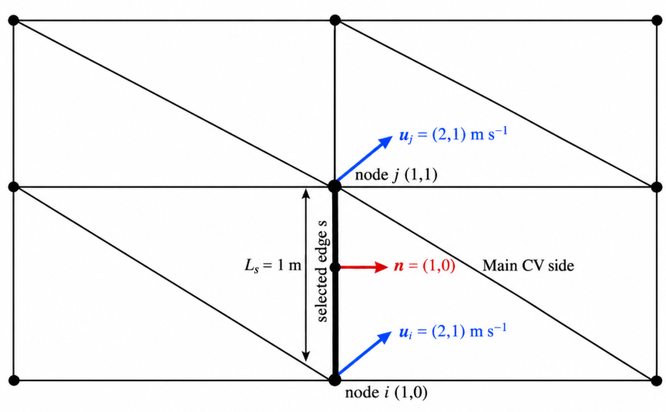
SCHISM-style verification mesh. The thick vertical line is the selected internal edge.
The prescribed values are:
Quantity | Prescribed value
Node $i$ | $\left(x_{i},y_{i}\right)=\left(1,0\right)$ m
Node $j$ | $\left(x_{j},y_{j}\right)=\left(1,1\right)$ m
Nodal velocity | $u=2$, $v=1$ m/s
Vertical levels | $z=\left[-3,-2,-1,0\right]$ m
Number of physical intervals | 3
Verification duration | 3600 s
The exact cross-edge velocity component is $u_{n}=2$ m/s, the edge length is 1 m and the total water depth is 3 m. Therefore the independent analytical discharge is
$$Q_{exact}=u_{n}L_{s}H=2×1×3=6 m^{3} s^{-1}.$$
For a constant one-hour period,
$$ΔV_{exact}=Q_{exact}Δt=6×3600=21600 m^{3}.$$

3. Step-by-step verification of Water RHS Method B

Step 1 - Read nodal velocity at each vertical level
At nodes $i$ and $j$,
$$\left(u_{i,k},v_{i,k}\right)=\left(2,1\right) m s^{-1},$$
$$\left(u_{j,k},v_{j,k}\right)=\left(2,1\right) m s^{-1}.$$
The same values are prescribed at all four saved vertical levels. This removes vertical interpolation ambiguity from the analytical verification.
Python result: all prescribed nodal velocities are recovered exactly. Status: PASS.

Step 2 - Calculate edge length
The Method B edge length is
$$L_{s}=\sqrt{{\left(x_{j}-x_{i}\right)}^{2}+{\left(y_{j}-y_{i}\right)}^{2}}.$$
Therefore,
$$L_{s}=\sqrt{{\left(1-1\right)}^{2}+{\left(1-0\right)}^{2}}=1 m.$$
Python result: $L_{s}=1$ m. Expected: 1 m. Status: PASS.

Step 3 - Define the unit normal to the edge
The documented unit normal is
$$n_{x}=\frac{y_{j}-y_{i}}{L_{s}},$$
$$n_{y}=\frac{x_{i}-x_{j}}{L_{s}}.$$
With node order $i=\left(1,0\right)$ to $j=\left(1,1\right)$,
$$\left(n_{x},n_{y}\right)=\left(1,0\right).$$
The vector therefore points to the right, which is defined as into the Main CV for this test. Its magnitude is
$$\sqrt{n_{x}^{2}+n_{y}^{2}}=1.$$
Python result: $\left(n_{x},n_{y}\right)=\left(1,0\right)$. Status: PASS.

Step 4 - Project nodal velocity onto the edge-normal direction
At node $i$,
$$u_{n,i,k}=u_{i,k}n_{x}+v_{i,k}n_{y}.$$
At node $j$,
$$u_{n,j,k}=u_{j,k}n_{x}+v_{j,k}n_{y}.$$
The edge value is
$$u_{n,s,k}=\frac{u_{n,i,k}+u_{n,j,k}}{2}.$$
Substitution gives
$$u_{n,i,k}=2\left(1\right)+1\left(0\right)=2 m s^{-1},$$
$$u_{n,j,k}=2\left(1\right)+1\left(0\right)=2 m s^{-1},$$
$$u_{n,s,k}=\frac{2+2}{2}=2 m s^{-1}.$$
Python result: $u_{n,s,k}=2$ m/s. Status: PASS.

Step 5 - Calculate layer thickness at the two edge nodes
For each vertical interval,
$$h_{i,k}=\left|z_{i,k+1}-z_{i,k}\right|,$$
$$h_{j,k}=\left|z_{j,k+1}-z_{j,k}\right|.$$
The edge thickness is
$$h_{s,k}=\frac{h_{i,k}+h_{j,k}}{2}.$$
For $z=\left[-3,-2,-1,0\right]$ m,
$$h_{i,k}=h_{j,k}=h_{s,k}=1 m$$
for each of the three intervals. The total edge depth is
k​hs,k=3 m.
Python result: three 1 m intervals and total depth 3 m. Status: PASS.

Step 6 - Calculate the cross-sectional area of one edge layer
For each edge layer,
$$A_{s,k}^{section}=L_{s}h_{s,k}.$$
Therefore,
$$A_{s,k}^{section}=1×1=1 m^{2}.$$
The three-layer total cross-sectional area is 3 m2.
Python result: 1 m2 per layer. Status: PASS.

Step 7 - Calculate water flux through one edge layer
The Method B edge-layer flux is
$$q_{s,k}\left(t\right)=W_{s}\left(t\right) u_{n,s,k}\left(t\right) A_{s,k}^{section}\left(t\right).$$
For each layer,
$$q_{s,k}=1×2×1=2 m^{3} s^{-1}.$$
The unit chain is
$$\left[m s^{-1}\right] \left[m^{2}\right]=\left[m^{3} s^{-1}\right].$$
Python result: 2 m³/s for each layer. Status: PASS.

Step 8 - Sum all three vertical layers of one edge
The total selected-edge discharge is
Qst=k​qs,kt.
Therefore,
$$Q_{s}=2+2+2=6 m^{3} s^{-1}.$$
This is identical to the independent analytical value $Q_{exact}=6$ m3/s.
Python result: $Q_{s}=6$ m³/s. Status: PASS.

Step 9 - Sum all selected boundary edges
For this verification, the selected Method B boundary contains exactly one edge. Therefore,
$$Q_{net}\left(t\right)=Q_{s}\left(t\right)=6 m^{3} s^{-1}.$$
Python result: $Q_{net}=6$ m³/s. Status: PASS.

Step 10 - Integrate over time
The Method B cumulative volume is
$$ΔV_{RHS,B}=\int_{t_{begin}}^{t_{end}}{Q_{net}}\left(t\right) dt.$$
The Python program uses the trapezoidal rule. For constant $Q_{net}=6$ m3/s over 3600 s,
$$ΔV_{RHS,B}=6×3600=21600 m^{3}.$$
Python result: 21600 m³. Expected: 21600 m³. Status: PASS.

4. Independent analytical edge-flux check
The exact flux through the selected rectangular vertical section can be calculated without the Method B reconstruction:
Qexact=A​u⋅n dA.
Because u · n = 2 m/s is uniform and A = 1 × 3 = 3 m²,
$$Q_{exact}=2×3=6 m^{3} s^{-1}.$$
The Method B result is therefore exactly equal to the independently derived analytical flux.

5. Verification summary
Verification item | Calculated | Expected | Status
Edge length | 1 m | 1 m | PASS
Unit normal | (1, 0) | (1, 0) | PASS
Edge-normal velocity | 2 m/s | 2 m/s | PASS
Layer thickness | 1 m per layer | 1 m per layer | PASS
Layer section area | 1 m² | 1 m² | PASS
Layer flux | 2 m³/s | 2 m³/s | PASS
Edge flux | 6 m³/s | 6 m³/s | PASS
One-edge net flux | 6 m³/s | 6 m³/s | PASS
One-hour cumulative volume | 21600 m³ | 21600 m³ | PASS
All reported single-edge analytical verification checks completed with PASS status.

