SPOON ESTUARY
TUFLOW FV-AED and SCHISM-AED
Setup comparison, boundary audit and preliminary SCHISM-AED results

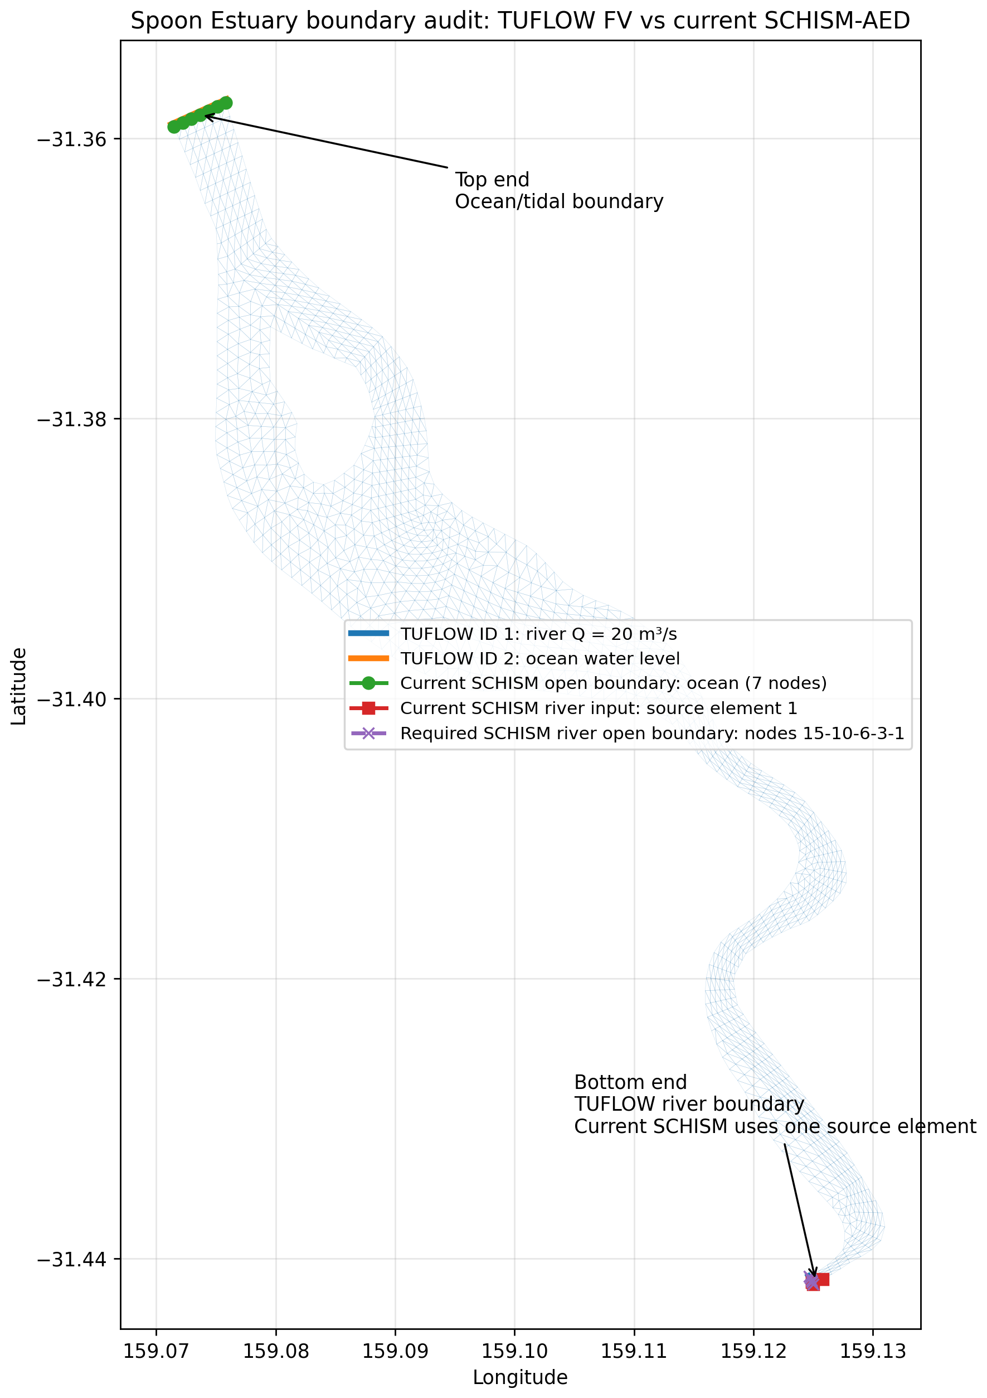
Boundary geometry audit used to verify the river and ocean ends of the benchmark domain.
Prepared by | Dongfang Liu
Version | 1.0
Date | 12 July 2026
Status | Preliminary technical report; current SCHISM results precede strict river-boundary correction

Executive summary
Main conclusion. The TUFLOW and SCHISM configurations use the same river and ocean ends, and the supplied discharge, tide, temperature, salinity and 17 AED boundary time series match numerically. However, the current SCHISM river inflow is implemented as a source in element 1 while TUFLOW uses a distributed Q boundary across the lower cross-section. The current SCHISM case is therefore a successful runnable and plotting benchmark, but it is not yet a strict boundary-for-boundary reproduction.

This report has two purposes. First, it records the main setup differences between Matt's TUFLOW FV-AED benchmark and the SCHISM-AED case prepared and run on UQ Bunya. Second, it presents the current SCHISM-AED hydrodynamic and water-quality plots in the same visual groups used by the TUFLOW plotting notebook.
- The current SCHISM-AED model completes stable hydrodynamic, tracer and AED time stepping and produces hourly output suitable for post-processing.
- The direction of the domain is correct: the river is at the lower/southern end and the ocean/tidal boundary is at the upper/northern end.
- The most important remaining correction is to replace the element source with a five-node SCHISM river open boundary and remove unmatched startup ramping before quantitative model comparison.
- The recommended dissemination route is to add a dedicated SCHISM-AED folder to the existing AquaticEcoDynamics Spoon Estuary GitHub repository, with an executed notebook, selected figures, model inputs and a clear data-availability statement.

Report structure
1. Purpose and benchmark context
2. Setup comparison: TUFLOW FV-AED and SCHISM-AED
3. Boundary audit and strict-comparison requirements
4. Preliminary SCHISM-AED results
5. Proposed GitHub publication and repository structure
6. Recommended next steps
Appendix A. Key model files and variables

1. Purpose and benchmark context
The Spoon Estuary example is a compact three-dimensional hydrodynamic and aquatic biogeochemical benchmark. Matt's reference case is configured in TUFLOW FV coupled with AED. A parallel SCHISM-AED case has been repaired, adapted and run on UQ Bunya so that the two model systems can be compared using common forcing and common output-variable groups.
The public AquaticEcoDynamics repository currently contains two top-level examples: spoon_tfvaed_example and spoon_sczaed_example. The TUFLOW README describes the case as a reference benchmark for interoperability and regression testing. The present report extends that idea by documenting the Bunya-ready SCHISM setup, the boundary audit and a reproducible results gallery.
Interpretation rule. The figures in Section 4 demonstrate successful SCHISM-AED output extraction, aggregation and plotting. They should not yet be interpreted as evidence of agreement with TUFLOW, because the river boundary representation and several numerical settings remain different.

2. Setup comparison: TUFLOW FV-AED and SCHISM-AED
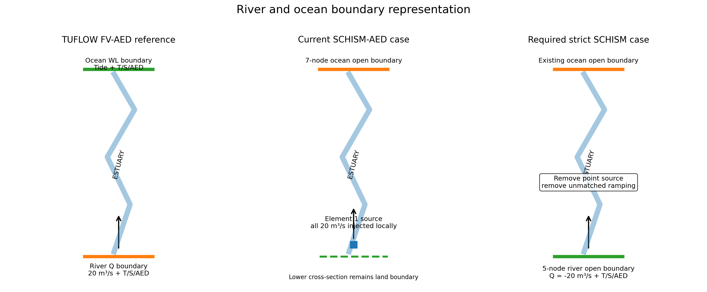
Figure 1. Conceptual comparison of the TUFLOW river boundary, the current SCHISM element-source representation and the required strict SCHISM river open boundary.

2.1 Shared benchmark design
- Simulation start: 1 May 2011 at 00:00, with hourly water-quality output.
- Horizontal vertex set: 1,419 geographic nodes covering the same small estuary.
- One river inflow and one ocean/tidal boundary.
- Temperature, salinity and 17 active AED state variables are transported.
- Meteorological forcing is based on the same 2011 CFSR period, converted into the model-specific forcing format.
- The supplied river and ocean boundary values and their record times were checked and found to match exactly between the audited files.

2.2 Main setup differences
Component | TUFLOW FV-AED reference | Current SCHISM-AED on Bunya | Comparison implication
Horizontal discretisation | TUFLOW FV cell-centred representation; 1,375 reported 2D cells and 1,419 vertices. | SCHISM triangular grid; 2,535 elements and 1,419 nodes. | The geographic domain is shared, but cell topology and variable locations are not one-to-one.
Vertical discretisation | TUFLOW z/sigma configuration with four sigma layers and a 1 m target 3D cell depth. | Explicit SCHISM sigma grid with five vertical levels and four active layers. | Use the same physical depth bands when plotting; do not compare layer numbers directly.
Time stepping | Adaptive, CFL controlled, 0.1-30 s; CFL = 0.6. | Fixed 60 s time step. | Phase and numerical-diffusion differences are expected even with identical forcing.
Wetting and drying | Dry/wet thresholds 0.001 m and 0.02 m. | Minimum wet depth h0 = 0.01 m. | Thresholds are not identical and may affect shallow cells.
Bottom resistance | Spatial material roughness under the TUFLOW ks formulation: 0.02, 0.75 and 1.3. | SCHISM uses nchi = 0 and drag.gr3. | Formulation and spatial values require a dedicated parity audit.
River hydrodynamic boundary | Distributed Q boundary on nodestring ID 1; constant 20 m³/s. | 20 m³/s injected into source element 1 through source_sink.in and vsource.th. | This is the critical current mismatch: correct end and correct quantity, but not equivalent momentum/distribution.
Ocean boundary | Water-level nodestring ID 2 with tide, T, S and AED values. | Seven-node open boundary with elevation, T, S and 17 AED time series. | Spatial location and supplied time series are aligned.
Startup treatment | Boundary series applied directly from the first record. | dramp = 2 days and dramp_ss = 1 day in the audited param.nml. | The first one to two days are not forced identically.
Advection/turbulence | TUFLOW spatial-order controls and included turbulence configuration. | SCHISM TVD-controlled tracer transport; itur = 3. | Numerical schemes should be documented, not forced to be identical.
AED coupling | External AED model with 17 state variables and diagnostic output. | SCHISM-AED coupling with corresponding 17 tracers and selected diagnostics. | State-variable mapping can be matched; diagnostic names and units must be checked.
Output organisation | Single combined cell-centred NetCDF file, HYD_aed.nc. | Multiple SCHISM NetCDF files organised by variable and output stack. | A common post-processing layer is required before comparison.
Computing workflow | Lightweight reference run, commonly executed as a local/single-node TUFLOW case. | MPI run on UQ Bunya with Slurm and separate scribe ranks. | Runtime and file-management workflows differ by design.

2.3 Boundary and constituent forcing
The audited river and ocean files contain 744 hourly records for the 31-day forcing set. The river discharge is 20 m³/s at every record. Temperature, salinity and all 17 AED values match between the TUFLOW CSVs and the corresponding SCHISM source/open-boundary files. The important issue is therefore not a copied value or a reversed end; it is the hydrodynamic representation of the river inflow.

3. Boundary audit and strict-comparison requirements

Figure 2. Spatial boundary audit. The lower/southern end is the TUFLOW river Q boundary and the current SCHISM source location. The upper/northern end is the ocean/tidal boundary in both models.

3.1 Confirmed findings
- The river and ocean ends have not been reversed.
- TUFLOW nodestring ID 1 is the lower/southern river boundary; TUFLOW nodestring ID 2 is the upper/northern ocean water-level boundary.
- The current SCHISM source element is at the river end, while the seven-node SCHISM open boundary is at the ocean end.
- The five SCHISM nodes corresponding to the TUFLOW river cross-section are 15, 10, 6, 3 and 1.
- Those five nodes are currently classified as exterior land-boundary nodes, so the lower cross-section is not yet a SCHISM open boundary.

3.2 Required correction before quantitative comparison
- Convert nodes 15, 10, 6, 3 and 1 into a second SCHISM open-boundary segment.
- Prescribe river discharge as -20 m³/s under the SCHISM inflow sign convention, together with the upstream temperature, salinity and 17 AED concentrations.
- Keep the existing seven-node ocean boundary and its water-level, temperature, salinity and AED series.
- Remove the element-source representation and disable source-specific ramping for the strict comparison case.
- Split the exterior land boundary correctly around the new river opening.
- Run a short hydrodynamic test first and verify cross-section flux, velocity direction, water volume and constituent mass balance before repeating the six-day comparison.
Recommended case naming. Retain the existing run as current_point_source_case for traceability. Create a separate strict_boundary_case so that the correction is auditable and the earlier results are not overwritten.

4. Preliminary SCHISM-AED results
The plots below follow the principal figure groups in Matt's TUFLOW notebook: water level, oxygen with velocity vectors, a three-variable water-quality panel, and a 3 × 3 surface/near-seabed/depth-averaged comparison. They demonstrate that SCHISM outputs can be transformed into the same reporting structure.

4.1 Water-surface elevation
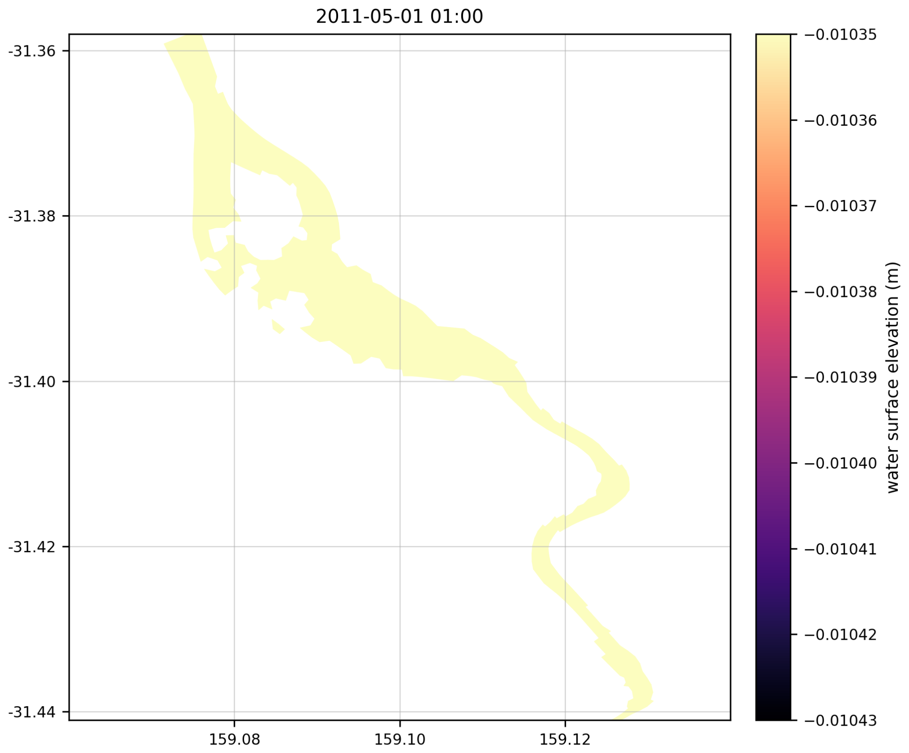
Figure 3. SCHISM-AED water-surface elevation snapshot at 1 May 2011 01:00.
The plotted field is spatially almost uniform at this instant, and the colour bar spans only a very small elevation range. This confirms successful extraction of the two-dimensional free-surface field, while also showing why fixed or shared colour limits will be essential in any side-by-side model comparison.

4.2 Dissolved oxygen and velocity vectors
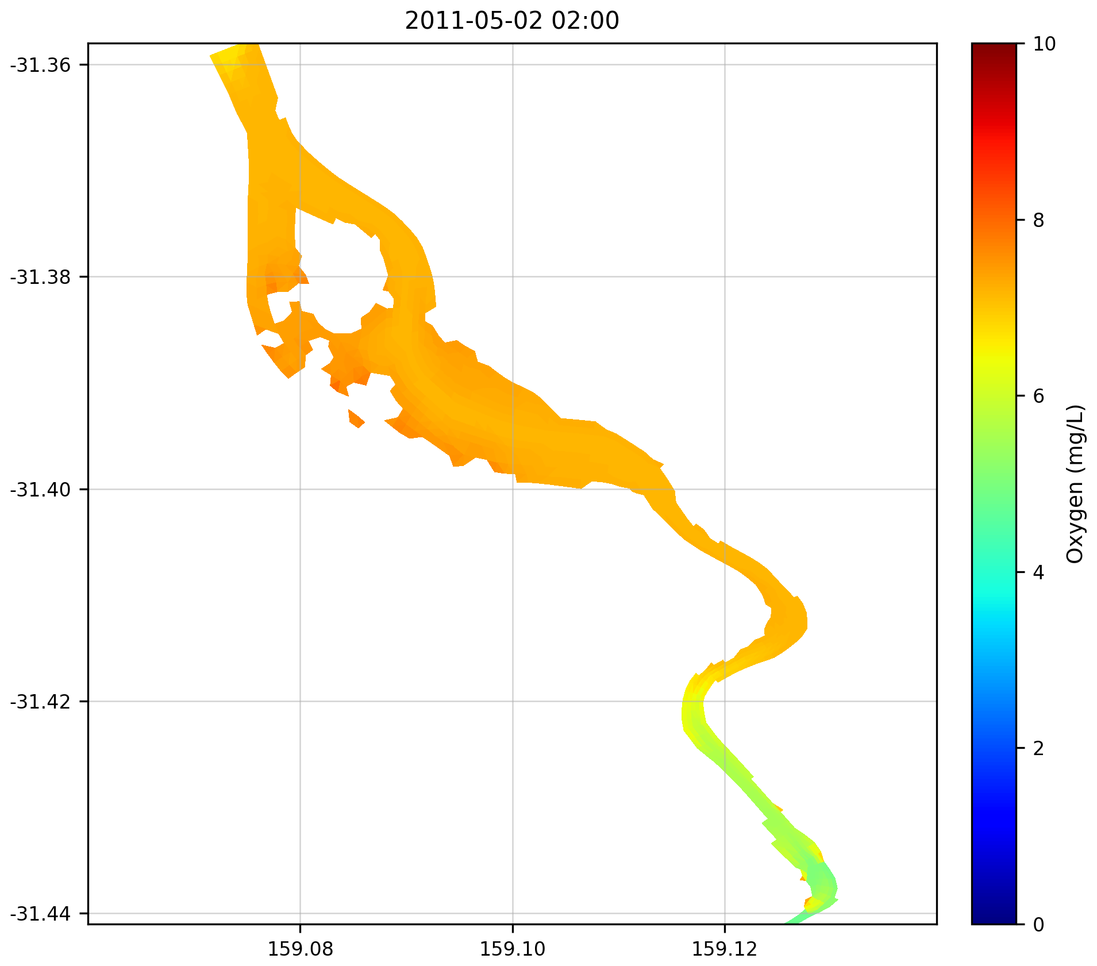
Figure 4. Dissolved oxygen with velocity vectors at 2 May 2011 02:00.
The overlay confirms that scalar water-quality fields and horizontal velocity vectors can be plotted on the same unstructured mesh. Vector direction is instantaneous and tidally varying; it should not be used alone to infer the long-term net transport direction.

4.3 Oxygen, total nitrogen and gross primary production
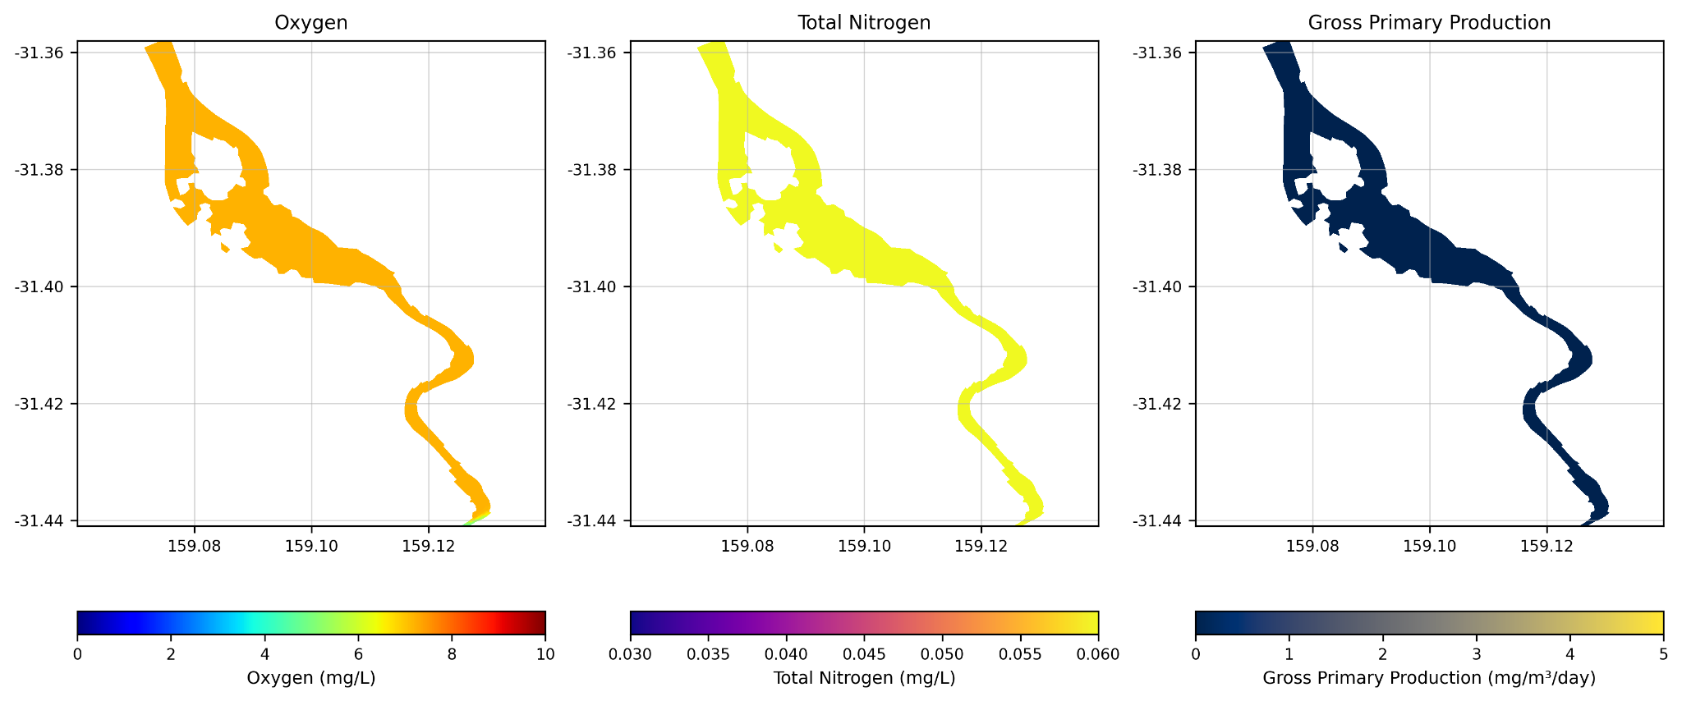
Figure 5. Three-panel SCHISM-AED water-quality view: oxygen, total nitrogen and gross primary production.
This group reproduces the visual logic of the TUFLOW notebook: related variables are evaluated at the same time and depth treatment, each with its own physically meaningful colour scale. The present figure is a plotting demonstration; subsequent comparison figures should use identical timestamps, depth definitions, colour limits and units for both models.

4.4 Surface, near-seabed and depth-averaged fields
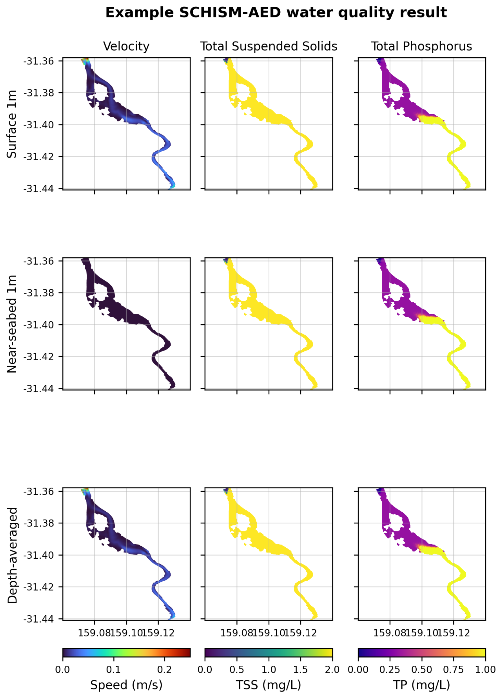
Figure 6. SCHISM-AED 3 × 3 panel showing velocity, total suspended solids and total phosphorus for the surface 1 m, near-seabed 1 m and depth-averaged water column.
The nine-panel layout is particularly useful for checking vertical consistency. It separates surface and near-bed behaviour from the depth-averaged signal and provides a direct template for future TUFLOW-SCHISM comparisons. Planned extensions should include chlorophyll-a, turbidity, total light/PAR and time-series or animation products.

4.5 Interpretation limits
- These figures show that the SCHISM-AED output pipeline is working; they do not yet demonstrate model validation.
- The current river source representation may alter local velocity, mixing and concentration gradients near the lower boundary.
- A fair comparison requires common geographic sample points or interpolated grids, common depth aggregation and common units.
- Mass-conservation diagnostics should accompany field plots, particularly for TN, TP, TSS and other derived summary variables.

5. Proposed GitHub publication and repository structure
Yes - the SCHISM-AED work can be presented through a GitHub link in the same way as Matt's TUFLOW material. The strongest approach is not to create a disconnected duplicate repository, but to add a dedicated Bunya-ready SCHISM folder to the existing AquaticEcoDynamics Spoon Estuary repository, subject to Matt/Badin/team approval and project data-governance checks.
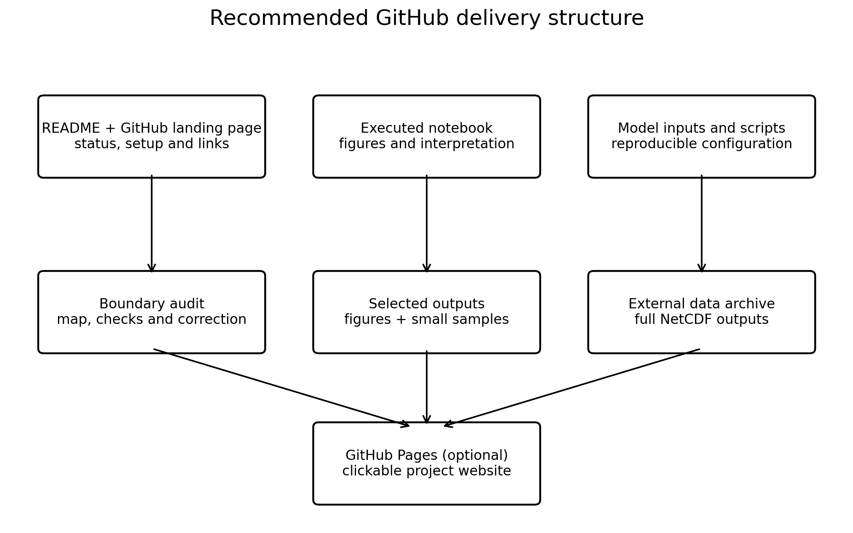
Figure 7. Recommended GitHub delivery architecture for model files, notebooks, figures and large outputs.

5.1 Recommended repository location
Proposed folder within the existing repository: spoon_sczaed_bunya/. A future direct link would therefore have the form .../spoon_estuary_multi_model/tree/main/spoon_sczaed_bunya after the folder is reviewed and merged.

5.2 Recommended content
spoon_sczaed_bunya/
├── README.md # landing page and current status
├── model_inputs/
│ └── current_point_source_case/ # audited current inputs, clearly labelled
├── boundary_audit/
│ ├── boundary_audit_map.png
│ └── boundary_audit_report.md
├── notebooks/
│ └── SCHISM_AED_results_gallery.ipynb
├── figures/
│ ├── water_surface_elevation.png
│ ├── oxygen_velocity.png
│ ├── oxygen_tn_gpp.png
│ └── velocity_tss_tp_3x3.png
├── docs/
│ ├── index.md # optional GitHub Pages site
│ └── setup_and_results_report.md
├── scripts/ # plotting/comparison scripts when finalised
├── .gitignore # excludes large NetCDF outputs and logs
└── PUBLISHING_GUIDE.md # review, push and data-release workflow

5.3 What should and should not be stored in normal Git history
- Store directly: text-based model inputs, Slurm scripts, plotting code, notebooks, README files, small CSVs and selected PNG figures.
- Do not store directly: full SCHISM output directories, large combined NetCDF files, temporary MPI/scribe files, logs or machine-specific binaries.
- Use a project data repository, UQ RDM location or a DOI-based archive for the complete output dataset. The GitHub README can link to that archive once approved.
- GitHub blocks normal repository files larger than 100 MiB. Git LFS can manage larger files, but a separate scientific data archive is usually clearer for full model outputs and long-term reproducibility.

5.4 Notebook and web presentation
An executed Jupyter notebook can render directly on GitHub and show the figures, methods and interpretation without requiring a user to run the model. For a more polished one-click experience, the repository can also publish the docs folder through GitHub Pages as a lightweight project website. The prepared package accompanying this report already contains a GitHub-renderable notebook, Markdown report, figures and a Pages-ready index file.

5.5 Governance before a public release
- Confirm that AquaticEcoDynamics/Matt agrees with the proposed contribution to the existing repository.
- Confirm whether the project inputs and outputs may be public, and whether any UQ or DETSI acknowledgement is required.
- Agree on a software/data licence before adding a licence file.
- Do not publish HPC executable binaries, credentials, personal paths or restricted project data.
- Clearly label preliminary and corrected cases so that users cannot mistake the point-source case for the final strict benchmark.

6. Recommended next steps
Priority | Action | Deliverable
1 | Correct the river boundary | Create the five-node SCHISM river open boundary, remove the source element and harmonise startup ramping.
2 | Run a short verification case | Check inflow sign, section-integrated discharge, velocity direction, water volume and mass balance.
3 | Repeat the six-day benchmark | Use the exact TUFLOW period and produce 145 common hourly records.
4 | Standardise the plotting notebook | Apply shared timestamps, colour limits, units, depth bands and spatial interpolation.
5 | Add quantitative comparison | Calculate time-series bias, RMSE, correlation, domain inventories and section fluxes.
6 | Publish through review | Place the prepared GitHub folder in a branch or fork, request Matt/Badin review, then merge into the existing repository.
7 | Archive full outputs separately | Deposit large NetCDF outputs in an approved research-data location and link them from GitHub.
Suggested message to the team. I have prepared a Bunya-ready SCHISM-AED results and documentation package that mirrors the structure of Matt's TUFLOW notebook. The river and ocean ends and all supplied boundary values have been verified, but the current SCHISM river inflow is still an element source rather than the equivalent cross-section Q boundary. I propose correcting that first, then adding the final SCHISM setup, executed notebook and selected results to the existing Spoon Estuary GitHub repository through a reviewed branch or pull request.

Appendix A. Key model files and variables
Model | File | Purpose
SCHISM | hgrid.gr3 / hgrid.ll | Mesh, bathymetry, geographic coordinates and boundary-node definitions.
SCHISM | vgrid.in | Vertical sigma levels and active-layer definition.
SCHISM | param.nml | Time stepping, wetting/drying, turbulence, ramping, sources and output controls.
SCHISM | bctides.in | Open-boundary types and links to elevation, temperature, salinity and AED forcing.
SCHISM | source_sink.in, vsource.th, msource.th | Current river element-source definition and constituent values.
SCHISM | elev.th, TEM_1.th, SAL_1.th, AED_1.th-AED_17.th | Ocean water level and constituent time series.
TUFLOW | HYD_aed.fvc | Main control file: geometry, time step, materials, boundary conditions and output.
TUFLOW | Upstream_Q_001.csv | River discharge and river T/S/AED boundary values.
TUFLOW | Downstream_WL_001.csv | Ocean water level and ocean T/S/AED boundary values.
TUFLOW | 2d_ns_OpenBoundaries_001_L.* | GIS nodestrings identifying river and ocean boundary locations.

Appendix B. Active AED state variables
NCS_ss1 - suspended sediment | OGM_poc - particulate organic carbon
OXY_oxy - dissolved oxygen | OGM_pon - particulate organic nitrogen
NIT_amm - ammonia | OGM_pop - particulate organic phosphorus
NIT_nit - nitrate | PHY_mixed - mixed phytoplankton
PHS_frp - filterable reactive phosphorus | TRC_age - age/retention-time tracer
PHS_frp_ads - adsorbed phosphorus | TRC_tr1 - conservative tracer 1
OGM_doc - dissolved organic carbon | TRC_tr2 - conservative tracer 2
OGM_don - dissolved organic nitrogen | TRC_tr3 - conservative tracer 3
OGM_dop - dissolved organic phosphorus

References and project links
- AquaticEcoDynamics Spoon Estuary multi-model repository
- TUFLOW FV-AED benchmark folder
- SCHISM-AED example folder
- GitHub documentation: large files
- GitHub Pages

