SPOON ESTUARY
TUFLOW FV-AED and SCHISM-AED
Setup comparison and preliminary SCHISM-AED results
Prepared as a concise progress report for internal review and feedback.
Version 1.1

Executive summary
- The SCHISM-AED Spoon Estuary case has now been set up on UQ Bunya, run stably, and post-processed into the same broad figure groups used in Matt’s TUFLOW notebook.
- The overall domain orientation is consistent between the two models: the river is located at the lower/southern end and the ocean/tidal boundary is at the upper/northern end.
- The river discharge magnitude, ocean water level, and associated temperature, salinity and AED constituent values used in the current SCHISM case are consistent with the audited TUFLOW forcing files.
- The main current setup difference is that SCHISM represents the river inflow as a local element source rather than a distributed river discharge boundary. This should be kept in mind when interpreting comparisons, but it does not prevent the current report from demonstrating that the SCHISM-AED case is working and producing useful outputs.
- The aim of the present report is therefore to show the current model status and available results, and to invite comments from the project team before any later refinements are considered.

1. Purpose and current context
This report is intended to present the current state of the Spoon Estuary SCHISM-AED case in a clear and practical way for team review. The focus is on two things: (1) explaining how the present SCHISM-AED setup compares with Matt’s TUFLOW FV-AED benchmark setup, and (2) showing the main SCHISM-AED outputs that have already been produced using a plotting style comparable to Matt’s notebook.
At this stage, the priority is to communicate what is already working: the case setup, the forcing audit, the successful model run, and the resulting figures. Any later refinements to achieve closer one-to-one alignment can be addressed separately after feedback from the team.

2. Setup comparison: TUFLOW FV-AED and the current SCHISM-AED case
Both model cases represent the same compact estuary benchmark and use the same overall physical concept: one river inflow, one ocean/tidal boundary, and transport of temperature, salinity and AED water-quality variables. The supplied forcing values were audited and the river/ocean ends were checked spatially.

2.1 Shared benchmark features
- Simulation start used for the benchmark forcing period: 1 May 2011, with hourly forcing records in the audited 31-day set.
- The same small Spoon Estuary domain and the same general upstream/downstream arrangement.
- One river-side freshwater input and one ocean-side water-level boundary.
- Temperature, salinity and 17 active AED state variables included in the transported constituent set.
- A common goal of producing comparable hydrodynamic and water-quality outputs for post-processing.

2.2 Main current implementation differences
Aspect | TUFLOW FV-AED reference | Current SCHISM-AED case
River inflow | Distributed river discharge boundary (Q boundary at the lower end). | Local element source used to inject the 20 m³/s river inflow near the lower end.
Ocean boundary | Ocean water-level boundary with temperature, salinity and AED values. | 7-node ocean open boundary with the corresponding water level, temperature, salinity and AED values.
Boundary geometry | River and ocean boundaries represented directly as nodestring boundaries. | Ocean represented as an open boundary; the lower cross-section remains a land boundary while river inflow is introduced internally.
Forcing values | River discharge, ocean water level, T/S and AED values provided in CSV forcing files. | Equivalent forcing values translated into SCHISM input files and audited against the TUFLOW reference.
Output presentation | Matt’s existing notebook figure groups. | SCHISM outputs re-plotted to follow the same broad figure groups for easier visual comparison.

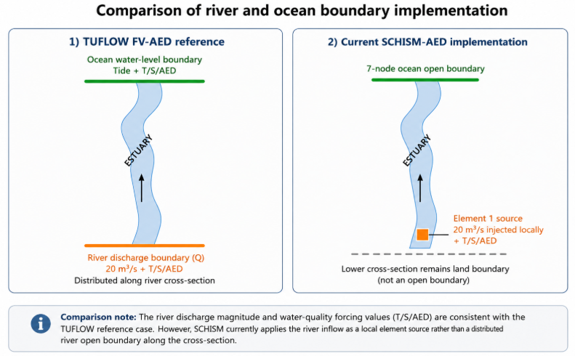
Figure 1. Conceptual comparison of river and ocean boundary implementation in the TUFLOW reference and the current SCHISM-AED case.

2.3 Key interpretation note
The current SCHISM case uses the same audited river discharge magnitude and the same audited water-quality forcing values as the TUFLOW reference, but the hydrodynamic implementation of the river inflow is different. This means that the present results are well suited to demonstrate successful setup and post-processing, while any detailed quantitative comparison should be interpreted with that implementation difference in mind.

3. Boundary audit and current interpretation
A dedicated boundary audit was completed to make sure that the river and ocean ends had not been reversed and that the forcing data had been transferred correctly. This was an important check because the estuary geometry is narrow and curved, and the visual results alone do not prove whether the boundary setup is spatially correct.
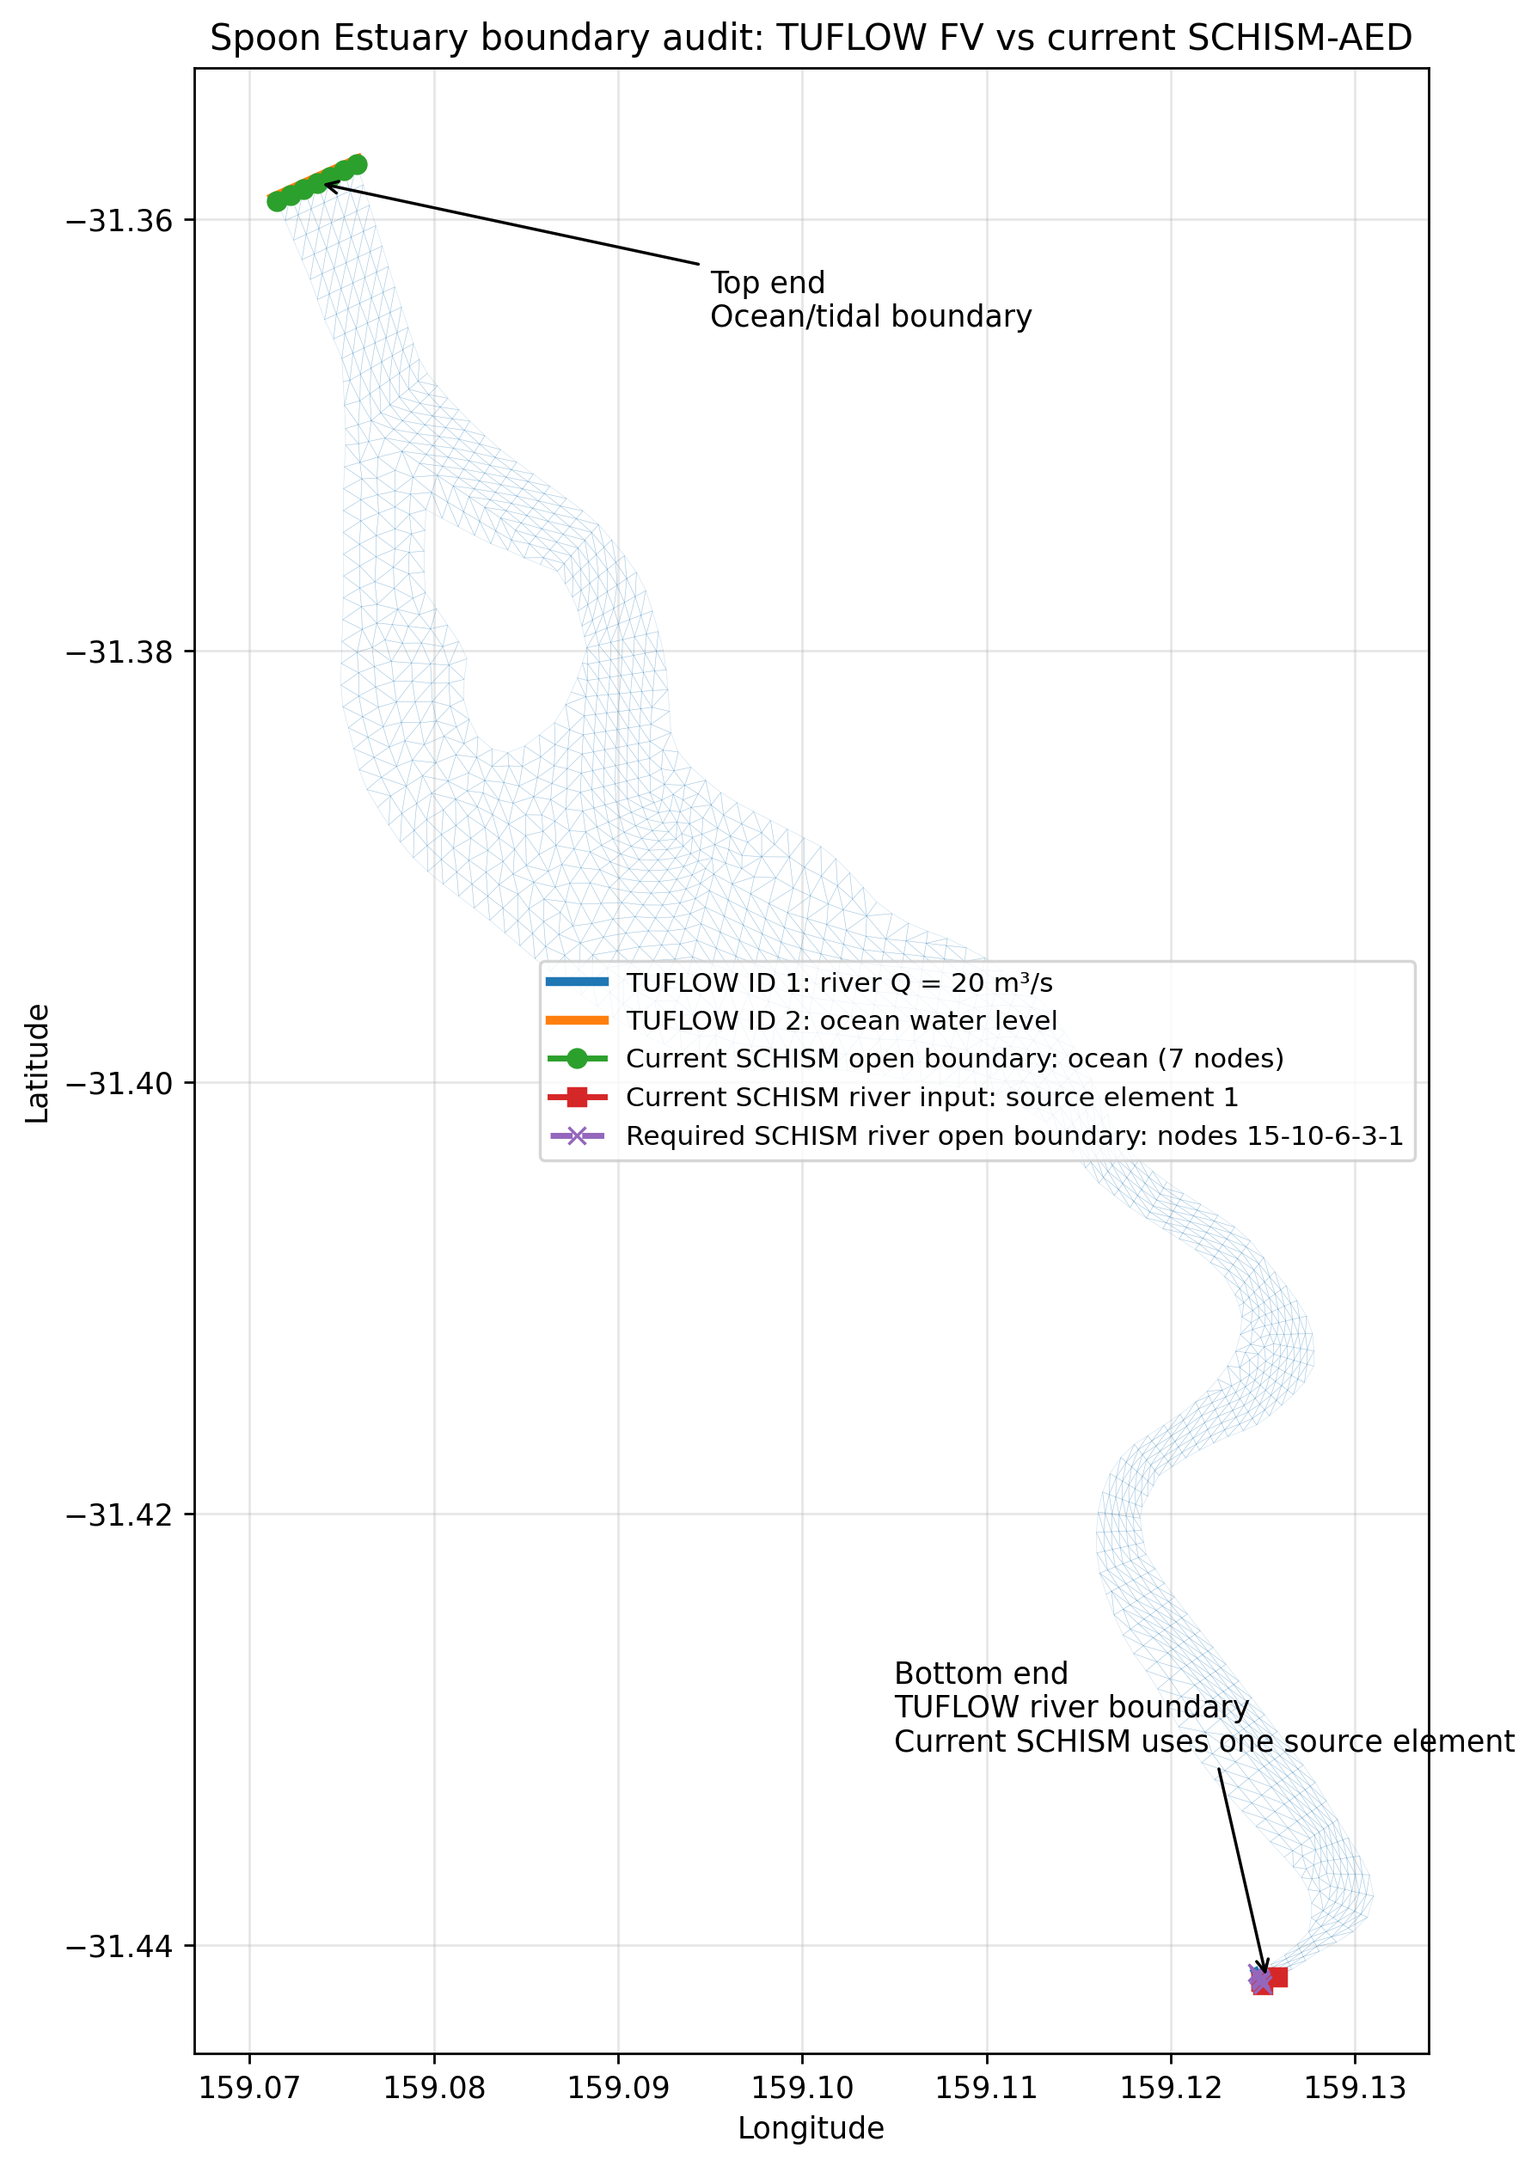
Figure 2. Spatial boundary audit showing the TUFLOW river boundary, the TUFLOW ocean boundary, the current SCHISM source location and the SCHISM ocean boundary.
- The forcing values themselves were found to be consistent between the audited TUFLOW and SCHISM input files.

The practical conclusion is that the current SCHISM setup is physically oriented correctly and uses consistent forcing values. The main difference is the way the river inflow is numerically applied.

4. Preliminary SCHISM-AED results
The figures below are intended to mirror the style of Matt’s TUFLOW notebook as closely as possible at this stage. The purpose is to show that the SCHISM-AED run has successfully produced hydrodynamic and water-quality output that can be organised into the same types of figure groups.

4.1 Water-surface elevation
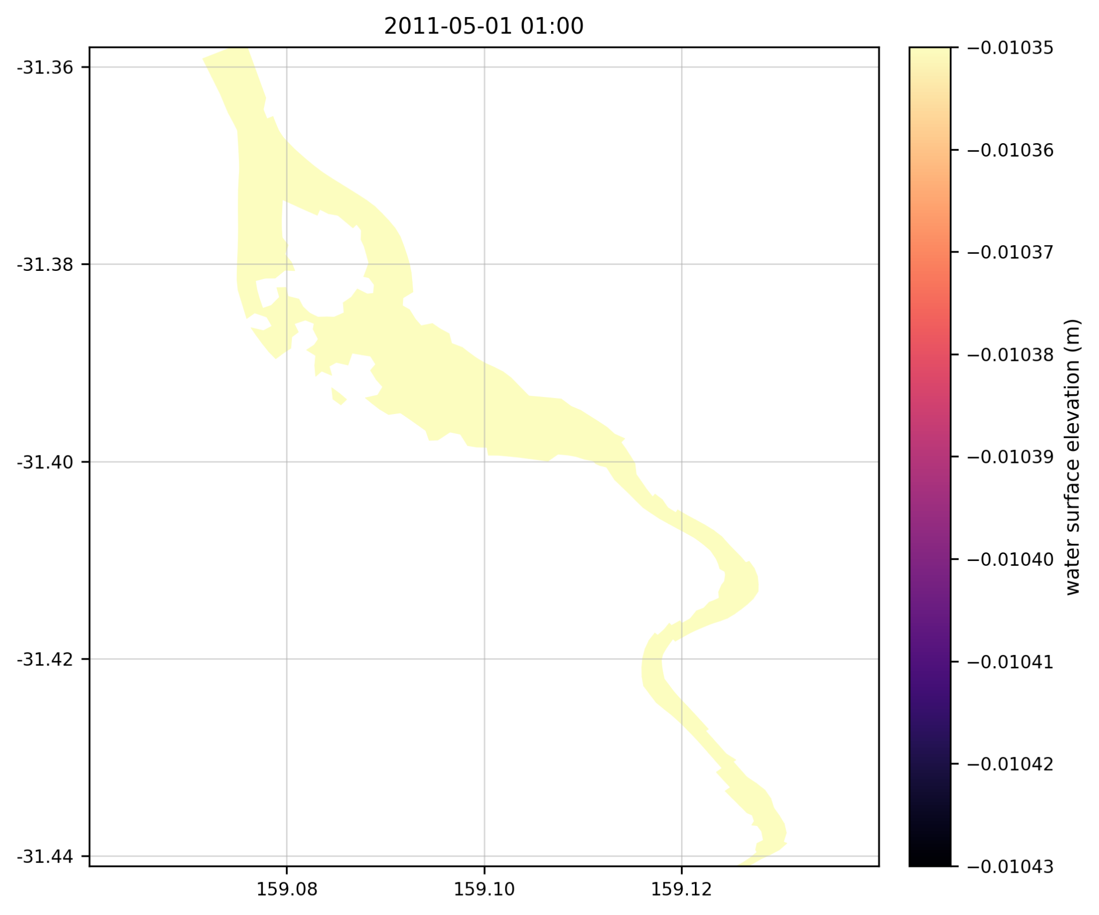
Figure 3. Example SCHISM-AED water-surface elevation snapshot.
This plot confirms successful extraction and mapping of the free-surface field from the SCHISM output. At the selected instant the spatial range is small, which explains the nearly uniform appearance of the field.

4.2 Dissolved oxygen example
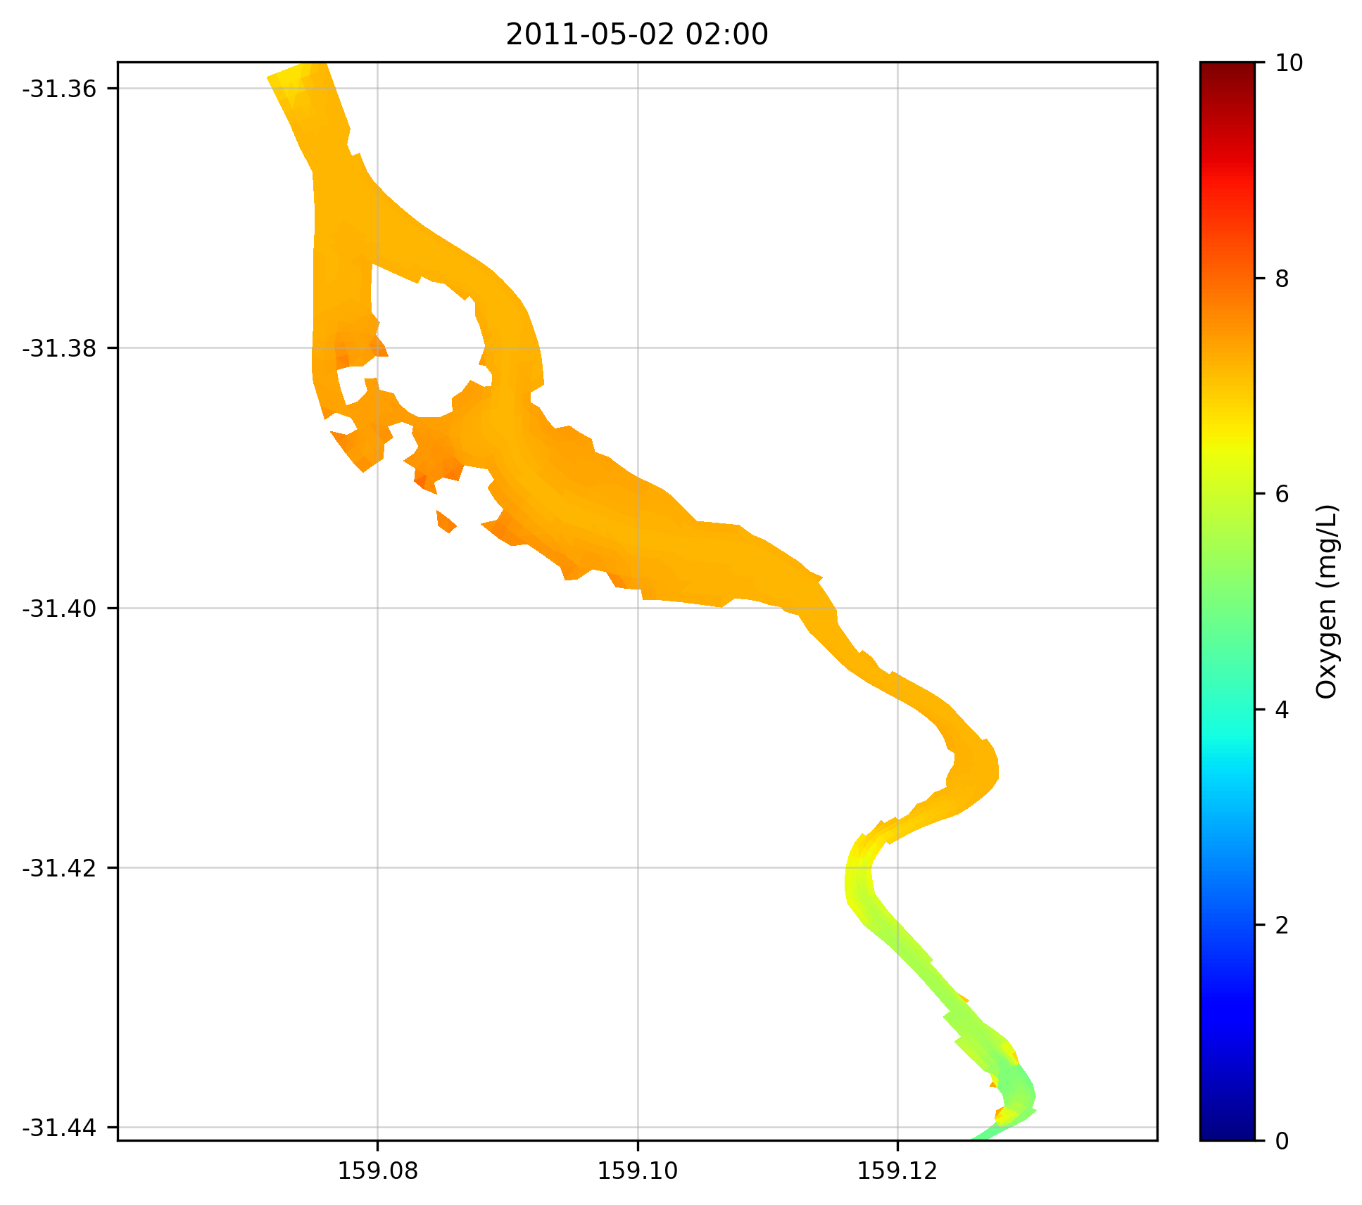
Figure 4. Example SCHISM-AED dissolved oxygen field.
This figure shows that water-quality scalars can be mapped cleanly on the unstructured grid and that the resulting visual style is suitable for later side-by-side comparison with TUFLOW outputs.

4.3 Multi-variable water-quality panel
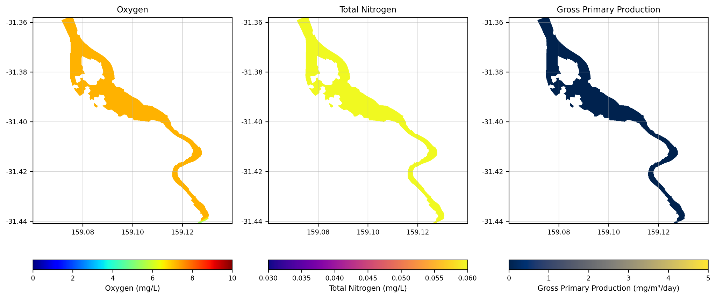
Figure 5. SCHISM-AED three-panel view showing oxygen, total nitrogen and gross primary production.
This panel reproduces the logic of the TUFLOW notebook by grouping related variables at the same analysis time. It is useful both as a quality-control figure and as a communication figure for discussing current spatial patterns.

4.4 Surface, near-seabed and depth-averaged fields
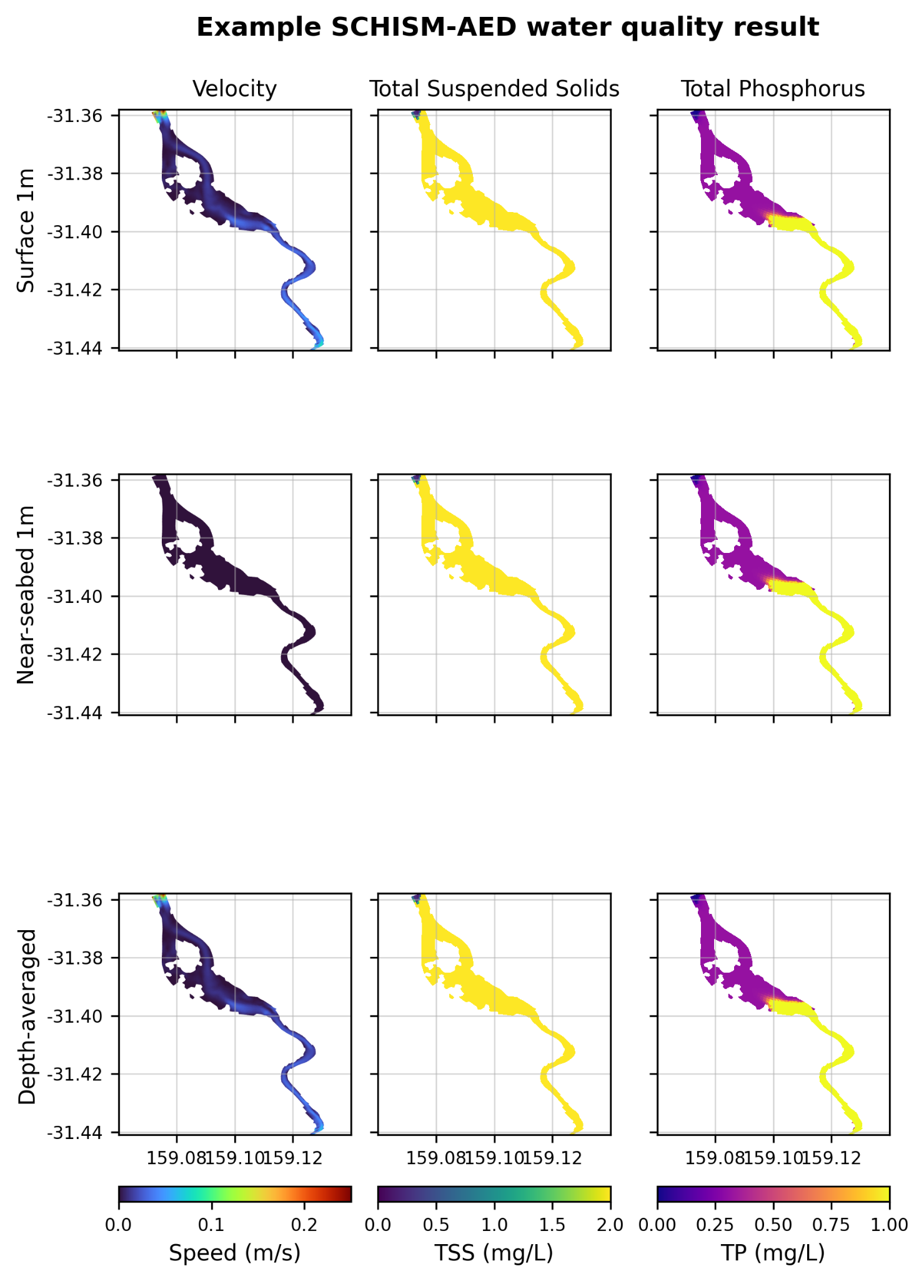
Figure 6. SCHISM-AED 3 × 3 panel showing velocity, total suspended solids and total phosphorus at three depth treatments.
The 3 × 3 layout is particularly helpful because it provides a compact view of both horizontal and vertical structure. It also establishes a good template for future discussion of variables such as chlorophyll-a, turbidity and total light.

4.5 What these figures show at the current stage
- They show that the SCHISM-AED case is set up, runs successfully, and can produce interpretable hydrodynamic and water-quality figures.
- They show that the current post-processing workflow is capable of generating figure groups similar to the TUFLOW notebook.
- They should be viewed as a current status demonstration intended to support team discussion and feedback.

5. GitHub-style dissemination option
Yes, this work can be presented in a GitHub-friendly way similar to Matt’s current notebook-based presentation. A practical approach would be to add a dedicated SCHISM-AED folder to the existing Spoon Estuary multi-model repository, rather than creating an entirely separate project.
Recommended repository content for the current stage:
- A README page describing the case status, purpose and current implementation.
- The audited model input files required to reproduce the current SCHISM-AED setup.
- One or more executed notebooks or Markdown reports showing the current result figures.
- Selected PNG figures for quick viewing by collaborators.
- A short boundary-audit note so readers understand the current implementation clearly.
- A clear statement that the package presents the current working case and is being shared for internal review and feedback.
This would let collaborators click into the repository and immediately see the model context, setup summary, key figures and the current status of the SCHISM-AED work. Large output files should still remain outside normal Git history and be stored in an appropriate data location if full output sharing is needed later.

6. Suggested purpose of the current circulation
The most useful immediate purpose of this report is to present the current SCHISM-AED setup and outputs to the team, so that they can comment on the model presentation, the setup explanation and the usefulness of the current result figures.
- Show the team that the SCHISM-AED case is now running and producing water-quality outputs.
- Explain clearly how the current setup compares with the TUFLOW reference.
- Invite feedback on whether the current figure groups are appropriate and what additional variables would be most useful to show next.
- Keep any later model refinements as a separate internal step rather than making them the focus of the present report.
In other words, this version is best framed as a concise setup-and-results update. It demonstrates what is already available and creates a good basis for discussion, without overcommitting the report to later refinement tasks.
End of report

