It is a optimized Todo Demo coded by myself. The data is from MongoDB.I used Node.js to provide the REST API , in the front-end, Used React to design the component and used Redux to maintain the data,use awai/async/Promise/fetch to perform the Restful API.
Technology used:
*Webpack
*React
*Redux
*Node.js
*Express
*Mongoose
*MongoDB

How to Run the project?
* you need to install mongoDB in your computer
* in the command line: type: npm install
* in the command line: type: node app.js
* open browser , type: localhost:3000 and you will see the result

Project Hierarchy
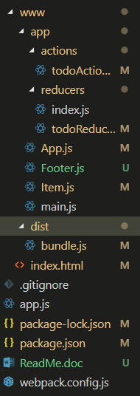
In the app.js , there are 4 restful API there ,they provide the method to manipulate the data
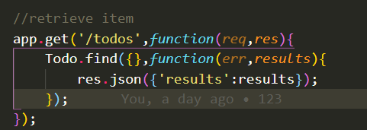

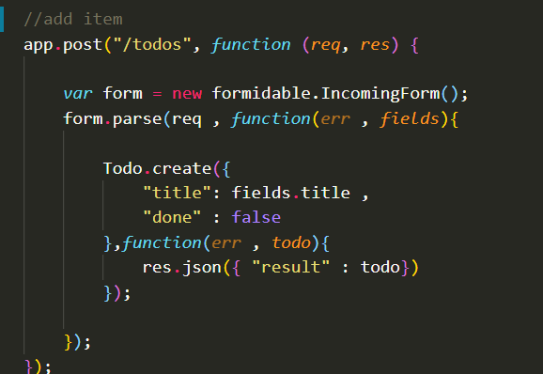

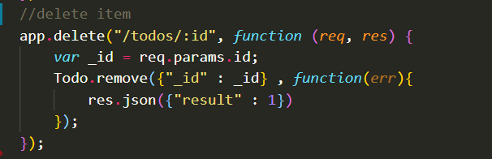
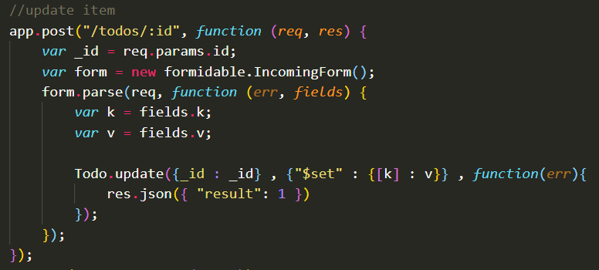

After that, statci the www folder and listen 3000 port.

In the App.js, it connect with reducer and actioncreation,reducer is used to get the data form redux store , action is to be dispatched and call the API.

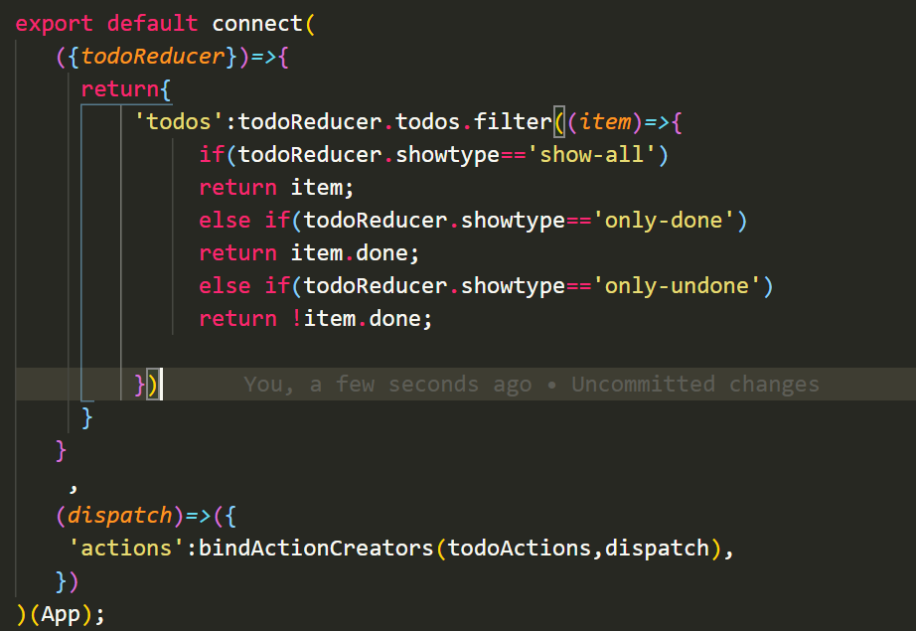

After fetching the data ,it can pass the data to its sub-component called Item.
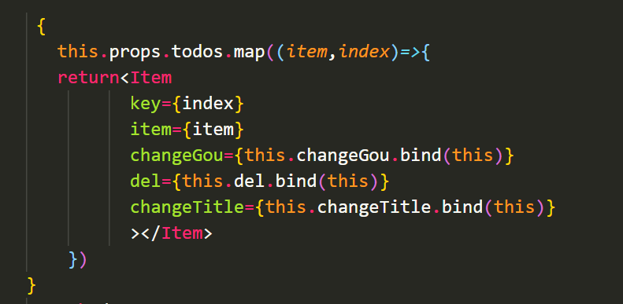

In the Item component,Meanwhile, App.js define some function such as changeGou/del/changeTitle and pass it to the Item component , in this way ,Item Component can use the 3 functions to influence the data
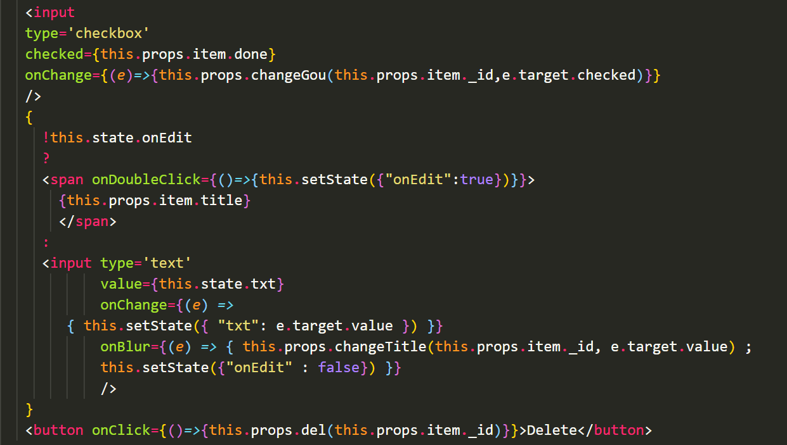

The key pat of the component is the action and reducers, they work together to make the system interact with the back-end api and maintain a copied data in the Redux store.
Taking add for example ,if a component dispatch an action , it will notify the the action creator
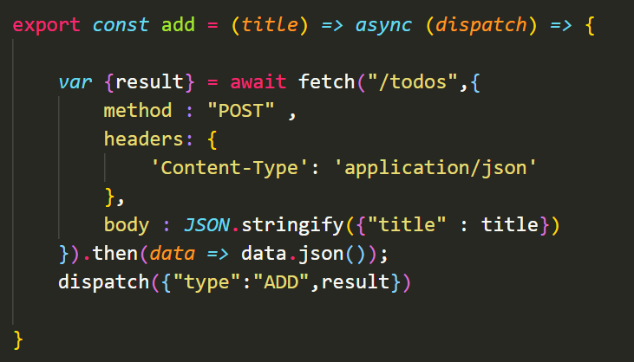
After getting the data form APi, normally ,we need to maintain a copied data in the store, I used ES6 to simplified the code:
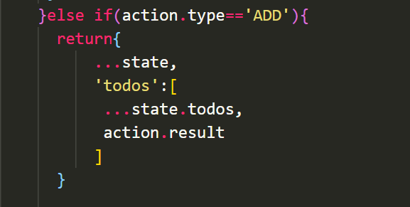

In this way, the code is concise and elegant

