**Algorithms**

**Final Assignment**

**Report**

알고리즘 03분반

소프트웨어학부

20202475 이동훈

Contents

1. Top-down Cut Rod Algorithm

2. BFS

3. Dijkstra Algorithm

4. Bellman-Ford Algorithm

5. TSP Algorithm

1. Top-down Cut Rod Algorithm

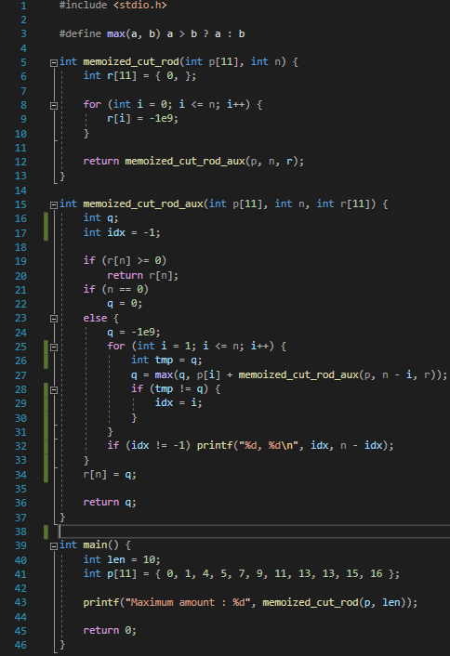Program Code



Execution Result

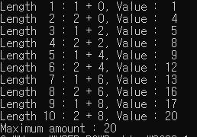

2. BFS

Program Code

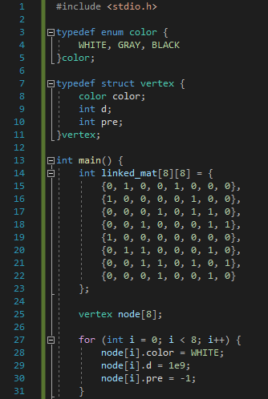

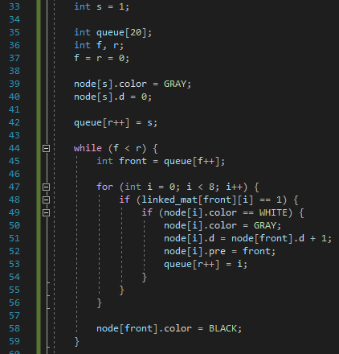

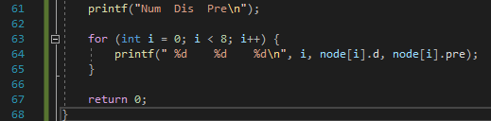

Execution Result

r : 0, s : 1, t : 2, u : 3

v : 4, w : 5, x : 6, y : 7

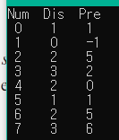

3. Dijkstra Algorithm

Program Code

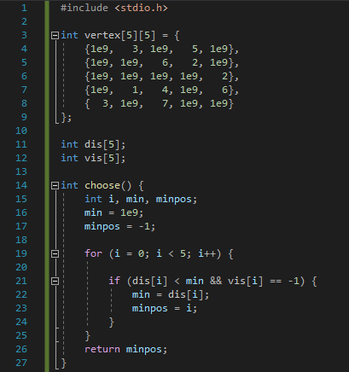 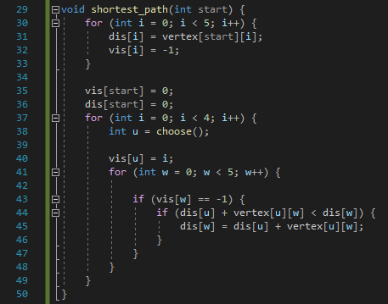 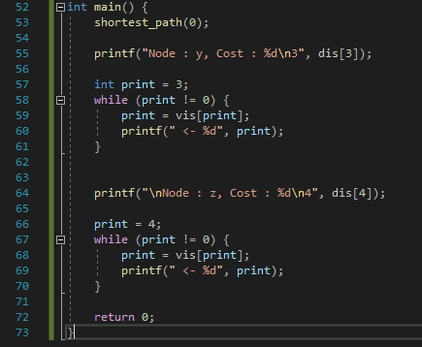

Execution Result

s : 0, t : 1, x : 2, y : 3, z : 4

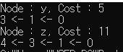

4. Bellman-Ford Algorithm

Program Code

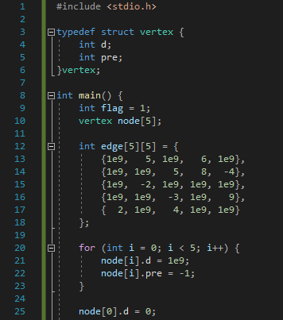 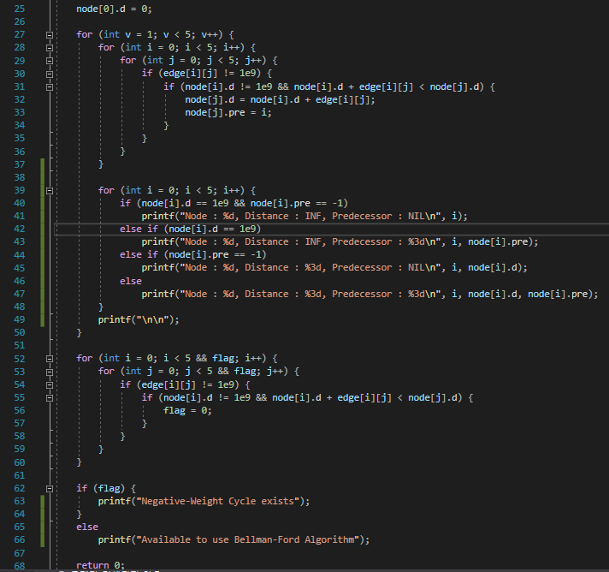

Execution Result

s : 0, t : 1, x : 2, y : 3, z : 4

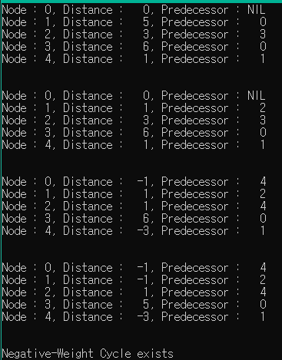

5. TSP

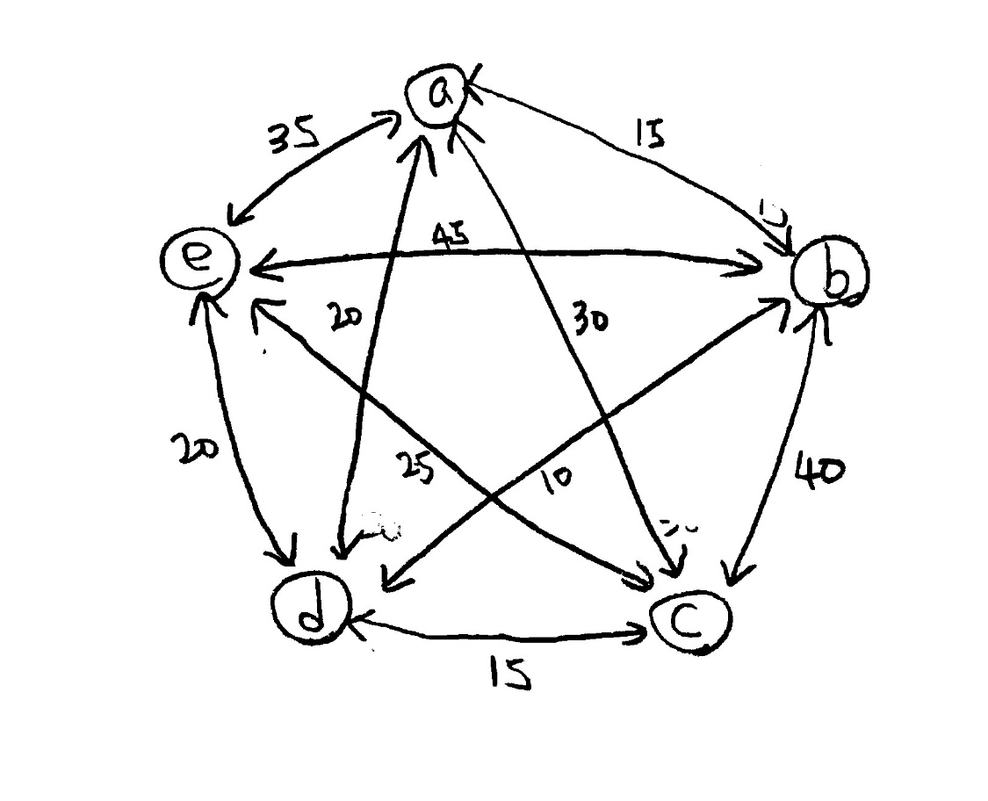 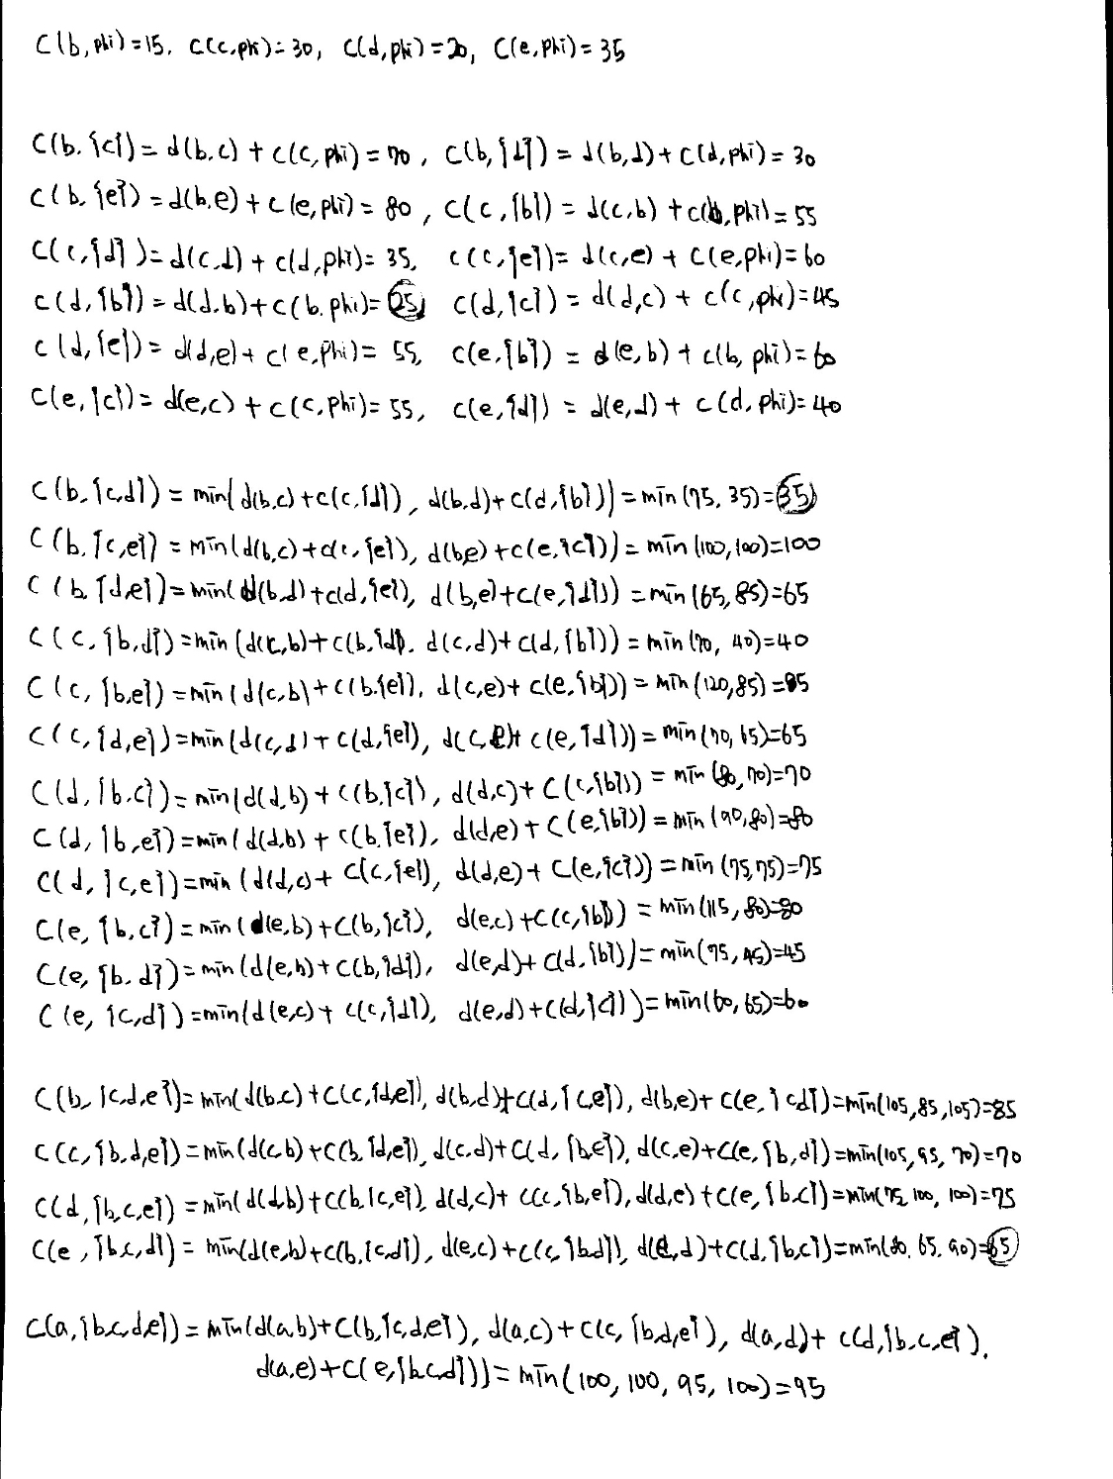

Shortest Route : A – D – B – C – E - A