Buy Organic

Logan Halstrom, 994885153, 5/30/2017

**A case to buy organic flowers in order to limit the adverse effects of pesticides and fertilizers on the environment and to improve the health of floral workers and consumers.**

The odds are that you have heard about the United States Department of Agriculture (USDA) certified organic label, which can be applied to agricultural products that a grown according to certain guidelines and regulations. But what does this certification actually mean in terms of the impact on human and environmental health? Among other regulations, USDA organic certifications requires that no pesticides have been used on the soil in which the plants have been grown for at least 3 years prior. Organic certification additionally limits the usage of synthetic fertilizers (McEvoy, 2012). These two regulations have significant influences on reducing the negative impacts of agricultural processes. Cut flower production is a subcategory of agriculture, and the benefits of organically grown flowers are, in most aspects, the same as those for grown food products.

What may be first and foremost in your mind about the impacts of organic regulations is the restriction of pesticide usage. Pesticides and herbicides are toxic substances that are added to agricultural soil and the plants themselves to kill unwanted insects and plants that hamper the growth of the desired product. The tools have proven to be extremely effective in increasing agricultural production and thus reducing the cost of agricultural products. However, this comes at the potential cost of adverse health effects on humans due to the toxic nature of these substances. Pesticides like Iprodine have been show to cause cancer in rats and have been found in cut flowers in concentrations of 50 times greater than the amount allowed in food by the USDA (Warrick 2000). Though cut flowers are not consumed by humans, which reduces the amount of pesticide exposure they might experience from the flower product, there is still a non-negligible amount of handling associated with flowers. Chemical absorption through the skin and inhalation could be of a significant enough amount to warrant health concerns. This fact alone is enough for a consumer to consider buying organic flowers over conventionally grown alternatives. Though USDA organic products may be more expensive, enjoying your flower product without risking your health can only improve your experience. Additionally, consumers are not the only one at risk from pesticides: flower workers who apply the pesticides come into direct contact with the poisons themselves. This kind of contact can constitute a much higher exposure rate, especially in an industry where worker safety regulations are less than perfectly adhered to. Therefore, buying organic flowers not only protects your own health, but also supports an agricultural industry that is safer for workers.

Humans are not the only ones negatively affected by pesticides. Honeybees and other pollinators may be even more susceptible to these poisons, since they actually consume nectar directly from the flowers. The death of these pollinating insects can have noticeable impacts global pollination processes. It is not uncommon to transport pollinators to production locations in the agricultural industry. For example, beehives can be placed near a field for an appropriate period of time to allow the bees to transfer pollen between individuals of the same species while gathering nectar. Pollination may not be as essential to cut flower production (since the flower – not the fruit – is the product), but all humans are consumers of other agricultural products that depend on pollinators. Thus, if a pollinator dies after feeding from a cut flower containing pesticide, the effect of a net decrease in total pollination may still affect a flower consumer. A global decrease in pollinator populations has been observed and has come to have a serious impact on the agricultural industries. Reducing pesticide usage in all agricultural processes, including cut flower production could help in curbing this population decline. Thus, buying organic flowers may be instrumental in maintaining global biodiversity through pollinator preservation.

Aside from limiting pesticide usage, a USDS organic certification also restricts the usage of fertilizers, which tend to excessively enrich the soil with nutrients. This has an obviously positive effect on agricultural production rate, as plants that are not starved of nutrients can grow without limitation. However, the broader-scale ecological impacts can be less that positive. Nutrients that are not absorbed by the production plants are washed away by irrigation into runoff and the water table, where they are conveyed to larger bodies of water like lakes. Every lake is its own specific ecosystem, where flora and fauna are in a specific balance that is defined, in part, by the availability of resources. If runoff from a farm where fertilizer was used suddenly removes the limitation of resources within an ecosystem like this, sudden imbalances can create positive feedback situations that uncontrollably destroy the ecosystem through a process called eutrophication (Khan and Mohammad, 2014). In lakes where nutrients have been added (specifically nitrogen), there can be a sudden spike in the algae population, which now, unlike before, has plenty of the resources it needs to grow. As the algal bloom proceeds, the body of water can become completely covered in surface algae (see Figure 1). This causes the water surface to become opaque, limiting the amount of light that reaches the photosynthetic organisms below the water that produce oxygen. Without light, these organisms cannot produce food and die, which means that oxygen will no longer be produced in the lake. Ultimately, the algae will die after exhausting their resources and reducing their own light source. This dead biological mass falls to the lake bottom and is consumed by bacteria, which also consume all of the dissolved oxygen remaining in the lake, killing any other oxygen-dependent organisms like fish. The final result is a water ecosystem with no plant or animal life; a massive reduction in biodiversity. The most effective way to avoid situations such as these is to reduce fertilizer usage in the agricultural industry. Buying organic foods and flowers will certify that the products you consume did not contribute to eutrophication in the environment.

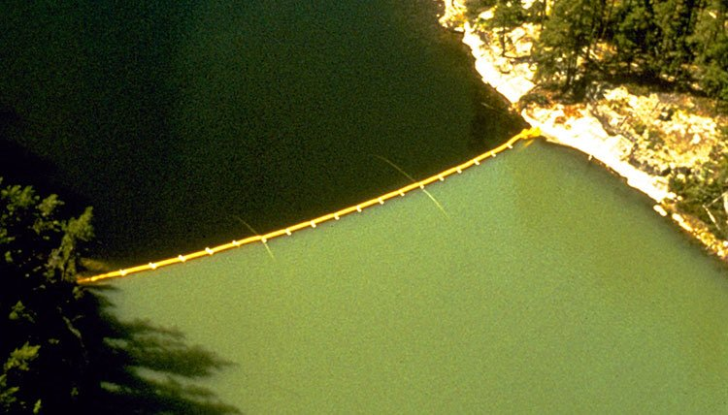

Figure 1: A lake that has been divided by a non-permeable membrane (along the yellow line) and where excess nutrients have been added to the lower section of the late. The result is an algal bloom and the eutrophication of the lower side of the lake (Johnson, 1971).

The arguments contained in this essay stress only a few of the advantages to buying organic flowers. Since the most noticeable difference between certified organic and non-organic foods and flowers to the consumer is price, arguing the case for buying organic is simply a matter of justifying the cost increase. The primary justifications for this cost increase in this paper are to directly improve the health of the consumer as well as that of the environment. If pesticides can adversely affect your health and reduce your life expectancy, is saving that money on the non-organic alternative truly worth it? In the same vein, the health of our environment and its biodiversity has innumerable benefits for humans and society, and it is in our best interest to preserve it as well as we can. Buying organic is a simple change that you can make that does not objectively reduce the quality of the products you receive and can have a significant effect on reducing our impact on the environment. These arguments represent some of the most important but not exclusive reasons why buying organic is worth the additional cost. More benefits of certified organic agriculture can be found on the USDA website.

References

Joby Warrick, “Fresh cut lowers: fragrant, beautiful--and often doused with pesticides”, *National Wildlife*. June 6, 2000.

Johnson, W. E., and Vallentyne, J. R. “Rationale background, and development of experimental lake studies in northwestern Ontario”, *Journal of the Fisheries Research Board of Canada, 28*(2),1971.

Khan, M. Nasir and Mohammad, F. "Eutrophication of Lakes", *Volume II of Eutrophication: Causes, Consequences and Control*, Springer, 2014.

Miles McEvoy, “Organic 101: What the USDA Organic Label Means”, *USDA Health and Safety Blog*, March 22, 2012.