**KPMG Test:**

**Environment:**

VS 2013,SQL Server 2012,MVC 5,Jquery,Ninject with Dependency Injection. Twitter bootstrap for responsive design, SOLID Principles.

Upload Functionality:

Notes:

It allows only CSV ,Xls and Xlsx files.

Main screen: (Upload & Tax information )



Upload(File can be selected and data will be validated and saved)

Selecting file:



Validating file:If validation failed table will be populated with error details.



Tax Information screen: (All the saved data populated in this screen and user can amend and delete the data)

Notes:

1. I have used Jquery data table to bind the data. It is very fast and searchable and can filtering.
2. Responsive design, fit to mobile and tablet and PC.

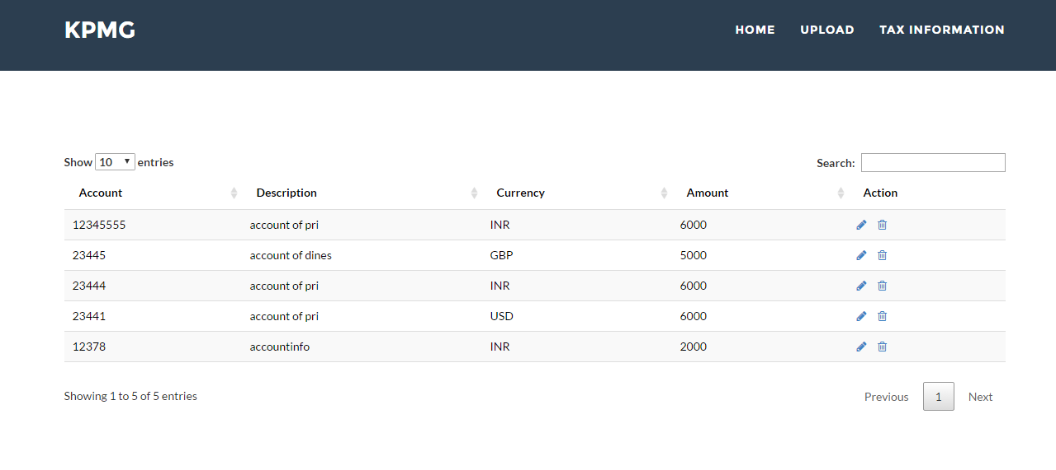

Responsive Design:

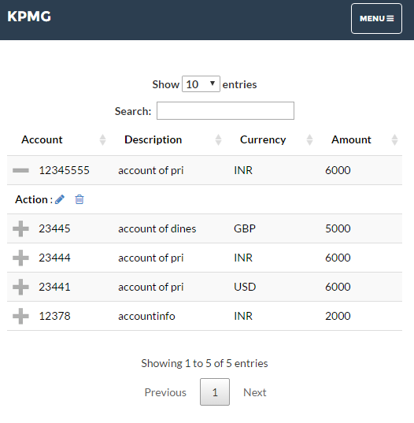

To edit Row:

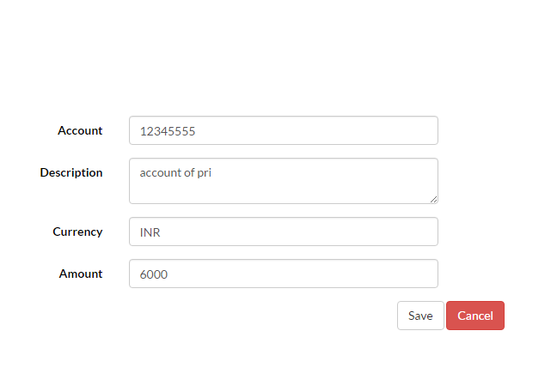

If user clicks delete button prompt the confirmation messag:

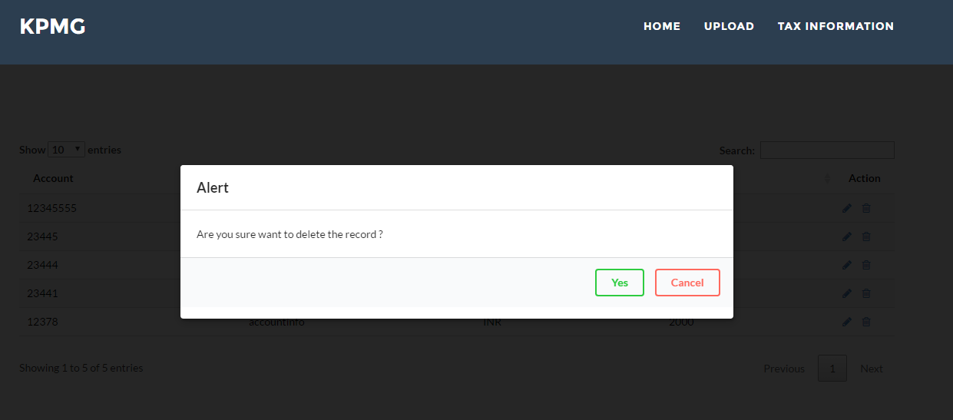

SQL Scripts:

IF db_id('Test') IS NULL

CREATE DATABASE WebAPI

GO

CREATE TABLE [dbo].[Tax_Information](

[TaxId] [bigint] IDENTITY(1,1) NOT NULL,

[Account] [text] NULL,

[Description] [text] NULL,

[Currency] [nchar](10) NULL,

[Amount] [decimal](18, 2) NULL,

CONSTRAINT [PK_Tax_Information] PRIMARY KEY CLUSTERED

(

[TaxId] ASC

)WITH (PAD_INDEX = OFF, STATISTICS_NORECOMPUTE = OFF, IGNORE_DUP_KEY = OFF, ALLOW_ROW_LOCKS = ON, ALLOW_PAGE_LOCKS = ON) ON [PRIMARY]

) ON [PRIMARY] TEXTIMAGE_ON [PRIMARY]