ESM–CREPE

(Equivalent Soil Mass – Cumulative Regression and Error Propagation Estimator)

User guide

Table of Contents
Information 2
Purpose 2
How the package works 3
Usage instructions 6
Where to find help 8
Details on contributors 8

Information

Version
v.1.1 5 January 2026

Author:
Leonard N. K. Doehl, PhD, FMCHC
Research Fellow in Sustainable Agriculture
Faculty of Environment and Social Sciences
School of Geography
University of Leeds
Leeds LS2 9JT
United Kingdom

Purpose

The GitHub repository, “ESM-CREPE (Equivalent Soil Mass – Cumulative Regression and Error Propagation Estimator)”, is a R-based package for the purpose of estimating differences or changes in soil organic carbon (SOC) stocks between different soil systems using the equivalent soil mass (ESM) method.

How the package works
The ESM–CREPE package is a R-based machine-learning algorithm for the purpose of calculating ESM-corrected SOC stocks of one or multiple sites using the cumulative soil mineral mass of a control site as the reference soil mineral mass equating the SOC stocks to. The package works in the following way – see figure 1 for a flow chart of this description:
- The user imports the data of soil samples collected for the purpose of calculating SOC stocks.
  - The dataset must contain the following data:
    - Study name (for example, name of study location).
    - Study site IDs, which must include the labels for the ‘control site’ and at least one ‘treatment site’.
    - ID of sample increment (for example, 1, 2, 3 and 4 for data collected at four soil sampling increments).
    - Core ID.
    - Sample thickness of each sample increment collected in cm.
    - Fine soil mass of each sample increment in g, as measured directly after separating coarse and plant matter using a 2-mm sieve and pestle and mortar.
    - SOC content of each sample increment in %, measured ideally using a dry combustion method, such as the elemental analyser.
    - Sample volume of each sample increment in cm³, which is the original volume of the soil sample collected (for example, the volume of the soil core borer).
    - SOM content of each sample increment in g, which is an optional measurement and not required if using the van Bemmelen factor (whether conventional or guessing an appropriate value) in the soil mineral mass calculations.
- The user also defines which site in the dataset is the ‘control site’ to which soil mineral masses are equated to in the ESM correction.
- The user defines how the van Bemmelen factor is quantified:
  - The conventional factor of 1.724.
  - Calculated using simple linear regression, which either accounts for an intercept term or not. Both SOC and SOM content measurements are required.
  - Guessing a value.
  - Not use the van Bemmelen factor (which requires that both SOC and SOM content are measured).
- The user selects the method of calculating the FD-based SOC stocks and soil mineral masses per sample increment:
  - If selecting ‘soc’, the SOC content is used for both, which requires defining the van Bemmelen factor for calculating the soil mineral massers.
  - If selecting ‘som’, the SOM content is used for both, which requires defining an appropriate van Bemmelen factor for calculating the SOC stocks.
  - If selecting ‘both’, SOC content is used to calculate SOC stocks and SOM content is used to calculate soil mineral masses, which avoids the use of the van Bemmelen factor.
- The user selects which regression function(s) is/are used:
  - LIN (linear approximation)
  - MCS (monotonic cubic spline)
  - CEDF (cumulative exponential distribution function)
- The user executes the main function of the algorithm.
- From the user definition, the van Bemmelen factor is quantified.
- The means and standard errors of all direct measurements are calculated as well as the covariances between measurements.
- The FD-based SOC stock per sample increment is calculated using the means of direct measurements, and errors and covariances are propagated to calculate the propagation error of the FD-based stock. The calculation uses the SOC content or SOM content with the van Bemmelen factor.
- The soil mineral mass per sample increment is calculated using means of direct measurements, and errors and covariances are propagated to calculate propagation error of the soil mineral mass. The calculation uses the SOM content or SOC content with the van Bemmelen factor.
- Calculate cumulative summation of FD-based SOC stock and propagate errors of FD-based SOC stocks per sample increment and covariance of these stocks between all sample increments.
- Calculate cumulative summation of soil mineral mass and propagate errors of soil mineral masses per sample increment and covariance of these masses between all sample increments.
- Create list of soil mineral mass values based on the largest estimated soil mineral mass in the dataset for the curve of the regression function.
- Extract the cumulative FD-based SOC stocks and soil mineral masses of the ‘control site’ based on the label provided by the user which it is in the dataset.
- Extract the cumulative FD-based SOC stocks and soil mineral masses of one ‘treatment site’ from the processed data.
- Fit the selected regression function to the extracted ‘treatment site’.
- Use the soil mineral mass of the curve to estimate the ESM-corrected SOC stock for the curve of the regression function fitted.
- Use the cumulative soil mineral masses of the ‘control site’ to the fitted regression function to calculate the cumulative ESM-corrected SOC stocks of the extracted ‘treatment site’.
- Repeat steps 15-18 for the next ‘treatment site’.
- After the fitting regression function to all ‘treatment sites’ and calculating the cumulative ESM-corrected SOC stocks with their propagation errors, repeat steps 8-19 and set the uncertainty of one input variable (direct measurement, van Bemmelen factor or regression coefficient of the CEDF, which includes both the standard error and associated covariances) to zero to calculate propagation error of FD-based and ESM-corrected SOC stocks.
- Repeat step 20 until propagation errors have been calculated with each uncertainty term omitted.
- If user defined multiple regression functions to run, rerun steps 7-21 for the next regression function.
- Calculate relative effect of the uncertainty terms on the propagation error of the final cumulative SOC stocks.
- Output all calculations.
- Plot all results:
  - Show visual of each ESM curve and each treatment site.
  - Show bar chart of cumulative SOC stocks between FD and ESM per treatment site and label manual significant differences relative to FD.
  - Show visual of relative PE effect.
- Export calculations by the defined sample increments, fitted regression curves, all raw and calculated variables for reproducibility and traceability of calculations and share effect of uncertainties.

For comprehensive details on the package in a peer-reviewed publication, visit the following resources:
- Döhl, L.N.K., Biffi, S., Black, H.I.J., Chapman, P.J. and Ziv, G. (2026). Improved quantification of changes in soil organic carbon stocks using equivalent soil mass correction (Submitted).
- Supplemental material to the above manuscript.

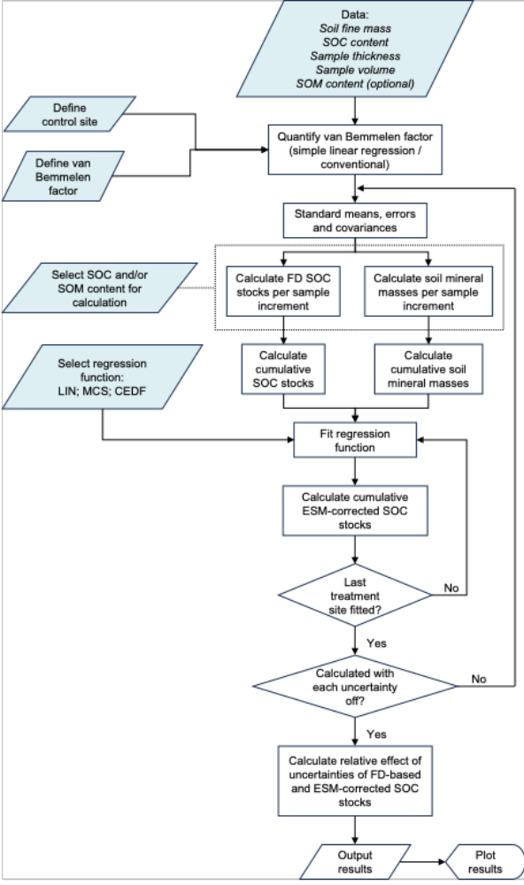
Figure 1. Flow chart of the ESM–CREPE package. Blue icons are user-defined input data. Error propagation analysis is integrated throughout the algorithm.

Usage instructions

- Download the package to your desktop.

The package contains a file and three directories:
- The project file “ESM–CREPE.Rproj”.
- “data” contains supplementary data to test and familiarise how the package works and check it has been correctly configured in your environment.
- “docs” contains relevant documentation about the package.
- “script” contains the project scripts:
  - “install.R” contains the relevant packages and libraries to compile and activate prior to running the package.
  - “functions.R” contains all the functions to execute the ESM correction.
  - “execute.R” is the script for the user to import and format their dataset and define the key input parameters to execute in the ESM correction.
  - “manuscript_doehl2026.R” is a version of the package specifically to reproduce the results published in Döhl et al. (2026).

- Unpack the package in your RStudio working directory.

- Open RStudio on your desktop.

- “Open project…” and select the ESM–CREPE.Rproj.

- “Open file…” and open the scripts provided in the “scripts” directory.

- In the “install.R” script, run the packages to import and activate the libraries required to use the ESM–CREPE package.

- In the “functions.R” script, run all functions provided to import them into your environment.

- In the “execute.R” script, run the provided test dataset and data reformatting function as well as the user inputs. At this point you should familiarise yourself with the inputs provided to run the ESM–CREPE package as a test before using your own dataset.

- Run the “esm_correction_main” function to execute the ESM correction.

Upon successful completion of the calculations:
- The cumulative FD-based and ESM-corrected SOC stocks are exported.
- A visual graph showing the fitted regression function(s) and SOC stocks with respect to cumulative soil mineral mass of the treatment sites and control site are shown.
- A visual graph showing the fitted regression function(s) and soil sample depths with respect to cumulative soil mineral mass of the treatment sites and control site are shown.
- The relative effect of the uncertainties on the propagation error of the FD-based and ESM-corrected SOC stocks are shown.

Note: if the data or input parameters are incorrectly defined, the package will terminate the run. Please check the format before running the ESM correction.

- After the test run, replace the “data_filename” and “data_sheet” with those of your own dataset to import it.

- Reformat the data using the “data_renamer” function.

For this part, give the column index of the following in your dataset:
- Study name
- Site name of study
- Sample increment
- Core
- Sample thickness (cm)
- Fine soil mass (g)
- SOC content (%)
- SOM content (%; optional)
- Sample volume (cm³)
If no SOM content measurements are collected, define the column index as “NA”.

Note: if your data is not in the correct units, convert your values to the given units above.

- Define the user input parameters you want to run.

You can select which soil content and van Bemmelen factor to use. The current code cannot run multiple entries at the same time as the raw input and calculation data frame has different formats that are incompatible.

Define the name of the site used as the ‘control site’ to which all ‘treatment sites’ will be equated and compared to in the ESM correction.

Define which regression function(s) to run, whether one, two or multiple functions will be used.

- Run the “esm_correction_main” function to execute the ESM correction.

- Export your results.

The calculations will be output as a “data_esm_results” list containing the following data frames:
- The results of the FD-based and ESM-corrected SOC stocks.
- The regression function curves.
- The input and calculations.
- Share effect of uncertainties on the FD-based and ESM-corrected SOC stocks.
Users can process the results to their needs.

Where to find help

If you have any questions, recommendations, ideas or other things with regards to the ESM–CREPE package, contact Leonard N. K. Döhl (l.n.k.doehl@leeds.ac.uk). If you are interested in discussions and potential collaboration, get in touch.

Details on contributors

Leonard N. K. Döhl
Faculty of Environment and Social Sciences
School of Geography
University of Leeds
Leeds LS2 9JT
United Kingdom

Sofia Biffi
Århus Institut for Agroøkologi
Århus Universitet
8830 Tjele
Denmark

Helaina I. J. Black
The James Hutton Institute
Invergowrie
Dundee DD2 5DA
United Kingdom

Agricarbon UK Limited
Muirloch Farm
Liff
Dundee DD2 5NQ

Pippa J. Chapman
Faculty of Environment and Social Sciences
School of Geography
University of Leeds
Leeds LS2 9JT
United Kingdom

Guy Ziv
Faculty of Environment and Social Sciences
School of Geography
University of Leeds
Leeds LS2 9JT
United Kingdom

