I400/B457 Midterm Exam (samples)

1. Provide 2-D 4-by-3 array g[x,y] and 3-by-3 array h[u,v] that satisfies the following equations respectively. Assume the boundary condition with zero paddings (i.e., the values outside the array boundary are all 0).
[ a b c d  e f g h  i j k l ] | * | [ 0 0 0  0 1 0  0 0 0 ] | = | g[x, y]

2. Gradients

- Provide the basic x-gradient and y-gradient filters (2-by-1 arrays) for the convolution filtering.
x-gradient:
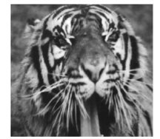 | * | ? | = | 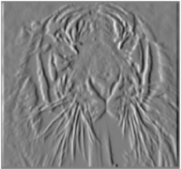

y-gradient:
 | * | ? | = | 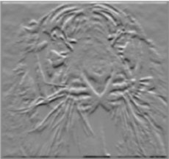

- Try to illustrate (draw) how would look like, based on the 1-D signals below. You may find it easier to visualize the answer in terms of cross correlation, and then adapt your answer given the relationship between convolution and cross-correlation.
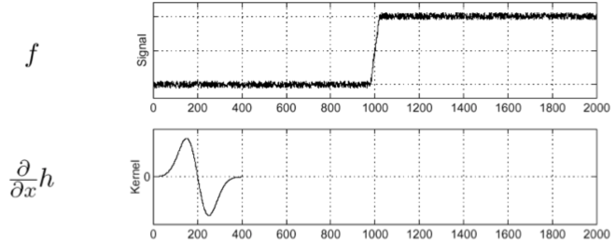
Here, is the Gaussian filter convolved with a gradient filter.

3. Seam Carving is a content-aware resizing algorithm. Consider the computation of the vertical seams, to reduce the width of the image. At every iteration, it computes “cumulative minimum energy” for all pixel location, which indicates the minimum amount of energy required to get to (i, j) from the top row. Let the cumulative minimum energy at (i,j) be denoted as M(i,j). Let the energy (i.e., the gradient magnitude) at (i,j) be denoted as R(i,j). Two pixels are considered as ‘connected’ only when one pixel is within 8-connected neighbor of the other.

- Provide a recursive equation to compute M(i, j).

4. Segmentation

- What are the main disadvantages of using k-means as a clustering algorithm for scene segmentation?

5. Hough voting

- Let us consider the problem of fitting a line to a set of points in a given image. We can describe a line with the equation . This means that we can do the voting in the parameter space of (m, b) to fit a line based on observations in image space (x,y). However, we used the equation instead. Why is this?

- Now let us consider the circle fitting. How many parameters do we need to model a circle?

- Try to visualize (draw) the Hough space for the circle fitting. Try to illustrate the points on the parameter space each (x,y) point in the image will correspond to.
Ans:

