**Target browser is Internet Explorer 11.**

**Please resolve any 2 tasks of 3.**

Task1

1. Edit Appointments And Encounters.html page (from attached zip archive) to distribute "X" links vertically with equal spaces from top and bottom of the line.

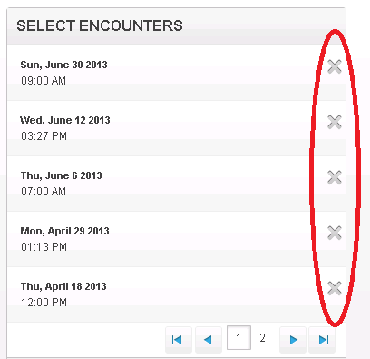

Task2

1. Open Appointments And Encounters.html page(from attached zip archive)

2. Date region in Select Encounters has "hand" pointer (marked with "1" in screenshot).

3. The rest of the line has "arrow" pointer (marked with "2" in screenshot)

4. Edit Appointments And Encounters.html page such way so the whole line has "hand" pointer and functions as link (the same behavior as date region currently has)

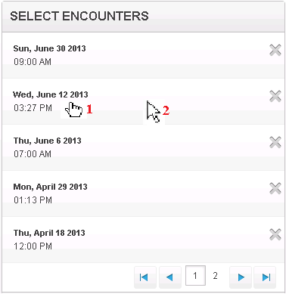

Task3

1. Make the sample page that has the following layout (first and third blocks changes their width when browser resize, the second block has fixed width)

