**CS4400 Database Project**

**GTPort**

**Phase II**

**Team Members:**

**Lin Dong**

**ldong247**

[**ldong247@gatech.edu**](mailto:ldong247@gatech.edu)

**Section A**

**Stephen Gadd**

**sgadd3**

[**sgadd3@gatech.edu**](mailto:sgadd3@gatech.edu)

**Section A**

**Nikhil Nandish**

**nnandish3**

[**nnandish3@gatech.edu**](mailto:nnandish3@gatech.edu)

**Section B**

**Linshu Wuliu**

**lwuliu3**

[**lwuliu3@gatech.edu**](mailto:lwuliu3@gatech.edu)

**Section C**

1. EER Diagram

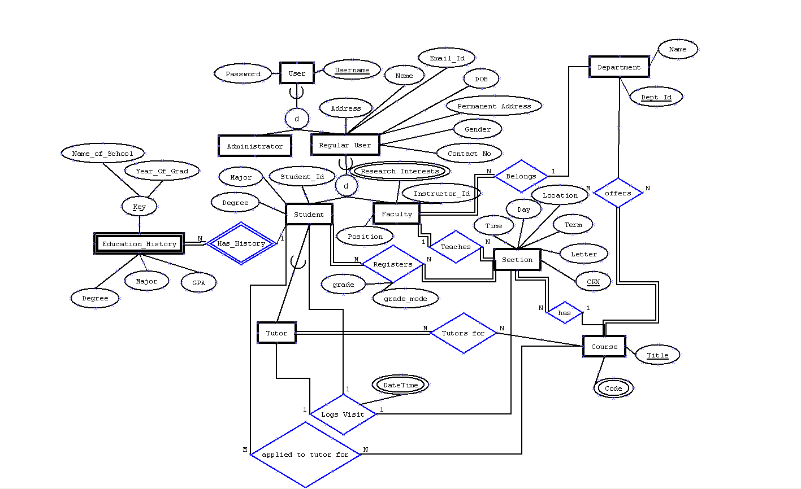

1. Information Flow Diagram

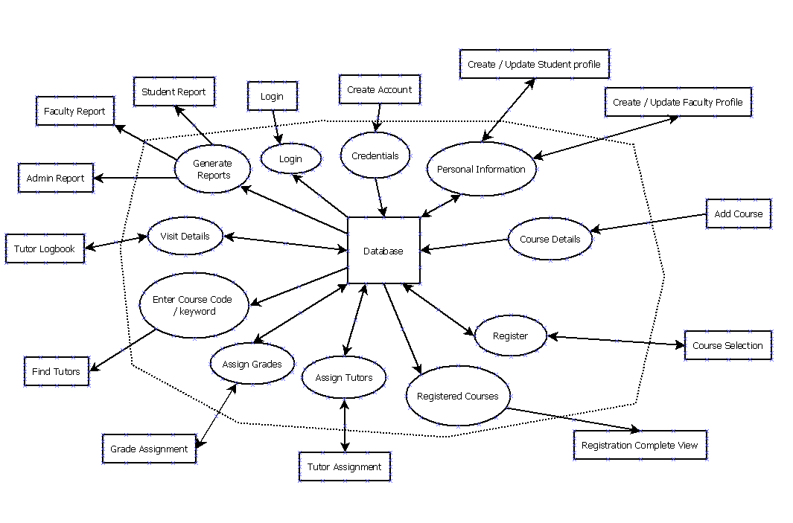

1. Task Decomposition Diagram

.

1. Relational Schema Diagram

User

|  |  |
| --- | --- |
| Username | Password |

Administrator

|  |
| --- |
| Username |

Regular_User

|  |  |  |  |  |  |  |  |
| --- | --- | --- | --- | --- | --- | --- | --- |
| Username | Address | Name | Email_Id | DOB | Permanent_Address | Gender | Contact_No |

Student

|  |  |  |  |
| --- | --- | --- | --- |
| Username | Student_Id | Major | Degree |

Education_History

|  |  |  |  |  |  |
| --- | --- | --- | --- | --- | --- |
| Username | Year_Of_Grad | Name_Of_School | Major | Degree | GPA |

Tutor

|  |
| --- |
| Username |

Department

|  |  |
| --- | --- |
| Dept_Id | Name |

Faculty

|  |  |  |  |
| --- | --- | --- | --- |
| Username | Instructor_Id | Position | Dept_Id |

Research_Interests

|  |  |
| --- | --- |
| Username | Interest |

Course

|  |
| --- |
| Title |

Code

|  |  |
| --- | --- |
| Title | Code |

Section

|  |  |  |  |  |  |  |  |
| --- | --- | --- | --- | --- | --- | --- | --- |
| CRN | Term | Letter | Location | Day | Time | Instructor_Username | Title |

Applied_To_Tutor_For

|  |  |
| --- | --- |
| Username | Title |

Tutors_For

|  |  |
| --- | --- |
| Username | Title |

Logs_Visit

|  |  |  |  |
| --- | --- | --- | --- |
| Student | Tutor | CRN | DateTime |

Registers

|  |  |  |  |
| --- | --- | --- | --- |
| Username | CRN | Grade | Grade_Mode |

Department_Offers_Course

|  |  |
| --- | --- |
| Dept_Id | Title |

1. Create Table statements

CREATE TABLE User

(Username VARCHAR(16) NOT NULL,

Password VARCHAR(16) NOT NULL,

PRIMARY KEY (Username));

CREATE TABLE Administrator

(Username VARCHAR(16) NOT NULL,

PRIMARY KEY (Username)

FOREIGN KEY (Username) REFERENCES User(Username),

ON DELTE CASCADE ON UPDATE CASCADE);

CREATE TABLE Regular_User

(Username VARCHAR(16) NOT NULL,

Address VARCHAR(30) NOT NULL,

Name VARCHAR(20) NOT NULL,

Email_Id VARCHAR(30) NOT NULL,

DOB DATE NOT NULL,

Permanent_Address VARCHAR(30) NOT NULL,

Gender CHAR(1) NOT NULL,

Contact_No INT NOT NULL,

PRIMARY KEY (Username),

UNIQUE (Email_Id),

FOREIGN KEY (Username) REFERENCES User(Username),

ON DELETE CASCADE ON UPDATE CASCADE);

CREATE TABLE Student

(Username VARCHAR(16) NOT NULL,

Student_Id INT NOT NULL AUTO_INCREMENT,

Major VARCHAR(33) NOT NULL,

Degree VARCHAR(4) NOT NULL,

PRIMARY KEY (Username),

UNIQUE (Student_Id),

FOREIGN KEY (Username) REFERENCES Regular_User(Username),

ON DELETE CASCADE ON UPDATE CASCADE);

CREATE TABLE Tutor

(Username VARCHAR(16) NOT NULL,

PRIMARY KEY (Username),

FOREIGN KEY (Username) REFERENCES Student(Username),

ON DELETE CASCADE ON UPDATE CASCADE);

CREATE TABLE Education_History

(Username VARCHAR(16) NOT NULL,

Year_Of_Grad INT NOT NULL,

Name_Of_School VARCHAR(40) NOT NULL,

Major VARCHAR(33) NOT NULL,

Degree VARCHAR(4) NOT NULL,

GPA DEC(2,1) NOT NULL,

PRIMARY KEY (Username, Year_Of_Grad, Name_Of_School),

FOREIGN KEY (Username) REFERENCES Student(Username),

ON DELETE CASCADE ON UPDATE CASCADE);

CREATE TABLE Department

(Dept_Id INT NOT NULL AUTO_INCREMENT,

Name VARCHAR(33) NOT NULL,

PRIMARY KEY (Dept_Id));

CREATE TABLE Faculty

(Username VARCHAR(16) NOT NULL,

Instructor_Id INT NOT NULL AUTO_INCREMENT,

Position VARCHAR(19) NOT NULL,

Dept_Id INT NOT NULL,

PRIMARY KEY (Username),

UNIQUE (Instructor_Id),

FOREIGN KEY (Username) REFERENCES Regular_User(Username),

ON DELETE CASCADE ON UPDATE CASCADE,

FOREIGN KEY (Dept_Id) REFERENCES Department(Dept_Id),

ON DELETE CASCADE ON UPDATE CASCADE);

CREATE TABLE Research_Interests

(Username VARCHAR(16) NOT NULL,

Interest VARCHAR(20) NOT NULL,

PRIMARY KEY (Username, Interest),

FOREIGN KEY (Username) REFERENCES Faculty(Username),

ON DELETE CASCADE ON UPDATE CASCADE);

CREATE TABLE Course

(Title VARCHAR(30) NOT NULL,

PRIMARY KEY (Tiltle));

CREATE TABLE CCode

(Title VARCHAR(30) NOT NULL,

Code VARCHAR(9) NOT NULL,

PRIMARY KEY(Title, Code),

FOREIGN KEY (Title) REFERENCES Course(Title),

ON DELETE CASCADE ON UPDATE CASCADE);

CREATE TABLE Section

(CRN INT NOT NULL AUTO_INCREMENT,

Letter CHAR(1) NOT NULL,

Term VARCHAR(6) NOT NULL,

Building CHAR(4) NOTL NULL,

Location VARCHAR(9) NOT NULL,

Time VARCHAR(19) NOT NULL,

Instructor_Username VARCHAR(16) NOT NULL,

Title VARCHAR(30) NOT NULL,

PRIMARY KEY (CRN),

FOREIGN KEY (Instructor_Username) REFERENCES Faculty(Username),

ON DELETE CASCADE ON UPDATE CASCADE);

FOREIGN KEY (Title) REFERENCES Course(Title),

ON DELETE CASCADE ON UPDATE CASCADE);

CREATE TABLE Applied_To_Tutor_For

(Username VARCHAR(16) NOT NULL,

Title VARCHAR(30) NOT NULL,

PRIMARY KEY (Username, Title),

FOREIGN KEY (Username) REFERENCES Student(Username),

ON DELETE CASCADE ON UPDATE CASCADE,

FOREIGN KEY (Title) REFERENCES Course(Title),

ON DELETE CASCADE ON UPDATE CASCADE);

CREATE TABLE Logs_Visit

(Tutor VARCHAR(16) NOT NULL,

Student VARCHAR(16) NOT NULL,

CRN INT NOT NULL,

DateTime TIMESTAMP NOT NULL,

PRIMARY KEY (Student, Tutor, CRN, DateTime),

FOREIGN KEY (Student) REFERENCES Student(Username),

ON DELETE CASCADE ON UPDATE CASCADE,

FOREIGN KEY (Tutor) REFERENCES Tutor(Username),

ON DELETE CASCADE ON UPDATE CASCADE,

FOREIGN KEY (CRN) REFERENCES Section(CRN),

ON DELETE CASCADE ON UPDATE CASCADE);

CREATE TABLE Tutors_For

(Username VARCHAR(16) NOT NULL,

Title VARCHAR(30) NOT NULL,

PRIMARY KEY (Username, Title),

FOREIGN KEY (Username) REFERENCES Tutor(Username),

ON DELETE CASCADE ON UPDATE CASCADE,

FOREIGN KEY (Title) REFERENCES Course(Title),

ON DELETE CASCADE ON UPDATE CASCADE);

CREATE TABLE Registers

(Username VARCHAR(16) NOT NULL,

Grade CHAR(1),

Grade_Mode VARCHAR(10) NOT NULL,

CRN INT NOT NULL,

PRIMARY KEY (Username, CRN),

FOREIGN KEY (Username) REFERENCES Student(Username),

ON DELETE CASCADE ON UPDATE CASCADE,

FOREIGN KEY (CRN) REFERENCES Section(CRN),

ON DELETE CASCADE ON UPDATE CASCADE);

CREATE TABLE Department_Offers_Course

(Dept_Id INT NOT NULL,

Title VARCHAR(30) NOT NULL,

PRIMARY KEY (Dept_Id, Title, Code),

FOREIGN KEY (Dept_Id) REFERENCES Department(Dept_Id),

ON DELETE CASCADE ON UPDATE CASCADE,

FOREIGN KEY (Title, Code) REFERENCES CCode(Title, Code),

ON DELETE CASCADE ON UPDATE CASCADE);

1. SQL statements for each task