Validation of SISVAT on ETH Camp
Hubert Gallée
Here are briefly reported the results of SISVAT at ETH camp after writing a new dynamical vertical discretisation of the snow model.
Variable dzepsi contains the minimum thickness of a single snow layer while dzmmin contains the minimum thickness of any snow layer.

dzepsi | dzmmin | 1990 | 1990 | 1991 | 1991
 |  | BIAS | RMSE | BIAS | RMSE
1.0 | 1.0 | 1,67 | 7,63 | -0,94 | 4,38
1.5 | 1.5 | 1,45 | 7,3 | -0,42 | 3,97
2.0 | 2.0 | 0,89 | 7,21 | -0,47 | 4,01
2.5 | 2.5 | 0,49 | 7,21 | -1,66 | 7,48
Table 1. Performances of SISVAT at ETH camp: Albedo

dzepsi | dzmmin | 1990 | 1990 | 1991 | 1991
 |  | BIAS | RMSE | BIAS | RMSE
1.0 | 1.0 | 1,45 | 12,38 | -13,19 | 15,33
1.5 | 1.5 | 0,49 | 11,57 | -13,35 | 15,49
2.0 | 2.0 | -0,42 | 10,63 | -13,8 | 15,94
2.5 | 2.5 | -1,58 | 9,75 | -14,44 | 16,63
Table 2. Performances of SISVAT at ETH camp: Snow Height

dzepsi | dzmmin | 1990 | 1990 | 1991 | 1991
 |  | BIAS | RMSE | BIAS | RMSE
1.0 | 1.0 | 5,71 | 13,54 | -1,36 | 7,59
1.5 | 1.5 | 4,58 | 12,36 | -1,15 | 7,87
2.0 | 2.0 | 3,59 | 11,04 | -1,36 | 7,8
2.5 | 2.5 | 2,25 | 9,62 | -2,27 | 7,77
Table 3. Performances of SISVAT at ETH camp: Surface Mass Balance

Basing on tables 1, 2 and 3 it appears that (dzepsi, dzmmin) = (2.5, 2.5) mm is not acceptable as far as albedo is concerned (see year 1991), that the simulated height is acceptable for (dzepsi, dzmmin) = (1.5, 1.5) mm and (2.0, 2.0) mm (see year 1990) while (dzepsi, dzmmin) = (2.5, 2.5) mm provides a good BIAS and RMSE for the simulated surface mass balance in 1990. Performances for (dzepsi, dzmmin) = (2.5, 2.5) mm seem contradictory when looking at both albedo and surface mass balance. We choose (dzepsi, dzmmin) = (2.0, 2.0) mm which ensures a best stability than (dzepsi, dzmmin) = (1.5, 1.5) mm.

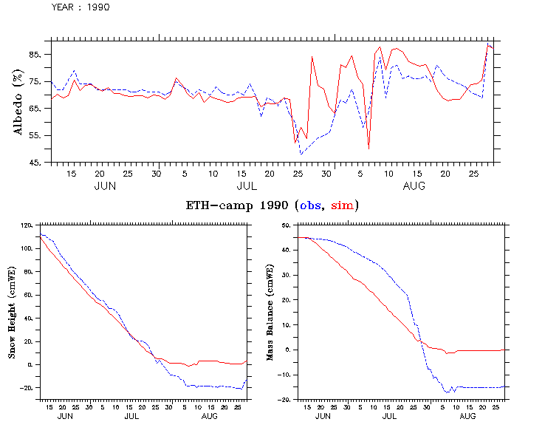

Figure 1. Snow model performances at ETH camp for (dzepsi, dzmmin) = (1.5, 1.5) mm

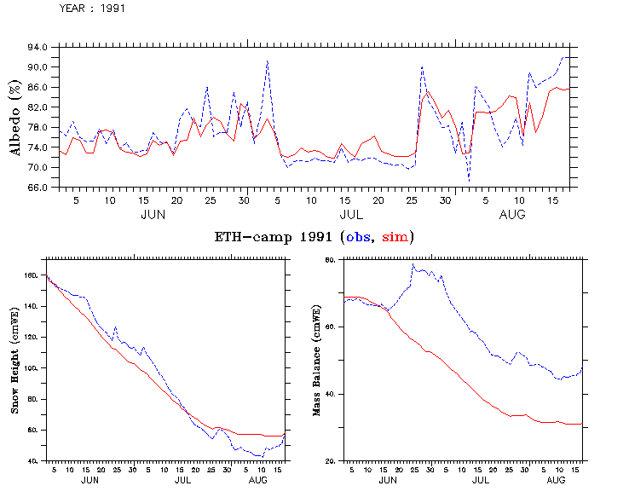
Figure 2. Snow model performances at ETH camp for (dzepsi, dzmmin) = (1.5, 1.5) mm

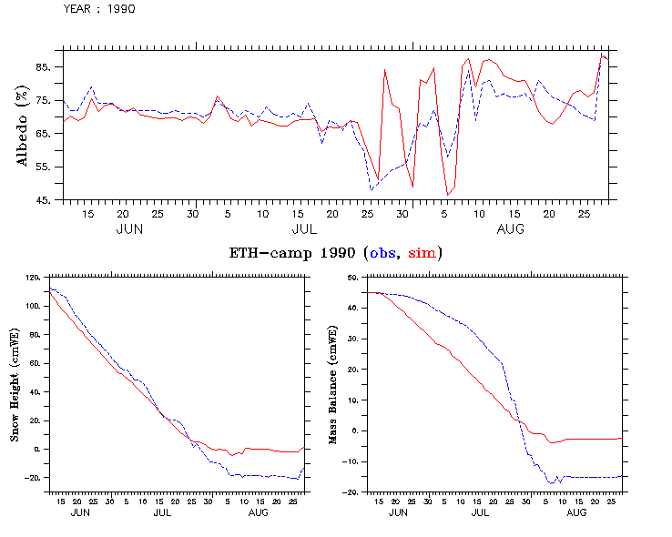

Figure 3. Snow model performances at ETH camp for (dzepsi, dzmmin) = (2.0, 2.0) mm

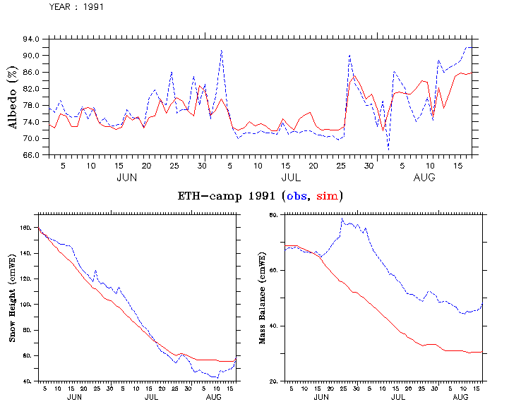

Figure 4. Snow model performances at ETH camp for (dzepsi, dzmmin) = (2.0, 2.0) mm

Remark, 5 july 2009: correction is performed by including the contribution of the turbulent fluxes. Also a height correction of wind speed and temperature measurements was previously included, in order to take into account the increasing distance between the level of measurements and the surface due to strong melting. This correction has been modified so that to avoid the destabilisation of the numerical scheme when the Monin-Obukhov length is small (in case of a strong stability/instability – see routine ECSVAT.f).
A stronger simulated melting results, especially in 1991, which leads to a new tuning of the snow model. After concluding that the model in not sensitive to modifications of (dzepsi, dzmmin) = (2.0, 2.0), the maximum thickness of a layer (dz_max) is increased from 0.08 to 0.1, giving again acceptable results (see figures 5 / 6 before / after icreasing dz_max.

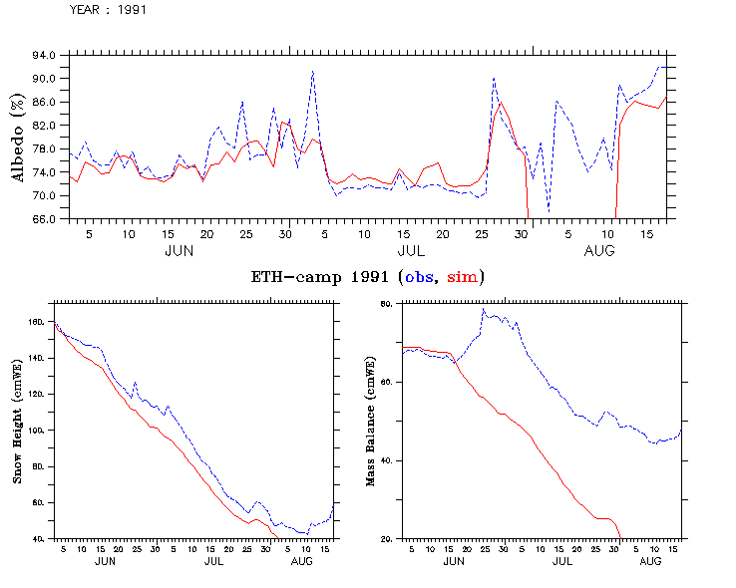
Figure 5. Snow model performances at ETH camp after including turbulent heat fluxes, for (dzepsi, dzmmin) = (2.0, 2.0) mm, before the tuning of dz_max (here 0.08 m)

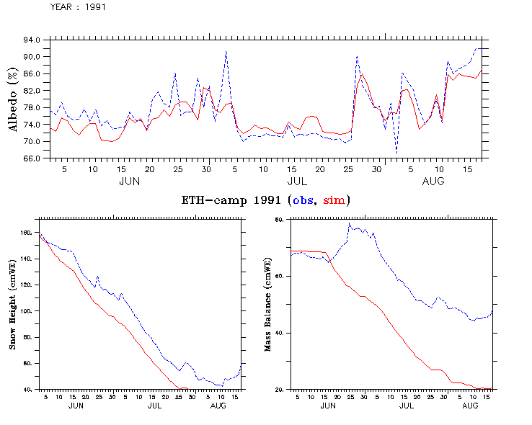
Figure 6. Snow model performances at ETH camp after including turbulent heat fluxes, for (dzepsi, dzmmin) = (2.0, 2.0) mm, after the tuning of dz_max (here 0.10 m)

