Response to Reviewer 3 Comments

The manuscript is an interesting work related to a potential new therapy of hepatocellular carcinoma (HCC) by using TTFields in combination with a TKI (Sorafenib). However, the limited experimental design and paucity of strong data ask for more experiments to proof the feasibility of this combination for treating HCC.

**Point 1:** In vitro experiments sub-section in Methods sections lacks many experimental details (e.g., type of plate/flask, plating overnight or not before experiment, number of plated cells). A very important missing is not showing the actual number of rats included in the final analyses (the ones who successfully received therapy for more than 18 hours/day). This must be added.

**Response 1**: We thank the reviewer for this comment. For the in vitro experiments with TTFields (sub-section 2.3) we tried not to elaborate too much and referenced previous work describing all details. We understand that we have cut off too many details, and are happy to add them “HepG2 and Huh-7D12 cell suspensions (500 µl, 25 x 103 cells/plate) were placed as a drop in the center of 35-mm inovitro™ dishes composed of high dielectric constant ceramic (lead magnesium niobate–lead titanate [PMN-PT]), with two perpendicularly pairs of transducer arrays printed on their outer walls. Cells were incubated overnight at 37 °C to allow attachment to the dish, and then 2 ml of fresh media were added.”

Regarding the number of rats included in the final analysis, we apologize this information was not clear. The 52 rats mentioned in the text were in fact the actual final number of animals in the analysis, since “all rats reached the required usage limit of ≥18 h/day”, as is now explicitly stated in the results sub-section 3.4.”

**Point 2:** What is puzzling in this investigation is showing functional data using two human cell lines and in vivo data using rat cells. While I do not know if the authors have the technology to perform TTFields in mice, where for sure they should have done xenograft models with the two human cell lines, why the rat cell line was not studied in vitro using the same experimental strategies as for human cells. This must be done and included for a better understanding of TTFields activity from in vitro to in vivo data. What are the p53 status and the apoptosis signaling pathway function in N1S1 cells? Maybe the cytotoxicity data will reveal a different better frequency.

**Response 2**: We thank the reviewer for raising this important issue. Using a xerograph model is indeed a good suggestion, however it would require working in immunosuppressed mice. It is currently not feasible for us to perform studies in which we apply TTFields to immunosuppressed animals, as these animals are of smaller weight thus the burden of wearing the electrodes may induce too much stress. Furthermore, these animals are more prone to contract infections during the process of electrodes placement and replacement on the animals. On the other hand, using the rat cells for in vitro experiments in the inovitro dishes turned out to be very technically challenging, as the cells were non-adherent, and so we could not pursue this important avenue. Nevertheless, we agree with the reviewer that there is a possibility that the optimal frequency may differ in the N1S1 relative to the human cell lines. Therefore, we have addressed this issue by including results of an additional frequency scan experiments done with N1S1 cells. We now mention this in the text, results sub-section 3.4: “The efficacy of combining TTFields with sorafenib relative to each modality alone was examined in the N1S1 HCC rat orthotopic model (timeline in Figure 4a). In vitro experiments confirmed that the 150 kHz TTFields frequency found optimal for treatment of the human cell lines was also optimal for treatment of the murine N1S1 cells used for the in vivo study (Figure S2).” We provide the relevant frequency scan figure in the supplementary material. Per the good question by the reviewer regarding the p53 status of the N1S1 cells we added: “It is also worth mentioning that the N1S1 murine cells used for this study, like the HepG2 cells, are p53 wild type.”



**Figure S2.** TTFields frequency scan in rat N1S1 HCC cells. N1S1 cells were treated with TTFields (1.7 V/cm RMS) across a frequency range of 100–400 kHz, and cell count were determined following 24 hours of treatment. Values are mean (N ≥ 3) ± SEM. *p < 0.05 relative to control; one-way ANOVA. ANOVA = analysis of variance; HCC = hepatocellular carcinoma; RMS = root mean square; SEM = standard error of the mean; TTFields = Tumor Treating Fields.

**Point 3:** Another puzzling experiment is the schedule for the in vivo work. Since the authors missed to add Figure 4A for timeline, based on Methods section the rats were treated for 5 days with TTFields and or sorafenib and a day later the rats were sacrificed. While a short “acute” follow-up is welcome the most important experiment should allow the follow-up for much more days to indeed observe the effect of TTFields added to sorafenib. I could not find an explanation for not including a long term follow-up. In my opinion, this is a key therapeutically experiment which must be done and included in the study.

**Response 3**: We thank the reviewer for this comment, and apologize that the illustration of the timeline was accidentally missing from the submission (we have now added it). The limiting factor for study duration was the well being of the animals. The tumors in the control group were very large, causing stress and weight loss of the animals. The arrays placed on the animals, together with the individual housing needed to prevent wire entanglement, adds even more stress and increases animal weight loss. Overall, it was non-ethical to continue the study further. We have now added this explanation to the discussion section to clarify this limitation of the study: “In the HCC animal model, the acute effects of TTFields and sorafenib were examined. Due to the large tumors developed in the control group and the stress experienced by the animals as a result of the individual housing and motility limitations imposed by the sham and TTFields arrays, longer treatment durations were not feasible.”

**Point 4:** There is no explanation why the most effective dose was 150 kHz and higher does actually decreases the killing. Can this dose observed in vitro on only tumor cells be translated to in vivo work where the tumor microenvironment is totally different?

**Response 4**: We thank the reviewer for this question. It is important to understand that the TTFields frequency is not the treatment dose, and hence increased frequency does not mean increased efficacy. In the case of TTFields, intensity, duration, and usage are the factors that contribute to the “treatment dose”. Nevertheless, we have added to the discussion an explanation on this issue of optimal frequency: “It has been previously shown that maximal effectivity of TTFields occurs at a different frequency for different cancer types, owing to the specific electrical properties of the cells [15, 28]. Hence, the first step in applying TTFields to a new tumor type includes frequency scans.”

Regarding the option that the optimal frequency will differ between in vitro and in vivo setting, this is indeed a concern. However, as shown by the in vitro frequency scans, the effect of TTFields is not dichotomic, and effectiveness can be seen at more than one frequency. Therefore, the relatively low expected differences between animals treated with different TTFields frequencies together with the variability inherent to animal studies, makes it technically problematic to perform frequency scans in vivo. As of today, in vitro frequency scans are the common practice for determining the optimal TTFields frequency for delivery to animals and to humans. In fact, in vitro frequency scans were the basis for the clinical studies leading to FDA approval of TTFields at 200 kHz for the treatment of GBM and at 150 kHz for the treatment of MPM. We have added this issue to the discussion as a limitation of the study: “Since the optimal TTFields frequency has been shown to be dependent on the electrical properties of the cells and it is not clear how much effect the tumor microenvironment has on these properties, and because it is technically problematic to perform TTFields frequency scans *in vivo*, the frequency detected in the cell cultures was also employed for the animal studies.”

**Point 5:** Why the in vitro experiment was performed for 72 hours and in in vivo for 120 hours?

**Response 5**: We thank the reviewer for this question. When it comes to testing efficacy, we would like to use a treatment duration as long as possible to maximize the effect. However, this duration varies between in vitro and in vivo work.

For cell cultures, the control samples continue to grow throughout the treatment duration, and so after 72 h the plates are very much confluent, and may not be left to continue and grow any further (without drastic changes in the environmental conditions, making them inadequate control cells). It is also noteworthy that such treatment periods for in vitro work are well accepted in the field of TTFields research.

In vivo, prior studies also used similar time frames of 2 to 3 weeks from inoculation when working with the N1S1 model (Buijs et al., 2012 -; Ju et al., 2009; Thompson et al., 2012). Extending treatment duration was also limited by the physical status of the animals, as was explained in response 3.

**Point 6:** Any explanation for why not using cloroquine in vivo to integrate better the in vitro data.

**Response 6**: We thank the reviewer for this question. Chloroquine was added to the cell cultures only at the final hours of the treatment for answering questions related to the mechanism of action, and not for boosting the efficacy of the other treatments. When using chloroquine in animal studies, it is for efficacy purposes, and so it is used throughout the treatment period. Since our animal experiment aimed to examine the efficacy of concomitant TTFields and sorafenib, with no additional agents, chloroquine was not employed.

**Point 7:** The authors claim that cytotoxicity was measured “by cell counting using iCyt EC800 (Sony Biotechnology) 123 flow cytometer, and expressed as a percentage relative to the control.” Does this imply that they counted the live cells and plotted the final data as percentage of untreated controls (as figure 1 suggests). However, is this a real cytotoxicity or a cell growth inhibition? Did they measure the adherent cells after trypsinization. Were the cells from supernatant counted (where are probably the majority of dead cells)? There is a big difference between a therapy which kills vs a therapy which induces a cellular arrest.

**Response 7**: We thank the reviewer for this question. For the cytotoxicity assay we remove the supernatant, washed the cells, and then collect the adherent cells following trypsinization and visual inspection to verify all cells were removed. Indeed, as the reviewer mentioned correctly, we “counted the live cells and plotted the final data as percentage of untreated controls”. We agree that this is not cytotoxicity per se, and that is why we also perform 7-AAD/annexin-V staining of the cells. For this apoptosis assay we do collect the supernatant together with the adherent cells. Increased apoptosis and/or necrosis indicates that reduction in the cell number observed in the cell count emanates at least in part from cytotoxicity. We agree with the reviewer that we should not confuse the cell count measurements with the term “cytotoxicity” prior to showing the effect on apoptosis, and therefore we have changed this terminology throughout the paper.

**Point 8:** Since sorafenib acts also on angiogenesis, did the authors investigate if TTFields may interfere with anti-angiogenic effect sorafenib-mediated? Also, is there any evidence that TTF may prevent the pretty common resistance to sorafenib observed in clinic? Moreover, there is a discrepancy between the fold changes in tumor weight vs. volume in the combination group vs. untreated group. Did the authors check changes in blood vessels density. Were the mice perfused before collecting the tumors?

**Response 8**: We thank the reviewer for these questions. Preliminary tests using CD31 staining revealed no differences between the groups regarding blood vessel density and therefore we did not pursue the research in that direction. We agree that measuring the effect of TTFields on the anti-angiogenic effect of sorafenib and on resistance to sorafenib are interesting, these topics were however not within the scope of the current study, and remain for future investigations.

Regarding possible discrepancy between the volume fold change and tumor weight, please see below a graph showing tumor volume (as measured by MRI) versus tumor weight, both measured at the end of the study. The graph shows very good correlation between the two parameters, indicating the reliability of the measurements. If the reviewer feels there is discrepancy, it may be due to the volume shown as fold change relative to the initial tumor volume and not as the end value.

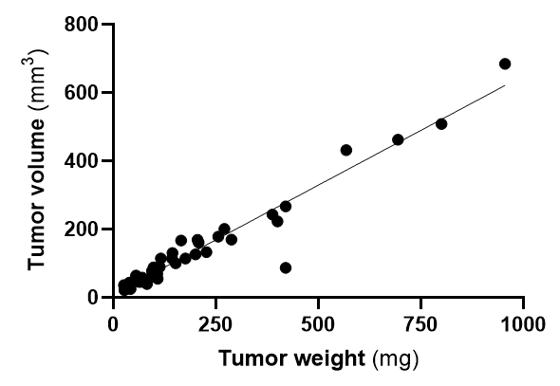

**Point 9:** Was Mycoplasma testing done routinely? Were the cells checked also for authenticity?

**Response 9**: We routinely examine our cells for Mycoplasma. Regarding authenticity, the cells were used shortly after purchase, and so there was no need to examine this.

**Point 10:** Is there any explanation why the combination of TTFields and sorafenib did not induce a significant level of autophagy as compared to untreated animals which invalid the initial hypothesis that “concomitant application of sorafenib and TTFields may increase stress levels enough to tilt autophagy towards the cell death pathway”.

**Response 10**: We appreciate this question. Autophagy is a process that is elevated in order to cope with cellular stress, but as stress level elevate, autophagy can no longer provide the protection the cell needs, and the cell will undergo apoptosis. This kind of kinetics means that the levels of autophagy markers will depend on the time point the cells are examined. This may be appreciated from figure 2 panel c and d, with the different kinetics displayed by the two cell lines. While for Huh-7D12 autophagy levels increase from 24 to 48 hours of treatment, in the HepG2 cells autophagy levels at 48 hours are lower than at 24 hours, indicating these cells are already after the autophagy peak and on the way to apoptosis. Indeed, figure 1d shows higher levels of apoptosis for HepG2 cells. To clarify we have added a few sentences to the text. In results sub-section 3.2: “However, autophagy kinetics seems to be faster in the HepG2 cells, in which LC3 markers are lower at 48 versus 24 hours, whereas elevation is seen from 24 to 48 hours for the Huh-7D12 cells.” In the discussion “While autophagy serves as a survival strategy of cells, when stress levels continue raising it may be over-activated and mediate cell death [9]. The faster autophagy kinetics seen for the HepG2 relative to Huh-7D12 cells following application of TTFields is in agreement with the higher apoptosis levels displayed by this cell line, and may serve as an additional rational for the higher efficacy of TTFields against it. Examination of the reasons for faster autophagy in HepG2 relative to Huh-7D12 cells is out of the scope of this work.”

For more clarity we have also added a more in-depth kinetic study, including additional relevant markers and additional time points, examinations that were performed for the combined treatment as compared to TTFields and sorafenib alone. We thank the reviewer for this comment, as these additions add much clarity to the mechanism of action of TTFields in combination with sorafenib and provide a more coherent explanation for the in vivo results. These additions may be seen in Figure 3 and are described in results sub-section 3.4, Autophagy-apoptosis Interplay For Treatment with Concomitant TTFields and Sorafenib: “In order to investigate the mechanism of action of TTFields-sorafenib co-application, HepG2 and Huh-7D12 cells were treated for 6, 24, or 48 hours with TTFields, sorafenib (3µM), or the two modalities together, and then examined for expression levels of various proteins. For HepG2 cells, the autophagy marker beclin-1 demonstrated elevation after 6 hours of treatment, which was later replaced with diminished expression levels (Figure 3d). This type of behavior was seen in all treatment groups, but was most pronounced for TTFields-sorafenib co-application. The autophagy marker LC3 also displayed such bi-phasic characteristics, but with a somewhat slower kinetics, showing some elevation at 6 hours of treatment, but higher elevation at the 24 hours time point (Figure 3d). As in the case of beclin-1, the magnitude of the effect was higher for co-treatment of TTFields and sorafenib relative to the monotherapies. GRP78, a marker of ER stress, remained low in all treatment groups for 6 and 24 hours of treatment, but demonstrated elevated levels at the later, 48-hours time point (Figure 3e). The apoptosis marker cleaved PARP displayed increased expression in the combined group already after 24 hours, elevating even further after 48 hours of treatment. For the monotherapies, cleaved PARP increase was only evident at 48 hours of treatment, and to a lower extent than that in the co-treatment group (Figure 3f). The slower kinetics of the autophagy-apoptosis path in the Huh-7D12 cells, as seen from the elevation of LC3 after as much as 48 hours (Figure 2c and d), prevented from detecting such changes in the levels of these markers in this cell line (Figure S1).”And in the discussion part “Kinetic examination in the HepG2 cells revealed elevation in autophagy levels as early as 6 hours of TTFields or sorafenib treatment, which diminished and were replaced with ER stress and apoptosis for 48 hours of treatment. These results are in line with a previous study that focused on the effects of sorafenib on such markers in HepG2 cells [32]. The higher changes in expression levels and faster kinetics when TTFields and sorafenib were applied together rather than alone indicate higher stress levels imposed on the cells in the former case”

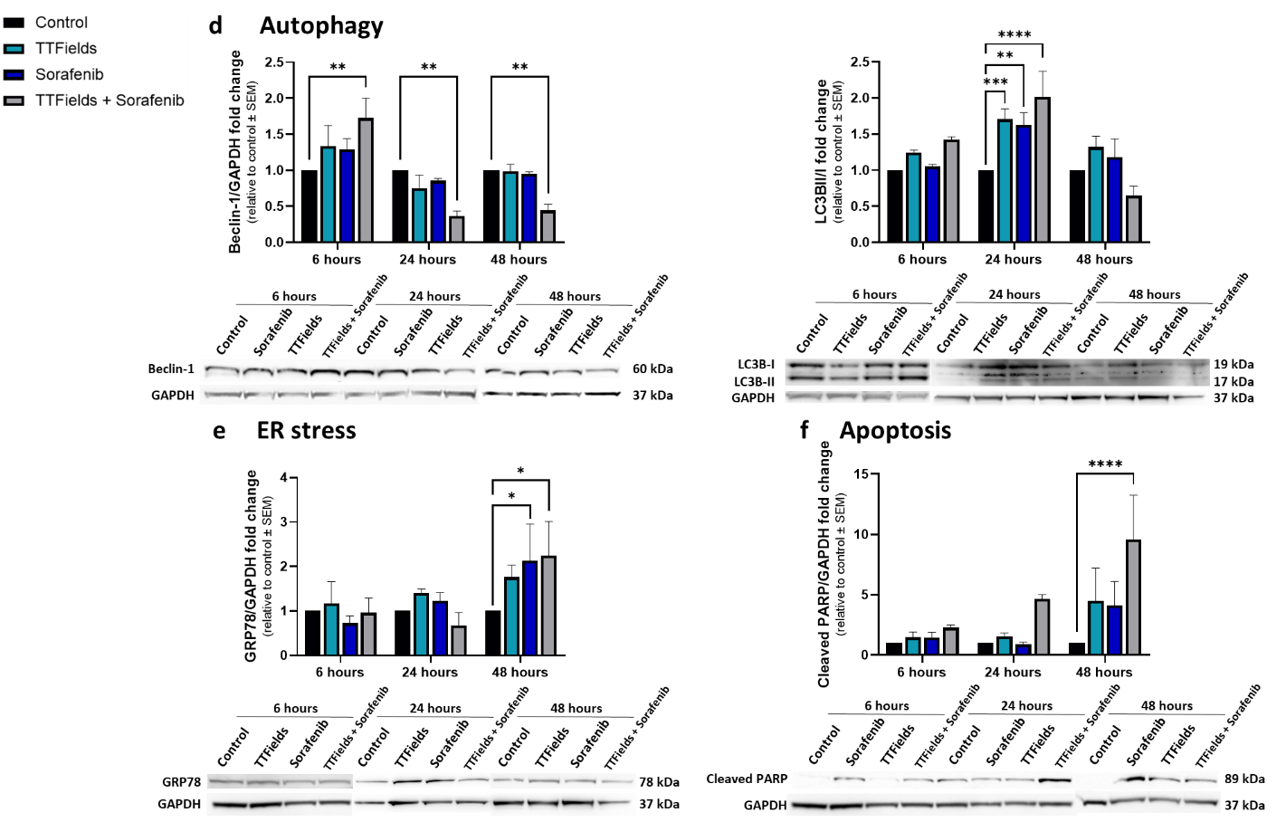

**Figure 3.** HepG2 cells were treated for 6, 24, or 48 hours with 150 kHz TTFields, 3 µM sorafenib, or the two treatments combined, followed by Western blot examination of the autophagy markers beclin-1 and LC3 (d), the ER stress marker GRP78 (e), and the apoptosis marker cleaved PARP (f). Values are mean (*N* ≥ 3) ± SEM. \**p* < 0.05, \*\**p* < 0.01, \*\*\**p* < 0.001, and \*\*\*\**p* < 0.0001 relative to time-respective control; two-way ANOVA.

In the animal study we may only measure one time point. The lower autophagy seen at this time for the combined treatment together with the higher apoptosis indicate that we are further along the kinetic timeline of autophagy relative to the monotherapies, suggesting higher stress in animals receiving the combined treatment. We have now added IHC examination of beclin-1, an additional autophagy marker, and of GRP78, a marker for ER stress, as described in results sub-section 3.4. Concomitant TTFields with Sorafenib Enhances Treatment Efficacy in Vivo: “Tumor histology and immunostaining for beclin-1 and LC3, GRP78, and cleaved PARP were performed to examine autophagy, ER stress, and apoptosis levels, respectively. Beclin-1 levels were increased more than 4-fold relative to control in all treatment groups, while intensity of LC3 staining was increased about 3-fold relative to control in the individual TTFields and sorafenib groups, but only 2-fold in the combination group (Figure 4e). GRP78 levels in the groups treated with TTFields or sorafenib alone remained unchanged from the control, but were elevated 2-fold in the TTFields plus sorafenib group (Figure 4f). Additionally, the percentage of cells positive for cleaved PARP was significantly higher relative to control only in the combination group (Figure 4g).” and also in the discussion: “The lower autophagy accompanied by the higher ER stress and apoptosis displayed in the conjunction group relative to the monotherapies groups following 6 days of treatment suggest that these animals were pushed further along the autophagy-apoptosis kinetic timeline due to the higher levels of stress experienced by these animals, in accordance with the results described for the cell cultures.”

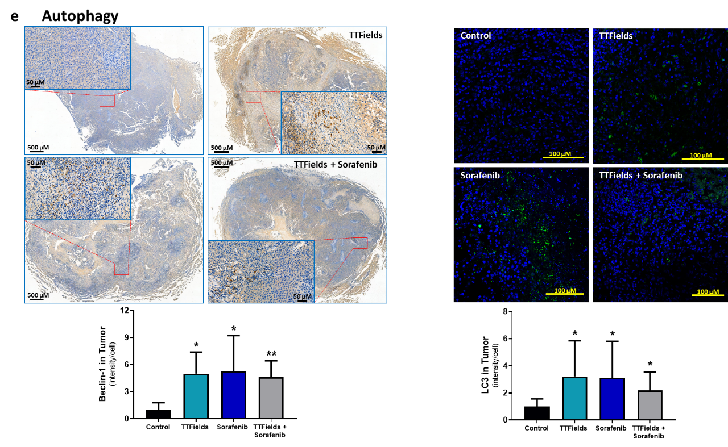

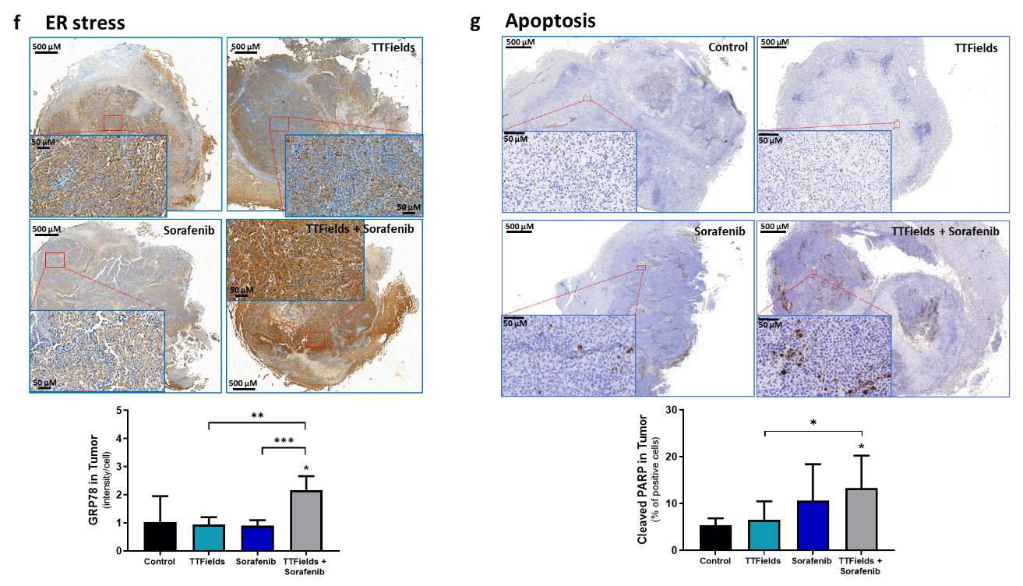

**Figure 4.** tumor slices were subjected to immunohistochemical analysis for beclin-1 and LC3 (e), GRP78 (f), and cleaved PARP (g). Values are mean ± SD. \**p* < 0.05, \*\**p* < 0.01, and \*\*\*\**p* < 0.0001 relative to control for labels above bars, or between indicated groups; Student’s T-test.

**Point 11:** The statement “TTFields concomitant with sorafenib induced a significant increase in apoptosis’ in the abstract section is overstated. When compared with sorafenib alone there is practically no difference. Moreover, TTFields failed to increases apoptosis when added to sorafenib and compared to sorafenib alone in one out of two human cells line investigated.

**Response 11**: We thank the reviewer for this comment. The sentence referred to was meant to describe only the in vivo outcomes. We have rephrased it to be more accurate and clear: “While each treatment alone elevated levels of autophagy relative to control, TTFields concomitant with sorafenib induced a significant increase versus control in tumor ER stress and apoptosis levels, demonstrating increased stress under the multimodal treatment.”

**Point 12:** Finally, adding to all the above questions, I found a very weak Discussion section which must be extended. Moreover, in the Discussion section, the authors concluded that “TTFields display efficacy for treatment of HCC in vitro and in vivo, with an optimal frequency of 150 kHz”. This is not a correct statement. While for in vitro data, the authors have data, for in vivo they used only one frequency of 150 Hz. At least one different dose should have been studied for comparison since this is a completely different tumor environment than the in vitro one.

**Response 12**: We thanks the reviewer for this comment. We have now elaborated on many issues throughout the discussion, as was described thorough this response letter. Regarding the conclusion, we have rephrased it for better accuracy: “TTFields were identified to be most efficient for treatment of HCC cells at 150 kHz, and this frequency further demonstrated *in vivo* efficacy.” Why only one frequency was used in vivo, and the difference between frequency and dose, were explained in response 4.