Response to Reviewer 4 Comments

In general, the manuscript is well written and provides novel and interesting data illustrating the possibility to enhance the efficacy of sorafenib in the therapy of hepatocellular carcinoma (HCC).

This might be achieved by using the combination of so-called Tumor Treating fields (TTFields) with targeted drug, I have the following suggestions about this manuscript:

**Point 1:** The authors demonstrate the efficacy of TTFields in vivo even when used as monotherapy. As shown in the Figure 4 C and D, TTFields were found less effective in terms of reducing the tumors volume and weight when compared with sorafenib. However, no differences in expression of LC3 marker were observed between these groups (treated with TTFields or with sorafenib) (as shown in Figure 4D). Similarly, low evidence of apoptosis (expression of cleaved PARP) was found in these groups, as shown in Figure 4F. What is the mechanism illustrating higher efficiency of sorafenib against HCC?

**Response 1**: We thank the reviewer for this question. Indeed, the sorafenib dose used in this study proved to be slightly more efficacious than TTFields in controlling tumor fold increase. Nevertheless, these differences between the monotherapies, did not reach statistical significance. In accordance, there was no statistical difference between the monotherapies in the expression levels of the LC3 marker and the levels of cleaved PARP. In order to better understand the mechanism of action, we have added experiments to better characterize the autophagy-apoptosis interplay for treatment with concomitant TTFields and sorafenib, which are described in response 3.

Of note, the clinical development of TTFields does not aim to replace sorafenib with TTFields, but rather to add TTFields on top of sorafenib and therefore this work focused mainly on the potential added value in combining these 2 modalities.

**Point 2:** Despite the expression of cleaved PARP was very low in the tumors treated with TTFields or sorafenib alone (as shown in IHC-images in Figure 4F), the authors declare about ~ 20% of positive cells, as show in the graphs below IHC-staining. Similar, the graphs illustrating the LC3 expression are not in a proper fit with the images shown in Figure 4D.

**Response 2:** We thank the reviewer for pointing out this issue. Quantification of the IHC images was done automatically. The whole slide was scanned, and the CaseViewer software was used to exclude non-tumor areas. The signals of the stained protein and the nuclei were resolved by color deconvolution and quantified separately using the FIJI software (ImageJ) software. Average signal per cell or percent of positive cells was calculated. As the reviewer pointed out, the high magnification images we chose to show do not correctly reflect the quantification performed by the software, and we have now replaced them with better representative fields of the slides.

**Point 3:** It will be much better to provide the data to explain the mechanisms illustrating why the monotherapy of TTFields or sorafenib induced autophagy, whereas the tumors treated with combination developed the substantial apoptotic death of tumor cells.

**Response 3:** We sincerely appreciate this well-taken comment. To better explain the correlation between autophagy and apoptosis we have performed additional examinations to include more markers and at additional time points. These examinations were performed for the combined treatment as compared to TTFields and sorafenib alone. We thank the reviewer for this comment, as these additions add much clarity to the mechanism of action of TTFields in combination with sorafenib and provide a more coherent explanation for the in vivo results. These additions may be seen in Figure 3 and are described in results sub-section 3.4, Autophagy-apoptosis Interplay For Treatment with Concomitant TTFields and Sorafenib: “In order to investigate the mechanism of action of TTFields-sorafenib co-application, HepG2 and Huh-7D12 cells were treated for 6, 24, or 48 hours with TTFields, sorafenib (3µM), or the two modalities together, and then examined for expression levels of various proteins. For HepG2 cells, the autophagy marker beclin-1 demonstrated elevation after 6 hours of treatment, which was later replaced with diminished expression levels (Figure 3d). This type of behavior was seen in all treatment groups, but was most pronounced for TTFields-sorafenib co-application. The autophagy marker LC3 also displayed such bi-phasic characteristics, but with a somewhat slower kinetics, showing some elevation at 6 hours of treatment, but higher elevation at the 24 hours time point (Figure 3d). As in the case of beclin-1, the magnitude of the effect was higher for co-treatment of TTFields and sorafenib relative to the monotherapies. GRP78, a marker of ER stress, remained low in all treatment groups for 6 and 24 hours of treatment, but demonstrated elevated levels at the later, 48-hours time point (Figure 3e). The apoptosis marker cleaved PARP displayed increased expression in the combined group already after 24 hours, elevating even further after 48 hours of treatment. For the monotherapies, cleaved PARP increase was only evident at 48 hours of treatment, and to a lower extent than that in the co-treatment group (Figure 3f). The slower kinetics of the autophagy-apoptosis path in the Huh-7D12 cells, as seen from the elevation of LC3 after as much as 48 hours (Figure 2c and d), prevented from detecting such changes in the levels of these markers in this cell line (Figure S1).”And in the discussion part “Kinetic examination in the HepG2 cells revealed elevation in autophagy levels as early as 6 hours of TTFields or sorafenib treatment, which diminished and were replaced with ER stress and apoptosis for 48 hours of treatment. These results are in line with a previous study that focused on the effects of sorafenib on such markers in HepG2 cells [32]. The higher changes in expression levels and faster kinetics when TTFields and sorafenib were applied together rather than alone indicate higher stress levels imposed on the cells in the former case.”

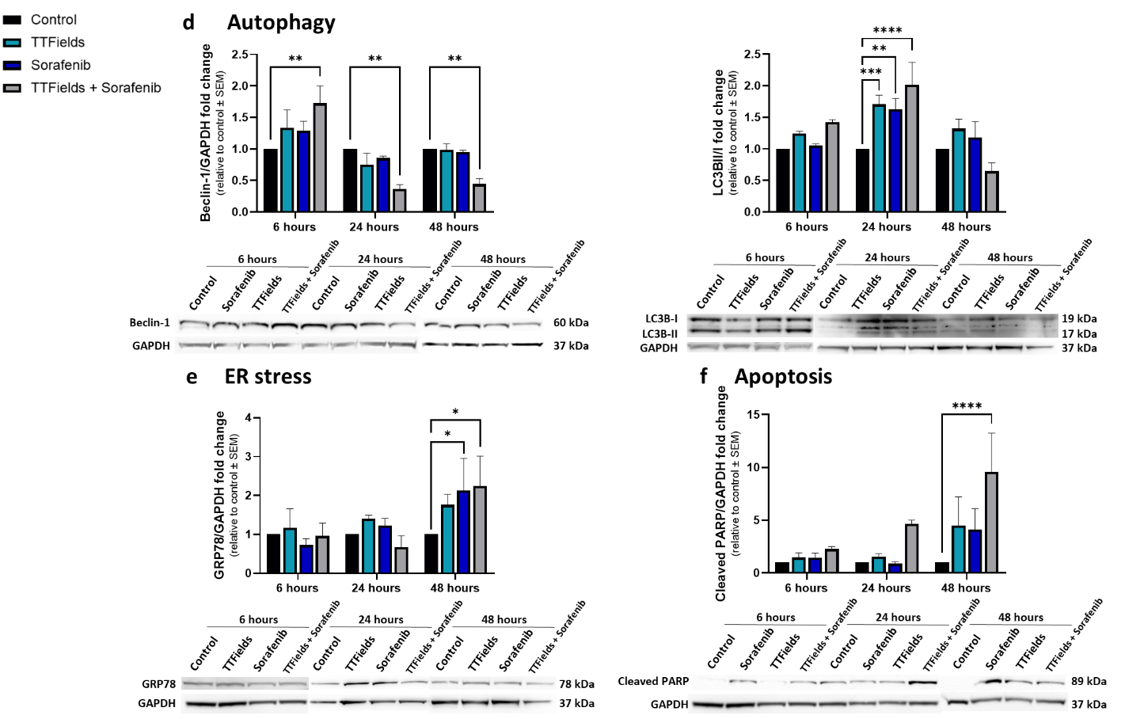

**Figure 3.** HepG2 cells were treated for 6, 24, or 48 hours with 150 kHz TTFields, 3 µM sorafenib, or the two treatments combined, followed by Western blot examination of the autophagy markers beclin-1 and LC3 (d), the ER stress marker GRP78 (e), and the apoptosis marker cleaved PARP (f). Values are mean (*N* ≥ 3) ± SEM. \**p* < 0.05, \*\**p* < 0.01, \*\*\**p* < 0.001, and \*\*\*\**p* < 0.0001 relative to time-respective control; two-way ANOVA.

In the animal study we have now added IHC examination of beclin-1 and of GRP78, a marker for ER stress, as described in results sub-section 3.4. Concomitant TTFields with Sorafenib Enhances Treatment Efficacy in Vivo: “Tumor histology and immunostaining for beclin-1 and LC3, GRP78, and cleaved PARP were performed to examine autophagy, ER stress, and apoptosis levels, respectively. Beclin-1 levels were increased more than 4-fold relative to control in all treatment groups, while intensity of LC3 staining was increased about 3-fold relative to control in the individual TTFields and sorafenib groups, but only 2-fold in the combination group (Figure 4e). GRP78 levels in the groups treated with TTFields or sorafenib alone remained unchanged from the control, but were elevated 2-fold in the TTFields plus sorafenib group (Figure 4f). Additionally, the percentage of cells positive for cleaved PARP was significantly higher relative to control only in the combination group (Figure 4g).” and also in the discussion: “The lower autophagy accompanied by the higher ER stress and apoptosis displayed in the conjunction group relative to the monotherapies groups following 6 days of treatment suggest that these animals were pushed further along the autophagy-apoptosis kinetic timeline due to the higher levels of stress experienced by these animals, in accordance with the results described for the cell cultures.”

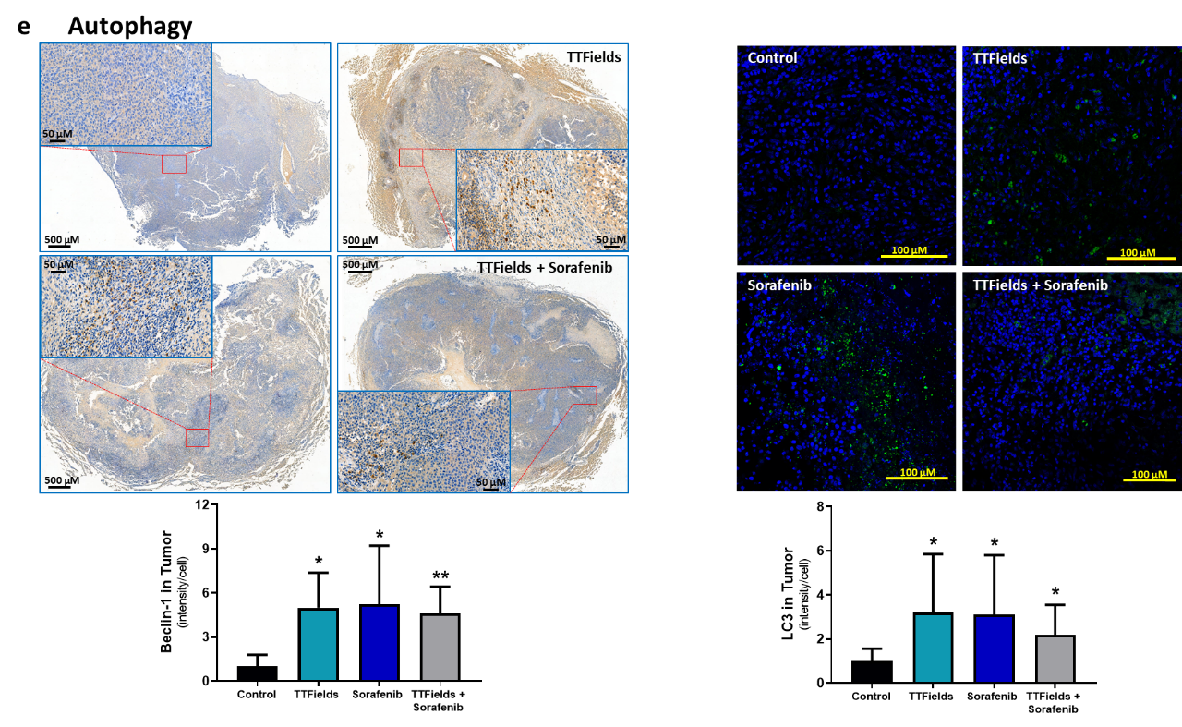

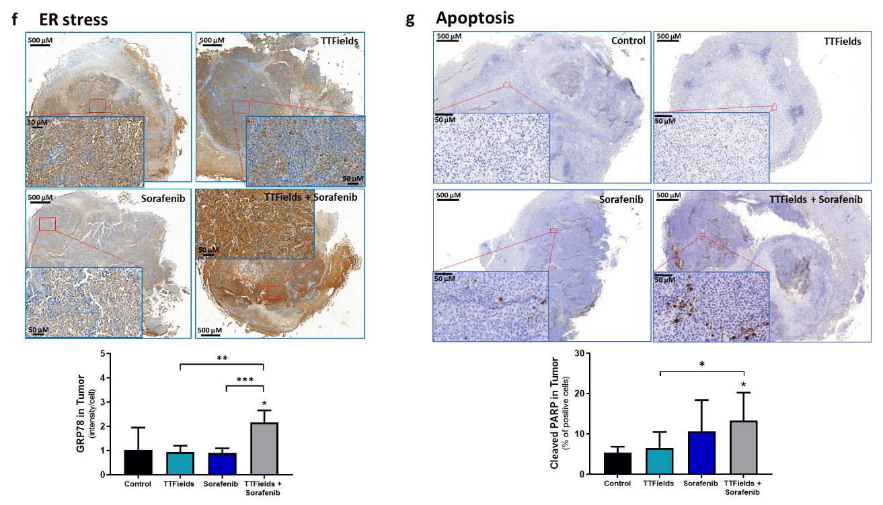

**Figure 4.** tumor slices were subjected to immunohistochemical analysis for beclin-1 and LC3 (e), GRP78 (f), and cleaved PARP (g). Values are mean ± SD. \**p* < 0.05, \*\**p* < 0.01, and \*\*\*\**p* < 0.0001 relative to control for labels above bars, or between indicated groups; Student’s T-test.

**Point 4:** Since Annexin V/7-ADD data was not convincing and the authors observed the minor increase of apoptotic cells after HCC cells were treated with combination of TTFields and sorafenib (when compared to the cells treated with TTFields and sorafenib alone), I suggest to run the WBs to examine the expression of the cleaved forms of PARP and caspase-3 (for both HCC cell lines). This might be helpful and make the in vitro data more relevant with the data shown in vivo.

**Response 4:** We thank the reviewer for this comment. Both cell lines experience elevation of apoptosis following application of sorafenib in a dose dependent manner, as evident from the AnnV/7AAD results. However, while TTFields greatly elevate apoptosis in HepG2 cells, they have a low effect on apoptosis levels in the Huh-7D12 cells, seen both in Figure 1d and in Figure 3c. As was explained in the discussion, this difference between the cell lines may be attributed to the different p53 status, wild type in HepG2 and mutated in Huh-7D12, as there are previous indications of lower TTFields-induced apoptosis in cell lines with mutated p53.

As suggested by the reviewer, in order to back up the AnnV/7AAD results we added WB for cleaved PARP, as described in response 3.

**Point 5:** Figure 4A is missing.

**Response 5:** We apologize for accidentally leaving out this figure, and have now added it.

**Point 6:** the different HCC cell lines were used for in vitro and in vivo experiments, therefore making difficult to compare these data.

**Response 6:** We thank the reviewer for this comment. In the in vitro experiments we used cell lines derived from humans. However, these cell lines cannot be implanted to rats, and so for the in vivo experiments we had to use a cell line from rats.