Article

Pathological Analysis of Encased Resected Recurrent Nerves in Locally Invasive Thyroid Cancer

Alexandre Dahan, MD, 1 Abir Al-Ghuzlan MD PhD, 2 Randa Chehab, MD, 2 Joanne Guerlain, MD, 1 Ingrid Breuskin, MD PhD, 1 Camilo Garcia, MD, 3 Livia Lamartina MD PhD, 3Julien Hadoux, MD PhD, 3 Eric Baudin, MD PhD, 3 Dana M. Hartl and MD PhD1

1 Department of Anesthesia, Surgery, and Interventional Radiology; Thyroid Surgery Unit

2 Department of Biology and Pathology

3 Department of Nuclear Medicine and Endocrine Oncology

**\*** Correspondence: author: dana.hartl@gustaveroussy.fr

**Abstract: Objective:** Thyroid cancer encasing the recurrent nerve is rare, and the decision to resect or preserve the nerve is multifactorial. The objective of this study was to histo-pathologically analyze resected encased nerves to assess the rate of nerve invasion and risk factors. **Materials and Methods:** Retrospective study of consecutive patients with resection of the recurrent nerve for primary or recurrent follicular-cell derived or medullary thyroid carcinoma from 2005 to 2020. Demographics, pathology, locoregional invasion, metastases, recurrences and survival were analyzed. Slides were reviewed blindly by two specialized pathologists (AAG, RC) for diagnosis of invasion deep to the epineurium. **Results:** Fifty-two patients were included: 25 females; average age 55 (range 8-87). Eighty-seven percent (45/52) were follicular-cell derived with 17/45 (37.8%) aggressive variants; 13% (7/52) were medullary carcinoma. Preoperative vocal fold (VF) paralysis was present in

|  |
| --- |
| **Citation:** Lastname, F.; Lastname, F.; Lastname, F. Title. *Cancers* **2022**, *14*, x. https://doi.org/10.3390/xxxxx  Academic Editor: Firstname Lastname  Received: date  Accepted: date  Published: date  **Publisher’s Note:** MDPI stays neutral with regard to jurisdictional claims in published maps and institutional affiliations.  A picture containing text, clipart  Description automatically generated  **Copyright:** © 2022 by the authors. Submitted for possible open access publication under the terms and conditions of the Creative Commons Attribution (CC BY) license (https://creativecommons.org/licenses/by/4.0/). |

16/52 (30.7%). Pathologically, the nerve was invaded in 44/52 cases (85%): 82 % of follicular-cell derived tumors (37/45), 88% of pediatric cases, and 100 % of medullary carcinomas (7/7). Nerve invasion was observed in 11/16 (69%) with preoperative VF paralysis and 33/36 (92%) with normal VF function. Only aggressive histology was correlated with nerve invasion in follicular-cell derived tumors (p=0.019).**Conclusions:** The encased nerves were pathologically invaded in 82 % of follicular-cell derived tumors and in 100 % of medullary carcinomas. Nerve invasion was statistically correlated with aggressive histo-pathological subtypes and was observed in the absence of VF paralysis in 92% of cases.

**Keywords:** thyroid cancer; recurrent nerve; vocal fold paralysis; aggressive subtypes; high-risk

1. Introduction

Thyroid cancer encasing the recurrent nerve is a rare entity and the decision to resect or to preserve the nerve depends on many factors. Current guidelines propose decision algorithms and criteria to take into account when performing a risk-benefit analysis between nerve resection and nerve preservation in locally invasive thyroid cancer.[1-3] When the nerve is encased, macroscopically complete tumor resection (R0/R1) is generally very difficult without nerve sacrifice and the consequences of leaving macroscopic residual disease, even if small, must be weighed against the benefits of complete resection or the possibility of effective adjuvant therapy.

The objective of this study was to histo-pathologically analyze encased recurrent nerves in cases where resection had been chosen, in order to assess the rate of true microscopic invasion within the epineurial nerve sheath itself and to evaluate risk factors for deep nerve invasion.

2. Materials and Methods

A retrospective study of patients having undergone resection of the recurrent nerve for primary or recurrent follicular-cell derived or medullary thyroid carcinoma from 2005 to 2020 was undertaken. The local institutional review board approved the study and individual patient consent was waived. Patient demographics, pathology, invasion of the visceral axis, distant metastases, local recurrences and survival were analyzed. Pathology was retrospectively reviewed blindly by two specialized pathologists (AAG, RC) for diagnosis of nerve invasion. Criteria for diagnosis of nerve invasion was the presence of tumor cells or stroma in contact with nerve fibers, that is, inside the inner epineurium. (figure 1). Risk factors for nerve invasion (age, gender, pathology, reoperation, preoperative recurrent nerve paralysis and resection of the visceral axis) were analyzed. Descriptive statistics and non-parametric statistical tests were performed using the SPSS software (IBM® version 5.0).

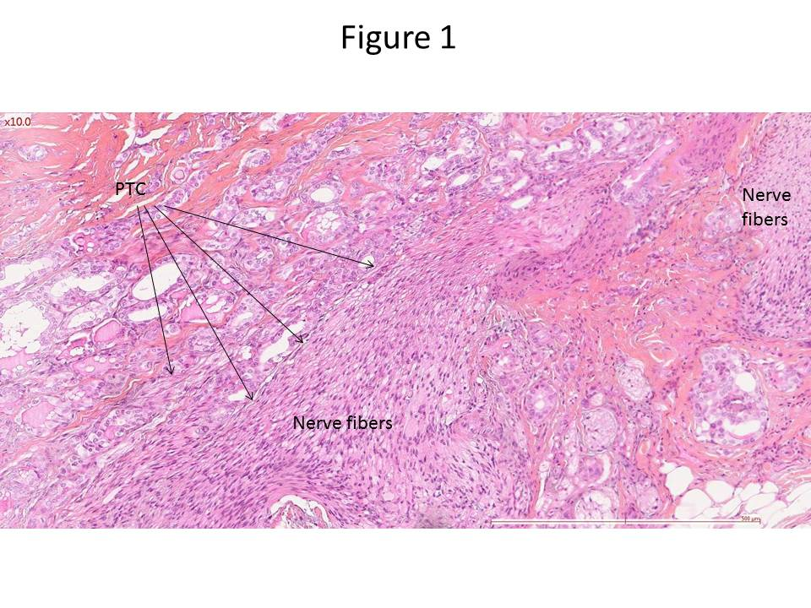

**Figure 1.** Classic papillary thyroid carcinoma (PTC) in contact with nerve fibers (schwann cells).

3. Results

Fifty-two patients were included, 25 females and 27 males, average age 55 years (range 8-87). Eight patients were under 18 years old.

Follicular-cell derived tumors represented the majority (45/52 or 87%) whereas medullary thyroid carcinoma represented 7 cases (13%). Of the 45 follicular-cell derived tumors, 17 (37.7%) were aggressive variants of papillary thyroid carcinoma (13 tall cell, 2 columnar cell and 2 diffuse sclerosing), 6 were Hürthle cell carcinomas, 5 poorly differentiated carcinoma and the others classic papillary carcinoma. Sixteen patients (35%) with follicular-cell derived tumors had known radioactive iodine-refractory tumors. The 8 pediatric cases were follicular-cell derived tumors (classic papillary n=6, diffuse scerlosing variant n=2).

Distant metastases were present at the time of nerve resection in 11 patients (21%), 5 of whom were children with lung metastases. The distant metastases in adults were judged to be low-volume lung metastases. All tumors were at a high risk of recurrence according to the 2015 ATA guidelines[4] and 25 patients (48%) were stage IV according to the 8th edition TNM classification.[5] All of the resections were preoperatively approved by our local tumor board, after discussing risks, benefits and alternative therapies.

Twenty patients were reoperative cases (38%) whereas 32 were primary resections (62%). In children, 7/8 were primary resections, the nerve being encased by the tumor, the lymph nodes or both. There were no cases in which the vocal fold had been paralyzed during a previous operation; preoperatively the vocal folds were paralyzed due to the primary tumor or the recurrent/persistent disease.

Preoperative vocal fold (VF) paralysis was present in 16/52 cases (30%). No patient had contralateral vocal fold paralysis pre- or postoperatively. Concomitant partial resection of the larynx, trachea and/or esophagus was performed in 9 cases, but no total laryngectomies were performed.

Nerve sacrifice was performed in an attempt to optimize locoregional tumor resection with R0/R1 margins.[5] For follicular-cell derived tumors in adults, tumor resection was considered R0 in 49% of cases, minimal R1 in 39% of cases and R2 in 4 (8%). Residual disease in patients with R2 resection was left on the tracheal wall, due to patient comorbidities precluding tracheal resection, and adjuvant external beam radiation therapy was administered to these 4 patients. A total of 18 patients—all adults, 15 with known radioactive iodine refractory tumors and 3 with medullary carcinoma, had postoperative external beam radiation therapy. All of the pediatric cases and 61% of the adult differentiated thyroid cancer cases received adjuvant radioactive iodine.

On retrospective pathological analysis, the nerve was microscopically invaded in 44/52 cases (85%) (Table 1).

**Table 1.** Relationship between preoperative vocal fold (VF) paralysis and histopathological nerve invasion.

|  |  |  |  |  |
| --- | --- | --- | --- | --- |
|  |  | Preoperative VF paralysis | Presence of nerve invasion | Rate of nerve invasion |
| Follicular cell derived carcinoma | Adults  n=37 | No n=23 | 21/23 | 30/37 (81%) |
| Yes n=14 | 9/14 |
| Children  n=8 | No n=7 | 6/7 | 7/8 (88%) |
| Yes n=1 | 1/1 |
| Medullary thyroid carcinoma | Adults  n=7 | No n=6 | 6/6 | 7/7 (100%) |
| Yes n=1 | 1/1 |

Preoperative vocal fold paralysis was not statistically related to nerve invasion (Fisher’s exact test, p= 0.09). The nerve was invaded in 92% of patients without preoperative vocal fold paralysis, and in 69% of patients with preoperative vocal fold paralysis. In the 44 patients with nerve invasion, 33 (75%) had normal preoperative vocal fold mobility.

Concomitant resection of the visceral axis was not statistically related to nerve invasion; in the 9 patients with associated tracheal or esophageal resection, 7 had deep epineurial invasion (Fisher’s exact test, p= 0.61). Age, gender, and primary versus reoperation were not statistically related to nerve invasion.

Aggressive tumor histology was the only factor found to be related to nerve invasion for follicular-cell derived carcinomas (p= 0.019 Fisher’s exact test). Classic papillary carcinoma invaded the nerve in 14/21 cases (figures 1 and 2) whereas aggressive variants invaded nerves in 22/23 cases (figure 3). Evaluating only the adult population, aggressive tumor histology was still associated with nerve invasion (p=0.008).

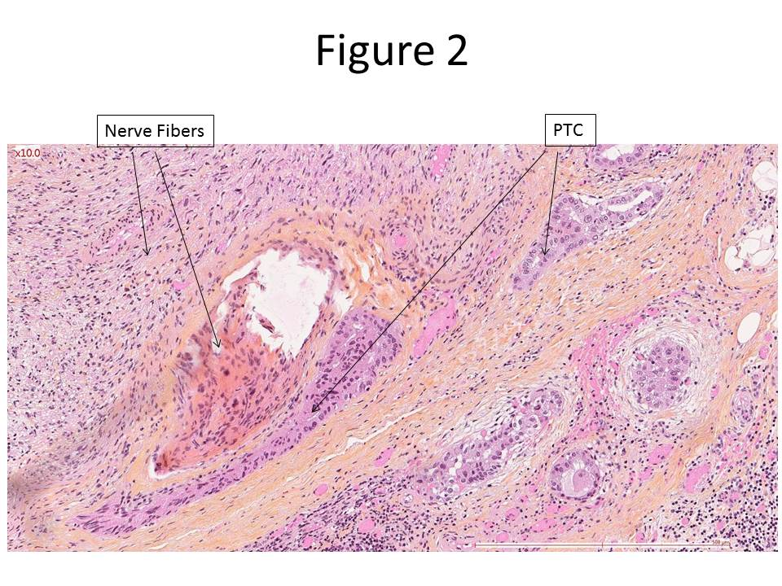

**Figure 2.** Classic papillary thyroid carcinoma (PTC) within the nerve sheath, in contact with nerve fibers.

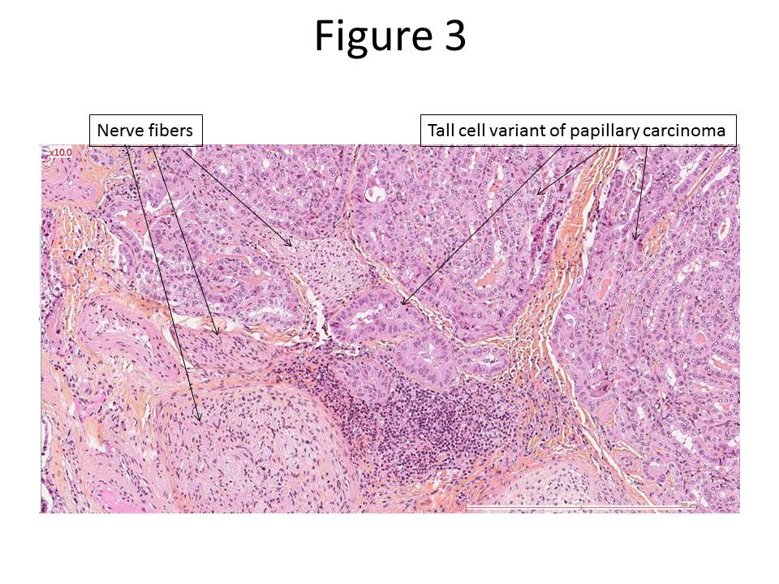

**Figure 3.** Tall cell variant of papillary thyroid carcinoma invading the nerve, in contact with nerve fibers.

Follow-up averaged 58.9 months, with a median follow-up of 54 months (range: 1 to 147 months). The Kaplan-Meier calculated overall survival rate for follicular-cell derived tumors in adults was 97% at 1 year and 86% at 5 years. For these tumors, 44% of patients achieved an excellent response according to the 2015 American Thyroid Association Guidelines, 22% a biochemically incomplete response and 33% a structurally incomplete response.[4] The group of medullary carcinomas was too small to calculate a meaningful actuarial survival rate, and there were no deaths in the pediatric group.

The rate of local recurrence in the region of the resected nerve was 0% at 5 years for patients with follicular-cell derived thyroid cancer and R0/R1 resection. Two of the 4 patients with R2 resection had local progression at the site of residual disease (trachea) despite adjuvant external beam radiation therapy. For medullary carcinoma, the overall rate of local recurrence at the level of the resected nerve was 14% (1/7). In the pediatric group, follow up ranged from 18 to 140 months (average 71 months). One local recurrence and one case of recurrent lung metastases occurred, treated with repeated doses of radioactive iodine. The other six of the eight pediatric patients achieved excellent response or biochemically incomplete response, without persistent structural disease at last follow-up.

From a functional standpoint, four adult patients and two pediatric patients required tracheostomy for concurrent laryngo-tracheal resections, but with only 1 adult patient maintaining a permanent tracheostomy. The two pediatric patients were decannulated after endoscopic laser-assisted medial arytenoidectomy. Intraoperative nerve reconstruction with ansa hypoglossi was performed in only 2 patients due to the distal resection of the nerve (close to the larynx) in most cases, but also due to the fact that in the early patients in our study, this practice was not routine. Sedondary vocal fold medialization was performed in 5 adults—3 autologous fat injections and 2 Isshiki type I thyroplasties [6]—and one child (autologous fat injection). Fifteen adult patients responded to a mailed questionnaire sent an average of 2 years post-operatively for subjective evaluation. The average voice handicap index (VHI 10) [7] for these fifteen patients was 19.7, with a median of 17 (range 4-34). The average score on the European Organization for Research and Treatment of Cancer Quality of Life Questionnaire-Head and Neck 35 (EORTC-QLQ-H&N35) [8] questionnaire was 60, with a median of 52 (range 35-108).

4. Discussion

Locally invasive thyroid cancer is rare, with reported incidences ranging from 4-10%.[9-11] Recurrent nerve invasion is the second most frequent type of local invasion after strap muscle invasion.[12] Often, this invasion does not only involve the nerve but also the trachea, larynx, and/or esophagus more or less superficially, requiring shaving or segmental resections. Disease-specific survival has been shown to be similar and not significantly different between R0 resections and R1 resections for locally invasive thyroid carcinoma.[13-18] However, in a recent study of 72 patients with intraoperative findings of recurrent nerve involvement, a positive resection margin was correlated with recurrence,[19] and completeness of resection is a prognostic factor when using the MACIS risk stratification system for surgical decision making.[20] Nerve involvement has been shown to impact recurrence-free survival, but to a lesser extent than tracheal or esophageal invasion. Recurrent nerve invasion alone has not been shown to be a factor for disease-specific survival, however. [11, 14, 17, 18, 21] Current guidelines and consensus statements emphasize nerve preservation in order to maintain quality of life, due to the relatively favorable prognosis of differentiated thyroid cancer and outline the multiple factors involved when deciding to preserve or resect a nerve for oncological purposes. (table 2). [1-3, 22] Tumors encasing the recurrent nerve are ATA high-risk lesions, with reported rates of structural recurrence of up to 40-50%.[4] From a survival standpoint, T4a tumors in patients over 55 years of age are stage III with a survival rate of 60-70%, and may warrant more aggressive surgical resection.[23]

**Table 2.** Factors to consider when choosing nerve preservation versus nerve resection (adapted from References [1, 2]).

|  |  |
| --- | --- |
| **Patient Factors** | **Oncologic Factors** |
| Age   * Young patients have a higher chance of RAI- avid disease * Older patients have a higher risk of PET+/RAI- disease | RAI+ versus PET+ disease   * RAI can be curative for low volume R2 disease |
| Comorbidities   * Risk of aspiration pneumonia | Risk of local complications if residual disease (R2) left near the visceral axis |
| Voice and laryngeal mobility   * Contralateral vocal fold mobility | Complete resection possible or not |
| Quality of life choices | Aggressive histology |
|  | Primary or recurrent disease |
|  | Distant metastases  -indication for systemic therapy |
|  | External beam radiation therapy possible |

RAI: Radioactive iodine.

PET: 18-fluorodeoxyglucose positron emission tomography.

Our study included 11 adult patients with low-volume distant metastases for whom the decision to resect the nerve was based on optimizing local control to avoid local complications of systemic therapies.[24] For the other patients, we favored complete resection to optimize chances of attaining an excellent response. Furthermore, the location of the tumors at the distal end of the recurrent nerve led us to favor complete resection in order to avoid potential tumor progression into the larynx or inferior constrictor muscles.

Aggressive variants and medullary thyroid carcinoma invaded the nerve more often than classic papillary thyroid carcinoma. Classic papillary thyroid carcinoma, particularly in young patients is also classically responsive to radio-iodine, with high rates of overall survival.(6) In these cases, preservation of the nerve with residual tumor and adjuvant radio-iodine (RAI) would thus seem appropriate. Leaving residual macroscopic disease, however, may lead to repeated administrations of RAI with high cumulative doses and risks of short- and long-term toxicity.[25, 26] Furthermore, many aggressive variants are RAI-refractory, but for primary resections the exact pathological subtype is not always known beforehand. Performing preoperative 18Fluorodeoxyglucose positron emission tomography with computed tomography (18FDG-PET CT) in locally invasive tumors may provide information on tumor aggressiveness and responsiveness to RAI.[27, 28] Even for RAI-sensitive tumors, a large remnant may not be completely cured with RAI, its efficacy being at a maximum for small-volume lesions.[29]

Nerves are composed of axons surrounded by endoneurium, grouped into fascicles by perineurial tissue, surrounded by the inner epineurial space then enclosed by the outer epineurium.[30] “Perineural invasion” of tumors (not to be confused with the perineur*ium*) was broadly defined in 1985 by Batsakis as tumor cell invasion in, around, and through the nerve. [31, 32] In a review of the literature published in 2009, Liebeg et al suggested that “finding tumor cells within any of the 3 layers of the nerve sheath (epineurium, perineurium or endoneurium) or tumor foci outside of the nerve with involvement of ≥ 33% of the nerve’s circumference” were features defining perineural invasion in malignant tumors.[32] The 2018 International Neuromonitoring study group guidelines defined neural invasion as involving >33% of the circumference of the nerve.[1] All of our patients met the International Neuromonitoring definition of neural invasion, all having encased nerves with over 33% of the circumference of the nerve surrounded by tumor.

To our knowledge, this is the largest histo-pathologic study of resected encased recurrent laryngeal nerves. Our high rate of microscopic invasion (85%) may be due to a selection bias of only encased nerves, reoperative cases (40%) and aggressive variants (37%).

Kihara et al histologically examined the normal part of 3 resected recurrent nerves and showed that 78-82% of what the surgeon sees as nerve is actually connective tissue surrounding the nerve: the actual axons only comprise 18-22% of the cross-sectional area of the nerve.[33] This finding justifies partial layer resection as described by Nishida et al when possible, preserving all or part of the nerve axons.[34] This type of nerve preservation, when possible, has been shown to provide better vocal results than nerve grafting or phonosurgery.[35, 36]

In our study, 33/36 patients without preoperative VF paralysis had nerve invasion on histologic examination. It is well known that axons can continue to function despite tumor infiltration. On the contrary, however, 5 patients with preoperative vocal fold paralysis did not have nerve invasion. This again may be due to a lack of complete pathological analysis of the entire nerve, due to the retrospective nature of our study, or these nerves may have been paralyzed by compression, devascularisation or inflammation, which we did not pathologically analyze.

With results supporting the results of our study, Chen et al compared a group of 105 patients with nerve invasion found visually and/or histopathologically with a control cohort of 3131 patients without nerve involvement.[37] The nerves were managed either with partial layer resection or resection and nerve reconstruction. Pre-operative vocal fold paralysis was a predictive factor for nerve involvement on multivariate analysis, as compared to the control group, but nonetheless 73% of the patients in the invaded-nerve group did not have preoperative vocal fold paralysis.

Kamani D et al studied 12 patients with preoperative vocal fold dysfunction and histological nerve invasion; intraoperatively a stimulated electrophysiologic nerve response was observed in 33% of these cases.[38] In the same study, in 22 nerves seen to be grossly invaded during surgery, 45% of patients had normal laryngeal mobility preoperatively and in the remaining 55% with abnormal focal fold function, 33% still had a stimulated electrophysiologic response intraoperatively. In the recent study by Kesby et al, of 154 patients with medullary thyroid carcinoma, 11 patients were found to have recurrent nerve invasion but 5 of these patients (45%) had normal preoperative vocal fold mobility.[39]

Our study has many drawbacks due to its retrospective nature. Nerve reconstruction was performed in only a few cases, anastomosing the ansa hypoglossi to the recurrent nerve stump as described by Crumley in 1986[40] and Miayuchi in 1998,[41] but long term voice or quality of life data was missing for the majority of our cases, making any kind of comparison impossible. The VHI and EORTC data were only available for 15 patients who responded to the questionnaires. A VHI 10 score above 11 is considered abnormal. [42] The VHI 10 scores observed (19.7 on average, with a median of 17) are similar to those reported for transoral laser-assisted vocal fold resection for laryngeal cancer. [43] The EORTC scores were comparable to average scores observed in patients treated for head and neck squamous cell carcinoma. [8] Today, we attempt ansa hypoglossi nerve anastomosis in all cases in which a small nerve stump can be preserved at the laryngeal entry point. We do not perform intralaryngeal anastomosis when the tumor involved the distal end of the recurrent nerve, but this technique seems to improve functional results when feasible.[36] We did not record quantitative measurements during surgery using intraoperative nerve monitoring. Stimulated amplitudes and latencies in patients with encased nerves but still-functioning vocal folds may be informative in predicting nerve invasion versus intact nerve envelopes. Finally, the oncologic results only reflect a very small heterogeneous cohort of rare and highly-selected tumors.

The retrospective nature of this study precluded any more detailed analysis of the invaded nerves, such as length of invasion, ratio of tumors stroma or macrophages versus tumor cells within the nerve sheath, or other aspects that may have allowed us to distinguish distinct groups according to the aspect of nerve invasion. We did not look at imaging to determine the sensitivity or specificity of different imaging techniques to predict nerve invasion. This would require a larger cohort and more patients without nerve encasement for comparison.

Finally, we were not able to draw precise conculsions as to exactly which factors were predominant in deciding to resect the recurrent nerve, due the heterogeneity and retrospective nature of our study. Each case was discussed preoperatively in our local tumor board and nerve resection (if necessary) was validated. When complete resection (R0/R1) was deemed to be possible by the tumor board (with surgeons attending), nerve resection was validated if necessary to achieve this goal. When the tumor was known to be iodine-refractory (for differentiated thyroid cancer) our tumor board generally also validated nerve resection. Most of these patients, howerever, were treated before the widespread use of BRAF or RET inhibitors or before neo-adjuvant treatment protocols were employed. Some of these cases today may have been amenable to neo-adjuvant treatment kinase inhibitors, and their nerves may possibly have been spared.

5. Conclusions

To our knowledge, this is the largest histo-pathologic evaluation of encased resected recurrent nerves for thyroid cancer. The inner epineurium or beyond was microscopically invaded by tumor cells in 82% of follicular-cell derived tumors in adults, 88% in children and in 100% in medullary carcinoma in adults, regardless of preoperative vocal fold mobility. Statistically, the only factor correlated with nerve invasion was an aggressive histologic subtype for follicular-cell derived tumors. Knowledge of the pathological subtype may help choose between nerve resection and nerve preservation, if effective adjuvant therapy is available.

**References**

1. Wu CW, Dionigi G, Barczynski M, Chiang FY, Dralle H, Schneider R, et al. International neuromonitoring study group guidelines 2018: Part II: Optimal recurrent laryngeal nerve management for invasive thyroid cancer-incorporation of surgical, laryngeal, and neural electrophysiologic data. The Laryngoscope. 2018;128 Suppl 3:S18-S27. doi: 10.1002/lary.27360. PubMed PMID: 30291765.

2. Shindo ML, Caruana SM, Kandil E, McCaffrey JC, Orloff LA, Porterfield JR, et al. Management of invasive well-differentiated thyroid cancer: an American Head and Neck Society consensus statement. AHNS consensus statement. Head & neck. 2014;36(10):1379-90. doi: 10.1002/hed.23619. PubMed PMID: 24470171.

3. Ito Y, Onoda N, Okamoto T. The revised clinical practice guidelines on the management of thyroid tumors by the Japan Associations of Endocrine Surgeons: Core questions and recommendations for treatments of thyroid cancer. Endocrine journal. 2020;67(7):669-717. doi: 10.1507/endocrj.EJ20-0025. PubMed PMID: 32269182.

4. Haugen BR, Alexander EK, Bible KC, Doherty GM, Mandel SJ, Nikiforov YE, et al. 2015 American Thyroid Association Management Guidelines for Adult Patients with Thyroid Nodules and Differentiated Thyroid Cancer: The American Thyroid Association Guidelines Task Force on Thyroid Nodules and Differentiated Thyroid Cancer. Thyroid : official journal of the American Thyroid Association. 2016;26(1):1-133. doi: 10.1089/thy.2015.0020. PubMed PMID: 26462967; PubMed Central PMCID: PMC4739132.

5. Amin MB ES, Greene F, Byrd DR, Brookland RK, Washington MK, Gershenwald JE, Compton CC, Hess KR, et al. (Eds.). . AJCC Cancer Staging Manual (8th edition): Springer International Publishing; 2017.

6. Isshiki N, Morita H, Okamura H, Hiramoto M. Thyroplasty as a new phonosurgical technique. Acta oto-laryngologica. 1974;78(5-6):451-7. doi: 10.3109/00016487409126379. PubMed PMID: 4451096.

7. Rosen CA, Lee AS, Osborne J, Zullo T, Murry T. Development and validation of the voice handicap index-10. The Laryngoscope. 2004;114(9):1549-56. doi: 10.1097/00005537-200409000-00009. PubMed PMID: 15475780.

8. Cancer. EEOfRaTo. <http://groups.eortc.be/qol/sites/default/files/img/specimen_for_printing_hn35.pdf>.

9. Honings J, Stephen AE, Marres HA, Gaissert HA. The management of thyroid carcinoma invading the larynx or trachea. The Laryngoscope. 2010;120(4):682-9. doi: 10.1002/lary.20800. PubMed PMID: 20213659.

10. Patel KN, Shaha AR. Locally advanced thyroid cancer. Current opinion in otolaryngology & head and neck surgery. 2005;13(2):112-6. doi: 10.1097/01.moo.0000156161.82671.43. PubMed PMID: 15761287.

11. McCaffrey TV, Bergstralh EJ, Hay ID. Locally invasive papillary thyroid carcinoma: 1940-1990. Head & neck. 1994;16(2):165-72. PubMed PMID: 8021137.

12. McCaffrey JC. Aerodigestive tract invasion by well-differentiated thyroid carcinoma: diagnosis, management, prognosis, and biology. The Laryngoscope. 2006;116(1):1-11. doi: 10.1097/01.MLG.0000200428.26975.86. PubMed PMID: 16481800.

13. Shelton VK, Skolnik EM, Berlinger FG, Arab M. Laryngotracheal invasion by thyroid-carcinoma. The Annals of otology, rhinology, and laryngology. 1982;91(4 Pt 1):363-9. doi: 10.1177/000348948209100407. PubMed PMID: 7114714.

14. McConahey WM, Hay ID, Woolner LB, van Heerden JA, Taylor WF. Papillary thyroid cancer treated at the Mayo Clinic, 1946 through 1970: initial manifestations, pathologic findings, therapy, and outcome. Mayo Clinic proceedings. 1986;61(12):978-96. doi: 10.1016/s0025-6196(12)62641-x. PubMed PMID: 3773569.

15. Park CS, Suh KW, Min JS. Cartilage-shaving procedure for the control of tracheal cartilage invasion by thyroid carcinoma. Head & neck. 1993;15(4):289-91. doi: 10.1002/hed.2880150403. PubMed PMID: 8360048.

16. Sywak M, Pasieka JL, McFadden S, Gelfand G, Terrell J, Dort J. Functional results and quality of life after tracheal resection for locally invasive thyroid cancer. American journal of surgery. 2003;185(5):462-7. doi: 10.1016/s0002-9610(03)00057-6. PubMed PMID: 12727568.

17. Wang LY, Nixon IJ, Patel SG, Palmer FL, Tuttle RM, Shaha A, et al. Operative management of locally advanced, differentiated thyroid cancer. Surgery. 2016;160(3):738-46. doi: 10.1016/j.surg.2016.04.027. PubMed PMID: 27302105; PubMed Central PMCID: PMC5126966.

18. Hotomi M, Sugitani I, Toda K, Kawabata K, Fujimoto Y. A novel definition of extrathyroidal invasion for patients with papillary thyroid carcinoma for predicting prognosis. World journal of surgery. 2012;36(6):1231-40. doi: 10.1007/s00268-012-1518-z. PubMed PMID: 22402972.

19. Na HS, Kwon HK, Shin SC, Cheon YI, Seo M, Lee JC, et al. Clinical outcomes of T4a papillary thyroid cancer with recurrent laryngeal nerve involvement: a retrospective analysis. Scientific reports. 2021;11(1):6707. doi: 10.1038/s41598-021-86226-x. PubMed PMID: 33758286; PubMed Central PMCID: PMC7988054.

20. Boucek J, Zabrodsky M, Kuchar M, Fanta O, Skrivan J, Betka J. A new strategy for the surgical management of RLN infiltrated by well-differentiated thyroid carcinoma. BioMed research international. 2014;2014:616521. doi: 10.1155/2014/616521. PubMed PMID: 24955363; PubMed Central PMCID: PMC4052845.

21. Eustatia-Rutten CF, Corssmit EP, Biermasz NR, Pereira AM, Romijn JA, Smit JW. Survival and death causes in differentiated thyroid carcinoma. The Journal of clinical endocrinology and metabolism. 2006;91(1):313-9. doi: 10.1210/jc.2005-1322. PubMed PMID: 16263822.

22. Lang BH, Lo CY, Wong KP, Wan KY. Should an involved but functioning recurrent laryngeal nerve be shaved or resected in a locally advanced papillary thyroid carcinoma? Annals of surgical oncology. 2013;20(9):2951-7. doi: 10.1245/s10434-013-2984-8. PubMed PMID: 23636513.

23. Tuttle RM, Haugen B, Perrier ND. Updated American Joint Committee on Cancer/Tumor-Node-Metastasis Staging System for Differentiated and Anaplastic Thyroid Cancer (Eighth Edition): What Changed and Why? Thyroid : official journal of the American Thyroid Association. 2017;27(6):751-6. doi: 10.1089/thy.2017.0102. PubMed PMID: 28463585; PubMed Central PMCID: PMC5467103.

24. Lamartina L, Ippolito S, Danis M, Bidault F, Borget I, Berdelou A, et al. Antiangiogenic Tyrosine Kinase Inhibitors: Occurrence and Risk Factors of Hemoptysis in Refractory Thyroid Cancer. The Journal of clinical endocrinology and metabolism. 2016;101(7):2733-41. doi: 10.1210/jc.2015-4391. PubMed PMID: 27082933.

25. Albano D, Bertagna F, Panarotto MB, Giubbini R. Early and late adverse effects of radioiodine for pediatric differentiated thyroid cancer. Pediatric blood & cancer. 2017;64(11). doi: 10.1002/pbc.26595. PubMed PMID: 28436606.

26. Parisi MT, Eslamy H, Mankoff D. Management of Differentiated Thyroid Cancer in Children: Focus on the American Thyroid Association Pediatric Guidelines. Seminars in nuclear medicine. 2016;46(2):147-64. doi: 10.1053/j.semnuclmed.2015.10.006. PubMed PMID: 26897719.

27. Deandreis D, Al Ghuzlan A, Leboulleux S, Lacroix L, Garsi JP, Talbot M, et al. Do histological, immunohistochemical, and metabolic (radioiodine and fluorodeoxyglucose uptakes) patterns of metastatic thyroid cancer correlate with patient outcome? Endocrine-related cancer. 2011;18(1):159-69. doi: 10.1677/ERC-10-0233. PubMed PMID: 21118976.

28. Robbins RJ, Larson SM. The value of positron emission tomography (PET) in the management of patients with thyroid cancer. Best practice & research Clinical endocrinology & metabolism. 2008;22(6):1047-59. doi: 10.1016/j.beem.2008.10.001. PubMed PMID: 19041831.

29. Durante C, Haddy N, Baudin E, Leboulleux S, Hartl D, Travagli JP, et al. Long-term outcome of 444 patients with distant metastases from papillary and follicular thyroid carcinoma: benefits and limits of radioiodine therapy. The Journal of clinical endocrinology and metabolism. 2006;91(8):2892-9. doi: 10.1210/jc.2005-2838. PubMed PMID: 16684830.

30. Reina MA, Boezaart AP, Tubbs RS, Zasimovich Y, Fernandez-Dominguez M, Fernandez P, et al. Another (Internal) Epineurium: Beyond the Anatomical Barriers of Nerves. Clinical anatomy. 2020;33(2):199-206. doi: 10.1002/ca.23442. PubMed PMID: 31381188.

31. Batsakis JG. Nerves and neurotropic carcinomas. The Annals of otology, rhinology, and laryngology. 1985;94(4 Pt 1):426-7. PubMed PMID: 4026129.

32. Liebig C, Ayala G, Wilks JA, Berger DH, Albo D. Perineural invasion in cancer: a review of the literature. Cancer. 2009;115(15):3379-91. doi: 10.1002/cncr.24396. PubMed PMID: 19484787.

33. Kihara M, Miyauchi A, Yabuta T, Higashiyama T, Fukushima M, Ito Y, et al. Outcome of vocal cord function after partial layer resection of the recurrent laryngeal nerve in patients with invasive papillary thyroid cancer. Surgery. 2014;155(1):184-9. doi: 10.1016/j.surg.2013.06.052. PubMed PMID: 24646959.

34. Nishida T, Nakao K, Hamaji M, Kamiike W, Kurozumi K, Matsuda H. Preservation of recurrent laryngeal nerve invaded by differentiated thyroid cancer. Annals of surgery. 1997;226(1):85-91. doi: 10.1097/00000658-199707000-00012. PubMed PMID: 9242342; PubMed Central PMCID: PMC1190911.

35. Miyamaru S, Murakami D, Nishimoto K, Kodama N, Tashiro J, Miyamoto Y, et al. Optimal Management of the Unilateral Recurrent Laryngeal Nerve Involvement in Patients with Thyroid Cancer. Cancers. 2021;13(9). doi: 10.3390/cancers13092129. PubMed PMID: 33925053; PubMed Central PMCID: PMC8125658.

36. Moritani S, Takenobu M, Yoshioka K, Kawamoto K, Fujii T, Yasunaga M, et al. Novel surgical methods for reconstruction of the recurrent laryngeal nerve: Microscope-guided partial layer resection and intralaryngeal reconstruction of the recurrent laryngeal nerve. Surgery. 2021;169(5):1124-30. doi: 10.1016/j.surg.2020.09.017. PubMed PMID: 33092811.

37. Chen W, Lei J, You J, Lei Y, Li Z, Gong R, et al. Predictive factors and prognosis for recurrent laryngeal nerve invasion in papillary thyroid carcinoma. OncoTargets and therapy. 2017;10:4485-91. doi: 10.2147/OTT.S142799. PubMed PMID: 28979140; PubMed Central PMCID: PMC5602280.

38. Kamani D, Darr EA, Randolph GW. Electrophysiologic monitoring characteristics of the recurrent laryngeal nerve preoperatively paralyzed or invaded with malignancy. Otolaryngology--head and neck surgery : official journal of American Academy of Otolaryngology-Head and Neck Surgery. 2013;149(5):682-8. doi: 10.1177/0194599813504735. PubMed PMID: 24046274.

39. Kesby NL, Papachristos AJ, Gild M, Aniss A, Sywak MS, Clifton-Bligh R, et al. Outcomes of Advanced Medullary Thyroid Carcinoma in the Era of Targeted Therapy. Annals of surgical oncology. 2022;29(1):64-71. doi: 10.1245/s10434-021-10980-5. PubMed PMID: 34716515.

40. Crumley RL, Izdebski K. Voice quality following laryngeal reinnervation by ansa hypoglossi transfer. The Laryngoscope. 1986;96(6):611-6. doi: 10.1288/00005537-198606000-00004. PubMed PMID: 3713403.

41. Miyauchi A, Matsusaka K, Kihara M, Matsuzuka F, Hirai K, Yokozawa T, et al. The role of ansa-to-recurrent-laryngeal nerve anastomosis in operations for thyroid cancer. The European journal of surgery = Acta chirurgica. 1998;164(12):927-33. doi: 10.1080/110241598750005093. PubMed PMID: 10029388.

42. Arffa RE, Krishna P, Gartner-Schmidt J, Rosen CA. Normative values for the Voice Handicap Index-10. Journal of voice : official journal of the Voice Foundation. 2012;26(4):462-5. doi: 10.1016/j.jvoice.2011.04.006. PubMed PMID: 21816570.

43. Galletti B, Freni F, Cammaroto G, Catalano N, Gangemi G, Galletti F. Vocal outcome after CO2 laser cordectomy performed on patients affected by early glottic carcinoma. Journal of voice : official journal of the Voice Foundation. 2012;26(6):801-5. doi: 10.1016/j.jvoice.2012.01.003. PubMed PMID: 22717493.