

### *China Institute of Water Resources and Hydropower Research*

### Chegongzhuang West Road NO. 20. Haidian District,

Beijing, 100048 P.R.China

Tel. (+86)13910796093

March 27

**Dear Editor and Reviewers：**

Thank you very much for the comments of my manuscript. I have carefully read the comments and made a revision. The following are the details of the revision and marked red in the “resubmit” version.

**Reviewer #2:**

1. The basic physi-chemical parameters of soils should be given.

**R:** It has been given in Supporting Information 2. Indeed, the characteristics of the soil are too limited. The main reason is that this experiment was conducted during my being in University of Florida, USA as a visiting scholar. My visiting time was only one year. At the end of the visiting time, I had no time to complete the microbiological test and the soil properties detection and was going to leave the United States. Worse more, the soil can not be brought to China. So I had to acquire the Florida soil properties information by website. However, the information I can acquire from the website was limited, which were shown in Supporting Information 2.

1. The irrigation water physi-chemical parameters should be given.

**R:** I think it is a little difficult for me to acquire the irrigation water physi-chemical parameters of Florida, but I can acquire the NP load in China irrigation water, which were cited from my former study of Wang et al., (2015). Bu in this study, the irrigation water was prepared in Lab according to the max NP concentration in reclaimed water in the study area to simulate NP in reclaimed water in the actual environment.

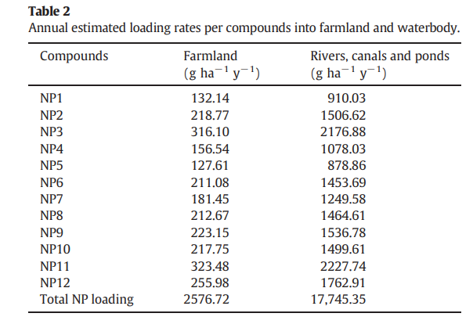

**Shiyu Wang**, Wenyong Wu*, Fei Liu, Shiyang Yin, Zhe Bao, Honglu Liu. Spatial distribution and migration of nonylphenol in groundwater following long-term wastewater irrigation. Journal of Contaminant Hydrology,2015,177-178（June–July）:85-92.

1. The kinect models should be given.

R: It has been given in Table1.

1. Figure 1 should be revised according to kinect model.

R: Accepted and revised in Figure1. All the isomers were revised according to kinect model except some isomers, such as NP2 NP5 and NP11. The degradation of these isomers were stable within the former several days, which mentioned in the manuscript. So these former points conformed to ﬁrst-order kinetic formula.

1. I strongly recommend the authors to analysis the biomass of the soil samples

R: Indeed, in this study, the analysis of biomass and microorganism of the soil samples is essential. But I did not do that. The main reason is that this experiment was conducted during my being in University of Florida, USA as a visiting scholar. My visiting time is only one year. At the end, I had no time to complete and analysis the microbial community and biomass of the soil samples. Worse more, the soil can not be brought to China. But in the further study of the NP isomers in reclaimed water soil, this should be taken into account.

Your careful review of this manuscript is highly appreciated. I am looking forward to the good news. Please feel free to contact me if any questions.

Yours sincerely,

Shiyu Wang

759932572@qq.com