Module 1.2 Assignment

Luis Rodriguez

6/7/26

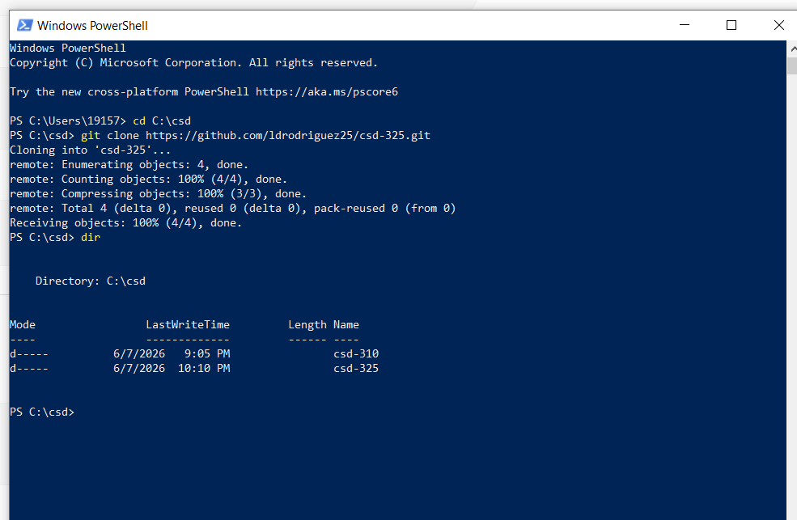
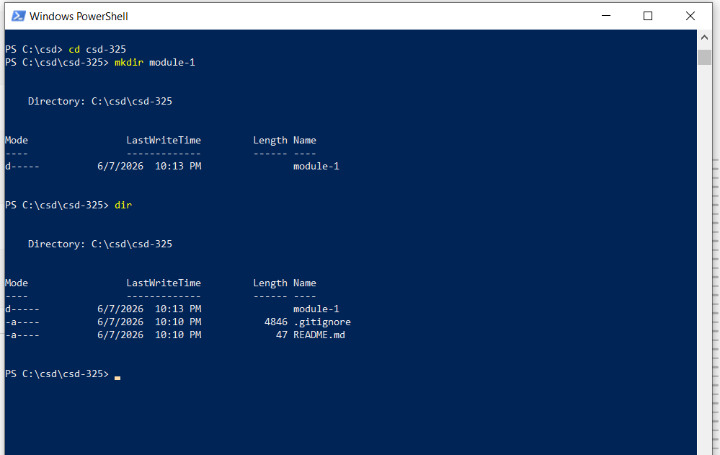

https://github.com/ldrodriguez25/csd-325

