1. 下载kRPC相应的.jar包

打开<https://github.com/krpc/krpc/releases>并点击下载Java文件



1. 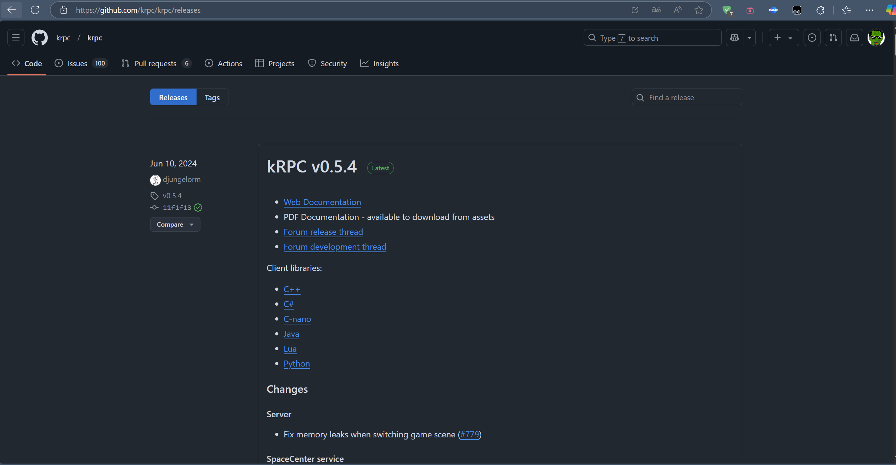新建 Java文件

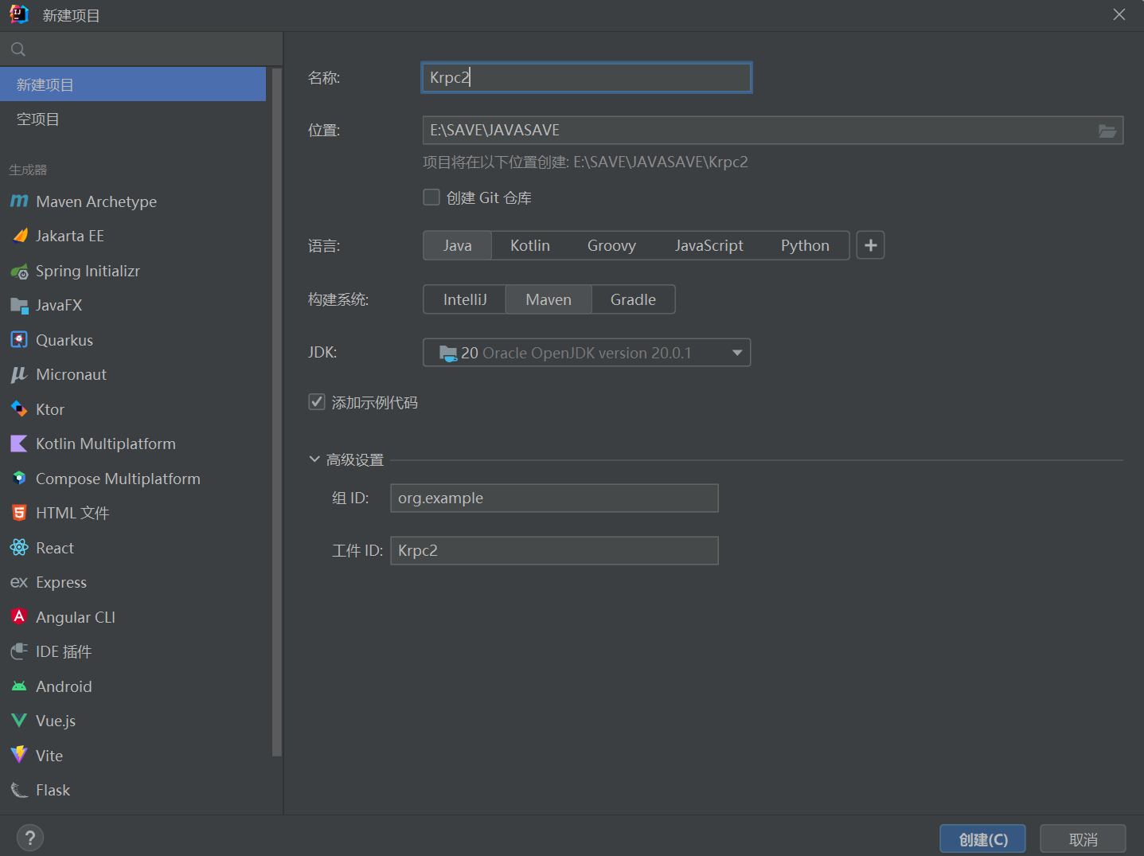创建新项目，构建系统选择Maven



打开项目结构->模块->依赖-> + ->JAR或目录->krpc-java-版本号.jar

1. 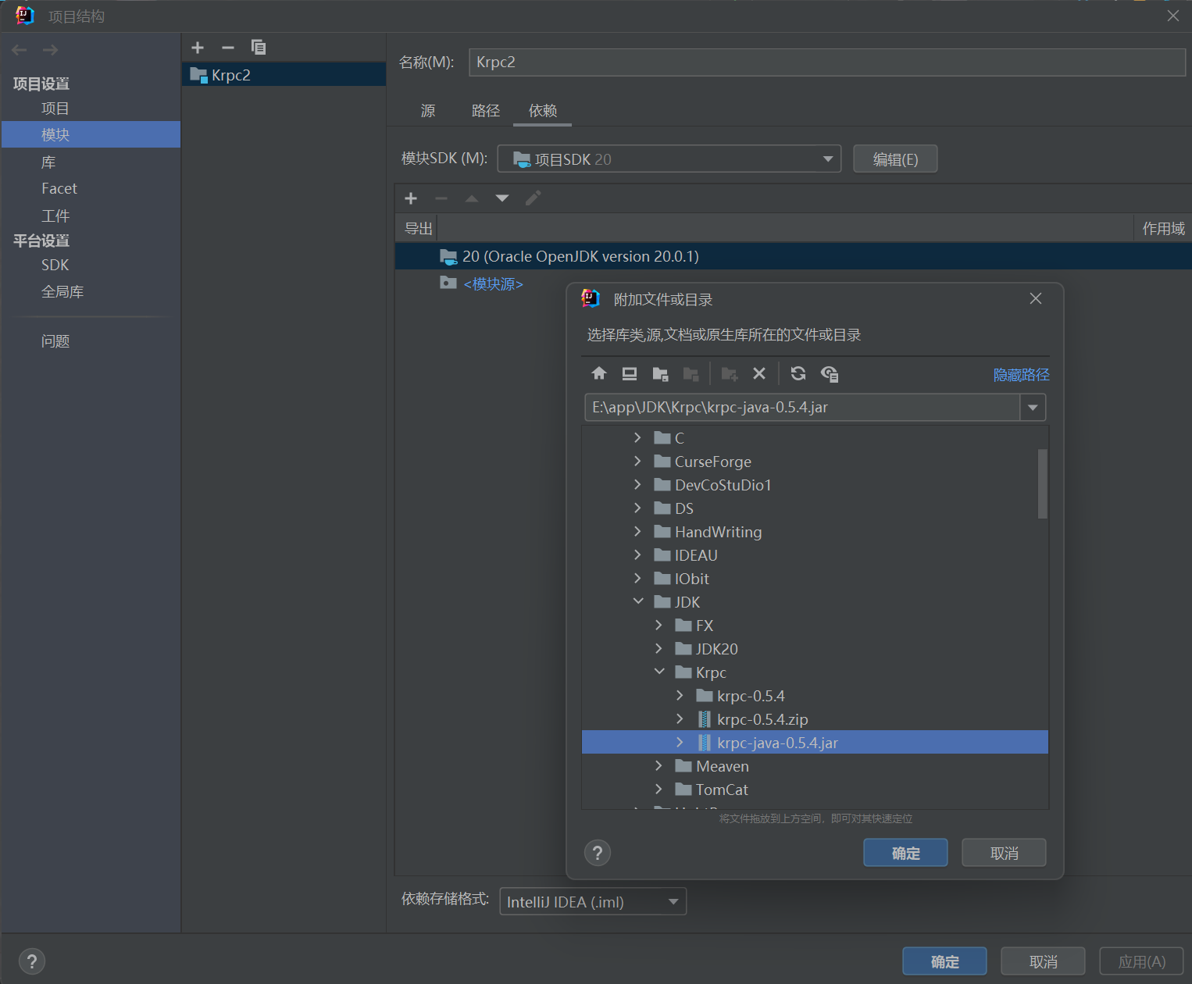打开pom.xml文件



全选粘贴以下文档，并点击“加载Maven更改”按钮

<?xml version="1.0" encoding="UTF-8"?>  
<project xmlns="http://maven.apache.org/POM/4.0.0"  
 xmlns:xsi="http://www.w3.org/2001/XMLSchema-instance"  
 xsi:schemaLocation="http://maven.apache.org/POM/4.0.0 http://maven.apache.org/xsd/maven-4.0.0.xsd">  
 <modelVersion>4.0.0</modelVersion>  
  
 <groupId>org.example</groupId>  
 <artifactId>KerbalNow</artifactId>  
 <version>1.0-SNAPSHOT</version>  
  
 <properties>  
 <maven.compiler.source>20</maven.compiler.source>  
 <maven.compiler.target>20</maven.compiler.target>  
 <project.build.sourceEncoding>UTF-8</project.build.sourceEncoding>  
 </properties>  
  
 <dependencies>  
 <dependency>  
 <groupId>com.google.protobuf</groupId>  
 <artifactId>protobuf-java</artifactId>  
 <version>3.19.1</version>  
 </dependency>  
  
 <dependency>  
 <groupId>org.javatuples</groupId>  
 <artifactId>javatuples</artifactId>  
 <version>1.2</version>  
 </dependency>  
 </dependencies>  
  
 <build>  
 <plugins>  
 <plugin>  
 <groupId>org.xolstice.maven.plugins</groupId>  
 <artifactId>protobuf-maven-plugin</artifactId>  
 <version>0.6.1</version>  
 <configuration>  
 <protocExecutable>path/to/protoc</protocExecutable>  
 <protoSourceRoot>${project.basedir}/src/main/proto</protoSourceRoot>  
 <outputDirectory>${project.basedir}/src/main/java</outputDirectory>  
 </configuration>  
 <executions>  
 <execution>  
 <goals>  
 <goal>compile</goal>  
 </goals>  
 </execution>  
 </executions>  
 </plugin>  
 </plugins>  
 </build>  
  
</project>

1. 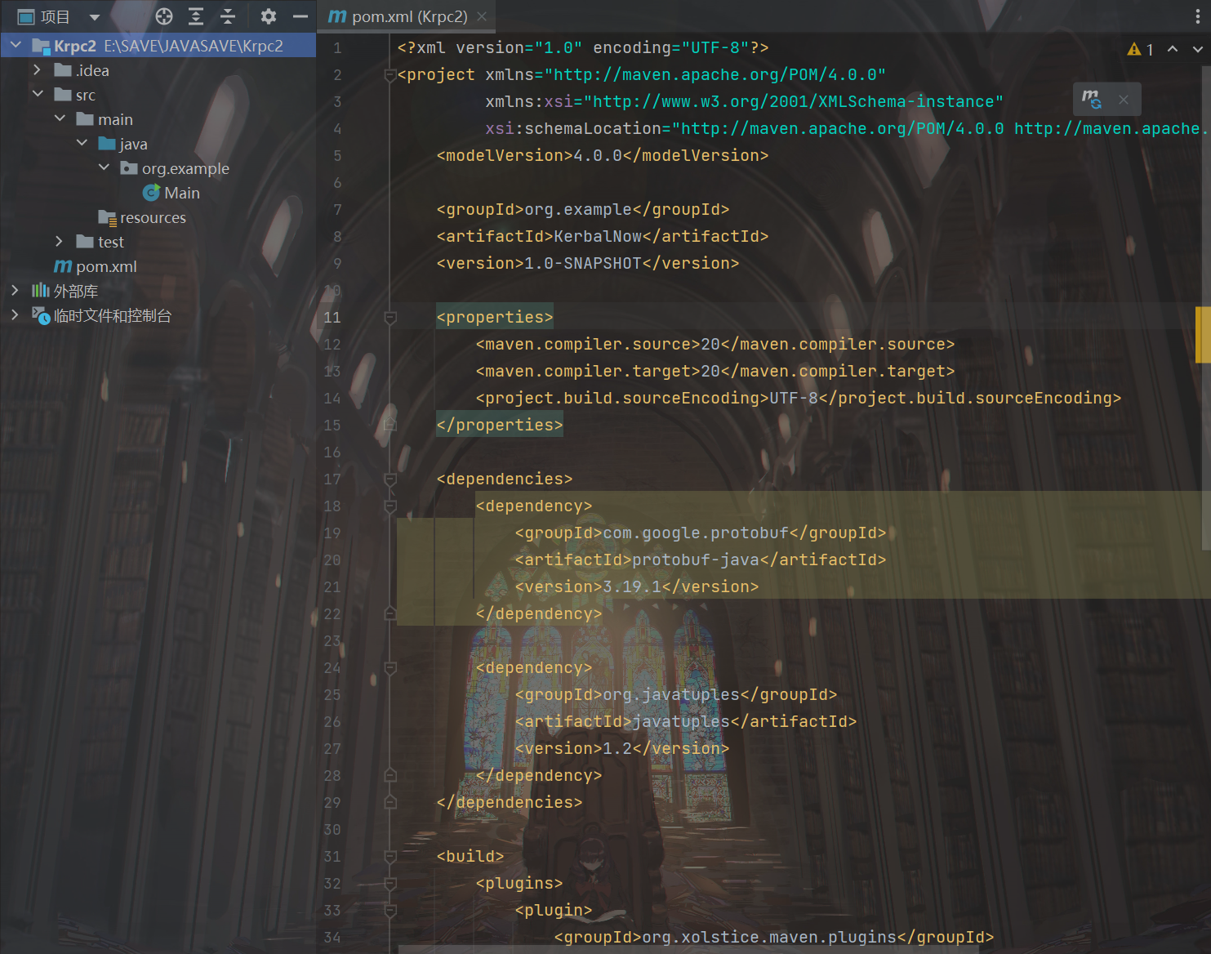**创建Java文件**



package org.example;

import krpc.client.Connection;

import krpc.client.RPCException;

import krpc.client.Stream;

import krpc.client.StreamException;

import krpc.client.services.SpaceCenter;

import java.io.IOException;

public class Main {

public static void main(String[] args) throws IOException, RPCException, StreamException, InterruptedException {

}

}

有关使用文档与教程参考[kRPC Documentation — kRPC 0.5.4 documentation](https://krpc.github.io/krpc/)，但此网站给出的案例程序有错，包含有很多空循环

1. **安装游戏插件**

词条不说明。运行Java程序前需要启动游戏内插件，需要打开服务器。