Exmormon_Motives_Survey_-_v10_-_Copy

Survey Flow

Standard: Introduction (3 Questions)

Standard: Demographics (23 Questions)

Block: TBM Background (5 Questions)

Standard: Catalyst for the crisis (14 Questions)

Standard: What sources? (3 Questions)

Standard: Where are you now with your faith? (9 Questions)

|  |  |
| --- | --- |
| Page Break |  |

Start of Block: Introduction

Q3 Welcome to the survey on why you stopped believing the narrative taught by the church.  
  
The purpose of this survey is primarily to answer the question of why Mormons leave the church, or at least why they leave orthodox Mormonism.  
  
We don't have an IRB for this so I won't be able to publish the results in an academic journal.  If you care about that sort of thing, you'll have to give us your blind faith that we will use this data for good and not evil.  IRB's are a pain in the butt, so we wouldn't want to really get into that anyway.  Once the results are published, if you want to use the results using a Category 4 exemption, knock yourself out.  
  
The survey does not contain any questions that would allow me to identify you unless you write your name, give too many personal details, or something like that.  If you do this, it is your own fault.  We will make the final results available in an excel sheet, so don't write anything that would identify yourself.  Seriously.  
  
We are also using built-in logic to disallow responses that come from the same computer.  Sorry if you live with your fellow non-believing significant other.  Use different devices if you both want to respond.  
  
Please answer honestly.  No one here is judging you.  This is mostly for curiosity.  
  
Finally, as we all know, a faith transition can be harrowing.  If talking about your experience is still too raw for you, you should probably skip the survey for now since most of the multiple choice questions are required.  When you are in a better place, we would love to hear your story.

Q4 I have read the above disclaimer, and I agree that by taking this survey I recognize that my anonymity can only be guaranteed as far as I am not stupid and identify myself voluntarily by typing something that would identify me in a comment box.

* Yes (1)
* No (2)

Skip To: End of Survey If Q4 = No

Q74 Did you participate in one of the earlier survey trials?  
  
Your answer does not affect the survey.  We ask only to help people who want to do statistics with the results.

* Yes (1)
* No (2)
* Don't remember (3)

End of Block: Introduction

Start of Block: Demographics

Q31 This section is for demographic questions.  I tried to keep it short and only included demographics that might have an interesting relationship with specific issues.

Q15 What is your age?

* <18 (1)
* 18-24 (2)
* 25-35 (3)
* 36-45 (4)
* 46-55 (5)
* 56-65 (6)
* 66+ (7)

Q16 What best describes your gender?

* Male (1)
* Female (2)
* Transgender or a non-conforming gender (3)

Q17 What best describes your sexual orientation?

* Heterosexual ("Straight") (1)
* Homosexual ("Gay or Lesbian") (2)
* Bisexual (3)
* Asexual, unsure, or other orientation (4)

Q18 What is your **current** marital status?

* Single (never married) (1)
* Currently married (2)
* Polygamously married (3)
* Divorced (4)
* Separated (5)
* Widowed (6)

Q19 What was your marital status when **your faith transition first started**?

* Single (never married) (1)
* Married (2)
* Polygamously married (3)
* Divorced (4)
* Separated (5)
* Widowed (6)

Q38 What sect of Mormonism did you belong to when your faith transition first started?

* The Church of Jesus Christ of Latter Day Saints (CoJCoLDS), Brighamite - Salt Lake City (1)
* Community of Christ (2)
* CoJCoLDS - Temple Lot (3)
* Fundamentalist CoJCoLDS (Colorado City) (4)
* Other (Please write it in) (5) ________________________________________________

Display This Question:

If Q19 = Married

Or Q19 = Polygamously married

Q23 Did your spouse join you in leaving the church narrative? (This question was added late)

* Yes (1)
* On their way, at least I hope (2)
* No (3)
* We divorced as a result of my faith transition (4)
* Other (Please write it in) (5) ________________________________________________

Q60 Are you from the US/Canada or elsewhere in the world?

* US/Canada (1)
* Elsewhere (2)

Display This Question:

If Q60 = US/Canada

Q61 What part of the US or Canada did you grow up in or do you call home?  Please click on the map approximately where you claim home.

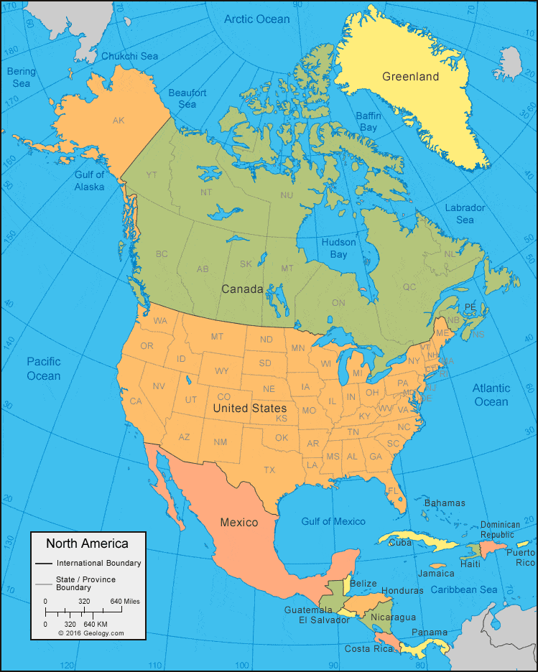

Display This Question:

If Q60 = Elsewhere

Q59 What part of the world did you grow up in or do you call home?  Please click on the map approximately where you claim home.

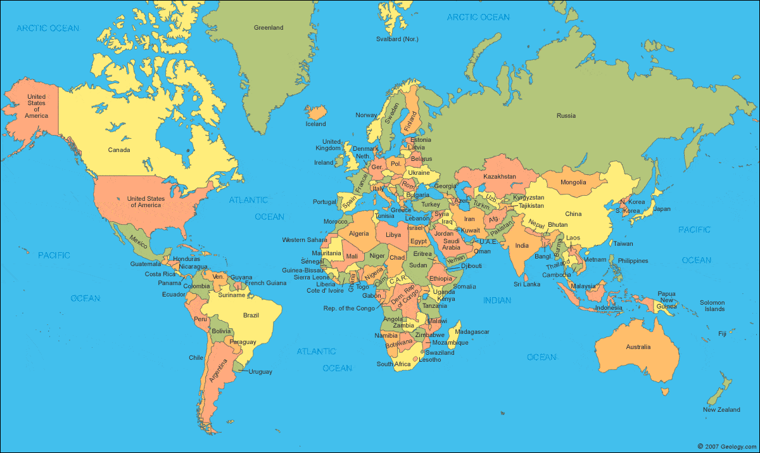

Q21 What is your current relationship with Mormonism?

* Never Mormon (1)
* Active member (no specific or concrete plans of leaving) (2)
* Transitional member (NOM, Exploring, current attending for various reasons but working my way out) (3)
* Currently under church discipline (7)
* Inactive member (4)
* Resigned (5)
* Excommunicated (question added after first ~120 respondents) (9)
* Post-Mormon (no longer identify as Mormon in any way) (6)
* Other (Please write it in) (8) ________________________________________________

Skip To: End of Block If Q21 = Never Mormon

Q22 How did the church come into your life?

* Born into a Mormon family where both parents were active (1)
* Born into a mixed-faith home (6)
* Family joined the church before I was 12 (2)
* Family joined the church when I was between 13 and 18 (3)
* Convert (I joined the church because I wanted to, any age) (4)
* Other (please write it in) (5) ________________________________________________

Q24 Mark all the callings you held at any point.  If these callings did not exist in your sect, use "other" to write in the ones you held.

* Never held a calling (1)
* Calling as a youth (YM/YW age) (2)
* Committee calling or a calling not found in the official handbook (3)
* Teaching/Sunday School (4)
* Primary/Nursery/Ward Choir/Pianist/Ward Missionary/Family History/Other Auxiliary (5)
* YM/YW/Sunday School Presidency/Ward Mission Leader (12)
* Elders Quorum/Relief Society Presidency (6)
* Bishopric/Branch presidency secretaries/clerks (15)
* Bishopric / Branch presidency (14)
* High Priest Leadership (7)
* Stake Calling (8)
* Stake Presidency (9)
* Evangelist (23)
* Mission, Area, Temple or counselor (10)
* General Authority (24)
* Patriarch (11)
* Other (Please write it in) (13) ________________________________________________

Q25 Did you serve an LDS mission?

* Yes (including service missions) (1)
* No (2)

Q26 Mark all the temple work you ever participated in.

* Never participated (1)
* Sealings (as a child, parents to children) (8)
* Baptisms for the dead (2)
* Initiatory (3)
* Endowments (16)
* Sealings (between spouses) (4)
* Temple worker (5)
* Second Anointing (6)
* Washing of the feet (12)
* Public services in Kirtland or Independence (Community of Christ) (9)
* Private services in Kirtland or Independence (community of Christ) (10)
* Other (Please write it in) (7) ________________________________________________

Display This Question:

If Q19 != Single (never married)

Q27 Were you sealed in an LDS temple?

* Yes - married and sealed on the same day (1)
* Yes - sealed a later day, after our wedding day (3)
* No (2)

Q37 Prior to your faith transition, what was your typical activity level?

* Never attended (4)
* Attended long enough to get each child baptized (5)
* Attended big holidays or family events (6)
* Attended off and on, but at least several times each year (7)
* Attended roughly every other Sunday (8)
* Attended most Sundays but only 1st hour OR most Sundays but skipped weekday meetings (9)
* Attended most Sundays and most weekday meetings (10)
* Attended nearly every meeting, fireside, and paid conference I could (and maybe felt bad if I didn't) (11)
* Other (please write it in) (12) ________________________________________________

Q46 At your **most active** in the church, what was your typical level of activity?

* Never attended (1)
* Attended long enough to get each child baptized (4)
* Attended big holidays or family events (5)
* Attended off and on, but at least several times each year (6)
* Attended roughly every other Sunday (7)
* Attended most Sundays but did not usually stay for more than sacrament or go to weekday meetings (8)
* Attended most Sundays and most weekday meetings (9)
* Attended nearly every meeting, fireside, and paid conference I could (and maybe felt bad if I didn't) (10)
* Other (please write it in) (3) ________________________________________________

Q47 What is your **current** activity level?

* Not attending (1)
* Attending long enough to get each child baptized (4)
* Attending big holidays or family events (5)
* Attending off and on, but at least several times each year (6)
* Attending roughly every other Sunday (7)
* Attending most Sundays but do not usually stay for more than sacrament or go to weekday meetings (8)
* Attending most Sundays and most weekday meetings (9)
* Attending nearly every meeting, fireside, and paid conference I can (10)
* Other (please write it in) (11) ________________________________________________

Q52 Did you experience any instances of sexual misconduct (molestation, rape, sexual harassment) by anyone affiliated with the church?   
  
This question is **not required**.  Only answer if you feel comfortable.

* Yes, often (1)
* Yes, occasionally (2)
* Yes, but only on a few instances (3)
* No (4)
* Other (please write it in) (5) ________________________________________________

Display This Question:

If Q52 != No

Q53 You answered that you experienced sexual misconduct from a member of the church or you entered "other".  What was the role of that person in the church?  If there was more than one person, answer for the highest ranking individual.  
   
 This question is **not required**.  Only answer if you feel comfortable.

* I did not experience sexual misconduct (1)
* A youth or someone without an ecclesiastical role (3)
* A YM/YW leader (4)
* A home teacher (5)
* A member of the bishopric (6)
* A member of the stake presidency (7)
* Other (please write in, if comfortable) (8) ________________________________________________

Display This Question:

If Q53 = A member of the bishopric

Q62 You selected that you experienced sexual misconduct from a member of the bishopric.  In what way did you experience this misconduct?

* Worthiness interviews that were inappropriate (1)
* Other, I'd rather not disclose (2)
* Other (please write it in) (3) ________________________________________________

End of Block: Demographics

Start of Block: TBM Background

Display This Question:

If Q21 != Never Mormon

Q32 This section probes what your testimony was like prior to losing your faith.

Q39 When you were **at your most active** in the church, at least a year before you started your faith transition, what were the **doctrines** that you believed in the **strongest**? (i.e. you had a strong testimony of these things)

* I never questioned any of these doctrines (53)
* I never believed any of these doctrines (59)
* Jesus Christ being real and divine (1)
* The atonement and the ability to change and repent (6)
* The Godhead (three unique, embodied beings who are Gods) (7)
* Heavenly mother(s) (8)
* Holy Ghost/Light of Christ providing comfort and guidance (2)
* Miracles (30)
* God hears and answers prayers (55)
* Joseph Smith being a true prophet who restored the original church in these latter days (9)
* The Book of Mormon being a true, historical book (11)
* D&C, Book of Abraham, and other translations and revelations being true and historical (12)
* The current prophet being a true prophet (13)
* The Church of Jesus Christ LDS being the one true church and having the sole claim to the priesthood (14)
* The "curse of Cain" being a reason that blacks could not receive the priesthood until after 1978 (16)
* The temple ceremonies being inspired by God (17)
* Eternal marriage (polygamous) (18)
* Eternal marriage (monogamous) (19)
* The work for the dead/family history being necessary for salvation (20)
* The plan of salvation (21)
* Becoming a god (23)
* The word of wisdom (25)
* The law of chastity (26)
* The law of tithing / consecration (27)
* The Second Coming and Millennium are near (29)
* Other (Please write it in) (3) ________________________________________________

Q64 When you were **at your most active** in the church, at least a year before you started your faith transition, what were the **doctrines** that you believed in the **least**? (i.e. you had a weak or no testimony of these things)

* I never questioned any of these doctrines (1)
* I never believed any of these doctrines (4)
* Jesus Christ being real and divine (5)
* The atonement and the ability to change and repent (6)
* The Godhead (three unique, embodied beings who are Gods) (7)
* Heavenly mother(s) (8)
* Holy Ghost/Light of Christ providing comfort and guidance (9)
* Miracles (10)
* God hears and answers prayers (11)
* Joseph Smith being a true prophet who restored the original church in these latter days (12)
* The Book of Mormon being a true, historical book (13)
* D&C, Book of Abraham, and other translations and revelations being true and historical (14)
* The current prophet being a true prophet (15)
* The Church of Jesus Christ LDS being the one true church and having the sole claim to the priesthood (16)
* The "curse of Cain" being a reason that blacks could not receive the priesthood until after 1978 (17)
* The temple ceremonies being inspired by God (18)
* Eternal marriage (polygamous) (19)
* Eternal marriage (monogamous) (20)
* The work for the dead/family history being necessary for salvation (21)
* The plan of salvation (22)
* Becoming a god (23)
* The word of wisdom (24)
* The law of chastity (25)
* The law of tithing / consecration (26)
* The Second Coming and Millennium are near (27)
* Other (please write it in) (3) ________________________________________________

Q41 What common Mormon activities gave you a strong sense of meaning, purpose, or beauty?

* Home/visiting teaching (1)
* Keeping the Sabbath day holy (4)
* Paying tithing and fast offerings (5)
* Fasting for a purpose (6)
* Rendering service (7)
* Reading your scriptures (8)
* Private prayer (9)
* Group prayer (23)
* Your own baptism (38)
* Taking the sacrament/communion (39)
* Attending meetings (10)
* Attending institute or other religion classes (11)
* Attending a live convert baptism (12)
* Baptisms for the dead (13)
* Initiatory/Endowment ceremony (14)
* Sealing Ceremony (15)
* Keeping a food storage (16)
* Doing family history (17)
* Family home evening (18)
* Receiving a patriarchal blessing (40)
* Witnessing or participating in priesthood blessings, such as baby blessing, healings, Father's blessings, etc. (20)
* Avoiding sexual encounters (21)
* Avoiding coffee, tea, tobacco, alcohol, or drug abuse (22)
* Other (Please write it in) (3) ________________________________________________

Q42 What common Mormon activities gave you a strong sense of discomfort or embarrassment or a strong desire to not participate?

* Home/visiting teaching (1)
* Keeping the Sabbath day holy (4)
* Paying tithing and fast offerings (5)
* Fasting for a purpose (6)
* Rendering service (7)
* Reading your scriptures (8)
* Private prayer (9)
* Group prayer (2)
* Your own baptism (24)
* Taking the sacrament/communion (25)
* Attending meetings (10)
* Attending institute or other religion classes (11)
* Attending a live convert baptism (12)
* Baptisms for the dead (13)
* Initiatory/Endowment ceremony (14)
* Sealing Ceremony (15)
* Keeping a food storage (16)
* Doing family history (17)
* Family home evening (18)
* Receiving a patriarchal blessing (26)
* Witnessing or participating in priesthood blessings, such as baby blessing, healings, Father's blessings etc. (20)
* Avoiding sexual encounters (21)
* Avoiding coffee, tea, tobacco, alcohol, or drug abuse (22)
* Other (please write it in) (3) ________________________________________________

End of Block: TBM Background

Start of Block: Catalyst for the crisis

Q33 This section explores what started you down "the rabbit hole".

Q11 How long did your faith transition last?  If you are still going through your transition, how long has it been since your transition started?

* I have not started a faith transition OR I have never believed in the church (6)
* 0-1 months (1)
* 2-9 months (2)
* 10 months to 2 years (3)
* 3 years to 10 years (4)
* More than 10 years (5)

Q6 Throughout our faith transitions, we find many reasons that the church is false.  Think back to the **primary reason** that caused you to **stop believing for good**.  
  
We'll ask about more details later.

* I never had a strong testimony (3)
* Social justice problems with the church, including gay rights, sexism, racism, financial transparency, other church policies (1)
* The troubling aspects of church history, including specific truth claims (2)
* Doctrinal issues, including specific doctrines and contradictions within scriptures (10)
* The historicity of scripture, including the Bible, Book of Mormon, etc. (13)
* Doctrines shifting over time (4)
* Tired of the workload, not spiritually or socially satisfied for all the effort (5)
* Lack of prophesy/leadership from the modern prophets (6)
* Epistemological/philosophical problems, including spiritual witnesses found in other faiths and unreliability of spiritual knowledge (12)
* Inability to control sinful nature, as defined by the church, including homosexuality, pornography, general chastity, keeping the Sabbath day holy, greed, etc. (7)
* Personally offended by a member of the church that you know (8)
* Had a spiritual experience that convinced you that the Mormon religion is not true (11)
* Other (please write in) (9) ________________________________________________

Q65 What were the specific topics/issues that caused you to initially lose your faith?  
  
This question is optional

________________________________________________________________

________________________________________________________________

________________________________________________________________

________________________________________________________________

________________________________________________________________

Q66 The following questions ask about specific issues that contributed to your faith transition.

Q7 Did any of the following **social issues** contribute to your faith transition?

* None of these issues bothered me (19)
* The church's efforts against gay marriage (1)
* The treatment of gays, including at BYU, especially in the 1970's (2)
* The church teaching that homosexuality is a choice and inherently sinful (10)
* The role of women in the church, including leadership positions and priesthood ordination (3)
* The treatment of victims, including domestic violence, rape, sexual abuse, and child victims (11)
* Private interviews covering sexual matters between adult men and children (12)
* The racism, including denying blacks the priesthood, calling Amerindians "Lamanites" and Polynesians "Haggoth's descendants", etc. (4)
* Financial issues, including the lack of financial transparency, salaries for church leaders, and the low amounts given to humanitarian efforts (5)
* The November policy (6)
* Family members without temple recommends being excluded from temple weddings (7)
* Unsupervised interviews probing sexual behavior between a middle-aged man and children (8)
* Other (please write it in) (9) ________________________________________________

Q5 Did any of the following **historical issues** contribute to your faith transition?

* None of these issues bothered me (16)
* Polygamy/polyandry/sexual predation, including the lies to hide it and the Nauvoo Expositor (1)
* Brigham Young's racism, including advocacy for slavery (2)
* Brigham Young's sexism (3)
* Blacks not receiving the priesthood (4)
* The Book of Abraham translation (5)
* The lack of archaeological, linguistic, cultural, and other evidence for the Book of Mormon (6)
* The evidence that shows the Book of Mormon is a 19th century work (7)
* The Kinderhook plates, Greek Psalter, etc. (8)
* The evolution of Joseph's claims, including the first vision, the priesthood restoration, his heavenly gift, etc. (9)
* Joseph's use of seer stones and other occult objects (10)
* The revisions to the Doctrine and Covenants (11)
* The treatment of apostates, including Thomas Marsh, the Avenging Angels, the Danites (12)
* The Salt Sermon / Danites / Avenging Angels (13)
* Masonic origins of the temple ceremony (14)
* Other (please write it in) (15) ________________________________________________

Q48 Did any of the following **doctrinal contradictions** contribute to your faith transition?

* None of these issues bothered me (6)
* The incompatibility of Mormon scriptures with Biblical Christianity (1)
* Differences between the current marriage and salvation doctrines and D&C 132 (2)
* Differences between modern interpretations of the Word of Wisdom and the scriptural version (3)
* Difference between the current church hierarchy / power distribution and the organization found in the D&C (4)
* Other (please write it in) (5) ________________________________________________

Q49 Did the **historicity** of any of the following **scriptures** contribute to your faith transition?

* The historicity of these scriptures did not bother me (17)
* Old Testament (1)
* New Testament (9)
* Book of Mormon (2)
* Book of Abraham (3)
* Book of Moses (4)
* Joseph Smith Translation (5)
* Joseph Smith - History (6)
* Doctrine and Covenants (7)
* Other (please write it in) (8) ________________________________________________

Q8 Did any of the following **church doctrines** contribute to your faith transition?

* None of these doctrines bothered me (13)
* The Adam-God doctrine (1)
* Blood atonement (2)
* Blacks not receiving the priesthood due to the curse of Cain until 1978 (3)
* The plan of salvation (4)
* The nature of God (Trinitarianism to henotheism) (5)
* The changes to the temple ceremonies (6)
* Polygamy being required for exaltation (7)
* The shift from revelations to declarations to proclamations to news-room announcements (8)
* Young earth creationism (9)
* Abortion, birth control, and other sexual issues (10)
* Tithing (11)
* Other (please write it in) (12) ________________________________________________

Q9 Did the of any of the following **"sins"**, as defined by the church, contribute to your faith transition?

* None (please check "other" if doing analysis, since this answer was added late) (8)
* Pornography/masturbation (1)
* Same-sex attraction/homosexuality (2)
* Keeping the Sabbath day holy (3)
* Fornication/adultery (heterosexual) (4)
* Keeping the Word of Wisdom (6)
* Other (please write it in) (5) ________________________________________________

Q67 Did any of the following **personal experiences with the church** contribute to your faith transition?

* The temple endowment (1)
* Sexual misconduct (2)
* Sacrament/worship not fulfilling (3)
* Shunning, gas-lighting, treatment of apostates (4)
* Home teaching (6)
* Lack of miracles, lack of healing (7)
* Learning you had been lied to about history (8)
* Other (please write it in) (5) ________________________________________________

Q37 If you feel comfortable, without giving personal details, feel free to share your faith transition story.  
  
This question is optional.

________________________________________________________________

________________________________________________________________

________________________________________________________________

________________________________________________________________

________________________________________________________________

Q58 What, if anything, do you miss about the church?

* Sense of identity and associating with a "force for good" (1)
* The built-in social network (2)
* Reputation (3)
* Service opportunities (4)
* Other (please write it in) (5) ________________________________________________

End of Block: Catalyst for the crisis

Start of Block: What sources?

Q34 This section asks what resources you used during your faith transition.

Q28 What resources did you use when you **first** started your faith transition?

* LDS.org and official, published literature (currently in print) (1)
* Books and other media authored by general authorities, including "unofficial" books (17)
* Primary sources, including journals, transcripts, the Journal of Discourses etc. (2)
* Unofficial faithful sources, including the Bloggernacle (20)
* Critical compilation sources, including the CES Letter, Letter to my Wife, Letter to an Apostle, and Mormonthink (10)
* Critical books, including Grant Palmer, Fawn Brodie, etc. (30)
* Apologetic sources, including fairmormon.org (4)
* Secular sources, including Wikipedia (19)
* Atheist sources (31)
* "Anti-Mormon" sources, including Outer Blogness, Mormons in Transition, the Tanners (5)
* Story focused blogs and sites, including Mormon Stories, Year of Polygamy (6)
* Exmormon-focused social media, including Facebook, Reddit, Recovery from Mormonism (7)
* Believing-focused social media, including Facebook or Reddit (8)
* Christian resources, including theological commentaries, sermons, books, etc. (16)
* Other (please write in) (9) ________________________________________________

Q29 What resources do you use now?

* LDS.org and official, published literature (currently in print) (1)
* Books and other media authored by general authorities, including "unofficial" books (17)
* Primary sources, including journals, transcripts, the Journal of Discourses etc. (18)
* Unofficial faithful sources, including the Bloggernacle (19)
* Critical compilation sources, including the CES Letter, Letter to my Wife, Letter to an Apostle, and Mormonthink (20)
* Critical books, including Grant Palmer, Fawn Brodie, etc. (29)
* Apologetic sources, including fairmormon.org (21)
* Secular sources, including Wikipedia (22)
* Atheist sources (30)
* "Anti-Mormon" sources, including Outer Blogness, Mormons in Transition, the Tanners (23)
* Story focused blogs and sites, including Mormon Stories, Year of Polygamy (24)
* Exmormon-focused social media, including Facebook, Reddit, Recovery from Mormonism (25)
* Believing-focused social media, including Facebook or Reddit (26)
* Christian resources, including theological commentaries, sermons, books, etc. (27)
* Other (please write in) (9) ________________________________________________

End of Block: What sources?

Start of Block: Where are you now with your faith?

Q35 Finally, a few questions about your current beliefs.

Q36 What are your feelings toward the LDS church?

* I think it is great and is a net positive in the world. I find truth in it, despite not finding its entire narrative to be true. (1)
* I do not care about the church. It is so insignificant in the grand scheme of things that I don't think much about what it is doing or if it is good or bad. (2)
* There are good parts and bad parts, and I can't say if the whole is good or bad (7)
* My feelings shift between neutral and negative (6)
* I think it is net negative in the world. I respect that others can find truth in it, but I think it does more harm than good. (3)
* The church embodies evil. It is a truly terrible organization and should be opposed. (4)
* Other (Please write it in) (5) ________________________________________________

Q30 How would you characterize your current belief in God?

* Agnostic - Non-Atheist, Non-Theist (if you don't know, choose this one) (3)
* Atheist - Agnostic (1)
* Atheist - Gnostic (2)
* Judeo-Christian Theist (4)
* Deist (7)
* Animist (8)
* Other Theist (5)
* Pantheist (11)
* Spiritualist (12)
* Other (please write in) (6) ________________________________________________

Q51 Which teachings of the church or how things are taught, if any, do you feel to be the most harmful?

* I do not find any of the teachings to be harmful (1)
* Teachings on family lines being broken by apostates (22)
* Teachings on homosexuality (2)
* Teachings on sexual activity outside marriage (3)
* Teachings on pornography / masturbation (13)
* Teachings on chastity, self worth, and modesty (i.e. rape culture, "chewed up gum" analogies, etc.) (11)
* Teachings on sexual differences between genders (5)
* Teachings on womanhood and gender roles (4)
* Teachings regarding Jesus Christ (6)
* Teachings regarding tithing (7)
* Teachings on the word of wisdom (8)
* Teachings regarding emotions, including anger (contention), happiness, etc. (9)
* Teachings regarding blind obedience (23)
* Teachings that make believers fear leaving the church (24)
* Other (Please write it in) (10) ________________________________________________

Q50 How has your family reacted to your transition?

* They do not know yet (8)
* With joy and welcomed me back with open arms (1)
* With indifference, they let me live my own life (2)
* With skepticism, they question my motives, but leave it at that (3)
* With disdain, they strongly disagree with me, but we keep it civil or don't talk about it. (4)
* With utter contempt. I've been shunned and shut out of most family events. (5)
* I was legally disowned (6)
* Other (Please write it in) (7) ________________________________________________

Q54 What lifestyle changes have you made as a result of your transition?

* I have not made any changes to my lifestyle (1)
* Stopped wearing my garments (9)
* Stopped paying my tithing (10)
* Living openly as homosexual (2)
* Having sex with someone you are not married to (3)
* Divorce (4)
* Using more pornography / masturbating more (5)
* Drinking alcohol (6)
* Using illegal drugs (7)
* Other (please write it in) (8) ________________________________________________

Q71 How much do you "sin" now that you no longer believe?  Answer the question based on **how the church defines sin**.

* I sin far less than before (1)
* I sin less than before (2)
* I sin about as often as before (3)
* I sin more than before (4)
* I sin much more than before (5)

Q72 How much do you "sin" now that you no longer believe.  Answer based on what **you now consider** to be sinful or immoral.

* I sin far less than before (1)
* I sin less than before (2)
* I sin about as often as before (3)
* I sin more than before (4)
* I sin much more than before (5)

Q68 What, if anything, would convince you to return and become (or continue to be) a Mormon again?  This includes being a 'cultural' or non-orthodox Mormon?  
  
This question is optional.

________________________________________________________________

________________________________________________________________

________________________________________________________________

________________________________________________________________

________________________________________________________________

End of Block: Where are you now with your faith?