
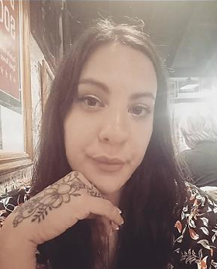
CARLA FRUGONI
frugonicarla@gmail.com

PERSONAL DETAILS
134 Stortini
General Fernández Oro, Río Negro
+54 9 299 6303494

ID: 32779144

OBJECTIVES
I am a very proactive and organized person. I like to get involved with my community and help out whenever I can. I´ve been studying English since I was 5, and I am trying to further develop my knowledge, vocabulary and culture. I am adaptable to new circumstances and I’m a fast learner.

EDUCATION
Instituto de Enseñanza Superior en Lenguas Vivas “Sofía B. de Spangenberg” Location: 3251 Juncal.Capital Federal. Buenos Aires.
Field of study: English translator Not finished

WORK EXPERIENCE

04/2024- PRESENT ORLANDO CITY CORPORATE HOUSING
- Housing Specialist
Tasks: Manage calendars, schedule meetings, contact potential clients, marketing, social media. Tools used: Google Calendar, Canva, Gmail, Trello.

10/2021- 01/2024 AVAYA
- Project Administrator
Tasks: this role was created by the company to assist Project Managers on their administrative and financial tasks. Tools used: Mavenlink, E-Project, SAP.

09/2020 – 10/2021 HOMELAND LANGUAGE SERVICE
- Over The Phone Interpreter
Tasks: being an intermediary between LEP’s and english-speaking clients like Government Departments, schools, private clinics, etc.

12/2017 – 03/2018 PELUQUERIA FLAVIA MARTINEZ (NEUQUEN)
- Hairstylist assistant
Tasks: assisting the hairstylist, applying hair products (color, hairtreatments, etc).

03/2016 – 12/2016 INSTITUTO PRIVADO ALMAFUERTE

- English Teacher
Tasks: class planning and teaching in secondary school.

04/2013 – 11/2013 HOLÍSTICO S.R.L

- English Teacher
Tasks: class planning and teaching adults.

COURSES AND SEMINARS

March 2015- December 2015
- Administrative- Accounting, salary settlement and Tax management- Instituto Balcarce (Cipolletti)
- Secretariat of Clinics and Hospitals- Instituto Balcarce (Cipolletti)

March 2012- June 2013
- Personal and Corporate Image Consultancy course- COE (CABA)

