TYPE YOUR TITLE HERE THE TEMPLATE HAS STYLES TO HELP FORMAT THE TITLE; STYLE NAMES ARE: “TITLE ONE-LINE” ETC

A Thesis
Presented to the
Faculty of
San Diego State University

In Partial Fulfillment
of the Requirements for the Degree
Type of Degree, e.g., Master of Arts
"in", "of", or "and"
Name of Degree, e.g. Education

by
Type Your Name Here
Term Completed: Fall, Spring,Or Summer year

SAN DIEGO STATE UNIVERSITY
The Undersigned Faculty Committee Approves the
Thesis of Type Your Name Here:
Type in Title of Thesis Here with Headline Style Capitalizaton

Type in Faculty Name (no DR or PhD), Chair
Type in Name of Department or School

Type in Faculty Name (no DR or PHD)
Type in Name of Department or School

Type in Faculty Name (no DR or PHD)
Type in Name of Department or School

Fourth Member, if needed
Type in Name of Department or School

Approval Date
Copyright © Year
by
Type Your Name Here
All Rights Reserved

dedication
Insert your dedication text here. This page is optional.

Insert you epigraph here if you have one, or delete this page plus the following section break.

ABSTRACT OF THE THESIS
Type in your Thesis Title Here in Headline Style
by
Your Name as it Appears on the Title Page
Your Degree as it Appears on the 3 Lines of the Title Page but Run Together here
San Diego State University, Year

Type in your abstract here using the “Single-spaced Text” Style. Indent paragraphs with one tab space; do not insert a blank line between paragraphs. This page is mandatory and must be 350 words or less. The abstract is a brief, comprehensive summary of the contents of the thesis. The abstract may not contain source documentation (citations).
TABLE OF CONTENTS
PAGE
ABSTRACT #
LIST OF TABLES #
LIST OF FIGURES #
ACKNOWLEDGEMENTS #
CHAPTER
- introduction 3
Heading 1 3
Heading 2 3
references 3
APPENDIX
- TITLE OF APPENDIX 3

The APPENDIX column heading and Preliminary page numbers (in lowercase Roman numerals) will need to be typed in manually, they will not generate automatically as part of the TOC. Add both things manually after generating the Table of Contents. See the “Generating a Table of Contents in the Template” guide on our website for additional help. Also, don’t forget to delete these instructions!
list of tables
PAGE
Table 1. Sample of a One-Row Table: Apply the Table Title Style in Text for Easy Formatting 3

list of figures
PAGE
Figure 1. SDSU photomontage. Applying the Caption style will help you update the List of Figures automatically. This includes matching text and the correct page number. 3
Figure 2. SDSU thesis template styles. Apply the Caption style in text for easy formatting. 3

acknowledgements
This page is optional. Insert your acknowledgements text here (except for students in Biology who will place this section after the text and before the reference list).

chapter 1
introduction
If you haven't done so already, read the Department Information guide for approved text formats and required department style guide before continuing any further.
There are many styles included in this template designed to make your formatting easier. For example we have created A CHAPTER LABEL and CHAPTER TITLE style that will help you automatically generate your Table of Contents. Applying the Chapter Label style will also begin the chapter on a new page and give you the correct 2” top margin. The 2” top margin required for all new sections is equivalent to 72 pts of space.

Heading 1
Here’s an example of what a Heading 1 might look like. This template has linked the Heading 1 and Heading 2 styles to the TOC so that they will automatically appear when you generate your Table of Contents.
- Lists are single spaced and followed by normal text spacing.
- Here is an example of a bullet list that wraps past 1 line. Here is an example of a bullet list that wraps past 1 line. Here is an example of a bullet list.
- Lists are single spaced and followed by normal text spacing.
- Here is an example of a numbered list that wraps past 1 line. Here is an example of a numbered list that wraps past 1 line.
Figure 1 and Figure 2 in this document show examples of figures so that you can see an example of the “List of Figures”. The same is true for Table 1. The thesis template styles make formatting these sections really easy. Simply apply the correct style to the desired text and update the field in the preliminary pages. Figures use the Caption style and Tables use the Table Title style.


Figure 1. SDSU photomontage. Applying the Caption style will help you update the List of Figures automatically. This includes matching text and the correct page number.
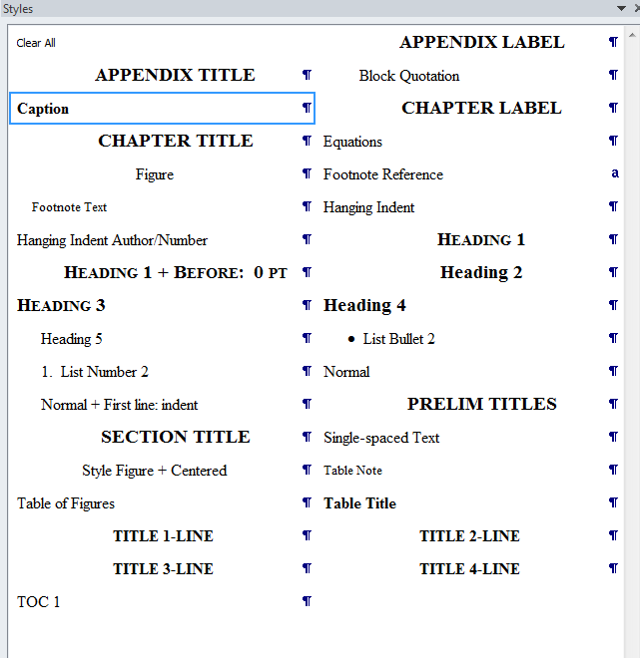
Figure 2. SDSU thesis template styles. Apply the Caption style in text for easy formatting.
Table 1. Sample of a One-Row Table: Apply the Table Title Style in Text for Easy Formatting
Sample Location | # of Samples | Type of Fungi | Relative Humidity, Temperature | Sampling Time
Environmental Chamber | 40 | Aspergillus niger | 50%, 25°C | 3 minutes
Note: Most tables will have more than one row; the purpose here is to show the table title.
Pages are provided in this template for the post-text sections, i.e., References, and Appendix (if you have appendices), just as they are for the preliminary page sections. Two pages formatted in LANDSCAPE orientation are also provided, but in a separate template document (SDSU Template Landscape Pages).

Heading 2
Here’s an example of a Heading 2. Remember to be consistent when formatting each heading level.
We have created an Equation style to help you center equations on a page and right align equation numbers. Here’s an example of an equation:
$x=\frac{-b±\sqrt{b^{2}-4ac}}{2a}$ (1.1)
Here is what a block quote looks like when you apply the Block Quotation style:
Direct quotations must always be documented with the correct source information and page number. Indirect citations (paraphrasing) must be documented in text but page numbers are optional unless your department style guide requires page numbers for this purpose. For example, the MLA Handbook requires page numbers for both direct and indirect citations. See your style guide for the correct format of source documentation. (p. 66)
If your manuscript is already written/partially written, and you want to start using the template, you may perform a subdocument import to maintain the template integrity. See the Subdocument Import guide for detailed instructions. Note that the “copy and paste special” option has limitations. Don’t forget to delete these examples.
references
Insert your source documentation according to your departmental style guide with the exception of single spacing each entry and using normal line spacing between entries. Both versions of the Hanging Indent style (examples shown below) are included in this template

HANGING INDENT (formatted according to APA here, but you must follow your departmental style):
Kilroy, L. (2005). Dissertation and thesis manual: Policies, procedures, and format (11.1 ed.). San Diego, CA: San Diego State University.
Moll, L. C. (2000). Writing as communication: Creating strategic learning environments for students. Theory into Practice, 25(3), 202-208.

HANGING INDENT AUTHOR/NUMBER (formatted according to IEEE here, but you must follow your departmental style):
[1] S. M. Hemmingen, Soft Science. Saskatoon: University of Saskatchewan Press, 1997.
[56] G. Liu, K.Y. Lee, and H.F. Jordan, “TDM and TWDM de Bruijn networks and shufflenets for optical communications,” IEEE Transactions on Computers, vol. 46, pp. 695-701, June 1997.

STOP Delete the contents of this page (except for the title) and apply the appropriate hanging indent style to your entries.
appendix
TITLE OF APPENDIX
Insert your appendix material here. When you apply the APPENDIX LABEL and APPENDIX TITLE style to this section the template will automatically add the Appendix Title to the TOC (you will have to add the Appendix Label to the TOC manually). Applying the Appendix Label style will also begin this section on a new page and give you the correct 2” top margin. Don’t forget to delete these comments.

