**Course: Data Mining**

**Homework 1**

**Student ID: 20C14001**

**Student Name: Le Duong Tuan Anh**

**Dataset: “top_movies_by_title.csv”**

*1) Desbribe the dataset*

Dataset type: Record.

This dataset has 200 rows and 5 columns.

|  |  |  |  |
| --- | --- | --- | --- |
| Column | Type | Datatype | Has missing value? |
| Title | Metadata | String | No |
| Studio | Nominal | String | No |
| Gross | Interval-scaled | Integer | No |
| Gross (Adjusted) | Interval-scaled | Integer | No |
| Year | Quantitative  (continuous interval) | Integer | No |

*2) Appy basic statictical descriptions for the dataset*

**2.1. Studio**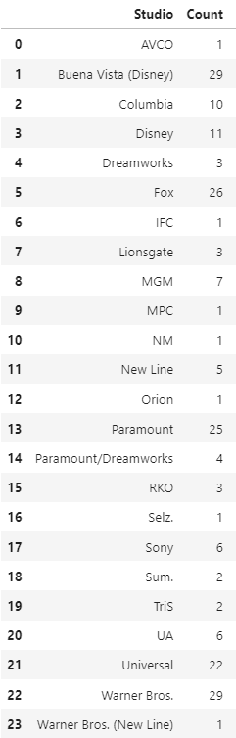

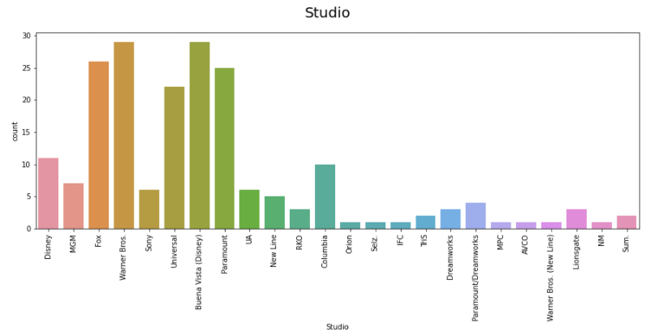Distribution Chart

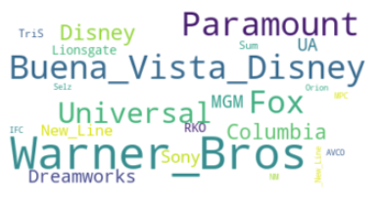Tag Cloud

**2.2. Gross**

 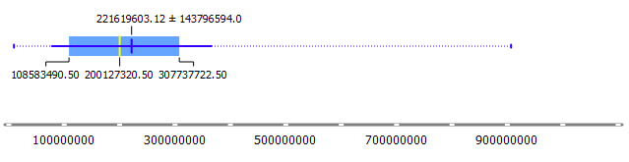

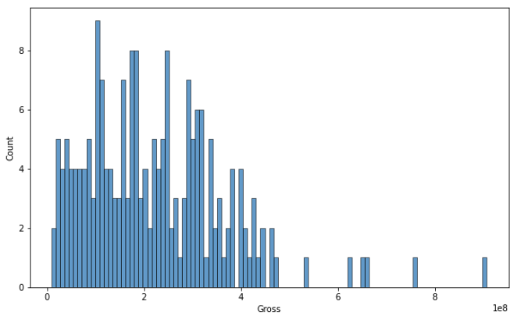

**2.3. Gross (Adjusted)**



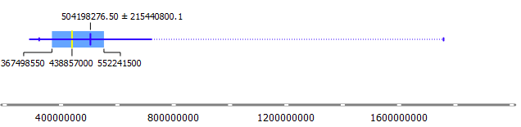

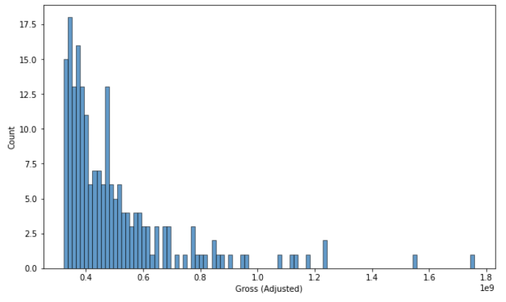

**2.4. Year**



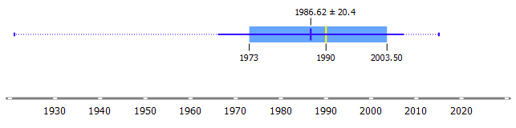

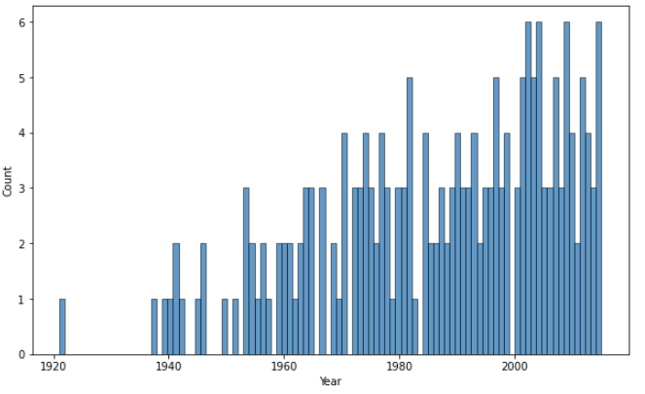

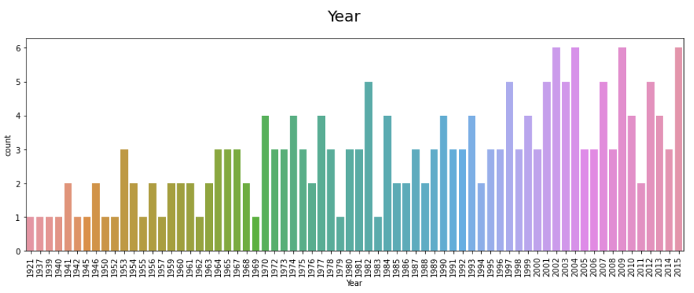

*3) Visualize this dataset by using scatterplot matrix*

**3.1. For every-pair, distinguish “Studio” column.**

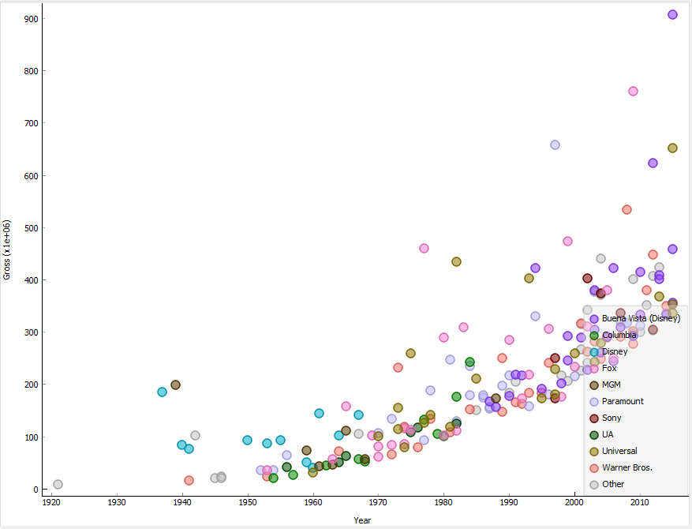

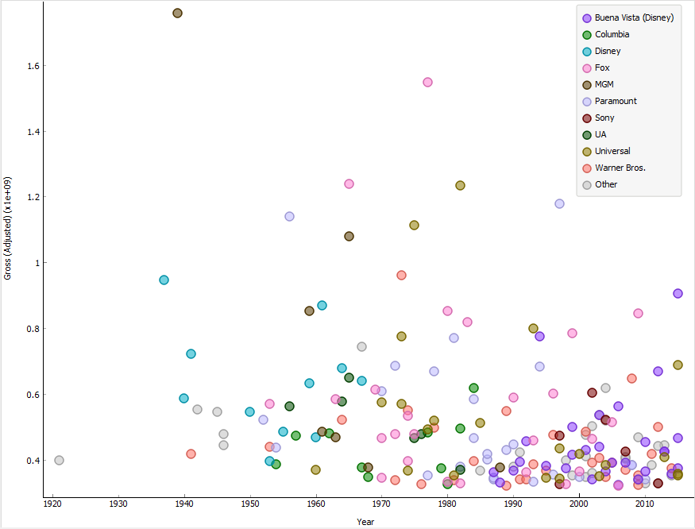

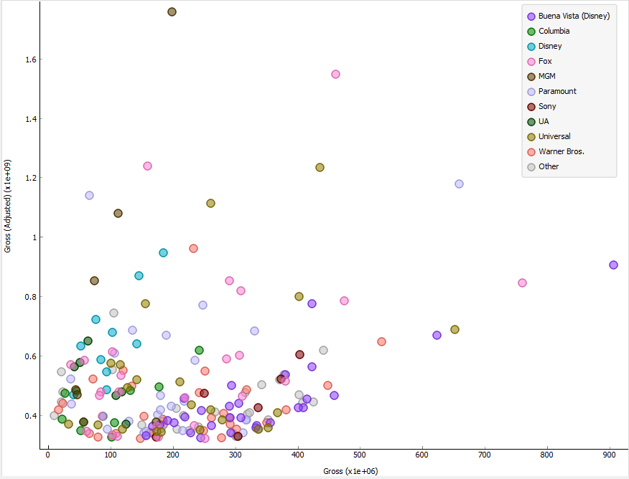

**3.2. For whole dataset, distinguish “Studio” column.**

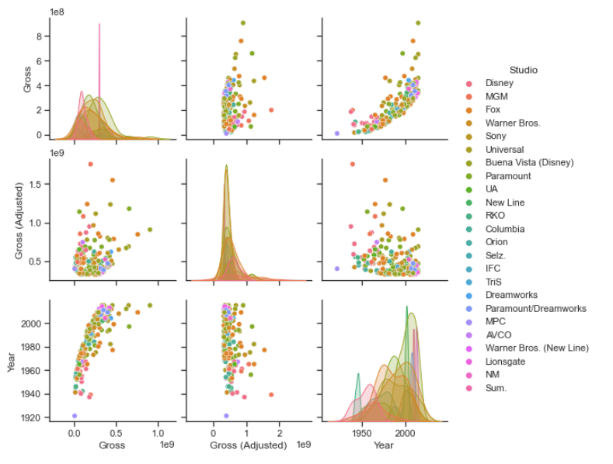

**3.2. For whole dataset, without distinguish “Studio”.**

