**Course: Data Mining**

**Homework 3**

**Student ID: 20C14001**

**Student Name: Le Duong Tuan Anh**

**Transaction Dataset**

|  |  |
| --- | --- |
| **TID** | **Item** |
| 1 | A C T W |
| 2 | C D W |
| 3 | A C T W |
| 4 | A C D W |
| 5 | A C D T W |
| 6 | C D T |

**minsup = 60% (s)**

**minconf = 80% (c)**

***1. Find all frequent itemsets by using Apriori.***

Total transaction: 6.

1st scan

|  |  |  |  |
| --- | --- | --- | --- |
| **Items** | **Support (count)** | **Support (%)** | **Acceptable minsup=60%** |
| A | 4 | 4 / 6 = 67% | Y |
| C | 6 | 6 / 6 = 100% | Y |
| T | 4 | 4 / 6 = 67% | Y |
| W | 5 | 5 / 6 = 83% | Y |
| D | 4 | 4 / 6 = 67% | Y |

2nd scan

|  |  |  |  |
| --- | --- | --- | --- |
| **Items** | **Support (count)** | **Support (%)** | **Acceptable minsup=60%** |
| {A, C} | 4 | 4 / 6 (67%) | Y |
| {A, T} | 3 | 3 / 6 (50%) | N |
| {A, W} | 4 | 4 / 6 (67%) | Y |
| {A, D} | 2 | 2 / 6 (33%) | N |
| {C, T} | 4 | 4 / 6 (67%) | Y |
| {C, W} | 5 | 5 / 6 (83%) | Y |
| {C, D} | 4 | 4 / 6 (67%) | Y |
| {T, W} | 3 | 3 / 6 (50%) | N |
| {T, D} | 2 | 2 / 6 (33%) | N |
| {W, D} | 3 | 3 / 6 (50%) | N |

3rd scan

|  |  |  |  |
| --- | --- | --- | --- |
| **Items** | **Support (count)** | **Support (%)** | **Acceptable minsup=60%** |
| {A, C, W} | 4 | 4 / 6 (67%) | Y |
| {C, T, W} | 3 | 3 / 6 (50%) | N |
| {C, T, D} | 2 | 2 / 6 (33%) | N |
| {C, W, D} | 3 | 3 / 6 (50%) | N |

4th scan (end)

|  |  |
| --- | --- |
| **Items** | **Support (count)** |
| {A, C, W} | 4 |

Frequent Itemsets:

|  |  |  |
| --- | --- | --- |
| **Items** | **Support (count)** | **Support (%)** |
| {A, C, W} | 4 | 4 / 6 (67%) |
| {C, T} | 4 | 4 / 6 (67%) |
| {C, W} | 5 | 5 / 6 (83%) |
| {C, D} | 4 | 4 / 6 (67%) |

***2. Find all frequent itemsets by using FP-Growth.***

Total transaction: 6.

Frequent 1-itemset

|  |  |  |  |
| --- | --- | --- | --- |
| **Items** | **Support (count)** | **Support (%)** | **Acceptable minsup=60%** |
| A | 4 | 4 / 6 = 67% | Y |
| C | 6 | 6 / 6 = 100% | Y |
| T | 4 | 4 / 6 = 67% | Y |
| W | 5 | 5 / 6 = 83% | Y |
| D | 4 | 4 / 6 = 67% | Y |

F-list, sorted by support.

|  |  |  |  |  |  |
| --- | --- | --- | --- | --- | --- |
| **F-list** | C | W | A | T | D |

Sort frequent items in transactions, based on F-list

|  |  |
| --- | --- |
| **TID** | **Item** |
| 1 | C W A T |
| 2 | C W D |
| 3 | C W A T |
| 4 | C W A D |
| 5 | C W A D T |
| 6 | C T D |

Construct FP-Tree

|  |  |  |
| --- | --- | --- |
| Transaction 1 | Transaction 2 | Transaction 3 |
| Transaction 4 | Transaction 5 | Transaction 6 |

Final FP-Tree

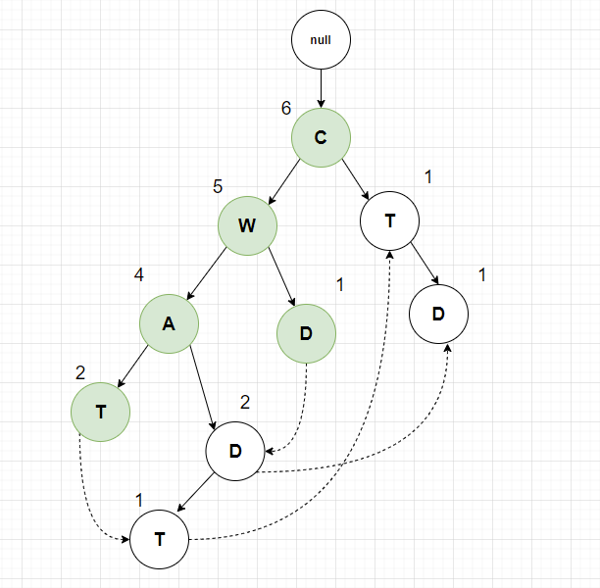

Conditional Database

|  |  |  |
| --- | --- | --- |
| **Item** | **Conditional Database** | **Acceptable with**  **minsup = 60% (3.6)** |
| W | C:5 | CW (5 = 83%) |
| A | CW: 4 | CWA (4 = 67%) |
| T | CWA: 2, CWAD: 1, C:1 | CT (4 = 67%) |
| D | CW: 1, CWAD: 2, CT: 1 | CD (4 = 67%) |

Frequent Itemsets:

|  |  |  |
| --- | --- | --- |
| **Items** | **Support (count)** | **Support (%)** |
| {C, W} | 5 | 5 / 6 (83%) |
| {C, W, A} | 4 | 4 / 6 (67%) |
| {C, T} | 4 | 4 / 6 (67%) |
| {C, D} | 4 | 4 / 6 (67%) |

*3. File all association rules that satisfy [s,c]*

|  |  |  |  |
| --- | --- | --- | --- |
| **Items / Support** | **Association Rule**  **X 🡪 Y** | **Confidence (%)**  **| X $∪$ Y | / | X |** | **Acceptable minconf=80%** |
| {A, W} / 67% | A 🡪 W | 4 / 5 (80%) | Y |
| {W, A} / 67% | W 🡪 A | 4 / 4 (100%) | Y |
| {A, C} / 67% | A 🡪 C | 4 / 6 (67%) | N |
| {C, A} / 67% | C 🡪 A | 4 / 4 (100%) | Y |
| {C, W} / 83% | C 🡪 W | 5 / 6 (83%) | Y |
| {C, W} / 83% | W 🡪 C | 5 / 5 (100%) | Y |
| {A, C, W} / 67% | A 🡪 C, W | 4 / 4 (100%) | Y |
| {A, C, W} / 67% | A, C 🡪 W | 4 / 4 (100%) | Y |
| {A, C, W} / 67% | A, W 🡪 C | 4 / 4 (100%) | Y |
| {A, C, W} / 67% | C 🡪 A, W | 4 / 6 (67%) | N |
| {A, C, W} / 67% | C, W 🡪 A | 4 / 5 (80%) | Y |
| {A, C, W} / 67% | W 🡪 A, C | 4 / 5 (80%) | Y |
| {C, T} / 67% | C 🡪 T | 4 / 6 (67%) | N |
| {C, T} / 67% | T 🡪 C | 4 / 4 (100%) | Y |
| {C, D} / 67% | C 🡪 D | 4 / 6 (67%) | N |
| {C, D} / 67% | D 🡪 C | 4 / 4 (100%) | Y |

*4) For each rule of question 3, use Lift measure to assess the degree to which the occurrence of the left part “lifts” the occurrence of the right part.*

|  |  |  |  |
| --- | --- | --- | --- |
| **Association Rule**  **X 🡪 Y** | **Confidence (%)**  **| X $∪$ Y | / | X |** | **Lift**  **conf(X 🡪 Y) / sup(Y)** | **Measure association rule** |
| A 🡪 W | 4 / 5 (80%) | 0.8 / 0.67 = 1.19 | Positively correlated |
| W 🡪 A | 4 / 4 (100%) | 1 / 0.67 = 1.49 | Positively correlated |
| C 🡪 A | 4 / 4 (100%) | 1 / 0.67 = 1.49 | Positively correlated |
| C 🡪 W | 5 / 6 (83%) | 0.83 / 0.83 = 1 | Independent |
| W 🡪 C | 5 / 5 (100%) | 1 / 1 = 1 | Independent |
| A 🡪 C, W | 4 / 4 (100%) | 1 / 0.83 = 1.2 | Positively correlated |
| A, C 🡪 W | 4 / 4 (100%) | 1 / 0.83 = 1.2 | Positively correlated |
| A, W 🡪 C | 4 / 4 (100%) | 1 / 1 = 1 | Independent |
| C, W 🡪 A | 4 / 5 (80%) | 0.8 / 0.67 = 1.19 | Positively correlated |
| W 🡪 A, C | 4 / 5 (100%) | 1 / 0.67 = 1.49 | Positively correlated |
| T 🡪 C | 4 / 4 (100%) | 1 / 1 = 1 | Independent |
| D 🡪 C | 4 / 4 (100%) | 1 / 0.67 = 1.49 | Positively correlated |