

***Group Report***

Enterprise Web Software Development

* *COMP1640* -

**Teams name:** Group 2

Team members + Positions + Commitment point

|  |  |  |  |
| --- | --- | --- | --- |
| ***Member’s name*** | ***ID*** | ***Roles*** | ***Commitment point (0-10)*** |
| Nguyen Van Chien (*Leader*) | 001248933 | Front-end programmer |  |
| Doan Trung Duc | 001250253 | Scrum Master- Interface design |  |
| Bui An Duyet | 001248946 | Tester – Product Owner |  |
| Lam Vien Thanh | 001249172 | Front-end programmer |  |
| Nguyen Khac Quoc Nhat | 001249082 | Back-end programmer |  |
| Nguyen Duc Truong Giang | 001248966 | Back-end programmer |  |

1. **Introduction.**
2. **Database**
   1. **Entity- relationship diagram (ERD)**

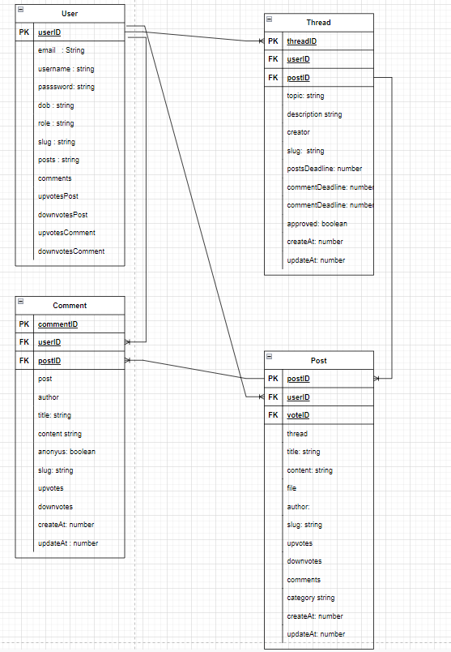

* 1. **Database design**

1. **Interface design**
   1. **Login**



* 1. **Student user view**

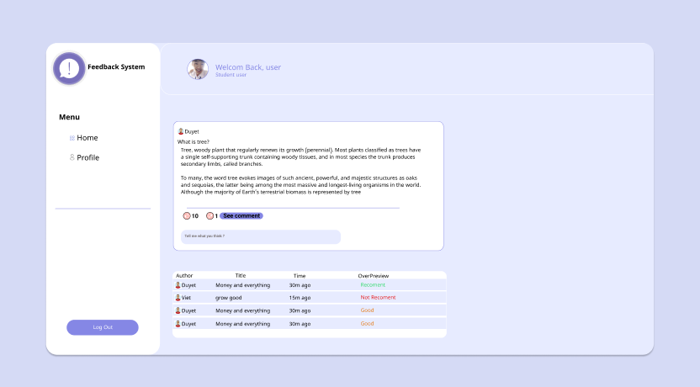

* 1. **Student new post**

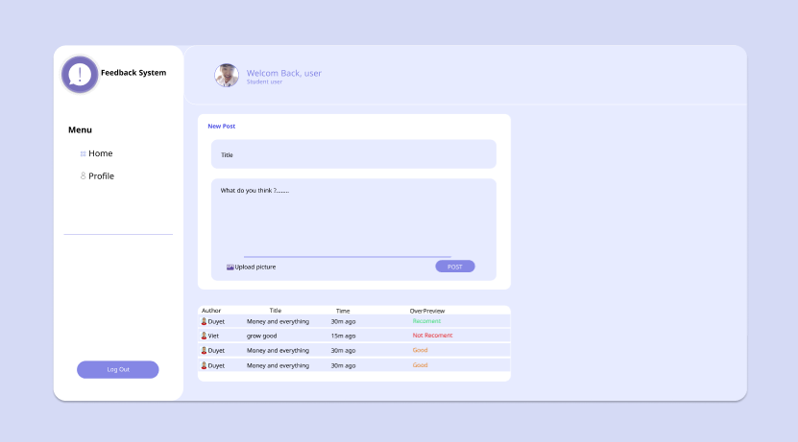

* 1. **Student user view**

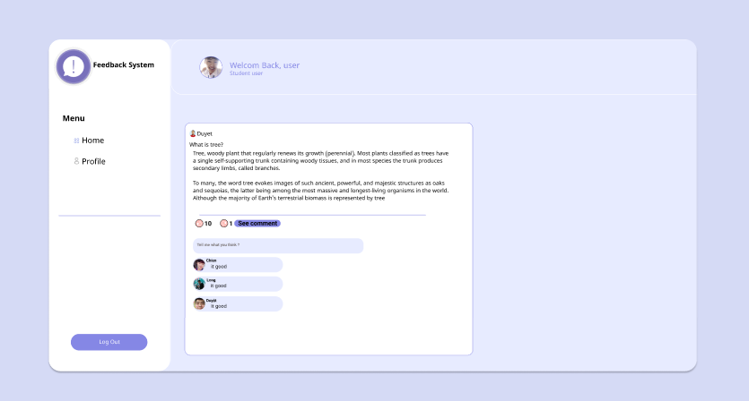

* 1. **Manager accept**

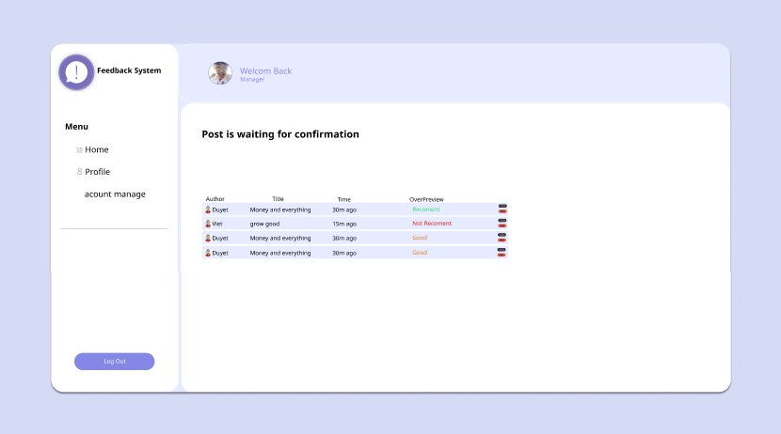

* 1. **Student edit profile**

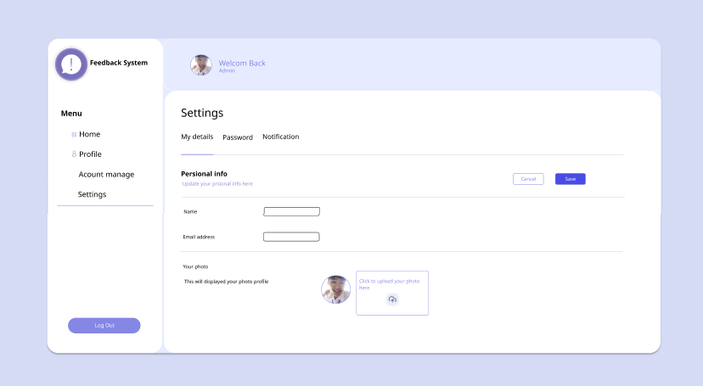

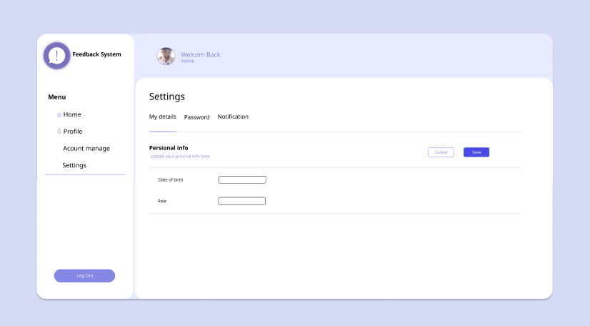

* 1. **Admin account**

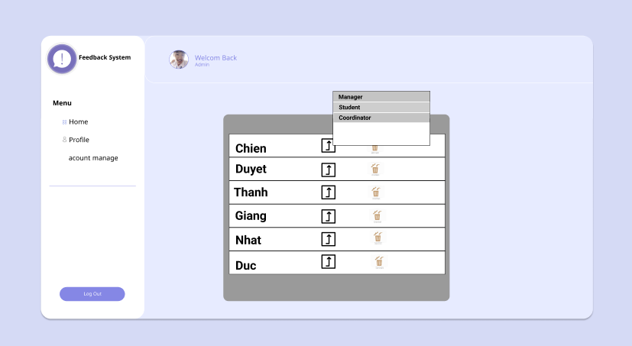

* 1. **Coordinator view**

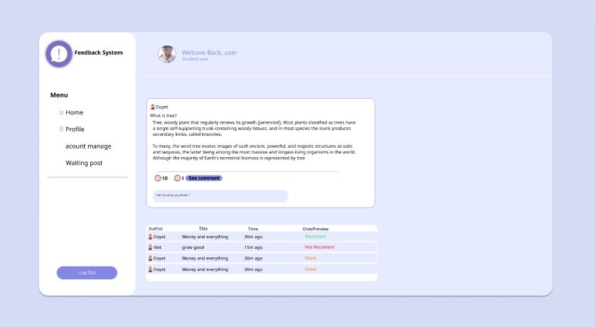

* 1. **Coordinator account view**

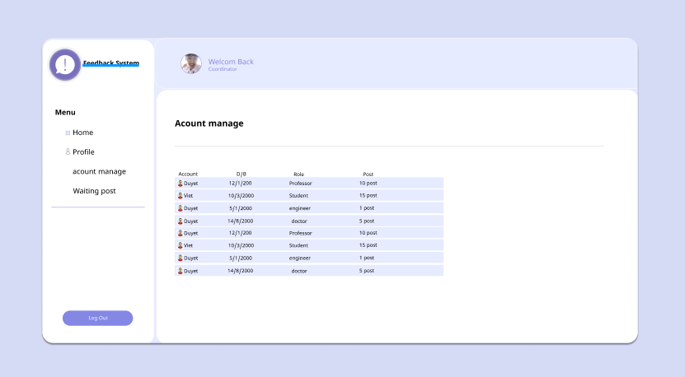

* 1. **Coordinator see profile**

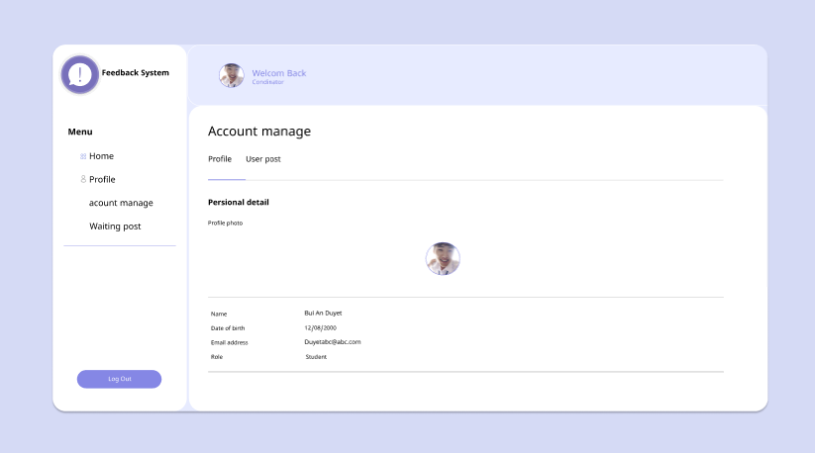

* 1. **Coordinator profile post**

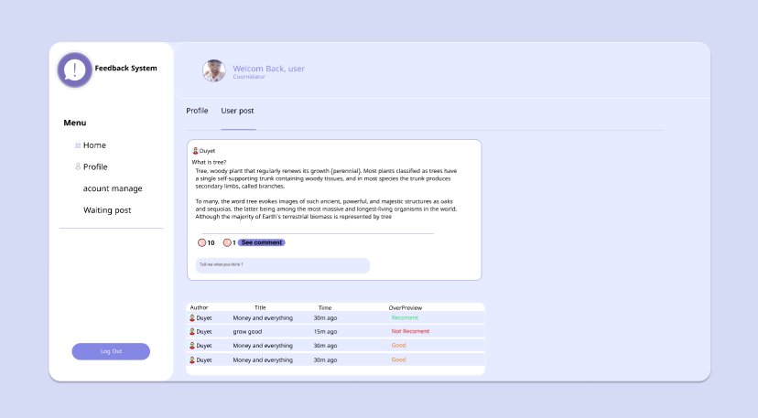

* 1. **Coordinator page**

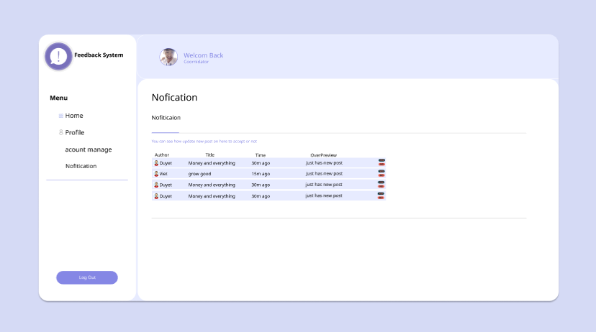

1. **Functionality**
   1. **Use case diagram**

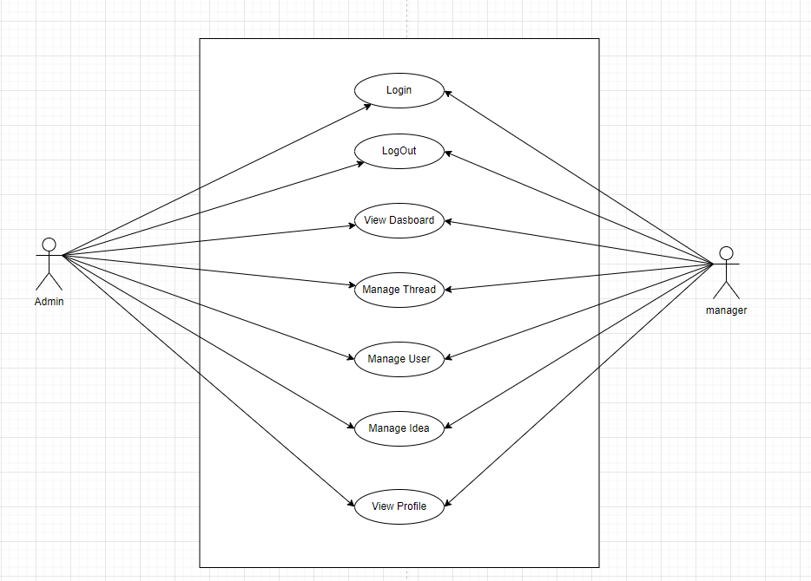

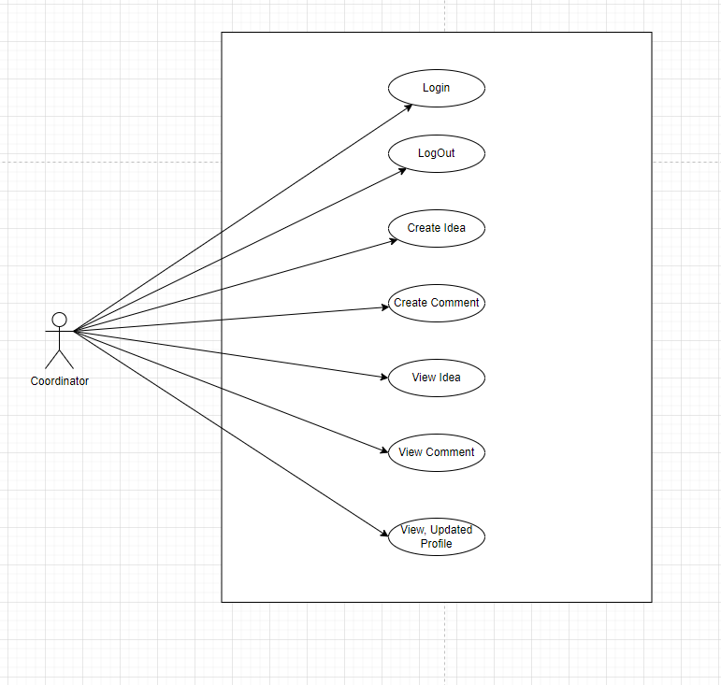

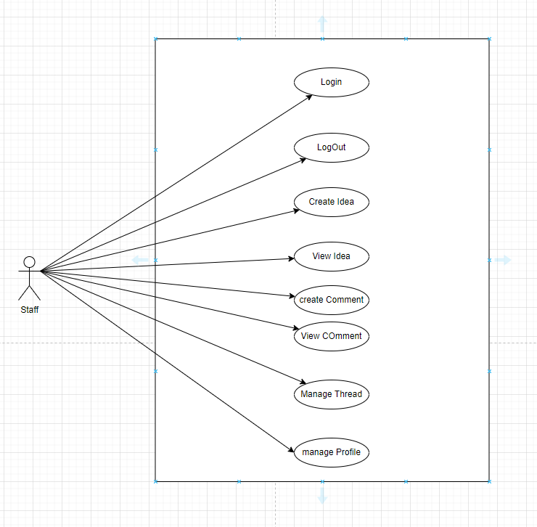

* 1. **Code implement**
  2. **User interface design on website**

1. **Login**

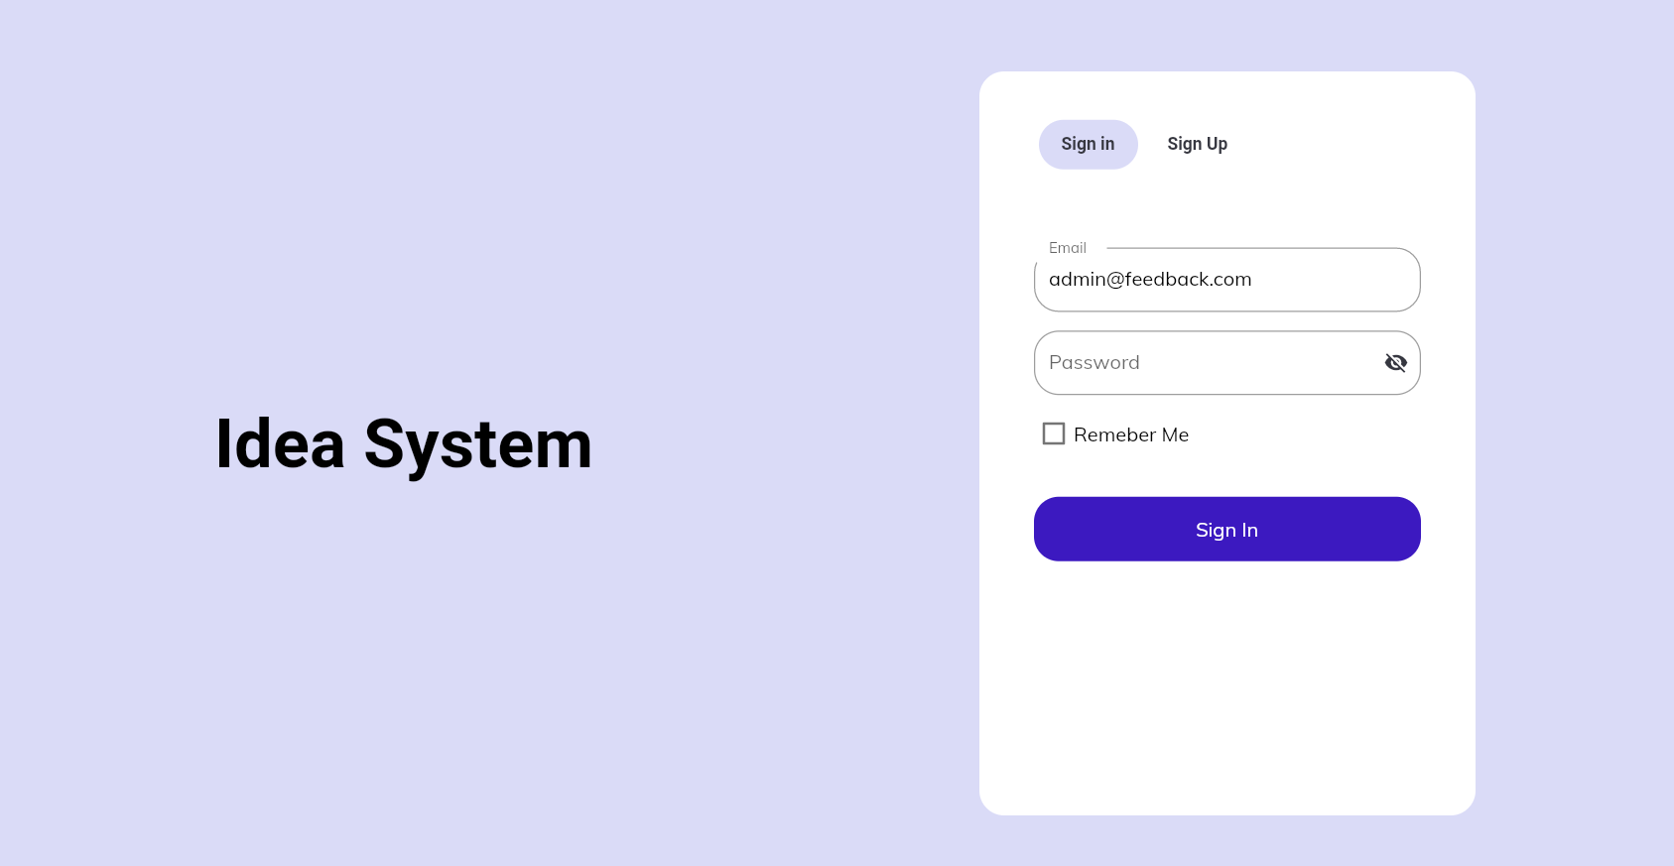

1. **Sign up**

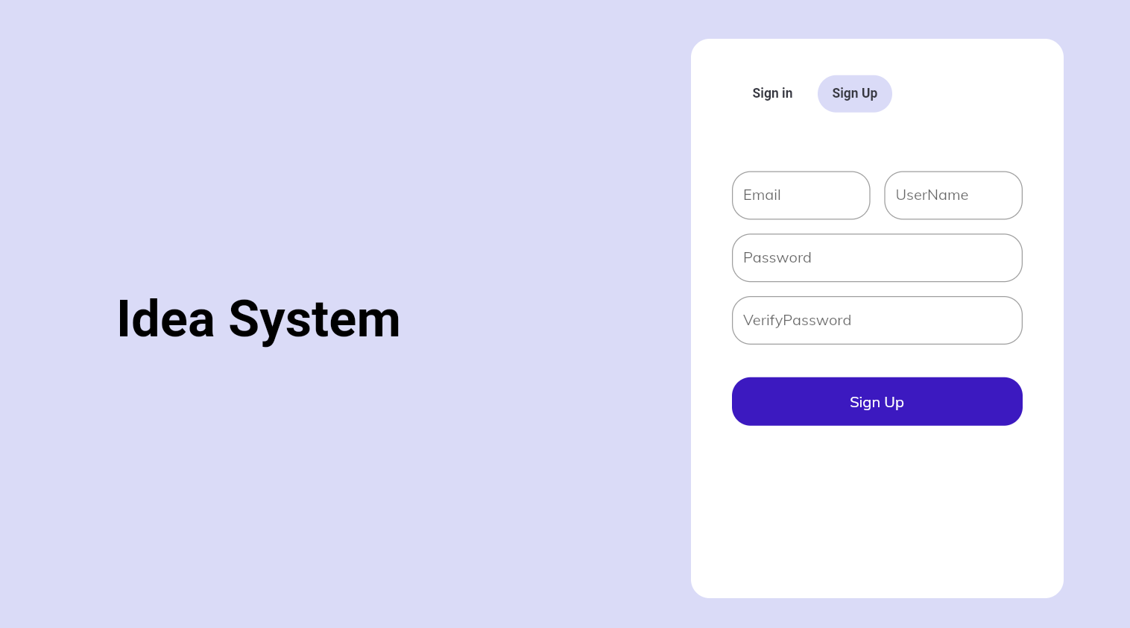

1. **Administrator page**

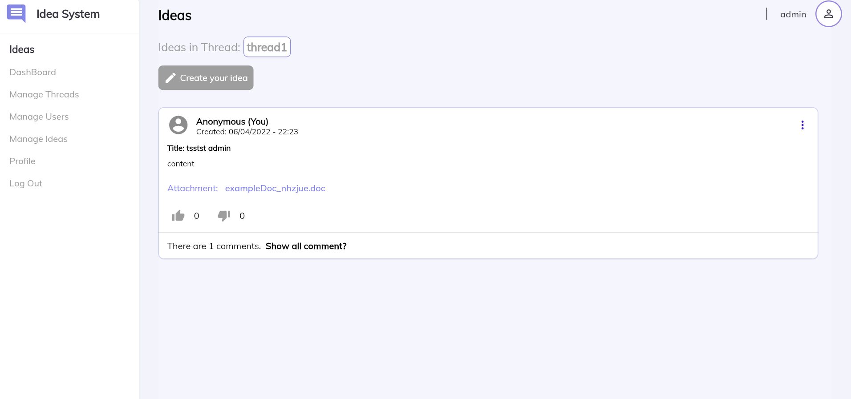

1. **Manager page**

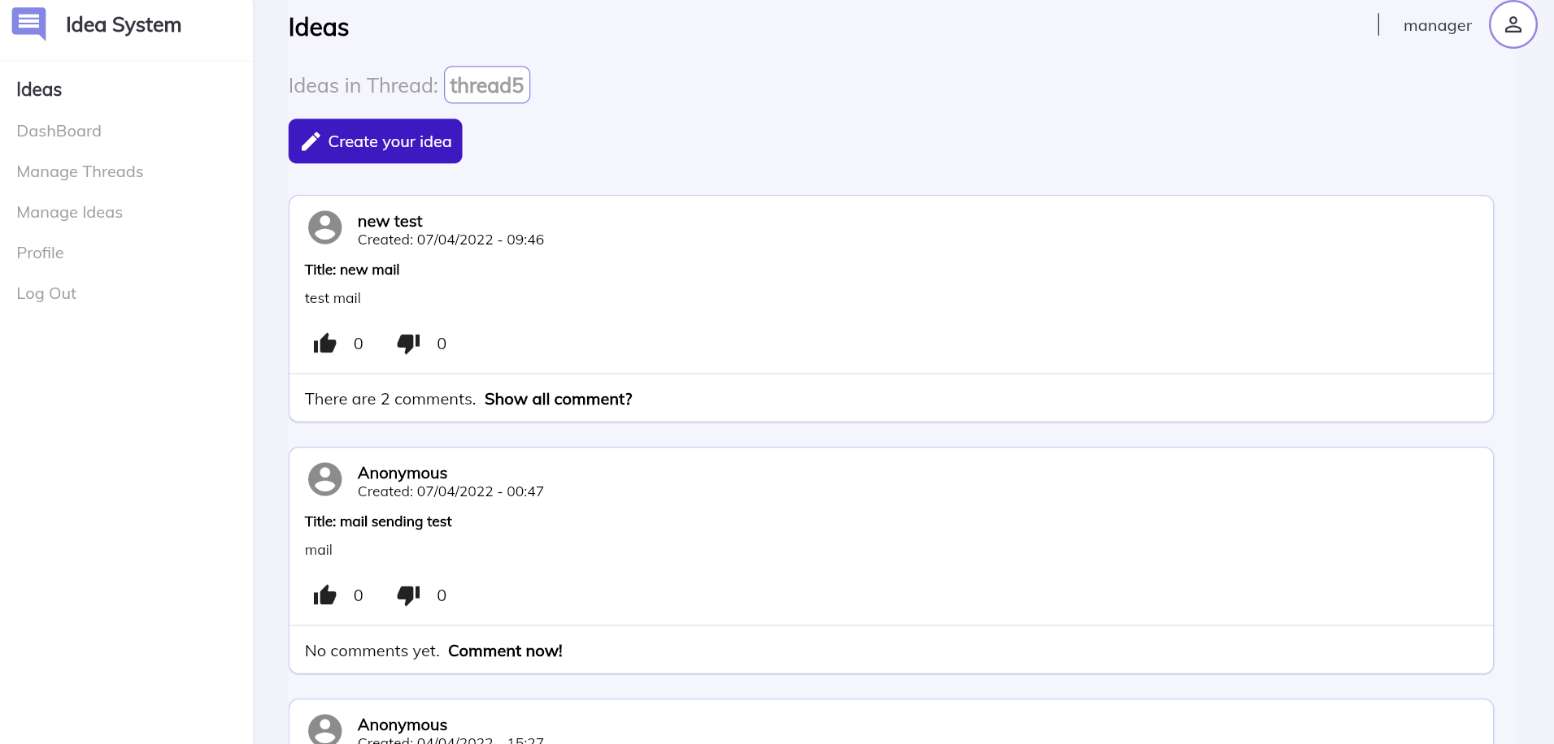

1. **Staff page**

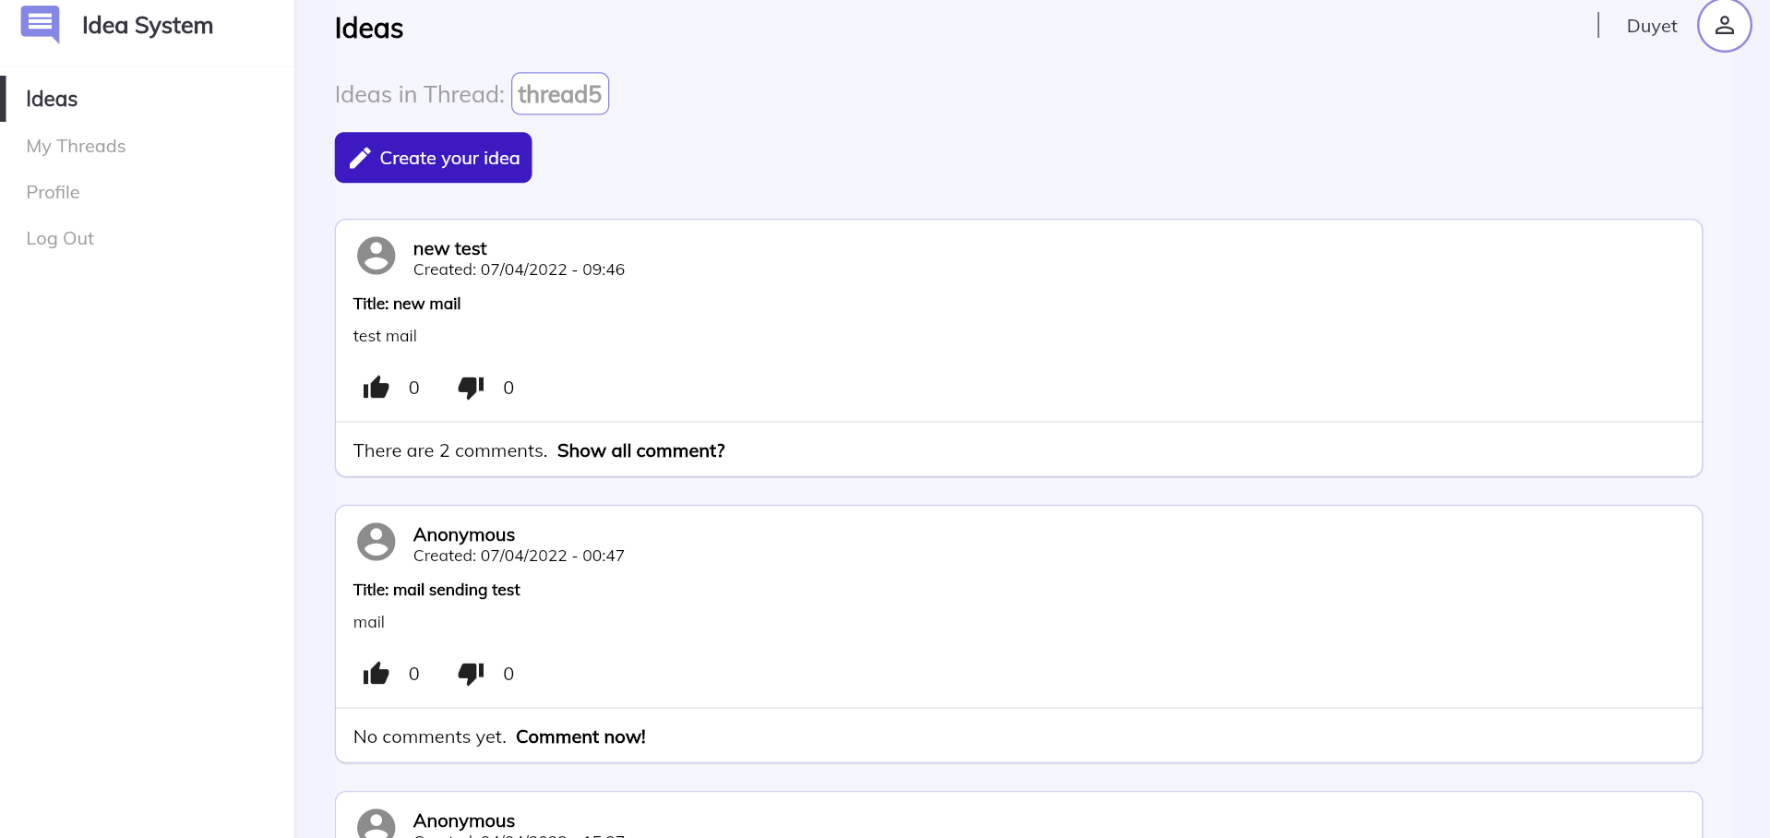

1. **Coordinator page**

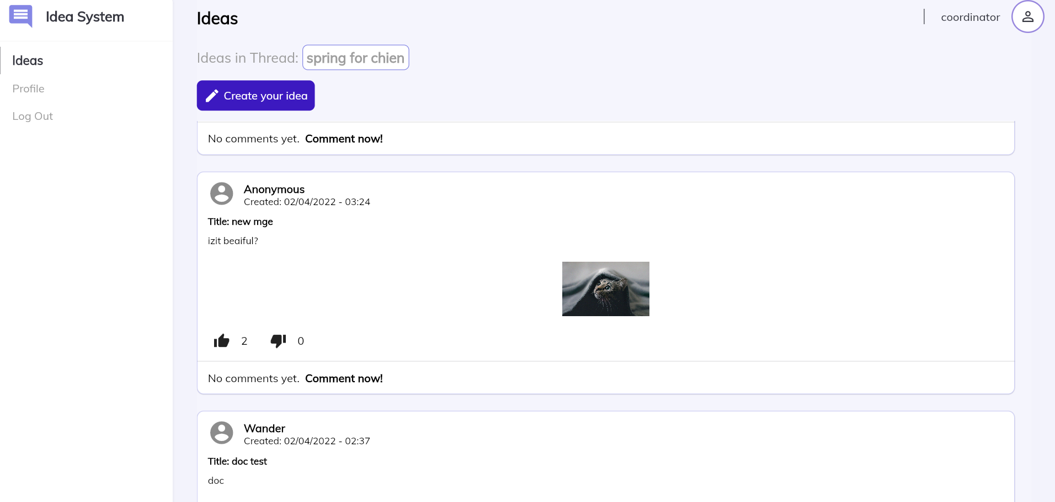

1. **Testing**
   1. **Test plan**

Table of plans to test the functions of each role in the exercise they did. Including Admin, staff, coordinator, manager.

|  |  |  |  |
| --- | --- | --- | --- |
| **Role** | **Function** | | **Test responsive** |
| **Administrator** | Log in | | Website PC. Mobile |
| Log out | |
| View Dashboard | |
| Idea | Create new idea |
| Edit idea |
| Download attachment |
| Delete their idea |
| Manage threads | Create new thread |
| View |
| Edit |
| Delete |
| Manage users | View |
| Edit |
| Delete |
| Manage ideas | View |
| Edit |
| Delete |
| View profile, update profile | |
| **Staff** | Log in | |
| Log out | |
| Idea | Create new idea |
| Edit idea |
| Download attachment |
| Delete their idea |
| View staff’s threads | |
| View profile | |
| **Manager** | Log in | |
| Log out | |
| Idea | Create new idea |
| Edit idea |
| Download attachment |
| Delete their idea |
| Dashboard | |
| Manage threads | Create new thread |
| View |
| Edit |
| Delete |
| Manage ideas | View |
| Edit |
| Delete |
| View profile, Update profile | |
| **Coordinator** | Log in | |
| Log out | |
| **Idea** | Create new idea |
| Edit idea |
| Download attachment |
| Delete their idea |
| **View profile, Update profile** | |

* 1. **Test responsive**

|  |  |  |  |  |
| --- | --- | --- | --- | --- |
| **No** | **Browser** | **Results** | | **Error** |
| **Devices** | **Website PC** | **Mobile** |
| **1** | **Admin page** | **Pass** | **Pass** |  |
| **2** | **Idea of admin page** | **Pass** | **Pass** |  |
| **3** | **Dashboard page** | **Pass** | **Pass** |  |
| **4** | **Manage threads** | **Pass** | **Pass** |  |
| **5** | **Manage users** | **Pass** | **Pass** |  |
| **6** | **Manager ideas** | **Pass** | **Pass** |  |
| **7** | **Profile page** | **Pass** | **Pass** |  |
| **8** | **Login page** | **Pass** | **Pass** |  |
| **9** | **Dialog of create new thread** | **Pass** | **Pass** |  |
| **10** | **Dialog of View thread** | **Pass** | **Pass** |  |
| **11** | **Dialog of Edit thread** | **Pass** | **Pass** |  |
| **12** | **Dialog of delete thread** | **Pass** | **Pass** |  |
| **13** | **Dialog of View information of user account** | **Pass** | **Pass** |  |
| **14** | **Dialog of Edit user account** | **Pass** | **Pass** |  |
| **15** | **Dialog of Delete user account** | **Pass** | **Pass** |  |
| **16** | **Dialog of View Information of Idea** | **Pass** | **Pass** |  |
| **17** | **Dialog of Delete Idea** | **Pass** | **Pass** |  |
| **18** | **Profile page** | **Pass** | **Pass** |  |
| **19** | **Dialog of Update profile** | **Pass** | **Pass** |  |
| **20** | **Dialog of Edit idea of each role** | **Pass** | **Pass** |  |
| **21** | **Dialog of Delete Idea of each role** | **Pass** | **Pass** |  |
| **22** | **Coordinator page** | **Pass** | **Pass** |  |
| **23** | **Manager page** | **Pass** | **Pass** |  |
| **24** | **Staff page** | **Pass** | **Pass** |  |

* 1. **Testing scope**
* Make sure the system requirements based on the web-based security roles work properly without any errors.
* Ensure the performance of the system.
* Testing time: 17/01/2022 – 25/04/2022
  1. **Test details**
* *Objective:* Provide suitable test cases for each sprint and test them.
* *Requirements testing:*
* Register/Login/Logout.
* *Test levels*
  + 1. **Sprint 1**

Date: 14/02/2022 – 21/02/2022

|  |  |  |  |  |  |  |
| --- | --- | --- | --- | --- | --- | --- |
| **User’s story** | **Task** | **Test Case Description** | **Test Input** | **Expected Output** | **Actual Output** | **Test Result** |
| Staff have to register and login in to the system if they want to add new contributions. | Verifying ''Register'' function | Input info into sign up form | validation: DONE  Info valid. | Successful | Successful | PASS |
| Verifying ‘Login’ function | Input email and password | validation: DONE.  Email and pass | Login successful | Login successful | PASS |
| Test login without password. | Username:  Password: 123456 | Login unsuccessful. The system display ‘Error invalid email@gmail.com’ | Login unsuccessful. The system display ‘Error invalid email@gmail.com’ | PASS |
| Test login without username | Username: [duyet123@gmail.com](mailto:duyet123@gmail.com)  Password: | Login unsuccessful. The system display ‘Enter a valid password’ | Login unsuccessful. The system display ‘Enter a valid password’ | PASS |
| Verify data in case the password is displayed under an asterisk. | Entering password: 123456 | Asterisk signs | Asterisk signs | PASS |
| Verifying ‘View post’ function | Login done then view posts | View posts | Successful | Successful | PASS |
| View comments | Login done then choose post | View comment list | Successful | Successful | PASS |
| Staff can view ideas on the website | Verifying ‘View ideas’ function | Staff view all existing ideas. | Staff can scroll down to see all ideas. | Successful | Successful | PASS |
| Coordinator login to website | Verifying ‘Login’ function | Input email and password | validation: DONE.  Email and pass | Login successful | Login successful | PASS |
| Test login without password. | Username:  Password: 12345 | Login unsuccessful. The system display ‘Error invalid email@gmail.com’ | Login unsuccessful. The system display ‘Error invalid email@gmail.com’ | PASS |
| Test login without username | Username: [coordinator@feedback.com](mailto:coordinator@feedback.com)  Password: | Login unsuccessful. The system display ‘Enter a valid password’ | Login unsuccessful. The system display ‘Enter a valid password’ | PASS |
| Manager login to website | Verifying ‘Login’ function | Input email and password | validation: DONE.  Email and pass | Login successful | Login successful | PASS |
| Test login without password. | Username:  Password: 12345 | Login unsuccessful. The system display ‘Error invalid email@gmail.com’ | Login unsuccessful. The system display ‘Error invalid email@gmail.com’ | PASS |
| Test login without username | Username: [manager@feedback.com](mailto:manager@feedback.com)  Password: | Login unsuccessful. The system display ‘Enter a valid password’ | Login unsuccessful. The system display ‘Enter a valid password’ | PASS |
| Administrator login to website | Verifying ‘Login’ function | Input email and password | validation: DONE.  Email and pass | Login successful | Login successful | PASS |
| Test login without password. | Username:  Password: 12345 | Login unsuccessful. The system display ‘Error invalid email@gmail.com’ | Login unsuccessful. The system display ‘Error invalid email@gmail.com’ | PASS |
| Test login without username | Username: [admin@feedback.com](mailto:admin@feedback.com)  Password: | Login unsuccessful. The system display ‘Enter a valid password’ | Login unsuccessful. The system display ‘Enter a valid password’ | PASS |
| Administrator logout | Logout function | Select “Logout” on sidebar | None | The system move to “Login” page | The system move to “Login” page | PASS |
| Manager logout | Logout function | Select “Logout” on sidebar | None | The system move to “Login” page | The system move to “Login” page | PASS |
| Coordinator logout | Logout function | Select “Logout” on sidebar | None | The system move to “Login” page | The system move to “Login” page | PASS |
| Staff logout | Logout function | Select “Logout” on sidebar | None | The system move to “Login” page | The system move to “Login” page | PASS |

**5.5.2. Sprint 2**

Date: 28/02/2022 – 13/03/2022

|  |  |  |  |  |  |  |
| --- | --- | --- | --- | --- | --- | --- |
| **User’s story** | **Task** | **Test Case Description** | **Test Input** | **Expected Output** | **Actual Output** | **Test Result** |
| Staff can create new idea | Verifying ’create your idea’ function. | Staff click on the box '' create your idea''. Staff added information of ''Title'' and "Content". | Title: News of the day.  Content: Good morning | New ideas appear on the interface of the website. | New ideas appear on the interface of the website. | PASS |
| Administrator can create new idea | Verifying ’create your idea’ function. | Administrator click on the box '' create your idea''. Administrator added information of ''Title'' and "Content". | Title: Back to school  Content: Notice to study directly at the school from 4/4/2022 | New ideas appear on the interface of the website. | New ideas appear on the interface of the website. | PASS |
| Manager can create new idea | Verifying ’create your idea’ function. | Manager click on the box '' create your idea''. Manager added information of ''Title'' and "Content". | Title: New note for students  Content: Students can apply for parking tickets from April 4, 2022 to April 15, 2022 | New ideas appear on the interface of the website. | New ideas appear on the interface of the website. | PASS |
| Staffs can see profile | Verifying “see profile” function. | Staff click on “Profile” on sidebar to view information | None | Website move to Profile page.  Email of staff  Username of staff  Role: staff  Number of posts created: …  Number of comments created: …  Create At: … | Website move to Profile page.  “Email: [duyet123@gmail.com](mailto:duyet123@gmail.com)  Username: Duyet  Role: Staff  Number of posts created: 0 post created  Number of comments created: 2 comments created  Create At: 02/04/2022-10:24” | PASS |
| Coordinator can see profile | Verifying “see profile” function. | Coordinator click on “Profile” on sidebar to view information | None | Website move to Profile page.  Email of coordinator  Username of coordinator  Role: coordinator  Number of posts created: …  Number of comments created: …  Create At: … | Website move to Profile page.  “Email: [coordinator@feedback.com](mailto:coordinator@feedback.com)  Username: coordinator  Role: coordinator  Number of posts created: 1 post created  Number of comments created: 0 comments created  Create At: 05/04/2022-6:24” | PASS |
| Administrator can see profile | Verifying “see profile” function. | Administrator click on “Profile” on sidebar to view information | None | Website move to Profile page.  Email of Administrator  Username of Administrator  Role: Administrator  Number of posts created: …  Number of comments created: …  Number of threads created  Create At: … | Website move to Profile page.  “Email: admin@feedback.com  Username: Administrator  Role: Admin  Number of posts created: 4 posts created  Number of comments created: 0 comments created  Number of threads created: 1 thread created  Create At: 06/04/2022-7:24” | PASS |
| Manager can see profile | Verifying “see profile” function. | Manager click on “Profile” on sidebar to view information | None | Website move to Profile page.  Email of manager  Username of manager  Role: manager  Number of posts created: …  Number of comments created: …  Create At: … | Website move to Profile page.  “Email: [manager@feedback.com](mailto:manager@feedback.com)  Username: manager  Role: manager  Number of posts created: 0 post created  Number of comments created: 0 comments created  Create At: 02/04/2022-00:15” | PASS |
| Staffs can ‘Like’ and ‘Dislike’ any idea. | Verifying” Like” function | Staff click on “like button” on an idea | None | The number of likes of the idea increased by 1 like | The number of likes of the idea increased by 1 like | PASS |
| Verifying” Dislike” function | Staff click on “Dislike button” on an idea | None | The number of dislikes of the idea increased by 1 like | The number of dislikes of the idea increased by 1 like |
| Coordinator can ‘Like’ and ‘Dislike’ any idea. | Verifying” Like” function | Coordinator click on “like button” on an idea | None | The number of likes of the idea increased by 1 like | The number of likes of the idea increased by 1 like | PASS |
| Verifying” Dislike” function | Coordinator click on “Dislike button” on an idea | None | The number of dislikes of the idea increased by 1 like | The number of dislikes of the idea increased by 1 like |
| Manager can ‘Like’ and ‘Dislike’ any idea. | Verifying” Like” function | Manager click on “like button” on an idea | None | The number of likes of the idea increased by 1 like | The number of likes of the idea increased by 1 like | PASS |
| Verifying” Dislike” function | Manager click on “Dislike button” on an idea | None | The number of dislikes of the idea increased by 1 like | The number of dislikes of the idea increased by 1 like |
| Administrator can ‘Like’ and ‘Dislike’ any idea. | Verifying” Like” function | Admin click on “like button” on an idea | None | The number of likes of the idea increased by 1 like | The number of likes of the idea increased by 1 like | PASS |
| Verifying” Dislike” function | Admin click on “Dislike button” on an idea | None | The number of dislikes of the idea increased by 1 like | The number of dislikes of the idea increased by 1 like |
| Administrator can see dashboard | Verifying “see dashboard” function | Admin click “Dashboard” on sidebar | None | Website move to dashboard page | Website move to dashboard page | PASS |
| Coordinator can see dashboard | Verifying “see dashboard” function | Coordinator click “Dashboard” on sidebar | None | Website move to dashboard page | Website move to dashboard page | PASS |
| Manager can see dashboard | Verifying “see dashboard” function | Manager click “Dashboard” on sidebar | None | Website move to dashboard page | Website move to dashboard page | PASS |

**5.5.3. Sprint 3**

Date: 14/03/2022 – 27/03/2022

|  |  |  |  |  |  |  |
| --- | --- | --- | --- | --- | --- | --- |
| **User’s story** | **Task** | **Test Case Description** | **Test Input** | **Expected Output** | **Actual Output** | **Test Result** |
| Administrator can view ideas by thread | Show ideas by thread | Select different threads in idea in thread | Click “spring for chien” on idea thread box | All ideas “spring for chien” appeared on the website | All ideas “spring for chien” appeared on the website | PASS |
| Coordinator can view ideas by thread | Show ideas by thread | Select different threads in idea in thread | Click “spring for chien” on idea thread box | All ideas “spring for chien” appeared on the website | All ideas “spring for chien” appeared on the website | PASS |
| Manager can view ideas by thread | Show ideas by thread | Select different threads in idea in thread | Click “spring for chien” on idea thread box | All ideas “spring for chien” appeared on the website | All ideas “spring for chien” appeared on the website | PASS |
| Staff can view ideas by thread | Show ideas by thread | Select different threads in idea in thread | Click “spring for chien” on idea thread box | All ideas “spring for chien” appeared on the website | All ideas “spring for chien” appeared on the website | PASS |
| Admin can view list of thread | Show list of thread | Select “Manage threads” on sidebar | None | Website move to manage threads page | Website move to manage threads page | PASS |
| Admin can view list of users account | Show list of user accounts | Select “Manage Users” on sidebar | None | Website move to manage threads page | Website move to manage threads page | PASS |
| Admin can view list of all ideas | Show list of all ideas | Select “Manage Ideas” on sidebar | None | Website move to manage threads page | Website move to manage threads page | PASS |
| Manager can view list of thread | Show list of thread | Select “Manage Threads” on sidebar | None | Website move to manage threads page | Website move to manage threads page | PASS |
| Manager can view list of all ideas | Show list of all ideas | Select “Manage Ideas” on sidebar | None | Website move to manage threads page | Website move to manage threads page | PASS |
| Admin add new threads | Create new thread | Select “Add New” button on Manage thread page | Create at: 4/04/2022 – 1h35am  Topic: Test Case  Content: Test  Deadline for all idea: 4h30am-5/04/2022  Deadline for all comments: 9h30am- 5/04/2022 | The system display “Idea or comment deadline must be at least 2 days” | The system display “Idea or comment deadline must be at least 2 days” | PASS |
| Create new thread | Select “Add New” button on Manage thread page | Create at: 4/04/2022 – 1h40am  Topic: Test Case  Content: Test  Deadline for all idea: 1h36am-7/04/2022  Deadline for all comments: 1h36am- 7/04/2022 | The system display “create a successful”.  New thread appears in list of threads | The system display “create a successful”.  New thread appears in list of threads | PASS |
| Manager add new threads | Create new thread | Select “Add New” button on Manage thread page | Create at: 4/04/2022 – 1h45am  Topic: Test Case  Content: Test  Deadline for all idea: 4h30am-5/04/2022  Deadline for all comments: 9h30am- 5/04/2022 | The system display “Idea or comment deadline must be at least 2 days” | The system display “Idea or comment deadline must be at least 2 days” | PASS |
| Create new thread | Select “Add New” button on Manage thread page | Create at: 4/04/2022 – 1h45am  Topic: Test Case  Content: Test  Deadline for all idea: 1h48am-7/04/2022  Deadline for all comments: 1h48am- 7/04/2022 | The system display “create a successful”. | The system display “create a successful”. | PASS |
| Administrator can view detail of thread | Show view detail of thread | Select Eye icon on action column | None | View Test Case thread:  Topic: TestCase  Description: testcase  Create: [admin@feedback.com](mailto:admin@feedback.com)  Slug: testcase-1649011308403  Posts: 0  Create Date: 04/04/2022-1:41  Expiration ideas date: 07/04/2022-1:41  Expiration comment date: 07/04/2022-1:41  Status: Not yet | View Test Case thread:  Topic: TestCase  Description: testcase  Create: [admin@feedback.com](mailto:admin@feedback.com)  Slug: testcase-1649011308403  Posts: 0  Create Date: 04/04/2022-1:41  Expiration ideas date: 07/04/2022-1:41  Expiration comment date: 07/04/2022-1:41  Status: Not yet | PASS |
| Manager can view detail of thread | Show view detail of thread | Select Eye icon on action column | None | View Test Case thread:  Topic: TestCase  Description: testcase  Create: [admin@feedback.com](mailto:admin@feedback.com)  Slug: testcase-1649011308403  Posts: 0  Create Date: 04/04/2022-1:41  Expiration ideas date: 07/04/2022-1:41  Expiration comment date: 07/04/2022-1:41  Status: Not yet | View Test Case thread:  Topic: TestCase  Description: testcase  Create: [admin@feedback.com](mailto:admin@feedback.com)  Slug: testcase-1649011308403  Posts: 0  Create Date: 04/04/2022-1:41  Expiration ideas date: 07/04/2022-1:41  Expiration comment date: 07/04/2022-1:41  Status: Not yet | PASS |
| Admin can edit information of thread | Show edit of thread | Select pen icon on action column | None | Show dialog of edit thread | Show dialog of edit thread | PASS |
| Edit information of thread | Select pen icon on action column | Change deadline for all idea 7/04/2022-1h41am -> 8/04/2022-1h41am  Change deadline for all comments 7/04/2022-1h41am -> 8/04/2022-1h41am | The system display: “edit successful” | The system display: “edit successful” | PASS |
| Admin approved for a new thread | Approved for a new thread | Select approved button on dialog of edit thread | Click checkbox “Approved for thread” | Status of “TestCase” thread change from “Not yet” to “Approved" | Status of “TestCase” thread change from “Not yet” to “Approved" | PASS |
| Disapproved for thread | Select approved button on dialog of edit thread | Click checkbox “Approved for thread” | Status of “TestCase” thread change from “Approved” to “Not yet" | Status of “TestCase” thread change from “Approved” to “Not yet" | PASS |
| Manager approved for a new thread | Approved for a new thread | Select approved button on dialog of edit thread | Click checkbox “Approved for thread” | Status of “TestCase” thread change from “Not yet” to “Approved" | Status of “TestCase” thread change from “Not yet” to “Approved" | PASS |
|  | Disapproved for thread | Select approved button on dialog of edit thread | Click checkbox “Approved for thread” | Status of “TestCase” thread change from “Approved” to “Not yet" | Status of “TestCase” thread change from “Approved” to “Not yet" | PASS |
| Administrator can delete a thread | Delete thread function | Select trash icon on action column | None | The system display dialog of delete thread | The system display dialog of delete thread | PASS |
| Delete thread function | Select “Delete” button on dialog of delete thread | None | The system display “Delete successful” | The system display “Delete successful” | PASS |
| Manager can delete a thread | Delete thread function | Select trash icon on action column | None | The system display dialog of delete thread | The system display dialog of delete thread | PASS |
| Delete thread function | Select “Delete” button on dialog of delete thread | None | The system display “Delete successful” | The system display “Delete successful” | PASS |
| Administrator can view information of User Account | View user account function | Select the eye icon on the action column in the row with email: nguyendtgiang@gmail.com | None | The system display dialog of view user account  “View Information of User Account  ID: 624732ef67299e0f3fcaa2e7  Email: [nguyendtgiang@gmail.com](mailto:nguyendtgiang@gmail.com)  Username:  [nguyendtgiang@gmail.com](mailto:nguyendtgiang@gmail.com)  Role: admin  Create Time: 02/04/2022- 00:14 | The system display dialog of view user account  “View Information of User Account  ID: 624732ef67299e0f3fcaa2e7  Email: [nguyendtgiang@gmail.com](mailto:nguyendtgiang@gmail.com)  Username:  [nguyendtgiang@gmail.com](mailto:nguyendtgiang@gmail.com)  Role: admin  Create Time: 02/04/2022- 00:14 | PASS |
| Administrator can change role of user account | Edit role of account function | Select pen icon on action column in the row with email: [duyet123@gmail.com](mailto:duyet123@gmail.com) | None | The system display dialog of edit role | The system display dialog of edit role | PASS |
| Edit role of account function | Select pen icon on action column in the row with email: [duyet123@gmail.com](mailto:duyet123@gmail.com) | Change role from “staff” to “admin” then click change button | The system display: Role of [duyet123@gmail.com](mailto:duyet123@gmail.com) is admin | The system display: Role of [duyet123@gmail.com](mailto:duyet123@gmail.com) is admin | PASS |
| Select pen icon on action column in the row with email: [duyet123@gmail.com](mailto:duyet123@gmail.com) | Change role from “admin” to “staff” then click change button | The system display: Role of [duyet123@gmail.com](mailto:duyet123@gmail.com) is staff | The system display: Role of [duyet123@gmail.com](mailto:duyet123@gmail.com) is staff | PASS |
| Administrator can delete user account | Delete user account function | Select trash icon on action column in the row with email: [duyet123@gmail.com](mailto:duyet123@gmail.com) | None | The system display dialog of delete user account | The system display dialog of delete user account | PASS |
| Select trash icon on action column in the row with email: [duyet123@gmail.com](mailto:duyet123@gmail.com) then click “Delete” button on dialog of delete user account | None | Information of [duyet123@gmail.com](mailto:duyet123@gmail.com) disappeared | Information of [duyet123@gmail.com](mailto:duyet123@gmail.com) disappeared | PASS |
| Manager can view information of idea | View idea function | Select eye icon on account column in the row of ID4 | None | The system display dialog of view idea  “ID: 62474fd75fa5b71b77bb8daa  Email: [nguyendtgiang@gmail.com](mailto:nguyendtgiang@gmail.com)  Title of idea: flutter  Thread: spring for chien  Create time: 02/04/2022- 2:17” | The system display dialog of view idea  “ID: 62474fd75fa5b71b77bb8daa  Email: [nguyendtgiang@gmail.com](mailto:nguyendtgiang@gmail.com)  Title of idea: flutter  Thread: spring for chien  Create time: 02/04/2022- 2:17” | PASS |
| Manager can delete idea | Delete idea function | Select trash idea on action column in the row of idea: flutter final docx | None | The system display dialog of delete idea | The system display dialog of delete idea | PASS |
| Select trash idea on action column in the row of idea: flutter final docx then click “Delete” button | None | Information of idea: flutter final docx disappeared | Information of idea: flutter final docx disappeared | PASS |
| Administrator can view information of idea | View idea function | Select eye icon on account column in the row of ID4 | None | The system display dialog of view idea  “ID: 62474fd75fa5b71b77bb8daa  Email: [nguyendtgiang@gmail.com](mailto:nguyendtgiang@gmail.com)  Title of idea: flutter  Thread: spring for chien  Create time: 02/04/2022- 2:17” | The system display dialog of view idea  “ID: 62474fd75fa5b71b77bb8daa  Email: [nguyendtgiang@gmail.com](mailto:nguyendtgiang@gmail.com)  Title of idea: flutter  Thread: spring for chien  Create time: 02/04/2022- 2:17” | PASS |
| Administrator can delete idea | Delete idea function | Select trash idea on action column in the row of idea: flutter2 | None | The system display dialog of delete idea | The system display dialog of delete idea | PASS |
| Select trash idea on action column in the row of idea: flutter2 then click “Delete” button | None | Information of idea: flutter2 disappeared | Information of idea: flutter2 disappeared | PASS |

**5.5.4. Sprint 4**

Date: 28/03/2022- 10/4/2022

|  |  |  |  |  |  |  |
| --- | --- | --- | --- | --- | --- | --- |
| **User’s story** | **Task** | **Test Case Description** | **Test Input** | **Expected Output** | **Actual Output** | **Test Result** |
| Administrator can change chart, thread on dashboard | Change chart function | Change chart from “Ideas & Like” to “Ideas & Dislike” | None | The system display from dashboard of “Ideas & Like” to dashboard of “Ideas & Dislike” | The system display from dashboard of “Ideas & Like” to dashboard of “Ideas & Dislike” | PASS |
| Change chart from “Ideas & Dislike” to “Threads & Ideas” | None | The system display from dashboard of “Ideas & Dislike” to dashboard of “Threads & Ideas” | The system display from dashboard of “Ideas & Dislike” to dashboard of “Threads & Ideas” | PASS |
| Change thread function | Change thread from “thread5” to “spring for chien” | None | The system display from dashboard of “thread5” to “spring for chien” | The system display from dashboard of “thread5” to “spring for chien” | PASS |
| Coordinator can change chart, thread on dashboard | Change chart function | Change chart from “Ideas & Like” to “Ideas & Dislike” | None | The system display from dashboard of “Ideas & Like” to dashboard of “Ideas & Dislike” | The system display from dashboard of “Ideas & Like” to dashboard of “Ideas & Dislike” | PASS |
| Change chart from “Ideas & Dislike” to “Threads & Ideas” | None | The system display from dashboard of “Ideas & Dislike” to dashboard of “Threads & Ideas” | The system display from dashboard of “Ideas & Dislike” to dashboard of “Threads & Ideas” | PASS |
| Change thread function | Change thread from “thread5” to “spring for chien” | None | The system display from dashboard of “thread5” to “spring for chien” | The system display from dashboard of “thread5” to “spring for chien” | PASS |
| Manager can change chart, thread on dashboard | Change chart function | Change chart from “Ideas & Like” to “Ideas & Dislike” | None | The system display from dashboard of “Ideas & Like” to dashboard of “Ideas & Dislike” | The system display from dashboard of “Ideas & Like” to dashboard of “Ideas & Dislike” | PASS |
| Change chart from “Ideas & Dislike” to “Threads & Ideas” | None | The system display from dashboard of “Ideas & Dislike” to dashboard of “Threads & Ideas” | The system display from dashboard of “Ideas & Dislike” to dashboard of “Threads & Ideas” | PASS |
| Change thread function | Change thread from “thread5” to “spring for chien” | None | The system display from dashboard of “thread5” to “spring for chien” | The system display from dashboard of “thread5” to “spring for chien” | PASS |
| Administrator can sort by roles of user | Sort by role function | Change from “All roles” to “Staff” in “Sort by” button | None | The system display all user account of staff | The system display all user account of staff | PASS |
| Change from “All roles” to “Admin” in “Sort by” button | None | The system display all user account of admin | The system display all user account of admin | PASS |
| Change from “All roles” to “Coordinator” in “Sort by” button | None | The system display all user account of coordinator | The system display all user account of coordinator | PASS |
| Change from “All roles” to “Manager” in “Sort by” button | None | The system display all user account of manager | The system display all user account of manager | PASS |
| The system display another page of manage threads | Display next page | Select next page 2 at the bottom of manage threads page | None | The system display all threads of next page | The system display all threads of next page | PASS |
| The system display another page of manage users | Display next page | Select next page 2 at the bottom of manage users page | None | The system display all users of next page | The system display all users of next page | PASS |
| The system display another page of manage ideas | Display next page | Select next page 2 at the bottom of manage ideas page | None | The system display all ideas of next page | The system display all ideas of next page | PASS |
| Administrator can comment on idea | Comment function | Select on comment space on the idea Title: News of the day 2 | Input: “love you” | The comment appears on “Comments:” | The comment appears on “Comments:” | PASS |
| Administrator can comment as Anonymous | Anonymous comment function | Select on comment space on the idea Title: News of the day 2. Then click checkbox Anonymous | Input: “I like it” | The comment appears on “Comments:” as Anonymous | The comment appears on “Comments:” as Anonymous | PASS |
| Administrator can edit their own comment | Edit comment function | Select on edit on their own comment. Then select on comment space of dialog of edit comment | Edit comment: “I like it” to “I like you” | The new comment appears on “Comments:” | The new comment appears on “Comments:” | PASS |
| Administrator can delete their own comment | Delete comment function | Select delete button on their own comment then click “Delete” button on dialog of delete comment | None | This comment disappears on “Comment” | This comment disappears on “Comment” | PASS |
| Administrator can edit their Anonymous comment | Edit comment function | Select on edit on their Anonymous comment. Then select on comment space of dialog of edit comment | Edit comment: “I have dog” to “I have a cat” | The new comment appears on “Comments:” | The new comment appears on “Comments:” | PASS |
| Administrator can delete their Anonymous comment | Delete comment function | Select delete button on their Anonymous comment then click “Delete” button on dialog of delete comment | None | This comment disappears on “Comment” | This comment disappears on “Comment” | PASS |
| Manager can comment on idea | Comment function | Select on comment space on the idea Title: News of the day 2 | Input: “love you mom” | The comment appears on “Comments:” | The comment appears on “Comments:” | PASS |
| Manager can edit their own comment | Edit comment function | Select on edit on their own comment. Then select on comment space of dialog of edit comment | Edit comment: “I have a pen” to “I have an apple” | The new comment appears on “Comments:” | The new comment appears on “Comments:” | PASS |
| Manager can delete their own comment | Delete comment function | Select delete button on their own comment then click “Delete” button on dialog of delete comment | None | This comment disappears on “Comment” | This comment disappears on “Comment” | PASS |
| Staff can comment on idea | Comment function | Select on comment space on the idea Title: News of the day 2 | Input: “love you dad” | The comment appears on “Comments:” | The comment appears on “Comments:” | PASS |
| Staff can edit their own comment | Edit comment function | Select on edit on their own comment. Then select on comment space of dialog of edit comment | Edit comment: “I love you” to “I love you too” | The new comment appears on “Comments:” | The new comment appears on “Comments:” | PASS |
| Staff can delete their own comment | Delete comment function | Select delete button on their own comment then click “Delete” button on dialog of delete comment | None | This comment disappears on “Comment” | This comment disappears on “Comment” | PASS |
| Administrator, staff, manager, coordinator can view all comment on idea | Show all comment function | Select “Show all comment?” on idea title: new of the day 2 | None | All comment of “title: new of the day 2” appear | All comment of “title: new of the day 2” appear | PASS |
| Administrator can export attachment of manage idea | Export attachment function | Select “export attachment” button on manage idea | None | The system display: Export Data attachment Successfully. Zip file downloaded to administrator's computer successfully | The system display: Export Data attachment Successfully. Zip file downloaded to administrator's computer successfully | PASS |
| Administrator can export data CSV of manage idea | Export data CSV function | Select “export data CSV” button on manage idea | None | The system display: Export Data CSV done Successfully. Zip file downloaded to administrator's computer successfully | The system display: Export Data CSV done Successfully. Zip file downloaded to administrator's computer successfully | PASS |
| Manager can export attachment of manage idea | Export attachment function | Select “export attachment” button on manage idea | None | The system display: Export Data attachment Successfully. Zip file downloaded to administrator's computer successfully | The system display: Export Data attachment Successfully. Zip file downloaded to administrator's computer successfully | PASS |
| Manager can export data CSV of manage idea | Export data CSV function | Select “export data CSV” button on manage idea | None | The system display: Export Data CSV done Successfully. Zip file downloaded to administrator's computer successfully | The system display: Export Data CSV done Successfully. Zip file downloaded to administrator's computer successfully | PASS |
| Administrator, manager can refresh table of manage thread | Refresh table function | Select “Refresh table” button on manage thread page | None | The system refreshes and displays all thread were existed | The system refreshes and displays all thread were existed | PASS |
| Administrator, manager can refresh table of manage ideas | Refresh table function | Select “Refresh table” button on manage thread page | None | The system refreshes and displays all ideas were existed | The system refreshes and displays all ideas were existed | PASS |
| Administrator can refresh table of manage users | Refresh table function | Select “Refresh table” button on manage thread page | None | The system refreshes and displays all users were existed | The system refreshes and displays all users were existed | PASS |
| Administrator, manager approve thread | Approve thread function and test display of dashboard | Select edit thread and select approve “Thread1” | None | Status of “Thread1” change from “Not yet” to “Approved” and dashboard display “All thread” increase 1 | Status of “Thread1” change from “Not yet” to “Approved” and dashboard display “All thread” increase 1 | PASS |
| Administrator, coordinator, manager can refresh chart | Refresh chart function | Select “Refresh chart” button on dashboard page | None | The system refreshes and displays the corresponding chart | The system refreshes and displays the corresponding chart | PASS |
| Administrator can update profile | Update profile function | Select “Update profile” button | None | The system display dialog of update profile | The system display dialog of update profile | PASS |
| Select “Update profile” button | Input:  Email: [admin@feedback.com](mailto:admin@feedback.com)  Username: admin  Old Password: 12345  Password: 12345  Verify Password: 12345 | Output:  Email:  [admin@feedback.com](mailto:admin@feedback.com)  Username: Admin  Role: Admin  Number of posts created: 3 posts created  Number of comments created: 2 comments created  Create At: 02/04/2022- 00:15 | Output:  Email:  [admin@feedback.com](mailto:admin@feedback.com)  Username: Admin  Role: Admin  Number of posts created: 3 posts created  Number of comments created: 2 comments created  Create At: 02/04/2022- 00:15 | PASS |
| Manager can update profile | Update profile function | Select “Update profile” button | None | The system display dialog of update profile | The system display dialog of update profile | PASS |
| Select “Update profile” button | Input:  Email: manager123@feedback.com  Username: manager2  Old Password: 12345  Password: 12345  Verify Password: 12345 | Output:  Email: manager123@feedback.com  Username: manager2  Role: manager  Number of posts created: 1 posts created  Number of comments created: 1 comments created  Create At: 03/04/2022- 4:15 | Output:  Email: manager123@feedback.com  Username: manager2  Role: manager  Number of posts created: 1 posts created  Number of comments created: 1 comments created  Create At: 03/04/2022- 4:15 | PASS |
| Staff can update profile | Update profile function | Select “Update profile” button | None | The system display dialog of update profile | The system display dialog of update profile | PASS |
| Select “Update profile” button | Input:  Email: duyet123@gmail.com  Username: Duyet  Old Password: 123456  Password: 123456  Verify Password: 123456 | Output:  Email: duyet123@gmail.com  Username: Duyet  Role: Staff  Number of posts created: 1 posts created  Number of comments created: 1 comments created  Create At: 04/04/2022- 4:15 | Output:  Email: duyet123@gmail.com  Username: Duyet  Role: Staff  Number of posts created: 1 posts created  Number of comments created: 1 comments created  Create At: 04/04/2022- 4:15 | PASS |
| Coordinator can update profile | Update profile function | Select “Update profile” button | None | The system display dialog of update profile | The system display dialog of update profile | PASS |
| Select “Update profile” button | Input:  Email: coordinator123@feedback.com  Username: coordinator  Old Password: 12345  Password: 12345  Verify Password: 12345 | Output:  Email: coordinator123@feedback.com  Username: coordinator  Role: coordinator  Number of posts created: 1 posts created  Number of comments created: 1 comments created  Create At: 03/04/2022- 4:15 | Output:  Email: coordinator123@feedback.com  Username: coordinator  Role: coordinator  Number of posts created: 1 posts created  Number of comments created: 1 comments created  Create At: 03/04/2022- 4:15 | PASS |
|  |  |  |  |  |  |  |
|  |  |  |  |  |  |  |
|  |  |  |  |  |  |  |