

Linux Desktop Testing Project – LDTP
http://ldtp.freedesktop.org
Tutorial

Copyright 2004 - 2007 Novell, Inc.
Copyright 2008 - 12 Nagappan Alagappan

Permission is granted to copy, distribute and/or modify this document
under the terms of the GNU Lesser General Public License, Version 2
or any later version published by the Free Software Foundation;
with no Invariant Sections, no Front-Cover Texts, and no Back-Cover Texts.
A copy of the license is included in the section entitled "GNU
Lesser General Public License".

You should have received a copy of the GNU GNU Lesser General Public
License along with this documentation; if not, write to the
Free Software Foundation, Inc., 59 Temple Place - Suite 330,
Boston, MA 02111-1307, USA.

Author
Nagappan A <nagappan@gmail.com>
Contributors:
Harsha <nharsha@gmail.com>
Premkumar J <prem.jothimani@gmail.com>
Guofu Xu <lavixu@gmail.com>
Surendran M <suren.silverprince@gmail.com>
Vamsi B <vamsi1985@gmail.com>

Table of Contents
About LDTP 5
Audience 5
About testing 5
Why testing ? 5
Why automation ? 5
Complexity of GUI testing ? 5
What type of testing can be done using LDTP ? 5
Advantage of accessibility based testing 6
Disadvantage of accessibility based testing 6
What applications can be tested ? 6
Supported platforms 6
Supported languages 6
LDTP Features 6
Web / Contact 7
LDTP on web 7
Development mailing list 7
Internet relay chatting – IRC 7
System requirements 7
Disk space requirement 7
Software requirements 7
Install the following dependency packages (Linux) 7
Optional packages (Linux) 7
Setup LDTP 8
Download source from GIT (Linux) 8
Download source from GIT (Windows) 8
Download source from GIT (Mac OS X) 8
Setup LDTP from source in Linux/Mac OS X environment 8
Setup LDTP from binary 8
Architecture 8
LDTP Overall Architecture 8
LDTP Internals 8
Server 9
Client Handler 9
Component Handler 10
Event Handler 10
LDTP conventions 10
Appmap 10
Appmap convention 10
Example Applications 12
How to Access UI Objects from LDTP scripts 13
Window name 13
Different window types 13
Glob pattern support 13
Different ways of representing window name 13
Window name formats 13
Object name 13
Label 13
Label by / Label for (associated label) 14
Object name with out label / associated label accessing via index 14
Object name with index 14
Object name with window id (Windows only) 14
Object identification with object type and index 14
Object name formats 15
Accessibility library 15
Enabling accessibility 15
Importing LDTP modules 16
Call a function to perform an operation 16
LDTP API 17
Using / Hacking LDTP 17
Identifying controls 17
Push button 18
Menu item 19
Toggle button 20
Text control 20
Table control 21
Push button 22
Check box 22
Spin button 24
Page tab 25
Check menu item 25
Radio menu item 26
Combo box – Menu item 27
Combo box – List item 28
Launch application 29
GUI exist 29
Timeout 30
Generate raw keyboard events 31
Generate raw mouse events 31
Application information 32
Callback – On new window creation 32
Advantage 32
Example 33
Logging 33
Example script 34
How to execute LDTP scripts 34
Suggestions from LDTP team 34
How to operate LDTP from a remote system 34
LDTP engine (Linux) 34
LDTP engine (Windows) 34
LDTP engine (Mac OS X) 35
LDTP client 35
Troubleshooting LDTP 35
Bibliography 36

About LDTP
Linux Desktop Testing Project (LDTP) is aimed at producing high quality test automation framework and cutting-edge tools that can be used to test GNU/Linux Desktop and improve it. It uses the Accessibility libraries to poke through the application's user interface. This idea has been extended to Microsoft Windows as Cobra, Mac OS X as ATOMac. With this, we can proudly say, we have implemented cross platform GUI testing tool. LDTP is now known to work on Windows / Mac / Linux / Palm Source / Solaris / NetBSD / FreeBSD.
LDTP core framework uses Appmap (application map) and the written test-cases to test an application and gives the status of each test-case as output. LDTP can test any .NET / GNOME / KDE (QT >= 4.8) application which are accessibility enabled, Mozilla, Open Office/Libre Office, any Java application (should have a UI based on swing)
We encourage you to join the project and help us to create robust, reliable and stable test tool / framework for Windows/Unix Desktops. Thanks to Microsoft / Apple / GNOME Accessibility team and Sun Microsystems Accessibility team for their great work and their continuous support !!!

Audience
Its assumed that the user of this document has little knowledge about UI controls in any GUI application, minimal Windows / Mac OS X/ Linux or Unix (Solaris / BSD flavor) knowledge.

About testing

Why testing ?
Testing is a process to identify defects in a (software) system. For more information - http://en.wikipedia.org/wiki/Software_testing

Why automation ?
Testing an application multiple times with same steps, automated process can do a better job.

Complexity of GUI testing ?
- Identification of object in a window (push button, menu item)
- Should be context sensitive (Window specific operation)
- Handling of unexpected pop-up windows
- Keeping the test script in sync with the UI changes
- Failures has to be verified on each operation
- Rendering of images / text in the display area

What type of testing can be done using LDTP ?
LDTP can be used to test the functionality of any accessibility enabled application.

Advantage of accessibility based testing
- Accessibility libraries provide applications property, state, its child items etc.
- No need to work in toolkit (GTK, AWT, QT) level

Disadvantage of accessibility based testing
- Application which are not accessibility enabled can't be tested

What applications can be tested ?
As of now, LDTP can test any .NET / GNOME application which are accessibility enabled, Mozilla, Open Office / Libre Office, any Java application (should have a UI based on swing) and KDE applications based on QT 4.8.

Supported platforms
- openSuSE
- OpenSolaris
- Debian
- Madriva
- Ubuntu
- Fedora
- SLES
- SLED
- RHEL
- CentOS
- FreeBSD
- NetBSD
- Windows (XP SP3/Vista SP2/7 SP1/8)
- Mac OS X (>=10.6)
- Embedded Platform (Palm Source / Access Company)

Supported languages

- Python
- Clojure
- Java
- Ruby
- C#
- VB.NET
- Power Shell
- Perl

LDTP Features
- LDTP concepts are derived from Software Automation Framework Support
- LDTP supports verification of actions performed (guiexist, verifystate, etc) - API Reference
- Writing test scripts are very easy, the script writer need not know about the object hierarchy
- CPU / Memory performance monitoring of application-under-test can be measured - Class pstats

Web / Contact

LDTP on web
- Website - http://ldtp.freedesktop.org
- Source / Binary - http://ldtp.freedesktop.org/wiki/Download
- API reference - http://ldtp.freedesktop.org/wiki/Docs
- HOWTO - http://ldtp.freedesktop.org/wiki/HOWTO
- FAQ - http://ldtp.freedesktop.org/wiki/FAQ

Development mailing list
http://lists.freedesktop.org/mailman/listinfo/ldtp-dev

Internet relay chatting – IRC
#ldtp of irc.freenod.net

System requirements

Disk space requirement
Less than 450 KB (Linux), 5 MB (Windows), 450 KB (Mac OS X)

Software requirements

Install the following dependency packages (Linux)
- python-atspi or relevant name in your distribution
- twisted-web or relevant name in your distribution
- python-gnome or relevant name in your distribution

Install the following dependency packages (Mac OS X)
- Xcode, if you plan to compile the software, else use egg from pypi

Optional packages (Linux)
- Import tool of ImageMagick - To capture a screenshot
- Python Imaging Library - Compare images, black out a region in an image
- pystatgrab - CPU / Memory utilization monitoring library

Setup LDTP

Download source from GIT (Linux)
- check out source from GIT with the following command: 'git clone git://anongit.freedesktop.org/git/ldtp/ldtp2.git'.
- change to the source directory with the following command: 'cd ldtp'

Download source from GIT (Windows)
- check out source from GIT with the following command: 'git clone https://github.com/ldtp/cobra.git'.

Download source from GIT (Mac OS X)
- check out source from GIT with the following command: 'git clone https://github.com/ldtp/pyatom.git'.
- change to the source directory with the following command: 'cd pyatom'

Setup LDTP from source in Linux/Mac OS X environment
- build with 'python setup.py build'
- setup with 'sudo python setup.py install' as the root user

Setup LDTP from binary
Download latest Mac OS X / Windows / RPM / Deb / Gentoo / Solaris package from http://ldtp.freedesktop.org/wiki/Download

Architecture

LDTP Overall Architecture
Test scripts uses LDTP API interface, which in-turn communicate to LDTP engine either by UNIX socket or by TCP socket. LDTP engine talks to Application under test (AUT) using AT-SPI library.

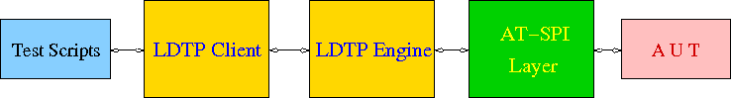
LDTP Internals
LDTP Clients can talk to LDTP engine with XML RPC protocol.

Most of LDTP ideas are implemented from http://safsdev.sf.net Most of the commands takes at-least 2 arguments. First argument will be context (window in which we want to operate) and the second argument will be component (object in which we want to operate, based on the current context).

Example: click ('*-gedit', 'btnNew') # Click operation will be performed on a window which is having *-gedit (regexp) and in that window object name 'New', which is of type 'push button'.

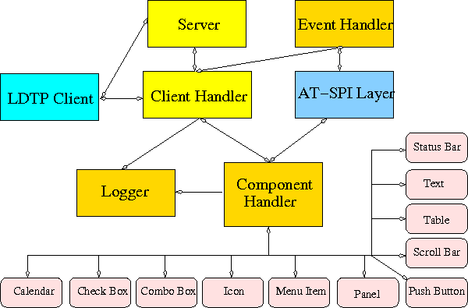

Server
When a test script is started, the LDTP client will establish a connection with the LDTP engine using AF_UNIX / AF_INET.

Client Handler
When ever a command is executed from the script, the client frames the XML data and send it to the server. LDTP engine parses the command request from the client and invoke the respective Component Handler.

Component Handler
Each individual component handlers uses the AT-SPI libraries to communicate to the respective application. Based on the execution status, success or failure will be notified as a response (in XML format) to the client. In few cases the requested data from the respective component will be returned to the client, based on the request (example: gettextvalue).

Event Handler
For unexpected windows (example: connection reset by peer /connection timed out dialogs) can be handled by registering a callback function and the respective callback function will be called, whenever the registered window with the title appears and even this window could be based on regular expression.

LDTP conventions

Appmap
'Appmap' [Application Map in short] is a text based representation of the GUI which is under testing. Each and every UI control viz., Button, Text Box etc., are represented using predefined conventions (which are listed in the table below) along with their parent UI object information. At runtime, a particular UI control is accessed by using the Appmap generated for the GUI under testing.
For more details about Appmap refer http://safsdev.sourceforge.net/DataDrivenTestAutomationFrameworks.htm#TheApplicationMap

Appmap convention

Class keywords | convention used in appmap
ACCEL_LABEL
ALERT | dlg
ANIMATION
ARROW
CALENDAR | cal
CANVAS | cnvs
CHECK_BOX | chk
CHECK_MENU_ITEM | mnu
COLOR_CHOOSER
COLUMN_HEADER
COMBO_BOX | cbo
DATE_EDITOR
DESKTOP_ICON
DESKTOP_FRAME | frm
DIAL | dial
DIALOG | dlg
DIRECTORY_PANE
DRAWING_AREA | dwg
FILE_CHOOSER | dlg
FILLER | flr
FONT_CHOOSER | dlg
FRAME | frm
GLASS_PANE
HTML_CONTAINER | html
ICON | ico
IMAGE | img
INTERNAL_FRAME
LABEL | lbl
LAYERED_PANE | pane
LIST | lst
LIST_ITEM | lsti
MENU | mnu
MENU_BAR | mbar
MENU_ITEM | mnu
OPTION_PANE | opan
PAGE_TAB | ptab
PAGE_TAB_LIST | ptl
PANEL | pnl
PASSWORD_TEXT | txt
POPUP_MENU | pop
PROGRESS_BAR | pbar
PUSH_BUTTON | btn
RADIO_BUTTON | rbtn
RADIO_MENU_ITEM | mnu
ROOT_PANE | rpan
ROW_HEADER | rhdr
SCROLL_BAR | scbr
SCROLL_PANE | scpn
SEPARATOR | sep
SLIDER | sldr
SPIN_BUTTON | sbtn
SPLIT_PANE | splt
STATUS_BAR | stat
TABLE | tbl
TABLE_CELL | tbl
TABLE_COLUMN_HEADER | tch
TABLE_ROW_HEADER | trh
TEAROFF_MENU_ITEM | tmi
TERMINAL | term
TEXT | txt
TOGGLE_BUTTON | tbtn
TOOL_BAR | tbar
TOOL_TIP | ttip
TREE | tree
TREE_TABLE | ttbl
UNKNOWN | unk
VIEWPORT | view
WINDOW | dlg
EXTENDED
HEADER | hdr
FOOTER | foot
PARAGRAPH | para
RULER | rul
APPLICATION | app
AUTOCOMPLETE | txt
CALENDARVIEW | cal
CALENDAREVENT | cal
EDITBAR | txt
ENTRY | txt

Example Applications
Examples will use gedit. You can download from https://projects.gnome.org/gedit/

How to Access UI Objects from LDTP scripts
Two main entities to act on an object, window name, object name.

Window name
To operate on a window, we need to know the window name (nothing but window title).

Different window types
- Frame (frm)
- Dialog (dlg)
- Alert (dlg)
- Font Chooser (dlg)
- File Chooser (dlg)
- Window (This type in general does not have any associated title, so we need to represent them using index - dlg)

Glob pattern support
Window name can be clubbed with glob patterns (* or ?)

Different ways of representing window name
- Window type and window title (Ex: 'frmUnsavedDocument1-')
- Window title (Ex: 'Unsaved Document 1 - gedit')
- Window type, glob expression and partial window title (Ex: 'frm*-gedit')
- Glob pattern and partial window title (Ex: '*-gedit')
- Window type, partial window title and glob pattern (Ex: 'frmUnsavedDocument1*')
- Window type, window title and index (If two windows of same title exist at same time. Ex: First window name 'dlgAppoinment', Second window name 'dlgAppoinment1')
- Window type and index (only if window does not have any accessible title, Ex: 'dlg0')

Window name formats
If window label contains space or new line characters, they will be stripped.
Example
- 'Unsaved Document 1 – gedit', will be represented as 'UnsavedDocument1-gedit'
- 'Unsaved Document 1
-
gedit', will be represented as 'UnsavedDocument1-tgedi'

Object name
Object (the type of control in which we want to operate) can be identified either with a label or by an associated label.

Label
In general menu / menu item / push button / toggle button type controls can be accessed through its label.
Example
mnuFile (gedit menu)
mnuNew (gedit menu item)
btnNew (gedit tool bar, push button)
tbtnLocation (gedit Open File dialog, toggle bar control)

Label by / Label for (associated label)
In general text / tables / check box / radio button / spin button / combo box controls can be accessed using the associated label only.
Example
txtLocation (gedit Open File dialog, text control)
tblFiles (gedit Open File dialog, table control)
cboSearchfor (gedit Find dialog, combo box control)
chkMatchcase (gedit Find dialog, check box control)
sbtnRightmarginatcolumn (gedit Preferences dialog, spin button control)

Object name with out label / associated label accessing via index
If a control does not have any label or associated label, then it can be accessed using index.
Example
txt0 (gedit text rendering region)
ptl0 (gedit Preferences dialog, page tab list control)
ptl0 (In gedit when more than one files are opened, a page tab list control will be available)

Object name with index
In some cases, a control type can be present in multiple places in the same window and chances that it may have same label too in that case, the first control can be accessed just with the default notation, but the second control and further can be accessed with the format control type, label or associated label and index starting from 1.
Example
btnAdd – First push button control with label Add
btnAdd1 – Second push button control with label Add
btnAdd2 – Third push button control with label Add

Object name with window id (Windows only)
Object can be identified with window id, which is unique across all the application that are currently running, even on i18n/l10n environment. Object name when passed to the API, it should start with # and then the unique number, for the widget.
Example
#1234 – With Visual UI Verify this is represented as Automation Id

Object identification with object type and index
On a window, identify the control with index of widget type. Object name format passed should be, LDTP convention object type and object index, respective to the given object type.
Example
btn#0 – First button on the current window
txt#1 – Second text widget on the current window

Object name formats
If object label or associated label contains space, dot, colon, under score or new line characters, they will be stripped.
Example
'Search for:' will be represented as 'Searchfor'

'File name 'a_txt' already exist.
Replace' will be represented as 'Filename'atxt'alreadyexistReplace'.

Accessibility library
LDTP uses accessibility libraries (at-spi) available in GNOME environment. Using accessibility we can get the information about application and its current state (property). We can be able to poke through each layer in any application, if and only if, the application is accessibility enabled.

Enabling accessibility
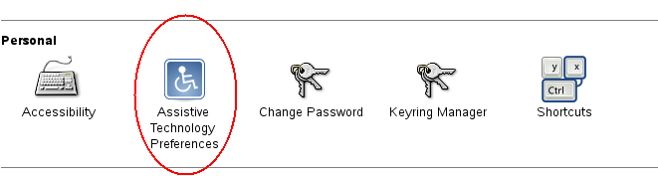
In gnome-control-center, open Assistive Technology for GNOME 2.x.
Drawing 1: Assistive technology preferences under GNOME control center

GNOME 3.x: Run the following command from command line to enable accessibility

gsettings set org.gnome.desktop.interface toolkit-accessibility true

Microsoft Windows: No need to change any settings, as accessibility is enabled by default.

Mac OSX: System wide accessibility must be enabled. Check the check box: System Preferences > Universal Access > Enable access for assistive devices. Failure to enable this will result in ErrorAPIDisabled exceptions during some module usage.
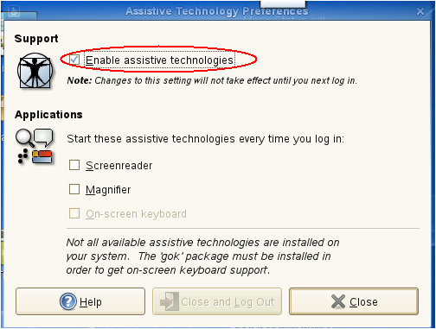
Drawing 2: Screenshot of Assisstive technology preferences dialog

Importing LDTP modules
- from ldtp import *
from ldtputils import *
Reason why we do importing based on the above format instead of 'import ldtp' is, if we do the first one, we can just directly use all the ldtp functions just by calling their name. If we import the module as 'import ldtp', then we need to call the corresponding function as ldtp.<function name>
Example 1:
from ldtp import *
selectmenuitem ('*-gedit', 'mnuFile;mnuNew')
Example 2:
import ldtp
ldtp.selectmenuitem ('*-gedit', 'mnuFile;mnuNew')

Call a function to perform an operation
LDTP generally operates on the given object in a particular window.
To select a menu item, you need to call selectmenuitem function. For example, to select open menu item in gedit application, call the below function
- selectmenuitem ('frmUnsavedDocument1-gedit', 'mnuFile;mnuOpen')
When you call the above a new dialog box will be poped up, you can verify whether the window is opened or not either by guiexist or by waittillguiexist
- guiexist function immediately returns either 1 (window exist) or 0 (window does not exist) waittillguiexist waits for the window to appear. Wait time out is by default 30 seconds. This default time out can be either increased on decreased using GUI_TIMEOUT
If you want to operate on a push button in a window, you need to call click function:
To press 'Cancel' button in a GTK Open File Selector dialog
- click ('dlgOpenFile', 'btnCancel')
When you do the above operation the GTK File selector dialog disappears. To verify whether the window actually quits or not use waittillguinotexist function
If you modify any opened file in gedit, the window title will be modified. To continue operating on the window you need to change your context of operation. Reason: As you are aware that LDTP works based on individual window, the context of window will be changed, when the title changes. To over come this use setcontext function and when you don't require them use releasecontext
Edit your current opened file using:
- settextvalue ('frmUnsavedDocument1-gedit', 'txt0', 'Testing editing')
This will change the window title. Note, before doing the above operation, title will be 'Unsaved Document 1 - gedit' and after editing the title will look like '*Unsaved Document 1 - gedit'. To further operate on the same window, use
- setcontext ('Unsaved Document 1 - gedit', '*Unsaved Document 1 - gedit')
So that you can continue using the same window name, for example:
- selectmenuitem ('frmUnsavedDocument1-gedit', 'mnuFile;mnuSaveAs')
The above function will invoke the GTK save dialog box
If any of the action releated functions (example: selectmenuitem, click, settextvalue) fail, an exception is raised. It has to be handled by the program to either continue operating on execution or just halt.

LDTP API
- Refer LDTP API page for list of implemented LDTP API's

Using / Hacking LDTP

Identifying controls
To operate on a window, first thing we need to know is the window title.

In the following picture you could notice red colored eclipse mark is the window title.

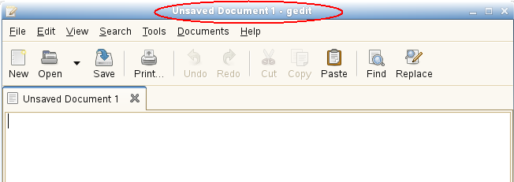

nags@nags:~> python
Python 2.5 (r25:51908, Nov 25 2006, 15:39:45)
[GCC 4.1.2 20061115 (prerelease) (SUSE Linux)] on linux2
Type "help", "copyright", "credits" or "license" for more information.
>>> from ldtp import *
>>> guiexist ('*-gedit')
1
>>> guiexist ('frmUnsavedDocument1-gedit')
1
>>> guiexist ('frmUnsavedDocument1-*')
1
>>> guiexist ('frm*-gedit')
1
>>> guiexist ('Unsaved Document 1 - gedit')
1

Push button
To operate on an object inside gedit window, we need to know the object information.

To click on open push button in gedit tool bar control, we need to use click API with window name as first argument and object name as second argument. The above command does the click operation. Informations to be gathered are Window name (Unsaved Document 1 – gedit) and push button control (Open).

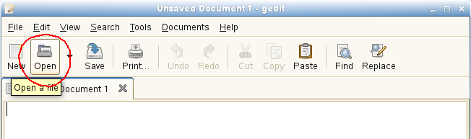

nags@nags:~> python
Python 2.5 (r25:51908, Nov 25 2006, 15:39:45)
[GCC 4.1.2 20061115 (prerelease) (SUSE Linux)] on linux2
Type "help", "copyright", "credits" or "license" for more information.
>>> from ldtp import *
>>> click ('*-gedit', 'btnOpen')
1

Menu item
To select a menu item under a menu in a window we need to use selectmenuitem API.

Informations to be gathered: Window name (Unsaved Document 1 – gedit), menu control (File), menu item control (New).

Incase of menu, we handle them in hierarchy. So, to access 'New' menu item, we need 'File' menu control too.

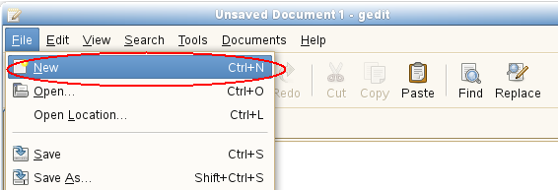

nags@nags:~> python
Python 2.5 (r25:51908, Nov 25 2006, 15:39:45)
[GCC 4.1.2 20061115 (prerelease) (SUSE Linux)] on linux2
Type "help", "copyright", "credits" or "license" for more information.
>>> from ldtp import *
>>> selectmenuitem ('*-gedit', 'mnuFile;mnuNew')
1

Toggle button
To operate on a toggle button with a click action, information required are window name (Open Files...) toggle button control (Type a file name).
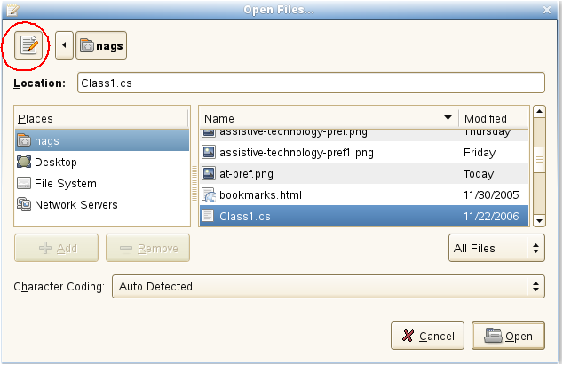

nags@nags:~> python
Python 2.5 (r25:51908, Nov 25 2006, 15:39:45)
[GCC 4.1.2 20061115 (prerelease) (SUSE Linux)] on linux2
Type "help", "copyright", "credits" or "license" for more information.
>>> from ldtp import *
>>> click ('dlgOpenFiles...', 'tbtnTypeafilename')
1

Text control
To set a text value in a text box, information like window name (Open Files...), text controls associated label (Location:) and the actual text to be placed (Class1.cs).

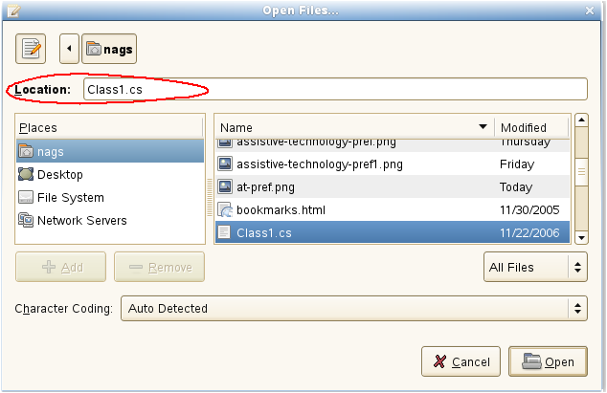

nags@nags:~> python
Python 2.5 (r25:51908, Nov 25 2006, 15:39:45)
[GCC 4.1.2 20061115 (prerelease) (SUSE Linux)] on linux2
Type "help", "copyright", "credits" or "license" for more information.
>>> from ldtp import *
>>> settextvalue ('dlgOpenFiles...', 'txtLocation', 'Class1.cs')
1

Table control
To select a row from the table of GTK open file selector, we need to collect information like, Window name (Open Files...), table name (Files – circled with blue color), row to be selected (Class1.cs).

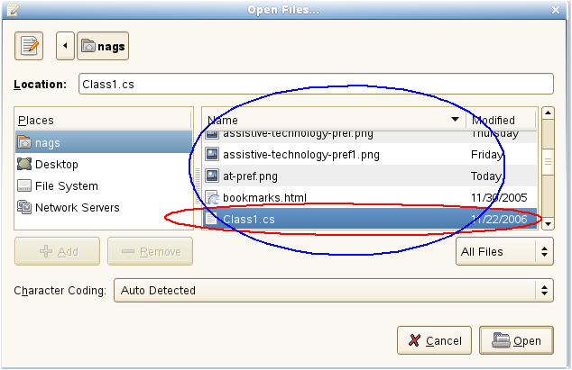
nags@nags:~> python
Python 2.5 (r25:51908, Nov 25 2006, 15:39:45)
[GCC 4.1.2 20061115 (prerelease) (SUSE Linux)] on linux2
Type "help", "copyright", "credits" or "license" for more information.
>>> from ldtp import *
>>> selectrow('dlgOpenFiles...', 'tblFiles', 'Class1.cs')
1

Push button
After selecting the file name, to open the file contents, we need to click on Open push button control. For doing this operation we need to gather informations like Window name (Open Files...), push button label name (Open).
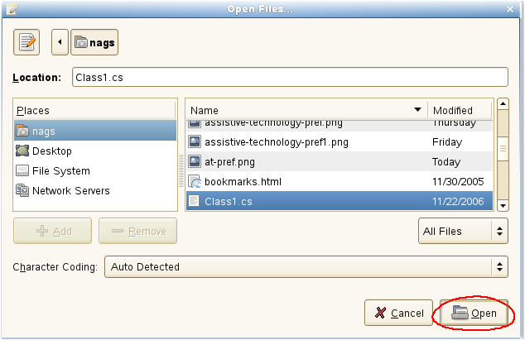
nags@nags:~> python
Python 2.5 (r25:51908, Nov 25 2006, 15:39:45)
[GCC 4.1.2 20061115 (prerelease) (SUSE Linux)] on linux2
Type "help", "copyright", "credits" or "license" for more information.
>>> from ldtp import *
>>> click ('dlgOpenFiles...', 'btnOpen')
1

Check box
To click on a check box control, we need to collect informations like window name (gedit Preferences), check box associated label name (Display line numbers).

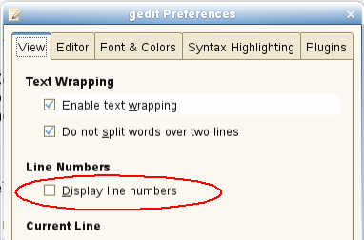

nags@nags:~> python
Python 2.5 (r25:51908, Nov 25 2006, 15:39:45)
[GCC 4.1.2 20061115 (prerelease) (SUSE Linux)] on linux2
Type "help", "copyright", "credits" or "license" for more information.
>>> from ldtp import *
>>> click ('dlggeditPreferences', 'chkDisplaylinenumbers')
1

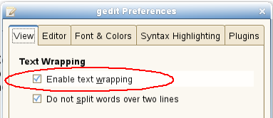

nags@nags:~> python
Python 2.5 (r25:51908, Nov 25 2006, 15:39:45)
[GCC 4.1.2 20061115 (prerelease) (SUSE Linux)] on linux2
Type "help", "copyright", "credits" or "license" for more information.
>>> from ldtp import *
>>> check ('dlggeditPreferences', 'chkEnabletextwrapping')
1

nags@nags:~> python
Python 2.5 (r25:51908, Nov 25 2006, 15:39:45)
[GCC 4.1.2 20061115 (prerelease) (SUSE Linux)] on linux2
Type "help", "copyright", "credits" or "license" for more information.
>>> from ldtp import *
>>> uncheck ('dlggeditPreferences', 'chkDisplaylinenumbers')
1

Spin button
To operate on a spin button, we need to collect information like Window name (gedit Preferences), spin button control name (Right margin at column).
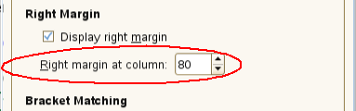

nags@nags:~> python
Python 2.5 (r25:51908, Nov 25 2006, 15:39:45)
[GCC 4.1.2 20061115 (prerelease) (SUSE Linux)] on linux2
Type "help", "copyright", "credits" or "license" for more information.
>>> from ldtp import *
>>> getvalue('dlggeditPreferences', 'sbtnRightmarginatcolumn')
80.0
>>> setvalue('dlggeditPreferences', 'sbtnRightmarginatcolumn', '81')
1
>>> setvalue('dlggeditPreferences', 'sbtnRightmarginatcolumn', '80')
1

Page tab
To operate on a page tab list, we need to collect information like window name (gedit Preferences), page tab list name (ptl0 in this case, as there are no label or associated label with this page tab list control), page tab name or index starting from 0.

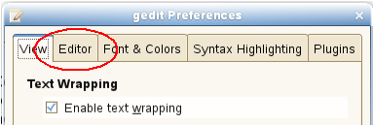

nags@nags:~> python
Python 2.5 (r25:51908, Nov 25 2006, 15:39:45)
[GCC 4.1.2 20061115 (prerelease) (SUSE Linux)] on linux2
Type "help", "copyright", "credits" or "license" for more information.
>>> from ldtp import *
>>> gettabcount ('dlggeditPreferences', 'ptl0')
5
>>> selecttabindex ('dlggeditPreferences', 'ptl0', 2)
1
>>> selecttab ('dlggeditPreferences', 'ptl0', 'Editor')
1

Check menu item
To operate on check menu item, we need to gather information like window name (Unsaved Document 1 – gedit), menu name (View), check menu item name (Side Pane).

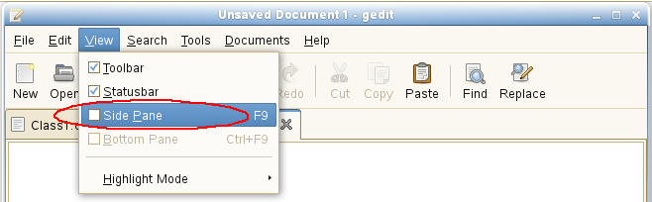
nags@nags:~> python
Python 2.5 (r25:51908, Nov 25 2006, 15:39:45)
[GCC 4.1.2 20061115 (prerelease) (SUSE Linux)] on linux2
Type "help", "copyright", "credits" or "license" for more information.
>>> from ldtp import *
>>> selectmenuitem ('*-gedit', 'mnuView;mnuSidePane')
1
>>> menuuncheck('*-gedit', 'mnuView;mnuSidePane')
1
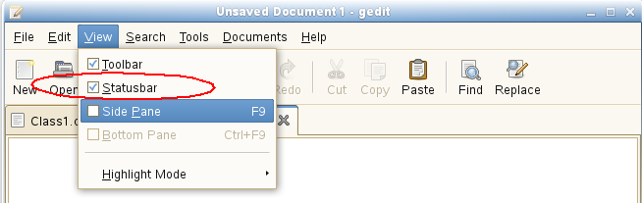

nags@nags:~> python
Python 2.5 (r25:51908, Nov 25 2006, 15:39:45)
[GCC 4.1.2 20061115 (prerelease) (SUSE Linux)] on linux2
Type "help", "copyright", "credits" or "license" for more information.
>>> from ldtp import *
>>> menucheck('*-gedit', 'mnuView;mnuStatusbar')
1

Radio menu item
To operate on a radio menu item control, we need to gather informations like window name (Unsaved Document 1 – gedit), menu name (Documents), menu item name (Class1.cs – assuming that Class1.cs is currently opened).
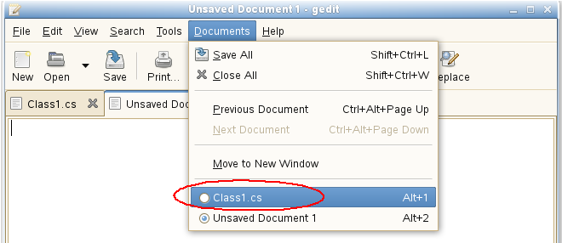
nags@nags:~> python
Python 2.5 (r25:51908, Nov 25 2006, 15:39:45)
[GCC 4.1.2 20061115 (prerelease) (SUSE Linux)] on linux2
Type "help", "copyright", "credits" or "license" for more information.
>>> from ldtp import *
>>> selectmenuitem ('*-gedit', 'mnuDocuments;mnuClass1.cs')
1
>>> menucheck ('*-gedit', 'mnuDocuments;mnuClass1.cs')
1

Combo box – Menu item
To select a menu item under a combo box, we need to gather informations like window name (Open Files...), combo box name (Character Coding), menu item name (Current Locale).
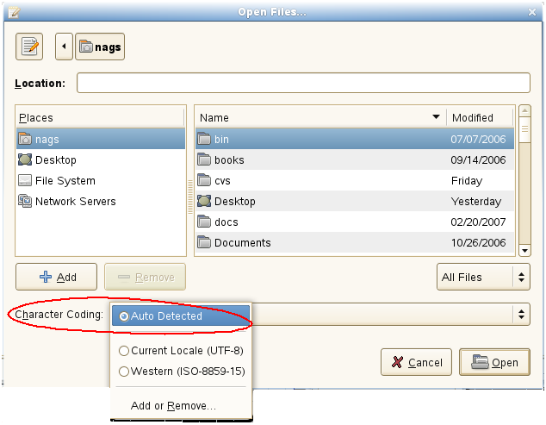

nags@nags:~> python
Python 2.5 (r25:51908, Nov 25 2006, 15:39:45)
[GCC 4.1.2 20061115 (prerelease) (SUSE Linux)] on linux2
Type "help", "copyright", "credits" or "license" for more information.
>>> from ldtp import *
>>> comboselect ('dlgOpenFiles...', 'cboCharacterCoding', 'Current Locale (UTF-8)')
1

Combo box – List item
To operate on list item under a combo box control, we need to gather informations like window name (Find), Combo box control name (Search for), list item existing content or list item index or new item name (OdbcMetaDataCollectionName.cs)

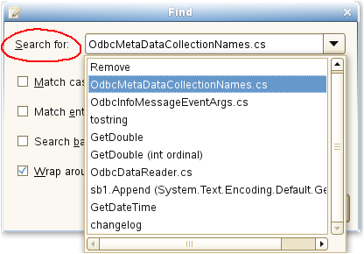

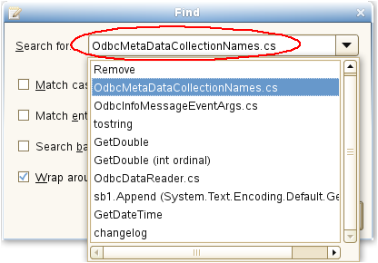

nags@nags:~> python
Python 2.5 (r25:51908, Nov 25 2006, 15:39:45)
[GCC 4.1.2 20061115 (prerelease) (SUSE Linux)] on linux2
Type "help", "copyright", "credits" or "license" for more information.
>>> from ldtp import *
>>> settextvalue('dlgFind', 'cboSearchfor', 'OdbcMetaDataCollectionNames.cs'')
1

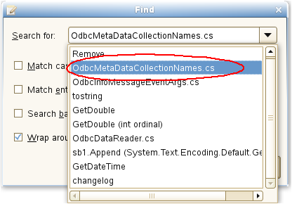

nags@nags:~> python
Python 2.5 (r25:51908, Nov 25 2006, 15:39:45)
[GCC 4.1.2 20061115 (prerelease) (SUSE Linux)] on linux2
Type "help", "copyright", "credits" or "license" for more information.
>>> from ldtp import *
>>> comboselect('dlgFind', 'cboSearchfor', 'OdbcMetaDataCollectionNames.cs')
1

Launch application
Application to be tested can be launched using LDTP API launchapp.

nags@nags:~> python
Python 2.5 (r25:51908, Nov 25 2006, 15:39:45)
[GCC 4.1.2 20061115 (prerelease) (SUSE Linux)] on linux2
Type "help", "copyright", "credits" or "license" for more information.
>>> from ldtp import *
>>> launchapp ('gedit')
1

GUI exist
To check a GUI (window) exist, you can use this guiexist API. Also it has different flavors like waittillguiexist, waittillguinotexist.

- guiexist function checks whether the given window exists or not. If exist returns 1, else returns 0.
- waittillguiexist function will wait for the given window to appear. If appeared returns 1, else returns 0. Difference between guiexist and waittillguiexist is, guiexist returns immediately, but waittillguiexist will wait for a max of 30 seconds for a window to appear. Note: On doing some operation, if the expected result is, a window will be pop-ed up, then it is recommended to use waittillguiexist, instead of wait or sleep. Reason: wait or sleep will wait till the time period, but waittillguiexist, will return immediately once the window appears.
- waittillguinotexist function will wait for the given window to close. If closed returns 1, else returns 0. waittillguinotexist will wait for a max of 30 seconds for a window to close. Note: On doing some operation, if the expected result is, an existing window will be closed, then it is recommended to use waittillguinotexist, instead of wait or sleep. Reason: wait or sleep will wait till the time period, but waittillguinotexist, will return immediately once the window closed.

Timeout
GUI timeout

GUI timeout, is the default timeout settings used, by waittillguiexist and waittillguinotexist functions. This function will wait for the specified number of seconds, for the window to either appear or disappear. Default timeout period is 30 seconds.

This default timeout period that can be modified:

- By setting the environment variable GUI_TIMEOUT to whatever seconds.
- By passing a value to guiTimeOut argument of waittillguiexist or waittillguinotexist functions.
- By calling guitimeout function.
- When invoking LDTP engine, use -g option.

Example 1
export GUI_TIMEOUT=30

Example 2
waittillguiexist ('*-gedit', guiTimeOut=30)
waittillguinotexist ('dlgOpenFiles...', guiTimeOut=30)

Example 3
guitimeout (30)

Example 4
ldtp -g 30

OBJ timeout

OBJ timeout, is the default timeout settings used, internally. This function will wait for the specified number of seconds, for the object inside a window to appear. Default timeout period is 5 seconds.

This default timeout period that can be modified:

- By setting the environment variable OBJ_TIMEOUT to whatever seconds.
- By calling objtimeout function.
- When invoking LDTP engine, use -o option.

Example 1
export OBJ_TIMEOUT=5

Example 2
objtimeout (5)

Example 3
ldtp -o 5

Generate raw keyboard events
In some cases, the window we are trying to operate may not be accessibility enabled or we may need to generate non-printable keys (ALT, CTRL, ENTER, BACKSPACE, ESC, F1-F12, SHIFT, CAPS LOCK, TAB, PAGE UP, PAGE DOWN, HOME, END, RIGHT / LEFT / UP / DOWN ARROW KEYS, INS, DEL). We can use generatekeyevent function or enterstring function to simulate the key events, as if the user typed. Note: All the non-printable characters will be enclosed with in angular brackets.
Example 1
<ctrl>lwww.google.co.in<enter>
Example 2
<alt><f1>
Example 3
<control>s

nags@nags:~> python
Python 2.5 (r25:51908, Nov 25 2006, 15:39:45)
[GCC 4.1.2 20061115 (prerelease) (SUSE Linux)] on linux2
Type "help", "copyright", "credits" or "license" for more information.
>>> from ldtp import *
>>> launchapp ('gedit')
1
>>> waittillguiexist ('*-gedit')
1
>>> enterstring ('<alt><tab>')
1
>>> enterstring ('*-gedit', 'txt0', '<caps>Testing enterstring API<enter>')
1
>>> generatekeyevent ('<alt><tab>')
1

Generate raw mouse events
To generate raw mouse events of different types like, b1c, b1d, b2c, b2d, b3c, b3d, X and Y of screen co-ordinates has to be provided. Here b is button, c is single click, d is double click.

nags@nags:~> python
Python 2.5 (r25:51908, Nov 25 2006, 15:39:45)
[GCC 4.1.2 20061115 (prerelease) (SUSE Linux)] on linux2
Type "help", "copyright", "credits" or "license" for more information.
>>> from ldtp import *
>>> generatemouseevent (100, 200) # Default is b1c
1
>>> generatemouseevent (100, 200, 'b1d') # To generate double click
1

Application information
On calling getapplist, will get all the accessibility application name that are currently running. To get window list for which the application map's are gathered and stored in local cache, use getwindowlist. To get all the object list under a window, use getobjectlist API. To get a list of properties available under an object, use getobjectinfo. To get the property of an object, use getobjectproperty.

nags@nags:~> python
Python 2.5 (r25:51908, Nov 25 2006, 15:39:45)
[GCC 4.1.2 20061115 (prerelease) (SUSE Linux)] on linux2
Type "help", "copyright", "credits" or "license" for more information.
>>> from ldtp import *
>>> getapplist ()
[u'gnome-session', u'gnome-power-manager', u'gnome-settings-daemon', u'Libbonoboui-Gtk-Module-init-info', u'nautilus', u'GnomeApplicationBrowser', u'/usr/lib/zen-updater/ZenUpdater.exe', u'gaim', u'gtk-window-decorator', u'gedit', u'xchat', u'gnome-panel', u'gnome-volume-manager', u'resapplet', u'nm-applet', u'soffice.bin']
>>> getwindowlist ()
[u'frmUnsavedDocument1-gedit']
>>> getobjectlist ('*-gedit')
...
>>> getobjectinfo ('*-gedit', 'btnNew')
[u'child_index', u'class', u'description', u'parent', u'label']
>>> getobjectproperty ('*-gedit', 'btnNew', 'class')
'New'

Callback – On new window creation
Register a callback event, when a window with given title is created. Glob type pattern can be given as title name.

Advantage
Unexpected window can be easily handled using this. For example, the password dialog box of Evolution, connection reset by peer dialog, application crash dialog, etc.

Example
from ldtp import *
import threading
# Thread creation
callbackRunning = threading.Event ()
callbackRunning.clear ()
callbackState = threading.Event ()
callbackState.clear ()
# Callback definition
def cb ():
callbackState.set ()
waittillguiexist ('dlgReplace')
click ('dlgReplace', 'btnClose')
callbackState.clear ()
callbackRunning.set ()
print 'callbackend'
# Callback registration
onwindowcreate ('Replace', cb)
# General operation, which will invoke a window
click ('*gedit', 'btnReplace')
click ('*gedit', 'btnOpen')
waittillguiexist ('dlgOpenFiles...')
click ('dlgOpenFiles...', 'btnClose')
# Wait for callback to complete, if invoked
if callbackState.isSet ():
print 'Waiting for callback to complete'
callbackRunning.wait ()
print 'callbackset'
print 'test end'

Logging
nags@nags:~> python
Python 2.5 (r25:51908, Nov 25 2006, 15:39:45)
[GCC 4.1.2 20061115 (prerelease) (SUSE Linux)] on linux2
Type "help", "copyright", "credits" or "license" for more information.
>>> from ldtp import *
>>> log ('test script', 'debug')
1
>>> log ('test script', 'warning')
1
>>> log ('test script', 'error')
1
>>> log ('test script', 'cause')
1

Example script
from ldtp import *
from ldtputils import *

try:
launchapp ('gedit')
if waittillguiexist ('*-gedit') == 0:
raise LdtpExecutionError ('Gedit window does not exist')
selectmenuitem ('*-gedit', 'mnuFile;mnuOpen')
if waittillguiexist ('dlgOpenFiles') == 0:
raise LdtpExecutionError ('Open Files dialog does not exist')
selectrow ('dlgOpenFiles...', 'tblFiles', fileName [0])
click ('dlgOpenFiles...', 'btnOpen')
if waittillguinotexist ('dlgOpenFiles') == 0:
raise LdtpExecutionError ('Open Files dialog still exist')
except LdtpExecutionError, msg:
raise

How to execute LDTP scripts
Make sure that you have the following files in current working directory
- You need to have test scripts to be executed

Invoking python script
$ python <script file name.py>
Example
python gedit.py

Suggestions from LDTP team
- When a new window is expected after an operation, we suggest to use waittillguiexist and on some operation, if a window is expected to close we suggest to use waittillguinotexist. In both cases, the time-out period is 30 seconds. This value can be modified – refer LDTP API reference.

How to operate LDTP from a remote system

LDTP engine (Linux)
Follow one of the options to start LDTP engine (ldtp binary) in the remote box
Option 1
$ldtp -s
Option 2
$ ldtp -p <port number to start> # Default port number is 4118

LDTP engine (Windows)
Execute CobraWinLDTP.exe in command line

LDTP engine (Mac OS X)
Execute ldtp in command line

LDTP client
Follow one of the options in the client side to communicate to LDTP engine
Option 1
export LDTP_SERVER_ADDR=host-name or ip address
export LDTP_SERVER_PORT=<port number to communicate, as mentioned in LDTP engine>
python <script file name>.py or ldtprunner test-runner.xml
Option 2
export LDTP_SERVER_ADDR=host-name or ip address
python <script file name>.py or ldtprunner test-runner.xml # This will use default port number.

Troubleshooting LDTP
In-case, if you want to see whats happening on executing some LDTP commands, follow the steps

In a terminal

$ export LDTP_DEBUG=2 # If bash shell (Linux/Mac OS X)
C:\> set LDTP_DEBUG=1 (Microsoft Windows)
$ ldtp # (Linux/Mac OS X) on Windows run CobraWinLDTP.exe
Client packet len: 82
i = 0
Data read 82, packet-len = 82, bytes read = 82, data: <?xml version="1.0"?><REQUEST><ACTION>124</ACTION><ID>MainThread124</ID></REQUEST>
PACKET LENGTH: 0
Received packet [<?xml version="1.0"?><REQUEST><ACTION>124</ACTION><ID>MainThread124</ID></REQUEST>] through 15
Node: ACTION
action_name: 124
Node: ID
request_id: MainThread124
Command: 124
Accessible application name: Thunderbird
Accessible application name: gnome-panel
Accessible application name: xchat
Accessible application name: nm-applet
Accessible application name: nautilus
Accessible application name: gaim
Accessible application name: acroread
Accessible application name: soffice.bin
Accessible application name: gtk-window-decorator
Accessible application name: gedit
LIST: <?xml version="1.0" encoding="utf-8"?><OBJECTLIST><OBJECT>nautilus</OBJECT><OBJECT>gaim</OBJECT><OBJECT>gtk-window-decorator</OBJECT><OBJECT>gedit</OBJECT><OBJECT>xchat</OBJECT><OBJECT>gnome-panel</OBJECT><OBJECT>Thunderbird</OBJECT><OBJECT>nm-applet</OBJECT><OBJECT>soffice.bin</OBJECT><OBJECT>acroread</OBJECT></OBJECTLIST>
resp_len = 117
Sending..
538
Response packet: <?xml version="1.0" encoding="utf-8"?><RESPONSE><ID>MainThread124</ID><STATUS><CODE>0</CODE><MESSAGE>Successfully completed</MESSAGE></STATUS><DATA><LENGTH>325</LENGTH><VALUE><![CDATA[<?xml version="1.0" encoding="utf-8"?><OBJECTLIST><OBJECT>nautilus</OBJECT><OBJECT>gaim</OBJECT><OBJECT>gtk-window-decorator</OBJECT><OBJECT>gedit</OBJECT><OBJECT>xchat</OBJECT><OBJECT>gnome-panel</OBJECT><OBJECT>Thunderbird</OBJECT><OBJECT>nm-applet</OBJECT><OBJECT>soffice.bin</OBJECT><OBJECT>acroread</OBJECT></OBJECTLIST>]]></VALUE></DATA></RESPONSE>
Msg:
Bytes sent: 542

In another terminal

$ export LDTP_DEBUG=2 # If bash
nags@nags:~> python
Python 2.5 (r25:51908, Nov 25 2006, 15:39:45)
[GCC 4.1.2 20061115 (prerelease) (SUSE Linux)] on linux2
Type "help", "copyright", "credits" or "license" for more information.
>>> from ldtp import *
>>> getapplist()
124 ( )
Send packet <?xml version="1.0"?><REQUEST><ACTION>124</ACTION><ID>MainThread124</ID></REQUEST>
Received packet size 538
Received response Packet <?xml version="1.0" encoding="utf-8"?><RESPONSE><ID>MainThread124</ID><STATUS><CODE>0</CODE><MESSAGE>Successfully completed</MESSAGE></STATUS><DATA><LENGTH>325</LENGTH><VALUE><![CDATA[<?xml version="1.0" encoding="utf-8"?><OBJECTLIST><OBJECT>nautilus</OBJECT><OBJECT>gaim</OBJECT><OBJECT>gtk-window-decorator</OBJECT><OBJECT>gedit</OBJECT><OBJECT>xchat</OBJECT><OBJECT>gnome-panel</OBJECT><OBJECT>Thunderbird</OBJECT><OBJECT>nm-applet</OBJECT><OBJECT>soffice.bin</OBJECT><OBJECT>acroread</OBJECT></OBJECTLIST>]]></VALUE></DATA></RESPONSE>
[u'nautilus', u'gaim', u'gtk-window-decorator', u'gedit', u'xchat', u'gnome-panel', u'Thunderbird', u'nm-applet', u'soffice.bin', u'acroread']
>>>

Bibliography
http://en.wikipedia.org/wiki/Software_testing
http://safsdev.sf.net

