
Agronomy
for Sustainable Development
INSTRUCTIONS TO AUTHORS

1. TYPES OF ARTICLES 2
2. SUBMISSION PROCESS 2
3. EDITORIAL PROCESS 2
4. REQUIRED FORMAT FOR RESEARCH ARTICLES 3
5. REQUIRED FORMAT FOR REVIEW ARTICLES 4
6. REQUIRED FORMAT FOR META-ANALYSES 5
7. REFERENCES 5
8. ARTWORK (TABLES AND FIGURES) 6
9. ELECTRONIC SUPPLEMENTARY MATERIAL 10
10. DECLARATIONS 10
10.1. Funding and conflicts of interest 11
10.2. Ethics approval 13
10.3. Consent to participate 13
10.4. Consent for publication 13
10.5. Data availability statement - Code availability statement 14
10.6. Authors contribution 14
11. ETHICAL RESPONSIBILITIES OF AUTHORS 17
12. AUTHORSHIP PRINCIPLES 19
13. PREPRINT POLICY 20
14. RESEARCH DATA POLICY 20
15. AFTER ACCEPTANCE

- TYPES OF ARTICLES
Agronomy for Sustainable Development publishes three types of papers: Research articles, Review articles and Meta-analyses (systematic reviews). The findings should deal with both Agriculture and Sustainable Development: see the Aims and Scope for specific topics.

- SUBMISSION PROCESS
Agronomy for Sustainable Development only accepts online submission, at the following address: http://www.editorialmanager.com/asde
Authors must verify that their manuscript complies with the Aims and Scope of the journal.
They must fill in the mandatory fields in the online form, and carefully check that the authors' first and last names in the online form correspond to those indicated in the manuscript. The ORCID identifier is mandatory for the corresponding author. Authors should choose one or several classification item(s) corresponding to the main topic of their manuscript.

The manuscript must be accompanied by a cover letter containing:
- the article title
- the full first name (no initial) and last name of all the authors,
- a paragraph describing why their findings are novel (for research articles and meta-analyses) or why a review on this subject is needed,
- a list of four suggested, international reviewers. The suggested reviewers must have no conflict of interest with the authors; they should not have co-authored previous publications with the present author(s). They must represent an international diversity. When suggesting reviewers, the Corresponding Author must provide an institutional email address for each suggested reviewer, or, if this is not possible to include other means of verifying the identity such as a link to a personal homepage, a link to the publication record or a researcher or author ID in the submission letter. Please note that the Journal may not use the suggestions, but suggestions are appreciated and may help facilitate the peer review process.

- EDITORIAL PROCESS
Upon submission, articles enter the pre-selection process. At that stage, the general quality of the manuscript and its compliance with the scope and author instructions are evaluated by the Managing Editor and the Editors in chief; the non-compliance is a cause for rejection. The articles pre-selected are then assigned to an Associate Editor and at least two external reviewers, in a single blind process.
The Associate Editor submits his/her decision to the Managing Editor, who communicates a final decision to the authors. When revisions are requested, the authors are asked to answer point by point each reviewer comment. The revised manuscript returns to the same Associate Editor and is eventually evaluated again by the same or by alternative reviewers. Upon acceptance of the manuscript, the journal requests that the authors provide a short post on their article, that will be published in the journal blog (http://ist.blogs.inra.fr/agronomy/). The purpose of this post is to convert the main research information into easily accessible language in order to be understandable by the largest possible audience. This post must be accompanied by a relevant photograph in landscape format.
At the production stage, it is the responsibility of the authors to carefully examine the article proofs. No major corrections such as change in authorship will be accepted at this stage.
No correction can be made after article online publication. If an error is identified after publication, an erratum should be required by the authors.

- REQUIRED FORMAT FOR RESEARCH ARTICLES

General
Research articles should report the results of original research. The material should not have been previously published or submitted for publication elsewhere. Research articles should focus on one major discovery supported by 2-4 results.

Novelty
The novelty, or difference, of the major finding versus current knowledge should be clearly explained in:
- the cover letter to the Editor-in-Chief;
- the abstract;
- the end of the Results and Discussion section;
- the Conclusion section.
Novelty claims should be made in an affirmative way, using for instance “Here we show for the first time that ...”, or “This is the first...”.
Only articles showing notable added value will be sent for in-depth evaluation.

English
All manuscripts should be written in high-quality American English. Non-English native authors should seek appropriate help from English-writing professionals before submission. The journal may ask authors to provide a certificate from an English language proofreading service, ensuring correct grammar and typographical error corrections (i.e., punctuation, spelling, inconsistencies…) to help authors present a clear and scientific message.

Sections
The manuscript should contain the following items (in the same order):
- article title
- full first and last names of authors with an asterisk “*” highlighting the corresponding author; affiliations and postal addresses; e-mail address of the corresponding author
- Abstract (less than 300 words)
- List of keywords (maximum 10)
- IMRaD elements:
- 1. Introduction
- 2. Materials and methods (including subsections - 2.1, 2.2...)
- 3. Results and discussion (including topical subsections - 3.1, 3.2...)
It is advisable to submit a combined Results and discussion section. Should the authors prefer to submit two distinct Results and Discussion sections, this choice would need to be justified in the cover letter.
- 4. Conclusion
- Acknowledgments
- Declarations: (see section 11 below)
- Funding (information that explains whether and by whom the research was supported)
- Conflicts of interest/Competing interests (include appropriate disclosures)
- Ethics approval (include appropriate approvals or waivers)
- Consent to participate (include appropriate statements)
- Consent for publication (include appropriate statements)
- Availability of data and material (see in section 13 below what is expected here)
- Code availability (software application or custom code)
- Authors' contributions (include appropriate statements)
- References (see section 8 below)
Other sections such as annexes and appendices are not accepted.

General presentation
The text length of research articles is limited to 8000 words, excluding figures, tables and references. All text should be written in a concise way, by focusing on major points, findings, breakthrough or discoveries, and their broad significance. All running text should be in Times 11 or Times New Roman 11, with 1.5 line spacing. Figure and table captions must be self-explanatory and they should be written in Times 10 or Times New Roman 10. Lines, as well as every page of the manuscript, including the title page, references, tables, etc. must be numbered.

Title
Titles should not be phrased as questions. The title of research articles should be concise and informative and focused on the main scientific discovery. Authors are advised to look at examples in recent issues of the journal.

Abstract
The research article abstract of less than 300 words should report concisely on the main scientific breakthrough. The abstract should not contain abbreviations nor literature references. The abstract is structured in three parts: the first part summarizes the Introduction section, it thus gives the background, the overall and specific issues, and the hypothesis (about 3-4 sentences). The second part summarizes the Experimental section, it thus gives a brief overview of the experiments or surveys (about 2-3 sentences). The third part summarizes the Results and discussion section, it thus gives: the 1-2 major results using precise trends and data, then the interpretation of those results, then the claimed novelty of those results versus current knowledge, then the basic or applied benefits of those results for sustainable agriculture. Novelty claims should be made in an affirmative way, using for instance “Here we show that ...”, “Here we demonstrate that ...” or “This is the first...”

Abbreviations
In general abbreviations should be avoided in the main text because they decrease article readability and impact. Only 1-2 common abbreviations such as DNA or LED are accepted in the main text. When their use is essential, abbreviations must be explained when they first appear in the text. Abbreviations in figures, tables and equations are accepted only if there is not enough space to write full words. Here, abbreviations should be explained in figure and table captions, or after equations.

Footnotes
Footnotes in the running text and in tables are not accepted. Table footnotes should be included in the table caption.

Units
Data description in the text, tables and figures should follow the International System of Units, as it is the most widely used system of measurement. The choice of another system of units may be tolerated if it is explained and argued clearly.

- REQUIRED FORMAT FOR REVIEW ARTICLES
The preferred type is the critical review, in which the critical component is key to its value. ASDE does not evaluate bibliometric reviews. For review articles please follow the general instructions for research articles, with the following exceptions:
- The text length of review articles is limited to 16000 words, excluding figures, tables and references.
- The title should end by “. A review” and not “: a review”.
- The abstract of less than 300 words should contain two parts: the first part should give general and global issues, then specific and scientific issues in about 5-6 sentences. The second part should start by, e.g., “Here we review…”, and explain the interest of the review. Then the major advances demonstrated in the article by literature analysis should be presented: “The major points are the following: 1)… 2)…”. The reader should clearly understand the added value of those advances.
- The first section of the article should be “1. Introduction”, and the last section “X. Conclusion”, and sections should have topics titles. The structure should not be of IMRaD type (Intro Methods Results and Discussion). All sections and sub-sections should be numbered. At the end of each section, authors are advised to propose a concise view of the novelty described and/or the main research hypotheses addressed by the reviewed knowledge.
- A Contents section should be inserted after the list of keywords, before the introduction section.

- REQUIRED FORMAT FOR META-ANALYSES
For meta-analyses, please follow the general instructions for research articles, with the following exceptions:
- The title should end by “. A meta-analysis”
- An additional section “References of the meta-analysis” gathering all the references used for conducting the meta-analysis should be inserted after the “References” section
Meta-analyses should meet the following criteria:
- The procedure used to select papers from scientific databases should be explained,
- Individual data should be weighted according to their level of precision when possible,
- Site-year variability of the results should be analyzed from an agronomic point of view, to identify relevant explanatory variables,
- Efforts should be made to check for the publication bias and confounding effects.

- REFERENCES

Citation
Cite references in the text by name and year in parentheses. Some examples:
  - Negotiation research spans many disciplines (Thompson 1990).
  - This result was later contradicted by Becker and Seligman (1996).
  - This effect has been widely studied (Abbott 1991; Barakat et al. 1995; Kelso and Smith 1998; Medvec et al. 1993).

Reference list
The list of references should only include works that are cited in the text and that have been published or accepted for publication. Personal communications and unpublished works should only be mentioned in the text. Do not use footnotes or endnotes as a substitute for a reference list.
Reference list entries should be alphabetized by the last names of the first author of each work. The DOI must be indicated when available as follows: https://doi.org/ (with the https, and not as “doi:”)
The authors should check very carefully that references cited in the text match with those in the reference list; and that all references in the list are actually cited in the text. The accuracy of references should also be carefully checked.
For authors using EndNote, an output style that supports the formatting of in-text citations and reference list is available at: https://endnote.com/downloads/styles/agronomy-for-sustainable-development/
For authors using Mendeley or Zotero, you can download the CSL file for this journal.

  - Journal article
Always use the standard abbreviation of a journal’s name, see https://images.webofknowledge.com/images/help/WOS/A_abrvjt.html
If the title you are looking for is not included, the words in the title of the journal must each be abbreviated in accordance with ISO standard 4, using the ‘Word search / Search the list of abbreviations by word’ available on the ‘ISSN List of Title Word Abbreviations’ site see http://www.issn.org/services/online-services/access-to-the-ltwa

Petit S, Alignier A, Colbach N et al (2013) Weed dispersal by farming at various spatial scales. A Review. Agron Sustain Dev 33:205. https://doi.org/10.1007/s13593-012-0095-8
Pereyra-Goday, F., Jebari, A., Takahashi, T. Pablo Rovira, Walter Ayala, Michael R. F. Lee, M. Jordana Rivero & Graham A. McAuliffe (2024) Carbon footprint of mixed farming crop-livestock rotational-based grazing beef systems using long term experimental data. Agron Sustain Dev 44:41. https://doi.org/10.1007/s13593-024-00977-1
Ideally, the names of all authors should be provided, but the usage of “et al” in long author lists will also be accepted for articles with more than 3 authors. The References section must be harmonized if you choose to use “et al”.
  - Book
The ISBN must be indicated. In case of an electronic version, the ISBN and DOI (https://doi.org/ format) must be indicated.
Burnham KP, Anderson DR (2002) Model selection and multimodel inference: a practical information-theoretic approach, 2nd edn. Springer, New York. https://doi.org/10.1007/b97636 (ISBN 978-0-387-22456-5)
  - Book chapter
The ISBN must be indicated. In case of an electronic version, the ISBN and DOI (https://doi.org/ format) must be indicated.
Lemaire G, Gastal F (1997) N uptake and distribution in plant canopies. In: Lemaire G (ed) Diagnosis of the nitrogen status in crops. Springer, Berlin, pp 3–43. https://doi.org/10.1007/978-3-642-60684-7_1 (ISBN 978-3-642-64506-8)
  - Online document
Andrews S (2010) FastQC. A quality control tool for high throughput sequence data. Babraham Bioinforma. http://www.bioinformatics.babraham.ac.uk/projects/fastqc/ Accessed 6 May 2019
  - Dissertation
Alloush GA (1990) The mechanism of mobilization of iron from soil minerals in the rhizosphere of Cicer arietinum L. PhD Dissertation, University of Leeds, UK

- ARTWORK (TABLES AND FIGURES)

Number of tables and figures
For research articles, the number of tables plus figures is limited to 8, including the introduction color figure. Figures should be preferred to tables. For review articles and meta-analyses, there is no limitation of tables/figures number.

Permissions
If you include tables or figures that have already been published elsewhere, you must obtain permission from the copyright owner(s) for both the print and online format and include evidence that such permission has been granted when submitting the manuscript. Please be aware that some publishers do not grant electronic rights for free and that Springer will not be able to refund any costs that may have occurred to receive these permissions. In such cases, material from other sources should be used. Please identify any previously published material by giving the original source in the form of a reference at the end of the table/figure caption.

Placement and Size
Tables and figures should be uploaded as separated files at the submission stage. Their place in the manuscript should be clearly indicated by the authors.
When preparing your figures, size figures to fit in the column width.

The figures should be 39 mm, 84 mm, 129 mm, or 174 mm wide and not higher than 234 mm.

Figures
- Color photograph in the introduction section
- For all the article types, the introduction must contain 1 color photo in landscape format, named Figure 1. The photo(s) should reveal the main topic of the article to a wide audience. The source of the photo must be indicated at the end of the figure caption (Photocredit: Name).

- Colors
Color illustrations are accepted at no charge both for the electronic version and the printed version of the journal.
- Format
There should be no frame around the figures or sub-figures, only the X and Y axes should be drawn in black and in a size of 1.5 with the graduation marks visible.
There should be no horizontal or vertical grid. The label of the y-axis should be written horizontally, positioned above the Y-axis, and aligned with it. The information in the axis label is short (name of the variable and unit); any other description (error bars, etc.) must be given in the caption.
No color legend is inserted in the graph, but the name of the treatments is indicated with a horizontal label and arrow lines pointing to the symbol or histogram.
Preferably, a graph should contain a maximum of 3 curves.
Regression equations should not appear on the graph, but rather at the end of the caption.
A figure should not contain too many sub-items, in order to be readable. Sub-items should not have any frame.
All abbreviations must be clearly explained in the captions. A Figure and its caption must be understandable without referring to the text of the article to find the meaning of the chosen abbreviations.

Examples of expected good figures:

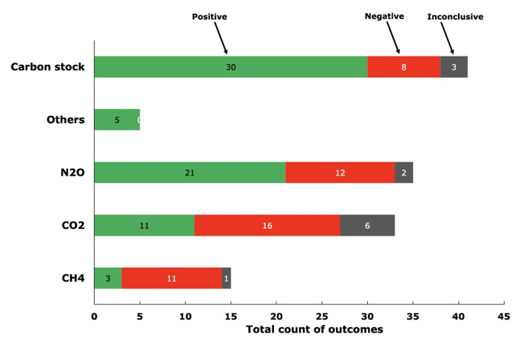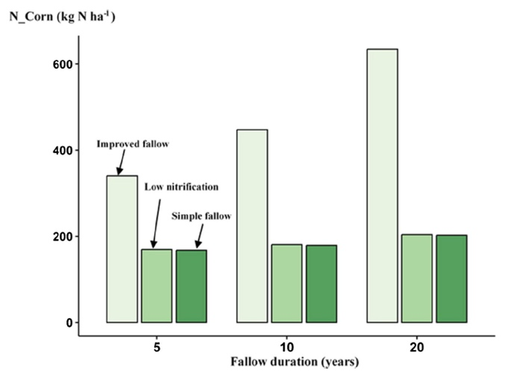
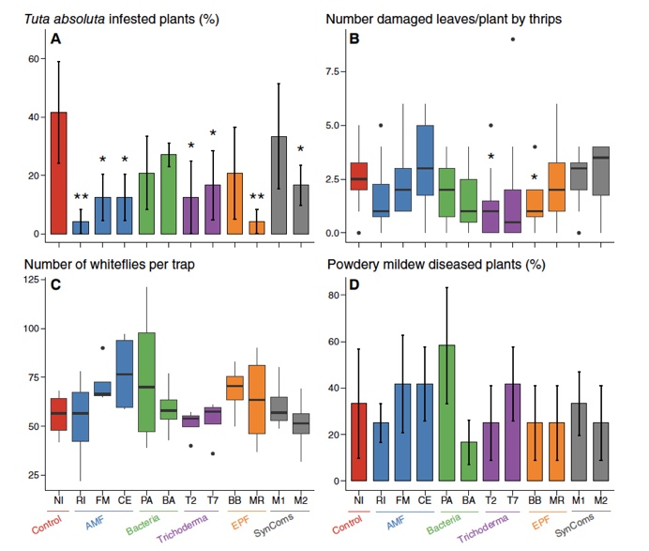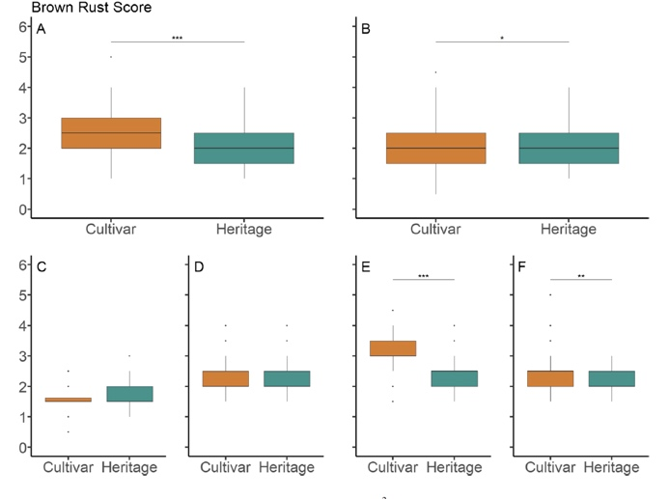
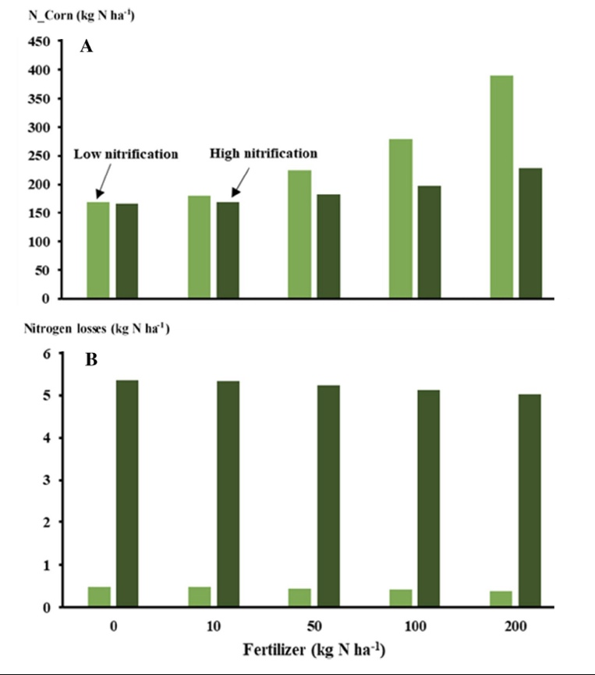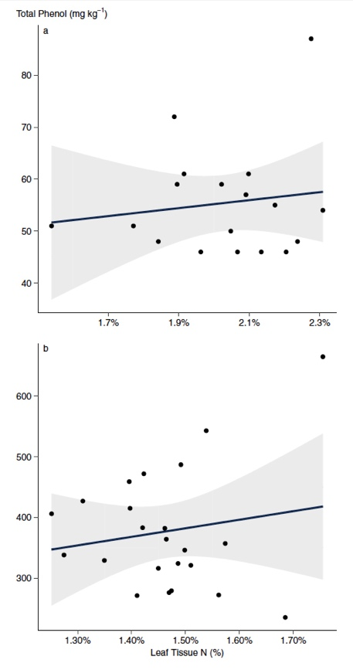
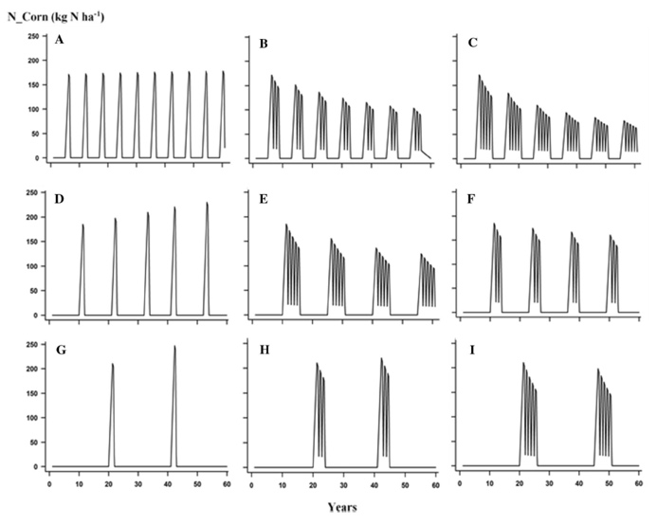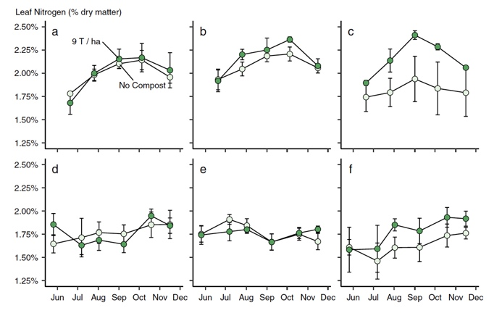

Composite figures should not mix figure types (example: Map + bar graph + line figure).
Sub-graphs must be well aligned and the final shape must be regular.
Authors are encouraged to use contrasting colors (red, blue, green…) to increase the readability.
Do not use faint lines and/or lettering and check that all lines and lettering are legible at final size.
Do not use background lines nor colored or shaded backgrounds.
No color legend should be inserted in the graph, but the name of the treatments is indicated with a horizontal label and arrow lines pointing to the symbol or histogram. This rule remains flexible, however, if there are many treatments (i.e., > 3), because the graph can become unreadable. Efforts must be put to produce an easily readable figure. Prefer two simple figures than a complex one.
All lines should be at least 1 pt wide
Do not repeat the curve or axis names in the different sub-figures.
- Lettering
To add lettering, it is best to use Helvetica or Arial (sans serif fonts).
Keep lettering consistently sized throughout your final-sized artwork, usually about 2–3 mm (8–12 pt).
Variance of type size within an illustration should be minimal, e.g., do not use 8-pt type on an axis and 20-pt type for the axis label.
Avoid effects such as shading, outline letters, etc.
Do not include titles or captions within your illustrations.
- Numbering
All figures are to be numbered using Arabic numerals.
Figures should always be cited in text in consecutive numerical order. Figure parts should be perfectly aligned and have the same size. The labels of the sub-figures (a, b,…) should be inside the subgraph, homogenous and positioned near the top of each sub-figure just on the right side of the Y-axis.
- Captions
A “scheme” or “photo” should be named “figure”. Figure captions should be self-explanatory and must contain a brief description of the main scientific point of the figure, using 1–2 well thought sentences: a figure should be almost understandable without reading the main body text of the article. The characters should be in Times or Times New Roman with an appropriate size to be readable after 50% reduction.
Do not refer to colors in the captions in case readers print in black and white.
- Resolution and quality
Figures should be of high quality.
Scanned line drawings and line drawings in bitmap format should have a minimum resolution of 1200 dpi.
Combination artwork should have a minimum resolution of 600 dpi.
Halftones should have a minimum resolution of 300 dpi.
- Accessibility
In order to give people of all abilities and disabilities access to the content of your figures, please make sure that
  - All figures have descriptive captions (blind users could then use a text-to-speech software or a text-to-Braille hardware)
  - Patterns are used instead of or in addition to colors for conveying information (color-blind users would then be able to distinguish the visual elements)
  - Any figure lettering has a contrast ratio of at least 4.5:1
Tables
Articles are typeset in a liquid lay-out so that readers can open and read them on all devices such as tablets, smart phones, e-readers, etc. Therefore, the tables have to follow several rules for their layout:
- Tables should have a reasonable size. Tables longer than 1 page are not recommended.
- Several simple tables should be preferred to a single complex table with many variables
- Horizontal and vertical lines in tables cannot be reproduced
- Column headers are left flushed and will not be centered over two columns
- Column headers should have a single level
- Text or Numbers in columns are top aligned and left flushed (not on the decimal dot or plus/minus sign)
All tables are to be numbered using Arabic numerals.
Tables should always be cited in text in consecutive numerical order.
For each table, please supply a table caption (title) explaining the components of the table.
Table footnotes are not accepted, significance values and other statistical data should be placed at the end of the table’s caption.

WRONG

RIGHT

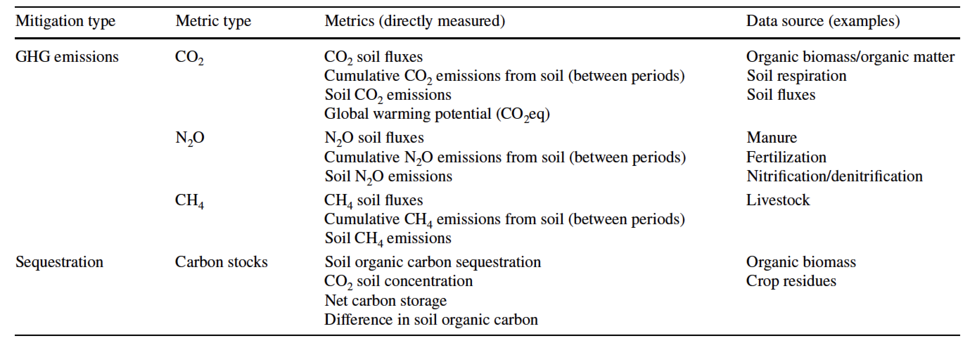

- ELECTRONIC SUPPLEMENTARY MATERIAL
The need for supplementary material section must be justified in the cover letter.
Data should be rather deposited in repositories than submitted as supplementary materials.

Submission
  - Supply all supplementary material in standard file formats.
  - Please include in each file the following information: article title, journal name, author names; affiliation and e-mail address of the corresponding author.
  - To accommodate user downloads, please keep in mind that larger-sized files may require very long download times and that some users may experience other problems during downloading.

Collecting Multiple Files
It is possible to collect multiple files in a .zip or .gz file.

Captions
For each supplementary material, please supply a concise caption describing the content of the file.

Processing of supplementary files
Electronic supplementary material will be published as received from the author without any conversion, editing, or reformatting.

Accessibility
In order to give people of all abilities and disabilities access to the content of your supplementary files, please make sure that
  - The manuscript contains a descriptive caption for each supplementary material
  - Video files do not contain anything that flashes more than three times per second (so that users prone to seizures caused by such effects are not put at risk)

- DECLARATIONS
All authors are requested to include information regarding sources of funding, financial or non-financial interests, study-specific approval by the appropriate ethics committee for research involving humans and/or animals, informed consent if the research involved human participants, and a statement on welfare of animals if the research involved animals (as appropriate).
If any of the sections are not relevant to your manuscript, please include the heading and write 'Not applicable' for that section.

The Editors reserve the right to reject manuscripts that do not comply with the guidelines. The author will be held responsible for false statements or failure to fulfill the guidelines.

  - Funding and conflicts of interest
Authors are requested to disclose interests that are directly or indirectly related to the work submitted for publication. Interests within the last 3 years of beginning the work (conducting the research and preparing the work for submission) should be reported. Interests outside the 3-year time frame must be disclosed if they could reasonably be perceived as influencing the submitted work. Disclosure of interests provides a complete and transparent process and helps readers form their own judgments of potential bias. This is not meant to imply that a financial relationship with an organization that sponsored the research or compensation received for consultancy work is inappropriate.
Interests that should be considered and disclosed but are not limited to the following:
Funding: Research grants from funding agencies (please give the research funder and the grant number) and/or research support (including salaries, equipment, supplies, reimbursement for attending symposia, and other expenses) by organizations that may gain or lose financially through publication of this manuscript.
Employment: Recent (while engaged in the research project), present or anticipated employment by any organization that may gain or lose financially through publication of this manuscript. This includes multiple affiliations (if applicable).
Financial interests: Stocks or shares in companies (including holdings of spouse and/or children) that may gain or lose financially through publication of this manuscript; consultation fees or other forms of remuneration from organizations that may gain or lose financially; patents or patent applications whose value may be affected by publication of this manuscript.
It is difficult to specify a threshold at which a financial interest becomes significant, any such figure is necessarily arbitrary, so one possible practical guideline is the following: "Any undeclared financial interest that could embarrass the author were it to become publicly known after the work was published."
Non-financial interests: In addition, authors are requested to disclose interests that go beyond financial interests that could impart bias on the work submitted for publication such as professional interests, personal relationships or personal beliefs (amongst others). Examples include, but are not limited to: position on editorial board, advisory board or board of directors or other type of management relationships; writing and/or consulting for educational purposes; expert witness; mentoring relations; and so forth.
Primary research articles require a disclosure statement. Review articles present an expert synthesis of evidence and may be treated as an authoritative work on a subject. Review articles therefore require a disclosure statement.
Please note that, in addition to the above requirements, funding information (given that funding is a potential conflict of interest (as mentioned above)) needs to be disclosed upon submission of the manuscript in the peer review system. This information will automatically be added to the Record of CrossMark, however it is not added to the manuscript itself. Under ‘summary of requirements’ (see below) funding information should be included in the ‘Declarations’ section.
Summary of requirements
The above should be summarized in a statement and placed in a ‘Declarations’ section before the reference list under a heading of ‘Funding’ and/or ‘Conflicts of interests’/’Competing interests’.
Please see the various examples of wording below and revise/customize the sample statements according to your own needs.
When all authors have the same (or no) conflicts and/or funding it is sufficient to use one blanket statement.
Examples of statements to be used when funding has been received:
• Partial financial support was received from [...]
• The research leading to these results received funding from […] under Grant Agreement No[…].
• This study was funded by […]
• This work was supported by […] (Grant numbers […] and […]

Examples of statements to be used when there is no funding:
• The authors did not receive support from any organization for the submitted work.
• No funding was received to assist with the preparation of this manuscript.
• No funding was received for conducting this study.
• No funds, grants, or other support was received.

Examples of statements to be used when there are interests to declare:
• Financial interests: Author A has received research support from Company A. Author B has received a speaker honorarium from Company Wand owns stock in Company X. Author C is consultant to company Y.
Non-financial interests: Author C is an unpaid member of committee Z.
• Financial interests: The authors declare they have no financial interests.
Non-financial interests: Author A is on the board of directors of Y and receives no compensation as member of the board of directors.
• Financial interests: Author A received a speaking fee from Y for Z. Author B receives a salary from association X. X where s/he is the Executive Director.
Non-financial interests: none.
• Financial interests: Author A and B declare they have no financial interests. Author C has received speaker and consultant honoraria from Company M and Company N. Dr. C has received speaker honorarium and research funding from Company M and Company O. Author D has received travel support from Company O.
Non-financial interests: Author D has served on advisory boards for Company M, Company N and Company O. Examples of statements to be used when authors have nothing to declare:
• The authors have no relevant financial or non-financial interests to disclose.
• The authors have no conflicts of interest to declare that are relevant to the content of this article.
• All authors certify that they have no affiliations with or involvement in any organization or entity with any financial interest or non-financial interest in the subject matter or materials discussed in this manuscript.
• The authors have no financial or proprietary interests in any material discussed in this article.

  - Ethics approval
When reporting a study that involved human participants, their data or biological material, authors should include a statement that confirms that the study was approved (or granted exemption) by the appropriate institutional and/or national research ethics committee (including the name of the ethics committee) and certify that the study was performed in accordance with the ethical standards as laid down in the 1964 Declaration of Helsinki and its later amendments or comparable ethical standards. If doubt exists whether the research was conducted in accordance with the 1964 Helsinki Declaration or comparable standards, the authors must explain the reasons for their approach, and demonstrate that an independent ethics committee or institutional review board explicitly approved the doubtful aspects of the study. If a study was granted exemption from requiring ethics approval, this should also be detailed in the manuscript (including the reasons for the exemption).
  - Consent to participate
For all research involving human subjects, freely-given, informed consent to participate in the study must be obtained from participants (or their parent or legal guardian in the case of children under 16) and a statement to this effect should appear in the manuscript.
For manuscripts reporting studies involving vulnerable groups where there is the potential for coercion or where consent may not have been fully informed, extra care will be taken by the editor and may be referred to the Springer Nature Research Integrity Group.
Examples of statements:
- Informed consent was obtained from all individual participants included in the study.
- Verbal informed consent was obtained prior to the interview.
  - Consent for publication
Individuals may consent to participate in a study, but object to having their data published in a journal article. Authors should make sure to also seek consent from individuals to publish their data prior to submitting their paper to a journal. This is in particular applicable to case studies.
Examples of statements:
- The authors affirm that human research participants provided informed consent for publication of the images in Figure(s) 1a, 1b and 1c.
  - Data availability statement - Code availability statement
The journal encourages authors to provide a statement of data availability in their article. Data availability statements should include information on where data supporting the results reported in the article can be found, including, where applicable, hyperlinks to publicly archived datasets analyzed or generated during the study. Data availability statements can also indicate whether data are available on request from the authors and where no data are available, if appropriate.
Data Availability statements can take one of the following forms (or a combination of more than one if required for multiple datasets):
1. The datasets generated during and/or analyzed during the current study are available in the [NAME] repository, [PERSISTENT WEB LINK TO DATASETS]
2. The datasets generated during and/or analyzed during the current study are not publicly available due [REASON WHY DATA ARE NOT PUBLIC] but are available from the corresponding author on reasonable request.
3. The datasets generated during and/or analyzed during the current study are available from the corresponding author on reasonable request.
4. Data sharing not applicable to this article as no datasets were generated or analyzed during the current study.
5. All data generated or analyzed during this study are included in this published article.
Please see Springer Nature’s website for detailed information about
-data policy types (https://www.springernature.com/gp/authors/research-data-policy/data-policy-faqs)
-list of repositories (https://www.springernature.com/gp/authors/research-data-policy/recommended-repositories)
-examples of data availability statements (http://www.springernature.com/gp/authors/research-data-policy/data-availability-statements)

When applicable, a code availability statement should be provided.

  - Authors contribution
Please provide your and your co-authors’ contribution to the research, according to the CRediT taxonomy defined in the table below. Please use initials to refer to each author's contribution.
Examples:
- " Conceptualization, S.C.P. and S.Y.W.; Methodology, A.B., S.C.P. and S.Y.W.; Investigation, M.E., A.N.V., N.A.V., S.C.P. and S.Y.W.; Writing – Original Draft, S.C.P. and S.Y.W.; Writing –Review & Editing, S.C.P. and S.Y.W.; Funding Acquisition, S.C.P. and S.Y.W.; Resources, M.E.V and C.K.B.; Supervision, A.B., N.L.W., and A.A.D"
- “All authors contributed to the study conception and design. Material preparation, data collection and analysis were performed by [full name], [full name] and [full name]. The first draft of the manuscript was written by [full name] and all authors commented on previous versions of the manuscript. All authors read and approved the final manuscript.”
For review articles where discrete statements are less applicable a statement should be included who had the idea for the article, who performed the literature search and data analysis, and who drafted and/or critically revised the work.
For articles that are based primarily on the student’s dissertation or thesis, it is recommended that the student is usually listed as principal author:
A Graduate Student’s Guide to Determining Authorship Credit and Authorship Order, APA Science Student Council 2006
See also Springer’s Authorship Principles.

CONTRIBUTOR ROLE | ROLE DEFINITION
Conceptualization | Ideas; formulation or evolution of overarching research goals and aims.
Methodology | Development or design of methodology; creation of models
Software | Programming, software development; designing computer programs; implementation of the computer code and supporting algorithms; testing of existing code components.
Validation | Verification, whether as a part of the activity or separate, of the overall replication/reproducibility of results/experiments and other research outputs.
Formal analysis | Application of statistical, mathematical, computational, or other formal techniques to analyze or synthesize study data.
Investigation | Conducting a research and investigation process, specifically performing the experiments, or data/evidence collection.
Resources | Provision of study materials, reagents, materials, patients, laboratory samples, animals, instrumentation, computing resources, or other analysis tools.
Data Curation | Management activities to annotate (produce metadata), scrub data and maintain research data (including software code, where it is necessary for interpreting the data itself) for initial use and later reuse.
Writing – original draft preparation | Creation and/or presentation of the published work, specifically writing the initial draft (including substantive translation).
Writing – review and editing | Preparation, creation and/or presentation of the published work by those from the original research group, specifically critical review, commentary or revision – including pre- or post-publication stages.
Visualization | Preparation, creation and/or presentation of the published work, specifically visualization/data presentation.
Supervision | Oversight and leadership responsibility for the research activity planning and execution, including mentorship external to the core team.
Project administration | Management and coordination responsibility for the research activity planning and execution.
Funding acquisition | Acquisition of the financial support for the project leading to this publication.

- ETHICAL RESPONSIBILITIES OF AUTHORS

- This journal is committed to upholding the integrity of the scientific record. As a member of the Committee on Publication Ethics (COPE) the journal will follow the COPE guidelines on how to deal with potential acts of misconduct.
- Authors should refrain from misrepresenting research results which could damage the trust in the journal, the professionalism of scientific authorship, and ultimately the entire scientific endeavor. Maintaining integrity of the research and its presentation is helped by following the rules of good scientific practice, which include*:
- The manuscript should not be submitted to more than one journal for simultaneous consideration.
- The submitted work should be original and should not have been published elsewhere in any form or language (partially or in full), unless the new work concerns an expansion of previous work. (Please provide transparency on the re-use of material to avoid the concerns about text-recycling (‘self-plagiarism’).
- A single study should not be split up into several parts to increase the quantity of submissions and submitted to various journals or to one journal over time (i.e. ‘salami-slicing/publishing’).
- Concurrent or secondary publication is sometimes justifiable, provided certain conditions are met. Examples include: translations or a manuscript that is intended for a different group of readers.
- Results should be presented clearly, honestly, and without fabrication, falsification or inappropriate data manipulation (including image based manipulation). Authors should adhere to discipline-specific rules for acquiring, selecting and processing data.
- No data, text, or theories by others are presented as if they were the author’s own (‘plagiarism’). Proper acknowledgments to other works must be given (this includes material that is closely copied (near verbatim), summarized and/or paraphrased), quotation marks (to indicate words taken from another source) are used for verbatim copying of material, and permissions secured for material that is copyrighted.

Important note: the journal uses a software to screen for plagiarism.

• Authors should make sure they have permissions for the use of software, questionnaires/(web) surveys and scales in their studies (if appropriate).
• Research articles and non-research articles (e.g. Opinion, Review, and Commentary articles) must cite appropriate and relevant literature in support of the claims made. Excessive and inappropriate self-citation or coordinated efforts among several authors to collectively self-cite is strongly discouraged.
• Authors should avoid untrue statements about an entity (who can be an individual person or a company) or descriptions of their behavior or actions that could potentially be seen as personal attacks or allegations about that person.
• Research that may be misapplied to pose a threat to public health or national security should be clearly identified in the manuscript (e.g. dual use of research). Examples include creation of harmful consequences of biological agents or toxins, disruption of immunity of vaccines, unusual hazards in the use of chemicals, weaponization of research/technology (amongst others).
• Authors are strongly advised to ensure the author group, the Corresponding Author, and the order of authors are all correct at submission. Adding and/or deleting authors during the revision stages is generally not permitted, but in some cases may be warranted. Reasons for changes in authorship should be explained in detail. Please note that changes to authorship cannot be made after acceptance of a manuscript.

*All of the above are guidelines and authors need to make sure to respect third parties rights such as copyright and/or moral rights.

Upon request authors should be prepared to send relevant documentation or data in order to verify the validity of the results presented. This could be in the form of raw data, samples, records, etc. Sensitive information in the form of confidential or proprietary data is excluded.

Suspicion of misbehavior/fraud
If there is suspicion of misbehavior or alleged fraud the Journal and/or Publisher will carry out an investigation following COPE guidelines. If, after investigation, there are valid concerns, the author(s) concerned will be contacted under their given e-mail address and given an opportunity to address the issue. Depending on the situation, this may result in the Journal’s and/or Publisher’s implementation of the following measures, including, but not limited to:
• If the manuscript is still under consideration, it may be rejected and returned to the author.
• If the article has already been published online, depending on the nature and severity of the infraction:
- an erratum/correction may be placed with the article
- an expression of concern may be placed with the article
- or in severe cases retraction of the article may occur.
The reason will be given in the published erratum/correction, expression of concern or retraction note. Please note that retraction means that the article is maintained on the platform, watermarked “retracted” and the explanation for the retraction is provided in a note linked to the watermarked article.
• The author’s institution may be informed
• A notice of suspected transgression of ethical standards in the peer review system may be included as part of the author’s and article’s bibliographic record.

Fundamental errors
Authors have an obligation to correct mistakes once they discover a significant error or inaccuracy in their published article. The author(s) is/are requested to contact the journal and explain in what sense the error is impacting the article. A decision on how to correct the literature will depend on the nature of the error. This may be a correction or retraction. The retraction note should provide transparency which parts of the article are impacted by the error.

Suggesting / excluding reviewers
When suggesting reviewers, authors should make sure they are totally independent and not connected to the work in any way.

- AUTHORSHIP PRINCIPLES
These guidelines describe authorship principles and good authorship practices to which prospective authors should adhere to.
The Journal and Publisher assume all authors agreed with the content and that all gave explicit consent to submit and that they obtained consent from the responsible authorities at the institute/organization where the work has been carried out, before the work is submitted.
The Publisher does not prescribe the kinds of contributions that warrant authorship. It is recommended that authors adhere to the guidelines for authorship that are applicable in their specific research field. In absence of specific guidelines it is recommended to adhere to the following guidelines*:
All authors whose names appear on the submission
1) made substantial contributions to the conception or design of the work; or the acquisition, analysis, or interpretation of data; or the creation of new software used in the work;
2) drafted the work or revised it critically for important intellectual content;
3) approved the version to be published; and
4) agree to be accountable for all aspects of the work in ensuring that questions related to the accuracy or integrity of any part of the work are appropriately investigated and resolved.

Role of the Corresponding Author
One author is assigned as Corresponding Author and acts on behalf of all co-authors and ensures that questions related to the accuracy or integrity of any part of the work are appropriately addressed.
The Corresponding Author is responsible for the following requirements:
- ensuring that all listed authors have approved the manuscript before submission, including the names and order of authors;
- managing all communication between the Journal and all co-authors, before and after publication;*
- providing transparency on re-use of material and mention any unpublished material (for example manuscripts in press) included in the manuscript in a cover letter to the Editor;
- making sure disclosures, declarations and transparency on data statements from all authors are included in the manuscript as appropriate (see above).
* The requirement of managing all communication between the journal and all co-authors during submission and proofing may be delegated to a Contact or Submitting Author. In this case please make sure the Corresponding Author is clearly indicated in the manuscript.

Affiliation
The primary affiliation for each author should be the institution where the majority of their work was done. If an author has subsequently moved, the current address may additionally be stated. Addresses will not be updated or changed after publication of the article.

Changes to authorship
Authors are strongly advised to ensure the correct author group, the Corresponding Author, and the order of authors at submission. Changes of authorship by adding or deleting authors, and/or changes in Corresponding Author, and/or changes in the sequence of authors are not accepted after acceptance of a manuscript.
Please note that author names will be published exactly as they appear on the accepted submission.
Please make sure that the names of all authors are present and correctly spelled, and that addresses and affiliations are current.
Adding and/or deleting authors at revision stage are generally not permitted, but in some cases it may be warranted. Reasons for these changes in authorship should be explained. Approval of the change during revision is at the discretion of the Editor-in-Chief. Please note that journals may have individual policies on adding and/or deleting authors during revision stage.

Author identification
Authors are recommended to use their ORCID ID when submitting an article for consideration or acquire an ORCID ID via the submission process.

Deceased or incapacitated authors
For cases in which a co-author dies or is incapacitated during the writing, submission, or peer-review process, and the co-authors feel it is appropriate to include the author, co-authors should obtain approval from a (legal) representative which could be a direct relative.

Authorship issues or disputes
In the case of an authorship dispute during peer review or after acceptance and publication, the Journal will not be in a position to investigate or adjudicate. Authors will be asked to resolve the dispute themselves. If they are unable the Journal reserves the right to withdraw a manuscript from the editorial process or in case of a published paper raise the issue with the authors’ institution(s) and abide by its guidelines.

Confidentiality
Authors should treat all communication with the Journal as confidential which includes correspondence with direct representatives from the Journal such as Editors-in-Chief and/or Handling Editors and reviewers’ reports unless explicit consent has been received to share information.

- PREPRINT POLICY
Posting of preprints on a public server is not considered prior publication and will not jeopardize consideration at Agronomy for Sustainable Development.
- RESEARCH DATA POLICY
Following a Springer Nature initiative, Agronomy for Sustainable Development adopted a standardized research data policy: the Research Data Policy Type 3.
Specifically, a submission to ASD implies that materials described in the manuscript, including all relevant raw data, will be freely available to any researcher wishing to use them for non-commercial purposes, without breaching participant confidentiality. ASD strongly encourages that all datasets on which the conclusions of the paper rely should be available to readers. We encourage authors to ensure that their datasets are deposited in publicly available repositories (where available and appropriate) whenever possible. The selection of the repository is the authors’ responsibility. ASD does not accept datasets as supplementary material.

- AFTER ACCEPTANCE
Upon acceptance of your article you will receive a link to the special Author Query Application at Springer’s web page where you can sign the Copyright Transfer Statement online and indicate whether you wish to order OpenChoice or offprints. Once the Author Query Application has been completed, your article will be processed and you will receive the proofs.

Open Choice
In addition to the normal publication process (whereby an article is submitted to the journal and access to that article is granted to customers who have purchased a subscription), Springer provides an alternative publishing option: Springer Open Choice. A Springer Open Choice article receives all the benefits of a regular subscription-based article, but in addition is made available publicly through Springer’s online platform SpringerLink. We regret that Springer Open Choice cannot be ordered for published articles.

Copyright transfer
Authors will be asked to transfer copyright of the article to the Publisher (or grant the Publisher exclusive publication and dissemination rights). This will ensure the widest possible protection and dissemination of information under copyright laws.
Open Choice articles do not require transfer of copyright as the copyright remains with the author. In opting for open access, they agree to the Springer Open Choice License.

Offprints
Offprints can be ordered by the corresponding author.

Proof reading
The purpose of the proof is to check for typesetting or conversion errors and the completeness and accuracy of the text, tables and figures. Substantial changes in content, e.g., new results, corrected values, title and authorship, are not allowed. After online publication, further changes can only be made in the form of an Erratum, which will be hyperlinked to the article.

Continuous Article Publishing
The article is published online after receipt of the corrected proofs. This is the first official publication citable with the DOI. Manuscripts are immediately assigned to the current issue. As a consequence, the final page and issue numbers are defined immediately. After release of the printed version, the article can also be cited by volume and article number.

Sharing your article
Upon acceptance, authors will be asked to provide ten email addresses of colleagues who will receive a complimentary copy of the PDF of the paper. We disseminate information about published papers via social networks (blog, twitter, Google+). Authors can post shareable link online on social media or any platform to give everyone access to a read-only version of the full-text article (SharedIt initiative).

Green Open Access
Self-archiving
Authors can deposit the accepted version of their manuscript on their personal webpage on condition that it is not the publisher (Springer) version and that they provide the publisher’s web link and the DOI.

Institutional archiving
All articles published in Agronomy for Sustainable Development are automatically deposited in an open repository (HAL, https://hal.archives-ouvertes.fr/ARINRA-AGRODEV/) 12 months after online publication for article published under subscription and upon publishing online for articles published in Open Access. Authors can deposit their manuscript on their Institute/University repository upon publishing online on condition that it is not the publisher (Springer) version and that they provide the publisher’s web link and the DOI.
- AI Use in manuscript preparation & research process

All AI use during the research process and the manuscript preparation must be declared by the authors in the cover letter and in the article. AI use must be fully described by a clear statement (ex. AI tools [Mistral, DeepL…] were used to assist translation of the original writing into english, but the final content was validated by the authors… etc). Authors may refer to general documents such as (The International Association of Scientific, Technical & Medical Publishers - STM) as a guideline for their declarations.

Philibert A, Loyce C, Makowski D (2012) Assessment of the quality of meta-analysis in agronomy. Agriculture, Ecosystems & Environment, 148, 72-82. https://doi.org/ 10.1016/j.agee.2011.12.003.
https://credit.niso.org/
^{Based on/adapted from:} ICMJE, Defining the Role of Authors and Contributors,Transparency in authors’ contributions and responsibilities to promote integrity in scientific publication, McNutt at all, PNAS February 27, 2018

