Agricultural productivity and soil and water conservation index (APSWCI) in dual-purpose corn production using fuzzy modeling

ABSTRACT
Soil structure and soil organic carbon are key variables for the sustainability of agricultural production in tropical environments, yet their interactions with crop yield remain difficult to quantify. This study aimed to evaluate the effects of different soil tillage systems, conventional tillage (CT), minimum tillage (MT), and no-tillage (NT), and cover crop species by integrating soil indicators into the Agricultural Productivity and Soil and Water Conservation Index (APSWCI). Aggregate stability indices, soil carbon content and stocks, and dual-purpose corn yield were assessed. A fuzzy inference system was applied to integrate multiple physical, chemical, and agronomic indicators, in combination with generalized linear models to test statistical differences among systems and species. Results showed that conservation systems significantly increased APSWCI scores compared to conventional tillage. Minimum tillage was the most efficient tillage system, yielding higher stability and consistency, particularly when combined with pigeon pea and pearl millet as cover crops. No-tillage showed intermediate performance but was strongly dependent on the cover crop, while conventional tillage consistently showed low efficiency in both conservation and productivity indicators. Among cover crops, cowpea tended to contribute more to productive sustainability, although differences were not statistically significant after multiple comparisons adjustment. The “system × species” interaction revealed that sustainability gains were modulated by the preceding cover crop, highlighting the importance of species selection in conservation systems. Overall, APSWCI proved effective in identifying scenarios where soil and water conservation aligns with dual-purpose corn productivity, reinforcing its potential as a diagnostic and decision-support tool for sustainable management in tropical agroecosystems.

1 INTRODUCTION
Conservation agriculture practices, such as agroforestry systems and sustainable soil management, have shown high potential in tropical environments by simultaneously enhancing agricultural productivity and natural resources conservation, even under adverse conditions such as high temperatures, intense rainfall, and low soil fertility (P. Sharma et al., 2025; VijayKumar et al., 2024).
The relevance of these practices goes beyond production systems, positioning them as strategic pillars for food security, climate change mitigation, and biodiversity preservation. In densely populated regions near consumer markets, where environmental and socioeconomic pressures are more pronounced, adopting such practices becomes imperative to reconcile food demand with the maintenance of ecosystem services (Kumar et al., 2025; Pangapanga-Phiri et al., 2022).
Soil quality, defined as the capacity of a soil to function within ecosystem boundaries to sustain biological productivity, maintain environmental quality, and promote plant and animal health, results from the complex interplay of physical, chemical, and biological attributes (Doran & Parkin, 1994). Among these, physical structure stands out as a major determinant of essential ecological processes, such as water infiltration and retention, soil aeration, microbial activity, and carbon sequestration (Maurya et al., 2020; Meurer et al., 2020).
Aggregate stability, in particular, emerges as a key parameter, as it sensitively reflects both the history of land management and current environmental conditions (Menon et al., 2020), while also critically regulating moisture retention, erosion resistance, and the dynamics of soil organic matter (Sauvadet et al., 2019).
However, structural degradation remains a recurring issue in conventional modern agriculture, generating negative externalities such as land degradation, water pollution, and greenhouse gas emissions. This scenario calls for the development and implementation of effective, economically viable, and environmentally sound monitoring and management strategies, especially in smallholder contexts, where limited resources and increased socio-environmental vulnerability prevail (Chellappa et al., 2021).
Traditional physical indicators, such as geometric mean diameter (GMD) and weighted mean diameter (WMD), are widely used to quantitatively characterize soil aggregation (Klute, 1986). However, while useful, these metrics have limitations, because they do not explicitly account for the direct contribution of soil organic carbon (SOC), a key binding element in the formation and persistence of stable aggregates (Tang et al., 2022). The dynamics of SOC are governed by the subtle balance between the input of plant residues and losses due to microbial decomposition and erosion, being strongly modulated by the management practices employed (Du et al., 2022).
Conventional tillage, characterized by intensive mechanical disturbance and the removal or burning of crop residues, accelerates the oxidation and decomposition of labile organic matter, damages soil structure by breaking down aggregates, and intensifies erosion processes (Hussain et al., 2021). In contrast, conservation practices such as no-tillage, the use of cover crops, and integrated crop–livestock–forestry systems favor the formation and stabilization of macroaggregates, increase the levels of particulate and mineral-associated organic carbon, and promote soil physical properties in a holistic manner, with positive effects on crop productivity in the medium and long term (Mulatu, 2024; Singh et al., 2024).
In this context, the adoption of integrated indicators, capable of synergistically articulating physical, chemical, and even biological and productive attributes, is essential for a comprehensive and multidimensional assessment of agricultural sustainability in tropical environments (Vanolli et al., 2025). However, a methodological gap remains in the development of tools that can integrate this multiplicity of variables, many of them imprecise and nonlinear in nature, into robust synthetic indices. It is within this scenario that fuzzy logic emerges as a methodological alternative.
Fuzzy logic, a computational intelligence tool, has proven highly effective for modeling complex systems and aggregating multiple criteria into evaluation indices. Recent applications range from farmland assessment for land consolidation (Nabati et al., 2020) to adaptive control in agro-industrial processes, such as analyzing the vulnerability of sugarcane production systems to climate change (Badillo-Márquez et al., 2021).
Other studies highlight its use in classifying agricultural areas under multiple environmental and social constraints (Z. Wang et al., 2023), assessing erosion risks under different conservation management systems (R. Sharma et al., 2025a), and predicting crop productivity under water stress in arid zones (Ahmed et al., 2023). Its main advantage lies in the ability to translate expert knowledge, often fragmented and qualitatively expressed, into mathematical inference rules, naturally handling the uncertainty inherent in agronomic and environmental data (Jayasinghe et al., 2023).
In this study, a Mamdani-type fuzzy inference system (FIS) was adopted, being widely applied in agricultural decision-making for its capacity to translate expert knowledge into membership functions. This approach has been successfully implemented in intelligent irrigation systems and crop selection based on environmental variables such as moisture and temperature (Patil et al., 2023), in the prioritization of treated water reuse based on risk and social acceptability (Vaseghi et al., 2020), and in environmental modeling of irrigated areas (Kuzmin et al., 2020).
Recent research has also highlighted the use of FIS in soil fertility assessment under high edaphic variability (Acar et al., 2022), delineation of agricultural zones in semiarid regions (Özkan et al., 2020), and the selection of sustainable management practices (R. Sharma et al., 2025b). The FIS has proven effective in integrating technical, social, and environmental dimensions, as seen in climate-smart agriculture (Qureshi et al., 2022) and sustainable land use incorporating cultural factors (Y. Wang & Zhang, 2024), with the advantage of addressing linguistic judgments and uncertainties common in agricultural systems. By applying triangular membership functions and centroid-based defuzzification, the model generates continuous estimates that reflect varying degrees of productive and conservationist sustainability, serving as a robust tool for agricultural management.
The use of fuzzy methods in agricultural assessments represents a methodological advance with the potential to enhance scientific legitimacy and social acceptance in decision-making processes. Understanding biophysical foundations, such as soil structure and organomineral nutrients, is essential for sustainability, although their interactions with productivity remain complex and difficult to quantify in tropical environments. In this regard, the objective of this study was to evaluate the effects of different soil tillage systems (conventional tillage, minimum tillage, and no-tillage) and cover crops by integrating soil indicators to construct the Agricultural Productivity and Soil and Water Conservation Index (APSWCI) in a dystrophic Red-Yellow Ultisol in northeastern Brazil, offering a robust and interpretable metric to support decision-making in tropical agricultural systems.

2 MATERIALS AND METHODS
The study was conducted at the Rural Campus Experimental Station of the Sergipe Federal University, in São Cristóvão (SE, Brazil), on a dystrophic Red-Yellow Ultisol in the 22nd year of a long-term experiment initiated in 2001. The experimental design consisted of strips corresponding to three soil tillage systems: conventional tillage (CT), minimum tillage (MT), and no-tillage (NT). These were arranged in a split-plot scheme with four cover crops: sunn hemp (Crotalaria juncea L.), cowpea (Vigna unguiculata L. Walp.), pigeon pea (Cajanus cajan (L.) Millsp.), and pearl millet (Pennisetum americanum L.), with three replicates (Figure 1).

Figure 1. (a) Aerial photograph of the experimental area and (b) field layout showing treatment strips and split plots.
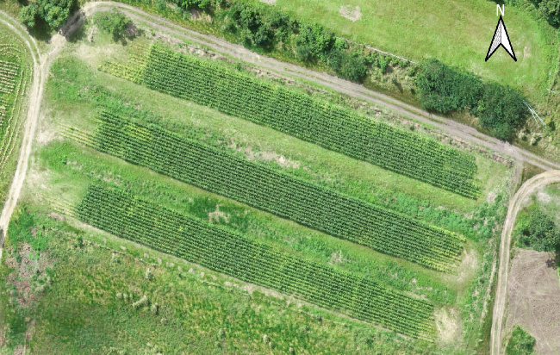 | 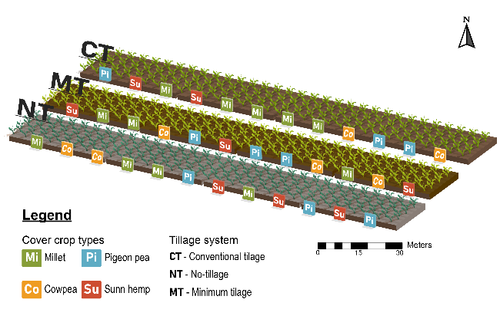
In the CT system, a disc plow was used as primary tillage and a leveling harrow as secondary tillage. For the MT system, only the leveling harrow was used, while in the NT system, no soil preparation was performed. Approximately 90 days after sowing the cover crops, tillage operations were carried out according to each system, followed by sowing of the SHS7990 PRO3 hybrid maize (SANTA HELENA®), a dual-purpose cultivar for green corn and silage production. Sowing was performed mechanically, with a row spacing of 0.80 m and 0.20 m between plants within rows.
Fertilization included 300 kg.ha^{–1} of urea (45% N), split into three applications: at sowing, 20 days after emergence, and 45 days after emergence. Additionally, all treatments received 90 kg.ha^{–1} of triple superphosphate (19% P₂O₅) and 110 kg.ha^{–1} of potassium chloride (59% K₂O) at sowing, based on soil analysis and regional recommendations (Sobral et al., 2007).
Productivity was evaluated based on the number of marketable ears (≥ 250 g). To characterize soil physical condition, aggregate stability indices were determined, expressed as geometric mean diameter (GMD) and weighted mean diameter (WMD), along with total soil organic carbon content.
Total organic carbon (TOC) was estimated from organic matter content determined according to Teixeira et al. (2017), using the van Bemmelen factor (1.724), which assumes that organic matter contains 58% carbon. Based on bulk density and carbon content, carbon stock was calculated using the equivalent soil mass method (Ellert & Bettany, 2011).
To assess aggregate stability, undisturbed soil samples were collected at 0–10 cm and 10–20 cm depths from three points within each plot. Analyses were performed using the wet-sieving method with a Yoder-type apparatus (1936), following the procedure described by Kemper and Chepil (1965). GMD and WMD values were calculated according to Castro Filho et al. (2002).
The hybrid maize SHS7990 PRO3 was sown after cover crop management, with row spacing of 0.80 m and 0.20 m between plants. Fertilization followed local recommendations and included 300 kg.ha^{–1} of urea (applied in three splits), 90 kg.ha^{–1} of triple superphosphate, and 110 kg.ha^{–1} of potassium chloride.

2.1 Data analysis
To integrate conservation-related soil indicators and agronomic indicators of dual-purpose corn performance, a fuzzy inference system was developed, resulting in the formulation of the Agricultural Productivity and Soil and Water Conservation Index (APSWCI). The methodological structure involved three main steps: (i) normalization of input variables, (ii) definition of membership functions and linguistic rules, and (iii) defuzzification using the centroid method.

2.1.1 Normalization of variables
All variables were transformed to a common scale ranging from 0 to 10, ensuring comparability among indicators with different orders of magnitude. Normalization was performed using robust linear scaling functions based on the 5% and 95% quantiles, such that values within this range were rescaled to the [0–10] interval, while observations outside the range were truncated. This strategy increases robustness against outliers:
$$x_{norm}=10× \frac{x- Q_{5\%}}{Q_{95\%}- Q_{5\%}} , with x ∈ [ Q_{5\%}, Q_{95\%}]$$
where x is the original variable value, Q₅% and Q₉₅% are the reference quantiles, and x_{norm} is the normalized fuzzy-scale value.
For inverse-interpretation variables, such as bulk density, sodium (Na), and macroaggregate ratio (RMP), an inverted form was applied, assigning lower scores to higher values. Constant or non-finite values were replaced with a neutral score of 5.
$$x_{norm, inv}=10× \frac{Q_{5\%}-x}{Q_{95\%}- Q_{5\%}} , with x ∈ [ Q_{5\%}, Q_{95\%}]$$

For index construction, 15 attributes were selected and previously transformed to the [0–10] scale to ensure comparability across variables with different units and ranges. These attributes were grouped into three main thematic indicators, in addition to the productivity variable (Figure 2).
Figure 2. Representation of the fuzzy inference system describing the interrelations between subindices (SOC, MrP, STAND, and Productivity) and the integrated Agricultural Productivity and Soil and Water Conservation Index (APSWCI).
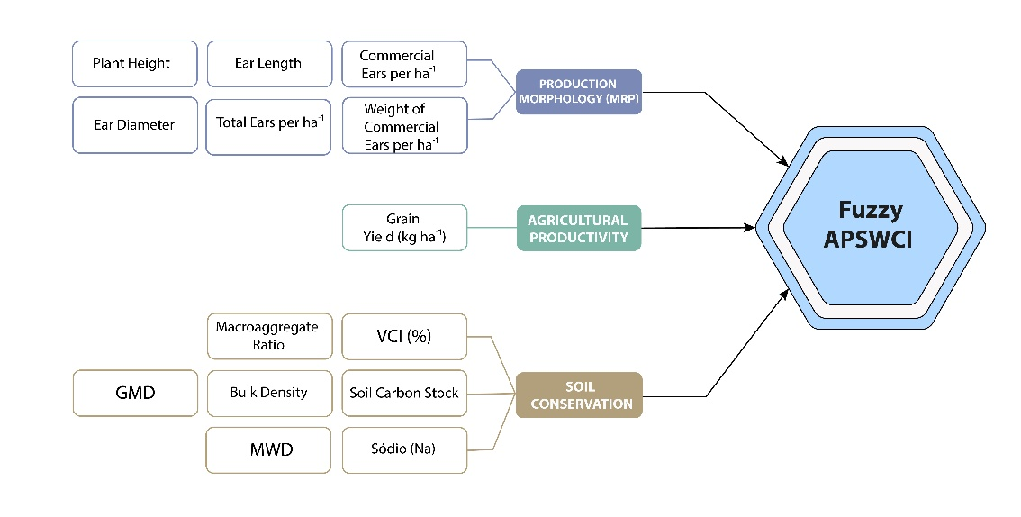
- Soil and Conservation (SOC): geometric mean diameter (GMD), weighted mean diameter (WMD), macroaggregate ratio (RMP, inverse), bulk density (inverse), sodium content (Na, inverse), vegetation cover index (VCI, %), and soil carbon stock.
- Production Morphology (MrP): mean plant height, mean ear diameter, mean ear length, total number of ears per hectare, number of marketable ears per hectare, and weight of marketable ears per hectare.
- Stand (STAND): number of plants per hectare.
- Productivity: total grain yield (kg.ha).
In the proposed model, grain productivity plays a dual role. In addition to being one of the analyzed indicators, it also acts as a modulating variable in the final stage of the fuzzy system, assigning differentiated weights to the inference rules. This mechanism enhances the interpretability of the index by emphasizing scenarios where soil conservation and agronomic performance indicators are synergistically aligned.

2.1.2 Fuzzy system structure and inference rules
The fuzzy inference system was developed in R using the FuzzyR package, following the Mamdani and Assilian (1975) approach. The knowledge base was constructed using triangular membership functions applied to fifteen input variables, all previously normalized to the [0–10] scale. For each variable, three linguistic terms were defined (low, medium, and high), enabling a qualitative representation of agronomic and environmental conditions.
The output variable, corresponding to the Agricultural Productivity and Soil and Water Conservation Index (APSWCI), was also modeled using three linguistic terms and triangular membership functions, similarly defined in the [0–10] interval.
Membership functions were dynamically parameterized and calibrated based on the empirical quartiles of each variable’s distribution. The general form of a triangular membership function is given by:
$$μA\left(x\right)=\max\left(min\left(\frac{x-a}{b-a}, \frac{c-x}{c-b}\right), 0\right), a<b<c$$

where a, b, and c represent, respectively, the lower bound, peak point, and upper bound of the membership function. In this study, these parameters were defined according to the quartiles of the normalized variable as follows:
- Low term: (a, b, c) = (0, Q₂₅, Q₅₀)
- Medium term: (a, b, c) = (Q₂₅, Q₅₀, Q₇₅)
- High term: (a, b, c) = (Q₅₀, Q₇₅, 10)
where Q₂₅, Q₅₀, and Q₇₅ represent the first quartile, the median, and the third quartile, respectively, of the empirical distribution of each variable in the [0–10] fuzzy scale.

2.1.3 Fuzzy rules and inference operator
The fuzzy rules were structured in an “IF–THEN” format, using the logical AND (minimum) operator to represent the conjunction between the linguistic terms of the input variables. The general structure of a fuzzy rule $R_{i}$ involves calculating the rule’s activation degree based on the minimum membership values of the input variables to their respective fuzzy sets, as shown in the formula:
$$α_{i}=\min{(μ_{A1}\left(x_{1}\right), μ_{A2 }\left(x_{1}\right), …, μ_{An }\left(x_{n}\right)}$$

The output set corresponding to each rule is weighted by the activation degree $α_{i}$, and all activated sets are then aggregated using the maximum (MAX) method.
A total of 15 input variables were used in the fuzzy inference system to represent conservation and productivity indicators of the evaluated agricultural systems. Based on these variables, 15 inference rules were formulated, which associate different combinations of indicator conditions (in linguistic categories: Low – L, Medium – M, High – H) with the expected value of the APSWCI index. The full list of fuzzy rules, including the combinations of linguistic terms and their respective weights, is presented in Appendix A.
Each variable was associated with three triangular membership functions (low, medium, and high) within the normalized range of 0 to 10. The output of the fuzzy system is the APSWCI index, which was defuzzified using the center of gravity method. The rules were assigned different weights according to the importance of the “Productivity” variable, with a higher weight (1.2) for high-productivity rules, a medium weight (1.0) for intermediate productivity, and a reduced weight (0.8) for low productivity.

2.1.4 Defuzzification using the centroid method
The final value of the APSWCI (Agricultural Productivity and Soil and Water Conservation Index) was obtained through the defuzzification process using the centroid (center of gravity) method, as represented by the following formula:

$$\hat{z}= \frac{\int{z∙ μAPSWI \left(z\right) dz}}{\int{z μAPSWI \left(z\right) dz}}$$
where:
- $\hat{z}$ = the defuzzified value of the APSWCI, i.e., the final continuous value of the index, expressed on a 0–10 scale;
- $μAPSWI \left(z\right)$ = the aggregated membership function of the activated rules, resulting from the combination of the fuzzy consequents (low, medium, or high), weighted by the activation strength of each rule;
- $z$ = the continuous output variable corresponding to the domain of the APWSI.
The integral in the numerator represents the moment of the area under the membership curve, while the integral in the denominator corresponds to the total area under that curve. The value of $\hat{z}$ is equivalent to the balance point (center of mass) of the resulting fuzzy distribution from the inference process.

2.1.5 Evaluation and interpretation of the APSWCI
The resulting APSWCI values are continuous and range from 0 to 10 and are interpreted according to the following categories:
- 0.0 – 3.3: low productive sustainability;
- 3.4 – 6.6: intermediate productive sustainability;
- 6.7 – 10.0: high productive and conservationist sustainability.
Higher values indicate agricultural systems with balanced and satisfactory levels of soil and productivity indicators. The index allows for the comparison of different management systems or cultivars, enabling the identification of production systems more aligned with the principles of sustainable agriculture.

2.1.6 Weight adjustment based on agricultural productivity
To refine the relative influence of each rule in determining the APSWCI, an adaptive weighting mechanism was implemented based on grain yield, favoring systems with better performance. The productivity variable, included among the input criteria, was used to automatically adjust the weights of the fuzzy rules, assigning greater weight to rules associated with high productivity levels (1.2), a neutral weight to intermediate levels (1.0), and a reduced weight to rules associated with low productivity (0.8).

2.1.7 Consistency and coverage indicators
The robustness of the Agricultural Productivity and Soil and Water Conservation Index (APSWCI) across different combinations of management systems and preceding crops was evaluated by adjusting the calculation of consistency and coverage indicators, following the logic of fuzzy-set Qualitative Comparative Analysis (fsQCA) proposed by Ragin (2008).
Consistency was defined as the proportion of cases in which a given system–crop configuration (e.g., MT–millet) resulted in APSWCI values classified in the high sustainability category (≥ 6.7). Gross coverage was calculated as the proportion of all high-sustainability cases that could be explained by each configuration. Unique coverage represented the share of high-sustainability cases attributed exclusively to a specific configuration, after discounting overlaps with other combinations. The classification of “high sustainability” was established based on the fuzzy system constructed for the APSWCI, with the range 6.7–10.0 used as the reference.

2.1.8 Statistical analysis of the index
The data derived from the fuzzy inference system for the APSWCI were stratified into two soil layers (0.00–0.10 m and 0.10–0.20 m) and analyzed using Generalized Linear Models (GLMs) to assess the effects of tillage systems (CT, MT, and NT), cover crops (cowpea, sunn hemp, pigeon pea, and millet), and their interaction.
These models were preferred over traditional ANOVA due to their greater flexibility in handling non-normal response distributions and heteroscedastic residuals, making them more robust for agricultural data with asymmetric patterns (McCullagh & Nelder, 2019).
The gamma distribution with the identity link function was chosen for the APSWCI models based on three criteria: (i) the index values were strictly positive and exhibited a right-skewed distribution with skewness > 1.5 and violation of the Shapiro–Wilk normality test (p < 0.01); (ii) comparisons between candidate distributions (normal, log-normal, and gamma) indicated a better fit for the gamma distribution, with reductions exceeding 10 units in the Akaike Information Criterion(1998) and the Bayesian Information Criterion (BIC); and (iii) model adequacy was confirmed by dispersion metrics, with Deviance/df and Pearson/df ratios < 0.15, demonstrating compliance with the assumed distribution.
Model diagnostics confirmed the absence of overdispersion (Cameron & Trivedi, 1990), and studentized residuals remained within ±2.5 standard deviations. The identity link function was retained after checking linearity between predictors and response through “component + residual” plots, which indicated the absence of nonlinear patterns (p > 0.05 in the lack-of-fit test).
Global effects of “system”, “crop”, and “system × crop” interaction on the APSWCI were tested using the Type III Wald chi-square test (car package). For significant effects, multiple comparisons of estimated marginal means were performed (emmeans package), with Bonferroni adjustment for type I error control. Adjusted means were presented with their respective standard errors and 95% confidence intervals, and compact letter displays were used to indicate statistically similar groups (p > 0.05).
All statistical analyses were conducted in the R environment (R Core Team, 2024) using the packages car, emmeans, multcomp, and ggplot2. Graphical outputs included boxplots of raw APSWCI values by system and crop, as well as plots of adjusted means with confidence intervals.

3 RESULTS AND DISCUSSION
The GLM (Gamma–Identity) model indicated a significant effect for Productivity [F(2, 50) = 28.94; p < 0.001], with a significant interaction between tillage systems and cover crops [F(6, 50) = 4.68; p < 0.001] (Figure 3a). The highest values were observed for the MT system combined with sunn hemp (9.09), followed by MT–pigeon pea (8.18) and MT–millet (7.35). The CT system with pigeon pea (1.67) and millet (2.42) showed the lowest values. These findings suggest that the synergy between conservation management and fast-growing, high-biomass cover crops such as sunn hemp is essential to maximizing productivity in tropical systems (Oliveira et al., 2024).

Figure 3. Adjusted means of the subindices composing the Agricultural Productivity and Soil and Water Conservation Index (APSWCI) under different tillage systems (CT = conventional tillage; MT = minimum tillage; NT = no-tillage) and cover crop species (cowpea, sunn hemp, pigeon pea, and pearl millet). (a) Yield; (b) Production Morphology (MrP); (c) Soil Conservation (SOC); (d) Plant Stand (STAND).
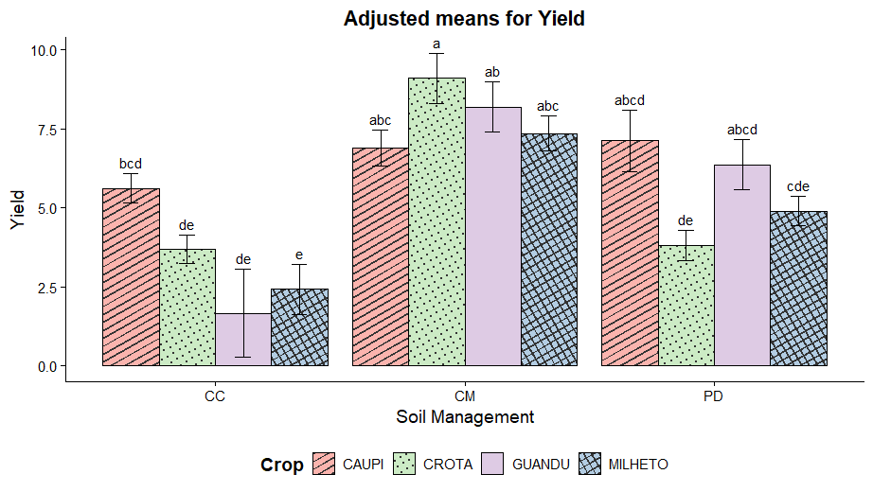 | 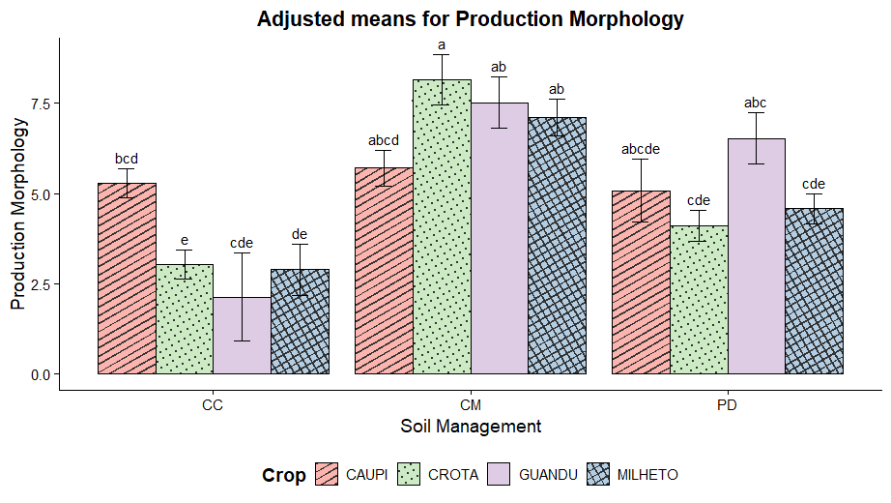
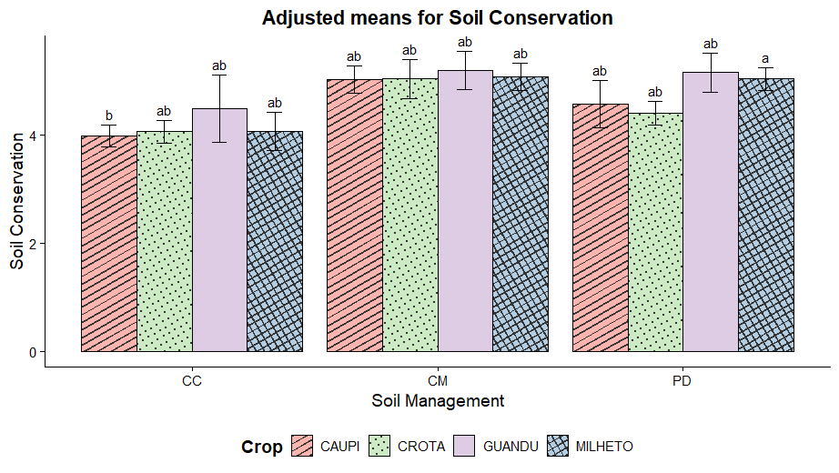 | 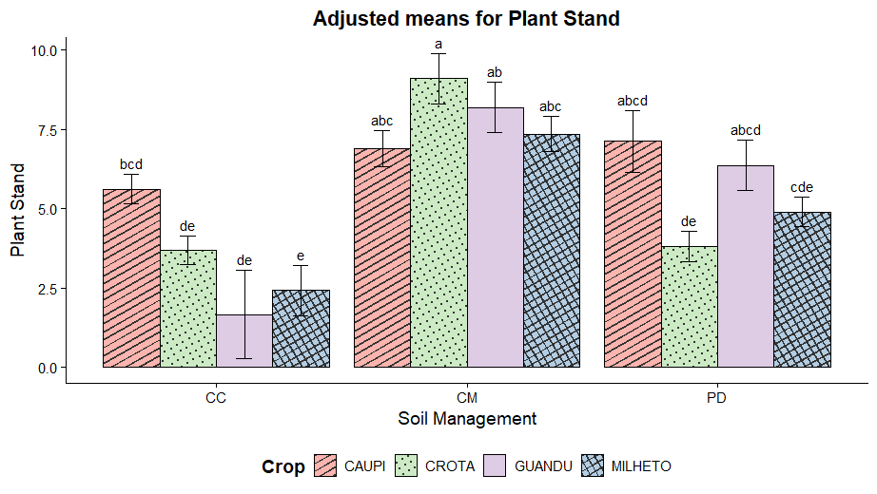

For the Production Morphology (MrP) sub-index, there was a significant effect of the tillage system [F(2, 50) = 25.49; p < 0.001] and its interaction with cover crops [F(6, 50) = 5.19; p < 0.001] (Figure 3b). The highest MrP values were recorded under MT–sunn hemp (8.15) and MT–pigeon pea (7.51), whereas the lowest occurred in CT–sunn hemp (3.03) and CT–pigeon pea (2.14). In relation to APSWCI, the higher expression of MrP under MT–sunn hemp and MT–pigeon pea indicates that combining conservation tillage with leguminous cover crops contributes to improved soil cover and subsequent maintenance.
Conversely, under the CT system, intense soil disturbance compromised the cover crop architecture, reducing the system’s ability to form a functional canopy. This degradation of vegetative structure under CT is directly linked to the physical breakdown of soil aggregates and the reduction in protective mulch cover, which are critical for maintaining soil moisture and temperature in tropical regions (Blanco‐Canqui & Ruis, 2020).
These results are supported by studies showing that intercropping Zea mays with sunn hemp improves radiation interception and solar light use efficiency in tropical and semiarid environments (Daniel et al., 2020; Dzvene et al., 2023). Additionally, crop rotations with legumes such as red clover and canola have been effective in optimizing canopy architecture in subsequent dual-purpose corn cycles (Sun et al., 2025), while row spacing adjustments have also been shown to enhance canopy structure and crop photosynthesis (Ding et al., 2025).
For the Soil Conservation (COS) sub-index, a significant effect was observed only for the tillage system factor [F(2, 50) = 10.30; p < 0.001], with no interaction with the cover crop species (Figure 3c). Adjusted means showed superior performance under conservation systems (MT and NT ≈ 5.0) compared to conventional tillage (CT ≈ 4.0), demonstrating that reduced soil disturbance consistently favors the preservation of soil structure. The absence of interaction reinforces that improvements in conservation indicators are primarily driven by the tillage method itself, confirming the well-established role of conservation practices in mitigating physical soil degradation (Kassam et al., 2019).
For STAND, the effects followed a pattern similar to that observed for Productivity, with significant effects for tillage system [F(2, 50) = 28.94; p < 0.001], cover crop [F(3, 50) = 3.38; p = 0.025], and their interaction [F(6, 50) = 4.68; p < 0.001] (Figure 3d). The highest plant densities were recorded under the MT system associated with sunn hemp (9.09 plants.m⁻²), pigeon pea (8.18 plants.m⁻²), and millet (7.35 plants.m⁻²), whereas the lowest values were observed under CT system with pigeon pea (1.67 plants.m⁻²) and millet (2.42 plants.m⁻²). These results reinforce that the final stand of dual-purpose corn is strongly dependent on the management–cover crop combination, being particularly compromised under the CT system.
The greater plant density observed under the MT system may be attributed to reduced soil disturbance, which helps maintain moisture, preserves pore continuity, and improves nutrient availability, which are essential conditions for uniform seedling emergence (Davoudi, 2011). In addition, the presence of cover crop residues contributes to thermal and moisture regulation in the surface layer, reducing abiotic stress during the critical germination period (Semmartin et al., 2023). Furthermore, the positive effect of sunn hemp and pigeon pea confirms the beneficial effect of legumes, which not only contribute nitrogen through biological fixation but also produce biomass residues with intermediate decomposition rates, ensuring more persistent ground cover and gradual nutrient release (Pittelkow et al., 2015).
In contrast, the poor stand performance under the CT system, especially when combined with pigeon pea and millet, indicates that the intensity of soil disturbance compromises structural stability and increases the susceptibility of superficial compaction, factors that hinder seedling emergence and reduce early plant survival (Rosa et al., 2013).

3.1 Agricultural Productivity and Soil and Water Conservation Index (APSWCI)
The Generalized Linear Model (GLM) revealed that the tillage system was the primary driver of the APSWCI ($χ^{2}=15.42;p<0.001$), while the effect of cover crops ($χ^{2}=2.15;p=0.54$) and the interaction ($χ^{2}=4.89;p=0.55$) were not significant. This result indicates that, for the edaphoclimatic conditions of the study, the mechanical management of the soil exerts a preponderant influence over the specific choice of the preceding plant species.
The Minimum Tillage (MT) system presented the highest mean index value ($5.72±0.21$), differing significantly from Conventional Tillage (CT) ($4.87±0.23$), while No-Tillage (NT) occupied an intermediate position ($5.51±0.22$), statistically similar to MT (Figure 4). The superiority of MT suggests that a slight mechanical intervention (scarification) may be beneficial in soils with a tendency to surface compaction, reconciling the preservation of aggregates with the creation of a physical environment favorable to root development. This finding aligns with Nunes et al. (2018), who observed that occasional tillage in tropical soils can alleviate physical constraints without compromising the long-term benefits of conservation systems.
In contrast, the low performance of CT reflects the "thermodynamic cost" of intensive disturbance. Although it may temporarily favor mineralization, it degrades the physical structure (lower GMD/WMD) and oxidizes organic carbon, penalizing the global index. This degradation mechanism is well-documented (Blanco-Canqui & Ruis, 2020; Kassam et al., 2019), confirming that the APSWCI correctly penalized systems that sacrifice soil capital for short-term gains.
The absence of a significant effect for cover crops suggests that, in the short term, the physical impact of tillage overrides the biological contribution of the preceding species. However, the presence of residues in MT and NT systems, regardless of the species, was sufficient to differentiate them from CT, corroborating the importance of soil cover maintenance (Pittelkow et al., 2015).

Figure 4. Boxplot of the Agricultural Productivity and Soil and Water Conservation Index (APSWCI) at soil depths of 0–10 cm (a) and 10–20 cm (b), under conventional tillage (CT) and conservation management systems—minimum tillage (MT) and no-tillage (NT)—with different cover crop species.
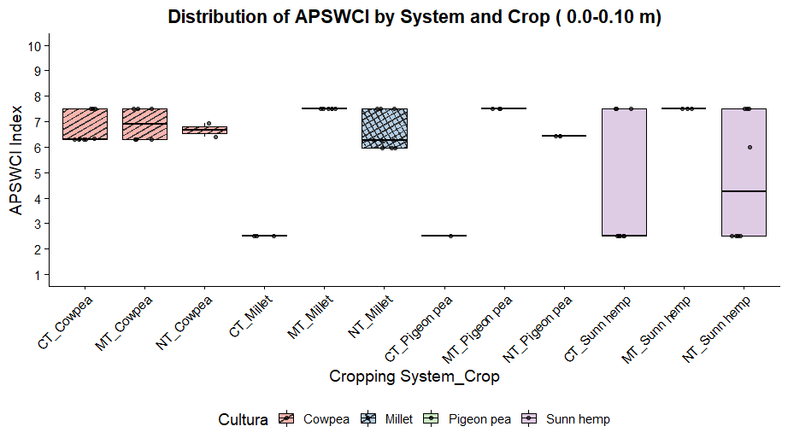 | 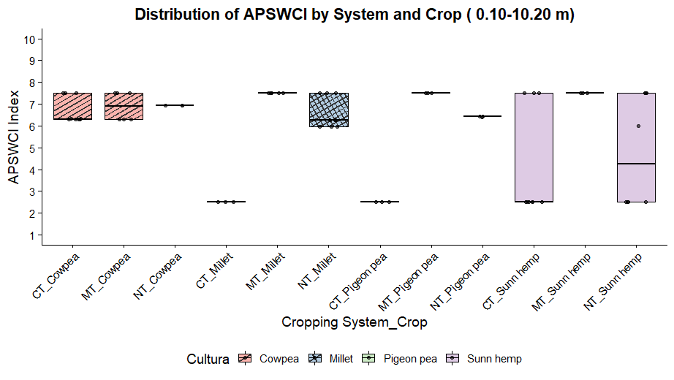
In pairwise comparisons of stratified soil layers, APSWCI values varied between tillage systems and cover crops in the 0–0.10 m layer (Table 1). The GLM (Gamma–Identity) model showed a significant effect for “crop” [Wald χ² (3) = 28.34; p < 0.001] and for the “system × crop” interaction [Wald χ² (6) = 21.24; p = 0.001], while the “system” factor alone was not significant [Wald χ² (2) = 0.034; p = 0.983]. The model fit was considered adequate (Deviance/df = 0.099; AIC = 257.55; BIC = 285.20).

Table 1. Adjusted means of APSWCI (± standard error) as a function of tillage system and cover crop species, at soil depths of 0.00–0.10 m and 0.10–0.20 m.
Tillage system | Preceding cover crop | APSWCI  (mean ± SE)
 |  | 0.0 – 0.10 m | 0.10 – 0.20 m
CT | Cowpea | 3.97^{(0.31)} Bc | 3.97^{(0.26)} Bc
 | Pigeon pea | 3.85^{(0.40)} Bc | 3.97^{(0.26)} Bc
 | Sunn hemp | 4.02^{(1.36)} Bc | 3.97^{(0.26)} Bc
 | Pearl millet | 4.05^{(0.29)} Bc | 3.97^{(0.26)} Bc
MT | Cowpea | 7.12^{(0.52)} Aa | 7.35^{(0.57)} Aa
 | Pigeon pea | 7.45^{(0.61)} Aa | 7.35^{(0.57)} Aa
 | Sunn hemp | 7.25^{(1.58)} Aa | 7.35^{(0.57)} Aa
 | Pearl millet | 7.59^{(0.54)} Aa | 7.35^{(0.57)} Aa
NT | Cowpea | 6.44^{(0.48)} Ab | 6.18^{(0.47)} Ab
 | Pigeon pea | 6.32^{(0.57)} Ab | 6.18^{(0.47)} Ab
 | Sunn hemp | 5.21^{(0.51)} Bb | 6.18^{(0.47)} Ab
 | Pearl millet | 6.47^{(0.45)} Ab | 6.18^{(0.47)} Ab
Note: Values in parentheses represent the standard error (SE) associated with each mean. Different uppercase letters in the column indicate significant differences among tillage systems within the same cover crop (Bonferroni, p < 0.05). Different lowercase letters in the row indicate significant differences among cover crops within the same tillage system (Bonferroni, p < 0.05). Means followed by the same letter do not differ statistically.
Bonferroni post hoc tests revealed significant differences between MT and CT (ΔM = 3.38; p < 0.001) and between NT and CT (ΔM = 2.15; p = 0.002), with no difference between MT and NT (p = 0.366). These results demonstrate that reducing soil disturbance increases the expression of conservation and productivity indicators incorporated into the index. Among the cover crops, cowpea showed the highest adjusted mean (6.75 ± 0.63), while sunn hemp, pigeon pea, and millet had similar values around 5.5, with no statistical differences (p > 0.65). The trend, however, suggests that cowpea contributes more strongly to productive sustainability due to its uniform ground cover and biomass input.
In the 0.10–0.20 m soil layer, a similar pattern to the surface was observed, but with a narrower range among treatments. The MT system maintained high values (7.35 ± 0.57), followed by the NT system (6.18 ± 0.47), both superior to the CT system (3.97 ± 0.26). The lack of significance for the system’s isolated effect in the GLM indicates that, at greater depths, the interaction between management and crop exerts a more determinant role. This result may be related to carbon and nutrient redistribution along the soil profile and the influence of cover crop root biomass. Deep-rooted species such as pigeon pea tend to enhance subsurface performance under NT systems, increasing porosity and water availability for dual-purpose corn (Ramos et al., 2010).
Consistency and coverage indicators (Table 2) reinforce this interpretation. Under the MT system, all combinations showed high consistency (> 6.0), with emphasis on MT–millet and MT–pigeon pea, which presented the highest gross and unique coverage values. The high consistency observed for MT–millet suggests strong sustainability potential, resulting from the interaction between millet’s high biomass production and reduced soil disturbance, conditions that favor the establishment and performance of dual-purpose corn (Page et al., 2020). In the NT system, intermediate values were observed, with NT–cowpea reaching a consistency of 0.50. Under conventional tillage, CT–cowpea and CT–sunn hemp showed low consistency (< 0.4), while CT–pigeon pea and CT–millet had no support (0.00), confirming the limitations of this system in generating sustainable scenarios.
Table 2. Consistency and coverage indicators of APSWCI by tillage system–cover crop configuration.
Configuration (System–Cover Crop) | Consistency | Gross coverage | Unique coverage
CT – Cowpea | 0.33 | 0.10 | 0.00
CT – Sunn hemp | 0.33 | 0.10 | 0.00
CT – Pigeon pea | 0.00 | 0.00 | 0.00
CT – Pearl millet | 0.00 | 0.00 | 0.00
MT – Cowpea | 1.00 | 0.29 | 0.29
MT – Sunn hemp | 1.00 | 0.18 | 0.10
MT – Pigeon pea | 1.00 | 0.14 | 0.14
MT – Pearl millet | 1.00 | 0.43 | 0.43
NT – Cowpea | 0.50 | 0.14 | 0.14
NT – Sunn hemp | 0.37 | 0.05 | 0.10
NT – Pigeon pea | 0.00 | 0.00 | 0.00
NT – Pearl millet | 0.33 | 0.05 | 0.08
Note: Consistency expresses the proportion of cases in which a given configuration is associated with a high sustainability outcome (APSWCI ≥ 6.7), reflecting the stability of causal relationships. Gross coverage indicates the proportion of explained cases among all sustainable outcomes, while unique coverage represents the exclusive contribution of each configuration, excluding overlaps with other combinations. Values close to 1.0 indicate high robustness or representativeness, whereas values near 0.0 indicate low empirical support.

3.2 Indicator configurations
The conservationist and productive indicator settings associated with APSWCI showed values ranging from 2.5 to 7.5, revealing clear differences across tillage systems and cover crop species (Table 3).

Table 3. Global configurations of conservation and productive indicators associated with the APSWCI.
Tillage system | Cover crop | SOC | MrP | STAND | Productivity | APSWCI class | APSWCI (mean)
CT | Cowpea | ◐ | ◐ | ○ | ◐ | Medium | 6.30
CT | Sunn hemp | ○ | ○ | ○ | ○ | Low | 2.50
CT | Pigeon pea | ○ | ○ | ● | ○ | Low | 2.50
CT | Pearl millet | ○ | ○ | ○ | ○ | Low | 2.50
MT | Cowpea | ◐ | ● | ○ | ● | Medium | 6.29
MT | Sunn hemp | ◐ | ● | ○ | ◐ | High | 7.50
MT | Pigeon pea | ● | ● | ○ | ● | High | 7.50
MT | Pearl millet | ● | ● | ○ | ● | High | 7.50
NT | Cowpea | ◐ | ○ | ○ | ● | Medium | 6.34
NT | Sunn hemp | ◐ | ○ | ○ | ◐ | Medium | 4.81
NT | Pigeon pea | ● | ● | ○ | ● | Medium | 6.42
NT | Pearl millet | ● | ◐ | ○ | ● | Medium | 6.57

Note: The table shows the integration of conservation (SOC), architectural (MrP), stand (STAND), and yield indicators used in the APSWCI calculation. Symbols denote the activation level of each attribute in the fuzzy system: ● = high, ◐ = medium, ○ = low. APSWCI scores were classified into three levels: Low (0.0–3.3), Medium (3.4–6.6), and High (6.7–10.0).
In the CT system, low activation of conservation indicators was observed, with SOC remaining at reduced levels across all species, thereby limiting the overall performance of the index. Both the production morphology (MrP) and plant stand (STAND) also showed restricted contributions, except for pigeon pea, which recorded higher STAND values. However, this did not translate into a positive effect on APSWCI due to the lack of synergy with the other indicators. As a result, combinations such as CT–sunn hemp, CT–pigeon pea, and CT–millet remained close to 2.5, classifying them as low-sustainability scenarios. The only exception was CT–cowpea, with an intermediate value (6.30), supported by moderate contributions from SOC, MrP, and productivity. This performance suggests that cowpea’s biomass input and surface coverage partially mitigated the adverse effects of intensive tillage, although they were insufficient to overcome the structural limitations of the CT system.
Under the MT system, values were consistently higher, ranging from 6.3 to 7.5, resulting from the simultaneous enhancement of SOC, MrP, and Productivity. The partial preservation of soil structure and reduced disruption to carbon dynamics favored gains across multiple indicators. Sunn hemp and pigeon pea contributed most to MrP, reflecting greater plant vigor and uniformity, while millet exhibited higher SOC and productivity values, likely due to its high biomass production and enhanced surface protection. The combinations MT–sunn hemp, MT–pigeon pea, and MT–millet achieved the maximum index score (7.5) and were classified as high-sustainability scenarios, underscoring the system’s efficiency in aligning conservation and productivity metrics.
The NT system showed intermediate values but greater variability across species. NT–pigeon pea (6.42) and NT–millet (6.57) achieved sustained performance through higher SOC and productivity, linked to the deep root system of pigeon pea, which improves subsurface porosity, and the high residue input from millet. NT–cowpea (6.34) was limited by lower contributions from MrP and STAND, likely due to the rapid decomposition of its biomass and reduced mulch persistence. In contrast, NT–sunn hemp (4.81) recorded the lowest value within the system, associated with low activation of both MrP and STAND.
Table 3 presents the global consistency and coverage indicators of the APSWCI index as a function of system–species combinations. The MT system showed maximum consistency across all combinations (1.0), indicating high system stability in generating scenarios classified as highly sustainable. Among the species, MT–millet stood out as the most representative configuration, with gross and unique coverage values of 0.43, followed by MT–cowpea (0.29), highlighting the role of these species in enhancing the effects of conservation management.
In contrast, the CT system showed substantially lower performance. The CT–cowpea and CT–sunn hemp combinations exhibited limited consistency (0.33) and coverage of only 0.10, while CT–pigeon pea and CT–millet did not exhibit any support (0.00). These results demonstrate that, even when using species with recognized conservation potential, CT fails to sustain high-sustainability scenarios, confirming the prevailing negative effect of intensive soil disturbance on the expression of the evaluated indicators.
The NT system showed intermediate performance, characterized by higher variability across species. NT–cowpea recorded a consistency value of 0.50 and coverage of 0.14, emerging as the most stable combination within the system. NT–sunn hemp showed a consistency of 0.37, with gross and unique coverage values of 0.05 and 0.10, respectively. NT–millet had a consistency of 0.33 and coverage values below 0.10. The NT–pigeon pea combination exhibited no support (0.00), indicating a limited ability to sustain high-sustainability scenarios.
Overall, the findings confirm that the APSWCI index is sensitive not only to tillage systems but also to their interaction with cover crop species. MT emerged as the most stable and comprehensive system, particularly when combined with millet and cowpea, which provided strong support and high consistency. In contrast, the CT system was unable to sustain stable arrangements, even when paired with species of recognized conservation potential, such as pigeon pea. The NT system occupied an intermediate position, showing strong dependence on the species used, which reflects its lower overall stability compared to the MT system.
From a methodological standpoint, the use of APSWCI represents a significant improvement over the isolated interpretation of traditional indicators such as geometric mean diameter (GMD) and weighted mean diameter (WMD). Although these indices are widely used to assess soil structural quality, they provide only a partial perspective of the system. They do not account for interactions among physical attributes or with other indicators of different natures, which may lead to incomplete or biased assessments.
By integrating multiple variables into a fuzzy inference system, APSWCI provides a continuous and synthetic metric capable of reflecting both productive and conservation sustainability in a holistic manner, thus overcoming the limitations of univariate metrics.

4 CONCLUSION
The long-term field experiment conducted in a Red-Yellow Ultisol of the Coastal Tablelands demonstrated that agricultural sustainability results from the interaction between conservation tillage practices and cover crop species, with direct impacts on soil structural quality, carbon stocks, and dual-purpose corn yield.
The minimum tillage (MT) system combined with cowpea and pigeon pea cover crops promoted higher levels of productive and conservation sustainability for dual-purpose corn under the edaphoclimatic conditions of the Coastal Tablelands.
Variations in the APSWCI index revealed clear differences among tillage systems and cover crops, indicating that the stability of the index depends on the synergistic interaction between soil management practices in long-term Ultisol experiments.
The MT system provided the most robust scenarios for balancing soil and water conservation with productivity, highlighting the potential of this grass species as a strategic cover crop in Ultisols.
Both MT and no-tillage (NT) systems ensured better activation of conservation indicators such as soil organic carbon (SOC) and mechanical resistance to penetration (MrP), with pigeon pea standing out as the most effective cover crop for improving soil structural stability and enhancing dual-purpose corn yield in terms of marketable ears.
The interaction between soil management systems and cover crops showed that the contribution of each species is not uniform: sunn hemp performed poorly under the NT system, while cowpea and pigeon pea amplified the positive effects in conservation systems.
The effectiveness of conservation systems in tropical environments strongly depends on the choice of cover crop species, with direct implications for soil conservation and dual-purpose corn productivity.
The APSWCI index proved to be an effective tool for integrating conservation and productive indicators in dual-purpose corn systems and is scalable for application in other tropical agroecosystems.

CONFLICT OF INTEREST
The authors declare no conflict of interest.

SUPPLEMENTAL MATERIAL
Appendix A presents fifteen linguistic rules linking these variables to the IPACS output, expressed in three fuzzy sets (low, medium, high) with corresponding weights. For instance, predominantly “low” attributes result in a “low” IPACS with reduced weight, while simultaneous “high” conservation and productivity attributes yield a “high” IPACS with increased weight.

REFERENCES
Acar, M., Çelik, İ., Budak, M., & Acir, N. (2022). Effect of long-term different land use on soil quality in an Entic Chromoxerert. https://doi.org/10.21203/rs.3.rs-2230202/v1
Ahmed, Z., Gui, D., Murtaza, G., Yunfei, L., & Ali, S. (2023). An Overview of Smart Irrigation Management for Improving Water Productivity under Climate Change in Drylands. Agronomy, 13(8), 2113. https://doi.org/10.3390/agronomy13082113
Akaike, H. (1998). Information Theory and an Extension of the Maximum Likelihood Principle. In E. Parzen, K. Tanabe, & G. Kitagawa (Eds.), Selected Papers of Hirotugu Akaike (pp. 199–213). Springer. https://doi.org/10.1007/978-1-4612-1694-0_15
Badillo-Márquez, A. E., Aguilar-Lasserre, A. A., Miranda-Ackerman, M. A., Sandoval-González, O. O., Villanueva-Vásquez, D., & Posada-Gómez, R. (2021). An Agent-Based Model-Driven Decision Support System for Assessment of Agricultural Vulnerability of Sugarcane Facing Climatic Change. Mathematics, 9(23), 3061. https://doi.org/10.3390/math9233061
Blanco‐Canqui, H., & Ruis, S. J. (2020). Cover crop impacts on soil physical properties: A review. Soil Science Society of America Journal, 84(5), 1527–1576. https://doi.org/10.1002/saj2.20129
Calonego, J. C., Raphael, J. P. A., Rigon, J. P. G., Oliveira Neto, L. de, & Rosolem, C. A. (2017). Soil compaction management and soybean yields with cover crops under no-till and occasional chiseling. European Journal of Agronomy, 85, 31–37. https://doi.org/10.1016/j.eja.2017.02.001
Cameron, A. C., & Trivedi, P. K. (1990). Regression-based tests for overdispersion in the Poisson model. Journal of Econometrics, 46(3), 347–364. https://doi.org/10.1016/0304-4076(90)90014-K
Castro Filho, C., Lourenço, A., de F. Guimarães, M., & Fonseca, I. C. B. (2002). Aggregate stability under different soil management systems in a red latosol in the state of Parana, Brazil. Soil and Tillage Research, 65(1), 45–51. https://doi.org/10.1016/S0167-1987(01)00275-6
Chellappa, J., Sagar, K. L., Sekaran, U., Kumar, S., & Sharma, P. (2021). Soil organic carbon, aggregate stability and biochemical activity under tilled and no-tilled agroecosystems. Journal of Agriculture and Food Research, 4, 100139. https://doi.org/10.1016/j.jafr.2021.100139
Daniel, D. F., Dallacort, R., Barbieri, J. D., Carvalho, M. A. C. de, Júnior, S. S., & Fenner, W. (2020). Evapotranspiration and Dual Crop Coefficient of Maize Second Season Intercropped with Crotalaria. Journal of Experimental Agriculture International, 142–157. https://doi.org/10.9734/jeai/2020/v42i130460
Davoudi, M. H. (2011). Influence of willow root density on shear resistance parameters in fine grain soils using in situ direct shear tests. Research Journal of Environmental Sciences, 5(2), 157.
Ding, X., He, Z., Zhang, M., Bai, J., Zhang, J., Liu, P., Ren, H., Ren, B., & Zhao, B. (2025). Optimizing row spacing to boost maize yield via enhanced photosynthesis and post-silking biomass allocation. Journal of Integrative Agriculture. https://doi.org/https://doi.org/10.1016/j.jia.2025.04.033
Dong, W., & Song, Y. (2020). The significance of flavonoids in the process of biological nitrogen fixation. International Journal of Molecular Sciences, 21(16), 1–18. https://doi.org/10.3390/ijms21165926
Du, X., Jian, J., Du, C., & Stewart, R. D. (2022). Conservation management decreases surface runoff and soil erosion. International Soil and Water Conservation Research, 10(2), 188–196. https://doi.org/10.1016/j.iswcr.2021.08.001
Dzvene, A. R., Tesfuhuney, W. A., Walker, S., & Ceronio, G. (2023). Planting time and stand density effect on radiation interception and use efficiency of maize and sunn hemp intercropping in semi-arid South Africa. Agricultural and Forest Meteorology, 341, 109690. https://doi.org/10.1016/j.agrformet.2023.109690
Ellert, B. H., & Bettany, J. R. (2011). Calculation of organic matter and nutrients stored in soils under contrasting management regimes. Https://Doi.Org/10.4141/Cjss95-075, 75(4), 529–538. https://doi.org/10.4141/CJSS95-075
Hussain, S., Hussain, S., Guo, R., Sarwar, M., Ren, X., Krstic, D., Aslam, Z., Zulifqar, U., Rauf, A., Hano, C., & El-Esawi, M. A. (2021). Carbon Sequestration to Avoid Soil Degradation: A Review on the Role of Conservation Tillage. Plants, 10(10), 2001. https://doi.org/10.3390/plants10102001
Jayasinghe, S. L., Thomas, D. T., Anderson, J. P., Chen, C., & Macdonald, B. C. T. (2023). Global Application of Regenerative Agriculture: A Review of Definitions and Assessment Approaches. Sustainability, 15(22), 15941. https://doi.org/10.3390/su152215941
Kassam, A., Friedrich, T., & Derpsch, R. (2019). Global spread of Conservation Agriculture. International Journal of Environmental Studies, 76(1), 29–51. https://doi.org/10.1080/00207233.2018.1494927
Kemper, W. D., & Chepil, W. S. (1965). Size distribution of aggregates. Methods of Soil Analysis: Part 1 Physical and Mineralogical Properties, Including Statistics of Measurement and Sampling, 9, 499–510.
Klute, A. (1986). Methods of soil analysis. Part 1. Physical and mineralogical methods. (1st ed., Issue Ed. 2).
Kumar, A., Vaishnav, R., Deori, C., Timung, B., Roy, S., Pradhan, R., Prakash, R., & Bochalya, R. S. (2025). Silvopastoral Systems in India for Fodder Production and Livestock Sustainability: A Review. Journal of Experimental Agriculture International, 47(3), 112–135. https://doi.org/10.9734/jeai/2025/v47i33321
Kuzmin, V. A., Tokarev, K. E., Yu Rudenko, A., & Pleshchenko, T. V. (2020). Modeling of an intellectual system for assessing the environmental safety of irrigated lands using fuzzy logic methods. IOP Conference Series: Earth and Environmental Science, 577(1), 012008. https://doi.org/10.1088/1755-1315/577/1/012008
Mamdani, E. H., & Assilian, S. (1975). An experiment in linguistic synthesis with a fuzzy logic controller. International Journal of Man-Machine Studies, 7(1), 1–13. https://doi.org/10.1016/S0020-7373(75)80002-2
Maurya, S., Abraham, J. S., Somasundaram, S., Toteja, R., Gupta, R., & Makhija, S. (2020). Indicators for assessment of soil quality: a mini-review. Environmental Monitoring and Assessment, 192(9), 604. https://doi.org/10.1007/s10661-020-08556-z
McCullagh, P., & Nelder, J. A. (2019). Generalized Linear Models. Routledge. https://doi.org/10.1201/9780203753736
Menon, M., Mawodza, T., Rabbani, A., Blaud, A., Lair, G. J., Babaei, M., Kercheva, M., Rousseva, S., & Banwart, S. (2020). Pore system characteristics of soil aggregates and their relevance to aggregate stability. Geoderma, 366, 114259. https://doi.org/10.1016/J.GEODERMA.2020.114259
Meurer, K., Barron, J., Chenu, C., Coucheney, E., Fielding, M., Hallett, P., Herrmann, A. M., Keller, T., Koestel, J., Larsbo, M., Lewan, E., Or, D., Parsons, D., Parvin, N., Taylor, A., Vereecken, H., & Jarvis, N. (2020). A framework for modelling soil structure dynamics induced by biological activity. Global Change Biology, 26(10), 5382–5403. https://doi.org/10.1111/gcb.15289
Mulatu, G. (2024). Influence of Conservation Agriculture on Certain Soil Qualities Both Physical and Chemical in Relation to Sustainable Agriculture Practices a Review. International Journal of Biochemistry, Biophysics & Molecular Biology, 9(1), 1–13. https://doi.org/10.11648/j.ijbbmb.20240901.11
Nabati, J., Nezami, A., Neamatollahi, E., & Akbari, M. (2020). GIS-based agro-ecological zoning for crop suitability using fuzzy inference system in semi-arid regions. Ecological Indicators, 117, 106646. https://doi.org/10.1016/j.ecolind.2020.106646
Nunes, M. R., van Es, H. M., Schindelbeck, R., Ristow, A. J., & Ryan, M. (2018). No-till and cropping system diversification improve soil health and crop yield. Geoderma, 328, 30–43. https://doi.org/10.1016/j.geoderma.2018.04.031
Oliveira, G. M. de, Moraes, L. A. de A., Silva, A. P. da, Machineski, G. S., Missio, F. de F., & Tavares Filho, J. (2024). Soil microbiological attributes and sugarcane productivity following implementation of three sugarcane reformation systems. Semina: Ciências Agrárias, 45(6), 1823–1832. https://doi.org/10.5433/1679-0359.2024v45n6p1823
Özkan, B., Dengiz, O., & Turan, İ. D. (2020). Site suitability analysis for potential agricultural land with spatial fuzzy multi-criteria decision analysis in regional scale under semi-arid terrestrial ecosystem. Scientific Reports, 10(1), 22074. https://doi.org/10.1038/s41598-020-79105-4
Page, K. L., Dang, Y. P., & Dalal, R. C. (2020). The Ability of Conservation Agriculture to Conserve Soil Organic Carbon and the Subsequent Impact on Soil Physical, Chemical, and Biological Properties and Yield. Frontiers in Sustainable Food Systems, 4. https://doi.org/10.3389/fsufs.2020.00031
Pangapanga-Phiri, I., Mungatana, E. D., Pangapanga, L., & Nkoka, F. S. (2022). Understanding the impact of sustainable land-scape management practices on farm productivity under intensifying tropical cyclones: Evidence from Southern Malawi. Tropical Cyclone Research and Review, 11(4), 265–276. https://doi.org/10.1016/j.tcrr.2023.02.002
Patil, V. H., Dhanke, J., Ghaly, M. A., Patil, R. N., Mane, A., Perwej, Y., & Shrivastava, A. (2023). A Novel Approach for Crop Selection and Water Management using Mamdani’s Fuzzy Inference &amp; IOT. International Journal on Recent and Innovation Trends in Computing and Communication, 11(9), 62–68. https://doi.org/10.17762/ijritcc.v11i9.8320
Pittelkow, C. M., Liang, X., Linquist, B. A., van Groenigen, K. J., Lee, J., Lundy, M. E., van Gestel, N., Six, J., Venterea, R. T., & van Kessel, C. (2015). Productivity limits and potentials of the principles of conservation agriculture. Nature, 517(7534), 365–368. https://doi.org/10.1038/nature13809
Quintarelli, V., Radicetti, E., Allevato, E., Stazi, S. R., Haider, G., Abideen, Z., Bibi, S., Jamal, A., & Mancinelli, R. (2022). Cover Crops for Sustainable Cropping Systems: A Review. Agriculture, 12(12), 2076. https://doi.org/10.3390/agriculture12122076
Qureshi, M. R. N. M., Almuflih, A. S., Sharma, J., Tyagi, M., Singh, S., & Almakayeel, N. (2022). Assessment of the Climate-Smart Agriculture Interventions towards the Avenues of Sustainable Production–Consumption. Sustainability, 14(14), 8410. https://doi.org/10.3390/su14148410
Ragin, C. C. (2008). Redesigning Social Inquiry. University of Chicago Press. https://doi.org/10.7208/chicago/9780226702797.001.0001
Ramos, M. E., Benítez, E., García, P. A., & Robles, A. B. (2010). Cover crops under different managements vs. frequent tillage in almond orchards in semiarid conditions: Effects on soil quality. Applied Soil Ecology, 44(1), 6–14. https://doi.org/10.1016/j.apsoil.2009.08.005
Rosa, J. D., Cooper, M., Darboux, F., & Medeiros, J. C. (2013). Processo de formação de crostas superficiais em razão de sistemas de preparo do solo e chuva simulada. Revista Brasileira de Ciência Do Solo, 37(2), 400–410. https://doi.org/10.1590/S0100-06832013000200011
Sauvadet, M., Tardy, V., Clivot, H., & et al. (2019). Soil organic matter dynamics and aggregate stability under agroforestry systems. Science of the Total Environment, 651, 2760–2769. https://doi.org/10.1016/j.scitotenv.2018.10.129
Semmartin, M., Cosentino, D., Poggio, S. L., Benedit, B., Biganzoli, F., & Peper, A. (2023). Soil carbon accumulation in continuous cropping systems of the rolling Pampa (Argentina): The role of crop sequence, cover cropping and agronomic technology. Agriculture, Ecosystems & Environment, 347, 108368. https://doi.org/10.1016/J.AGEE.2023.108368
Sharma, P., Shah, D., Negi, A., Singh, J., KS, A., Chauhan, S., & Mubeen. (2025). Agroforestry Systems for Enhancing Biodiversity and Soil Conservation in Agricultural Landscapes. Asian Journal of Soil Science and Plant Nutrition, 11(1), 507–523. https://doi.org/10.9734/ajsspn/2025/v11i1499
Sharma, R., Rallapalli, S., & Magner, J. (2025a). Optimizing water-efficient agriculture: evaluating the sustainability of soil management and irrigation synergies using fuzzy extent analysis. Scientific Reports, 15(1), 29382. https://doi.org/10.1038/s41598-025-15426-6
Sharma, R., Rallapalli, S., & Magner, J. (2025b). Optimizing water-efficient agriculture: evaluating the sustainability of soil management and irrigation synergies using fuzzy extent analysis. Scientific Reports, 15(1), 29382. https://doi.org/10.1038/s41598-025-15426-6
Singh, M., Bir Yadav, D., Yadav, S., Mor, V., & Poonia, B. S. (2024). Potential of Conservation Agricultural Practices on Soil Quality, Carbon Sequestration, Salinity Management and Productivity of Rainfed Areas. Journal of Soil Salinity and Water Quality, 16(3), 329–344. https://doi.org/10.56093/jsswq.v16i3.158116
Sobral, L. F., Viégas, P. R. A., Siqueira, O. J. W., Anjo, J. L., Barretto, M. C. V., & Gomes, J. B. V. (2007). Recomendações para o uso de corretivos e fertilizantes no estado de Sergipe. (Vol. 1). Embrapa Tabuleiros Costeiros. https://www.bdpa.cnptia.embrapa.br/consulta/busca?b=ad&id=372419&biblioteca=CPATSA&busca=autoria:%22ANJOS,%20J.%20L.%20dos%22&qFacets=autoria:%22ANJOS,%20J.%20L.%20dos%22&sort=&paginacao=t&paginaAtual=1
Sun, M., Zhang, L., Zhou, J., Liu, Z., Peng, C., Jia, Z., Lv, Y., & Wang, Y. (2025). Leveraging cover crop functional traits and nitrogen synchronization for yield-optimized waxy corn production systems. Frontiers in Plant Science, 16. https://doi.org/10.3389/fpls.2025.1591506
Tang, X., Qiu, J., Xu, Y., Li, J., Chen, J., Li, B., & Lu, Y. (2022). Responses of soil aggregate stability to organic C and total N as controlled by land-use type in a region of south China affected by sheet erosion. CATENA, 218, 106543. https://doi.org/10.1016/j.catena.2022.106543
Teixeira, P. C., Donagemma, G. K., Fontana, A., & Teixeira, W. G. (2017). Manual de Métodos de Análise de Solo (3rd ed.). Embrapa Solos.
Vanolli, B. da S., Dias, H. B., da Luz, F. B., Lamparelli, R. A. C., Magalhães, P. S. G., & Cherubin, M. R. (2025). Crop–Livestock Integrated Systems Improve Soil Health in Tropical Sandy Soils. Agronomy, 15(2), 378. https://doi.org/10.3390/agronomy15020378
Vaseghi, E., Zare Mehrjerdi, M. R., Nikouei, A., & Mehrabi Boshrabadi, H. (2020). Prioritizing potential use of urban treated wastewater using expert-oriented and multi-criteria decision-making approaches: a case study in Iran. Water Science and Technology, 82(1), 81–96. https://doi.org/10.2166/wst.2020.330
VijayKumar, R., Lallawmkimi, M. C., Gautam, S. K., Tiwari, P., KS, A., Sekhar, M., & Upadhyay, L. (2024). Agroforestry Practices as a Keystone for Biodiversity Conservation: A Review. Journal of Experimental Agriculture International, 46(9), 61–76. https://doi.org/10.9734/jeai/2024/v46i92805
Wang, Y., & Zhang, J. (2024). Research on cultural diversity and sustainable land-use management assessment model. Frontiers in Environmental Science, 12. https://doi.org/10.3389/fenvs.2024.1359521
Wang, Z., Dai, Y., Liu, J., Chen, Z., & Yu, Z. (2023). Integrating multi-influencing factor techniques and fuzzy methods to identify recommendation domains for out-scaling conservation agriculture in China. Frontiers in Sustainable Food Systems, 7. https://doi.org/10.3389/fsufs.2023.1219938
Yoder, R. E. (1936). A Direct Method of Aggregate Analysis of Soils and a Study of the Physical Nature of Erosion Losses ¹. Agronomy Journal, 28(5), 337–351. https://doi.org/10.2134/agronj1936.00021962002800050001x

