**Assignment 12**

**Name: DONGWOOK LEE**

**Problem 12.1** *Shortest Path Algorithm*  (3 points)

**Idea Explanation:**

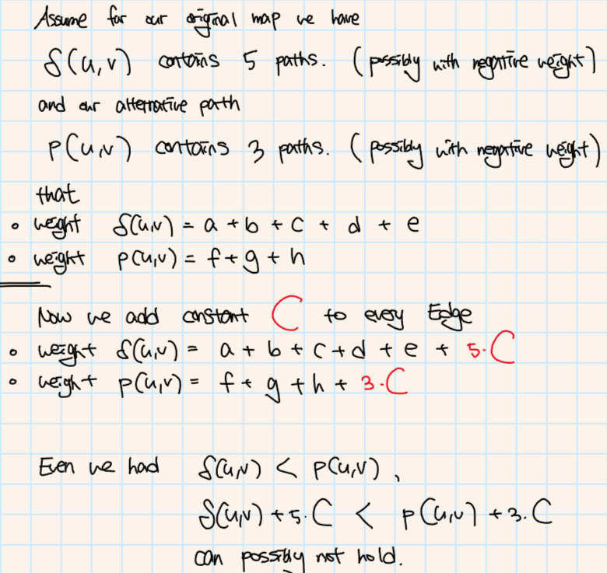

**Counter Example:**

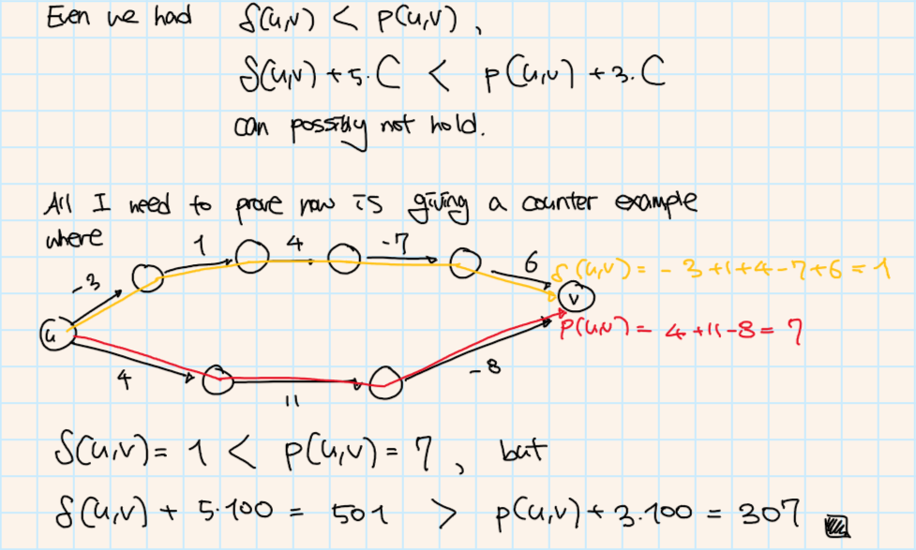

**Problem 12.2** *Optimal Meeting Point*  (7 points)

**Dijkstra Algorithm:**

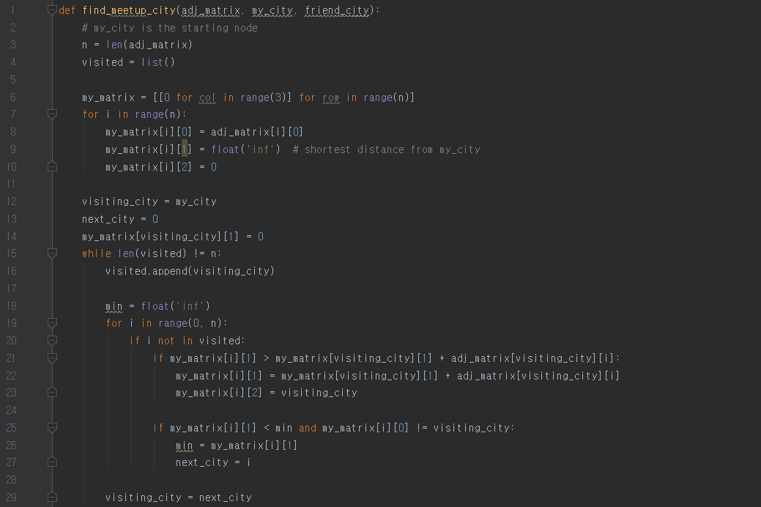

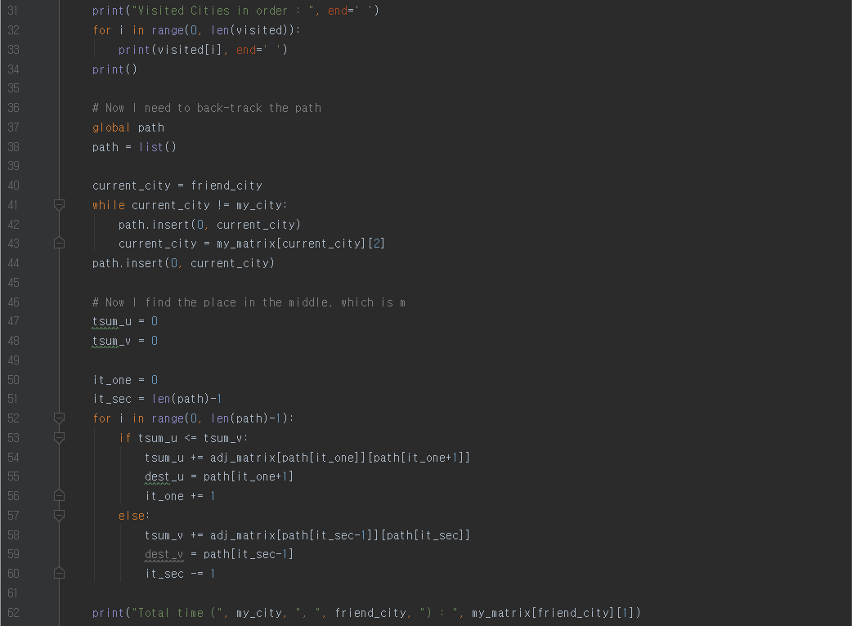

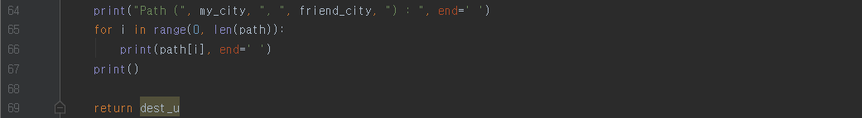

**Input 1:**

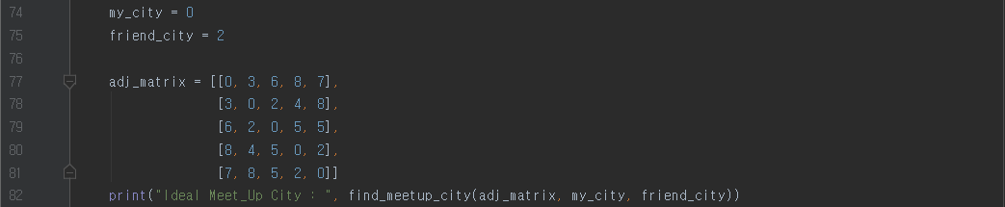

1. Make my own Matrix with n rows and 3 columns

|  |  |  |
| --- | --- | --- |
| Current City | Shortest Distance from my_city | Previous City |
| **0 (Start)** | INF | **None** |
| 1 | INF | **None** |
| 2 | INF | **None** |
| 3 | INF | **None** |
| 4 | INF | **None** |

1. Use Dijkstra Algorithm to fill up the above matrix

|  |  |  |
| --- | --- | --- |
| Current City | Shortest Distance from my_city | Previous City |
| **0 (Start)** | INF |  |
| **1** | 3 | 0 |
| **2** | 5 | 1 |
| **3** | 7 | 1 |
| **4** | 7 | 0 |

1. Find the Path by back tracking (ex) 0 🡪 2)

|  |  |  |
| --- | --- | --- |
| Current City | Shortest Distance from my_city | Previous City |
| **0 (Start)** | INF |  |
| **1** | 3 | 0 |
| **2** | 5 | 1 |
| **3** | 7 | 1 |
| **4** | 7 | 0 |

1. Find the middle point by my own algorithm

**m = 1**

**Output 1:**

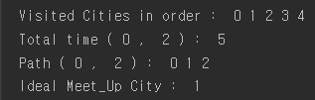

**Input 2:**

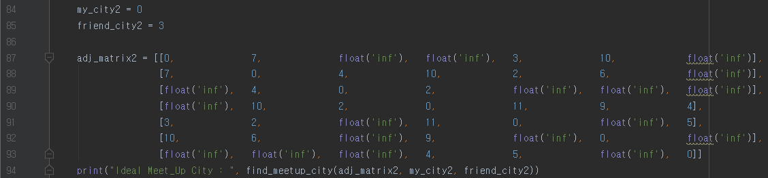

1. Follow the same algorithm used in Input 1

**Output 2:**

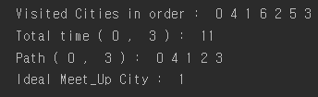

**Problem 12.3** *Number Maze*  (10 points)

(a) (2 points)

Assume we have a matrix **A** with nxn size.

All the elements of the array become nodes of our graph,

and all the one-step reachable elements from one another are represented as directed edges.

Ex) Our matrix A = [[1, 2, 2, 1], [3, 3, 1, 2], [2, 1, 2, 3], [1, 1, 1, 3]]

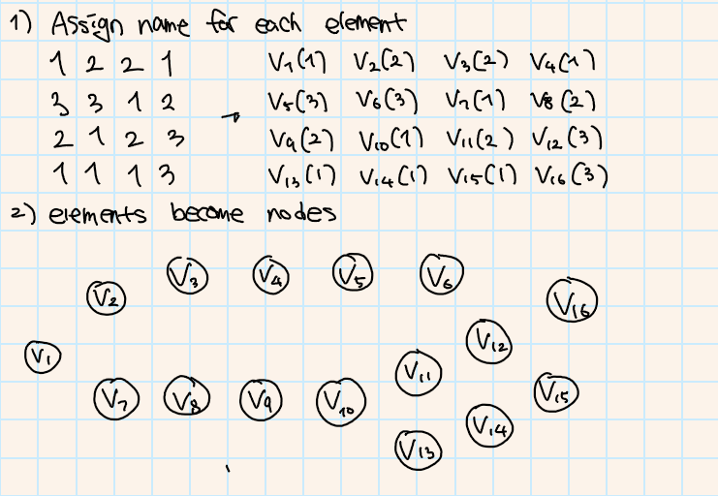

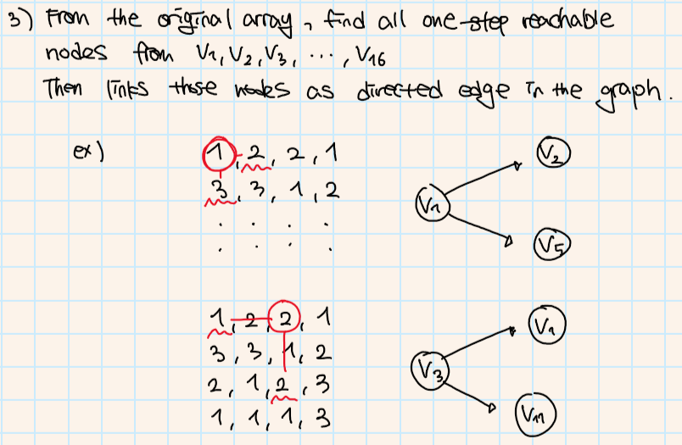

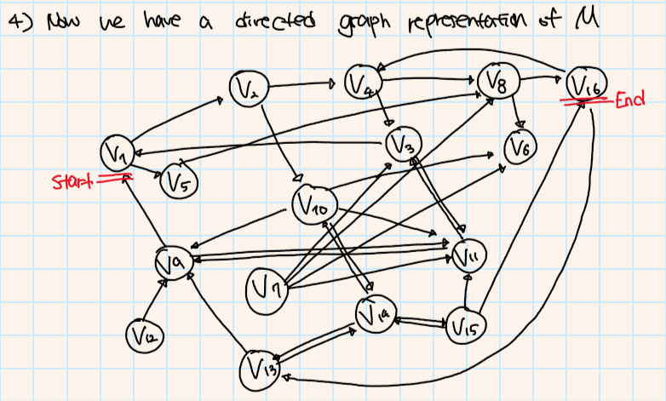

(b) (4 points)

**Class Declaration and Definition:**



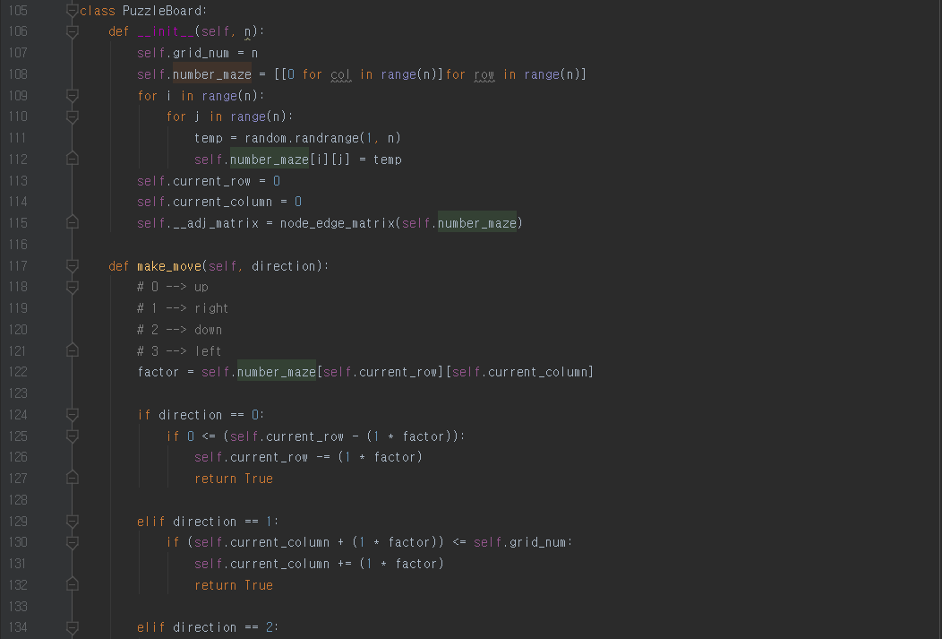

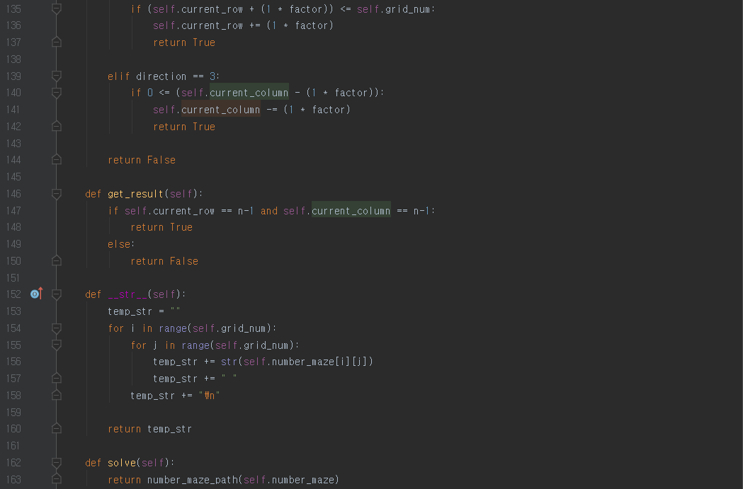

*’def number_maze_path(self.number_maze)’ of ’def solve(self)’ defined in Bonus Answer Sheet

**Main Function:**

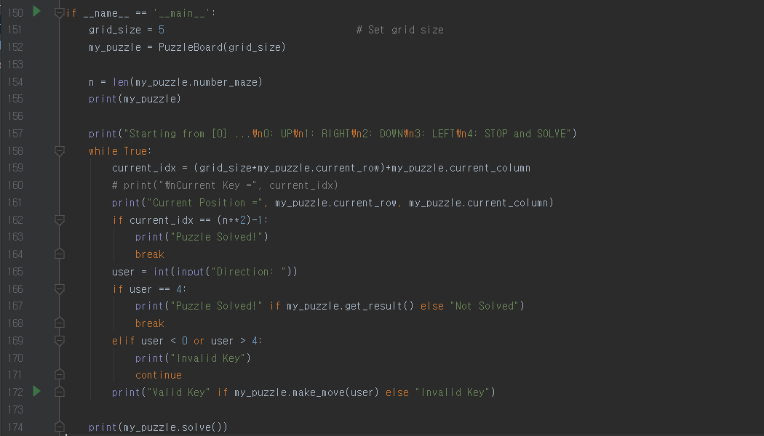

**Sample Test:**

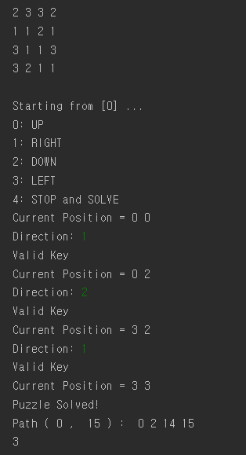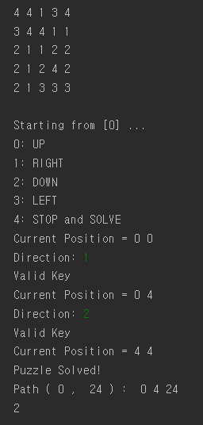

**Changed Grid Size into 4 Changed Grid Size into 5**