**Assignment 12**

**Name: DONGWOOK LEE**

**Problem 12.3** *Number Maze*

(c) **Bonus** (4 points)

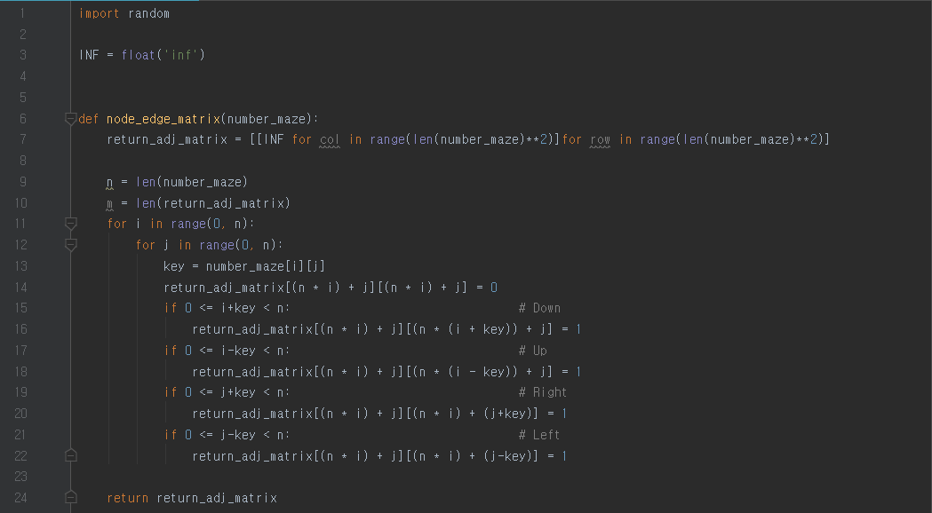

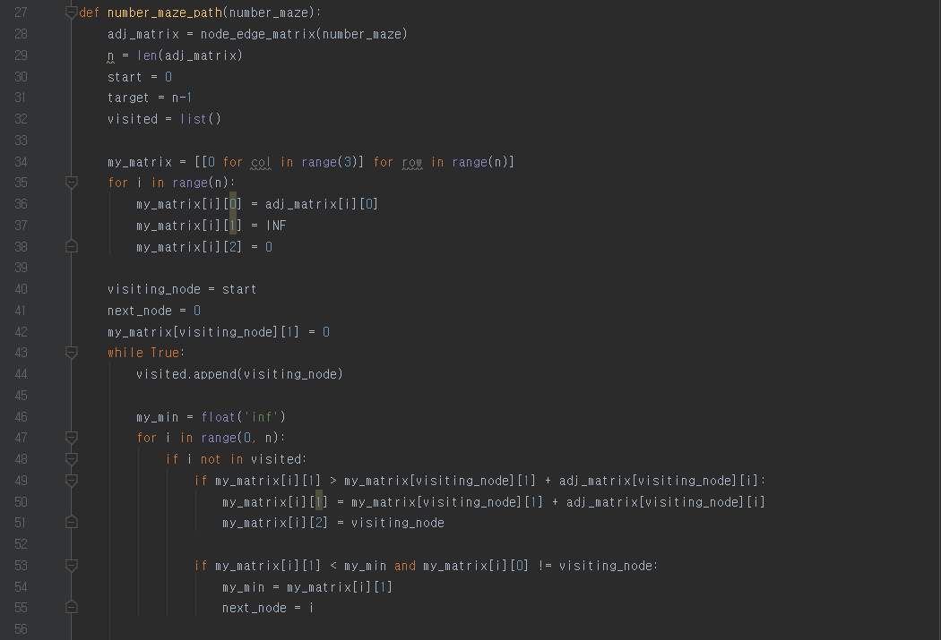

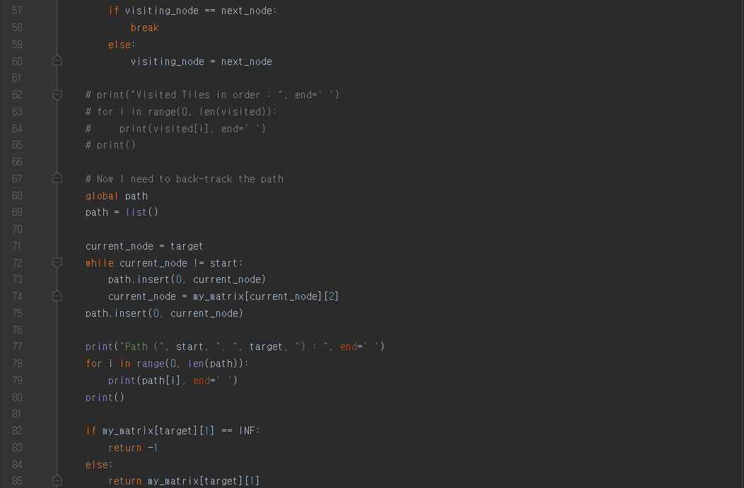

**Test Case:**

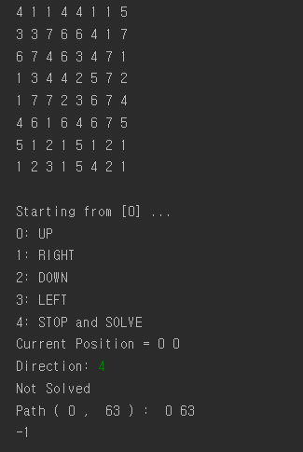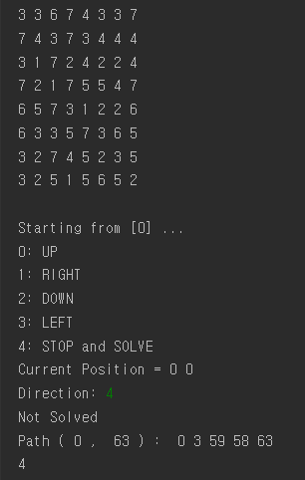

**No Solution Solution Given**