# ST MCSDK学习笔记

## hall_speed_pos_fdbk

根据HALL1/2/3 跳变捕获时间，计算得到电机当前转速。

该工程使用STM32的TIM2定时器的CH1、CH2、CH3分别接HALL1、HALL2、HALL3，采用(Hall Sensor Mode)/XOR ON三个引脚异或来捕获跳变时间。

PseudoFreqConv 为转换系数

PseudoFreqConv = ((TIMClockFreq / 6)/hMeasurementFrequency) * (DPPConvFactor);

SensorPeriod[SpeedBufferSize]为SpeedBufferSize个TIM2最近捕获的周期数

SensorPeriod[SpeedFIFOIdx] = (TIM2->PSC + 1)*TIM2->CCR1;

ElPeriodSum 为最近SensorPeriod[SpeedBufferSize]累加值

hElSpeedDpp 为dpp（digit-per-PWM） 每个测量周期的电角度（65536表示360度）

hAvrMecSpeedUnit 为电机速度，单位0.1rps(0.1圈/秒)

AvrElSpeedDpp = PseudoFreqConv / ( ElPeriodSum / SpeedBufferSize );

hElSpeedDpp = AvrElSpeedDpp ;

令 kElSpeedDpp2MecSpeedUnit = (hMeasurementFrequency * SPEED_UNIT ) / ( DPPConvFactor * bElToMecRatio );

hAvrMecSpeedUnit = AvrElSpeedDpp * kElSpeedDpp2MecSpeedUnit ;

hMaxReliableMecSpeedUnit为速度报错上限值，单位0.1rps

hMinReliableMecSpeedUnit为速度报错下限值，单位0.1rps

## **speed_torq_ctrl**

目标速度接收，解析串口数据帧

**ClientFrameReceivedCallback**

**-->MCP_ReceivedFrame**( pBaseHandle->ClientEntity,

pBaseHandle->RxFrame.Code,

pBaseHandle->RxFrame.Buffer,

pBaseHandle->RxFrame.Size );

**MCI_ExecSpeedRamp**(pMCI,(int16_t)((wValue*SPEED_UNIT)/_RPM),0);

单位转换：rpm转换为0.1rps

pMCI->hTargetFinal = (wValue*SPEED_UNIT)/_RPM;

SpeedRefUnitExt = ( int32_t )pMCI->hTargetFinal * 65536;

速度环PI控制，以及FOC控制

FOC_CalcCurrRef( M1 );

**-->STC_CalcTorqueReference**(pSTC[bMotor]);

wCurrentReference = SpeedRefUnitExt;

hTargetSpeed = ( int16_t )( wCurrentReference / 65536 );

hMeasuredSpeed = hAvrMecSpeedUnit ;

hError = hTargetSpeed - hMeasuredSpeed;

hTorqueReference = PI_Controller( pHandle->PISpeed, ( int32_t )hError );

SpeedRefUnitExt = wCurrentReference;

TorqueRef = ( int32_t )hTorqueReference * 65536;

## 3、ST-MCSDK坐标转换

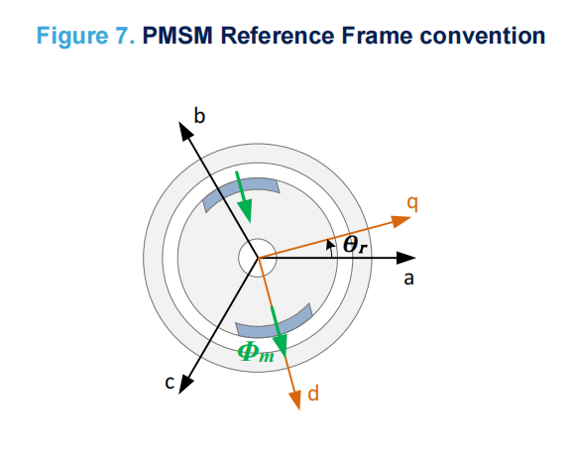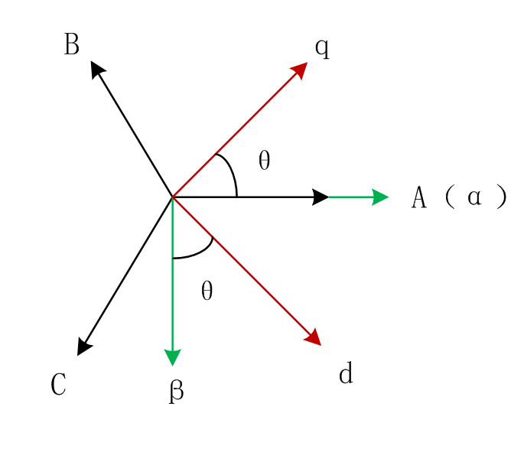

**MCM_Clarke变换**

 

**MCM_Park变换**



**MCM_Rev_Park**



**P**WMC_SetPhaseVoltag**e**



辅助变量



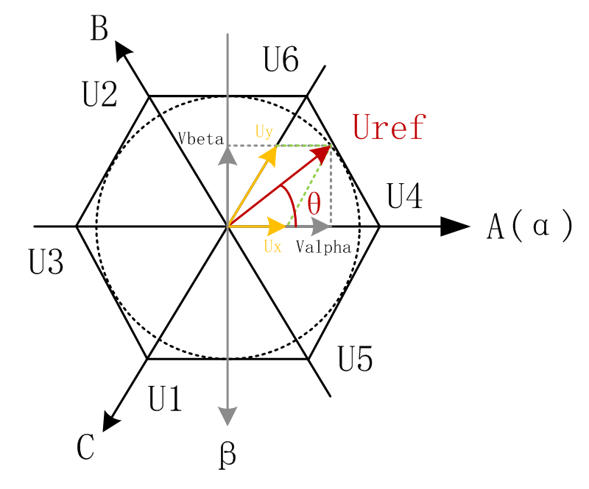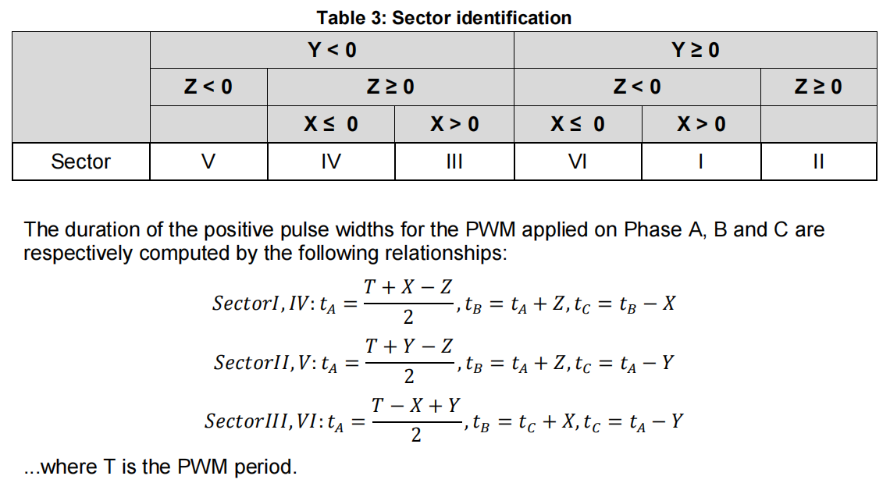

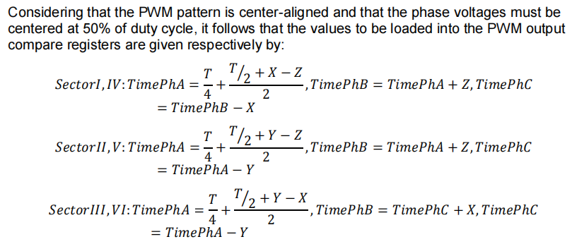

扇区I分析



 

wUAlpha 和 wUBeta 都乘以系数2*PWMperiod ，即wX、wY、wZ都包含2T的系数。但是因为STM32采用的是中央对齐模式，所以设置减小为原来的1/2。



