**Project0_Recon_Cartesian_using_FFT**

**一、重建图形**

1. **傅里叶逆变换重建图像， 观察图像的模,相位,实部,虚部**

原始图像的实部,虚部,模,相位如图：

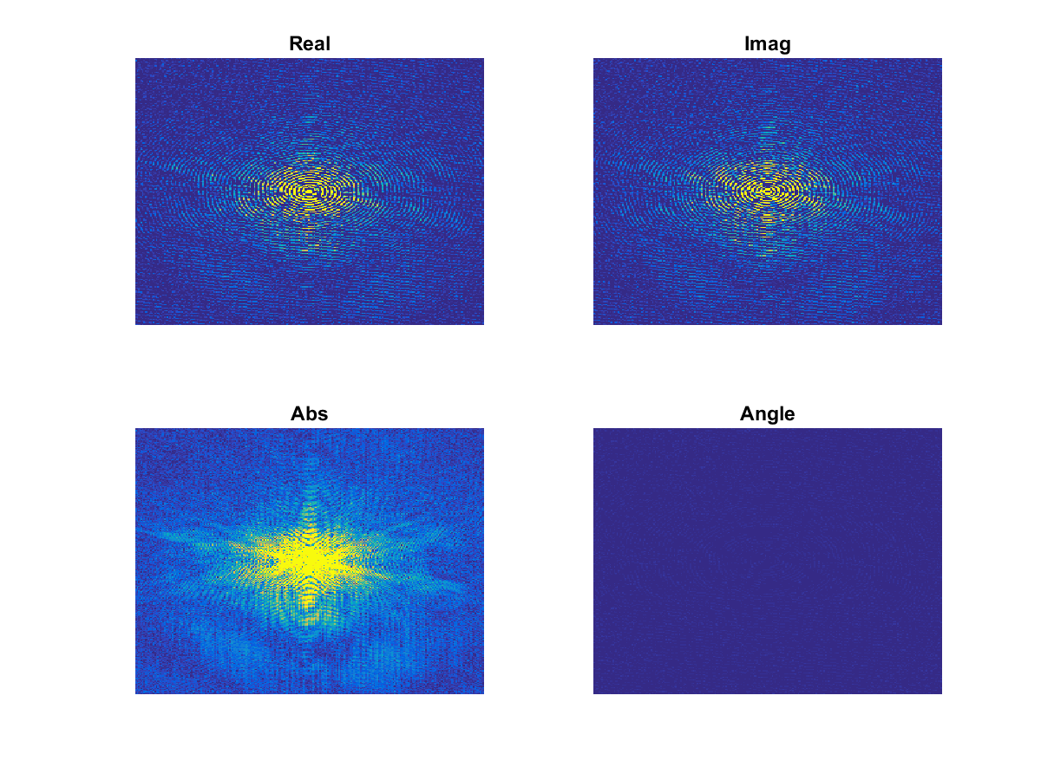

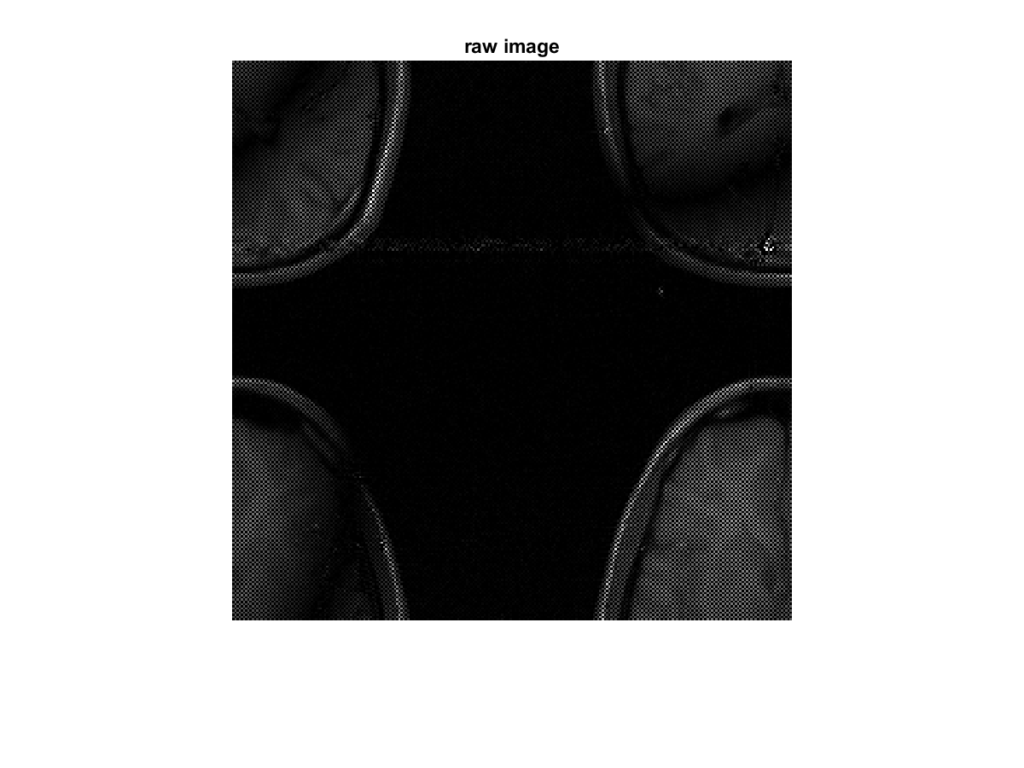

对原始数据进行二维傅立叶反变换后，图像反映的解剖结构错乱，重整后，如图

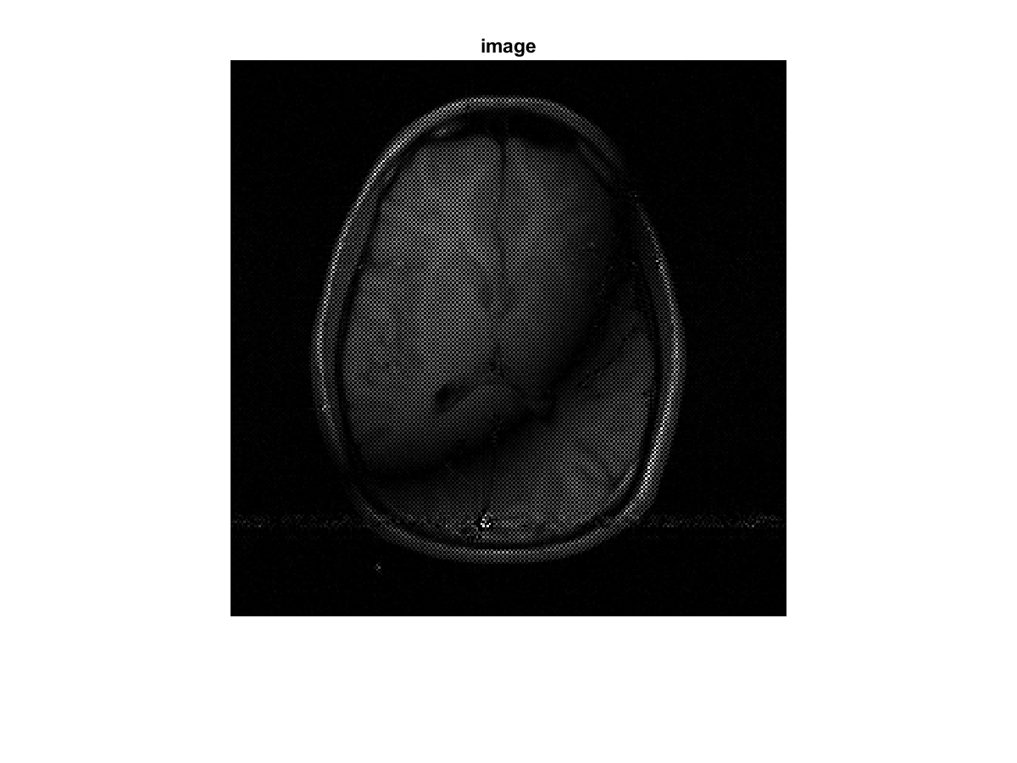

1. **将数据第1到64行数据置0**

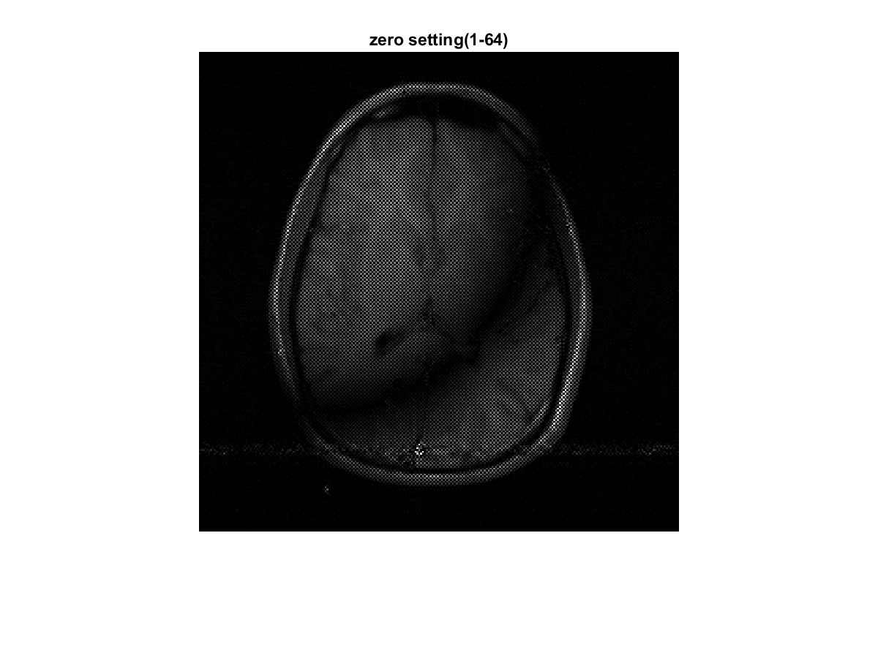

1. **将数据1到64行与193到256行置0**

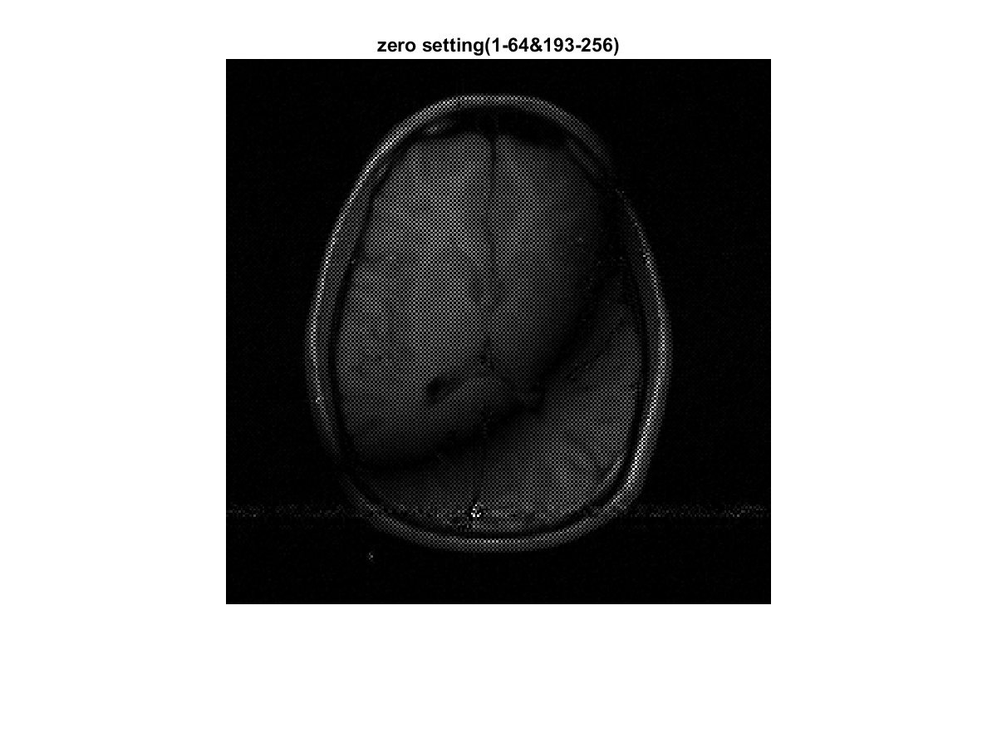

1. **将数据奇数行置0**

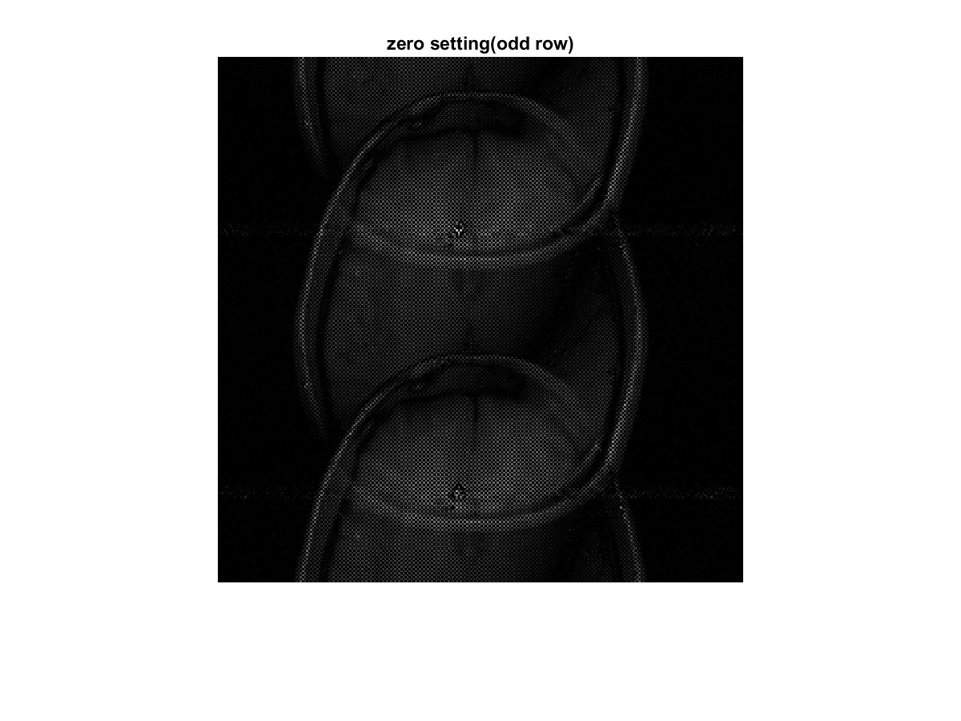

1. **将数据偶数行置0**

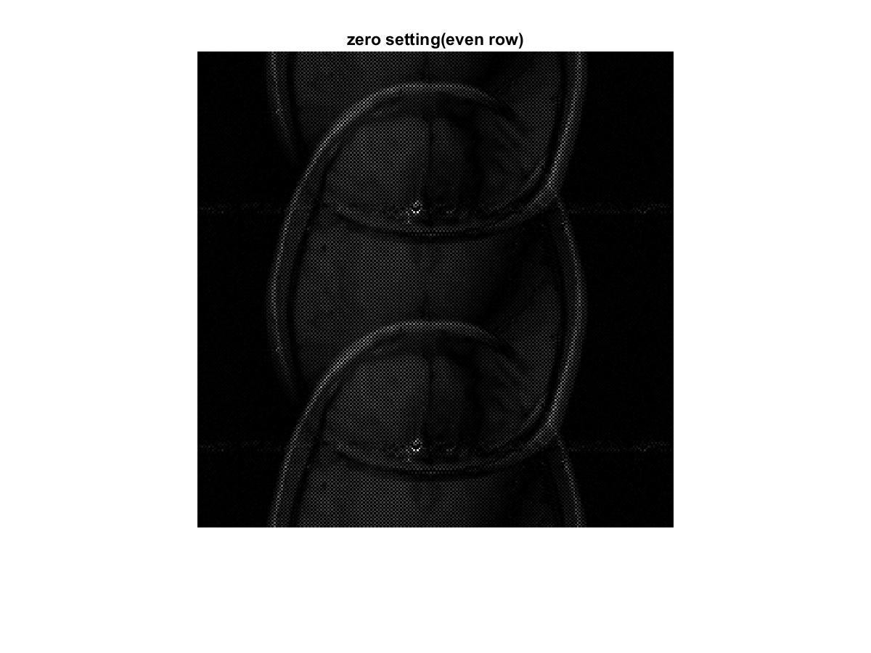

1. **将数据奇数行置0，奇数列置0**

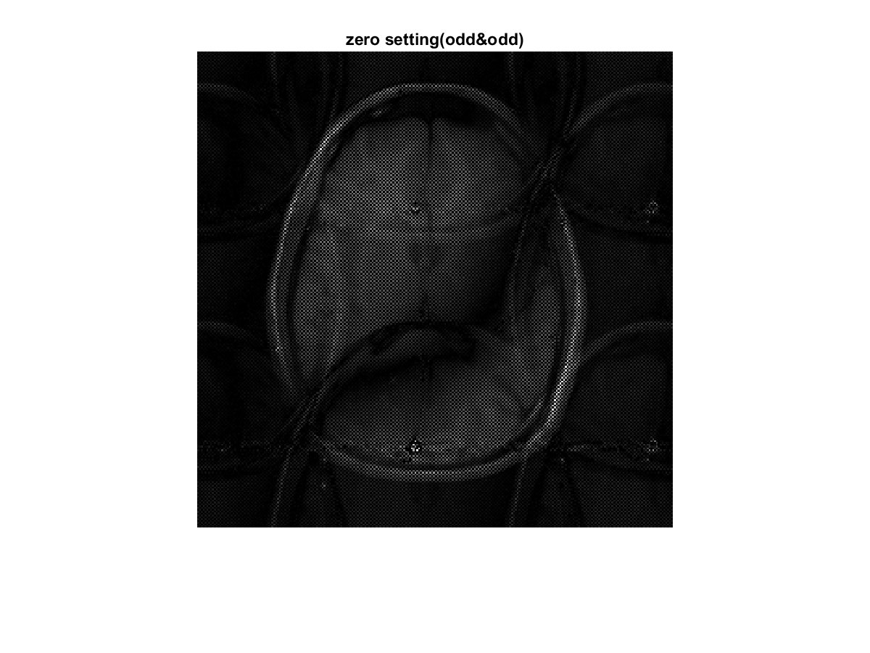

1. **将数据放到512*512大小的矩阵中心，其他位置处为0**

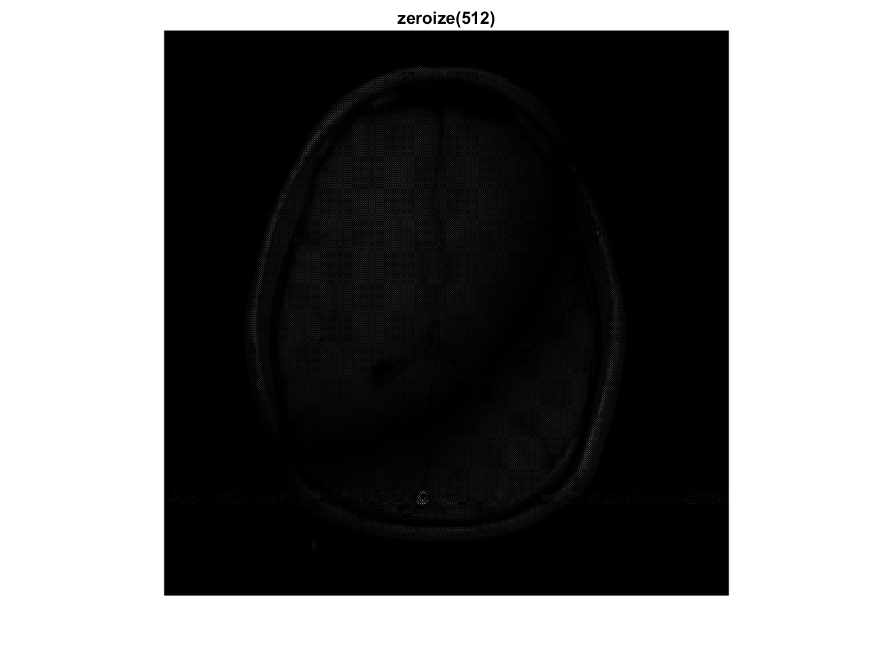

**二、代码**

% %2017/4/8 MRI重建图像

% 李丹阳

% 作业要求

% – 傅里叶逆变换重建图像， 观察图像的模,相位,实部,虚部

% – 将数据第1到64行数据置0，然后重建

% – 将数据1到64行与193到256行置0，…

% – 将数据奇数行置0， …

% – 将数据偶数行置0， …

% – 将数据奇数行置0，奇数列置0， …

% – 将数据放到512*512大小的矩阵中心，其他位置处为0， …

%将原始数据headraw.mat至于Matlab当前工作目录下

load('headraw.mat');

%观察原始数据的实部，虚部和模

Real_H=real(headraw);

Imag_H=imag(headraw);

Abs_H=abs(headraw);

Angle_H=angle(headraw);

subplot(2,2,1),image(Real_H),axis off,title('Real');

subplot(2,2,2),image(Imag_H),axis off,title('Imag');

subplot(2,2,3),image(Abs_H),axis off,title('Abs');

subplot(2,2,4),image(Angle_H),axis off,title('Angle');

saveas(gcf,'Real&Imag&Abs&Angle.png');

%重建图像

ifft2H=ifft2(headraw);

figure,imshow(ifft2H)

title('raw image');

saveas(gcf,'raw image.png');

headraw1=ones(256,256);

headraw1(1:128,1:128)=ifft2H(129:256,129:256);headraw1(129:256,129:256)=ifft2H(1:128,1:128);

headraw1(1:128,129:256)=ifft2H(129:256,1:128);headraw1(129:256,1:128)=ifft2H(1:128,129:256);

figure,imshow(headraw1)

title('image');

saveas(gcf,'image.png');

%1到64行置零后重建

headraw1_64=headraw;

headraw1_64(1:64,:)=0;

ifft2H1_64=ifft2(headraw1_64);

headraw2(1:128,1:128)=ifft2H1_64(129:256,129:256);headraw2(129:256,129:256)=ifft2H1_64(1:128,1:128);

headraw2(1:128,129:256)=ifft2H1_64(129:256,1:128);headraw2(129:256,1:128)=ifft2H1_64(1:128,129:256);

figure,imshow(headraw2)

title('zero setting(1-64)');

saveas(gcf,'zero setting(1-64).png');

%1到64行，193到256行置零重建

headraw1_64_193_256=headraw;

headraw1_64_193_256(1:64,193:256)=0;

ifft2H1_64_193_256=ifft2(headraw1_64_193_256);

headraw3=zeros(256,256);

headraw3(1:128,1:128)=ifft2H1_64_193_256(129:256,129:256);

headraw3(129:256,129:256)=ifft2H1_64_193_256(1:128,1:128);

headraw3(1:128,129:256)=ifft2H1_64_193_256(129:256,1:128);

headraw3(129:256,1:128)=ifft2H1_64_193_256(1:128,129:256);

figure,imshow(headraw3)

title('zero setting(1-64&193-256)');

saveas(gcf,'zero setting(1-64&193-256).png');

%奇数行置零重建

headrawodd=headraw;

headrawodd(1:2:end,:)=0;

ifft2Hodd=ifft2(headrawodd);

% figure,imshow(ifft2Hodd)

headrawodd1=zeros(256,256);

headrawodd1(1:128,1:128)=ifft2Hodd(129:256,129:256);

headrawodd1(129:256,129:256)=ifft2Hodd(1:128,1:128);

headrawodd1(1:128,129:256)=ifft2Hodd(129:256,1:128);

headrawodd1(129:256,1:128)=ifft2Hodd(1:128,129:256);

figure,imshow(headrawodd1)

title('zero setting(odd row)');

saveas(gcf,'zero setting(odd row).png');

%%偶数行置零重建

headraweven=headraw;

headraweven(2:2:end,:)=0;

ifft2Heven=ifft2(headraweven);

% figure,imshow(ifft2Heven)

headraweven1=zeros(256,256);

headraweven1(1:128,1:128)=ifft2Heven(129:256,129:256);

headraweven1(129:256,129:256)=ifft2Heven(1:128,1:128);

headraweven1(1:128,129:256)=ifft2Heven(129:256,1:128);

headraweven1(129:256,1:128)=ifft2Heven(1:128,129:256);

figure,imshow(headraweven1)

title('zero setting(even row)');

saveas(gcf,'zero setting(even row).png');

%%奇数行和奇数列置零重建

headrawodd_odd=headraw;

headrawodd_odd(1:2:end,1:2:end)=0;

ifft2Hodd_odd=ifft2(headrawodd_odd);

% figure,imshow(ifft2Hodd_odd)

headrawodd_odd1=zeros(256,256);

headrawodd_odd1(1:128,1:128)=ifft2Hodd_odd(129:256,129:256);

headrawodd_odd1(129:256,129:256)=ifft2Hodd_odd(1:128,1:128);

headrawodd_odd1(1:128,129:256)=ifft2Hodd_odd(129:256,1:128);

headrawodd_odd1(129:256,1:128)=ifft2Hodd_odd(1:128,129:256);

figure,imshow(headrawodd_odd1)

title('zero setting(odd&odd)');

saveas(gcf,'zero setting(odd&odd).png');

%数据放置在512*512中，重建

headraw_512=zeros(512,512);

headraw_512(129:384,129:384)=headraw;

ifft2H_512=ifft2(headraw_512);

% figure,imshow(ifft2H_512)

headraw_512_1=zeros(512,512);

headraw_512_1(1:256,1:256)=ifft2H_512(257:512,257:512);

headraw_512_1(257:512,257:512)=ifft2H_512(1:256,1:256);

headraw_512_1(1:256,257:512)=ifft2H_512(257:512,1:256);

headraw_512_1(257:512,1:256)=ifft2H_512(1:256,257:512);

figure,imshow(headraw_512_1)

title('zeroize(512)');

saveas(gcf,'zeroize(512).png');