## NO.2

## KNOWLEDGE AND INTELLIGENCE IN ARTIFICIAL SYSTEMS

**INTRODUCTION**

Knowledge representation serves as the bedrock upon which machine s emulate human-like intelligence.By enveloping real-world information in a computationally digestible format. It enables AI systems to process, reason and act upon complex data sets. This paper focuses on the landscape of knowledge representation, exploring its pivotal role in shaping the trajectory of AI research and its implications for the intersection of knowledge and intelligence.

**DEFINITION OF KNOWLEDGE REPRESENTATION**

Knowledge representation is a field of artificial intelligence that is concerned with presenting real-world information in a form that the computer can understand and use to solve real-life problems or handle real-life tasks. It describes the representation of knowledge and basic study of how beliefs, intentions and judgement of an intelligent agent which can be expressed suitably for automated reasoning.It represents information from the real world for a computer to understand and then utilize this knowledge to solve complex real-life problems like communicating with human beings in natural language.

It is not just about storing data in a database, it allows a machine to learn from that knowledge and behave intelligently like a human being.

**THE KNOWLEDGE REPRESENTATION CYCLE IN AI**

This cycle is summarized in the following:

- Perception

- Learning

- Knowledge Representation & Reasoning

- Planning

- Execution

KNOWLEDGE REPRESENTATION CYCLE

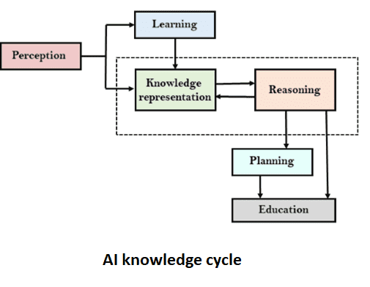

The above diagram shows the interaction of an AI system with the real world and the components involved in showing intelligence.

The perception component retrieves data or information from the environment, find out the source of noises and check if the AI was damaged by anything. Also, It defines how to respond when any sense has been detected.

The learning component that learns from the captured data by the perception component with the goal to build computers of self-improvement. In order to learn new things, the system requires knowledge acquisition, inference, acquisition of heuristics, faster searches.

Knowledge Representation and Reasoning which is the main component in the cycle shows the human-like intelligence in the machines. Knowledge representation is all about understanding intelligence and rather than trying to understand or build brains from the bottom up, its goal is to understand and build intelligent behavior from the top-down and focus on what an agent needs to know in-order to behave intelligently. It defines how automated reasoning procedures can make this knowledge available as needed.

The Planning and Execution components**,** this depends on the analysis of knowledge representation and reasoning .Here, planning includes giving an initial state ,finding their preconditions and effects, and a sequence of actions to achieve a state in which a particular goal holds. Now once the planning is completed, the final stage is the execution of the entire process.

**KNOWLEDGE AND INTELLIGENCE**

Knowledge is a familiarity, awareness, or understanding of someone or something such as facts, information, descriptions, or skills, which is acquired through experience or education by perceiving, discovering, or learning. It can also refer to a theoretical or practical understanding of a subject. In the real world, knowledge plays a key role in intelligence as well as creation of artificial intelligence. It demonstrates the intelligence behaviour in AI agents or systems. It is possible for an agent or system to act accurately on some input only when it has the knowledge or experience about the input.

In the exploration of knowledge, there's an initial tendency to perceive it as a broad, overarching feeling rather than a collection of discrete thoughts. This perception is challenged by the difficulty in expressing certain types of knowledge, particularly procedural knowledge like yo-yo tricks or baking techniques. Despite this challenge, much of what we know can indeed be articulated with some mental effort.This articulation becomes apparent when we apply our knowledge to solve new problems or answer unfamiliar questions. For instance, when asked whether a crocodile could run a steeplechase, we draw upon our existing knowledge of crocodiles and steeplechases to form a response. This process involves combining separate pieces of knowledge to address a novel situation, exemplifying commonsense reasoning.The crux of this commonsense reasoning lies in the ability to merge disparate pieces of knowledge to generate new insights. However, the exact process of combining these pieces of knowledge to form new ideas remains a theoretical question, one that cannot be answered by conventional scientific disciplines. Instead, insights into this process may be gleaned from philosophical inquiries, such as those proposed by Gottfried Leibniz, offering a unique perspective on the nature of knowledge and reasoning.

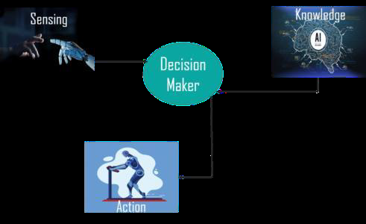

In the example above, there is one decision-maker whose actions are justified by sensing the environment and using knowledge. In case of removal of the knowledge part, there will not be display of any intelligent behaviour.

Knowledge can be represented in a variety of types which include:

**Declarative Knowledge** : This includes concepts, facts, and objects and expressed in a declarative sentence.

**Structural Knowledg**e: This has a basic problem-solving knowledge that describes the relationship between concepts and objects.

**Procedural Knowledge**: This is responsible for knowing how to do something and includes rules, strategies, procedures, etc

**Meta Knowledge** : This is responsible for knowing how to do something and includes rules, strategies, procedures, etc

**Heuristic Knowledge**: This represents some expert knowledge in the field or subject

**CLASSIFICATION OF COMMON SENSE**

Classification of common sense under intelligence or knowledge often centers on the complex interplay between understanding and responding to human emotions. Common sense, inherently, involves navigating the complexities of human interaction, which heavily relies on emotional intelligence which is a blend of cognitive abilities and emotional awareness.

In the context of Artificial Intelligence, common sense becomes a crucial yet elusive attribute. While AI systems excel in specialized tasks, they often lack the broad, adaptable intelligence characteristic of human common sense. The discussion highlights the disparity between AI systems' expertise and their inability to exhibit common sense across diverse scenarios.

Common sense knowledge covers a broad array of everyday objects, events, and concepts, reflecting our understanding of the world. It involves more than mere definitions as it extends to articulating the basic properties and characteristics of various entities, such as hospitals. This knowledge is organized within a conceptual structure, which facilitates generalizations and analogies between different entities. Expressing common sense knowledge often involves making general statements about categories of things, but these statements are subject to annotation and refinement as our understanding evolves. Common sense knowledge is fundamental to intelligence, as it enables individuals to navigate everyday situations effectively. Thus, representing and articulating this knowledge is crucial for developing computational systems capable of exhibiting common sense behavior.

First and foremost , the capacity to sense emotions through various cues, whether verbal or non-verbal, speaks to the intelligence of a system. Machines capable of analyzing language nuances, tone variations, and subtle behavioral signals demonstrate a form of intelligence honed through accumulated knowledge about human behavior and emotional patterns. Though, this intelligence alone is not sufficient without the contextual knowledge required to interpret these emotional cues accurately.

Moreover, the appropriate response to emotions, such as offering empathy or comfort, necessitates both intelligence and knowledge. While machines can be programmed to respond empathetically, the effectiveness of such responses hinges on a deep understanding of human emotions and social norms. Knowing when to intervene, how to offer support, and understanding the nuances of each situation requires not only cognitive intelligence but also a wealth of knowledge about emotional dynamics and social interactions.

The emergence of relational agents underscores this fusion of emotional intelligence and knowledge. These agents aim to establish long-term social-emotional relationships with users, indicating a sophisticated understanding of human emotions and social interactions. Their success in fostering bonds with users highlights the importance of emotional intelligence coupled with knowledge about human behavior in enhancing human-machine interactions.

**CONCLUSION**

In the grand tapestry of AI, knowledge reigns supreme as the catalyst for true intelligence. As we navigate the vast realms of perception, learning, and reasoning, it is through the prism of knowledge representation that AI systems ascend towards cognitive prowess. By utilizing the power of knowledge representation, we open the potential for machines to not only comprehend but also reason, plan, and execute tasks with ingenuity akin to human intelligence. As we stand on the precipice of a new era in AI, let us embrace the transformative potential of knowledge representation, forging a future where machines stand as equals in the realm of intellect.

**CITATION**

- Smith, J. (2022). Artificial Intelligence: A Modern Approach (4th ed.). London: Pearson.

Jones, R. (2023).Machines Like Us: Towards AI with Common Sense. Cambridge: Cambridge University Press.

Brown, T. (2019).Computational Models of Referring: A Study in Cognitive Science. Oxford: Oxford University Press.

Cass, R. (2001). "Artificial Intelligence and Legal Reasoning." Journal of Legal Studies, 25(3), 45-67. University of Chicago Press.

Picard, R. W. (2000). "Toward Machines with Emotional Intelligence." MIT Media Laboratory Technical Report, Cambridge, MA: MIT Press.