Algonquin College Logo

# SCHOOL OF ADVANCED TECHNOLOGY

### ICT - Applications & Programming

### Computer Engineering Technology – Computing Science



A11

Game Interface

Ngoc Phuong Khanh Le - Id: 041004318

Game Proposal - NumPuz

***This template is suggested (not mandatory) to answer A11 Specification.***

|  |  |
| --- | --- |
| **Part**  **1** | **GUI Definition** |

**EXPLANATION**

*The purpose of this assignment is to define the elements of the GUI application to be used in your game implementation.*

* ***Example****:*

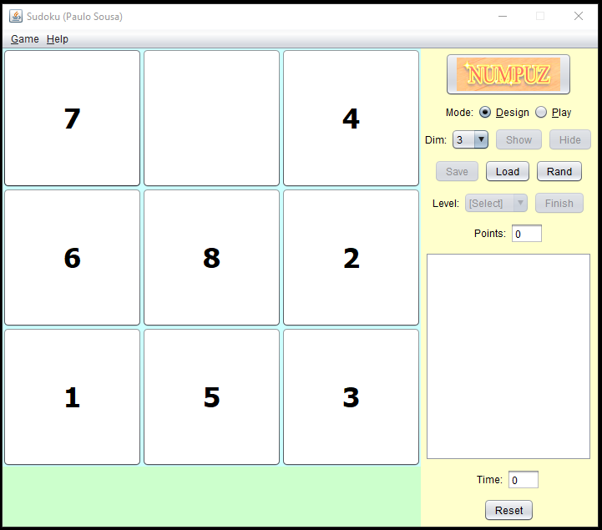

* ***Note****: The professor interface is also a proposal. It means that your own implementation can be different. What does matter is that the game functionality will be respected.*
  1. **Defining the Components**

**List of components**

JFrame, JPanel, JRadioButton, JComboxBox, JButton, JTextField, JTextArea, JTabbedPane

**Functionalities and Behaviors**

* **Functionalities**
* JFrame: containing panels, labels, buttons, etc.
* JPanel: grids of numbers
* JPanel: stores GUI for functionalities
* JTabbedPane: game and help panel above the functionality panel
* JRadioButton: design and play in mode
* JComboxBox: dropdown for dimension
* JButton: save and hide solutions from player (disable when user is playing)
* JButton: save and load configuration from files
* JButton: Start the game
* JButton: Restart the game, interrupting the current execution
* **Behaviors:**
* JTextField: number of points
* JTextArea: information about the execution
* JTextField: time of current execution

**Details**

*Drawn your interface (ex: in an image from Paint / Powerpoint slide, or any sketch tool), describing:*

* *The components.*
* *The properties (ex: size, dimension, color, position, etc)*
* *Additional GUI components (ex: the layout to be used).*

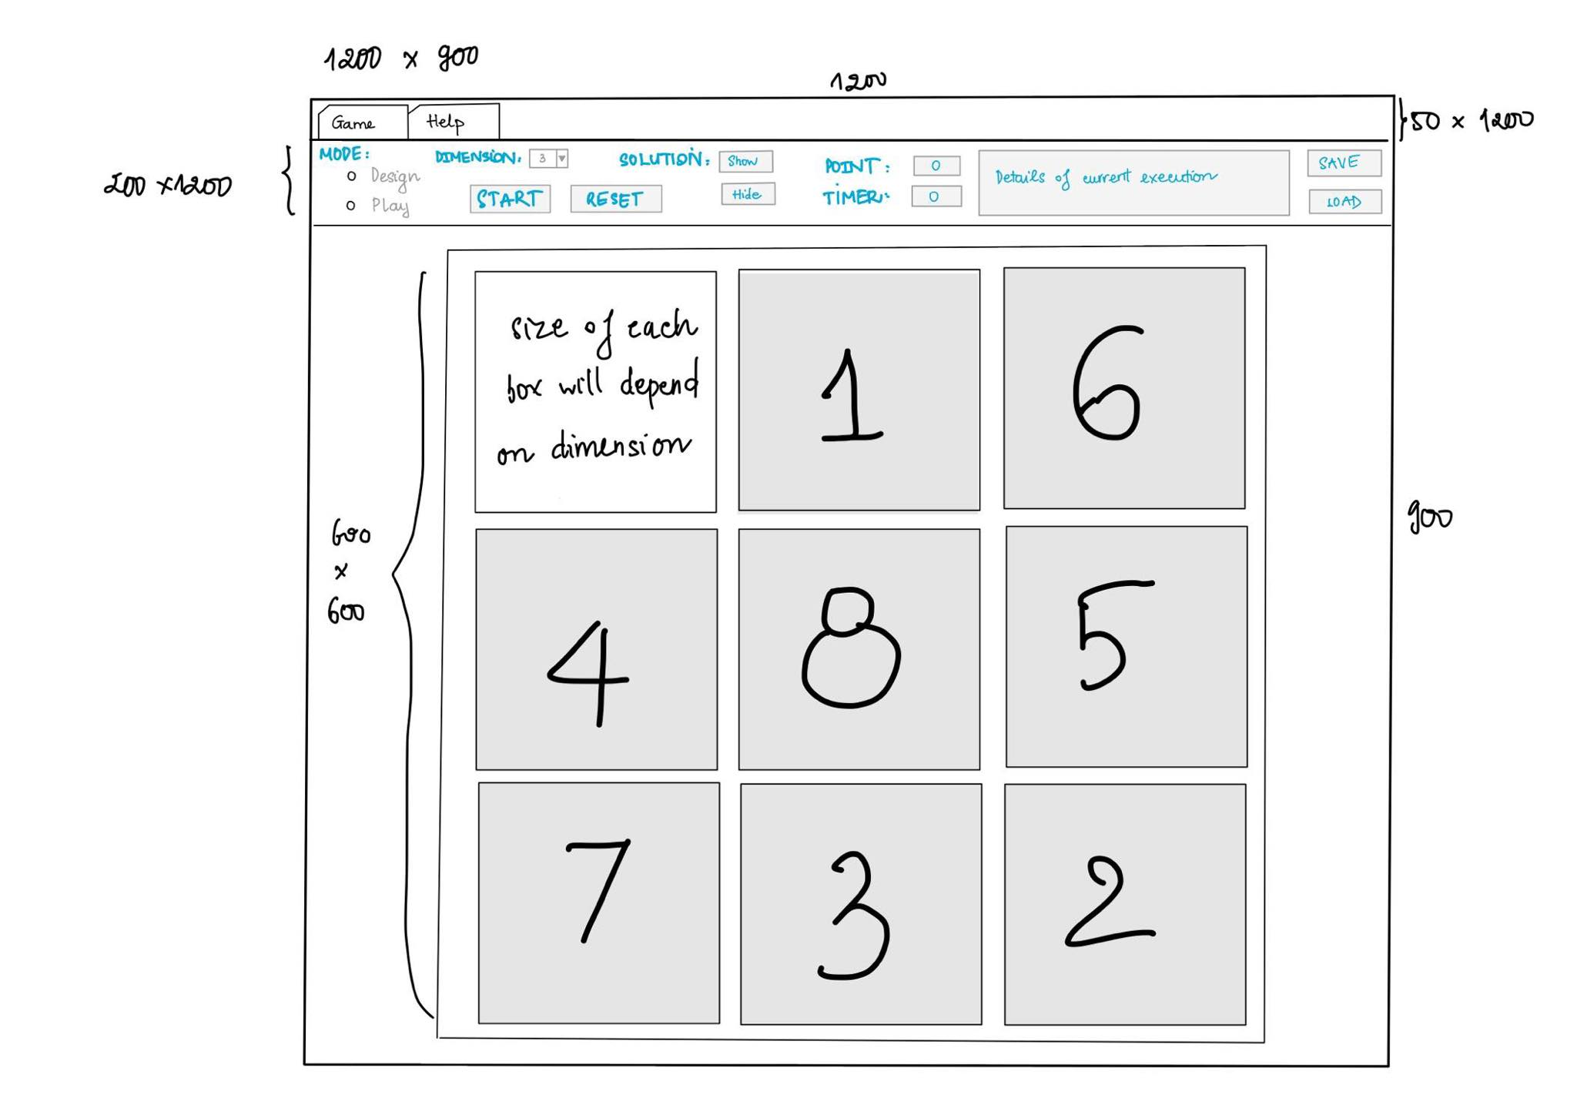

* 1. **User Manual**

**Basic cycle**

*Create a brief description about how your game can be used.*

***Example****: If you have to design the solution to be saved and played later, how are the stems. Most importantly, how someone can play the* ***NumPuz****.*

* *Note: your process does not need to be followed exactly when you are going to the implementation. For while, it is only a script about how to play.*

This proposal will be about sliding number puzzle game. The user will choose what dimension they want to play and click “Start” to play the game. There will be numbers in the grid in random order and a blank box. The purpose of this game is to move numbers around so that they are all in ascending order from left to right, top to bottom.

Click “Reset” to restart the game. User can also save the current game they’re playing and load it again the next time to continue to play. I am thinking of storing it into a file and load the file to read the numbers from previous game (but I am not sure it will work or not).

**FINAL SUGGESTIONS**

*Here some ideas to think about your language....*

* *Try to create a game whose execution can be very intuitive (easy to be played).*
* *Remember that this game will be in fact implemented only in the next assignment.*

I think this game is straightforward. Therefore, I do not have anything much to add here.

**References**

*I draw the picture myself, thus I do not use any source outside to give references to.*

Algonquin College

Fall, 2022