1️⃣ 首页
- Hero部分目前的字母是 COG，但应该是「CAG」 ，对应 子页面那里的 Compass, Access, Growth 的首字母

- Hero 和our services 板块之间 增加一section About Us
内容是：
From strategic intelligence to executive immersion, from partner scouting to joint venture creation, we help global innovators move beyond surface-level narratives and engage directly with the people, technologies, and opportunities shaping the future.
— We are not a tour operator.
— We are not a traditional consultancy.
— We are your China innovation intelligence and execution partner.

- Our Services section 这里
Our Core Expertise 改为 ENGAGEMENT MODEL

- SELECTED PROJECTS 标题改为 「OUR METHOD」
What We Do 改为「Intelligence. Communication. Network.」
小字：Successful cross-border innovation requires more than information. It requires context, trust, timing, and the right people at the table.
图片可以先不改，但文字得从下面这张截图里挑着来用
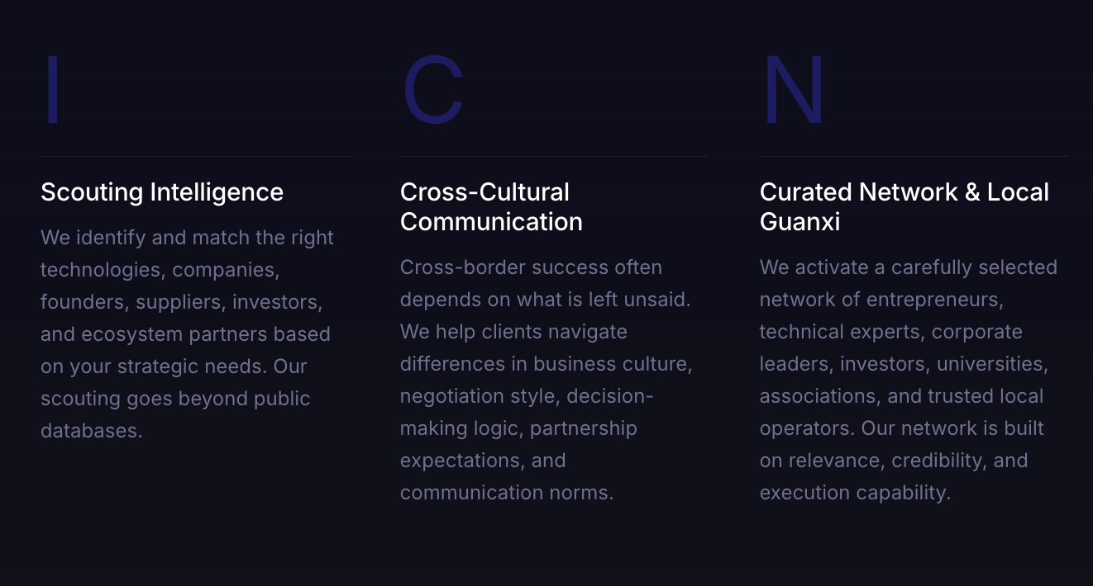

- 然后添加一新的section 「We’re AI-propelled」
Intelligence Platform

PROPELLER is building an AI-powered open-source intelligence platform designed to decode China's AI and robotics ecosystem for global businesses.
- 5000+ filtered AI Builder and Innovator profiles
- Patent, financing, team, and company-change tracking
- Real-time monitoring of breakthrough technologies
- Smart alerts across priority technology sectors
- China Innovation ecosystem mapping based on Trusted Network across academia, industry, media, and entrepreneurial communities.

- 尾部「ready to churn the water」section 加上两行小字
Move with clarity, confidence, and trusted local access.
Start with Compass. Enter with Access. Grow with PROPELLER.

-

2️⃣ Our Story page
- hero部分的背景需要动态的海面波光粼粼 feature a dynamic, sparkling ocean video or CSS shader animation (波光粼粼海面) covering the background

- Hero的文字行间距加大点（尤其主 slogan 和辅助解释文字之间的距离）
- Our Origin 这段文字里的「the Fish」 超级链接改到这里 https://www.goodreads.com/book/show/50887097-why-fish-don-t-exist

- Include a dedicated image placeholder for "MIT Building 20 (MIT 2.0)"

3️⃣ 底部加上联系方式
CONNECT business@globalpropeller.com

底部：YouTube链接改为 https://www.youtube.com/@PROPELLER_theArch

